Melissa Davies | melissa.davies@redburnatlantic.com
Michael Taylor | michael.taylor@redburnatlantic.com

23 July 2025
Economics
The Money Map July 2025
Uncertainty about the level and effect of tariffs will keep all but one of the four major central banks on hold in the latest round. The Fed and ECB are in a good place and able to respond to developments as necessary. The BoJ is more constrained as it also faces high inflation. The BoE, less concerned with tariff uncertainty, will cut Bank Rate by 25bp in August as it looks through above-target inflation and focuses on slowing wages growth.
The Fed, the ECB and BoJ will hold rates this month. All three are waiting to see the fallout from US tariffs. In the US, there are upside risks to both inflation and unemployment. Inflation risks are more immediate and will take precedence in Fed policy decisions over employment levels, which in any case are holding up. But the inflationary consequences of tariffs are highly uncertain and – so far up to June – CPI has shown few signs of an effect. A significant rise in CPI inflation would keep the Fed on hold for the rest of the year. This remains our call, as we await more evidence on tariffs and inflation.
The ECB signalled a pause in its easing cycle after last month’s 25bp cut to 2%. The message is that it is well placed to deal with the consequences of any tariff regime imposed on the EU. As it stands, unless a trade deal is agreed by 1 August, the EU will face a 30% tariff. In this case, the demand deflationary effect would almost certainly be offset with cuts in the Deposit rate, probably 50bp. Meanwhile the Japanese economy is facing the twin headwinds of high inflation, led by food prices, and the uncertainty about US trade policy. The effect is to prevent the BoJ from further normalisation of monetary policy, probably into next year.
The one central bank likely to cut rates this time is the BoE, maintaining the pattern of a 25bp cut at every quarterly forecasting round. A cut in August will take Bank Rate to 4%. Having secured a trade deal with the US in May, the UK is not subject to the 1 August deadline. Despite CPI at 3.6% in June, the MPC is confident that slowing wages growth will bring services inflation down, allowing for a further reduction in the restrictive policy stance. Our view is that Bank Rate will then be on hold for the rest of the year, reflecting slow progress in reducing services inflation.

Contents
The Fed 3
The next meeting: 29-30 July 3
The next 12 months 3
The longer-term view 3
The European Central Bank 10
The next meeting: 24 July 10
The next 12 months 10
The longer-term view 10
The Bank of England 17
The next meeting: 7 August 17
The next 12 months 17
The longer-term view 18
The Bank of Japan 24
The next meeting: 30 -31 July 24
The next 12 months 24
The longer-term view 25

The Fed
The Fed will be in ‘wait and see’ mode into the Autumn. Economic activity is solid and the labour market in healthy balance. So far, the inflationary effect of tariffs has not materialised. Inflation and jobs market data in coming months will determine the path of interest rates. Our view of inflation rising above 3% with continued steady economic growth suggests no rate cuts this year. But policy remains restrictive, and easing is likely in H1 2026.

The next meeting: 29-30 July
We expect the Fed to keep the Federal Funds rate on hold at 4.25-4.5%.

The next 12 months
The economy continues to show solid economic activity. The Atlanta Fed GDPNow estimate is for an annualised 2.4% for Q2. (The first official estimate is due on 30 July.) In addition, the labour market is consistent with full employment. Indeed, the unemployment rate ticked down 0.1 percentage points in June to 4.1%, while payrolls have averaged 150,000 a month over the last three months. Given this backdrop, the July FOMC meeting will almost certainly leave the Federal Funds rate unchanged.
The Minutes of the June FOMC meeting reaffirmed that most members expected that it would be appropriate to reduce the Fed Funds rate later this year. This view is based on either that the increase in inflation from tariffs will be modest and temporary or that some weakening of economic activity and labour market conditions could occur. On inflation, the June data showed no significant upward influence from tariffs – the run-down of inventories built up ahead of tariff announcements is delaying the impact. We expect CPI to peak at 3-3.5% later this year (it reached 2.7% in June), subject to where tariffs ultimately land.
Our view is that upside risks to inflation will persist through the rest of the year, while economic activity and the labour market do not show material weakness. Household balance sheets are in good shape. Real wages growth will slow as inflation rises, but we expect it to remain positive, supporting consumer spending. At the turn of the year, the jobs market may begin to show signs of significant cooling, triggering rate cuts early in 2026. For now, we retain our no rate cut view for this year, while acknowledging the risk that, by December, conditions may warrant a 25bp rate cut.

The longer-term view
On 4 July, President Trump signed the Big Beautiful Bill into law. The tax and spend measures included in the legislation will add significantly to US debt levels over the next decade. The 2017 tax cuts introduced in President Trump’s first term are made permanent. Other significant measures include no tax on tips or overtime, both time-limited to 2028. On the spending side, there are cuts to Medicaid and food benefits to low-income families. The Penn Wharton Budget Model (PWBM) at the University of Pennsylvania estimates that the overall effect will be to boost the US primary deficit (excluding interest payments) by $2.8trn over the ten years to 2034. This is made up of $4.6trn of tax cuts offset by $1.8trn of spending cuts. Interest on government debt is on course to increase significantly, boosting the total budget deficit. Over the next ten years, interest costs are projected to more than double, from $900bn to almost $2trn (4.5% of GDP).
The impact on US debt levels is shown in Fig 1, using estimates from the Committee for a Responsible Federal Budget. US government debt is set to rise by a further eight percentage points above the 17 percentage points already slated by existing policies. The debt to GDP ratio rises to 125% by 2034, or 129% if time-limited measures are made permanent.
Fig 1: US public sector debt, % of GDP
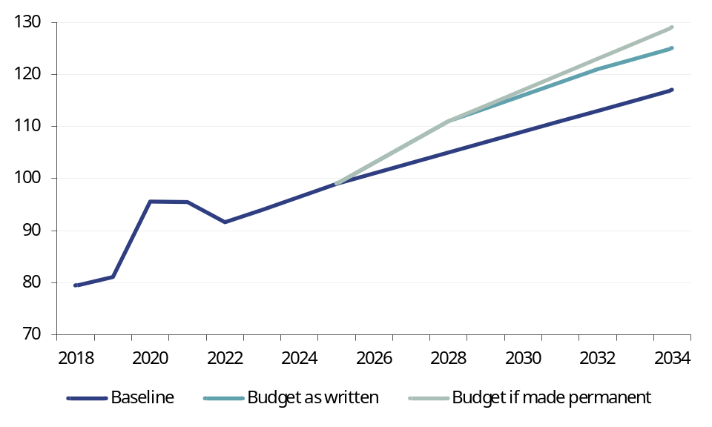
Source: Committee for a Responsible Federal Budget

Fig 2: US M1 and M2 YoY |  | Fig 3: Effective Fed Funds Rate (%)
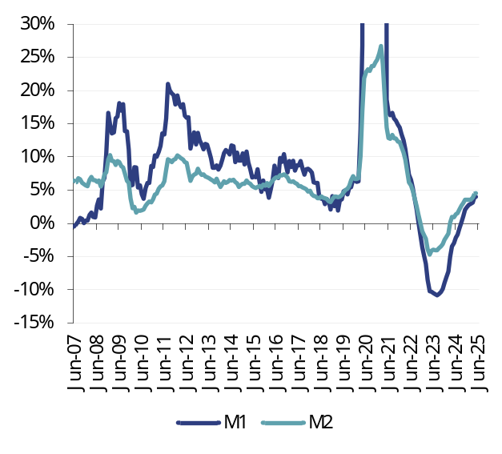 |  | 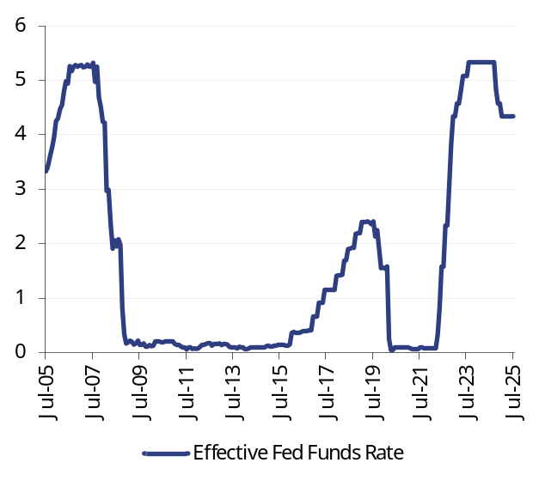
Source: Datastream |  | Source: Datastream

Fig 4: Corporate loans, YoY |  | Fig 5: Household loans, YoY
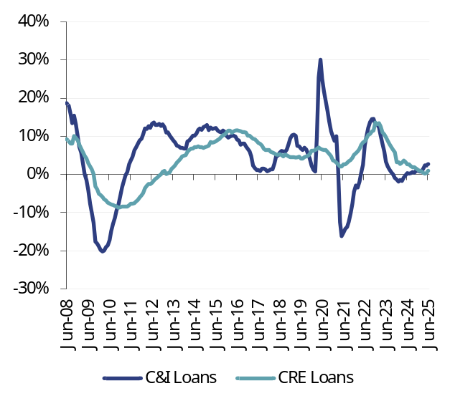 |  | 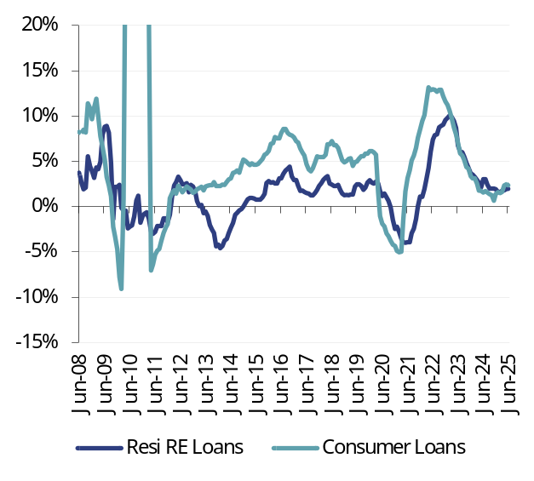
Note: C&I = commercial and industrial; CRE = commercial real estate  Source: Datastream |  | Note: RE = real estate  Source: Datastream

Fig 6: Fed Senior Loan Officer (SLO) Survey – corporate credit (net balance) |  | Fig 7: Fed SLO Survey – credit cards (net balance)
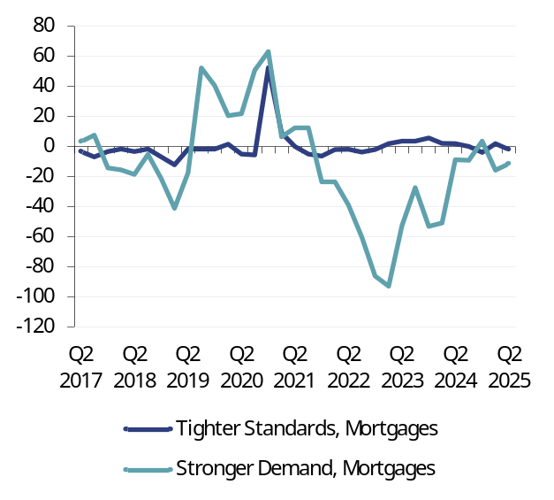 |  | 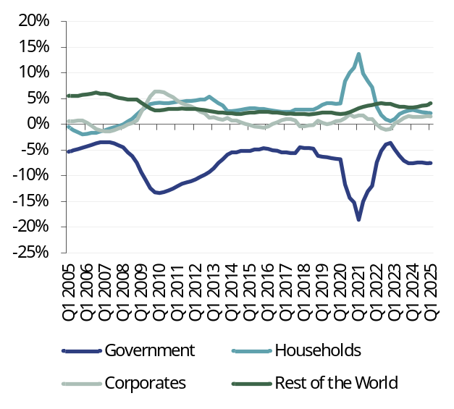
Source: Datastream, Fed Senior Loan Officer Survey |  | Source: Datastream, Fed Senior Loan Officer Survey
Fig 8: Fed SLO Survey – mortgages (net balance) |  | Fig 9: US sector financial balances (% GDP)
Source: Datastream, Fed Senior Loan Officer Survey |  | Source: Datastream

Fig 10: US CPI |  | Fig 11: US corporate profits
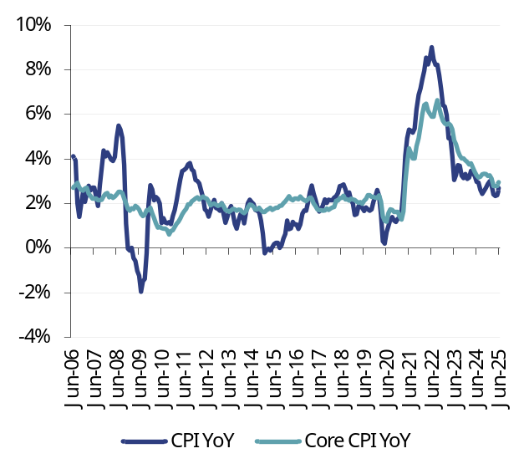 |  | 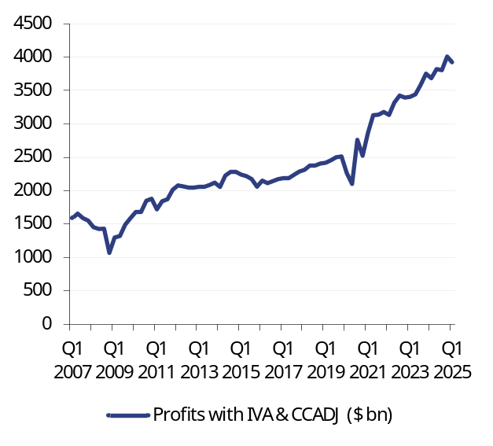
Source: Datastream |  | Note: IVA = Inventory Valuation Adjustment; CCADJ = Capital Consumption Adjustment  Source: Datastream

Fig 12: UMich five-year inflation expectations (%) |  | Fig 13: US ten-year inflation linked swap (%)
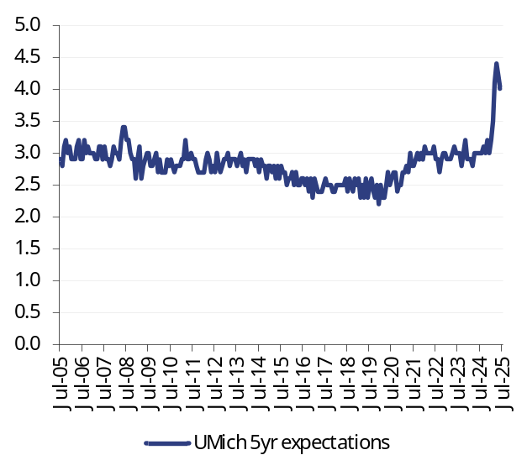 |  | 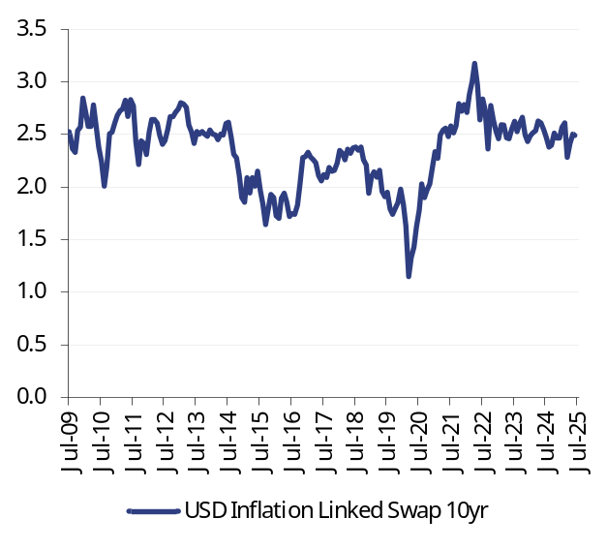
Source: Datastream |  | Source: Datastream

Fig 14: Atlanta Fed wage tracker (%) |  | Fig 15: US job openings and jobless claims (’000s)
Source: Datastream |  | Source: Datastream

Fig 16: US ISM surveys |  | Fig 17: Nominal broad dollar exchange rate
Source: Datastream |  | Source: Datastream, Federal Reserve

Fig 18: Fed assets ($m) |  | Fig 19: Fed reserves and ON RRP ($m)
Source: Datastream |  | Source: Datastream

Fig 20: Overnight Index Swap (OIS) curve (%) |  | Fig 21: US yield curve (%)
Source: Datastream |  | Source: Datastream, Federal Reserve

The European Central Bank
The ECB is in ‘wait and see’ mode, content that a 2% deposit rate is consistent with the 2% inflation target. The nature of any EU-US trade deal will be a key influence on the future course of policy. If the current proposed 30% tariff is implemented, then rate cuts in short order are likely. A deal with much lower tariffs and reduced uncertainty may keep the ECB on hold for a while. The forthcoming boost to defence spending will have macroeconomic consequences, but mainly from 2028 onwards.

The next meeting: 24 July
We expect the ECB to keep the Deposit rate at 2.0%.

The next 12 months
At the last policy meeting in June, the Governing Council voted unanimously to cut the Deposit rate by 25bp to 2.0%. The message at the press conference is that the ECB now moves into ‘wait and see’ mode, the main uncertainty being trade relations with the US. New ECB staff projections presented three scenarios for the ultimate outcome. Baseline, which assumes 10% tariffs on exports to the US, has CPI dipping to 1.6% in 2026 – mainly on energy prices and a stronger euro – before picking up to the 2% target in 2027. Hence the ECB is content with rates at 2% for now and awaits developments.

The current position – ahead of a potential deal before the 1 August deadline – is that the EU will face 30% tariffs on goods exports to the US. This more closely corresponds with staff projections’ ‘severe’ scenario, which also assumes retaliatory tariffs on the US. In this case, staff view the demand-deflationary effect of high tariffs to be greater than the inflationary effect of EU tariffs. So, by 2027, CPI on this scenario is put at 1.8%. This would imply ECB rate cuts, down to at least 1.5%. The ECB is set to hold rates at the July meeting and to await greater visibility by the time of the next monetary policy meeting in September.

The longer-term view
Europe will be spending significantly more on defence in coming years. But the impact on GDP for a given level of spending – the so-called multiplier – is highly uncertain, with a wide range of estimates. Fig 22 illustrates modelling by the European Commission of the effect on the EU economy of a debt-financed, permanent 1.5% of GDP boost to defence spending.0F
At its peak in 2028, EU GDP is boosted by 0.5%, but in the medium to long term the effect is smaller at just under 0.3%, implying a multiplier of around 0.2. This relatively low estimate is caused by two main factors. Firstly, 20% of the extra spending is assumed to go on imports, in line with historical averages. Secondly, because the rise in defence spending is assumed to be financed with government debt, there are expectations of higher taxation in the future, which dampens private consumption. In addition, 10% of expenditure is assumed to go on R&D – again in line with the long-term average – implying only a marginal lift to potential GDP growth. If the share of imports and R&D turns out to be more favourable to the EU, say because of expansion in the European defence industry that reduces imports, the boost to EU growth would be greater, but only modestly. Germany is the only major European country with the fiscal capacity to borrow over a sustained period to boost defence spending. In the long term, other European countries will have to either increase taxation or reduce government spending in other areas, implying difficult political choices.
Fig 22: Impact on EU GDP of an increase in defence spending (percentage points of GDP)
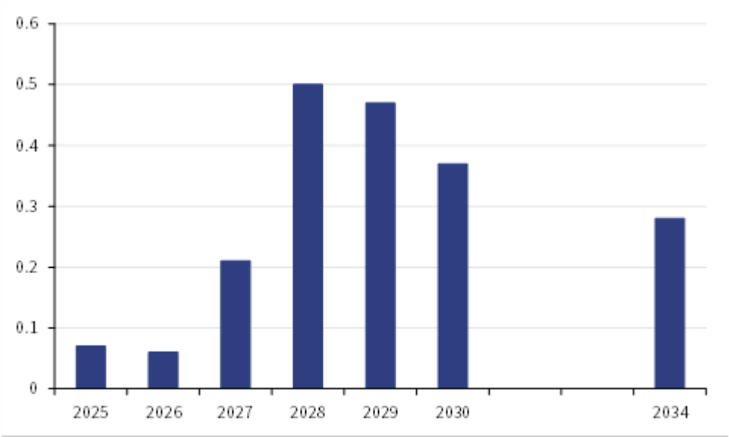
Source: European Commission

Fig 23: Eurozone M1 and M3, YoY |  | Fig 24: ECB deposit facility rate (%)
Source: Datastream |  | Source: Datastream

Fig 25: Corporate loans, YoY |  | Fig 26: Household loans, YoY
Note: NFCs = non-financial corporates  Source: Datastream |  | Source: Datastream

Fig 27: ECB Bank Lending Survey – corporate credit (net balance) |  | Fig 28: ECB Bank Lending Survey – consumer credit (net balance)
Source: Datastream, ECB Bank Lending Survey |  | Source: Datastream, ECB Bank Lending Survey
Fig 29: ECB Bank Lending Survey – mortgages (net balance) |  | Fig 30: German sector financial balances (% GDP)
Source: Datastream, ECB Bank Lending Survey |  | Source: Datastream, Eurostat

Fig 31: Eurozone CPI |  | Fig 32: Eurozone non-financial corporate profits
 |  | 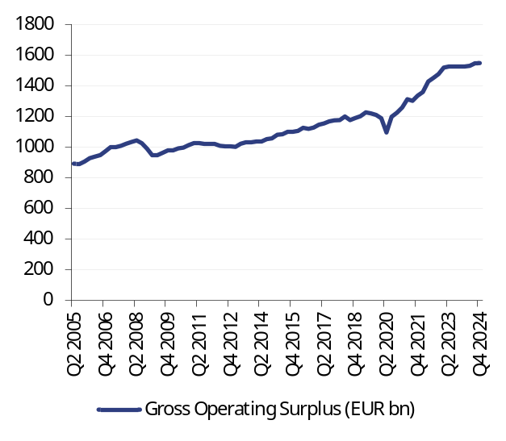
Source: Datastream |  | Source: Datastream

Fig 33: Eurozone consumer price expectations (%) |  | Fig 34: Euro ten-year inflation-linked swap rate (%)
Source: Datastream, European Commission Surveys |  | Source: Datastream

Fig 35: Eurozone wage growth, YoY |  | Fig 36: Eurozone unemployment rate (%)
Source: Datastream, Eurostat |  | Source: Datastream, Eurostat

Fig 37: Eurozone PMI surveys (diffusion index) |  | Fig 38: Nominal broad euro exchange rate (index)
Source: Markit, Datastream |  | Source: Datastream

Fig 39: European Central Bank assets (€m) |  | Fig 40: European Central Bank reserves (€m)
Source: Datastream |  | Source: Datastream

Fig 41: Overnight Index Swap (OIS) curve (%) |  | Fig 42: Eurozone yield curve (%)
Source: Datastream |  | Source: Datastream

The Bank of England
The BoE is set to cut Bank Rate to 4% in August and then join other major central banks in a ‘wait and see’ approach, dependent partly on global trade developments. Domestically, GDP growth will be steady in H2, supported by consumer spending. Inflation is well above target and service inflation is proving sticky. The domestic case for further cuts in Bank Rate needs clear evidence of slowing wages growth.

The next meeting: 7 August
Bank Rate cut by 25bp to 4% with a 7-2 vote.

The next 12 months
Despite monthly contractions in GDP in both April and May, the economy is not about to establish a declining trend. Some of the recent weakness reflects a correction after housing and housing-related activity was pulled into March, ahead of Stamp Duty changes at the end of the month. Quarterly GDP in Q2 will be around 0.2%, down from 0.7% in Q1 – an annualised rate of 1.8% in the first half. The outlook for the second half of the year is modest growth, supported by consumer spending. Consumer spending has maintained a steady upward trend, rising at an annual rate of around 1% in recent years, despite the shock of the energy crisis and rise in Bank Rate (Fig 43). More recently, real incomes have risen by more than consumption, resulting in the savings ratio rising into double digits, well above its pre-COVID average of 8%. We now expect a gradual decline in the savings ratio to support consumer spending, as real incomes slow as nominal wages growth moderates.
Fig 43: Real household disposable income and consumer spending (Index Q4 2021 = 100)
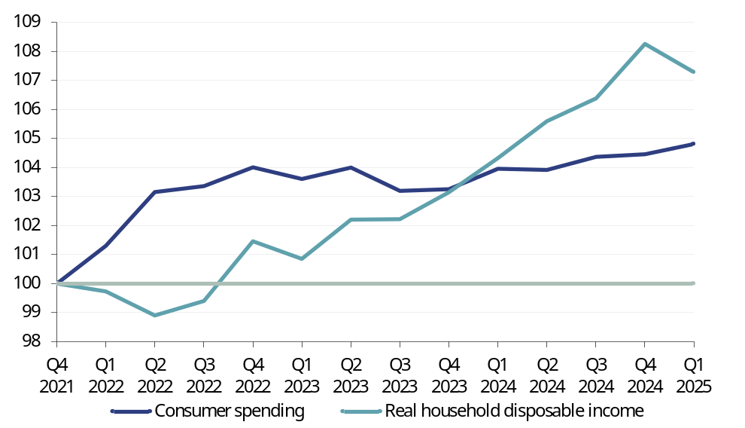
Source: Datastream, Rothschild & Co Redburn
Housing market activity will also support consumer spending, especially on durables and electricals. Lead indicators, such as mortgage approvals and the Royal Institute of Chartered Surveyors (RICS) survey of new buyer enquiries, point to momentum in the housing market, helped by lower mortgage interest rates.
CPI inflation jumped to 3.6% in June, mainly on base effects (smaller falls in petrol and clothing and footwear prices than a year ago). We would agree with the BoE forecast that inflation is to fall back towards the 2% target next year. This view assumes that wages growth slows to below 4%, as suggested by business surveys such as the BoE’s Decision Maker Panel. Services inflation was steady at 4.7% in June. A rate of around 3.5% is needed to be consistent with 2% inflation.
The Bank has maintained a pattern of cutting Bank Rate by 25bp at the time of each quarterly Monetary Policy Report. The August meeting will be no exception, with a cut to 4% highly likely. After August, further rate cuts are less certain. Our view is that domestic demand will be relatively resilient and wages growth will slow only gradually, resulting in rates on hold into 2026.

The longer-term view
A cloud on the near- and long-term horizon is the UK’s unsustainable fiscal position. Recent policy reversals on winter fuel payments and welfare benefits have substantially reduced – if not eliminated – the Chancellor’s fiscal headroom of just under £10bn, established in March. Meeting the key fiscal rule (day-to-day spending to be met through revenue, not borrowing) by 2029/30 will require tax increases in this Autumn’s Budget. The areas likely to be targeted include pensions, capital gains and inheritance. The size of tax increases will be smaller than the £40bn raised in last October’s Budget, but a non-trivial £10-15bn looks likely at present, given the erosion of the safety margin caused by policy reversals.

In its latest Fiscal Risks and Sustainability Report, published earlier this month, the Office for Budget Responsibility (OBR) notes that “Efforts to put the UK’s public finances on a more sustainable footing have met with only limited and temporary success”. Citing in particular the abandonment of planned spending reductions, the OBR comments that borrowing remains too high to be consistent with stabilising debt as a share of GDP. Over the past 20 years, the debt to GDP ratio has increased by 60 percentage points, to almost 100%. The OBR warns that given demographic factors pushing up spending on health and pensions, the UK’s debt profile is at present unsustainable.

Fig 44: UK M1 and M4, YoY |  | Fig 45: Bank Rate (%)
Source: Datastream, Bank of England |  | Source: Datastream, Bank of England

Fig 46: Corporate loans, YoY |  | Fig 47: Household loans, YoY
Source: Datastream, Bank of England |  | Source: Datastream, Bank of England

Fig 48: Credit Conditions Survey – corporate credit (net balance) |  | Fig 49: Credit Conditions Survey – consumer credit (net balance)
Source: Datastream, Bank of England Credit Conditions Survey |  | Source: Datastream, Bank of England Credit Conditions Survey
Fig 50: Credit Conditions Survey – mortgages (net balance) |  | Fig 51: UK sector financial balances (% GDP)
Source: Datastream, Bank of England Credit Conditions Survey |  | Source: Datastream

Fig 52: UK CPI |  | Fig 53: UK non-financial corporate profits
Source: Datastream |  | Source: Datastream

Fig 54: UK consumer price expectations |  | Fig 55: GBP ten-year inflation-linked swap rate (%)
Source: Datastream, YouGov/Citi |  | Source: Datastream

Fig 56: UK wage growth, YoY |  | Fig 57: UK unemployment rate (%)
Source: Datastream, Office for National Statistics |  | Source: Datastream, Office for National Statistics

Fig 58: UK PMI surveys (diffusion index) |  | Fig 59: Nominal broad euro exchange rate (index)
Source: Markit, Datastream |  | Source: Datastream

Fig 60: Bank of England assets (£m) |  | Fig 61: UK reserves (£m)
Source: Datastream, Bank of England |  | Source: Datastream, Bank of England

Fig 62: Overnight Index Swap (OIS) curve (%) |  | Fig 63: UK yield curve (%)
Source: Datastream |  | Source: Datastream

The Bank of Japan
Headwinds from rocketing rice prices and the ongoing uncertainty about US trade policy are constraining the scope for the BoJ to raise the policy rate. High inflation is eroding real wages and threatens the rise in consumer spending needed to establish the benign wage-price spiral. Inflation is likely to fall back in coming months, and trade uncertainty may diminish if a trade deal is reached. But a rate rise before the New Year is unlikely.

The next meeting: 30 -31 July
Policy interest rate on hold at 0.5%.

The next 12 months
The Japanese economy is facing the twin headwinds of a rise in inflation and the extreme uncertainty about US trade policy. Headline inflation is at 3.3% in June, well above the 2% target. Much of this is due to food price inflation, which is running over 7%. Rice prices have doubled over the last 12 months; this alone adds 0.6 percentage points to annual inflation. The BoJ has noted that as rice is a staple food, its price could affect perceived inflation and inflation expectations, requiring close monitoring of rice prices. Rice price inflation is likely to fall back in the coming months, but there have already been economic – and political – consequences. Higher inflation has squeezed real wages and is beginning to hurt consumption, which was flat in Q1, as was GDP (Fig 64). Meanwhile, the cost of living is likely to have been a major influence in the LDP-coalition losing its majority in the Upper House elections on 20 July.

Fig 64: Real wages and consumer spending (Index 2020 = 100)
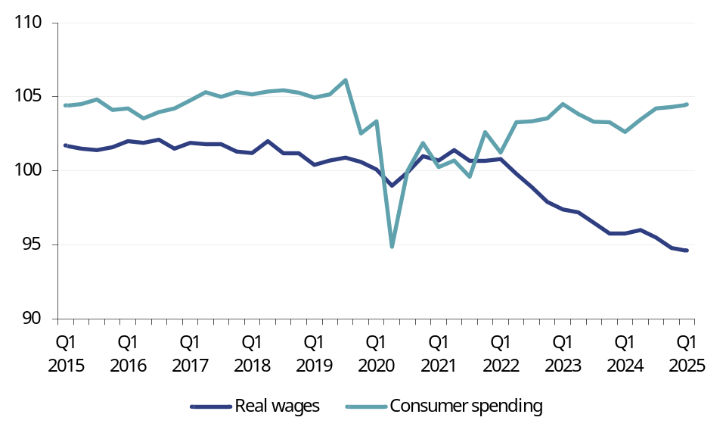
Source: Datastream, Rothschild & Co Redburn

Trade uncertainty continues to weigh on sentiment and hold back growth. Negotiations with the US ahead of the 1 August deadline are ongoing, but car exports appear to be a sticking point. For now, the BoJ is clearly in ‘wait and see’ mode, but with the ultimate goal of raising the policy rate towards a normal level, likely at least 1%. Our view is that it will be Q1 next year at the earliest before conditions are in place for a rise in the policy rate.

The longer-term view
In recent months, Japanese inflation has been above corresponding rates in the US and eurozone, contributing to an appreciation of the real exchange rate. However, this has hardly dented the long-term decline over the last 15 years (Fig 65). But this improved competitiveness has not helped export volumes, which are also on a declining trend. Japan now runs a trade deficit, with its overall current account surplus generated by a growing surplus on investment income. This is a consequence of a declining working population: instead of producing domestically and exporting, companies are investing in overseas productive capacity earning profits that boost investment income.
The exchange rate’s influence is increasingly felt domestically through the effect of import prices on inflation. The high rate of inflation was caused in part by a weaker yen pushing up import prices – especially for energy – as well as surging rise prices. In the future, with BoJ monetary policy normalised, the central bank may be content with a stronger yen that makes imports cheaper and boosts the real consumption wages of households. Throughout, the BoJ will wish to avoid sharp moves in the exchange rate that result in excessive financial market volatility.
Fig 65: Japan real effective exchange rate (Index 1990 =100)
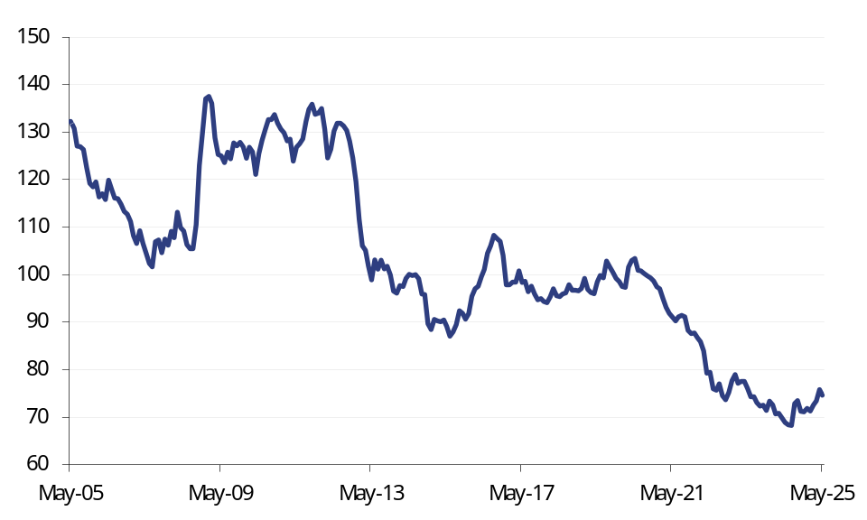
Source: Datastream

Fig 66: Japanese M1 and M4, YoY |  | Fig 67: Policy rate (%)
Source: Datastream, Bank of Japan |  | Source: Datastream, Bank of Japan

Fig 68: Corporate loans, YoY |  | Fig 69: Household loans, YoY
Source: Datastream, Bank of Japan |  | Source: Datastream, Bank of Japan

Fig 70: Loan Survey – corporate credit (net balance) |  | Fig 71: Loan Survey – consumer credit (net balance)
Source: Datastream, Bank of Japan |  | Source: Datastream, Bank of Japan
Fig 72: Loan Survey – mortgages (net balance) |  | Fig 73: Japanese sector financial balances (% GDP)
 |  | 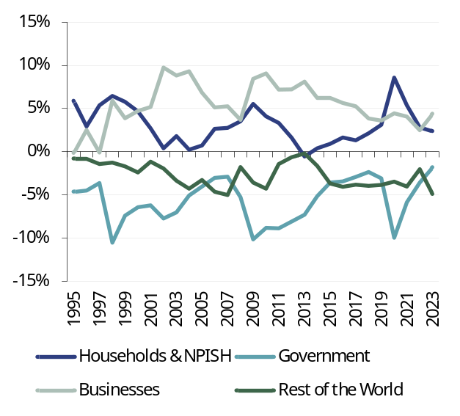
Source: Datastream, Bank of Japan |  | Note: NPISH = Non-Profit Institutions Serving Households  Source: Datastream

Fig 74: Japan CPI |  | Fig 75: Japanese non-financial corporate profits
 |  | 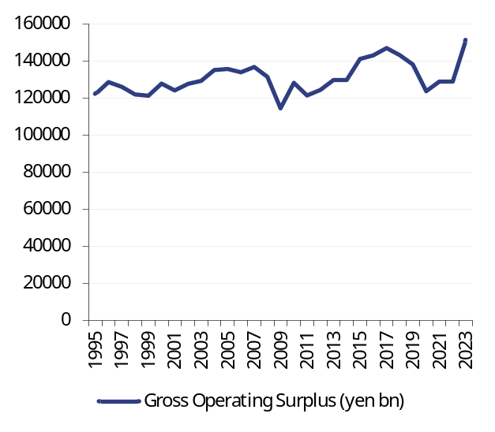
Source: Datastream |  | Source: Datastream

Fig 76: Japanese consumer price expectations (net balance) |  | Fig 77: JPY ten-year inflation-linked swap rate (%)
Source: Datastream |  | Source: Datastream

Fig 78: Japanese wage growth, YoY |  | Fig 79: Japanese unemployment rate (%)
Source: Datastream |  | Source: Datastream

Fig 80: Japanese PMI surveys (diffusion Index) |  | Fig 81: Nominal broad JPY exchange rate (index)
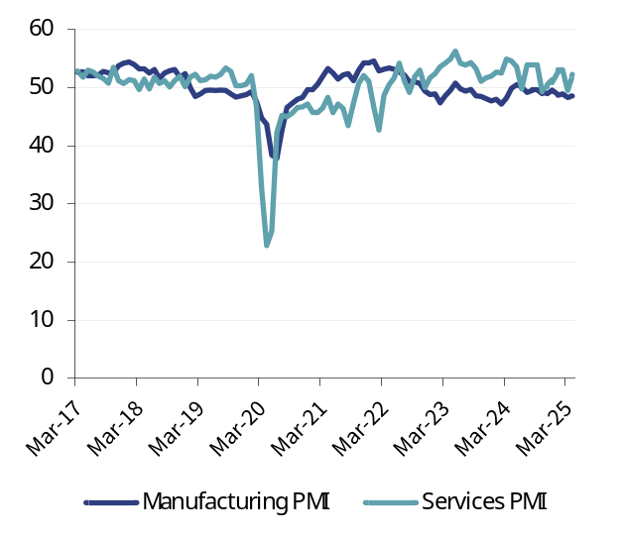
Source: Datastream |  | Source: Datastream

Fig 82: Bank of Japan assets (¥100m) |  | Fig 83: Japanese reserves (¥100m)
Source: Datastream, Bank of Japan |  | Source: Datastream, Bank of Japan

Fig 84: Overnight Index Swap (OIS) curve (%) |  | Fig 85: Japanese yield curve (%)
Source: Datastream |  | Source: Datastream

Melissa Davies  Economics  Rothschild & Co Redburn  Capital House  85 King William Street  London EC4N 7BL  D +44 20 7000 2064  T +44 (0)20 7000 2020  E melissa.davies@redburnatlantic.com |  | Michael Taylor  Economics  Rothschild & Co Redburn  Capital House  85 King William Street  London EC4N 7BL  D +44 20 7000 2066  T +44 (0)20 7000 2020  E michael.taylor@redburnatlantic.com
https://redburn.rothschildandco.com/

Research disclosures

This report has been issued by Redburn (Europe) Limited (‘Rothschild & Co Redburn’), authorised and regulated by the Financial Conduct Authority (“FCA”) and registered as an investment adviser with the Securities and Exchange Commission (“SEC”). This report is intended for use by Professional Clients and Eligible Counterparties only. Rothschild & Co Redburn is a member of the Rothschild & Co group (“R&Co”). Redburn (Europe) Limited is registered in England (company number: 4710622). Our registered office is New Court, St. Swithin’s Lane, London, EC4N 8AL. The FCA's registered office is 12 Endeavour Square, London E20 1JN.

All of Rothschild & Co Redburn’s investment research is written by employees whose job title is “Analyst”.

This research was completed at 2025-07-22 12:45.
This research was published at 2025-07-23 06:30.

Unless specified, all dates and times in the document are UK standard time.

Where this report reaches conclusions or recommendations, the basis of valuation, methodology and/or the underlying assumptions on which those conclusions are based appear in the relevant commentary.

A redacted version of the full model in which certain worksheets have been removed and any links to the removed worksheets have been hardcoded is available at https://redburn.rothschildandco.com/. Information in the model (including share prices, forex rates, consensus etc.) is not live as any links are hardcoded on the date of upload. Our intention in providing this model service is to give our clients access to a comprehensive, working model, which is entirely consistent with our published forecasts for the subject issuer. If you experience any technical difficulties with the spreadsheet, please contact numbers@redburnatlantic.com. If you have questions regarding the logic of, or assumptions made in the model, please contact the Analyst directly.

Buy: Rothschild & Co Redburn argues that the stock price will rise by at least 15% over one year. For high beta stocks the hurdle rate may be commensurately higher.
Sell: Rothschild & Co Redburn argues that the stock price will be lower over one year.
Neutral: Rothschild & Co Redburn argues that the stock price will trade within the above ranges.

Rothschild & Co Redburn has no timetable for the publication of research material. Material is published when an Analyst believes a report is warranted, and not to any timetable specified in advance.

Rothschild & Co Redburn or another member of the R&Co group may offer investment banking services to issuers that are the subject of investment recommendations. Should this be the case, information about the nature of the service provided and the relationship between the issuer and Rothschild & Co Redburn will be disclosed on Rothschild & Co Redburn’s disclosure webpage https://disclosures.redburn.rothschildandco.com/. In addition, employees that make or produce investment recommendations may receive a remuneration based upon various factors including overall firm revenues, which include investment banking revenues. Analyst remunerations are not linked to investment banking or capital markets transactions activities.

Each Analyst is primarily responsible for the content of their investment recommendations, and in whole or in part, certifies that all of the views expressed accurately reflect his or her personal views about any and all of the subject securities or issuers.
Rothschild & Co Redburn’s Conflicts of Interest Policy is set out in Regulatory Information at www.rothschildandco.com.

 | Coverage universe |  | Investment Banking client
 | Count | % | Count | % total IB client | % rating category
Buy | 266 | 47.16 % | 33 | 49.25 % | 12.41 %
Neutral | 232 | 41.13 % | 27 | 40.30 % | 11.64 %
Not Rated | 18 | 3.19 % | 6 | 8.96 % | 33.33 %
Sell | 48 | 8.51 % | 1 | 1.49 % | 2.08 %
Total | 564 | 100.00 % | 67 | 100.00 % | 11.88 %
Data relating to R&Co relates to the period (which is less than 12 months) since Rothschild & Co Redburn has been a member of the R&Co group

Research reports are solely for the information of the addressee only and is not an offer, or solicitation of an offer, to sell, or buy, any securities or any derivative instruments or any other rights pertaining thereto. The information used to create or provide research reports are compiled from sources believed to be reliable, however, neither Rothschild & Co Redburn nor any of its officers or employees, make any representations or warranties as to its accuracy or completeness. Any opinions, forecasts or estimates expressed constitute a judgement, as at the date of the research report, that is subject to change without notice. Rothschild & Co Redburn has no obligation to update those opinions, forecasts or estimates. The recipient agrees that Rothschild & Co Redburn shall have no liability for any misstatement or omission or fact or any opinion expressed, nor for the consequences of any reliance upon any statement, conclusion or opinion. Rothschild & Co Redburn may have disseminated information contained in research reports prior to their publication. Research reports do not have regard to the specific investment objectives, financial situation and the particular needs of any specific person who may receive them. Nothing in our research reports should be construed as investment, tax, legal, accounting, regulatory or other advice or as creating a fiduciary relationship.

Rothschild & Co Redburn’s products and services are intended distribution in the United States only to Major U.S. Institutional Investors as that term is defined for purposes of SEC Rule 15a-6.

Redburn (Europe) Limited is not a member of the Financial Industry Regulatory Authority (“FINRA”), and as such its Analysts are not subject to FINRA’s rules on research analysts and research reports, including FINRA restrictions on communications with a subject issuer, public appearances, and trading securities held by a research analyst account. Redburn (Europe) Limited is a correspondent of Redburn (USA) LLC, a SEC-registered broker-dealer. All US persons receiving research reports and wishing to buy or sell the securities discussed herein should do so through a representative of Redburn (USA) LLC.

© 2025 – Redburn (Europe) Limited (trading as Rothschild & Co Redburn)

The economic impact of higher defence spending, The European Commission 19 May 2025. https://economy-finance.ec.europa.eu/economic-forecast-and-surveys/economic-forecasts/spring-2025-economic-forecast-moderate-growth-amid-global-economic-uncertainty/economic-impact-higher-defence-spending_en#potential-fiscal-and-macroeconomic-impact-of-higher-defence-spending

