Andrew Tam | Andrew.Tam@redburnatlantic.com | 

Ticker: EVO SS
Share price: SEK726
Target price: SEK610
Mkt cap: SEK146bn
20 October 2025
Evolution AB
Winter of Discontent
Thesis: A year ago, investors were expecting a 2H25-weighted inflection in growth as Evolution digested the twin growth headwinds of Asian cyberattacks and European ‘ringfencing’. But in our view, cyberattacks have now become a ‘forever war’, while our work suggests that further ringfencing headwinds are to come. We see downside risks to 2026E consensus expectations of a return to double-digit revenue growth.
No ‘Sommar’ at all – ‘Winter of Discontent’ instead. Our recent catch-up with Evolution suggested mixed trends (at best) during 3Q25. Early signs of stabilisation in Europe are potentially encouraging, but a recovery in Asian revenue growth remains distant. North American market growth remains tilted towards Evolution’s weak spot (random number generator (RNG) slots), while Latin America has promise, despite signs of near-term softness in Brazil.
‘Tom & Jerry’ in Asia: Evolution’s own ‘forever war’. Evolution characterised the impact of its cyberattack countermeasures as a bit of a ‘cat and mouse’ game – the bad actors hijacking the Evolution feed simply find ways to circumvent the new countermeasures implemented by the company. To us, the much hoped for revenue growth recovery in Asia remains as distant as ever. Meanwhile, gambling crackdowns in Asia continue at pace and add structural headwinds.
European ringfencing checks indicate Evolution has fallen behind peers. Our latest ringfencing checks in Europe have been expanded to examine the extent of Evolution’s ringfencing compared to other large industry peers such as Hacksaw Gaming (Not Rated) and Pragmatic Play (Not Listed). We see risks of Evolution ringfencing doubling from just seven countries to 14 in Europe – we do not believe this has been factored into consensus estimates.
Reiterate Sell (price target: SEK610) – recent consensus cuts are not enough. We argue that rebased consensus growth expectations still imply rebounds in group revenue growth to 9% and 10% in 2026E and 2027E respectively. But, for the reasons outlined above, we continue to see risks to consensus estimates. We trim our EBITDA estimates by 1%/3%/3% in 2025E/2026E/2027E, reflecting the more modest top-line trends. We reiterate our Sell rating and lower our price target to SEK610 (from SEK650).

Systematic View – IDEAS and Technical Analysis

Evolution AB: Factor Scores |  | Gambling sector: Factor Scores
    IDEAS Score: 59/100
    
    Value (implied change) | 79
    Growth | 60
    Ests Mom (EPS) | 19
    Ests Mom change (3m) | -26
    Quality (returns) | 95
    IDEAS Score: 51/100
    
    Value (implied change) | 19
    Growth | 73
    Ests Mom (EPS) | 56
    Ests Mom change (3m) | -2
    Quality (returns) | 43
Evolution AB: Estimates Momentum |  | Gambling sector: Estimates Momentum
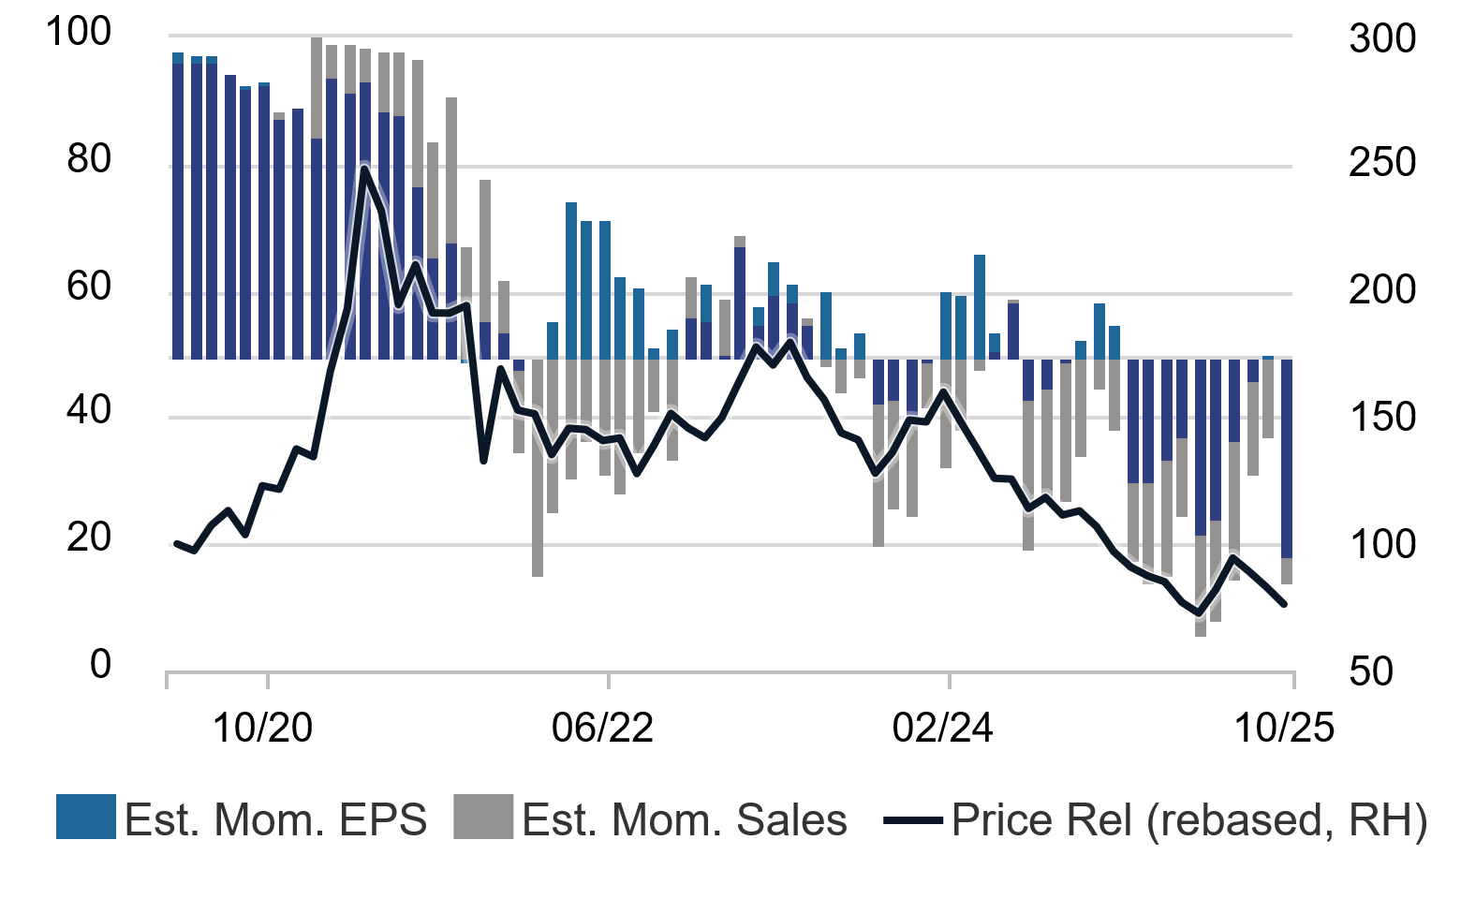 |  | 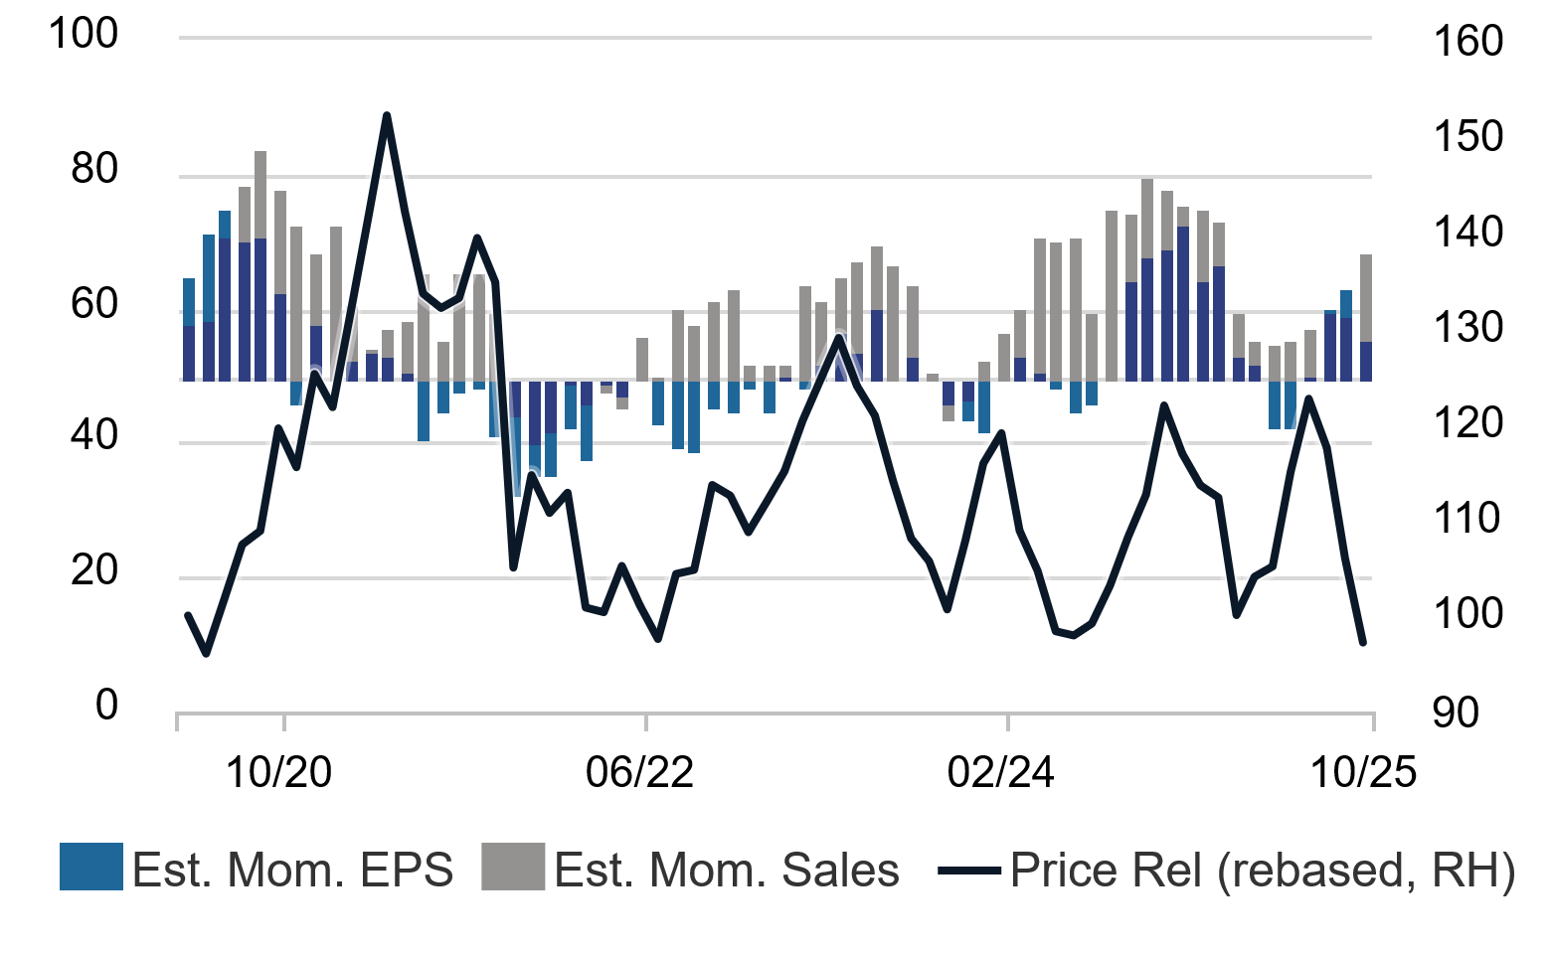
Source: Rothschild & Co Redburn IDEAS |  | Source: Rothschild & Co Redburn IDEAS
Gambling sector: IDEAS and Technical Analysis data
 | IDEAS Score (/100) | Ests Mom – EPS | Ests Mom change (3m) – EPS | Wave column | Technical Score (/10) | Relative perf. 3m | Relative perf. 12m | Relative high/low
Evolution AB | 59.0 | 18.6 | -25.8 | 1. Early | 2.5 | -10.2% | -29.6% | N
Gambling | 50.7 | 55.6 | -2.4 | 5. Hold | 2.8 | -9.2% | -0.6%
Gambling sector | 51.0 | 56.0 | -2.0

Note: see https://ideas.redburn.rothschildandco.com for live information as well as an explanation of The IDEAS Wave, The IDEAS Score and Estimates Momentum
Source: Rothschild & Co Redburn IDEAS. Data correct as of 15 October 2025. Copyright © 2025 FactSet UK Limited. All rights reserved
Click here to view the Gambling sector IDEAS Wave. For more information on IDEAS Systematic Analysis and for an explanation of The IDEAS Wave, The IDEAS Score and Estimates Momentum please click here or visit https://ideas.redburn.rothschildandco.com.

Please contact the team at ideas@redburnatlantic.com if you would like to arrange a demonstration.

Summary financials and valuation
 | Rothschild & Co Redburn current |  |  | --------------- vs old --------------- |  |  |  | -------- vs VA consensus ---------
Y/E Dec (€m) | FY25E | FY26E | FY27E |  | FY25E | FY26E | FY27E | FY25E | FY26E | FY27E
Revenue | 2,120 | 2,240 | 2,429 |  | (1%) | (2%) | (2%) | (1%) | (4%) | (5%)
EBITDA | 1,384 | 1,435 | 1,545 |  | (1%) | (3%) | (3%) | (2%) | (7%) | (10%)
Adjusted EPS | €5.25 | €5.42 | €5.81 |  | (1%) | (4%) | (4%) | (0%) | (9%) | (15%)

Source: Rothschild & Co Redburn, Visible Alpha
Summary financials and valuation
 |  |  | ------- P/E ------- |  | ---- EV/EBIT ---- |  | -- EV/EBITDA -- |  | ---- EV/sales --- |  | ND/ EBITDA
 | Rating | Mcap (m) | 2025E | 2026E | 2025E | 2026E | 2025E | 2026E | 2025E | 2026E | 2025E
B2B suppliers
Evolution AB | Sell | 145,962 kr | 12.7x | 11.2x | 10.2x | 9.3x | 9.1x | 8.3x | 6.1x | 5.6x | (0.4x)
Light & Wonder Inc | Neutral | $6,417 | 14.9x | 12.0x | 13.1x | 10.6x | 7.8x | 7.1x | 3.3x | 3.1x | 3.3x
Playtech | Neutral | £1,038 | 25.0x | 18.9x | 3.1x | 2.6x | 1.3x | 1.1x | 1.4x | 1.3x | (0.1x)
Aristocrat | Not Rated | A$40,465 | 26.6x | 22.9x | 19.7x | 17.7x | 16.1x | 14.7x | 7.2x | 6.3x | 0.1x
B2C operators
Cirsa Enterprises SAU | Buy | €2,495 | 13.2x | 10.0x | 9.9x | 8.8x | 6.1x | 5.6x | 1.9x | 1.8x | 2.0x
DraftKings | Neutral | $17,471 | -- | -- | -- | -- | -- | 14.7x | 2.5x | 2.5x | 0.1x
Entain | Buy | £5,347 | 14.5x | 11.2x | 11.1x | 9.8x | 7.8x | 7.2x | 1.7x | 1.6x | 3.2x
Flutter Entertainment | Buy | $43,998 | 30.1x | 20.7x | 34.7x | 19.9x | 16.4x | 12.3x | 3.2x | 2.7x | 2.8x
FDJ United | Neutral | €4,933 | 11.5x | 10.4x | 11.9x | 11.3x | 7.4x | 7.1x | 1.8x | 1.7x | 1.8x
Lottomatica Group | Buy | €5,470 | 15.0x | 11.5x | 11.1x | 9.5x | 8.4x | 7.5x | 3.2x | 2.9x | 2.2x

Source: Rothschild & Co Redburn, FactSet

Key charts of the report
Fig 1: Pragmatic Play content geoblocked from Italy |  | Fig 2: Evolution consensus revenue growth (YoY) expectations, 2025E-28E
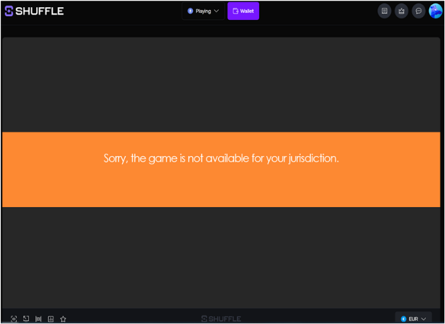 |  | 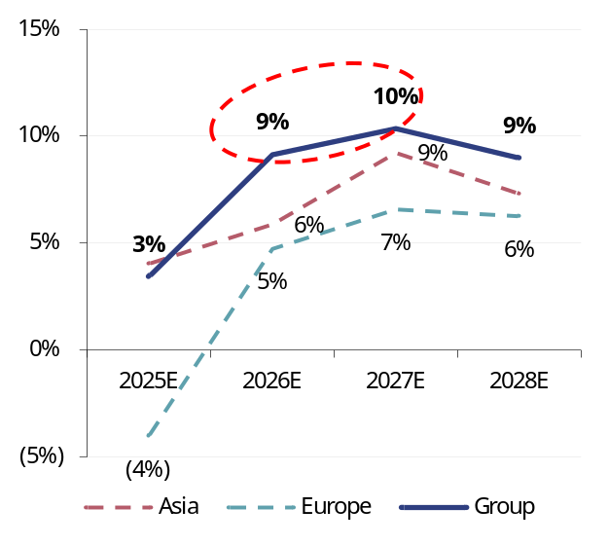
Source: shuffle.com |  | Source: Rothschild & Co Redburn

Winter of our discontent
Earlier this month, we had a catch-up with the company discussing recent developments within the Evolution business. It is fair to say that trends remain mixed:
- Asia continues to be impacted by the cyberattacks/hijacking, where Evolution’s countermeasures are gradually circumvented. The company described its efforts here as a bit of a game of ‘cat and mouse’. To us, it appears that a reacceleration of revenue growth in Asia remains a far-off prospect.
- In Europe, the company expects some sequential improvement into 2H25 as the ringfencing takes hold. However, our ringfencing work in this report suggests that incremental headwinds continue to loom, with at least a further seven EU countries potentially subject to incremental ringfencing.
- In Latin America, Evolution remains at the mercy of the softer than expected market start in Brazil despite its longer-term promise. The company characterised the market as positive, despite being slow growing. This corresponds with recent commentary from Entain (Buy) management, which suggested that iGaming remains soft in Brazil, with recent growth being led largely by sports betting.
- In North America, the company has conceded that it remains a slots-driven market, and that the focus has turned to improving the RNG product in order to drive growth in the region.

Asia headwinds: no end in sight
To us, it appears that the revenue growth inflection in Asia is further away than ever – cyberattacks and gambling crackdowns are continuing to impact the business.
As a reminder, we remain sceptical about the impact that cyberattacks and hijacking are having on Evolution’s Asian business. In ‘Regulatory Revolution’ (17 January 2025), we argued that there was likely a confluence of both cyclical (cyberattacks) and structural (gambling crackdown) elements at play.
Nonetheless, the cyberattack narrative has now morphed from a cyclical/transitory one to a ‘forever war’, where revenue headwinds continue to impact the business as Evolution’s countermeasures are eventually circumvented by the content hijackers.
On the structural elements, as we discussed in ‘Not Yet Sommar’ (24 July 2025), the regulatory crackdowns on online gambling continue across numerous jurisdictions, with the following developments over recent weeks:
- In Japan, on top of the previously reported arrests of end players, authorities have reportedly taken action against online casino advertising. There have been a number of developments:
  - Two individuals were arrested for promoting offshore gambling and receiving commissions from gambling sites, as authorities begin to target online affiliates in the country. This follows new laws that came into effect on 25 September 2025 that ban online casinos and prohibit social media platforms and websites from displaying gambling ads.
  - Moreover, authorities have even gone as far as appealing to regulators in Malta, Costa Rica, Georgia, Anjouan and Curaçao, among others, to seek assistance in curbing illegal online gambling offered by overseas operators in Japan. This mirrors efforts from regulators in Australia, which has sought similar assistance from overseas jurisdictions.
- South Korea has shut down an illegal online gambling operation that was based in Cambodia, which reportedly handled as much as KRW44bn in gambling flows. Ten individuals were arrested and a further 174 who played the games were charged. Games allegedly played included Baccarat.
- In India, which recently passed a new law banning all forms of real money gaming, the Enforcement Directorate of India has taken steps to seize funds linked to illegal online gambling in the country – targeting various sports stars and well-known actors who were reportedly gambling on 1xBet. Evolution content is indeed available on 1xBet, while our industry contacts noted that the content was being distributed into the country via aggregators such as Diamond Exchange and BollyTech.
- Vietnamese authorities have reportedly jailed as many as 43 people in a $3.8bn illegal gambling case linked to crypto and money laundering, with offences dating back as far as 2020-21.
- In Malaysia, the gambling crackdowns continue, with 328 arrested in a large-scale operation as recently as August 2025.
- Philippines banned the Philippine Offshore Gaming Operators (POGOs) more than a year ago and continues its crackdown on operators that have failed to heed the new laws. 91 illegal Chinese workers were deported with China’s cooperation.
- Indonesia has reportedly taken down up to 2.8 million posts on social media and online forums linked to illegal online gambling in the country since October 2024.

Regulatory ringfencing update
Our ringfencing updates show no material changes on the surface. The seven EU countries where Evolution appears to ringfence its products are: Czech Republic, Denmark, Greece, Latvia, Netherlands, Romania and Sweden. The well-documented UK Gambling Commission (UKGC) licence review also sees the UK as an eighth European market where Evolution ringfences.
However, we have expanded upon our checks to include peer B2B suppliers Hacksaw Gaming (Not Rated) and Pragmatic Play (Not Listed) in a comparison versus Evolution. This draws out some interesting observations with respect to potential incremental ringfencing risks for Evolution (Fig 3).
Fig 3: Evolution ringfencing checks – availability of Evolution content by EU country
 |  | --------------------------- Evolution ----------------------- |  |  | Hacksaw |  | Pragmatic
 |  | May 2025 | July 2025 | October 2025 | October 2025 | October 2025
1 | Austria | ü | ü | ü | ü | ü
2 | Belgium | ü | ü | ü | ü | ü
3 | Bulgaria | ü | ü | ü | ü | û
4 | Croatia | ü | ü | ü | ü | ü
5 | Cyprus | ü | ü | ü | û | ü
6 | Czech Republic | û | û | û | ü | ü
7 | Denmark | û | û | û | û | û
8 | Estonia | ü | ü | ü | ü | ü
9 | Finland | ü | ü | ü | ü | ü
10 | France | ü | ü | ü | û | û
11 | Germany | ü | ü | ü | ü | ü
12 | Greece | û | û | û | û | ü
13 | Hungary | ü | ü | ü | ü | ü
14 | Ireland | ü | ü | ü | ü | ü
15 | Italy | ü | ü | ü | ü | û
16 | Latvia | û | û | û | ü | ü
17 | Lithuania | ü | ü | ü | ü | û
18 | Luxembourg | ü | ü | ü | ü | ü
19 | Malta | ü | ü | ü | û | ü
20 | Netherlands | û | û | û | ü | û
21 | Poland | ü | ü | ü | ü | ü
22 | Portugal | ü | ü | ü | ü | ü
23 | Romania | û | û | û | ü | û
24 | Slovakia | ü | ü | ü | ü | ü
25 | Slovenia | ü | ü | ü | ü | ü
26 | Spain | ü | ü | ü | û | û
27 | Sweden | û | û | û | û | û

Note: ringfencing checks are conducted via a broad selection of offshore cryptocasino operators including Snatch Casino, BC Game, stake.com, 7Bit casino, shuffle.com, freshbet, boomerang casino, wazamba, sportsbet.io, bitcasino.io and toshi.bet
Source: Rothschild & Co Redburn

While there are some cases like Denmark where availability is consistently restricted across all three suppliers, we note several examples of EU countries where Hacksaw and/or Pragmatic Play have chosen to ringfence their content and limit supply to the unregulated crypto casino channel, but where Evolution content remains available. We regard these jurisdictions as potentially at risk of incremental ringfencing at Evolution, driven by more onerous regulatory enforcement.
There are a further seven EU markets where either Hacksaw or Pragmatic Play has decided to restrict its content, yet where Evolution’s content is freely available. These markets are Bulgaria, Cyprus, France, Italy, Lithuania, Malta and Spain.

Italy: suppliers are beginning to restrict access
In Italy, we were able to access Evolution content on six out of 12 unregulated sites checked (Fig 4). However, our extended ringfencing checks observed that other competitor B2B suppliers are beginning to ringfence and restrict supply.
Notably, for reasons that remain unclear, our checks suggest that Pragmatic Play has begun to restrict supply from most unregulated sites in Italy (with the sole exception of the Soft2bet-linked Boomerang casino).
Fig 4: Italy supplier/operator ringfencing matrix
 | Snatch Casino | BC.Game | Stake | Rainbet | 7Bit casino | Shuffle | Freshbet | Boomerang | Wazamba | Sportsbet.io | Bitcasino.io | toshi.bet
Evolution | û | ü | û | ü | ü | ü | ü | ü | û | û | û | û
Hacksaw | û | û | û | ü | ü | ü | ü | ü | û | ü | ü | ü
Pragmatic | û | N/A | û | û | û | û | û | ü | û | û | û | û

Source: Rothschild & Co Redburn

Consistent with several other sites, Pragmatic Play’s live dealer content appears to have been subject to supplier-side ringfencing – shuffle.com displays the below message following attempts to launch a Pragmatic Play live dealer game on its platform (Fig 5).
Fig 5: Pragmatic Play content ringfenced supply in Italy
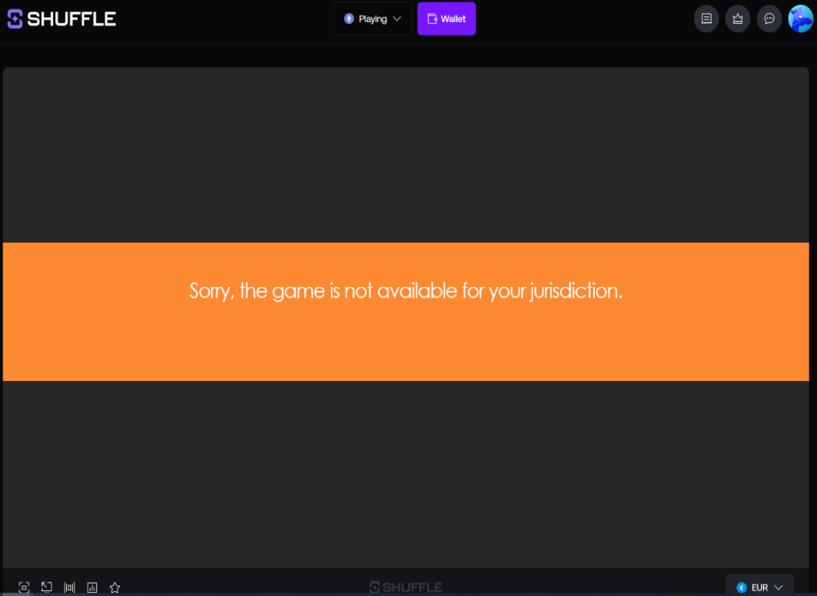
Source: shuffle.com

Indeed, Rainbet has already proactively ‘greyed out’ Pragmatic Play live dealer content from its casino lobby (Fig 6), suggesting that this ringfencing has been coordinated with operators. This stands in stark contrast to the broader availability of Evolution games on unregulated sites in Italy.
In our view, Italy is a good candidate for incremental ringfencing of B2B suppliers driven by regulators. Legitimate operators in the regulated Italian market have just paid €7m for an upfront concession to operate. We suspect that these operators would not have invested an upfront fee 35x higher than the prior concession tender (along with a higher gaming tax rate) without requesting that the regulator crack down on the black market in return.
Ironically, crypto casino stake.com is one operator that has applied for a new concession and operates within the regulated Italian market. Its unregulated ‘.com’ site redirects users to its ‘legitimate’ alternative stake.it site.
Fig 6: Rainbet’s live dealer casino lobby (October 2025)
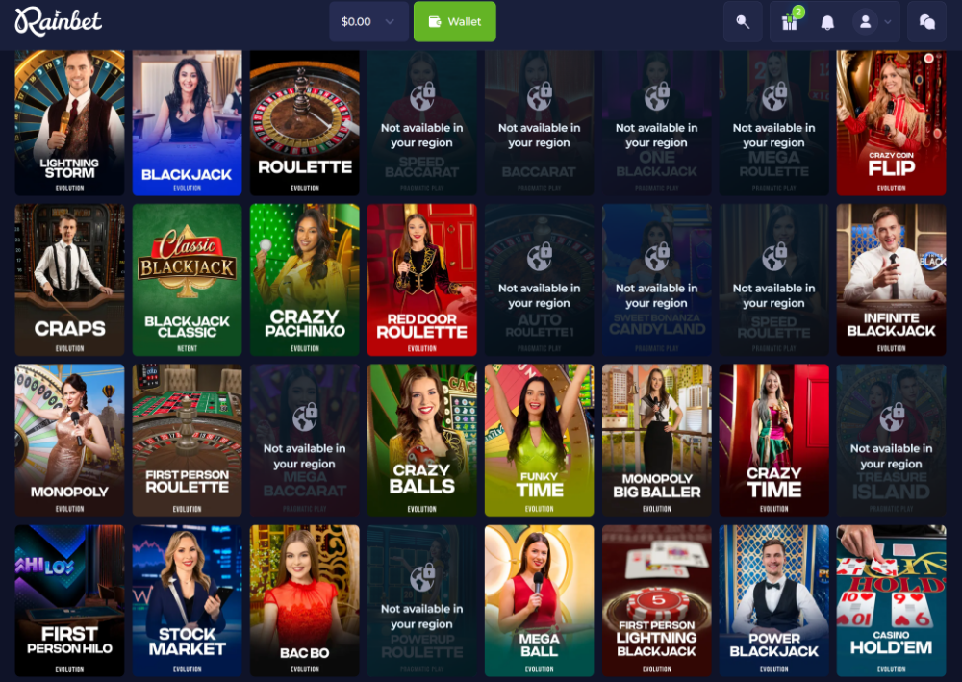
Source: Rainbet

Elsewhere, it appears that other operators have been more proactive than Evolution when it comes to restricting content in other explicitly illegal markets such as France (Fig 7).

Fig 7: France supplier/operator ringfencing matrix
 | Snatch Casino | BC[.]Game | Stake | Rainbet | 7Bit casino | Shuffle | Freshbet | Boomerang | Wazamba | Sportsbet.io | Bitcasino.io | toshi.bet
Evolution | ü | ü | ü | ü | û | ü | ü | û | û | û | û | ü
Hacksaw | ü | û | û | û | û | û | û | û | û | û | û | û
Pragmatic | û | N/A | û | û | û | û | û | û | û | û | û | û

Source: Rothschild & Co Redburn

Our ringfencing checks found that Evolution continues to perform no explicit ringfencing for the French market, despite iGaming being illegal in the country. We were able to stream and play Crazy Time via a French IP address as recently as October 2025 using a VPN (Fig 8). Evolution seemingly relies on operators to not serve its content into the French market but does no checks of its own to ensure that it is not supplying its games into the French market.
In contrast, Pragmatic’s content is not even clickable on stake.com (Fig 9), while the supplier actively blocks its content on other unregulated sites. We found a similar experience with Hacksaw games when using a French IP address via VPN.
Fig 8: stake.com – Evolution’s Crazy Time continues to be accessible via French IP addresses |  | Fig 9: stake.com – Pragmatic Play content geoblocked on French IP addresses
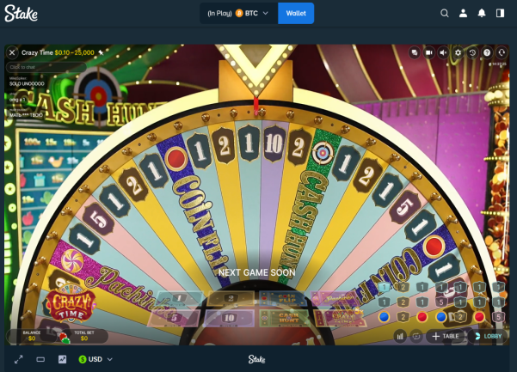 |  | 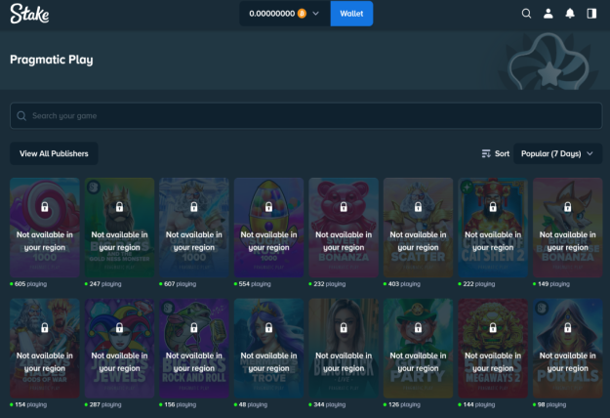
Source: stake.com |  | Source: stake.com

Meanwhile in Spain, we found Evolution content available on just one site – Freshbet – indicating that Evolution’s existing ringfencing could be more robust when compared to other suppliers.

Consensus expectations have moderated… but not enough
Consensus revenue expectations have been cut since our 24 July 2025 report, with the downgrades largely coming from Asia (Fig 10). This has correspondingly driven cuts of 4-7% at the EBITDA line between 2026E and 2028E (Fig 11).
Fig 10: Evolution consensus revenue estimate changes since 24 July 2025, by geography |  | Fig 11: Evolution consensus EBITDA estimate changes since 24 July 2025
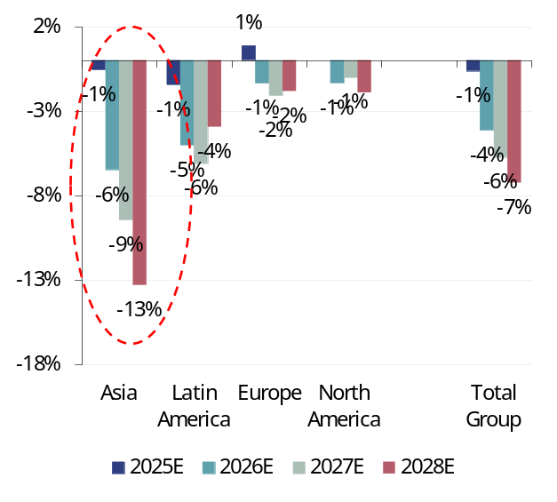 |  | 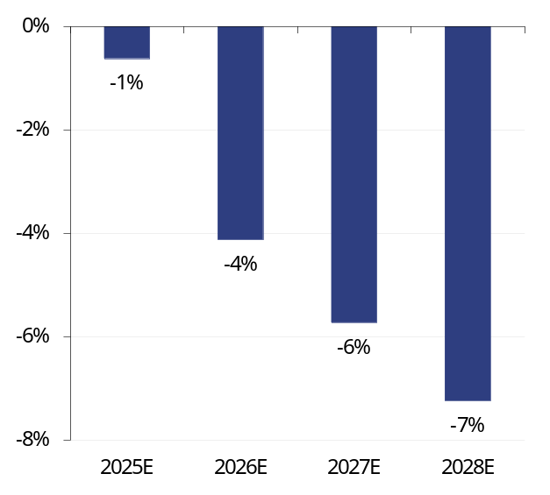
Source: Rothschild & Co Redburn, Visible Alpha |  | Source: Rothschild & Co Redburn, Visible Alpha

However, despite the recent downgrades, consensus continues to expect a revenue reacceleration to 9-10% in 2026E and 2027E, driven by a recovery in both Asia and Europe (Fig 12). Our work in this report suggests that this may be too optimistic:
- Asia is likely to remain soft in our view, as the ‘forever war’ of cyberattacks and hijacking acts as an ongoing handbrake to Asian growth.
- Incremental European ringfencing looks increasingly likely, with Evolution ultimately being forced to double the number of countries ringfenced from seven to 14. In our view, consensus has yet to factor this in.
Fig 12: Evolution consensus revenue growth (YoY) expectations, 2025E-28E
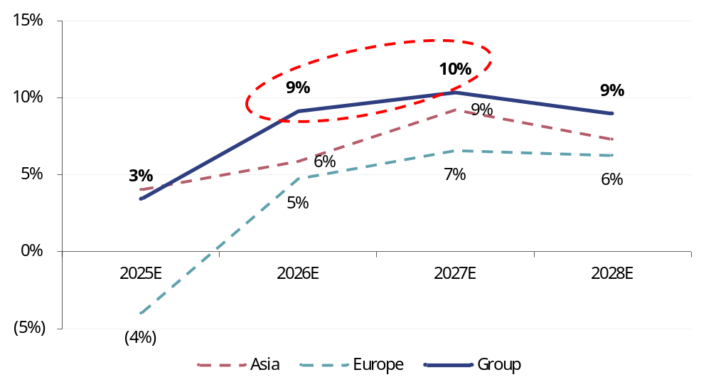
Source: Rothschild & Co Redburn, Visible Alpha

Consequently, we trim our 2025E/2026E/2027E revenue estimates by 1%/2%/2% respectively, reflecting a more modest growth trajectory from 2026E onwards as further incremental ringfencing takes hold in Europe and subdued growth in Asia remains as Evolution’s countermeasures prove ineffective. This leaves us 4% and 5% below consensus revenues in 2026E and 2027E respectively, leading to our estimates being 7% and 10% below consensus at the EBITDA line (Fig 13).
Fig 13: Evolution estimate revisions and vs consensus
 | Rothschild & Co Redburn current |  |  | -------------- vs old --------------- |  |  | --------- vs VA consensus --------
Y/E Dec (€m) | FY25E | FY26E | FY27E | FY25E | FY26E | FY27E | FY25E | FY26E | FY27E
Revenue | 2,120 | 2,240 | 2,429 | (1%) | (2%) | (2%) | (1%) | (4%) | (5%)
EBITDA | 1,384 | 1,435 | 1,545 | (1%) | (3%) | (3%) | (2%) | (7%) | (10%)
Adjusted EPS | €5.25 | €5.42 | €5.81 | (1%) | (4%) | (4%) | (0%) | (9%) | (15%)

Source: Rothschild & Co Redburn, Visible Alpha

Can Evolution placate shareholders?

We believe Evolution will seek to placate shareholders at 3Q25 results via the announcement of a new c€500m share buyback over and above the existing programme. The existing buyback programme is on track for completion by November 2025 (Fig 14). However, we have not included this in our refreshed estimates.
Furthermore, with the existing Galaxy Gaming (GLXZ) acquisition still subject to a multitude of regulatory approvals (including Nevada), we suspect that Evolution may seek to withdraw from the deal and pivot towards returning the capital to shareholders instead. Galaxy’s share price continues to trade at a material discount to the $3.20/share bid price, implying significant market scepticism that the deal will indeed close during 2H25 (Fig 15).
Fig 14: Cumulative Evolution share buybacks vs announced programme (SEKm) |  | Fig 15: Galaxy Gaming share price discount to bid
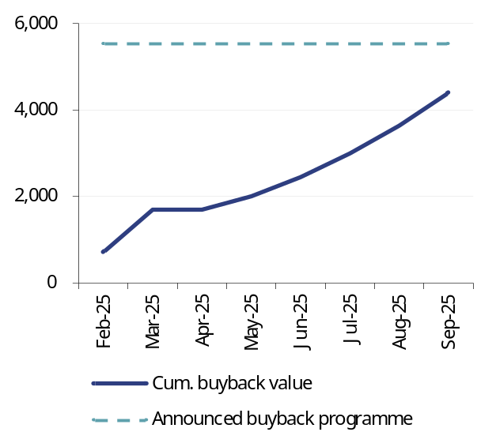 |  | 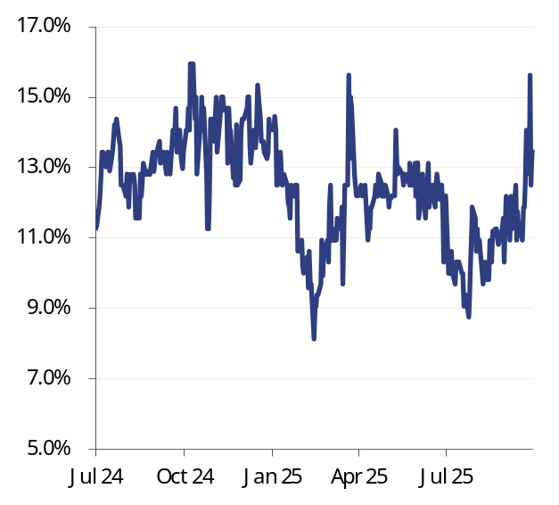
Note: €500m announced buyback programme at spot EUR/SEK rates  Source: Rothschild & Co Redburn, company, FactSet |  | Source: Rothschild & Co Redburn, FactSet

Withdrawing from the GLXZ deal would unlock a further c€100m (c$120m enterprise value) of capital that could be put towards a new share buyback programme in 2026.
However, this would raise a question around the regulatory issues Evolution faced that stalled the deal completion in the first place. If state regulators found reason to stall or delay regulatory approvals for GLXZ, what could this mean for Evolution’s prospects of securing incremental iGaming supplier licences should these same states eventually elect to legalise iGaming?
Consequently, we would regard Evolution’s failure to complete the GLXZ acquisition negatively given the longer-term implications for Evolution’s North American growth prospects.

Reiterate Sell rating
Given our below-consensus earnings estimates, we continue to see downside risk to Evolution’s share price. We cut our target price to SEK610 (from SEK650) and reiterate our Sell rating.
Upside risks to our valuation include a faster than anticipated recovery in growth, led by Asia and Europe. However, our ringfencing checks suggest that this much hoped for growth inflection appears ever distant, and we believe it will begin to test investor patience. We do not believe that a renewed share buyback will be enough to placate shareholders with respect to the possible negative implications for Evolution’s North American growth prospects.

Fig 16: Evolution summary financials and valuation
Y/E December (€m) |  | 2024 |  | 2025E |  | 2026E | 2027E |  | 2028E |  |  |  |  |  |  |  | 2024 |  |  | 2025E |  |  | 2026E |  |  | 2027E |  |  | 2028E
P&L |  |  |  |  |  |  |  |  |  |  |  |  |  | Cash flow
Live revenues |  | 1,776 |  | 1,827 |  | 1,938 | 2,119 |  | 2,324 |  |  |  |  | EBITDA |  |  | 1,562 |  |  | 1,384 |  |  | 1,435 |  |  | 1,545 |  |  | 1,671
RNG revenues |  | 287 |  | 293 |  | 302 | 310 |  | 319 |  |  |  |  | Exceptionals/other |  |  | (148) |  |  | 0 |  |  | 0 |  |  | 0 |  |  | 0
Other revenues |  | 151 |  | 0 |  | 0 | 0 |  | 0 |  |  |  |  | Net int. rec./(paid) |  |  | 21 |  |  | 15 |  |  | 13 |  |  | 10 |  |  | 7
Revenue |  | 2,214 |  | 2,120 |  | 2,240 | 2,429 |  | 2,643 |  |  |  |  | Tax paid |  |  | (74) |  |  | (188) |  |  | (194) |  |  | (208) |  |  | (224)
-growth |  | 23.1% |  | (4.2%) |  | 5.7% | 8.5% |  | 8.8% |  |  |  |  | W. cap. movements |  |  | (59) |  |  | 14 |  |  | (23) |  |  | (37) |  |  | (35)
Personnel expenses |  | (438) |  | (489) |  | (539) | (600) |  | (667) |  |  |  |  | Operating cash flow |  |  | 1,301 |  |  | 1,226 |  |  | 1,231 |  |  | 1,311 |  |  | 1,419
Other op. expenses |  | (215) |  | (247) |  | (266) | (285) |  | (305) |  |  |  |  | Capex (inc. M&A) |  |  | (286) |  |  | (293) |  |  | (305) |  |  | (327) |  |  | (355)
EBITDA |  | 1,562 |  | 1,384 |  | 1,435 | 1,545 |  | 1,671 |  |  |  |  | Other CFI items |  |  | (104) |  |  | 0 |  |  | 0 |  |  | 0 |  |  | 0
EBITDA margin |  | 70.5% |  | 65.3% |  | 64.0% | 63.6% |  | 63.2% |  |  |  |  | Investing cash flow |  |  | (248) |  |  | (148) |  |  | (157) |  |  | (170) |  |  | (185)
D&A |  | (142) |  | (148) |  | (157) | (170) |  | (185) |  |  |  |  | Dividends |  |  | (559) |  |  | (578) |  |  | (564) |  |  | (570) |  |  | (612)
EBIT |  | 1,420 |  | 1,236 |  | 1,278 | 1,375 |  | 1,486 |  |  |  |  | Financing |  |  | (826) |  |  | (1,195) |  |  | (533) |  |  | (33) |  |  | (33)
Net finance items |  | 19 |  | 15 |  | 13 | 10 |  | 7 |  |  |  |  | Financing cash flow |  |  | (1,238) |  |  | (1,095) |  |  | (581) |  |  | (587) |  |  | (628)
Profit before tax |  | 1,439 |  | 1,251 |  | 1,290 | 1,385 |  | 1,493 |  |  |  |  | Equity FCF |  |  | 1,146 |  |  | 1,061 |  |  | 1,058 |  |  | 1,124 |  |  | 1,218
Tax expense |  | (195) |  | (188) |  | (194) | (208) |  | (224)
Net income |  | 1,244 |  | 1,063 |  | 1,097 | 1,177 |  | 1,269 |  |  |  |  | Valuation
Diluted EPS (€) |  | 5.91 |  | 5.25 |  | 5.42 | 5.81 |  | 6.27 |  |  |  |  | Share price (SKr) |  |  | 853 |  |  | 718 |  |  | 718 |  |  | 718 |  |  | 718
DPS (€) |  | 2.80 |  | 2.80 |  | 2.82 | 3.02 |  | 3.26 |  |  |  |  | Market cap (€m) |  |  | 15,759 |  |  | 15,759 |  |  | 15,759 |  |  | 15,759 |  |  | 15,759
 |  |  |  |  |  |  |  |  |  |  |  |  |  | Group EV (inc. leases) |  |  | 16,337 |  |  | 16,339 |  |  | 16,846 |  |  | 17,412 |  |  | 18,031
Balance sheet
Total assets |  | 5,347 |  | 5,350 |  | 5,865 | 6,466 |  | 7,123 |  |  |  |  | EV/sales |  |  | 7.4x |  |  | 7.7x |  |  | 7.5x |  |  | 7.2x |  |  | 6.8x
Total liabilities |  | (1,375) |  | (1,393) |  | (1,375) | (1,370) |  | (1,369) |  |  |  |  | EV/EBITDA |  |  | 10.5x |  |  | 11.8x |  |  | 11.7x |  |  | 11.3x |  |  | 10.8x
Shareholders’ equity |  | 3,972 |  | 3,957 |  | 4,490 | 5,096 |  | 5,753 |  |  |  |  | Adjusted P/E |  |  | 12.6x |  |  | 12.4x |  |  | 12.0x |  |  | 11.2x |  |  | 10.4x
Net debt/(cash) |  | (578) |  | (580) |  | (1,087) | (1,653) |  | (2,272) |  |  |  |  | EFCF yield |  |  | 7.3% |  |  | 6.7% |  |  | 6.7% |  |  | 7.1% |  |  | 7.7%
 |  |  |  |  |  |  |  |  |  |  |  |  |  | Net debt/EBITDA |  |  | (0.4)x |  |  | (0.4)x |  |  | (0.8)x |  |  | (1.1)x |  |  | (1.4)x
Geographic revenues
Europe |  | 779 |  | 747 |  | 763 | 811 |  | 864 |  |  |  |  | Return on capital
Asia |  | 803 |  | 826 |  | 850 | 891 |  | 933 |  |  |  |  | NOPAT |  |  | 1,225 |  |  | 1,048 |  |  | 1,084 |  |  | 1,167 |  |  | 1,262
North America |  | 258 |  | 303 |  | 358 | 423 |  | 500 |  |  |  |  | Capital Employed |  |  | 3,394 |  |  | 3,377 |  |  | 3,403 |  |  | 3,443 |  |  | 3,481
Latin America |  | 146 |  | 154 |  | 174 | 205 |  | 243 |  |  |  |  | Post-tax ROCE |  |  | 36% |  |  | 31% |  |  | 32% |  |  | 34% |  |  | 36%
Other |  | 78 |  | 91 |  | 95 | 100 |  | 104 |  |  |  |  | EV/IC |  |  | 4.8x |  |  | 4.8x |  |  | 5.0x |  |  | 5.1x |  |  | 5.2x
Total revenues |  | 2,063 |  | 2,120 |  | 2,240 | 2,429 |  | 2,643
Shareholders | % |  |  |  |  |  |  |  |  | %
Kenneth Dart | 20.3% |  |  |  | R. Livingstone |  |  |  |  | 2.0%
Österbahr Ventures | 11.0% |  |  |  | Avanza Pension |  |  |  |  | 1.8%
Capital | 9.2% |  |  |  | Norges IM |  |  |  |  | 1.6%
BlackRock | 3.7% |  |  |  | Edgepoint |  |  |  |  | 1.3%
Vanguard | 3.4% |  |  |  | Tredje AP-Fonden |  |  |  |  | 1.1%

Source: Rothschild & Co Redburn, company, FactSet

Andrew Tam
Transport & Leisure Research
Rothschild & Co Redburn
Capital House
85 King William Street
London EC4N 7BL
D +44 20 7000 2070
T +44 (0)20 7000 2020
E Andrew.Tam@redburnatlantic.com

https://redburn.rothschildandco.com/

Research disclosures

This report has been issued by Redburn (Europe) Limited (‘Rothschild & Co Redburn’), authorised and regulated by the Financial Conduct Authority (“FCA”) and registered as an investment adviser with the Securities and Exchange Commission (“SEC”). This report is intended for use by Professional Clients and Eligible Counterparties only. Rothschild & Co Redburn is a member of the Rothschild & Co group (“R&Co”). Redburn (Europe) Limited is registered in England (company number: 4710622). Our registered office is New Court, St. Swithin’s Lane, London, EC4N 8AL. The FCA's registered office is 12 Endeavour Square, London E20 1JN.
All of Rothschild & Co Redburn’s investment research is written by employees whose job title is “Analyst”.

This research was completed at 2025-10-17 17:45.
This research was published at 2025-10-20 06:30.
This research was priced as of close 2025-10-16.

Unless specified, all dates and times in the document are UK standard time.

Where this report reaches conclusions or recommendations, the basis of valuation, methodology and/or the underlying assumptions on which those conclusions are based appear in the relevant commentary.

A redacted version of the full model in which certain worksheets have been removed and any links to the removed worksheets have been hardcoded is available at https://redburn.rothschildandco.com/. Information in the model (including share prices, forex rates, consensus etc.) is not live as any links are hardcoded on the date of upload. Our intention in providing this model service is to give our clients access to a comprehensive, working model, which is entirely consistent with our published forecasts for the subject issuer. If you experience any technical difficulties with the spreadsheet, please contact numbers@redburnatlantic.com. If you have questions regarding the logic of, or assumptions made in the model, please contact the Analyst directly.

Buy: Rothschild & Co Redburn argues that the stock price will rise by at least 15% over one year. For high beta stocks the hurdle rate may be commensurately higher.
Sell: Rothschild & Co Redburn argues that the stock price will be lower over one year.
Neutral: Rothschild & Co Redburn argues that the stock price will trade within the above ranges.

Rothschild & Co Redburn has no timetable for the publication of research material. Material is published when an Analyst believes a report is warranted, and not to any timetable specified in advance.

Rothschild & Co Redburn or another member of the R&Co group may offer investment banking services to issuers that are the subject of investment recommendations. Should this be the case, information about the nature of the service provided and the relationship between the issuer and Rothschild & Co Redburn will be disclosed on Rothschild & Co Redburn’s disclosure webpage https://disclosures.redburn.rothschildandco.com/. In addition, employees that make or produce investment recommendations may receive a remuneration based upon various factors including overall firm revenues, which include investment banking revenues. Analyst remunerations are not linked to investment banking or capital markets transactions activities.

Each Analyst is primarily responsible for the content of their investment recommendations, and in whole or in part, certifies that all of the views expressed accurately reflect his or her personal views about any and all of the subject securities or issuers.

Rothschild & Co Redburn’s Conflicts of Interest Policy is set out in Regulatory Information at www.rothschildandco.com.

Rothschild & Co Redburn has made previous recommendations concerning the same financial instrument or issuer during the preceding 12-month period. These recommendations can be found at https://redburn.rothschildandco.com/companies/rbid/b8fdab3c-c297-4a1f-0c9d-08d98cb36db5.

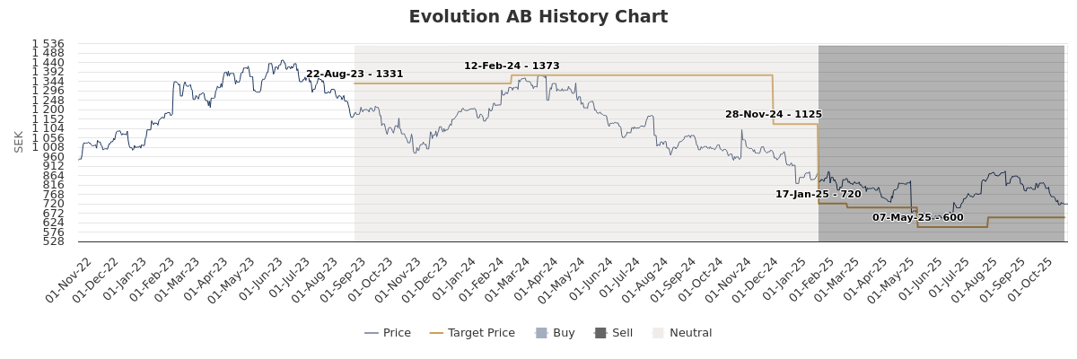

 | Coverage universe |  | Investment Banking client
 | Count | % | Count | % total IB client | % rating category
Buy | 264 | 45.99 % | 36 | 47.37 % | 13.64 %
Neutral | 243 | 42.33 % | 33 | 43.42 % | 13.58 %
Not Rated | 17 | 2.96 % | 6 | 7.89 % | 35.29 %
Sell | 50 | 8.71 % | 1 | 1.32 % | 2.00 %
Total | 574 | 100.00 % | 76 | 100.00 % | 13.24 %
Data relating to R&Co relates to the period (which is less than 12 months) since Rothschild & Co Redburn has been a member of the R&Co group

Research reports are solely for the information of the addressee only and is not an offer, or solicitation of an offer, to sell, or buy, any securities or any derivative instruments or any other rights pertaining thereto. The information used to create or provide research reports are compiled from sources believed to be reliable, however, neither Rothschild & Co Redburn nor any of its officers or employees, make any representations or warranties as to its accuracy or completeness. Any opinions, forecasts or estimates expressed constitute a judgement, as at the date of the research report, that is subject to change without notice. Rothschild & Co Redburn has no obligation to update those opinions, forecasts or estimates. The recipient agrees that Rothschild & Co Redburn shall have no liability for any misstatement or omission or fact or any opinion expressed, nor for the consequences of any reliance upon any statement, conclusion or opinion. Rothschild & Co Redburn may have disseminated information contained in research reports prior to their publication. Research reports do not have regard to the specific investment objectives, financial situation and the particular needs of any specific person who may receive them. Nothing in our research reports should be construed as investment, tax, legal, accounting, regulatory or other advice or as creating a fiduciary relationship.

Rothschild & Co Redburn’s products and services are intended distribution in the United States only to Major U.S. Institutional Investors as that term is defined for purposes of SEC Rule 15a-6.

Redburn (Europe) Limited is not a member of the Financial Industry Regulatory Authority (“FINRA”), and as such its Analysts are not subject to FINRA’s rules on research analysts and research reports, including FINRA restrictions on communications with a subject issuer, public appearances, and trading securities held by a research analyst account. Redburn (Europe) Limited is a correspondent of Redburn (USA) LLC, a SEC-registered broker-dealer. All US persons receiving research reports and wishing to buy or sell the securities discussed herein should do so through a representative of Redburn (USA) LLC.

© 2025 – Redburn (Europe) Limited (trading as Rothschild & Co Redburn)

