Charlie Higgs | Charlie.Higgs@rothschildandco.com | 

Ticker: CCEP US
Share price: USD89
Target price: USD102
Mkt cap: USD41bn
21 November 2025
Coca-Cola Europacific Partners
Pop Britain - Site Visit
CCEP hosted a site visit in Great Britain – its largest market for operating income. This reinforced our positive view on a business unit that has delivered outstanding c5% sales growth pa over the past decade despite the pandemic, challenges in the away-from-home channel and the introduction of a UK sugar tax. CCEP trades on 17.6x forward P/E, which is attractive for a stock that offers a c10% EPS CAGR over the next three years with easing commodity costs and less downside risk versus staples peers.
Great Britain is 16% of CCEP’s sales and, we estimate, the largest contributor to operating at c21% of the total. CCEP hosted an excellent site visit to its Wakefield production plant (the largest soft drinks plant in Europe) and a market visit to at-home and away-from-home (AFH) outlets to witness the improved execution.
In this report we discuss our key learnings, such as the investment made at Wakefield to boost efficiency and improve margins. Capacity is being added: necessary given the British soft drinks market has grown at c4% pa over the past decade and Coca-Cola Great Britain’s (CCGB) sales grew even faster at 5.2% pa, on our estimates. The highlight of the market tour for us was a visit to a wholesaler, which demonstrated how CCGB’s field sales team drive sales growth with a highly fragmented end-customer base, as well as how wholesalers support CCEP’s ambition to place c100,000 coolers in the AFH channel across its markets, which should lead to faster sales growth of the higher margin single-serve packs.
We also discuss the evolving landscape of the British soft drinks market, namely Britvic’s acquisition by Carlsberg (Buy rated) and the onslaught of regulation that, while burdensome, could cement the position of the large incumbents. Britvic’s key products were deeply discounted ahead of the acquisition, but the innovation launches in 2025 are encouraging and should expand the industry’s profit pool. Meanwhile, the upcoming UK deposit return scheme (DRS) in October 2027 could pose challenges to multipacks of cans, requiring both CCGB and Carlsberg-Britvic to reassess their respective price/pack architecture.
Our CCEP estimates are unchanged and we continue to forecast a c10% EPS CAGR over the next three years with a c3% dividend yield. This is broadly in line with consensus. CCEP trades on 17.6x one-year forward P/E; a 5% discount to its pre-pandemic average, despite offering faster top- and bottom-line growth today, with high free cash flow delivery. With potential margin upside in 2026/27 from falling sugar and plastic costs, and less downside risk versus the broader sector, we maintain our Buy rating on CCEP with an unchanged $102/share target price.

Systematic View – IDEAS and Technical Analysis

CCEP: Factor Scores |  | Soft drinks: Factor Scores
    IDEAS Score: 17/100
    
    Value (implied change) | 40
    Growth | 31
    Ests Mom (EPS) | 40
    Ests Mom change (3m) | +1
    Quality (returns) | 47
    IDEAS Score: 21/100
    
    Value (implied change) | 44
    Growth | 20
    Ests Mom (EPS) | 52
    Ests Mom change (3m) | -1
    Quality (returns) | 79
CCEP: Estimates Momentum |  | Soft drinks: Estimates Momentum
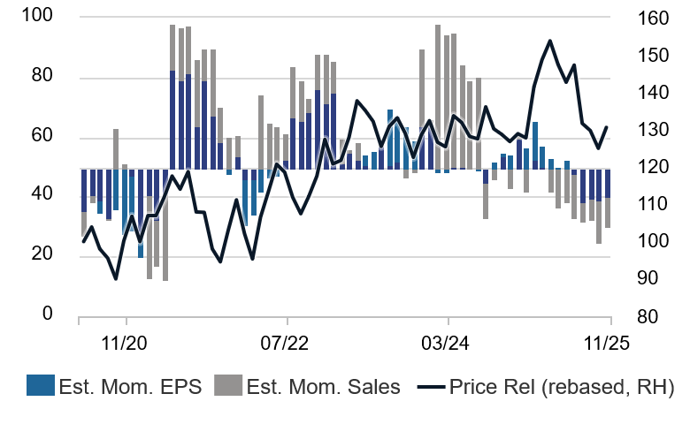 |  | 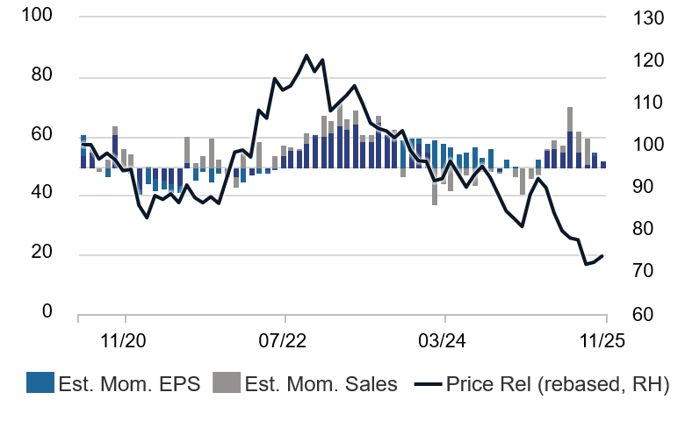
Source: Rothschild & Co Redburn IDEAS |  | Source: Rothschild & Co Redburn IDEAS
Soft drinks: IDEAS and Technical Analysis data
 | IDEAS Score (/100) | Ests Mom – EPS | Ests Mom change (3m) – EPS | Wave column | Technical Score (/10) | Relative perf. 3m | Relative perf. 12m | Relative high/low
Coca-Cola | 7.0 | 50.6 | -5.8 | 6. Watch- | 4.1 | -5.1% | -3.8%
Coca-Cola HBC | 56.3 | 64.7 | 0.1 | 5. Hold | 5.8 | -10.3% | 11.3%
Keurig Dr Pepper | 36.6 | 51.3 | -2.7 | 6. Watch- | 2.3 | -27.5% | -31.4%
Arca Continental | 34.6 | 14.7 | -14.5 | 1. Early | 2.2 | -11.3% | -7.8% | NN
PepsiCo | 31.5 | 63.7 | 6.1 | 5. Hold | 2.1 | -7.7% | -25.3%
Coca-Cola FEMSA | 28.9 | 18.1 | -8.4 | 1. Early | 3.5 | -3.1% | -16.1%
CCEP | 16.6 | 40.3 | 1.4 | 7. Bad | 2.6 | -6.0% | 3.1% | NN
Coca-Cola Bottlers Japan | 11.7 | 4.6 | -58.9 | 1. Early | 2.6 | -5.5% | -3.5%
Soft drinks | 20.7 | 52.3 | -1.4

Note: see https://ideas.redburn.rothschildandco.com for live information as well as an explanation of The IDEAS Wave, The IDEAS Score and Estimates Momentum
Source: Rothschild & Co Redburn IDEAS. Data correct as of 12 November 2025. Copyright © 2025 FactSet UK Limited. All rights reserved
Click here to view the Soft drinks IDEAS Wave. For more information on IDEAS Systematic Analysis and for an explanation of The IDEAS Wave, The IDEAS Score and Estimates Momentum please click here or visit https://ideas.redburn.rothschildandco.com.

Please contact the team at ideas@redburnatlantic.com if you would like to arrange a demonstration.

Coca-Cola Europacific Partners Summary financials and valuation
Y/E December (€m) | 2020 | 2021 | 2022 | 2023 | 2024 | 2025E | 2026E | 2027E
Net sales | 13,535 | 14,819 | 17,320 | 18,302 | 20,706 | 20,910 | 21,307 | 22,093
Operating profit | 1,492 | 1,886 | 2,138 | 2,373 | 2,663 | 2,803 | 2,962 | 3,164
Operating margin (%) | 11.0% | 12.7% | 12.3% | 13.0% | 12.9% | 13.4% | 13.9% | 14.3%
EPS adjusted, diluted (€) | 2.19 | 2.97 | 3.39 | 3.71 | 3.95 | 4.12 | 4.49 | 4.94
Consensus EPS adjusted, diluted (€) |  |  |  |  |  | 4.09 | 4.45 | 4.87
Redburn EPS vs consensus (%) |  |  |  |  |  | 0.7% | 0.8% | 1.5%
DPS (€) | 0.85 | 1.40 | 1.68 | 1.84 | 1.97 | 2.06 | 2.20 | 2.42
Net debt/(cash) | 5,700 | 11,607 | 10,206 | 9,457 | 9,672 | 10,032 | 10,615 | 11,429
Net debt/EBITDA (x) | 3.2 | 4.6 | 3.5 | 3.0 | 2.7 | 2.7 | 2.7 | 2.8
Valuation
P/E (x) | 33.2 | 19.1 | 16.7 | 16.8 | 21.3 | 18.7 | 17.2 | 15.8
EV/EBIT (x) | 28.6 | 19.6 | 17.5 | 16.1 | 18.7 | 16.5 | 15.2 | 13.7
EV/EBITDA (x) | 16.5 | 13.5 | 12.6 | 12.1 | 13.7 | 12.5 | 11.6 | 10.6
Equity free cash yield | 5.1% | 6.5% | 9.3% | 6.8% | 5.2% | 5.2% | 5.5% | 6.7%
Dividend yield | 2.2% | 2.9% | 3.2% | 3.1% | 2.6% | 2.7% | 2.8% | 3.1%

Source: Rothschild & Co Redburn, company
Fig 1: CCEP net sales by region |  | Fig 2: CCEP key metrics by legacy unit
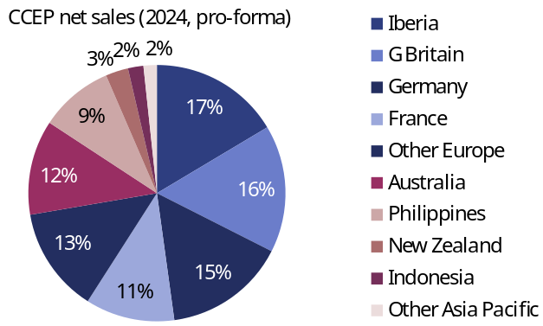 |  | 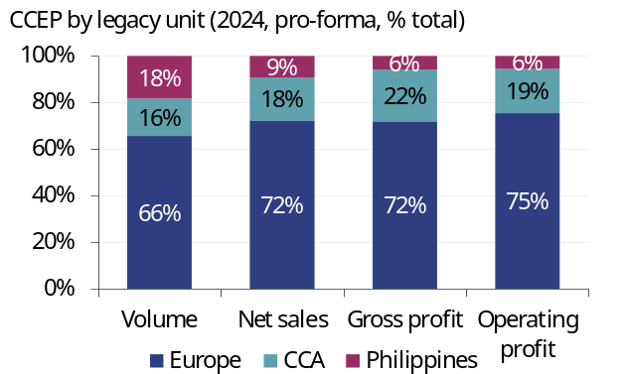
Note: Blue shading denotes Europe, red shading denotes Asia, Pacific and Southeast Asia  Source: Rothschild & Co Redburn, company |  | Source: Rothschild & Co Redburn, company

Contents
Brief British history 5
Disrupting the competitor 6
Changing hands 7
The British footprint 10
Site visit: Wakefield production plant 11
The British soft drinks market 12
The out-of-home recovery story… 13
Winning in the away-from-home channel 15
The evolving grocery landscape 16
Imitation is the sincerest form of flattery 18
What does the shift to discounters mean for CCGB? 20
Market visit: tour around Leeds 21
Tesco visit 22
Bestway visit 24
AFH blitz 25
The road ahead 26
Implications of Carlsberg-Britvic 26
Better competition in sparkling 27
Washed up Rockstar 30
The next territories? 32
Sugar taxes, Extended Producer Responsibility and Deposit Return Schemes 33
Not so sweet 33
Disaster Rocks Soft drinks 34
What does the DRS mean for CCGB? 35
Neverending regulation 36
Updated estimates 38
No change to our long-term forecasts 39
Changes to forecasts 40
Valuation 41

Brief British history
Great Britain has a longstanding affinity towards soft drinks, starting with the arrival of cordials from Italy in the 15th century. In 1767, British chemist Joseph Priestly discovered a process for carbonating water that he published in a 1772 paper Directions for Impregnating Water with Fixed Air. Building on Priestly’s work, a young Swiss watchmaker named Johann Jacob Schweppe developed the first commercial process for producing carbonated mineral water in Geneva in 1783. His new company – Schweppes Company – expanded into Great Britain in 1792, producing soda water for medicinal purposes at a small factory on Drury Lane in London. In 1835, Schweppes Company launched a lemonade, kickstarting a wave of copycat competitors (e.g. R White’s in 1845, now part of Britvic), before expanding into ginger ale (1870) and the eponymous tonic water (1871).
Coca-Cola was a relative latecomer, first introduced to Great Britain in 1900 by the son of Asa Candler (who incorporated The Coca-Cola Company (TCCC) in 1892) and sold in Spence’s Department store next to St Paul’s Cathedral. Local Coca-Cola bottling began in Brighton in 1932 and 1,250 cases were sold in the first year of operation. This rapidly rose to seven plants selling 90,000 cases by the end of the Second World War, but over the following decades the British network remained fragmented and Coca-Cola bottling was performed by partners that were not focused on soft drinks, such as Grand Metropolitan (now Diageo (Neutral rated)). Paired with an increasingly competitive local market, this meant that per capita consumption of TCCC’s beverages in Great Britain remained low.
In 1981, Roberto Goizueta was appointed CEO of TCCC. One of his many legacies was strengthening TCCC’s international business and at the time Great Britain was an outlier – despite the territory’s soft drinks heritage, Great Britain’s per capita consumption was below both the world average and other Anglosphere markets like the US and Australia (Fig 3).
Fig 3: Late British bloomer
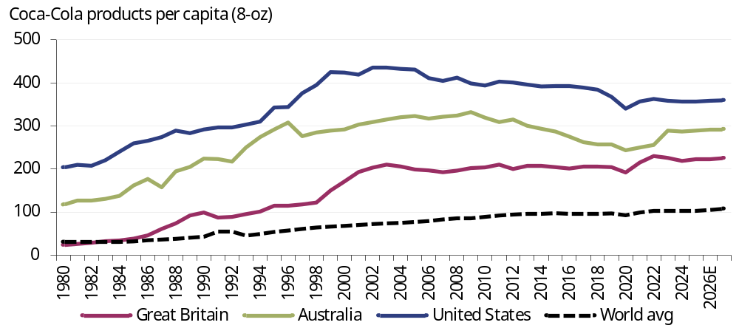
Source: Rothschild & Co Redburn, UN

This presented TCCC with a clear growth opportunity and on 1 June 1984 it acquired Grand Metropolitan’s Coca-Cola bottling business and then began consolidating the bottling network in Great Britain into a single bottler – Amalgamated Beverages.
In January 1987, TCCC merged Amalgamated Beverages with the UK soft drinks business of Cadbury Schweppes plc (Cadbury merged with Schweppes in 1969), forming a joint venture called Coca-Cola & Schweppes Beverages (CCSB) (Fig 4). This combined the Coca-Cola portfolio with the Schweppes brand, Appletiser, Oasis, Capri-Sun, Rose’s cordials and Kia-Ora.
CCSB accounted for one-third of total UK soft drinks market volumes in 1987 and its formation transformed the UK soft drinks market.
Fig 4: Great Britain sales have grown at a c5% CAGR since 1987
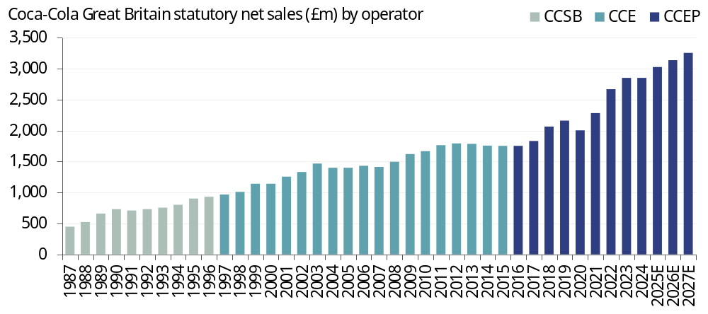
Source: Rothschild & Co Redburn, company

Disrupting the competitor
Cadbury Schweppes had been a Pepsi bottler for over 20 years in Great Britain and its switch to Coca-Cola in 1987 prompted PepsiCo to consolidate and strengthen its own UK bottling network into a single bottler – Britvic – which acquired the soft drinks brands of Beecham Group (Tango etc) in 1987 to create a scaled soft drinks competitor with a 20% volume share of the UK soft drinks market.
As part of the licensing deal, PepsiCo acquired a 10% stake in Britvic from its owner Britannia Soft Drinks; a division of brewer Allied-Lyons that was created in 1980 by merging the soft drinks businesses of Allied Breweries, Whitbread and Bass Brewery. This deal strengthened Pepsi’s access to the AFH channel – Bass owned what is now Mitchells & Butlers, one of the UK’s largest managed pub operators, while Whitbread owned 1,600 managed pubs as well as franchises for Pizza Hut and T.G.I. Fridays – and created a stronger cola competitor to Coca-Cola.

Keep calm and drink cola
As such, we tend to focus on the UK soft drinks market from 1987 given it largely reflects the competitor dynamics of today.
CCSB’s greater scale, focus and investment drove significant growth for the overall soft drinks category – especially for the cola category – since 1987, we estimate that Trademark Coca-Cola has grown at a 2% volume CAGR (Fig 5).
This growth was underpinned by a major capital expenditure programme that CCSB started upon its creation, including the commissioning of the Wakefield production plant. Wakefield was (and still is) the largest soft drinks plant in Europe and once this new mega plant ramped up production in 1990, CCSB then closed two older plants to unlock cost savings, which were partially reinvested behind top-line growth initiatives. Growth was also supported by higher marketing spend by TCCC, including the iconic 1995 UK “Diet Coke Break” advert – today the UK is still the second largest market for Diet Coke behind the US.
Meanwhile, Britvic raised the competitive intensity in the overall soft drinks industry. This was particularly acute in the cola category, helped by the successful launch of the sweeter tasting, sugar free Pepsi Max in 1993. Trademark Pepsi (Pepsi, Diet Pepsi, Pepsi Max etc) gradually started to win volume share from Trademark Coca-Cola (Classic, Diet, Zero Sugar etc), helped by affordability challenges in the Global Financial Crisis (Pepsi generally retails at a discount to Coca-Cola) and by upscaling the on-the-go Pepsi Max format from a 500ml to a 600ml PET bottle in 2010 but keeping the price the same (a de facto price cut on a per 100ml basis). Since 1987, we estimate that Trademark Pepsi grew at a 5% CAGR in Great Britain, faster than Trademark Coca-Cola, albeit off a smaller base.
Britvic was acquired by Carlsberg (Buy rated) in January 2025 as part of the Danish brewer’s strategy to expand beyond beer. We discuss some of the potential implications for CCEP later in this report.
Fig 5: Red versus Blue
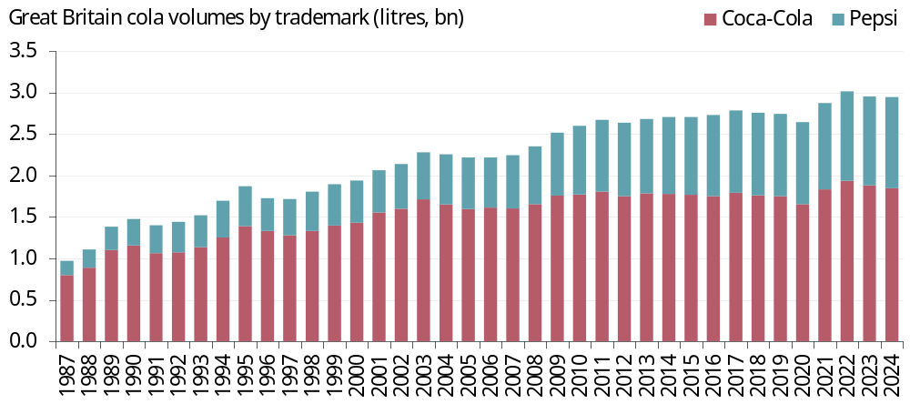
Source: Rothschild & Co Redburn, company, GDI, Nielsen

Changing hands
Despite a healthy rivalry with Britvic in the cola category, we estimate that Coca-Cola Great Britain (CCGB) has averaged 5.3% organic sales growth since 1988, although growth skews to the earlier years when the business was operated by CCSB (Fig 6).
Fig 6: Coca-Cola Great Britain organic sales growth by operator
Operator | Total | CCSB | CCE | CCEP | CCEP
Period | 1988-2024 | 1988-96 | 1997-2015 | 2016-24 | 2024-30E
Volume | 2.9% | 6.2% | 1.8% | 1.8% | 1.3%
Price/mix | 2.4% | 2.5% | 1.7% | 4.0% | 2.4%
Organic | 5.3% | 8.8% | 3.4% | 5.8% | 3.7%

Source: Rothschild & Co Redburn, company
Coca-Cola Enterprises (CCE) acquired CCGB in 1997 as part of the then North American bottler’s plans to diversify internationally, and TCCC committed to a five-year upweighted marketing plan to support strong volume growth from 1997-2002.
This drove mid-single-digit growth for six consecutive years, as shown in Fig 7. But thereafter CCGB’s volume growth faced challenges, such as in February 2004 when it infamously expanded into the bottled water category with Dasani, only to discontinue the brand in March 2004 following poor consumer reception and a product recall. The launches of Coca-Cola Zero Sugar (2005) and Monster Energy (2008) helped spur volume growth to 2010, when TCCC acquired the US operations of CCE as part of its North American bottler refranchising – discussed in ‘Super System’ (8 September 2023).
Thereafter, CCE became a Europe-only bottler, but despite this heightened focus it struggled to combat the rise of Pepsi Max in the 2010s, contributing to CCGB’s weak organic sales growth performance in 2012-15.
Fig 7: Britain struggled under CCE’s tenure, but has recovered under CCEP
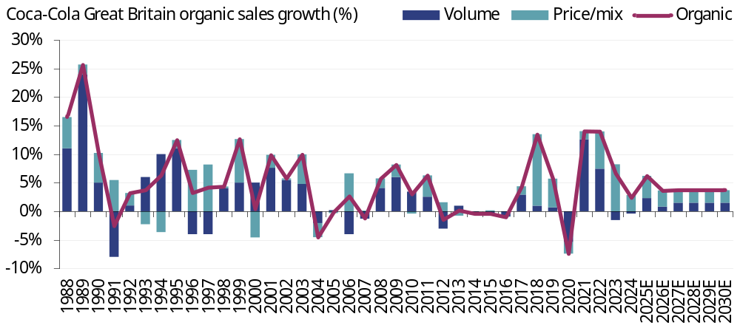
Source: Rothschild & Co Redburn, company

CCE’s performance was not much better in its other European markets (France, Benelux, the Netherlands, Norway and Sweden) and in May 2016, CCE was combined with Coca-Cola Iberian Partners (Spain and Portugal) and Coca-Cola Erfrischungsgetränk AG (Germany) to form Coca-Cola European Partners (CCEP, now Coca-Cola Europacific Partners).
CCEP then began to rejuvenate the business and since 2016, on our estimates, CCGB has averaged 1.8% volume growth pa, while revenue per case has risen at 4% pa, leading to 5.8% organic sales growth pa. This is impressive given the challenging backdrop that the UK has faced during CCEP’s tenure:
- In April 2018, the UK government introduced a soft drinks industry sugar levy (SDIL). This taxed beverages with added sugar, leading to an industry-wide shift from sugar-sweetened sparkling beverages to zero-sugar options, which dented volumes for market leader Coca-Cola Classic in the cola category (Fig 8). Pepsi Max was the main beneficiary, supported by additional production capacity in late 2019 after Britvic completed its supply chain investment plan termed the ‘Business Capability Programme’. Since then, Pepsi Max has consistently won volume share from Coca-Cola Classic and Diet Coke (although the latter has now stabilised in 3Q25), while Coca-Cola Zero Sugar has consistently gained volume share, helped by the successful 2021 reformulation by TCCC;
- CO2 shortages have threatened carbonated soft drinks production in Great Britain several times, most acutely in 2018 and 2021;
- The pandemic and slow reopening in 2020-21 restricted footfall in the AFH channel, which in 2019 was 46% of Coca-Cola Great Britain’s volumes. The AFH channel then faced ongoing challenges post-pandemic, such as high inflation from 2022 and adverse government policies at the 2024 Autumn Budget, including an increase to the minimum wage and employer National Insurance contributions, and reduced business rates relief;
- Widespread inflation following the 2022 war in Ukraine led to both higher input costs for CCGB and a weaker consumer environment.
Alongside this, CCEP’s portfolio pruning of Kia-Ora (2019-20) and Capri-Sun (2024-25) held back volume growth in the affected years, although this should modestly improve the territory’s long-term growth profile. Today, CCGB focuses on two categories: sparkling beverages and energy drinks, which together are 93% of total volumes (Fig 9). This is in contrast to the more balanced category profile of the total UK soft drinks market, but it is worth noting that CCEP does not operate in the juice category because TCCC does via the innocent brand, while in water CCEP has made the strategic decision to focus on small single-serve packs of Smartwater that earn a better margin.
Fig 8: Max attack |  | Fig 9: Not exactly a Total Beverage Company region
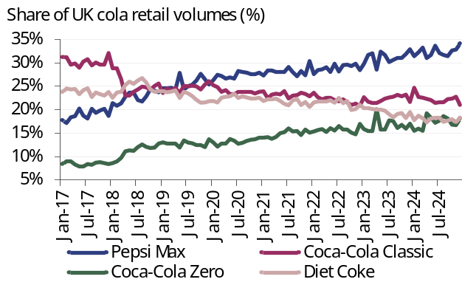 |  | 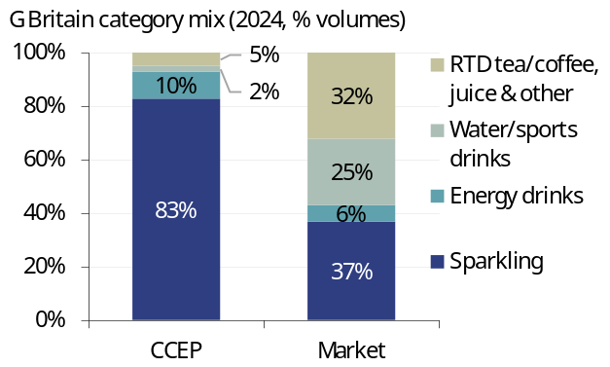
Source: Rothschild & Co Redburn, Circana |  | Source: Rothschild & Co Redburn, company, GDI

The British footprint
CCGB has a production footprint that is little changed over the past 30 years, apart from the closure of the Milton Keynes plant in 2019 (Fig 10). CCGB’s five production plants are strategically located close to key cities and near to major motorways to improve their distribution reach.
Fig 10: Coca-Cola Great Britain production footprint
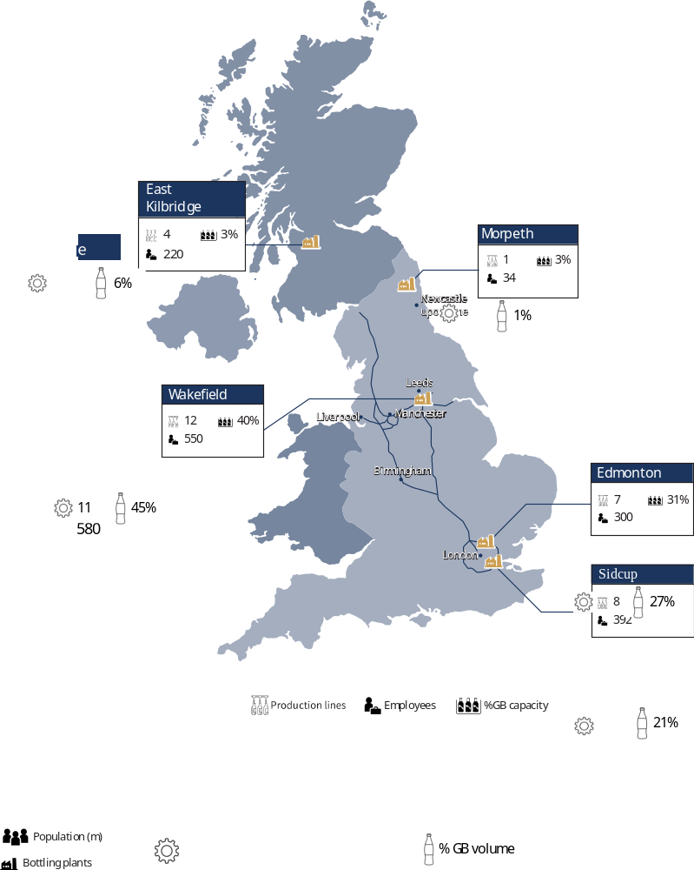
Source: Rothschild & Co Redburn
Edmonton and Sidcup surround Britain’s biggest city by population, London, and are close to the M25 motorway. Wakefield is the largest plant at c45% of CCGB’s volumes and it is positioned at the crossroads of the M1 and M62 so that it can service Leeds and Manchester (the third and fifth biggest cities respectively by population) as well as Birmingham (second biggest city) and even London.
Meanwhile, the Morpeth plant is the smallest with one production line that produces solely water under the Glaceau Smartwater and Abbey Well brands for the whole of Great Britain. Morpeth came from TCCC’s acquisition of Abbey Well in 2008, which as CCE described in its 10-K that year was “an important first step in creating a viable water strategy in Great Britain” following the failure of Dasani. The strategy involved heavy marketing and activation for Abbey Well to accompany the London 2012 Olympics, but as shown in Fig 9, this never led to a sustained improvement for CCGB’s water volumes.
There are similar nuances elsewhere: the Edmonton plant produces all of the post-mix syrup for Great Britain and East Kilbride produces all of the Appletiser glass bottle formats. Sidcup is the oldest plant (opened in 1961 by Schweppes) and it focuses on smaller pack formats; it is the only site that produces the 150ml and 250ml ‘mini cans’.

Site visit: Wakefield production plant
When the Wakefield plant was completed in 1989 it housed two canning lines and two PET lines. It was built adjacent to Nacanco’s aluminium can manufacturing plant, which supplied Wakefield with aluminium cans through a ‘hole in the wall’, providing Wakefield with a cost advantage compared to competitors’ plants.
In the years since, Wakefield has expanded to 11 production lines plus an Automated Storage Retrieval System (ASRS, effectively a large, automated warehouse). Below is a plant diagram from CCEP (Fig 11) and we have added a green box to highlight the bridge that connects Wakefield to the aluminium can manufacturing plant, which is now owned by Ball Corporation (Not rated).
Fig 11: The Wakefield mega plant
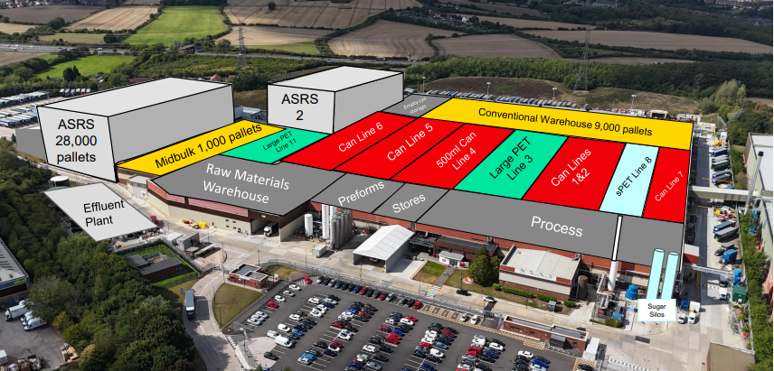
Note: Redburn green box for emphasis
Source: Rothschild & Co Redburn, company

Wakefield has received consistent investment over the years, including over £100m since 2019, within which £42m is to build a new ASRS (‘ASRS 2’ in Fig 11) that will double Wakefield’s onsite storage capacity to 58,500 pallets when it is completed (due in 2026). This comes just over ten years after the first ASRS was completed in 2014 and should boost CCGB’s operating margin by removing c£6m pa of logistics costs.
CCEP hosted an excellent site visit to the Wakefield plant and a market tour around Leeds on 18 November 2025. Wakefield is the company’s second largest plant by volumes after the Canlubang plant in the Philippines, which we also visited earlier in the year, see ‘From Manila to Jakarta’ (8 July 2025).
The site visit showcased where all this investment had been spent: rows of state-of-the-art manufacturing lines (including one of the two Monster Energy drinks lines in Great Britain), robotic automatic palletising machines, a 38 metre tall ASRS that seamlessly stores and retrieves thousands of pallets, and more (Fig 12).
Like Canlubang, all the employees that we encountered at the Wakefield plant were passionate about their role and highly knowledgeable about their domain. One aspect that impressed us was the future-proofing at the plant; not just building a new ASRS to help meet future demand, but a local hiring programme to train young engineers to counter any potential ‘cliff edge’ when c100-150 more senior employees retire in future (many of whom joined the plant back in 1989).
Fig 12: Producing just under half of CCGB’s volumes
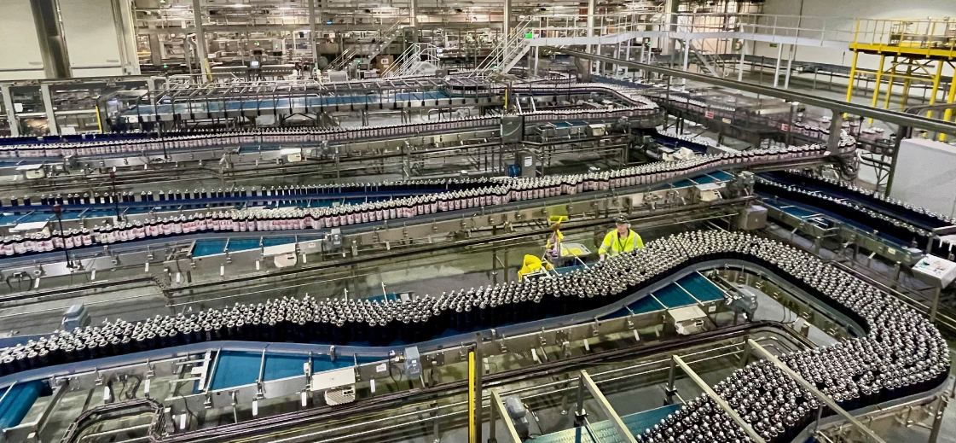
Source: Rothschild & Co Redburn

The British soft drinks market
Before discussing the Leeds market visit it is worth setting the scene by discussing the British soft drinks industry.
CCGB’s strong route-to-market underpins its leadership in a soft drinks category that we estimate is worth just over £21bn in retail value and has grown at just over a c4% CAGR over the past decade (Fig 13). The largest channel is grocery (i.e. supermarket chains like Tesco) at 48% of total soft drinks value, while the AFH channel – convenience stores, licensed outlets (hotels, pubs, restaurant) and food service (quick-service restaurants, leisure and travel) – is 52%.
Fig 13: Keep Calm and Carry On
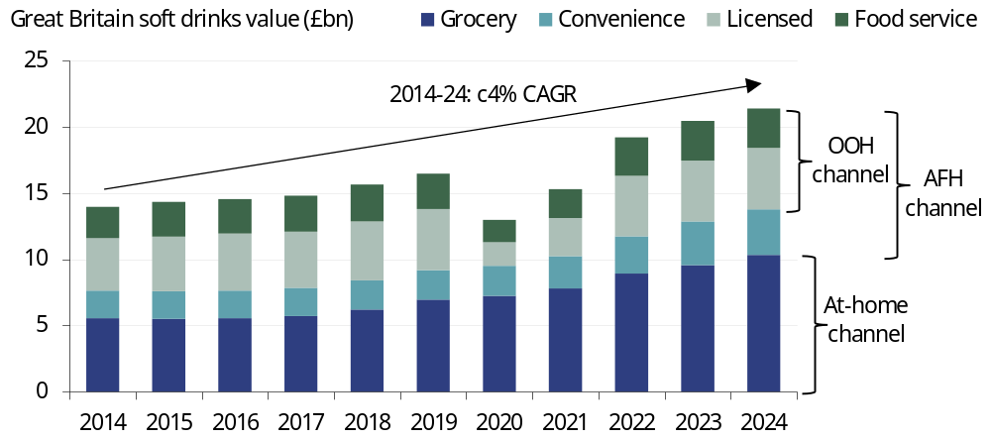
Source: Rothschild & Co Redburn, Nielsen CGA, Circana, Kantar

In the five years prior to the pandemic, the British soft drinks market grew at c3.5% pa, balanced between volume growth and average realised price (ARP) growth, which is what we expect it will grow at in future (Fig 14). The 2020 pandemic led to a c-8% volume contraction, on our estimates, with a c-14% ARP decline due to the negative mix effect of volumes shifting to the lower revenue-per-litre grocery channel, coupled with private label then winning share from branded players within the grocery channel.
Volumes sold through the licensed and food service channels have not recovered to pre-pandemic levels due to the constant challenges faced by the UK hospitality industry since 2020 – lockdown closures and a slow reopening, high inflation (particularly labour, food and energy) since 2022, and tax hikes in 2024 (Fig 15).
Fig 14: Pandemic induced disruption… |  | Fig 15: …led to sustained channel shift
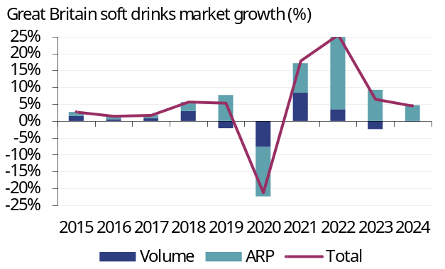 |  | 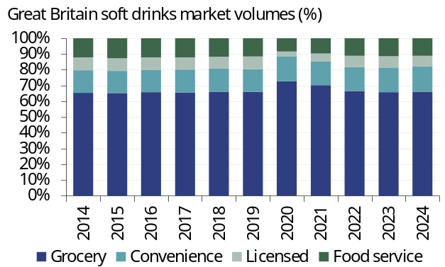
Source: Rothschild & Co Redburn, Nielsen CGA, Circana, Kantar |  | Source: Rothschild & Co Redburn, Nielsen CGA, Circana, Kantar

The out-of-home recovery story…
The AFH channel definition includes convenience stores which have performed well since the pandemic – volumes are up 9% versus 2019 and the channel has risen from a 13% value share of total soft drinks in 2019 to 16% in 2024. However, it is unclear whether drinks purchased in convenience stores are immediately consumed, or whether they are brought home for future consumption.
As such, we also look at the ‘out-of-home’ (OOH) channel (a subset of the AFH channel) where beverages are consumed immediately. This is the combined performance of the licensed and food service channels and where there has been the most pressure in recent years – 2024 volumes sold in the OOH channel are -10% compared to 2019 and the OOH channel has dropped from 46% of total soft drinks value in 2019 to 36% in 2024, with the grocery channel picking up much of the gains and rising from 42% to 48% of total industry value over the same period.
We suspect that most of the weakness in the OOH channel is linked to near-term affordability issues – for example, numerous quick-service-restaurant operators like McDonalds’s (Sell rated) raised prices aggressively in 2022, hitting footfall and same-store-sales growth, and are now back peddling to improve their affordable menu offering. The only sub-channel where we see structural pressure is in the nightclubs (c9%/c3% of OOH/total Great Britain soft drinks value) as following the pandemic younger consumers have shunned socialising with strangers in dark clubs in favour of healthier lifestyles and visiting the gym.
For CCGB, there is potentially a significant price/mix growth opportunity if the OOH channel recovers. For context, soft drinks sold through the licensed channel earn an ARP that is 3.2x that of the market average and 4.4x that of the grocery channel (Fig 16). Meanwhile, soft drinks sold through food service earn an ARP that is 24% higher than the market average.
We are not holding our breath ahead of the 2025 Autumn budget on 26 November, which could further dampen the consumer environment if, as widely expected, tax hikes are on the way. As discussed later in the market visit section, CCGB is not sitting idly waiting for the OOH channel to recover.
If and when the OOH channel recovers, CCGB is well positioned to capitalise – we estimate that it holds a 46% and 47% value share of the total soft drinks category in the licensed and food service channels respectively, well ahead of the number two player Britvic (27% and 14% respectively) (Fig 17).
Fig 16: Significant price differences by channel |  | Fig 17: Coca-Cola’s strength is out-of-home
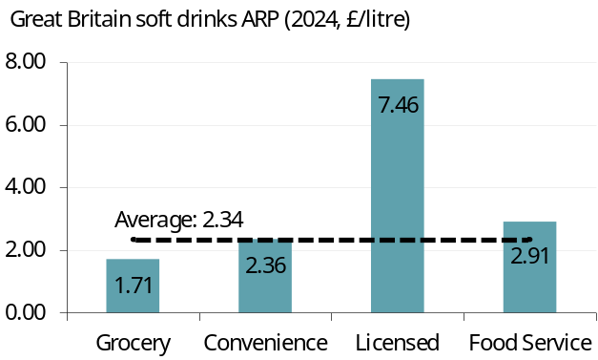 |  | 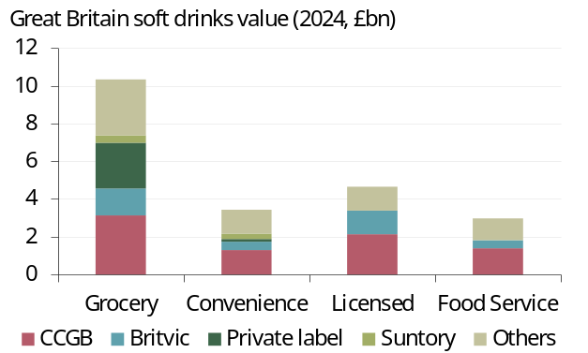
Source: Rothschild & Co Redburn, Nielsen CGA, Circana, Kantar |  | Source: Rothschild & Co Redburn, Nielsen CGA, Circana, Kantar
Sparkling beverages account for two-thirds of total soft drinks value in the OOH channel and CCGB is even stronger here, holding a 76% value share in the sparkling category and 89% value share of colas.
CCGB has longstanding strength in colas in the OOH channel due to the relatively more premium proposition of Coca-Cola relative to Pepsi, helped by Coca-Cola’s iconic contour bottle that has helped it to win outlet distribution for many decades to the detriment of Pepsi (which lacks a memorable bottle design) (Fig 18). In partnership with TCCC, CCGB has also successfully executed the ‘Coke with Meals’ strategy to link Coca-Cola to meal occasions over many decades, starting with Wimpy’s launch in the UK in 1954 (the first restaurant to serve hamburger-based meals in the country) and turbocharged by McDonald’s UK entry in 1974.
As a result, Coca-Cola also has a durable advantage in post-mix (e.g. syrup in a box that is dispensed from a soda gun), which is worth 45% of soft drinks value in the OOH channel and where CCGB has a dominant 54% share, well ahead of Britvic’s 19% (Fig 19). This is partly because CCGB’s fourth largest customer is McDonald’s.
The Coca-Cola System and McDonald’s have a very strong, longstanding relationship; 2025 marks the 70th anniversary since Coca-Cola was first sold in its outlets. TCCC even has a President of the McDonald’s Division (Roberto Mecade) to manage this key relationship across over 100 countries. In our view, it is incredibly unlikely that McDonald’s would ever switch from Coca-Cola to Pepsi and this bedrock customer grants scale that provides certainty to CCEP to invest behind post-mix – as shown in Fig 10, the Edmonton site produces all of the post-mix for Great Britain and in 2019 it received £20m of investment to help build a new state-of-the-art post-mix line.
Fig 18: Differing taste by channel |  | Fig 19: Mix master
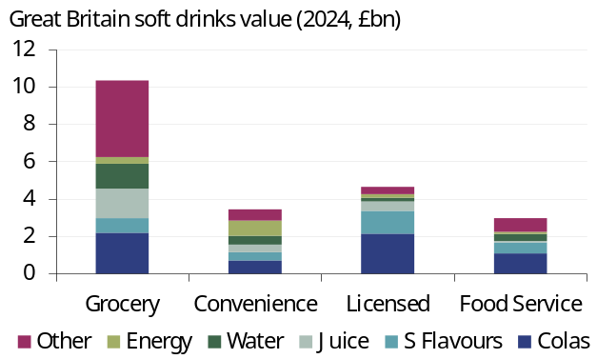 |  | 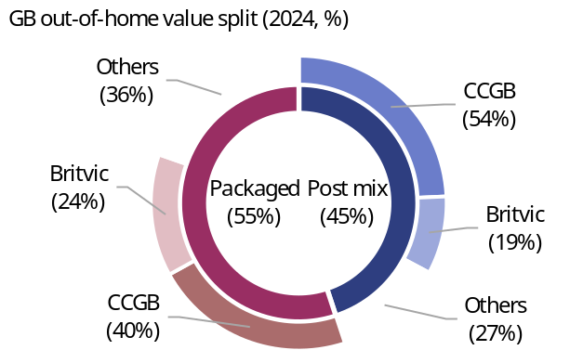
Source: Rothschild & Co Redburn, Nielsen CGA, Circana, Kantar |  | Source: Rothschild & Co Redburn, Nielsen CGA, Circana, Kantar

Winning in the away-from-home channel
Despite near-term pressure in certain sub channels – particularly quick-service restaurants and casual dining which has held back the food service channel – CCGB has won value share in the AFH channel since 2019 (Fig 20). As at 2024, there were c285,000 outlets in the AFH channel and CCGB held a 48% value share of total soft drinks and a 65% value share of the sparkling category.
Fig 20: Strong in out-of-home, scope to improve in at-home
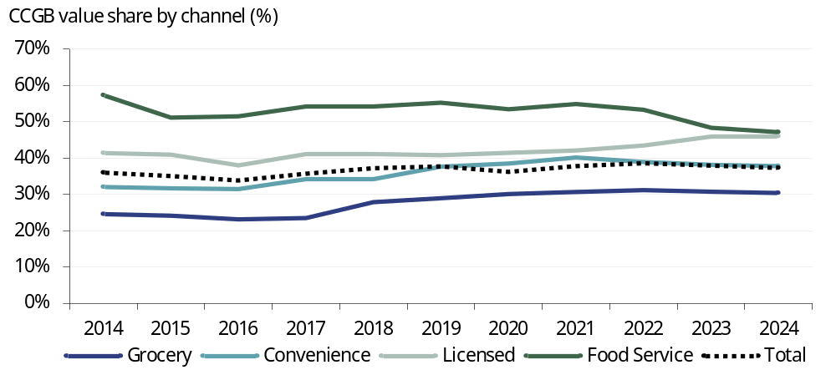
Source: Rothschild & Co Redburn, Nielsen CGA, Circana, Kantar

CCGB wants to raise its value share of the sparkling category to more than 70% and the site visit highlighted numerous customer wins and renewals that should support ongoing sales growth and value share gains:
- In August 2025, CCGB became Arsenal football club’s official partner in its Emirates stadium. This complements TCCC’s new three-year partnership with the British Premier League and CCGB’s Premier League logo cans. Importantly, football is the number one ‘passion point’ for British consumers and these partnerships should help to further strengthen Trademark Coca-Cola’s brand perception and recognition in Great Britain;
- As discussed later, in 2025 CCGB won distribution in pub operator Fuller, Smith & Turner from Britvic;
- CCGB’s distribution agreements with Greggs, Whitbread (Premier Inn), Domino’s Pizza and Burger King were all recently extended to 2030.

The evolving grocery landscape
The at-home channel, namely grocery, is where there is most scope for CCGB to improve its value share performance. As shown earlier in Fig 13, grocery is the largest channel at 66% of total British soft drinks volumes, but it only accounts for 48% of value due to the lower ARP, as shown in Fig 16.
CCGB is the market leader in the grocery channel with a 30% value share and we estimate that it has won 100bp of share since 2019. The next largest player in grocery is private label (23% share), followed by Britvic (14% share).
CCGB’s value share performance is impressive given the shifting landscape in the UK grocery channel – namely the rise of e-commerce and the rise of the German discounters. To illustrate, we have plotted the UK market share by key grocer back to 2000 (Fig 21). We use UK data as data for Great Britain is not readily available, but the two are highly comparable.
Fig 21: The evolving landscape in UK grocery
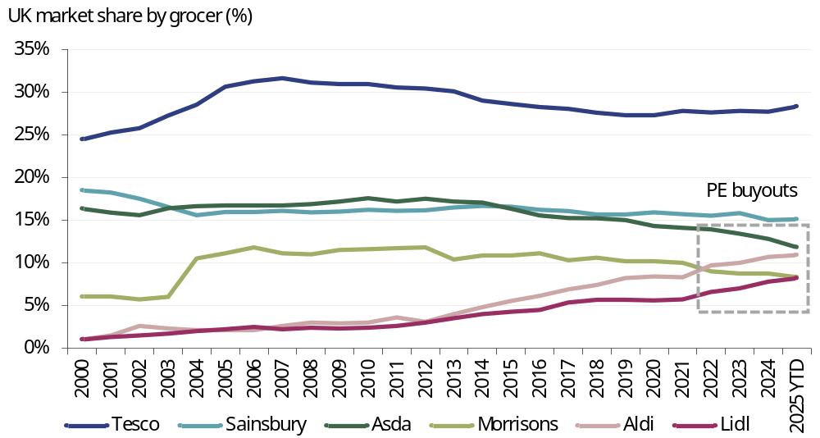
Note: Morrisons acquired Safeway in 2004
Source: Rothschild & Co Redburn, Kantar
The largest grocer is Tesco which has consistently held over a quarter of total market share. For Diageo investors, the incoming CEO Sir Dave Lewis was previously CEO of Tesco in 2014-20 and although the grocer lost UK value share during his tenure, Lewis’ accomplishments far outweighed this:
- Stabilised the company’s finances (including closing 43 loss-making UK stores);
- Strengthened Tesco’s relationships with suppliers like CCGB, while also building a stronger private label offering (‘Tesco finest’);
- Strengthened Tesco’s online operations and clubcard offering. Today, more than 24 million UK households use a Tesco clubcard (i.e. c83% of the c29 million households in the UK – an incredibly high penetration rate) and it has become an increasingly useful tool for suppliers like CCGB to refine their promotional spend in Tesco;
- Acquired wholesaler Booker in 2018 to diversify Tesco’s revenue streams into the OOH channel;
- Finally, Lewis earnt the moniker ‘Drastic Dave’, partly thanks to ‘Project Reset’ in 2015 which involved cost cutting and SKU trimming to help fight against the German discounters Aldi and Lidl.
Aldi and Lidl launched in the UK in the early 1990s and they have consistently won value share thanks to their cheaper price point, slimmer product line up and speedy checkout service. Combined, Aldi and Lidl have risen from a c2% share of total UK grocery value to almost 20% today – a staggering improvement that has consequences for the entire FMCG category, discussed shortly.

German discounters versus private equity
The UK’s third largest grocer, Asda, was acquired by the Issa brothers and private equity firm TDR Capital in February 2021. Then in October 2021, the fourth largest grocer, Morrisons, was bought by private equity firm Clayton, Dubiler & Rice. As shown in Fig 21, both grocers have struggled since being taken private: Asda has lost 250bp of market share since 2020 while Morrisons has lost 200bp. Aldi and Lidl have been the main beneficiaries, both winning 250bp of market share since 2020.
Morrisons is in a tough spot having been levered up to extract dividends while concurrently failing to improve its value offering. In July 2025, Fitch forecasted that Morrisons would end FY25E on 6.2x net-debt EBITDAR, falling modestly to just below 6.0x in FY26E. Fitch also downgraded Morrisons’ debt rating from 'BB' to 'BB-' i.e. one notch above CCC, the grade that signals “substantial risk” of default.
Morrisons announced price cuts on c650 products in September 2025 and in October 2025 it announced plans to shut 145 sites (c8% of the total store footprint) as part of an ongoing cost cutting programme. We will have to see wait and see if this is enough because, following suit, in October 2025 Asda announced price cuts on over 960 products in an attempt to win back market share.
Despite these countermeasures, we would expect Aldi and Lidl to continue winning share from Asda and Morrisons. In our coverage, Morrisons’ challenges pose the most risk to AG Barr (Buy rated), which is relatively stronger in the North of England (where Asda and Morrisons have a higher market share compared to the South of England). CCGB should be relatively less affected, but nevertheless, the structural shift towards Aldi and Lidl could create a few challenges.

Imitation is the sincerest form of flattery
Firstly, the German discounters are famous for their cheaper knock-off private label products that bear an uncanny (and legally opaque) resemblance to branded products – Aldi’s Vive Orange Zero brings back memories of the old Fanta Zero branding, before it was updated in 2023 to a new Fanta font (Fig 22).
As shown later in Fig 24 these private label products are significantly cheaper on both an absolute and a pence per litre basis, although they tend to have an inferior taste to branded products. Regardless, when British consumer budgets are under pressure, these private label products present a viable trade-down option.
Secondly, other grocers like Tesco and Sainsbury have started matching the price point of certain key products to the discounters. For example, several Coca-Cola Classic formats contain an ‘Aldi Price Match’ logo on Tesco’s website and the price point is indeed the same as on Aldi’s website (Fig 23).
Fig 22: Flashbacks to Fanta’s past branding |  | Fig 23: Limited by the Aldi Price Match
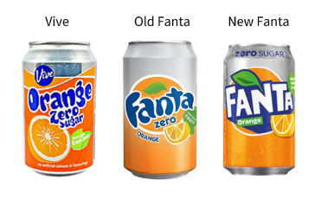 |  | 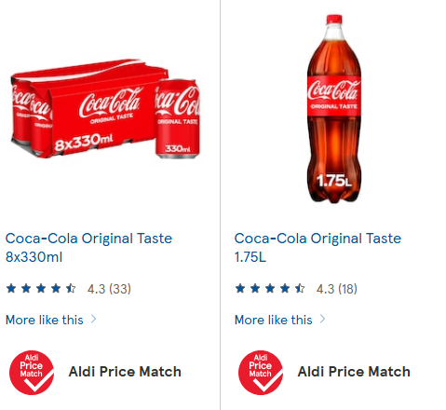
Source: Rothschild & Co Redburn |  | Source: Tesco.co.uk
These price match guarantees are usually funded by both the retailer and CCGB, lessening the hit to CCGB’s price/mix growth. The issue is that price matching could limit CCGB’s pricing power with the UK’s largest grocers. Moreover, as the discounters continue to win market share (and therefore consumer footfall) there is a risk that consumers could switch to their cheaper private label products.
Comparing the price points at Tesco and Sainsbury to the two German discounters across larger multi-pack formats illustrates this point (for comparability reasons, the discounters do not offer many single-serve formats) (Fig 24). As discussed, Tesco has matched Aldi’s price point for the 1.75 litre PET bottle format of Coca-Cola Classic, which equates to just 15 pence per 100ml of product.
If we look at the private label offerings of each grocer, Tesco and Sainsbury colas in the comparable two-litre PET bottle format are just 4 pence per 100ml (c75% discount to Coca-Cola Classic) while Aldi and Lidl colas are just 2 pence per 100ml (c85% discount). We would conjecture that most consumers would switch back to Coca-Cola Classic after tasting these private label offerings, which CCGB can capitalise on by expanding distribution of smaller single-serve formats that have a low absolute price point, like the 150ml ‘mini cans’ that retail for £0.60-0.75 each and are usually on offer at five cans for £2.50.
Fig 24: The vast price gap between branded products and private label
Grocer | Brand | Format | £ | ml | p per 100ml
Branded
Tesco | Coca-Cola Classic | 1x 1.75 litre PET | 2.55 | 1,750 | 15
Sainsbury | Coca-Cola Classic | 1x 1.75 litre PET | 2.65 | 1,750 | 15
Aldi | Coca-Cola Classic | 1x 1.75 litre PET | 2.55 | 1,750 | 15
Lidl | Coca-Cola Classic | 1x 1.75 litre PET | 2.55 | 1,750 | 15
Private label
Tesco | Tesco | 1x 2 litre PET | 0.80 | 2,000 | 4
Sainsbury | Sainsbury | 1x 2 litre PET | 0.85 | 2,000 | 4
Aldi | Vive | 1x 2 litre PET | 0.49 | 2,000 | 2
Lidl | Freeway | 1x 2 litre PET | 0.49 | 2,000 | 2

Source: Rothschild & Co Redburn, Tesco.co.uk, Sainsbury.co.uk, Aldi.co.uk, Lidl.co.uk

What does the shift to discounters mean for CCGB?
From a margin perspective, the shift from traditional grocers to discounters could create gross margin pressure for CCGB. This stems firstly from the lower revenue per case that CCGB earns from selling to the discounters, and secondly from the ‘price matches’ that could limit pricing power with the traditional grocers.
It is difficult to glean much information from the statutory accounts of the impact of the shift to discounters because the gross margin has been knocked repeatedly by the 2018 UK sugar tax, the 2020 pandemic and then ongoing inflation following the 2022 war in Ukraine (Fig 25). Furthermore, in 2025 the UK sugar tax was increased, leading to more gross margin pressure.
If pricing power is more limited due to the rise of discounters, then improving the gross margin will depend on improving the cost base at CCGB. The statutory accounts imply that concentrate is c33% of cost of goods sold (COGS) in Great Britain and this is largely fixed due to the bottler agreement with TCCC. But for the remaining two-thirds of COGS, CCGB can improve its cost base to drive gross margin expansion – as discussed on page 10, the new warehouse being built at Wakefield should help in this regard.
The operating margin should not face as much pressure from the shift to the discount channel as although CCGB sells to the discounter at a lower gross margin, operating expenses are also lower as products are shipped to the distributors’ warehouses and merchandised by their in-store clerks.
We therefore suspect that CCGB’s operating margin in the discount channel is not vastly lower than its average in the at-home channel, which as discussed in ‘Europe Emerging’ (10 March 2025) we estimate was 12.8% in Europe in 2019 compared to the region’s average of 13.9% and the European AFH channel average of 15.4%.
Fig 25: Falling gross margin, rising operating margin
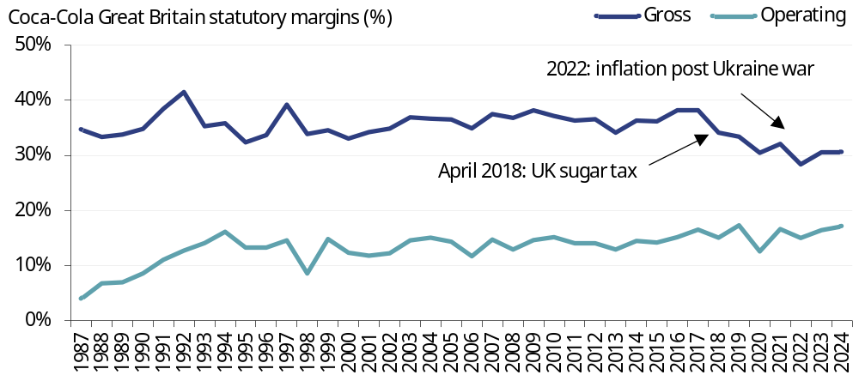
Source: Rothschild & Co Redburn, company
From a top-line growth perspective, ongoing market share gains by the discount channel means that private label could win share in certain soft drinks subcategories, hampering CCGB’s sales growth. Branded colas have usually fended off private label thanks to their superior taste and brand equity, while lemonades and orangeades are more susceptible to private label trade down. However, market share data shows that private label still only accounted for c12% of total soft drinks value in 2024, up from the historical average of c10% but below the peak of c13% during the 2020 pandemic (Fig 26).
CCGB has managed to fend off private label through a variety of measures and we expect it can continue to do so. Firstly, CCGB has improved its execution in the discount channel. Although Coca-Cola products in Great Britain have been available in Aldi since 2012, the price/pack architecture was immature and generally consisted solely of large PET bottles. Today, there are multi-packs of cans and single-serve PET formats to offer a wider array of options that also earn a higher revenue per case.
Secondly, as discussed, CCGB has won value share in the AFH channel, while the site visit highlighted the improved execution across the entire business which should help mitigate the risk of share losses both to other competitors and to private label.
Fig 26: Private label has not won much share, despite a weak consumer
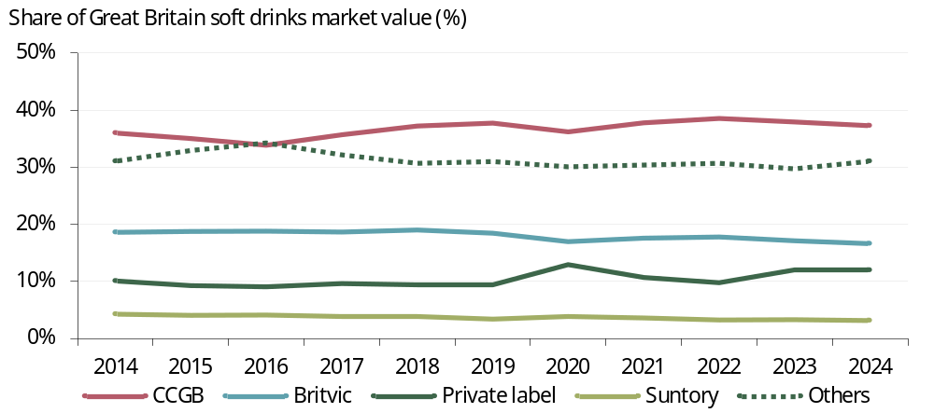
Source: Rothschild & Co Redburn, Nielsen CGA, Circana, Kantar

Market visit: tour around Leeds
One of the key elements behind the improved execution both at CCGB and across the wider CCEP is the increasing power of the company’s data and analytics tools. These were discussed in detail at CCEP’s 2025 Capital Markets Event in Manila, so we will not repeat here apart from the Right Execution Daily (RED) One application.
Each of CCGB’s c800 field sales team has an iPad with the RED One app. This is a proprietary app that improves in-store execution by providing the field sales team with store-level planograms and data and analytics tools to help review each store’s performance and suggest actions for improvement. The tool can also help to help optimise routes, maximising the field sales rep’s productive time in store and minimising the unproductive time travelling between stores. It is an incredibly powerful tool and has helped CCEP to strengthen its relationships with customers, both through selling more soft drinks but also through selling more of the customer’s products – for example, RED One often suggests initiatives such as placing Coca-Cola products adjacent to a retailer’s food products, which leads to greater sales of both products.
The RED One application then scores each store out of 100 using a variety of metrics – the higher the REDScore, the better the overall execution. This introduces a gamification aspect to the field sales role, making the job more engaging (important for talent retention) with improvements to the REDScore tied to incentives.

Tesco visit
As discussed, Tesco is the largest UK grocer and it is CCGB’s largest customer by volume. We visited a Tesco ‘Extra’ (one of Tesco’s large hyperstore formats) at the Seacroft Green Shopping Centre – the largest Tesco store by sales for CCGB in Yorkshire.
This store had a REDScore of 92 out of 100 i.e. very good, and it was easy to see why. Coca-Cola products had a very strong presence throughout the store and especially at the end-of-aisle displays; the ‘prime real estate’ for brand building.
We saw numerous examples of both affordability and premiumisation initiatives – a barbell pricing strategy that CCEP has deployed in numerous markets to drive both volume and price/mix growth in a soft consumer environment.
Using Coca-Cola Zero Sugar as an example, at the low end of the pricing ladder, consumers could purchase two two-litre PET bottles for £2.75 under a Tesco clubcard promotion, equivalent to 7p per 100ml. Slightly higher up the ladder, the new 8+2 extra free multipack can format for Coca-Cola Zero Sugar was prevalent across the store and has been performing “very well” for CCGB year-to-date (Fig 27). This format is also sold under a clubcard promotion for £3.50 (11p per 100ml) to further improve affordability.
At the top of the ladder, premium ‘mini cans’ of Coca-Cola Zero Sugar were placed at the end of the spirits aisle and priced at £6 (33p per 100ml) to complement various whisky products (Fig 28). The premium priced Jack Daniels and Coke alcoholic ready-to-drink (ARTD) format was also present (48p per 100ml on clubcard promotion) to offer a more convenient pack format and a lower absolute all-in cost compared to buying both a bottle of whiskey and a pack of mini cans.
Fig 27: Highlighting the extra value on the pack |  | Fig 28: Whiskey Oscar Whiskey
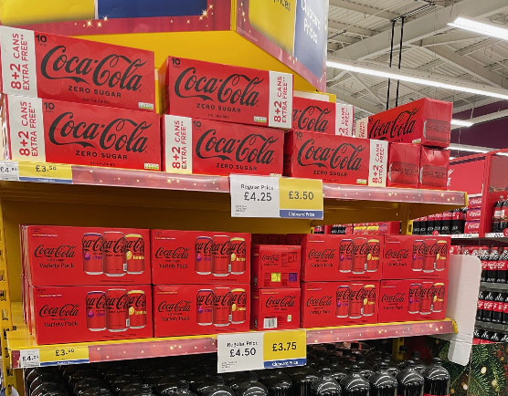 |  | 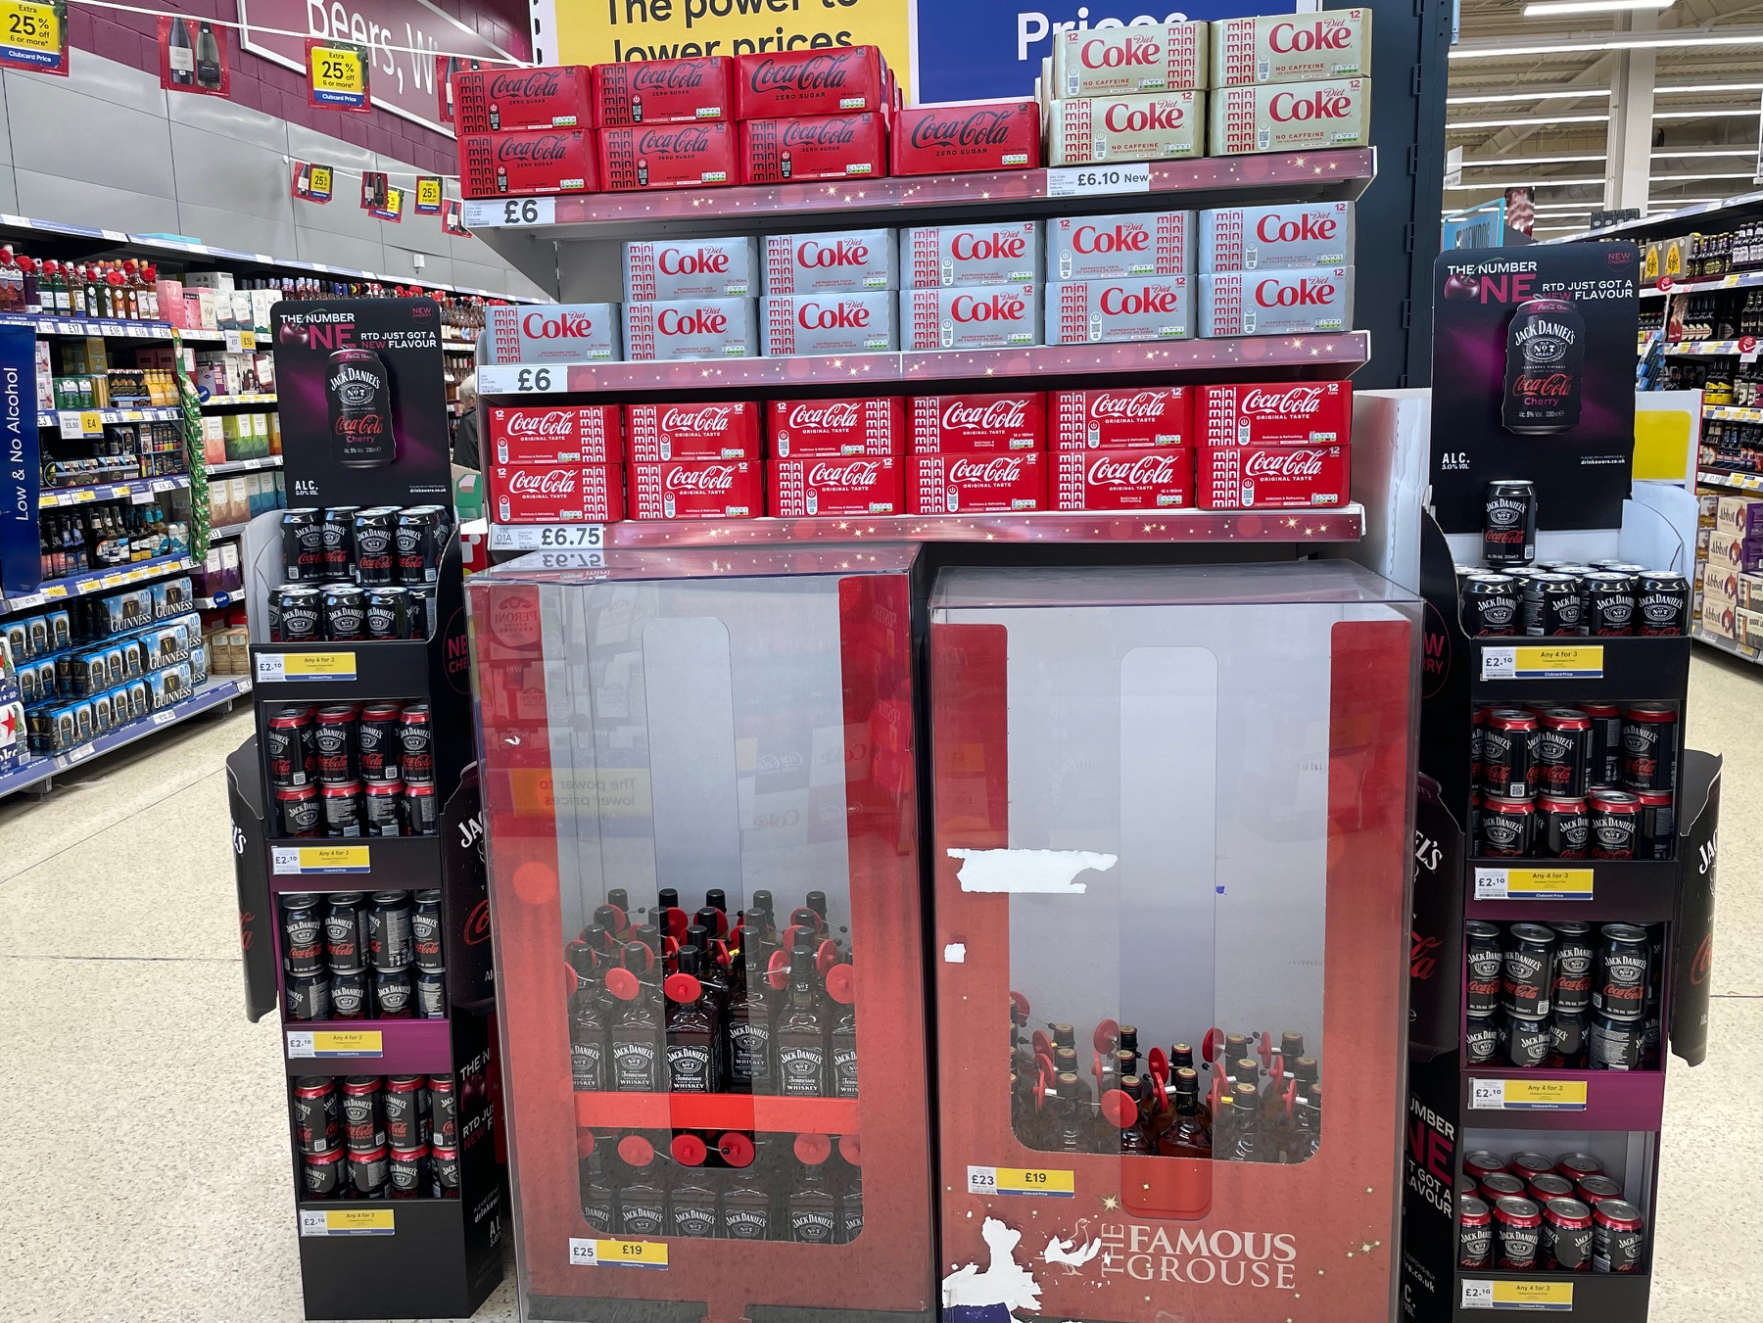
Source: Rothschild & Co Redburn |  | Source: Rothschild & Co Redburn

CCGB has a 58% share of the shelf space across all the coolers within this Tesco store and the visit showcased the proprietary cooler tool that helps the field sales team to optimise the assortment and availability in each cooler (Fig 29). This ultimately helps to drive faster sales growth of the higher margin, single-serve packs. We also saw a new multi-can variety-pack format for the sugar-free Monster Ultra, which is currently a Tesco-exclusive format, but could be expanded with other customers from 2026 (Fig 30).
Fig 29: Efficient coolers |  | Fig 30: Variety is the spice of life
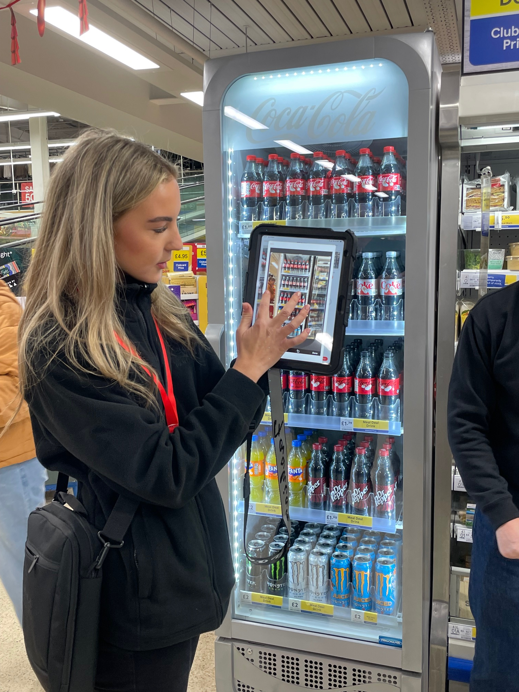 |  | 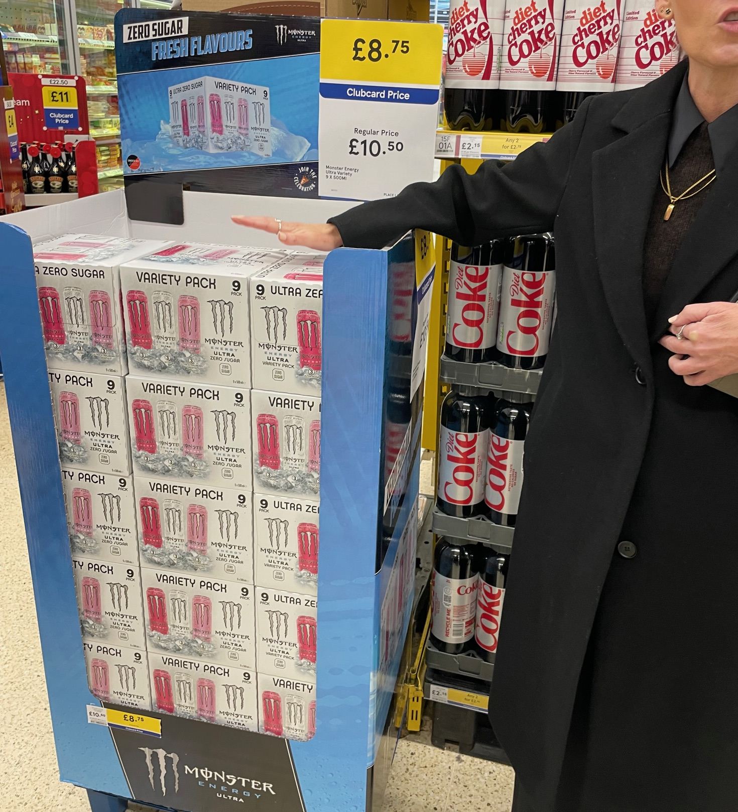
Source: Rothschild & Co Redburn |  | Source: Rothschild & Co Redburn
Monster Energy has been hugely successful in Great Britain – now the second largest market for Monster Energy after the US – but growth has historically been driven by the convenience channel. Expanding these multipack can formats in the grocery channel offers a more affordable price point (19p per 100ml on clubcard promotion, a c40% discount compared to the 33p per 100ml for a single can of Monster Ultra in the convenience channel) to drive further volume growth for CCGB’s energy drinks portfolio, as well as continued value share gains for Monster – in Great Britain, Monster’s value share in Nielsen-tracked channels has tripled over the past decade to c35% as at 3Q25 (Fig 31).
Fig 31: Bottom left to top right
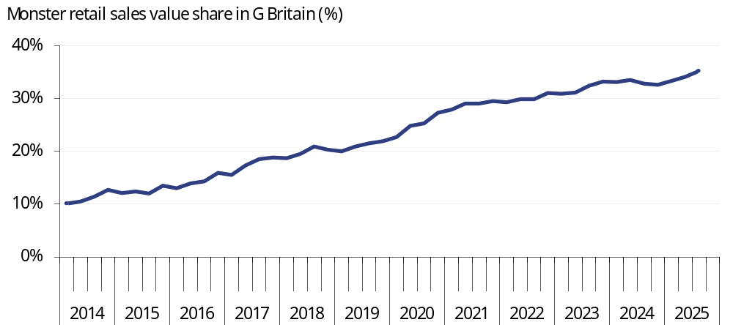
Source: Rothschild & Co Redburn, NiQ

Bestway visit
The second stop on the site visit was a Bestway depot in Stourton that had a 90 REDScore. Bestway is the second largest wholesaler in the UK behind Booker (which is owned by Tesco). CCGB sells its products to Bestway, which then sells on the products to end-customers in the AFH channel, such as convenience store and restaurant owners.
As such, Bestway is a classic no-frills cash-and-carry with large pallets of Coca-Cola products that helps CCGB to reach the c178,000 independent customers across Great Britain (i.e. the smaller, more fragmented customer base that is not part of a national chain) (Fig 32).
Many of the packs in Bestway were price-marked packs (PMPs) i.e. each 500ml PET bottle of Coca-Cola Zero Sugar in the pallet would have “£1.40” printed on the side. This allows CCGB to maintain price point discipline across the fragmented customer base, as well as launch targeted campaigns to drive faster growth of certain pack formats. For example, ahead of Christmas there is a deal on the 500ml PET bottles that will earn customers a 40.8% Profit on Return (POR) i.e. the gross margin for the customer (Fig 33).
Fig 32: Preparing to pounce |  | Fig 33: Profitable for customers
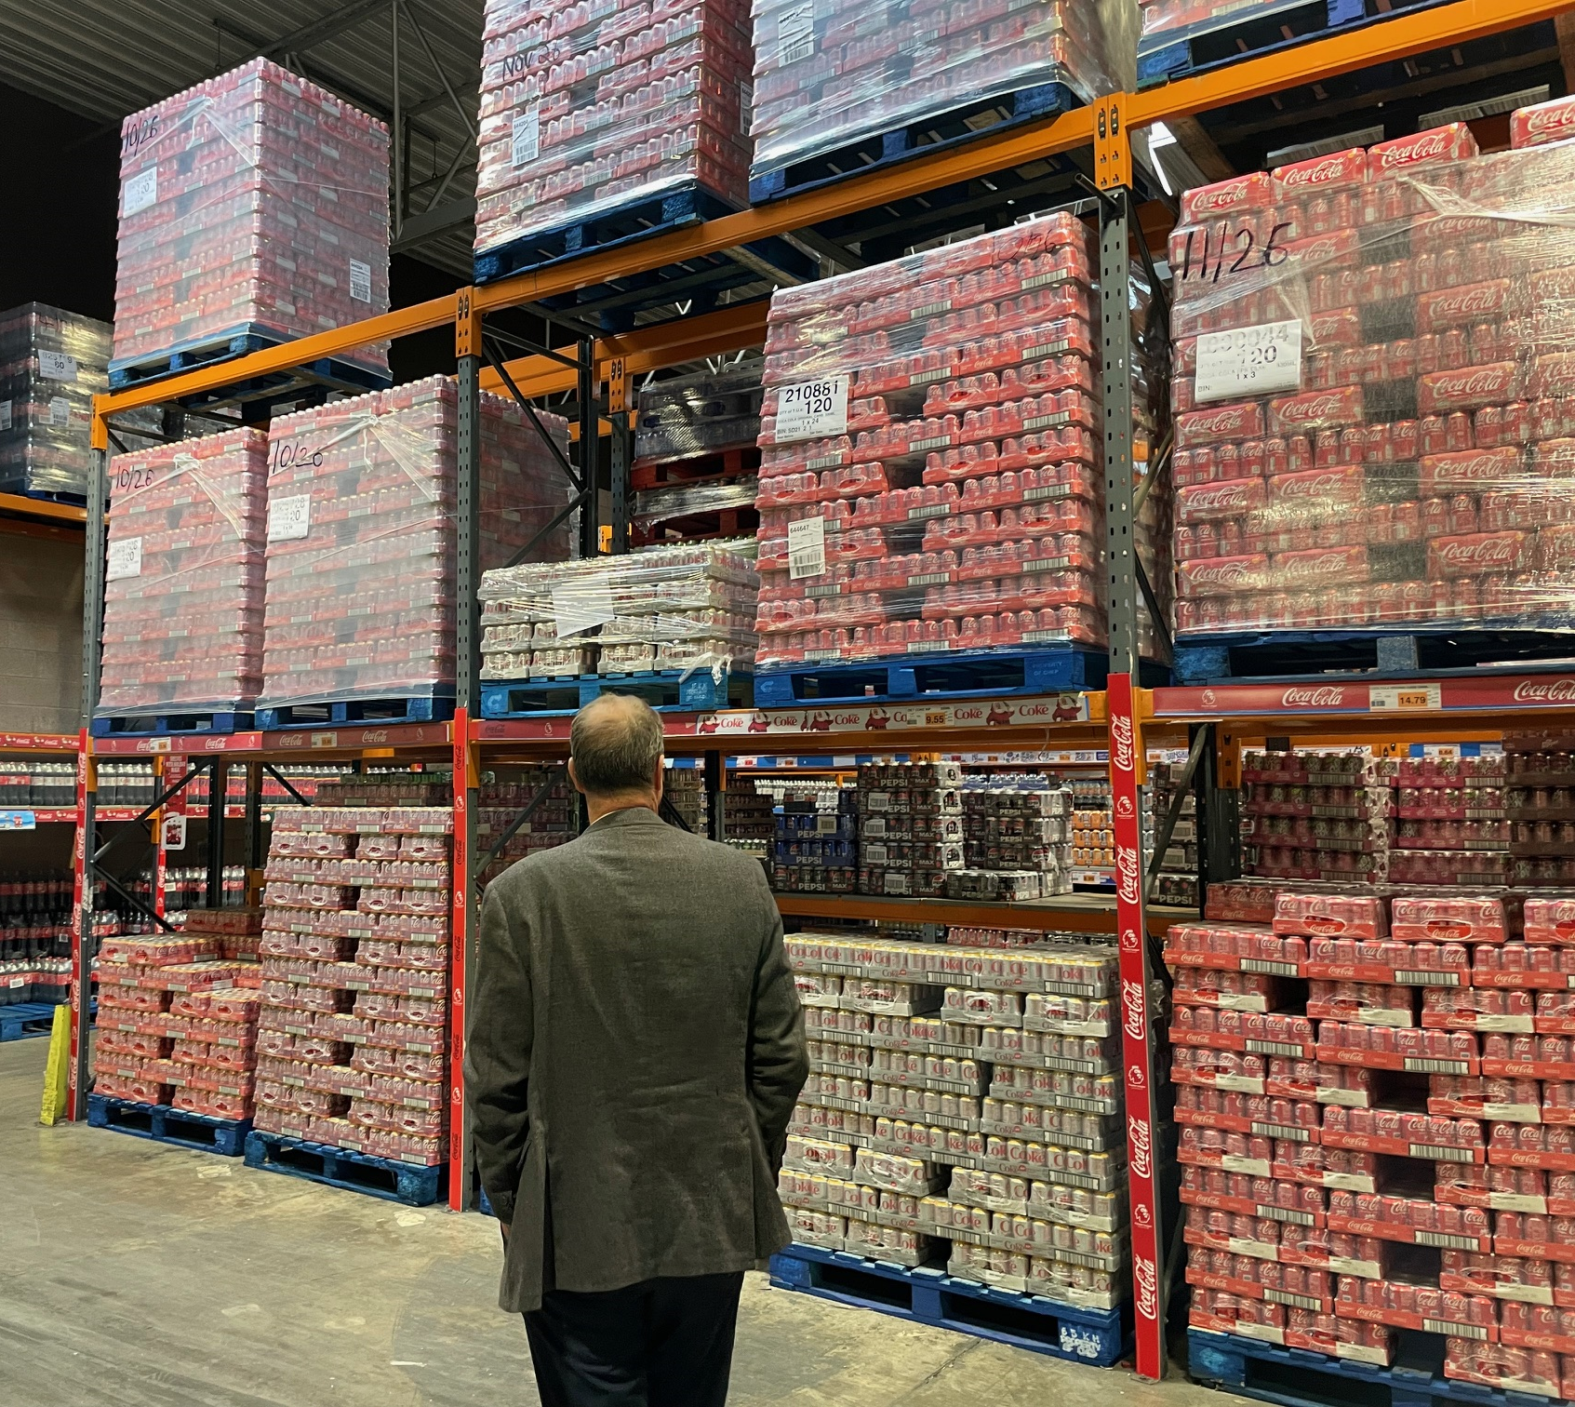 |  | 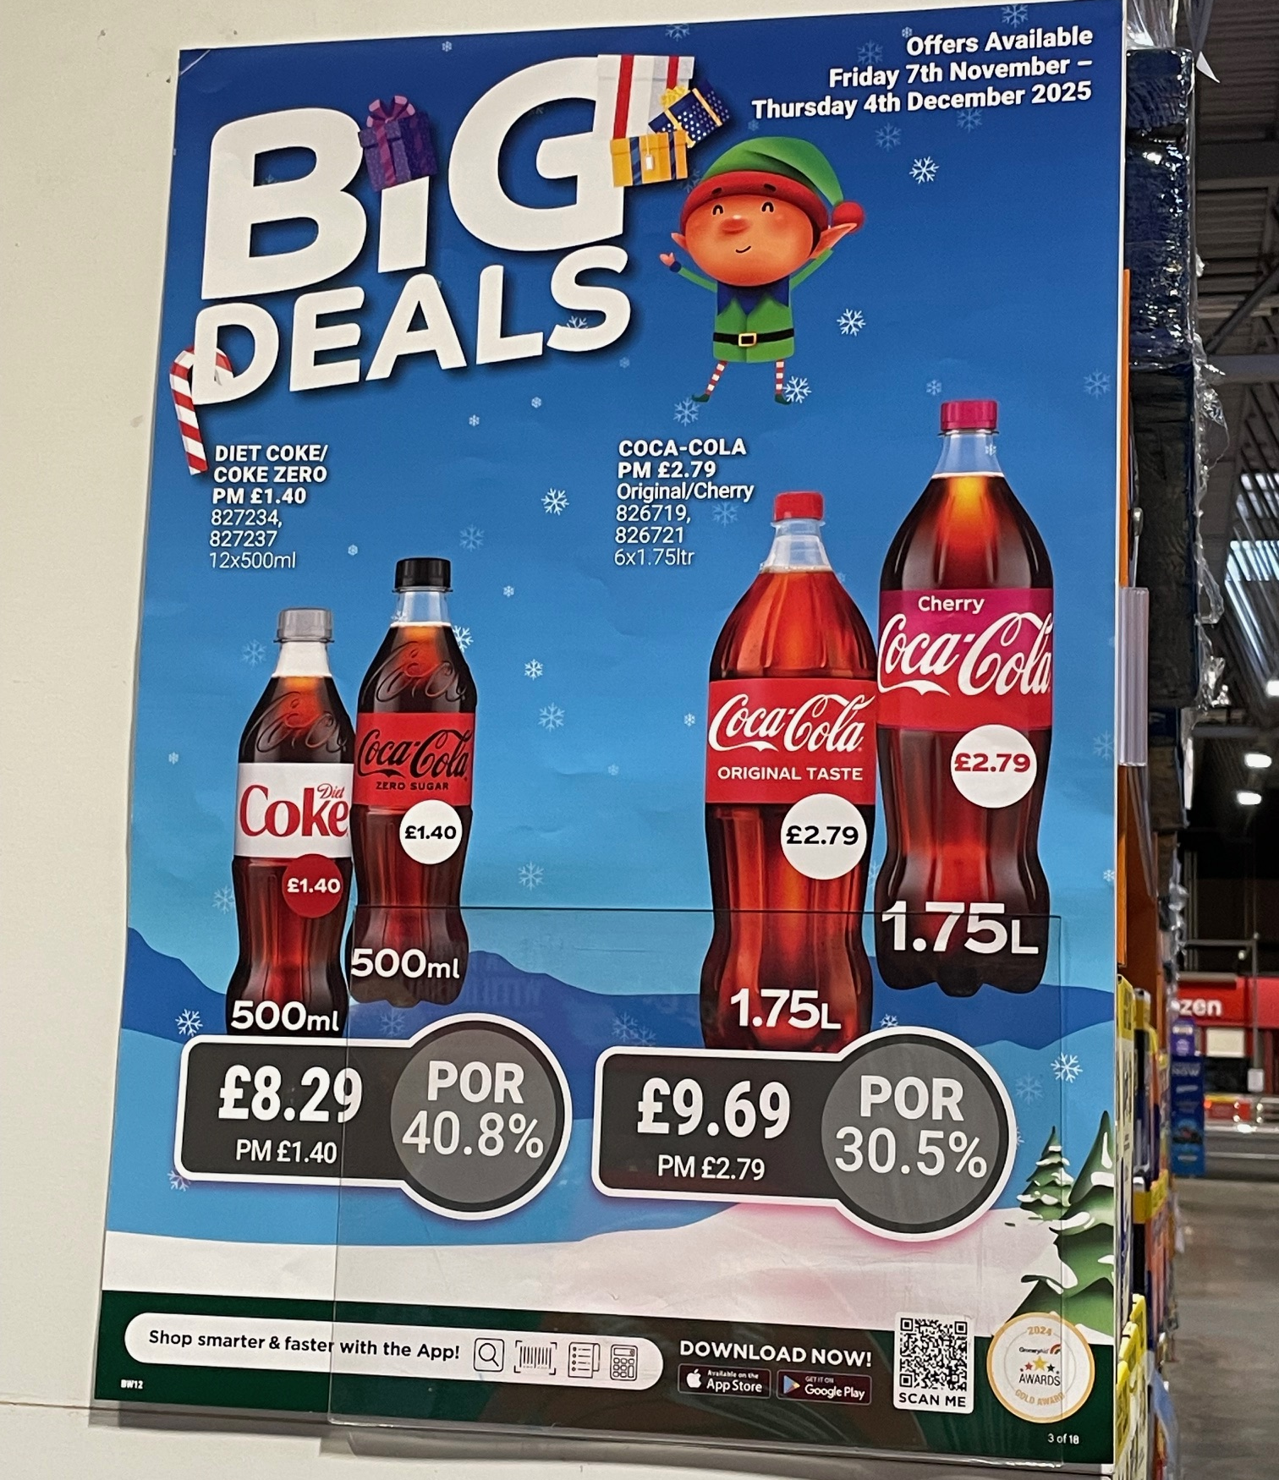
Source: Rothschild & Co Redburn |  | Source: Rothschild & Co Redburn
Given Bestway is a major supplier to convenience stores there was also a sizeable amount of shelf space dedicated to energy drinks, which the store clerk said had been winning shelf space from the beer category.
CCGB’s execution went beyond simply dropping a pallet of Monster Ultra off at the depot – there were end-of-aisle Monster displays to promote Monster Ultra with the latest video game campaign, along with promotional material to highlight Monster’s rapid rate-of-sale (Fig 34). These packs also earned a c40% POR and help to explain why energy drinks do so well in convenience stores: they earn a high margin and rotate very quickly, meaning they are highly cash generative for customers.
CCGB’s field sales team uses the wholesale channel to create and/or develop new business with end-customers. For example, during the site visit Stephen Moorhouse (General Manager of Great Britain) led from the front and spotted the owner of a newly-opened restaurant adding two trays of Coca-Cola Classic to their trolley. After a brief conversation, Stephen obtained the end-customer’s details and a field sales rep will now follow up to suggest an appropriate assortment of CCGB’s products to complement the restaurant’s food and help to design the drinks menu.
The wholesale channel can also act as a showroom to promote CCGB’s coolers and help drive cooler placements. In this Bestway depot there was an area that explained the benefits to end-customers of installing Coca-Cola coolers in their outlets – in this case, installing a cooler could lift the outlet’s soft drinks sales by 23% (Fig 35). As a reminder, part of CCEP’s 2025 capital expenditure involves placing more than 100,000 coolers across the AFH channel in its markets to support volume growth and margin expansion. CCGB had 116,000 coolers across Great Britain at the end of 2024 and this has since risen by 7% year-to-date in 2025.
Fig 34: Showcasing the perks of Monster… |  | Fig 35: …as well as the benefits of coolers
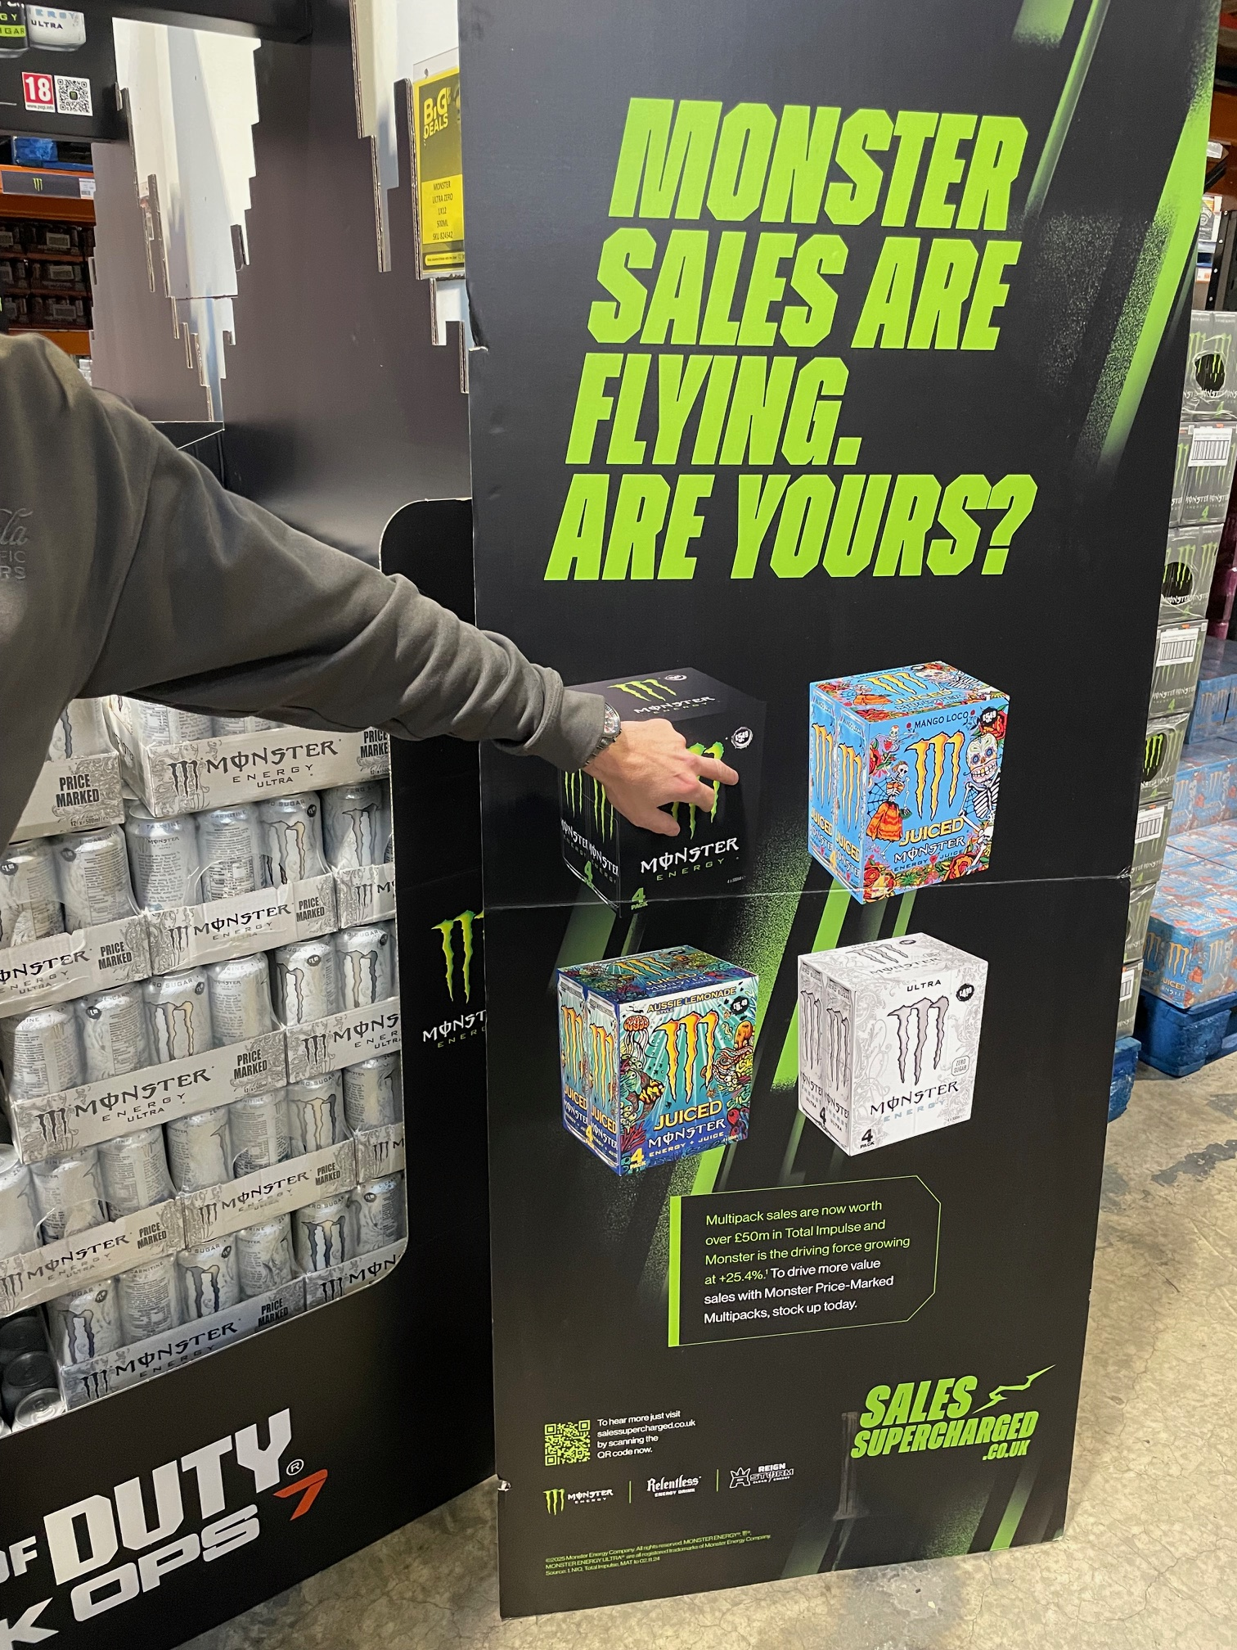 |  | 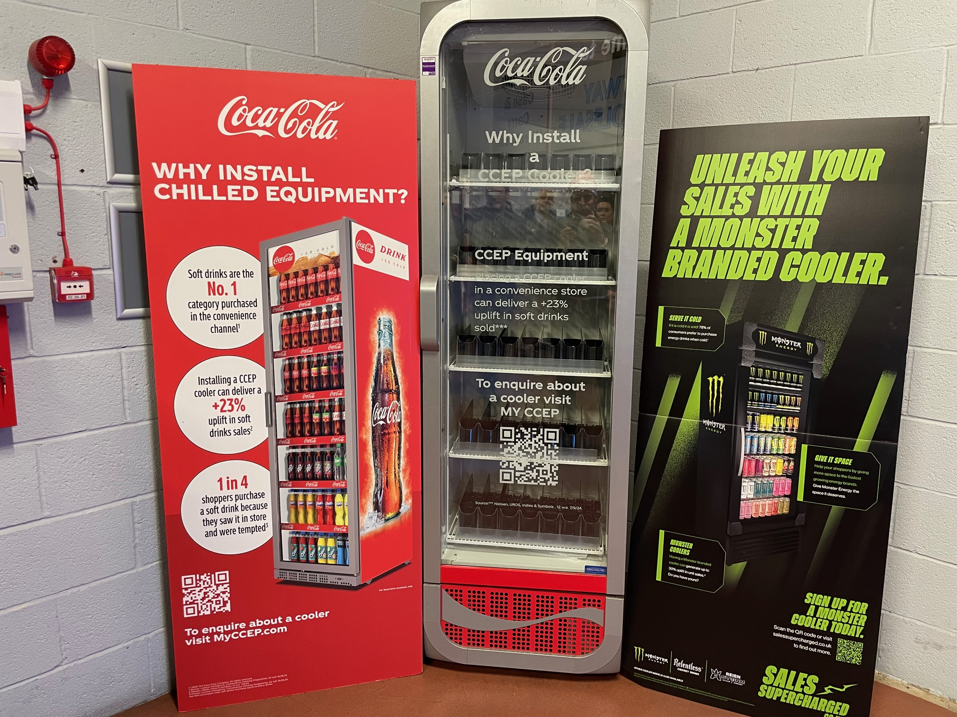
Source: Rothschild & Co Redburn |  | Source: Rothschild & Co Redburn

AFH blitz
Altogether, we were surprised and impressed by the amount of in-store execution that CCGB’s field sales team (and Stephen Moorhouse) perform in Bestway, which is critical to ensuring product availability in the AFH channel.
This was certainly needed in the convenience store that we visited next. The store was opened relatively recently, but it has already become a prime example of what CCEP’s cooler placement programme can achieve, with two Coca-Cola branded coolers and a Monster cooler inside the store (Fig 36). There was only one cooler from a competitor (Red Bull) and as a result, CCGB’s products held a 90% value share in the store and c120 cases of CCGB’s products are sold each week, equivalent to roughly one 500ml PET bottle of Coca-Cola every five minutes during opening hours. Given the products are mainly small single-serve packs from the coolers, the store is likely highly profitable for CCGB.
The final stop was a food court (i.e. the food service channel), which showcased CCGB’s point-of-sale marketing material to drive higher incidence of its soft drinks with food orders (Fig 37). We also learnt that CCGB has improved the way that it funds these marketing materials by devolving spending power to the local field sales team. CCGB head office allocates a budget by city, then the local field sales rep can decide which outlet receives the investment based on their deep knowledge of their customers to help improve the return on investment.
The site visit also highlighted how CCGB’s execution remains strong even at the smaller, lower revenue generating operators (those with under 30 outlets). CCGB has won distribution to c100 of these operators over the past year and the hope is that, in a nirvana, one of them could scale and become the next McDonald’s. But even if that does not happen, showcasing Coca-Cola products alongside a wide variety of food operators (we saw Mexican, Italian and Korean ‘fusion’ on the site visit) helps to strengthen the association with food and can help drive sales growth for CCGB in the grocery channel.
Fig 36: Dominant share of shelves |  | Fig 37: Stimulating sales at the checkout register
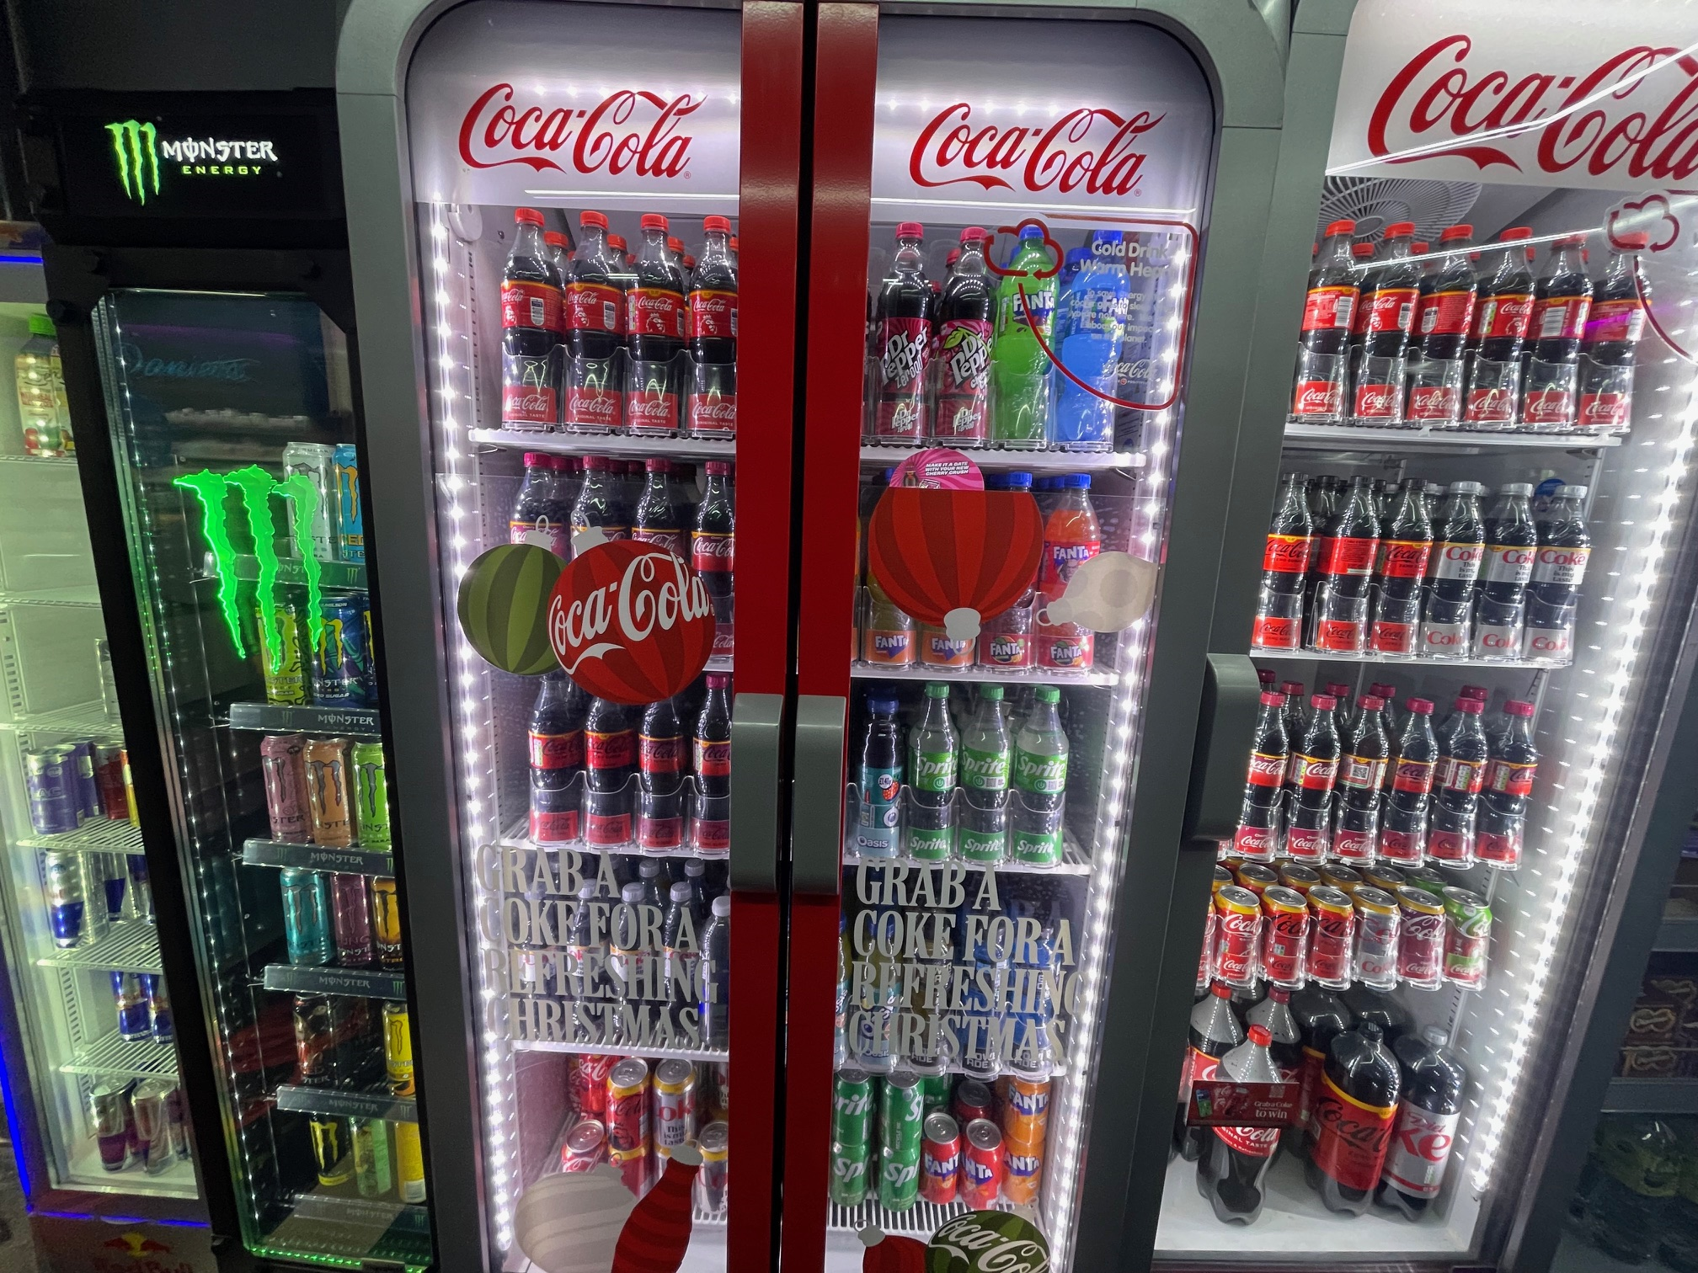 |  | 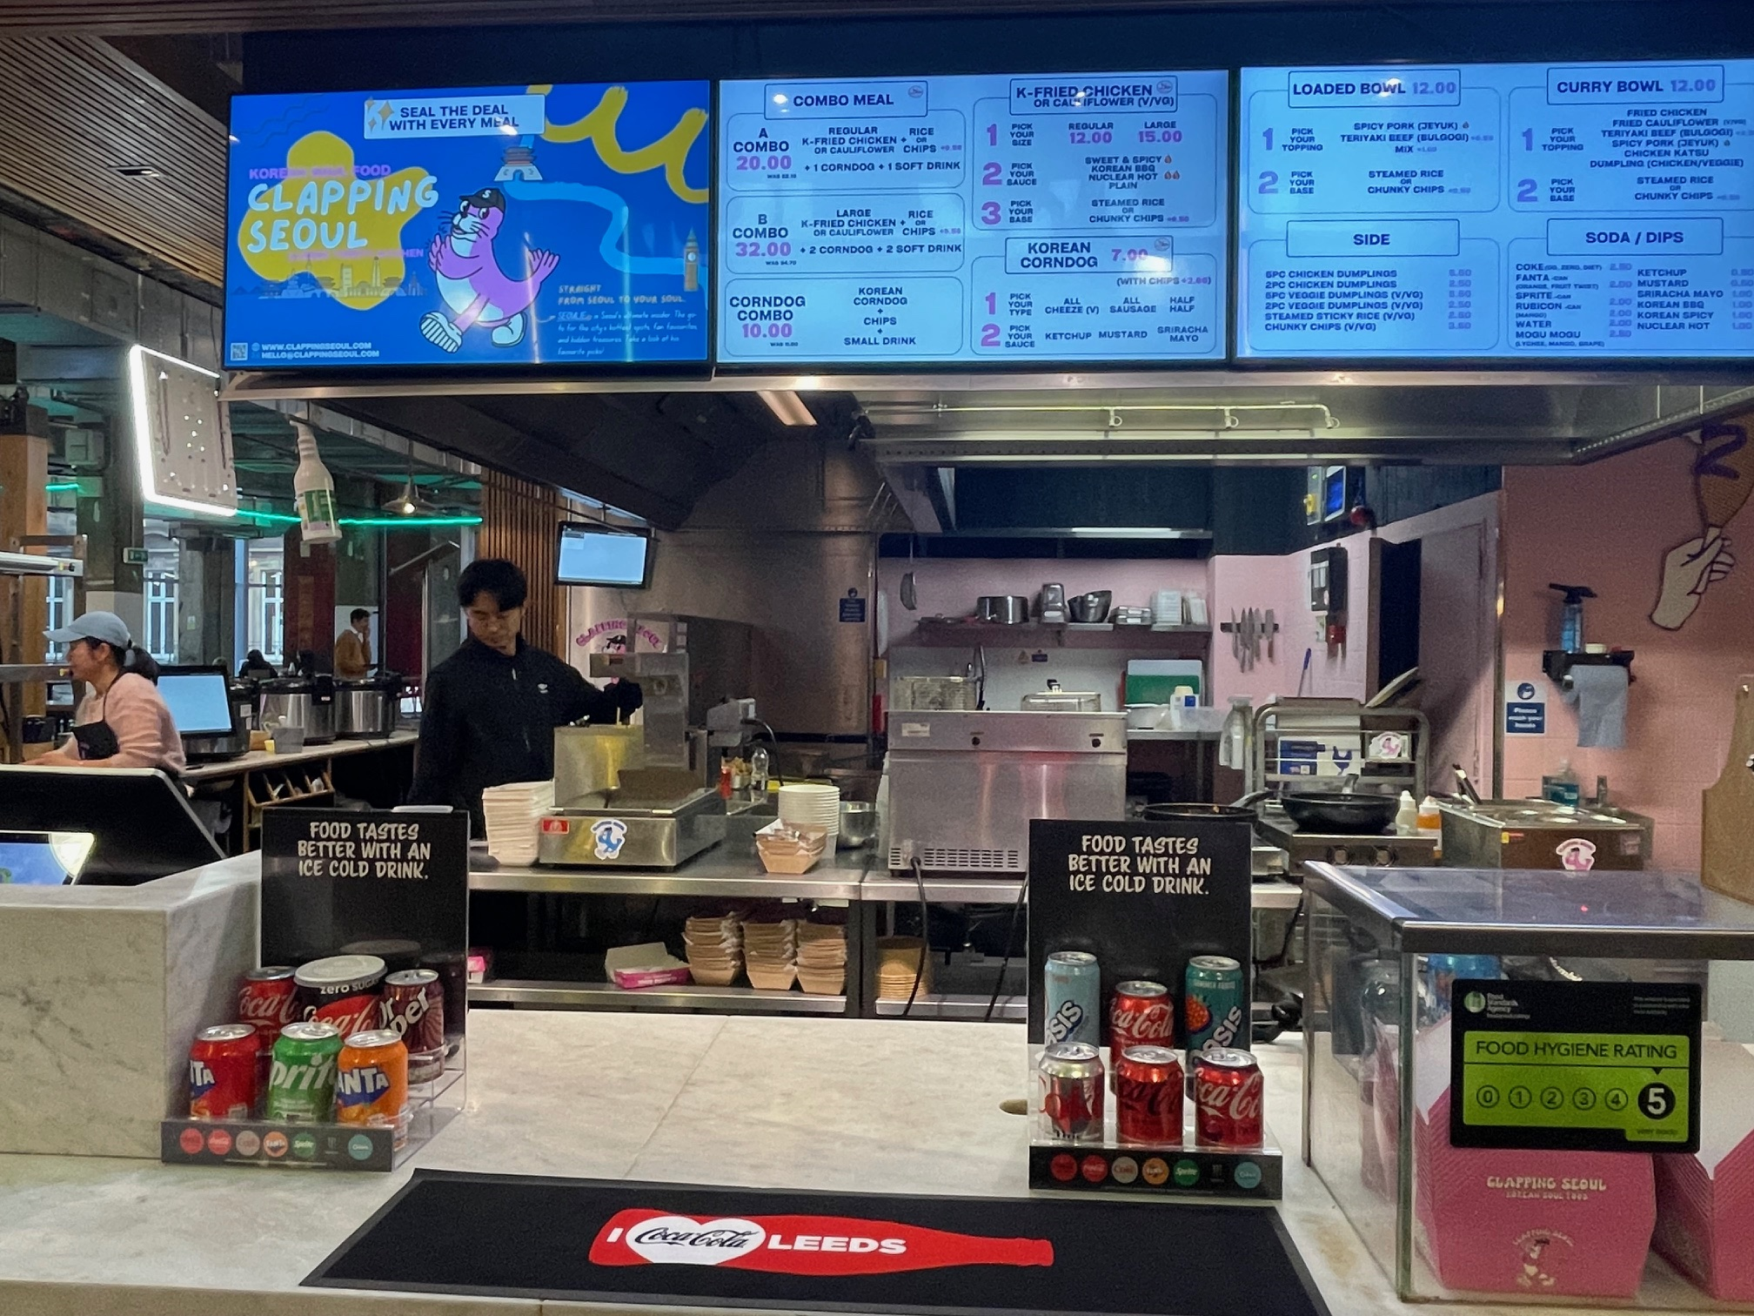
Source: Rothschild & Co Redburn |  | Source: Rothschild & Co Redburn

The road ahead
The market tour reinforced our view that CCGB’s execution has made a step change improvement since the days of CCE. The local culture has been transformed and it was notable that the field sales team is now ‘playing to win’ rather than the old defensive mindset in the 2010s as CCE struggled to combat the rise of Pepsi Max under Britvic.
Going forwards, the local operating environment in Great Britain is unlikely to ease and, in our view, the two biggest risks to CCGB’s long-term sales growth come from aggressive competitor behaviour and further government policy changes.

Implications of Carlsberg-Britvic
In January 2025, CCGB’s main competitor and the Pepsi bottler in the UK, Britvic, was acquired by Carlsberg to create Carlsberg-Britvic, which is now the largest multi-beverage supplier in the UK. Before discussing the impact this could have on the British soft drinks market, the most pressing question we have received from investors regards the cost savings plan.
Upon acquisition, Carlsberg announced a £100m cost savings plan for Carlsberg-Britvic to the end of 2029, equivalent to 6% of Britvic’s sales, from sources such as procurement, supply chain and administration and overheads.
Before the acquisition we covered Britvic with a Buy rating and we would have struggled to envisage cost savings of this magnitude were possible without exiting parts of the business and without jeopardising front-line execution, especially after the company underwent a £240m supply chain transformation (termed the ‘Business Capability Programme’ (BCP)) in Great Britain (two-thirds of Britvic’s total revenue) from 2015-19 with the aim of optimising and future-proofing the business. This was a vast programme that included commissioning ten new, more efficient production lines, shifting production from Norwich to Rugby to reduce logistics costs, upgrading the existing warehouses, and building a new, fully automated high-bay warehouse at Rugby, and more.
Then, at its October 2025 Capital Markets Day, Carlsberg raised the cost savings target from £100m to £110m (7% of Britvic’s sales). We suspect that part of this increase is due to the planned closure of the Teisseire plant in France and the decision to outsource production to Slaur-Sardet; a copacker for Teisseire since 2022. This will unlock cost savings, but it will not solve Teisseire's top-line issues: Britvic’s largest French brand had been in decline for a decade with softening volumes and pricing that was insufficient to cover inflation, leading to worsening profitability. We would not be surprised if Carlsberg were to review the broader legacy Britvic France business.
In our view, this cost savings plan could create an opportunity for CCGB if, for example, Carlsberg-Britvic loses key talent which negatively impacts its execution, or if Carlsberg-Britvic loses focus as it tries to deliver the sizeable cost savings programme, which would have the same outcome.
We have already seen the former happen and talent is leaving the legacy Britvic business for competitors – AG Barr has been a beneficiary and hired Dino Labbate as the new Chief Commercial Officer (previously Britvic’s GB Commercial Director for Hospitality) and James Quemby as Retail Sales Director (previously Grocery Customer Director at Britvic i.e. the main driver in the grocery channel behind Ben Parker, who remains at Carlsberg-Britvic as VP Sales – Off Trade).
On the latter, we will have to wait and see – it is rare in the consumer staples sector to see a company deliver both cost savings and accelerating top-line growth. Currently, there is little clarity on the specifics of Carlsberg’s £110m cost savings plan, other than the high-level sources already outlined.
Conversely, the main risk to CCEP is that the new Carlsberg-Britvic entity, helped by a stronger strategic partnership with PepsiCo, creates a more capable competitor in Great Britain.

Better competition in sparkling
The crown jewel in Britvic’s Great Britain portfolio is Pepsi Max which we estimate accounted for close to half of Britvic’s Great Britain sales prior to acquisition. The brand has risen from c17% volume share of the UK cola category in 2017 to c30% today, helped by the 2018 sugar tax which shifted consumers towards zero-calorie soft drinks (Fig 38).
More recently, Pepsi Max was also helped by a disastrous reformulation for regular Pepsi in early 2023 to accompany the then-new Pepsi logo – the sugar content was reduced and a blend of acesulfame-K and sucralose was added to replace the lost sweetness. Circana data implies these lost volumes were picked up by Pepsi Max, which now accounts for c85% of Trademark Pepsi volumes in the UK.
Fig 38: All about Pepsi Max
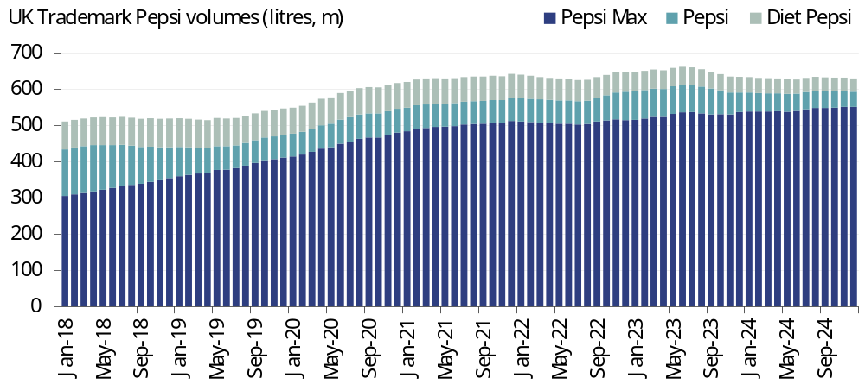
Source: Rothschild & Co Redburn, Circana

In 2025, we have seen a raft of new innovation launches by Carlsberg-Britvic in Great Britain to support the sparkling portfolio:
- Pepsi Zero Sugar Strawberries ‘N’ Cream Soda and Cream Soda launched in January 2025 (these were launched in the US first and have now been launched in the UK, but the products were not rebranded to the UK’s Pepsi ‘Max’);
- Tango Strawberry Smash launched in February 2025;
- Aqua Libre Watermelon & Strawberry launched in February 2025;
- Tango Cherry Blast and Raspberry Blast returned in April 2025 as limited edition releases;
- 7-UP Pink Lemonade launched in April 2025;
- London Essence Crisp Apple Crafted Soda launched in April 2025, mirroring Fever-Tree’s strategy to expand the mixer range into premium adult soft drinks;
- Purdey’s (Britvic’s ‘natural’ energy drink brand) underwent a brand refresh in September 2025, coupled with two new flavour launches: Berry & Dragon Fruit and Orange & Mango;
- Pepsi Zero Sugar went incredibly early and launched a Christmas-inspired Gingerbread flavour on 1 October 2025.
So far, we are encouraged by Carlsberg-Britvic’s innovation launches – this is healthy competition that should support growth for both the company and the overall sparkling category.
This is in contrast to last year, ahead of the acquisition, when we observed some deep promotions to drive volume growth. For example, in Iceland there was a longstanding mix-and-match promotion for 72x 330ml cans of Pepsi Max and/or Tango for £24 in the grocery channel, equivalent to just 10 pence per 100ml (Fig 39).
Fig 39: Britvic promotion in Iceland (October 2024)
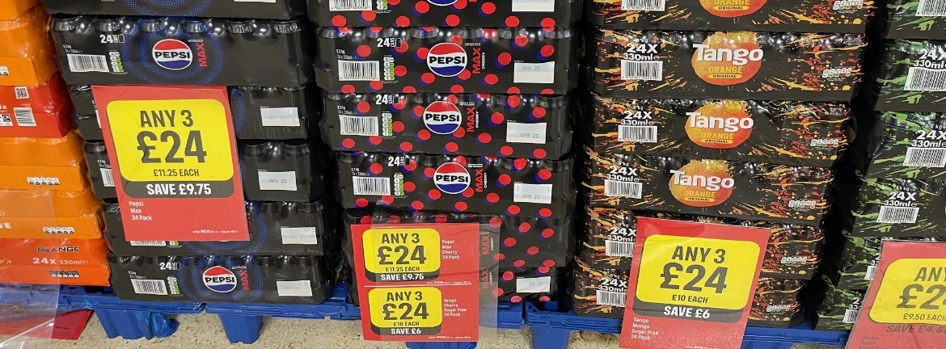
Source: Rothschild & Co Redburn

Also in Iceland, there was also a long-running ‘2 for £4.50’ offer on three-litre PET bottles of Pepsi Max (7.5p per 100ml) (Fig 40). The problem is that this then creates a tough comparative for the following year and we have observed even deeper discounting in Iceland in 2025 with a ‘Buy 2, Get 1 Free’ offer on three-litre PET bottles for £5.90 on Pepsi and Pepsi Max (6.6p per 100ml) (Fig 41). It is encouraging to see the new three-litre capacity at Rugby from the BCP is being utilised, but we struggle to imagine that these offers were helpful to Britvic’s gross margin.
Fig 40: Pepsi Max Iceland promotion (June 2024) |  | Fig 41: Pepsi Max Iceland promotion (July 2025)
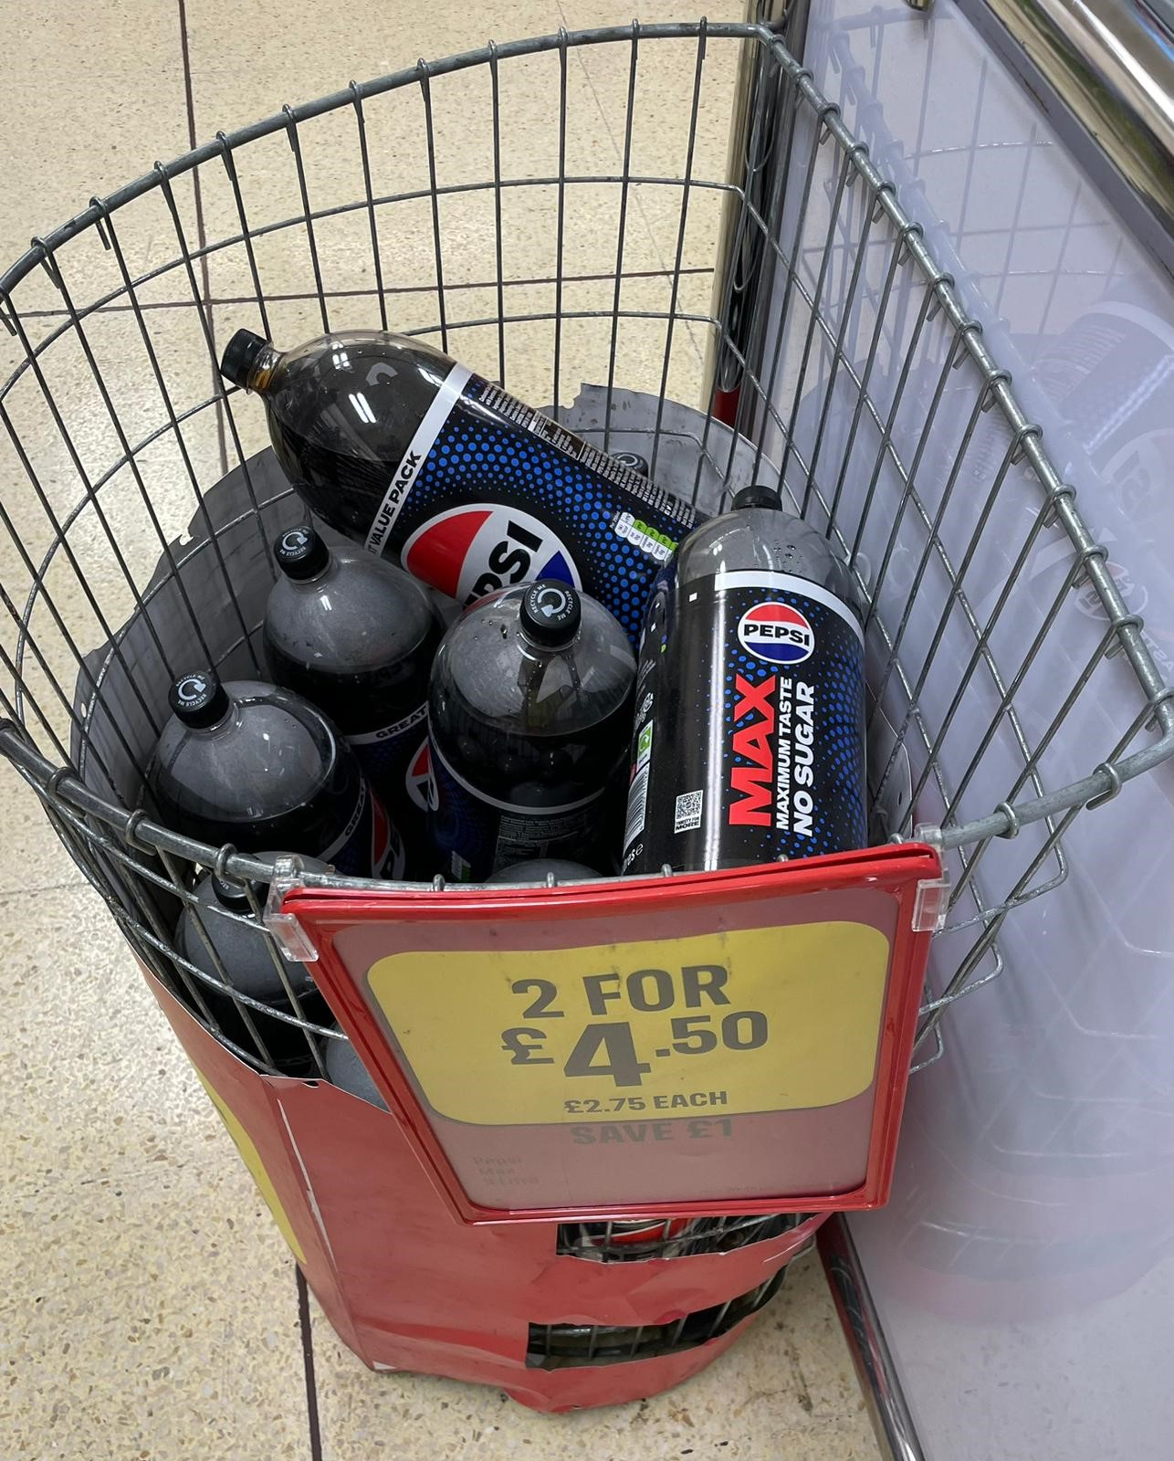 |  | 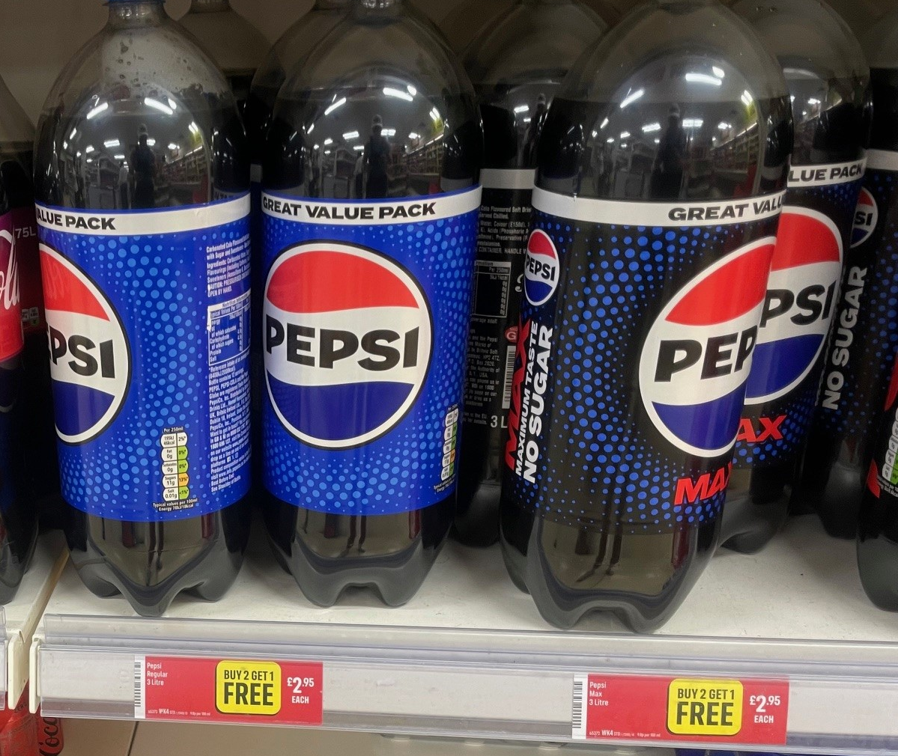
Source: Rothschild & Co Redburn |  | Source: Rothschild & Co Redburn
These offers signal a potential risk for CCGB: sparkling beverages are 83% of CCGB’s volumes and if the main competitor were to become more aggressive on pricing and/or promotions to drive less profitable volume growth, then this could impede CCGB’s top-line growth prospects.
It is worth noting that Carlsberg-Britvic tends to quote its market share in terms of volume, while CCEP focuses on value share, which could indicate where the former’s priorities lie.
However, we expect that Carlsberg-Britvic will remain a rational competitor as Carlsberg must rebuild its group return on invested capital (ROIC) post the Britvic acquisition, as well as de-lever the balance sheet. Cutting prices will not help in this regard and could merely shrink the size of the profit pool for the sparkling category, especially because, as discussed, there are viable trade down options in the discount channel.
Moreover, if Carlsberg-Britvic were to compete in irrational ways against CCGB, we suspect there could be an even higher likelihood that Carlsberg loses its Coca-Cola bottling licenses in Denmark and Finland, discussed shortly.

Washed up Rockstar
Elsewhere in Carlsberg-Britvic’s portfolio, Britvic historically struggled in one of the fastest growing sub-categories – energy drinks – which overindexes to the out-of-home channel (as shown earlier in Fig 18, c75% of energy drinks value is in the convenience channel). Rockstar has been a perennial underperformer in the UK energy drinks category, falling from a c7% value share in 2017 to just c1% at the end of 2024, despite numerous initiatives to improve the brand’s performance (Fig 42). Constant rebrands and refreshes failed to rejuvenate Rockstar and we doubt Carlsberg will be able to transform the brand’s fortunes.
Fig 42: The long, steady decline of Rockstar
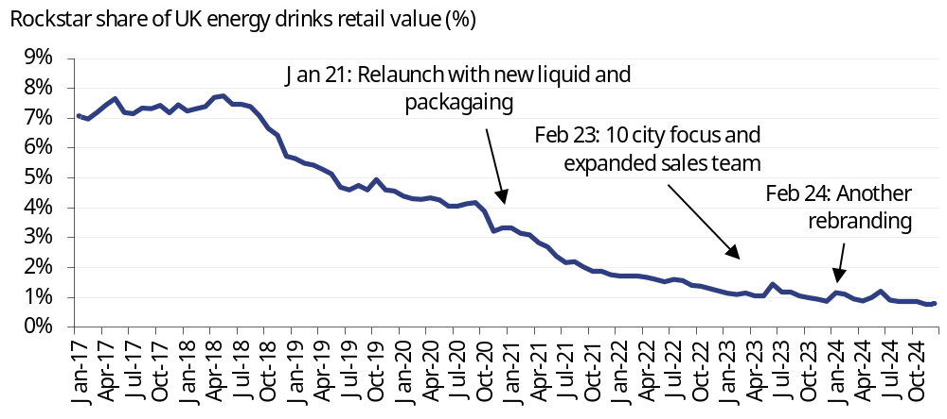
Source: Rothschild & Co Redburn, Circana

To make matters more complicated, in August 2025, Celsius (Not rated) acquired the Rockstar brand in North America, while PepsiCo retains the brand in international markets. Celsius will now be tasked with trying to grow Rockstar in North America, but in the UK Rockstar will still be managed by PepsiCo. Moreover, PepsiCo and Celsius strengthened their strategic partnership as part of this deal, but in the UK Celsius is distributed by Suntory and competes against Pepsi bottler Carlsberg-Britvic. This conflict may be resolved soon however, as we have observed Celsius products being heavily discounted in its sole UK retailer (Tesco) from £1.95 to just £1 per can, which implies that the Celius could be delisted shortly.
We suspect that Carlsberg-Britvic will focus on Purdey’s following the brand refresh, which is a different consumer proposition to Monster Energy. This, combined with the lack of focus on Rockstar, provides confidence that Monster Energy will continue to post strong growth (for context, Monster Energy retail sales grew 24% YoY in Great Britain in 3Q25 in Nielsen-tracked channels) and that it will continue to win market share (as shown in Fig 31).

Limited overlap
For CCGB’s remaining 7% of volumes (water, sports drinks, RTD tea and coffee etc) there is not much overlap with Carlsberg-Britvic’s portfolio. CCGB has an immaterial presence in the squash category via Rose’s, whereas Robinsons is a low-double-digit percentage of Carlsberg-Britvic’s Great Britain sales. The main target could be CCGB’s sports drink Powerade, but historically Britvic’s Gatorade never took off in Great Britain, partly due to the strong local competitor Lucozade (owned by Suntory) and partly due to operational issues: Gatorade lacks local production (it is shipped in from France) and PepsiCo historically placed lofty minimum margin requirements on the brand, which limited its distribution potential.

Wins and losses in the OOH channel
As discussed in ‘The Juggernaut’ (4 November 2022), PepsiCo always struggled in the out-of-home channel relative to TCCC and it acquired KFC, Pizza Hut and Taco Bell in the 1970s partly to secure end-customers for its products. PepsiCo spun off these operators in 1997 to form Tricon, now Yum! Brands (Buy rated).
However, the US challenges never held back Britvic, which developed a competent in-house dispense solutions business in the 2000s, strengthened by the 2020 acquisition of The Boiling Tap Company. A classic example was the Britvic-patented Pepsi Xtra Cold dispenser, launched in the late-2000s across Mitchells & Butlers’ 2,000 outlets (Fig 43). This dispenser never took off, partly because it launched in the midst of the GFC, but in October 2025 Carlsberg-Britvic is back with a new ‘Halo’ dispenser that it hopes can turn the tide against Coca-Cola in post-mix (Fig 44).
This new dispenser could be necessary as although the combination of Carlsberg and Britvic adds scale that is useful for customer negotiations in the grocery channel, it can create friction in the more profitable out-of-home channel.
For example, Heineken (Buy rated) owns c2,400 pubs around the UK through Star Pubs: would it be happy to list Pepsi products, thereby helping one of its beer competitors, Carlsberg? Before the acquisition this would not have been an issue for Britvic, yet we have already seen an example of this potential issue in action. Britvic lost the Pepsi distribution agreement with Fuller, Smith & Turner (c400 pubs) to CCGB in 2025. Meanwhile, Carlsberg-Britvic won a distribution agreement with St Austell (c160 pubs) from CCGB, but clearly this will not fully offset the lost Fuller, Smith & Turner outlets.
Net-net, this is a win for Coca-Cola and a loss for Pepsi, that perhaps would not have happened previously. CCGB could win further outlets in the licensed channel following Carlsberg’s acquisition of Britvic and/or it could make it easier for CCGB to renew existing agreements (for example, CCGB’s agreement with Stonegate was recently renewed). However, we doubt that long-standing Pepsi vendor JD Wetherspoon would ever switch to Coca-Cola, which provides some certainty to Carlsberg-Britvic’s soft drinks sales in the licensed channel.
Fig 43: The blue font 1.0 |  | Fig 44: The blue font 2.0
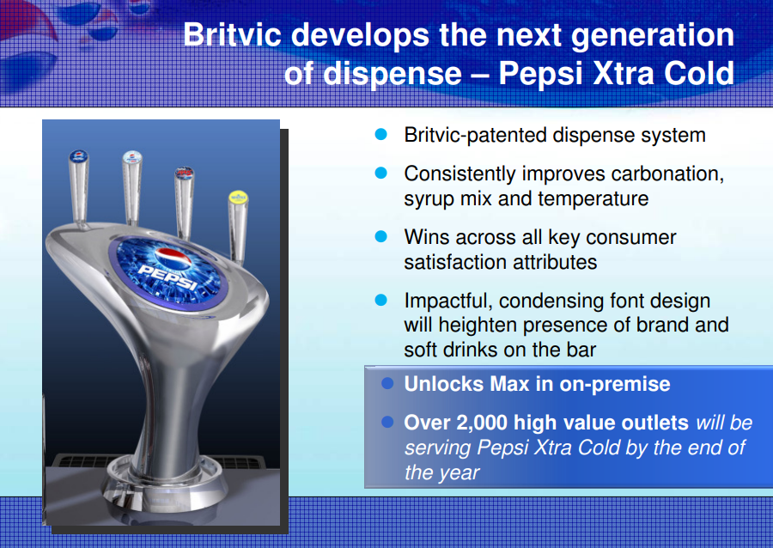 |  | 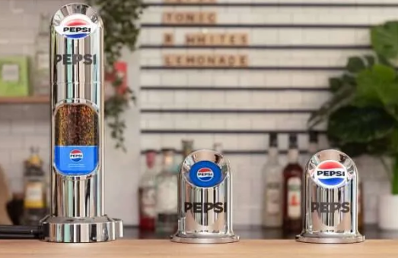
Source: Britvic |  | Source: barmagazine.co.uk
In conclusion, we do not expect that Britvic’s acquisition by Carlsberg will impede CCGB’s long-term growth trajectory. If anything, it could present an opportunity for CCGB to win further share in the out-of-home channel, which coupled with the aforementioned volume recovery story could lead to multiple years of strong price/mix growth in Great Britain.

The next territories?
Lastly, there is an open question around whether Carlsberg can both expand its strategic partnership with PepsiCo (alongside taking over UK Pepsi bottling, it will also take on Pepsi bottling in Kazakhstan and Kyrgyzstan) while continuing to bottle Coca-Cola in Denmark and Finland. Our understanding is that the Coca-Cola bottling licenses in Denmark and Finland are up for renewal in 2026.
As discussed in ‘Super System’ (8 September 2023), in the modern era there are few examples of TCCC not renewing a bottler’s contract for reasons other than broader System refranchising initiatives. The key exceptions were when bottlers competed against TCCC with their own products, such as Castel with World Cola in its African markets, which was significantly cheaper than the Coca-Cola Classic that it was also bottling. Castel’s Coca-Cola bottling agreement ended in 2022.
The problem for TCCC is that Carlsberg is a good partner in Denmark: it has the best distribution network, enormous local influence and longstanding relationships with the key customers.
Carlsberg took on Coca-Cola bottling in Denmark in 2002 after a deal to restructure the former 51:49 joint venture that it had with TCCC in the Nordics. From 2002-19 we estimate the Carlsberg’s Danish soft drinks volumes (which are predominantly comprised of TCCC’s brands) rose at a 4-5% CAGR (Fig 45). However, it is difficult to know whether this is a ‘clean’ growth rate as there was a thriving cross-border business between Denmark and northern Germany that encroached on CCEP’s sales growth. In 2020, TCCC stepped in and asked Carlsberg to cease this cross-border trade – a sign of TCCC’s strong alignment with CCEP, but for Carlsberg it meant that its Danish soft drinks volumes are still c15-20% lower than in 2019.
Fig 45: From Green to Red
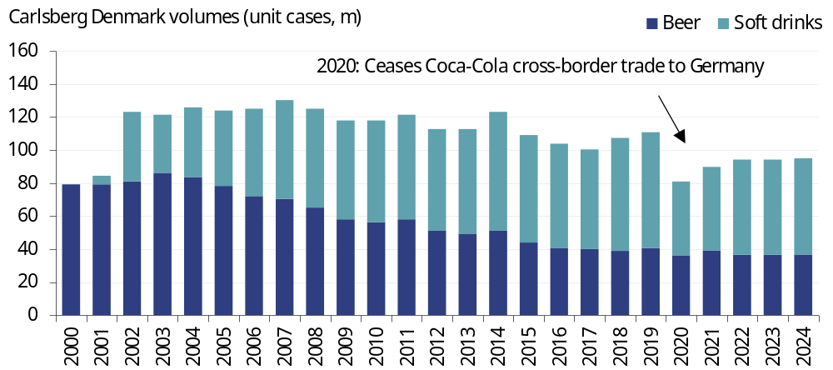
Source: Rothschild & Co Redburn, company

In our view, if Carlsberg continues to expand into new Pepsi bottling territories, then it will eventually lose the Coca-Cola bottling licenses in Denmark and Finland.
Combined, we estimate that Coca-Cola bottling in Denmark and Finland was worth c80-90 million unit cases in 2024, which if it were to move to CCEP would add c3%/c2% to CCEP’s European/group volumes. In other words, it would be useful, but it is not particularly material.
For Carlsberg, losing Coca-Cola bottling in Denmark would cause significant disruption. As shown in Fig 45, in volume terms, Carlsberg sells more soft drinks than it does beer in its home country. Losing this quantity of volume would dent margins unless there were significant restructuring, and it is unlikely that Carlsberg could find a replacement as Pepsi bottling is already performed by Royal Unibrew (Not rated) in Denmark.

Sugar taxes, Extended Producer Responsibility and Deposit Return Schemes
The final topic to discuss in Great Britain is the increasingly burdensome regulatory environment for soft drinks companies, which could constrict the long-term margin expansion story for CCGB. Positively, however, it could also cement the market positions of the incumbents.
The three areas we follow closely are changes to the UK soft drinks industry levy (SDIL), the proposed Deposit Return Scheme due to start on 1 October 2027, and the changes being made to Extended Producer Responsibility (EPR).

Not so sweet
On 30 October 2024, the UK government announced that the SDIL rates will be increased annually (from 1 April 2025) across five years (from 2025 to 2030) to spread the burden of a 27% cumulative increase. This is to catchup on years of inflation since the levy was introduced in April 2018 – the levy was previously a fixed rate depending on the sugar content of the beverage and as a result, when soft drinks prices rose from 2022 as manufacturers passed on severe cost inflation, the levy fell as a proportion of the retail price of the soft drink. Beyond 2030, the SDIL rates will increase every year in line with the Consumer Price Index (CPI).
We assume that CCGB will fully pass on the levy increase each year, meaning that price/mix will receive a boost in 2025-30 (and beyond, albeit at a lower amount). There will also be gradual ongoing margin pressure as the levy raises CCGB’s revenue, but it does not impact the gross profit (as it is passed on to the UK government).
As it stands the levy would not affect the majority of CCGB’s portfolio – in 2024, 68% of volumes were from low- or no-calorie products (Fig 46). But the UK government is proposing to lower the threshold at which the levy applies from 5g of sugar per 100ml to 4g of sugar per 100ml.
Clearly this would be more beneficial to government coffers than it would be to public health. This proposed SDIL change could lead to more reformulations for CCGB, for example, Fanta in the UK has 4.5g of sugar per 100ml and Oasis has 4.0g of sugar per 100ml, below the current threshold but above the proposed future threshold. However, it is not clear that further reformulations would be a permanent solution as the government could decide to lower the threshold again in future. It is worth noting that regular Pepsi has 4.5g of sugar per 100ml in the UK and it could require a further reformulation, although as shown earlier in Fig 38 Carlsberg-Britvic is focused on sugar-free Pepsi Max.
The main issue that we see for CCGB is that if the UK government is looking for additional tax revenue then soft drinks (an sin taxes in general) is an easy target and we could see further changes, such as a tax on non-nutritive sweeteners, or energy drinks. As discussed in our recent report ‘Resilience in Taxing Times’ (28 October 2025) this is a theme across the global soft drinks landscape and, positively, CCEP already has plenty of experience successfully navigating sugar taxes and it operates in territories with higher-income consumers that are better able to weather the tax-induced price rise.

Disaster Rocks Soft drinks
To put it nicely, the UK’s Deposit Return Scheme (DRS) has so far been chaotic. The UK government initially proposed a DRS back in 2018. But there was not a joined-up approach between England, Scotland, Wales and Northern Ireland, and each had their own timelines, policy design and legal frameworks. This would have created a nightmare for the soft drinks manufacturers.
For example, the Scotland DRS was initially due to launch in September 2022; nearly a year before the England DRS was supposed to begin in August 2023. The large manufacturers like CCGB, Britvic and AG Barr all operate supply chains that span across England and Scotland and would have had to design Scotland-specific packaging for a lone year. Meanwhile, Scottish consumers could travel across the border to England, buy cheaper bottles of their favourite soft drink, and then return them to reverse vending machines in Scotland to receive a deposit rebate.
There was also uncertainty around the mechanics of the DRS scheme, with the UK government initially proposing to charge VAT on unredeemed deposits. In the grand scheme this would have raised an immaterial amount of tax revenue, but it would have imposed a higher fee for consumers and created an accounting and packaging-tracking nightmare for the soft drinks manufacturers.
As it stands, a UK-wide DRS is due to be implemented on 1 October 2027. The deposit amount has not been confirmed yet by the scheme administrator – the Deposit Management Organisation (DMO) – but we expect it will be around 20p per single-use container, in line with other European countries that operate DRSs. Glass bottles are currently excluded from the UK DRS, but PET, aluminium and steel containers are all covered. The UK DRS covers any single-use vessel between 150ml to 3-litres, regardless of whether they are sold individually or as part of a multipack.
The soft drinks manufacturers will also be required to pay an ongoing producer fee, which once again has yet to be confirmed by the DMO. This fee will help to fund the rollout of reverse-vending machine infrastructure, as well as the ongoing costs to run the DRS. Analysis from DEFRA suggests the producer fee could amount to 4p per container in year one, falling to 3p per unit thereafter once the initial investment for the required infrastructure is completed. Note, this fee does not raise the price of the beverage (unless the soft drinks manufacturers decide to pass it on to consumers) and instead it increases the manufacturer’s COGS.

What does the DRS mean for CCGB?
Using the company’s disclosure, our interpretation is that the DRS covers c85% of CCGB’s volumes (Fig 47). It is worth noting that Great Britain is an outlier in CCEP’s markets in terms of the proportion of volumes sold in aluminium cans.
The majority of these cans are in multipacks and the UK DRS looks as if it will cover each individual can within a multipack: the draft wording states it will cover “single-use drinks containers”. The issue is that an 8x 330ml can format effectively contains eight single-use containers, even though it is a multi-serve format.
Fig 46: Shifting away from sugar |  | Fig 47: Brits love cans
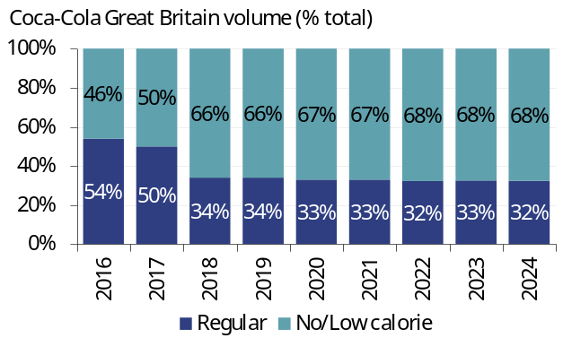 |  | 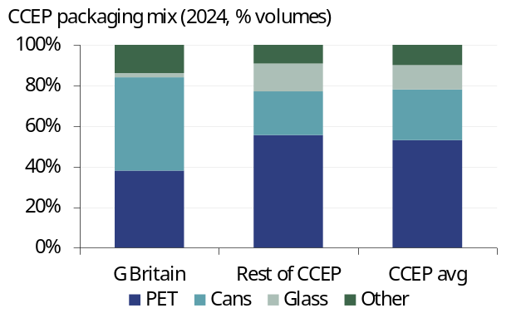
Source: Rothschild & Co Redburn, company |  | Source: Rothschild & Co Redburn, company

This could have implications for CCGB’s price/pack architecture. To illustrate, we show how a 20p deposit per single-use container would impact the price of a range of Coca-Cola Classic formats (Fig 48).
If the 20p deposit applies to every can in an 8x330ml multipack, the retail price would rise by 29% from £5.59 to £7.19. Meanwhile, the retail price for a two-litre PET bottle would only rise by 9%, a 1.25-litre PET bottle by 10%, and a 500ml PET bottle by 11%. A rational consumer would therefore stop buying the multipack of cans and instead buy a two-litre PET bottle and a 1.25-litre PET bottle for a combined price of £4.55; 17% cheaper than the multipack of cans and with 23% more volume.
We await further details from the DMO, but if the deposit does apply to every can in a multipack then CCGB may need to reevaluate its price/pack architecture before the DRS is implemented, and possibly its supply chain too – if consumers permanently switch from multipacks of cans to PET bottles, are more PET production lines required while canning lines need to be decommissioned? This could also create issues for Carlsberg-Britvic as part of the investment in the BCP was to expand the canning capacity at the Rugby site to be able to compete more aggressively with Pepsi Max in multipack cans.
Fig 48: Impact of a 20p deposit on various packaging formats
Brand | Format | ml | Retail price (£) | Deposit (£) | Post deposit (£) | Uplift (%) | p per 100ml
Coca-Cola Classic | 8x 330ml can | 2,640 | 5.59 | 1.60 | 7.19 | 29% | 27
Coca-Cola Classic | 1x 2-litre PET | 2,000 | 2.15 | 0.20 | 2.35 | 9% | 12
Coca-Cola Classic | 1x 1.25-litre PET | 1,250 | 2.00 | 0.20 | 2.20 | 10% | 18
Coca-Cola Classic | 1x 500ml PET | 500 | 1.90 | 0.20 | 2.10 | 11% | 42

Note: our example only includes the deposit fee but not the possibility that the producer fee is also passed on
Source: Rothschild & Co Redburn, Tesco

More broadly, there is a risk that volumes across the soft drinks industry could fall following the retail price increases caused by the DRS. However, given the DRS will result in an industry-wide, one-off price increase, which also impacts other beverage categories like beer and spirits, we would expect the volume hit to be modest.
Indeed, a review performed by Reloop and the Container Recycling Institute, which examined the impact of DRS implementation in numerous regions (Scandinavia, the Baltics, Germany, Australia etc), concluded that “None of the case studies provide definitive evidence suggesting that the introduction or expansion of a DRS caused a decline in beverage sales”.
For now, we await more information from the DMO regarding the specifics of the deposit amount and producer fee before updating of CCGB forecasts.

Neverending regulation
Finally, there is Extended Producer Responsibility (EPR). This has increased the reporting burden (and costs) for soft drinks manufacturers as they are required to register and report packaging tonnage data twice a year to the government’s online Report Packaging Data (RPD) portal. From January 2025, large manufacturers like CCGB were then charged a base fee for each tonne of packaging placed into the market, based on the material used, with the first invoice in October 2025 (Fig 49).
Fig 49: UK EPR fees (2025)
Material | EPR fee (per tonne) | EPR fee (per kg)
Paper/board | £196 | £0.20
Plastic | £423 | £0.42
Glass | £192 | £0.19
Aluminium | £266 | £0.27
Steel | £259 | £0.26
Wood | £280 | £0.28
Fibre-based composite | £461 | £0.46
Other materials | £259 | £0.26

Source: UK Department for Environment

Note that the EPR fees for glass and aluminium have decreased from the draft rates that we discussed for Fever-Tree in ‘Post FY24 results: RTDs and EPR’ (1 April 2025), which were far more punitive (the draft rates from UK Department for Environment were originally £240 per tonne for glass and £435 per tonne for aluminium). The initial design was a bit odd given the purpose of EPR is to promote a circular economy, but as EPR is based on weight and glass is naturally heavy it was punished, even though glass can theoretically be recycled an infinite number of times and has a high collection rate, whereas PET bottles cannot and have a lower collection rate.
CCEP does not provide enough data to calculate the impact of EPR, but we expect that it will have a modest impact in Great Britain as glass is only c2% of volumes.
For reference, Fever-Tree estimates that EPR will add c£1.5m of costs (worth c1.4% of total UK sales) to its UK off-trade business and if EPR extends to the on-trade (which is an open debate with the UK government) this would add a further c£3m of costs (c2.7% of UK sales, bringing the total potential EPR costs to c4.1% of Fever-Tree’s UK sales). Fever-Tree is much more skewed towards glass than CCGB is, so we would expect that the EPR cost for CCGB will be lower as a percentage of sales.
From October 2026, EPR could become even more complicated with fee modulation under a new traffic-light grading system called Recyclability Assessment Methodology (RAM). Soft drinks manufacturers must then not only report the weight and material, but also the recyclability class (via RAM) and “nation data” i.e. in which UK nation was the packaging supplied in, and in which nation was the packaging discarded in.
We have no idea how this disposal data will be accurately collected in practice, but regardless, this will further increase the reporting burden for CCGB. It may also lead to packaging alterations to, for example, shift a pack from “amber” to “green” under the RAM system.
In conclusion, the regulatory burden of operating in the UK soft drinks market is set to increase dramatically. We expect the large incumbents like CCGB and Carlsberg-Britvic will be able to navigate these challenges and, perhaps positively, the rising regulatory burden could cement the position of the incumbents.
It will also be interesting to see how the grocers navigate these challenges with their private label offerings – the per unit ‘regulation cost’ will rise, knocking the already low profitability of their private label soft drinks. This means that the grocers could prune their low velocity private label SKUS, which could benefit the branded soft drinks manufacturers by freeing up shelf space.

Updated estimates
In the 38 years since 1987, organic sales growth has turned negative only nine times for CCGB (Fig 50). Six of these occasions were during CCE’s tenure, while under CCEP’s tenure it has dipped negative twice; in 2016 when three bottlers were being integrated and during the 2020 pandemic.
CCGB’s organic sales growth improved to 5.8% pa, on average, under CCEP’s tenure so far, and we forecast a sustained improvement from the days of CCE to 3.8% growth pa i.e. broadly in line with the group’s medium-term ambition for c4%+ organic sales growth pa and ahead of the guidance for +2-3% pa in Europe.
Fig 50: Rejuvenating Great Britain’s performance
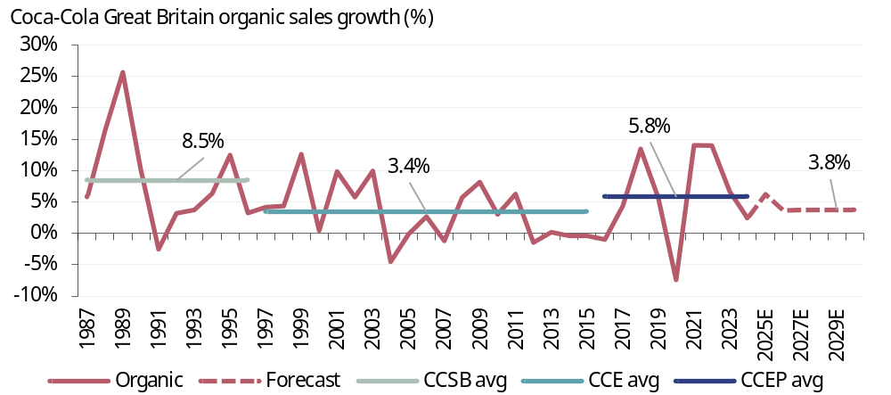
Source: Rothschild & Co Redburn, company

From a profitability perspective, in 2024 we estimate that CCGB earned a c17% operating margin, well ahead of CCEP’s group average (12.9%) and the average 12% operating margin earned on average across other European Coca-Cola bottling territories (Fig 51).
The Wakefield site visit highlighted areas for further, minor operating efficiency improvements to boost profitability, but we continue to forecast more modest operating margin in Great Britain relative to the rest of CCEP’s European territories, especially given the upcoming DRS in 2027. The site visit also highlighted areas for positive category and packaging mix to boost CCGB’s margin, and as discussed in this report, there is a material opportunity for revenue per case and margin expansion if volumes were to recover in the licensed channel.
In conclusion the site visit provided confidence that CCGB still has plenty of top- and bottom-line growth opportunities ahead. Given Great Britain is, on our estimates, CCEP’s largest contributor to operating income at 22%, this also provides greater confidence that CCEP can at least achieve its medium-term ambitions.
Fig 51: The European peers
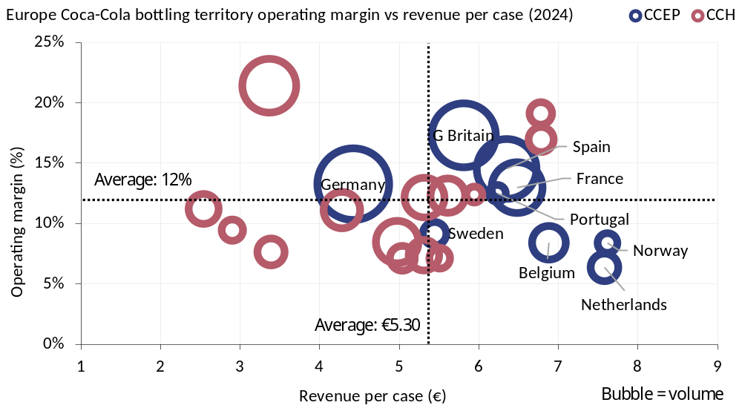
Note: CCH European territories only. Excludes CCEP’s Iceland territory, which is off the chart to the right due to its highly revenue per case accretive local beer (Viking).
Source: Rothschild & Co Redburn, company

No change to our long-term forecasts
We continue to forecast c4% organic sales growth pa for CCEP. By region, Europe is c70% of total sales and we forecast just over c3% organic sales growth pa, with the remaining c30% of sales from APS (Australia, Pacific & South East Asia) where we forecast c5.5% pa (Fig 52). As discussed in ‘From Manila to Jakarta’ (8 July 2025), Indonesia has the greatest scope for upside following the changes that CCEP has made to its local route-to-market (which should be broadly finished by the end of 2025), but for now we forecast c2.5% organic sales growth for the country in 2026, followed by an improvement to c5% pa from 2027.
From 2023-28, CCEP has a €350-400m cost savings programme that supports c2.5-3.0% of operating income growth pa at the group level. We forecast c7% organic income growth pa over this period, in line with the company’s medium-term ambition, which is powered by c6% pa in Europe from areas such as network optimisation, the expansion of the Bulgaria shared services centre and the company’s ongoing SAP integration, and faster c9% pa in APS from rebuilding the operating margin in Australia and the Philippines (Fig 53).
Fig 52: Acquisitions have been accretive to growth |  | Fig 53: Steady, rising operating income
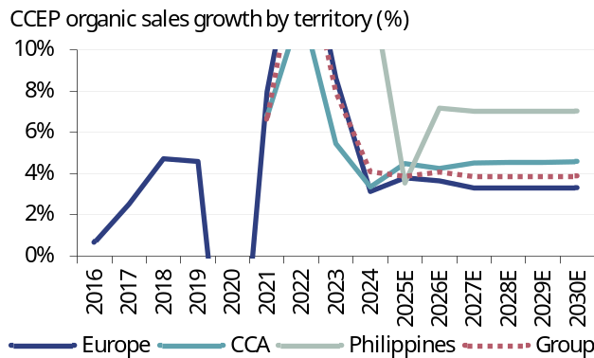 |  | 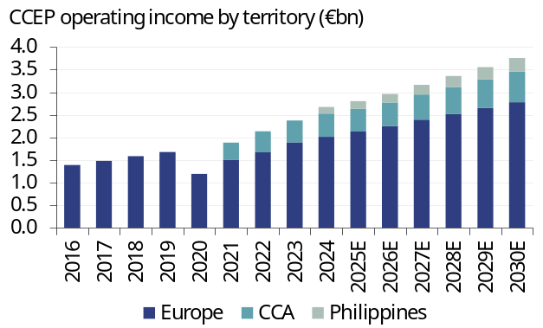
Source: Rothschild & Co Redburn, company |  | Source: Rothschild & Co Redburn, company

Steady operating income growth pa is paired with a deleveraging balance sheet, which on our estimates reaches c2.7x net debt/EBITDA at the end of 2025 (Fig 54). This is towards the mid-point of the company’s 2.5-3.0x leverage target range and despite a c€1bn share buyback programme during 2025, as well as elevated capital expenditure to support cooler placements in the AFH channel and a greenfield production plant in the Philippines.
We model c€1.5bn of share repurchases in 2026 (worth c200bp to EPS growth) and c€2bn pa thereafter (worth c300bp pa to EPS growth) to maintain CCEP’s leverage at 2.75x net debt/EBITDA i.e. the mid-point of the target range (Fig 55). If a Coca-Cola territory were available for purchase and it is a good strategic fit for CCEP, then this would take priority over share buybacks. As discussed in this report, Denmark and Finland could be potential options in Europe and as discussed in ‘Pearl of the Orient’ (11 March 2024), Malaysia and Singapore could one day be potential options in the APS region when TCCC decides to refranchise them from its BIG division.
Fig 54: Back in the target range |  | Fig 55: Scope for ongoing €2bn pa buybacks
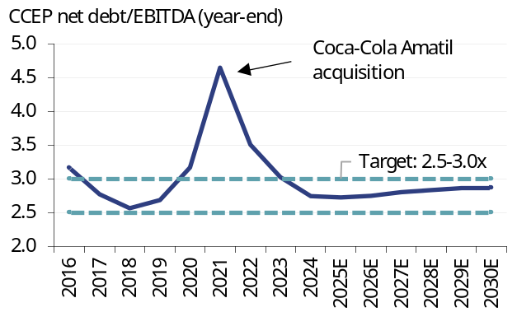 |  | 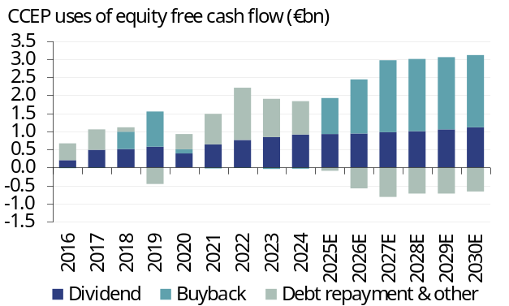
Source: Rothschild & Co Redburn, company |  | Source: Rothschild & Co Redburn, company

Changes to forecasts
Our CCEP forecasts are broadly unchanged following the site visit (Fig 56).
Fig 56: Rothschild & Co Redburn CCEP estimates changes
 | ------------ 2025E ------------ |  |  |  | ------------ 2026E ------------ |  |  |  | ------------ 2027E ------------
Y/E December (€m) | Old | New | Diff |  | Old | New | Diff |  | Old | New | Diff
Net sales | 20,891 | 20,910 | 0.1% |  | 21,317 | 21,307 | -0.1% |  | 22,083 | 22,093 | 0.0%
Organic sales growth (%) | 3.9% | 3.9% | 0bps |  | 4.0% | 4.1% | 3bps |  | 3.8% | 3.8% | 10bps
Operating income | 2,800 | 2,803 | 0.1% |  | 2,968 | 2,962 | -0.2% |  | 3,167 | 3,164 | -0.1%
Operating margin (%) | 13.4% | 13.4% | 1bps |  | 13.9% | 13.9% | -2bps |  | 14.3% | 14.3% | -2bps
Adjusted, diluted EPS (€) | 4.12 | 4.12 | 0.1% |  | 4.50 | 4.49 | -0.2% |  | 4.94 | 4.94 | -0.1%

Source: Rothschild & Co Redburn, company
A summary of our estimates versus consensus are shown below (Fig 57). We remain ahead on organic sales growth because we strip out the Beam Suntory spirits discontinuation in Australia from July 2025 and in New Zealand from January 2026.
If we were to include this, then our 2025 organic sales growth forecast would drop 100bp to 2.9% and our 2026 organic sales growth forecast would drop 70bp to 3.4%. We are modestly ahead on operating margin from 2026, helped by a gross margin recovery as European sugar cost pressures ease and hedges rollover.
Fig 57: Rothschild & Co Redburn CCEP estimates vs consensus
 | ------------ 2025E ------------ |  |  |  | ------------ 2026E ------------ |  |  |  | ------------ 2027E ------------
Y/E December (€m) | RDBN | Cons | Diff |  | RDBN | Cons | Diff |  | RDBN | Cons | Diff
Net sales | 20,910 | 20,951 | -0.2% |  | 21,307 | 21,481 | -0.8% |  | 22,093 | 22,282 | -0.8%
Organic sales growth (%) | 3.9% | 3.0% | 85bps |  | 4.1% | 3.3% | 78bps |  | 3.8% | 3.9% | -5bps
Operating income | 2,803 | 2,807 | -0.1% |  | 2,962 | 2,972 | -0.3% |  | 3,164 | 3,175 | -0.3%
Operating margin (%) | 13.4% | 13.4% | 1bps |  | 13.9% | 13.8% | 7bps |  | 14.3% | 14.3% | 7bps
Adjusted, diluted EPS (€) | 4.12 | 4.09 | 0.7% |  | 4.49 | 4.45 | 0.8% |  | 4.94 | 4.87 | 1.5%

Source: Rothschild & Co Redburn, company, Visible Alpha

Valuation
On FactSet consensus estimates CCEP trades on 17.6x one-year forward P/E, an 8% premium to the historical average of 16.3x, but a 5% discount to the company’s pre-pandemic rating of 18.5x (Fig 58). This is an attractive entry point given CCEP offers faster top- and bottom-line growth today compared to pre-pandemic (c4% “and more” organic sales growth pa today versus c3% pa pre-pandemic, and c7% organic profit growth pa versus c5% pa pre-pandemic) along with high free cash flows (at least €1.7bn pa today versus at least €1.25bn pa pre-pandemic).
On our above-consensus estimates, CCEP trades on 17.3x one-year forward P/E and offers a 10% EPS CAGR over the next three years, with a c3% dividend yield.
Historically, the Coca-Cola bottlers traded at a 10-20% discount to the consumer staples sector on one-year forward P/E, largely due to the perceived risk that TCCC could one day decide not to renew their bottling agreements, and due to the bottlers’ lower return on invested capital (ROIC) versus peers. As discussed in ‘Super System’ (8 September 2023), in reality the risk that TCCC would not renew the bottling agreement for CCEP – its largest bottler globally by sales and the largest contributor to TCCC’s operating income – is in our view remote. Likewise, CCEP’s 10.8% ROIC in 2024 is hampered relative to consumer staples peers by the accounting treatment of its franchise intangible assets.
Today, CCEP trades at a 9% premium to the sector on one-year forward P/E (Fig 59). We argue this premium is justified by CCEP’s faster EPS growth and relatively more favourable risk/reward profile versus the broader sector: it is not exposed to the potential headwinds facing the US consumer staples stocks, such as the near-term operational risks from tariffs and the longer-term threat of GLP-1 agonists on terminal growth rates. Moreover, in the near term CCEP has gross margin support in 2026 from easing European sugar and PET costs that we argue is not adequately reflected in consensus estimates, as well as longer-term margin upside if the AFH channel recovers to pre-pandemic levels.
Fig 58: Discount to the pre-pandemic multiple |  | Fig 59: Trading at a justified premium
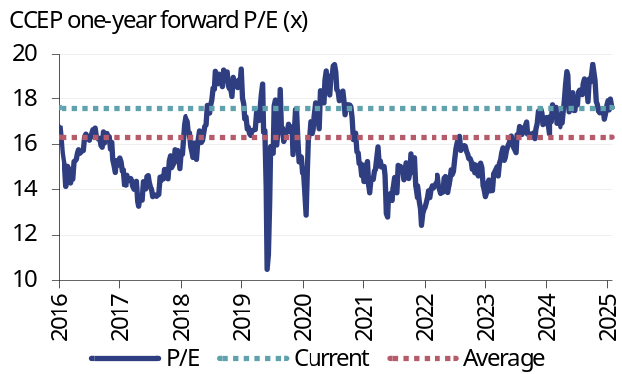 |  | 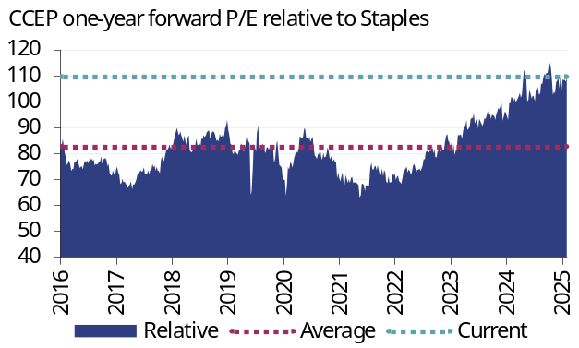
Source: Rothschild & Co Redburn, FactSet |  | Source: Rothschild & Co Redburn, FactSet
Our 12-month price target is unchanged at $102 per share, which is based on a ten-year DCF model that assumes a 7.7% WACC, 4% post-currency sales growth, a 16.1% operating margin in year ten and a ROIC of c16.5%, with long-term growth of 2.8% pa. This equates to 20.4x forward P/E and, with a c3% dividend yield, offers a potential total shareholder return of 17%. We maintain our Buy rating.
Downside risks to our forecasts include the implementation of additional government levies, a weaker-than-expected consumer environment, lower-for-longer volumes in Indonesia and integration issues that could arise from the ERP system consolidation. Upside risks to our forecasts include stronger profit growth following greater-than-expected cost savings realisation, faster-than-expected volume growth in the European AFH channel in 2026 and faster-than-expected volume growth in the Philippines.

Fig 60: Beverages valuation
 | RDBN | Price | -------- P/E (x) ------- |  |  | --- Dividend yield --- |  |  | - Equity FCF yield - |  |  | ---- EV/EBIT (x) ----
Company | rating | (lc) | 2025E | 2026E | 2027E | 2025E | 2026E | 2027E | 2025E | 2026E | 2027E | 2025E | 2026E | 2027E
ABInBev | Buy | €52.6 | 16.4 | 14.6 | 12.9 | 1.8% | 2.1% | 2.3% | 8.0% | 9.7% | 10.6% | 11.7 | 10.6 | 9.4
Boston Beer | Sell | $193.0 | 19.4 | 16.5 | 14.3 | 0.0% | 0.0% | 0.0% | 4.9% | 6.6% | 7.5% | 13.2 | 11.4 | 10.0
Carlsberg | Buy | DKr764 | 13.2 | 12.5 | 11.3 | 3.5% | 3.6% | 3.6% | 5.1% | 6.1% | 6.8% | 13.2 | 12.4 | 11.2
Constellation Brands | Buy | $129.3 | 8.6 | 7.7 | 6.9 | 3.5% | 3.9% | 4.3% | 8.5% | 10.7% | 13.1% | 9.2 | 8.2 | 7.3
Heineken | Buy | €68.3 | 14.7 | 13.5 | 12.3 | 2.7% | 3.0% | 3.3% | 6.2% | 7.5% | 8.6% | 12.4 | 11.5 | 10.5
Molson Coors | Neutral | $45.3 | 6.8 | 6.6 | 6.4 | 4.1% | 4.3% | 4.5% | 14.3% | 14.6% | 14.8% | 6.8 | 6.4 | 6.1
Brewers |  |  | 13.2 | 11.9 | 10.7 | 2.6% | 2.8% | 3.0% | 7.8% | 9.2% | 10.2% | 11.1 | 10.1 | 9.1
Brown-Forman | Neutral | $27.3 | 15.4 | 14.5 | 13.4 | 3.4% | 3.5% | 3.8% | 5.7% | 5.7% | 6.1% | 12.8 | 12.0 | 11.3
Campari | Sell | €5.35 | 19.4 | 17.2 | 14.9 | 1.1% | 1.2% | 1.3% | 3.2% | 5.9% | 5.9% | 15.4 | 13.9 | 12.1
Diageo | Neutral | 1,686p | 13.8 | 13.1 | 12.2 | 4.7% | 4.8% | 5.1% | 5.8% | 6.5% | 7.1% | 12.8 | 12.3 | 11.4
Pernod Ricard | Neutral | €78.5 | 12.8 | 13.0 | 12.1 | 5.6% | 5.2% | 5.2% | 5.4% | 6.8% | 6.9% | 12.3 | 12.5 | 11.8
Rémy Cointreau | Sell | €39.9 | 17.9 | 16.8 | 15.1 | 2.8% | 3.0% | 3.3% | 3.7% | 3.9% | 4.6% | 12.8 | 12.1 | 11.1
Distillers |  |  | 15.9 | 14.9 | 13.6 | 3.5% | 3.5% | 3.7% | 4.7% | 5.7% | 6.1% | 13.2 | 12.6 | 11.6
AG Barr | Buy | 642p | 14.2 | 12.7 | 12.4 | 2.9% | 3.2% | 3.4% | 5.2% | 6.2% | 6.8% | 10.3 | 8.7 | 8.2
Coca-Cola EP | Buy | £68.0 | 19.4 | 17.6 | 15.8 | 2.7% | 2.9% | 3.1% | 5.2% | 5.5% | 6.7% | 16.5 | 15.2 | 13.7
Coca-Cola HBC | Not rated | - | - | - | - | - | - | - | - | - | - | - | - | -
Fever-Tree | Sell | 773p | 33.8 | 31.5 | 27.0 | 2.3% | 2.5% | 2.8% | 4.4% | 4.1% | 4.6% | 24.2 | 22.5 | 18.8
Monster Beverages | Neutral | $63.0 | 32.6 | 29.5 | 27.1 | 0.0% | 0.0% | 0.0% | 3.0% | 3.2% | 3.5% | 24.5 | 22.4 | 20.4
PepsiCo | Sell | $147.1 | 19.3 | 18.0 | 16.9 | 3.7% | 3.7% | 3.9% | 4.1% | 4.6% | 5.3% | 16.5 | 15.5 | 14.7
The Coca-Cola Co. | Buy | $71.1 | 23.7 | 22.2 | 20.8 | 2.9% | 3.0% | 3.2% | 0.9% | 3.6% | 4.2% | 18.7 | 17.4 | 16.2
Soft drinks |  |  | 22.7 | 20.8 | 19.1 | 2.5% | 2.6% | 2.8% | 4.1% | 4.8% | 5.4% | 17.6 | 16.1 | 14.6
Beverages average |  |  | 17.6 | 16.2 | 14.7 | 2.8% | 2.9% | 3.1% | 5.5% | 6.5% | 7.2% | 14.2 | 13.1 | 11.9
Consumer average |  |  | 18.9 | 16.8 | 14.9 | 2.9% | 3.0% | 3.3% | 4.9% | 5.7% | 6.6% | 15.4 | 13.5 | 11.8

Source: Rothschild & Co Redburn, FactSet

Fig 61: Coca-Cola Europacific Partners financial summary and valuation
Y/E December (€m) | 2020 | 2021 | 2022 | 2023 | 2024 | 2025E | 2026E | 2027E | 2028E | 2029E
Income statement (pre-exceptional)
Net sales | 13,535 | 14,819 | 17,320 | 18,302 | 20,706 | 20,910 | 21,307 | 22,093 | 22,913 | 23,765
Operating profit | 1,492 | 1,886 | 2,138 | 2,373 | 2,663 | 2,803 | 2,962 | 3,164 | 3,357 | 3,553
Profit before tax | 1,330 | 1,736 | 2,009 | 2,239 | 2,467 | 2,588 | 2,724 | 2,848 | 2,953 | 3,124
Net income | 1,004 | 1,369 | 1,551 | 1,701 | 1,820 | 1,874 | 1,967 | 2,052 | 2,123 | 2,243
EPS adjusted, diluted (€) | 2.19 | 2.97 | 3.39 | 3.71 | 3.95 | 4.12 | 4.49 | 4.94 | 5.45 | 6.16
DPS (€) | 0.85 | 1.40 | 1.68 | 1.84 | 1.97 | 2.06 | 2.20 | 2.42 | 2.67 | 3.02
Weighted average diluted shares (m) | 456 | 457 | 458 | 459 | 461 | 454 | 438 | 416 | 390 | 364
Cash flow
EBITDA | 1,800 | 2,498 | 2,910 | 3,127 | 3,524 | 3,683 | 3,862 | 4,081 | 4,287 | 4,499
Working capital | 295 | 264 | 359 | 125 | 158 | 76 | 71 | 111 | 124 | 58
Net capex | (475) | (560) | (745) | (859) | (1,081) | (1,045) | (1,065) | (928) | (917) | (951)
Other operating cash flow | (696) | (742) | (324) | (533) | (796) | (878) | (1,008) | (1,103) | (1,211) | (1,273)
Equity free cash flow | 924 | 1,460 | 2,200 | 1,860 | 1,805 | 1,835 | 1,860 | 2,160 | 2,284 | 2,334
Dividends paid | (386) | (638) | (763) | (841) | (910) | (923) | (943) | (974) | (1,006) | (1,060)
Net acquisitions | 0 | (5,401) | 0 | (282) | (1,524) | 0 | 0 | 0 | 0 | 0
Shares issued (bought) | (115) | 28 | 13 | 43 | 31 | (1,000) | (1,500) | (2,000) | (2,000) | (2,000)
Other | (11) | 144 | (196) | (321) | 885 | (272) | 0 | 0 | 0 | 0
Net cash flow | 412 | (4,407) | 1,254 | 459 | 287 | (360) | (583) | (814) | (722) | (726)
Balance sheet
Fixed assets | 15,128 | 23,044 | 22,558 | 22,548 | 24,267 | 24,705 | 24,870 | 24,882 | 24,868 | 24,872
Working capital | (634) | (775) | (1,206) | (1,331) | (1,614) | (1,690) | (1,761) | (1,872) | (1,995) | (2,053)
Net (debt)/cash | (5,700) | (11,607) | (10,206) | (9,457) | (9,672) | (10,032) | (10,615) | (11,429) | (12,151) | (12,877)
Other assets/(liabilities) | (2,769) | (3,452) | (3,699) | (3,784) | (3,996) | (4,086) | (4,091) | (4,089) | (4,082) | (4,071)
Net assets | 6,025 | 7,210 | 7,447 | 7,976 | 8,985 | 8,897 | 8,403 | 7,493 | 6,640 | 5,871
Invested capital (operating) | 13,455 | 17,779 | 19,666 | 19,030 | 20,559 | 20,751 | 21,103 | 21,111 | 20,998 | 20,901
ROIC (operating) | 6.9% | 8.1% | 8.6% | 9.6% | 9.9% | 10.3% | 10.7% | 11.5% | 12.2% | 13.0%
Redburn core metrics
Core EBITDA | 1,432 | 2,345 | 2,747 | 3,033 | 3,260 | 3,587 | 3,802 | 4,051 | 4,272 | 4,499
Core EBIT | 826 | 1,619 | 1,975 | 2,279 | 2,399 | 2,707 | 2,902 | 3,134 | 3,342 | 3,553
Core EPS | 1.19 | 2.57 | 3.12 | 3.55 | 3.53 | 3.97 | 4.39 | 4.88 | 5.42 | 6.16
Valuation
Closing price (€) | 39.50 | 49.08 | 52.00 | 59.50 | 75.00 | 77.20 | 77.20 | 77.20 | 77.20 | 77.20
Market cap | 17,973 | 22,380 | 23,764 | 27,311 | 34,500 | 35,085 | 33,835 | 32,085 | 30,085 | 28,085
Enterprise value | 23,638 | 31,685 | 34,500 | 36,653 | 44,781 | 44,755 | 44,103 | 43,041 | 41,799 | 40,512
EV/EBITDA | 16.5 | 13.5 | 12.6 | 12.1 | 13.7 | 12.5 | 11.6 | 10.6 | 9.8 | 9.0
EV/EBIT | 28.6 | 19.6 | 17.5 | 16.1 | 18.7 | 16.5 | 15.2 | 13.7 | 12.5 | 11.4
P/E | 33.2 | 19.1 | 16.7 | 16.8 | 21.3 | 18.7 | 17.2 | 15.8 | 14.2 | 12.5
Dividend yield | 2.2% | 2.9% | 3.2% | 3.1% | 2.6% | 2.7% | 2.8% | 3.1% | 3.5% | 3.9%
Equity free cash yield | 5.1% | 6.5% | 9.3% | 6.8% | 5.2% | 5.2% | 5.5% | 6.7% | 7.6% | 8.3%

Source: Rothschild & Co Redburn, company

Charlie Higgs
Consumer Staples Research
Rothschild & Co Redburn
Capital House
85 King William Street
London EC4N 7BL
D +44 20 7000 2177
T +44 (0)20 7000 2020
E Charlie.Higgs@rothschildandco.com

https://redburn.rothschildandco.com/

This report has been issued by Redburn (Europe) Limited (‘Rothschild & Co Redburn’), authorised and regulated by the Financial Conduct Authority (“FCA”) and registered as an investment adviser with the Securities and Exchange Commission (“SEC”). This report is intended for use by Professional Clients and Eligible Counterparties only. Rothschild & Co Redburn is a member of the Rothschild & Co group (“R&Co”). Redburn (Europe) Limited is registered in England (company number: 4710622). Our registered office is New Court, St. Swithin’s Lane, London, EC4N 8AL. The FCA's registered office is 12 Endeavour Square, London E20 1JN.
All of Rothschild & Co Redburn’s investment research is written by employees whose job title is “Analyst”.
This research was completed at 2025-11-20 16:29.
This research was published at 2025-11-21 06:30.
This research was priced as of close 2025-11-19.
Unless specified, all dates and times in the document are UK standard time.
Where this report reaches conclusions or recommendations, the basis of valuation, methodology and/or the underlying assumptions on which those conclusions are based appear in the relevant commentary.
A redacted version of the full model in which certain worksheets have been removed and any links to the removed worksheets have been hardcoded is available at https://redburn.rothschildandco.com/. Information in the model (including share prices, forex rates, consensus etc.) is not live as any links are hardcoded on the date of upload. Our intention in providing this model service is to give our clients access to a comprehensive, working model, which is entirely consistent with our published forecasts for the subject issuer. If you experience any technical difficulties with the spreadsheet, please contact numbers@redburnatlantic.com. If you have questions regarding the logic of, or assumptions made in the model, please contact the Analyst directly.
Buy: Rothschild & Co Redburn argues that the stock price will rise by at least 15% over one year. For high beta stocks the hurdle rate may be commensurately higher.
Sell: Rothschild & Co Redburn argues that the stock price will be lower over one year.
Neutral: Rothschild & Co Redburn argues that the stock price will trade within the above ranges.
Rothschild & Co Redburn has no timetable for the publication of research material. Material is published when an Analyst believes a report is warranted, and not to any timetable specified in advance.
Rothschild & Co Redburn or another member of the R&Co group may offer investment banking services to issuers that are the subject of investment recommendations. Should this be the case, information about the nature of the service provided and the relationship between the issuer and Rothschild & Co Redburn will be disclosed on Rothschild & Co Redburn’s disclosure webpage https://disclosures.redburn.rothschildandco.com/. In addition, employees that make or produce investment recommendations may receive a remuneration based upon various factors including overall firm revenues, which include investment banking revenues. Analyst remunerations are not linked to investment banking or capital markets transactions activities.
Each Analyst is primarily responsible for the content of their investment recommendations, and in whole or in part, certifies that all of the views expressed accurately reflect his or her personal views about any and all of the subject securities or issuers.
Rothschild & Co Redburn’s Conflicts of Interest Policy is set out in Regulatory Information at www.rothschildandco.com.
Rothschild & Co Redburn has made previous recommendations concerning the same financial instrument or issuer during the preceding 12-month period. These recommendations can be found at https://redburn.rothschildandco.com/companies/rbid/3014dbba-53e2-4302-9358-60cb6198c2df.
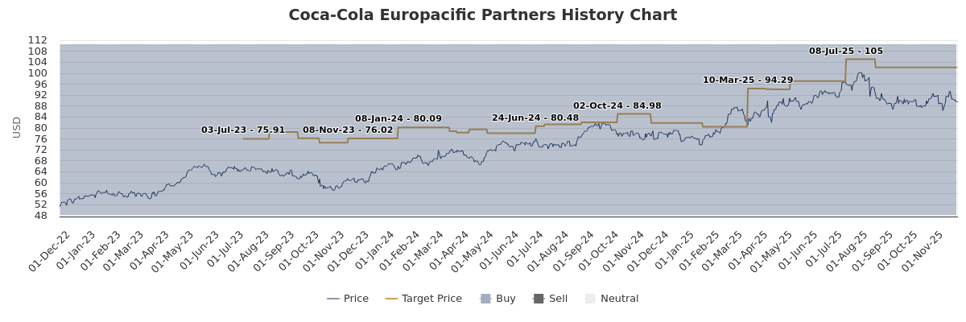
1 | Coverage Universe |  | Investment Banking Client |  | 1
1 | Count | % | Count | % Total IB Client | % Rating Category
Buy | 264 | 45.99 % | 36 | 47.37 % | 13.64 %
Neutral | 243 | 42.33 % | 33 | 43.42 % | 13.58 %
Not Rated | 17 | 2.96 % | 6 | 7.89 % | 35.29 %
Sell | 50 | 8.71 % | 1 | 1.32 % | 2.00 %
Total | 574 | 100.00 % | 76 | 100.00 % | 13.24 %
Data relating to R&Co relates to the period (which is less than 12 months) since Rothschild & Co Redburn has been a member of the R&Co group
Research reports are solely for the information of the addressee only and is not an offer, or solicitation of an offer, to sell, or buy, any securities or any derivative instruments or any other rights pertaining thereto. The information used to create or provide research reports are compiled from sources believed to be reliable, however, neither Rothschild & Co Redburn nor any of its officers or employees, make any representations or warranties as to its accuracy or completeness. Any opinions, forecasts or estimates expressed constitute a judgement, as at the date of the research report, that is subject to change without notice. Rothschild & Co Redburn has no obligation to update those opinions, forecasts or estimates. The recipient agrees that Rothschild & Co Redburn shall have no liability for any misstatement or omission or fact or any opinion expressed, nor for the consequences of any reliance upon any statement, conclusion or opinion. Rothschild & Co Redburn may have disseminated information contained in research reports prior to their publication. Research reports do not have regard to the specific investment objectives, financial situation and the particular needs of any specific person who may receive them. Nothing in our research reports should be construed as investment, tax, legal, accounting, regulatory or other advice or as creating a fiduciary relationship.
Rothschild & Co Redburn’s products and services are intended distribution in the United States only to Major U.S. Institutional Investors as that term is defined for purposes of SEC Rule 15a-6.
Redburn (Europe) Limited is not a member of the Financial Industry Regulatory Authority (“FINRA”), and as such its Analysts are not subject to FINRA’s rules on research analysts and research reports, including FINRA restrictions on communications with a subject issuer, public appearances, and trading securities held by a research analyst account. Redburn (Europe) Limited is a correspondent of Redburn (USA) LLC, a SEC-registered broker-dealer. All US persons receiving research reports and wishing to buy or sell the securities discussed herein should do so through a representative of Redburn (USA) LLC.
© 2025 - Redburn (Europe) Limited (trading as Rothschild & Co Redburn)

Beecham Group was also a former Coca-Cola bottler, but the company refocused on its pharmaceuticals business in the mid-1980s and merged with Smith, Kline & French in 1989, creating the precursor to pharmaceuticals giant GlaxoSmithKline (Buy rated).
‘Coca-Cola become our Official Soft Drink Partner’, Arsenal football club (20 August 2025)
‘COCA-COLA UNVEILS PARTNERSHIP WITH PREMIER LEAGUE’, TCCC (21 May 2025).
‘Fitch Assigns Morrison's Senior Secured Debt Final 'BB-' Rating; Maintains Positive Outlook on IDR’ (31 July 2025).
‘Introducing a Deposit Return Scheme on beverage containers’, Department for Environment, Food & Rural Affairs (15 February 2019).
‘The impact of deposit return schemes on beverage sales’ (July 2023).

