**Galen Framework**

Galen Framework is an [open source](https://en.wikipedia.org/wiki/Open_source) layout and functional testing framework for websites, written in Java, which allows you to test look and feel of responsive websites. It has its own language called “[Galen Specs](https://en.wikipedia.org/wiki/Galen_Framework#Galen_Specs_Language)” for describing the positioning and alignment of elements on a [Web page](https://en.wikipedia.org/wiki/Web_page). It is based on [Selenium](https://en.wikipedia.org/wiki/Selenium_(Software)) and could be executed via [Selenium Grid](https://en.wikipedia.org/wiki/Selenium_(software)#Selenium_Grid) for cross-browser testing.

**The features supported by Galen are:**

* Testing location and size of elements on page
* Image comparison for selected area
* Functional testing
* Applying [TDD](https://en.wikipedia.org/wiki/Test-driven_development) approach in [Web development](https://en.wikipedia.org/wiki/Web_development)

**Installing and configuring Galen:**

1. Install Java version 1.8 or greater
2. Go to the <http://galenframework.com/> and download the latest galen framework binary available.
3. Once you download the archive just extract its contents and place it anywhere on your file system. The screenshot of the folder is shown below. Make sure it contains **galen.bat** file in it.

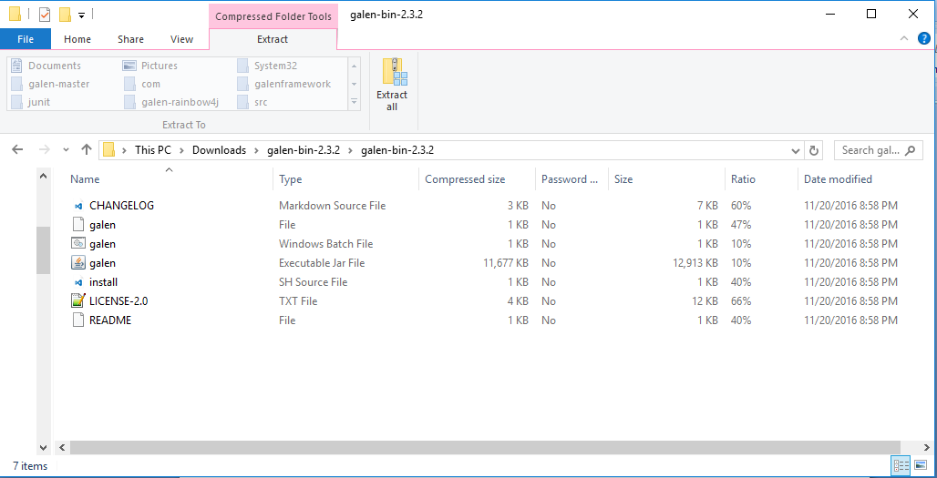

1. Now configure path in system variables

* Click **"Start"** button, type in search **"system variables"** and then click **"Edit the system environment variables"**
* In **"System Properties"** window click **"Environment variables"** button
* In the second **"System variables"** list look for **"Path"** variable, select it and click on the **"Edit"** button
* In the **"Edit System Variable"** dialog add the path of the galen framework folder. Ex: “**;C:\galenframework\;”**

1. Open “cmd” command line program in the galen framework folder and type the command “**galen.bat --version**”. It should print you the version of Galen Framework you are using.

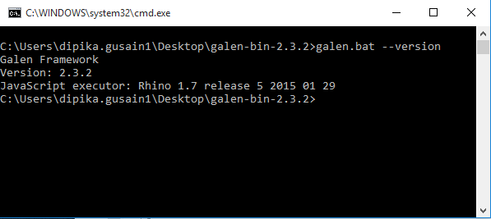

1. Make a file “**galen.config**” in your project directory or you can run “**galen config**” command and this will generate a galen config file for you.

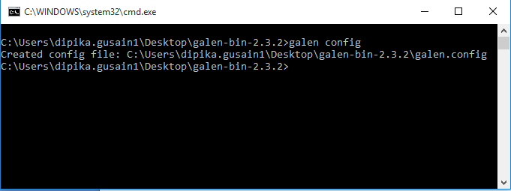

1. Config file can also be created globally by using the command “**galen config –global**”.

You can understand various commands in config file from <http://galenframework.com/docs/getting-started-configuration/>

1. Open config file and set the default browser for the test cases to be run using the line

**“galen.default.browser=chrome”.**

1. Set the respective driver path using following lines

* $.webdriver.gecko.driver=/path/to/geckodriver
* $.webdriver.chrome.driver=/path/to/chromedriver
* $.phantomjs.binary.path=/path/to/phantomjs

The set of browsers supported by galen are firefox,chrome,ie,edge,phantomjs.

**Writing and running a spec file:**

1. Make a file with .spec extension. For ex “**home-page.spec**”.

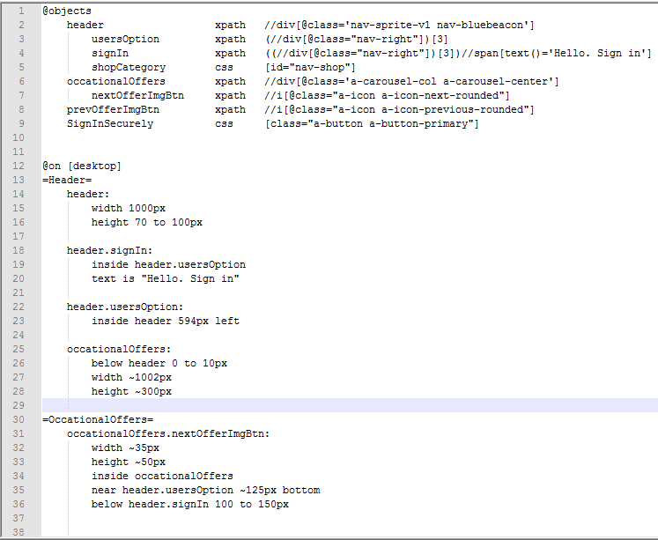

1. Now open command promt in the project folder and run the test case using the command ::

“**galen check home-page.spec --url http://www.amazon.in/ --size 1024x800 --htmlreport reports. “**

Browser should load the url with the dimension of the browser window mentioned in the command. The html reports will be generated in a folder called reports inside project directory. The report in command promt should look loke this:

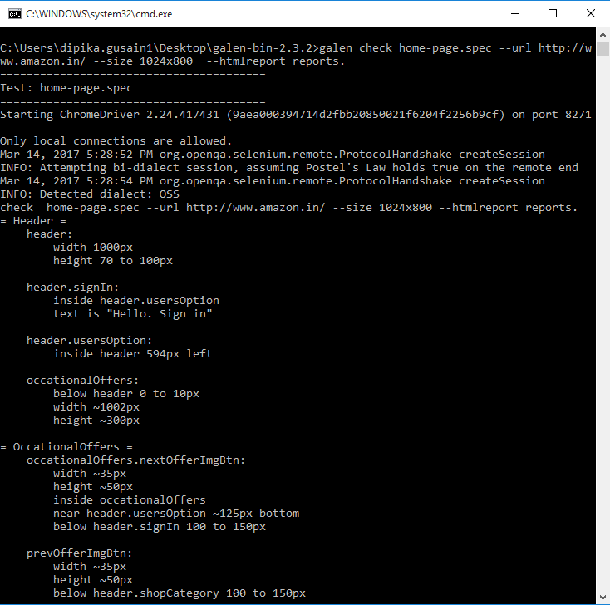

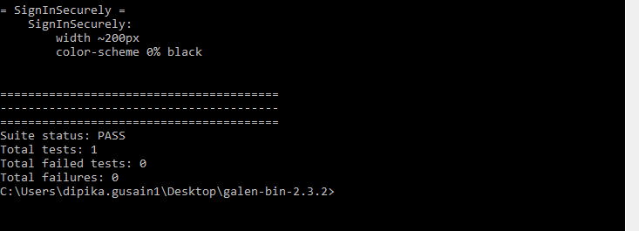

1. The report folder will have the following files

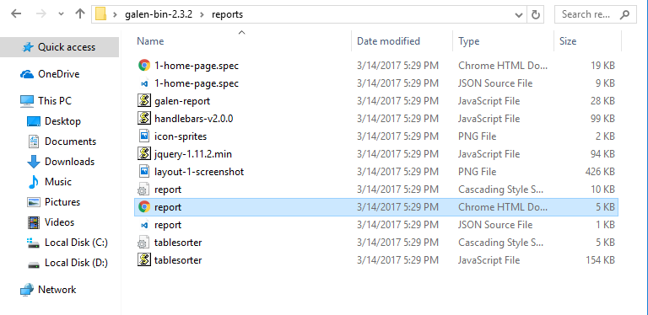

1. “**report.html**” will look like this

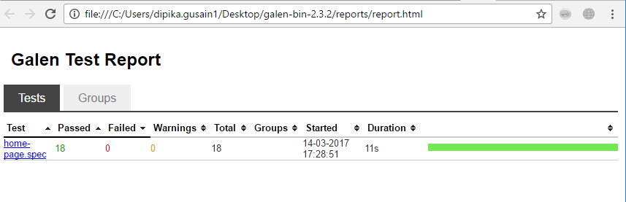

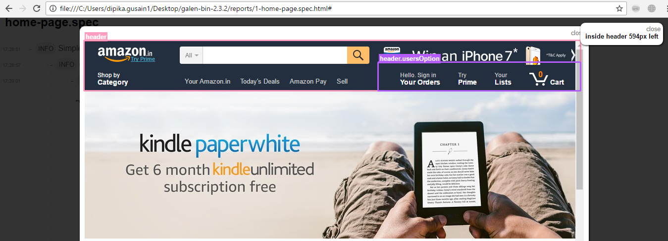

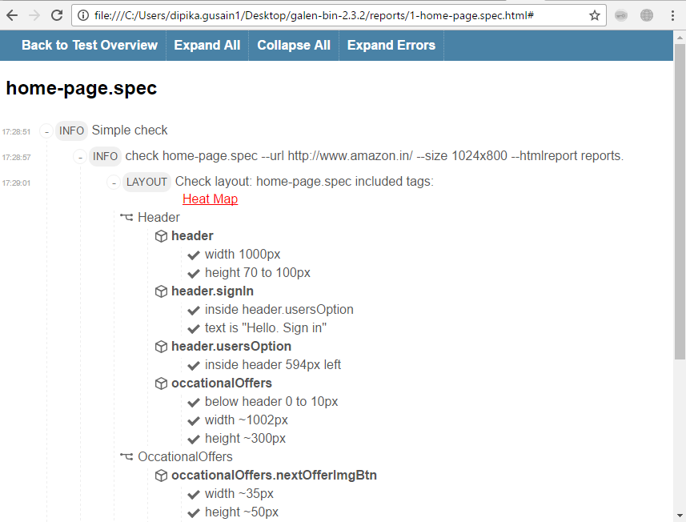

For further information on writing and running a spec file refer :

* <https://www.youtube.com/watch?v=hn4YvigVMGw>
* <http://galenframework.com/docs/tutorial-first-project/>

**Project related details:**

**Prerequisites:** (Before importing project)

* java (version - 1.8.0)
* galen (version – 2.3.2)
* eclipse with maven plugin
* chrome(version – 57.0)
* firefox(version – 51.0)

**Project structure will be look like below**

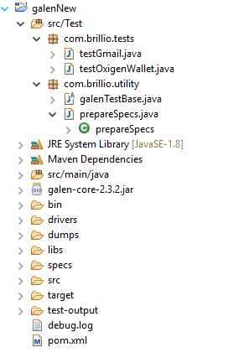

Source folder has two packages , one package regarding configurations and other will be test cases.

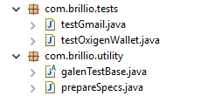

* 1. com.brillio.tests : where test cases are written.
  2. com.brillio.utility: where configurations has to handle.

Under utility package we have 2 classes

1. galenTestBase : Browser and URL related configuration are handled here

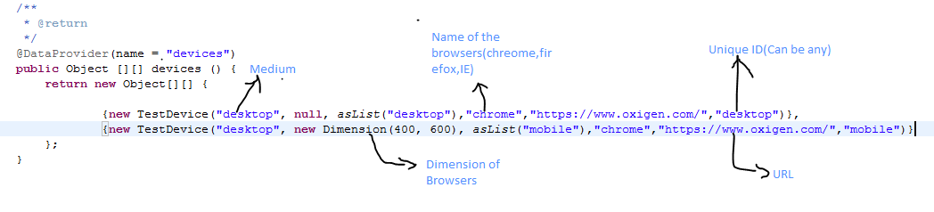

Set browser , medium , URL and resolution as mentioned in above screenshot.

2. prepareSpecs : where input spec , dump file and output spec generate.

* Drivers folder : which has driver executables for chrome , firefox and internet explorer browsers , which helps in launching browsers.

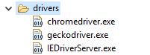

* Dump folder : folder where dump file is create which helps in generating output specs automatically by using input spec file.

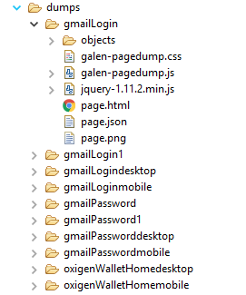

* Libs : where project related jars are stored.
* Specs : which has 2 folder inside to store input spec and out spec files.

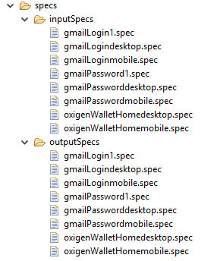

Input spec has all locators with respect to page and output spec contains locators and specifications.

Input spec sample:

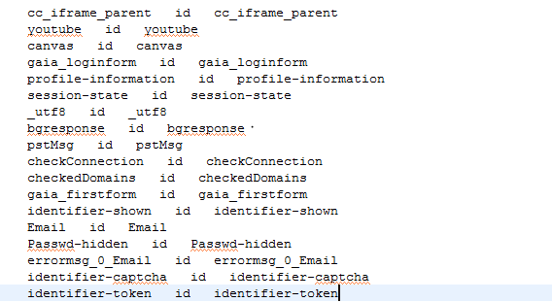

Output Spec sample:

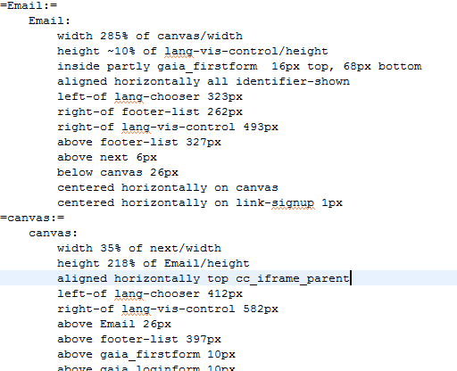

* Target : folder where reports will generate.

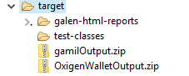

Inside galen-html-report folder galen reports will be there.

Report samples:

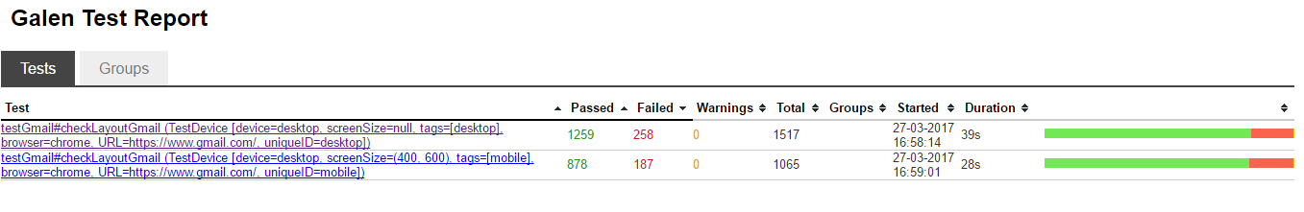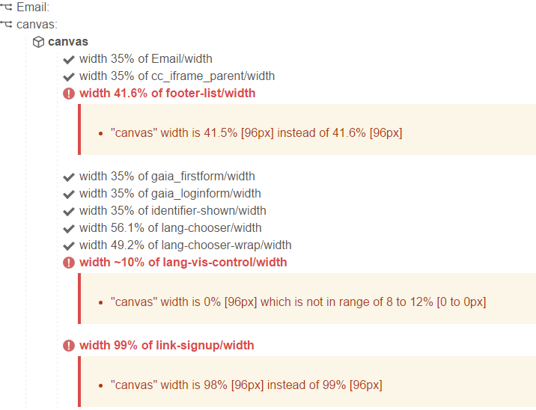

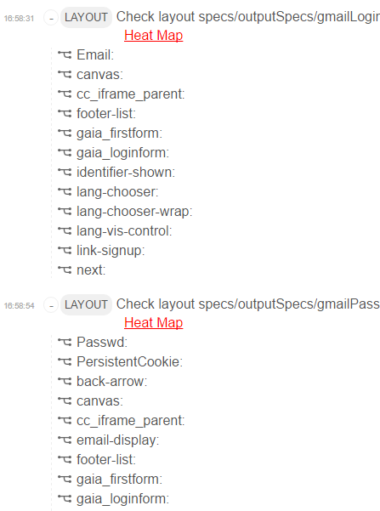

**Steps to run :**

Step 1: Import the project as maven project

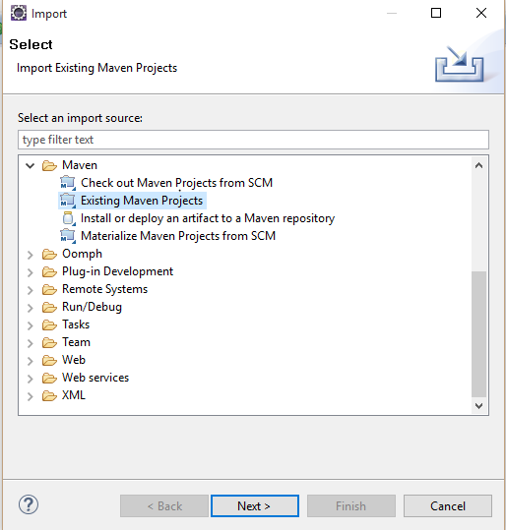

Step2 : Set the browser , url and resolution in prepareSpecs.java inside utility package.

Step 3: Create the test cases in tests package

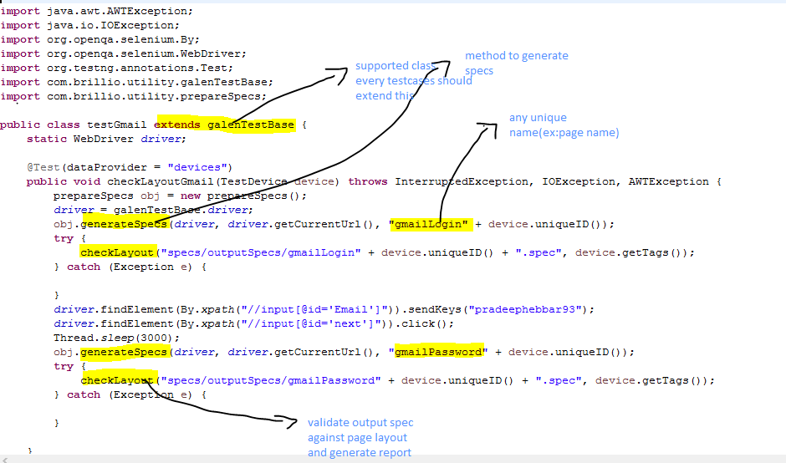

Step 4: test case can be run through testing

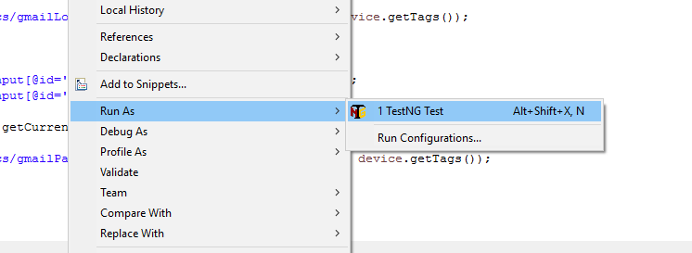

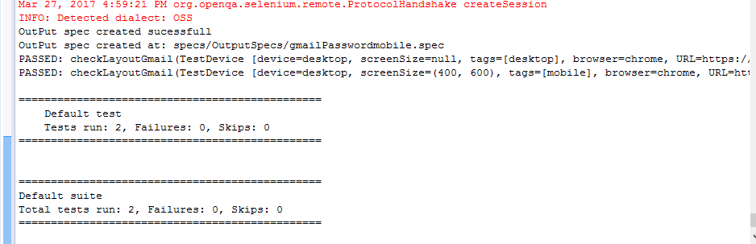

Input spec , output spec and report will be generate in respective folders.