**Project Structure:**

Contain methods which call respective endpoints

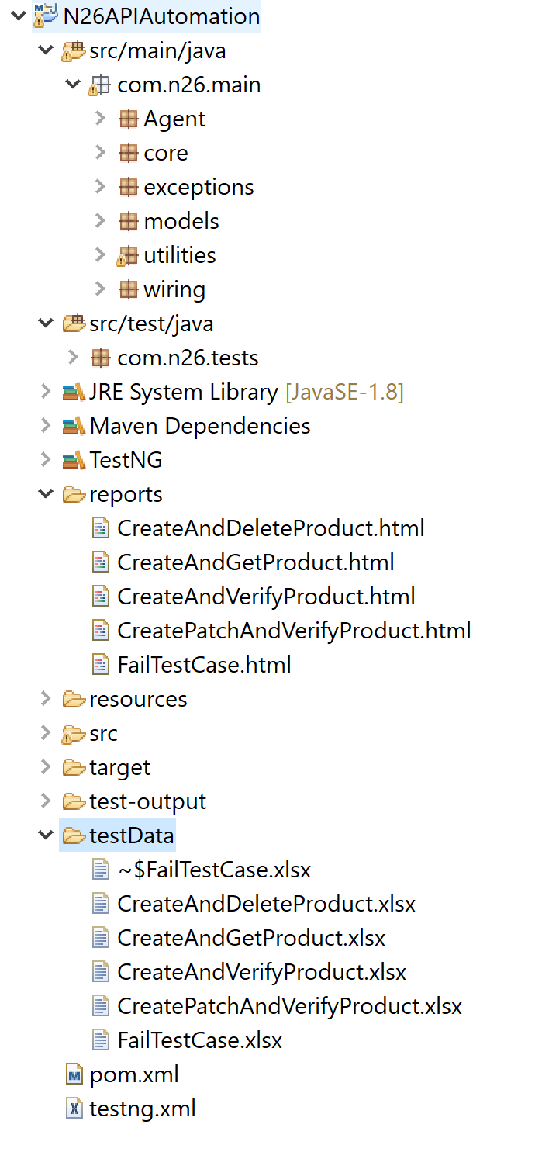

Input for the test cases can be stored here

Contain configuration related files

Reports store here after the execution of test cases

All test cases reside here

Contain classes which are used to extract data from the response

Contain some utility class required by project

Contain POJO class which are used to create payload

Contain base class and handles pre and post conditions

**How to run the test case:**

All test cases are reside in package (“com.n26.tests”)

Unit test case execution:

A test case can be executed by Performing run as TestNG test

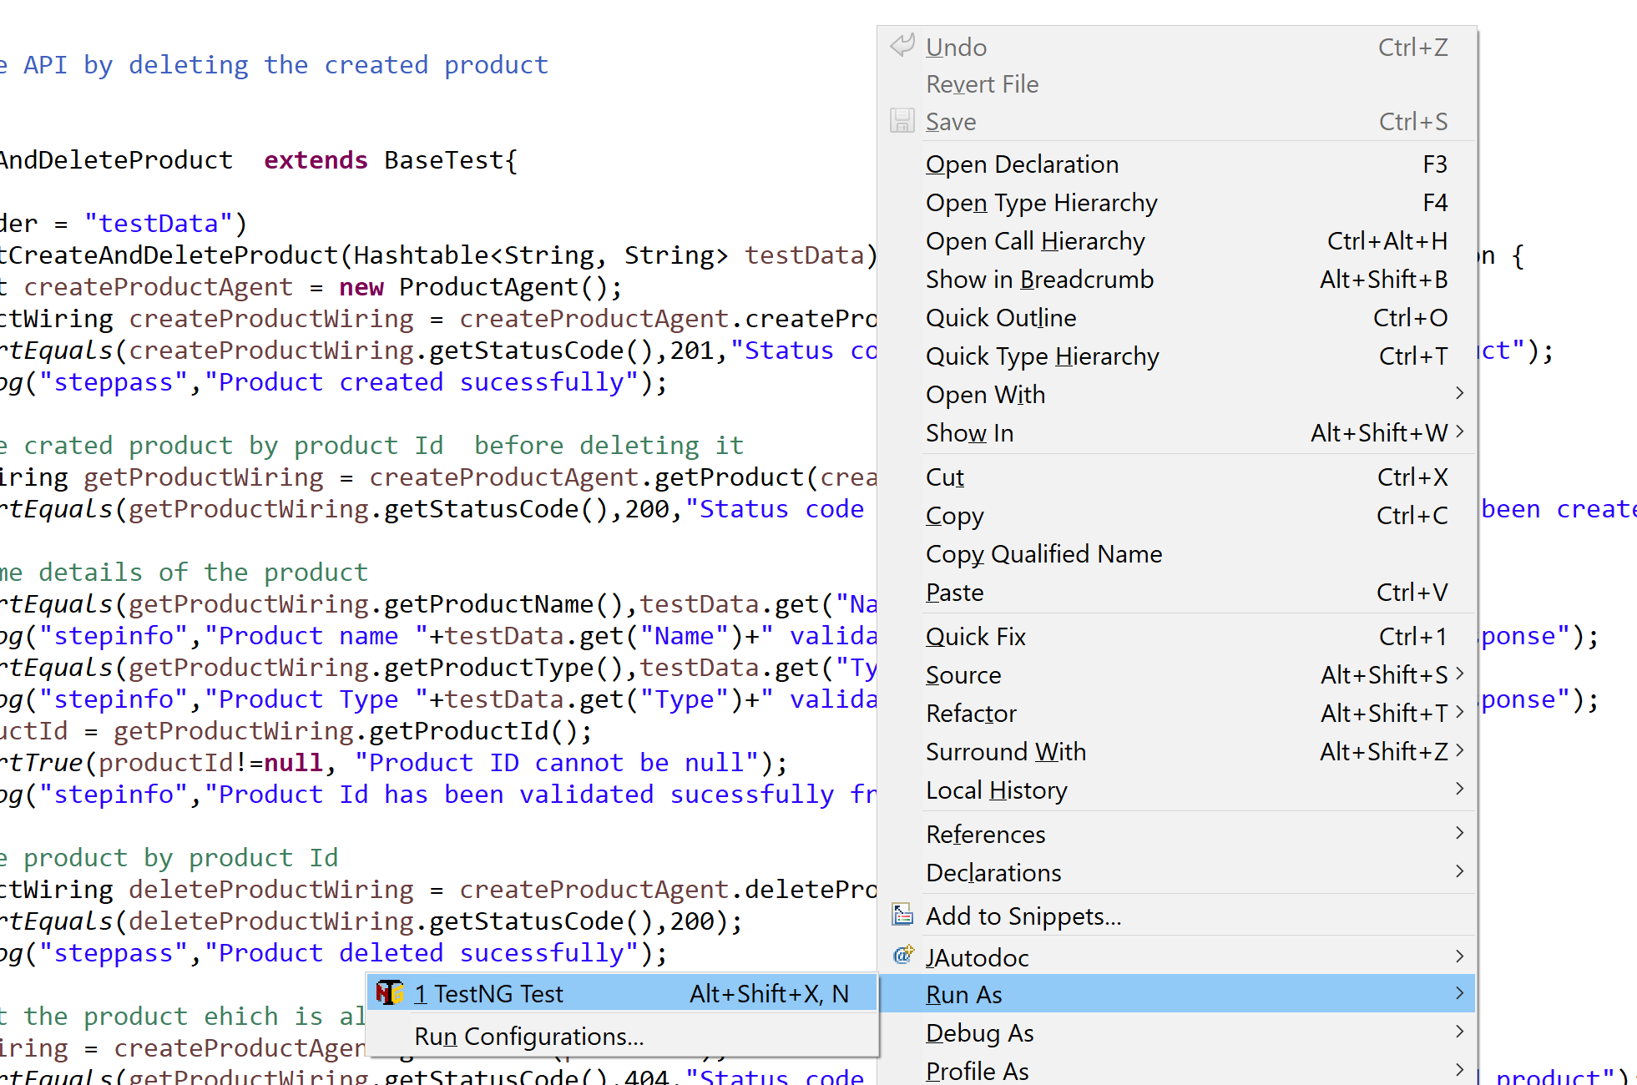

Batch Execution:

All test cases present in the package (“com.n26.tests”) can be execute by using testing.xml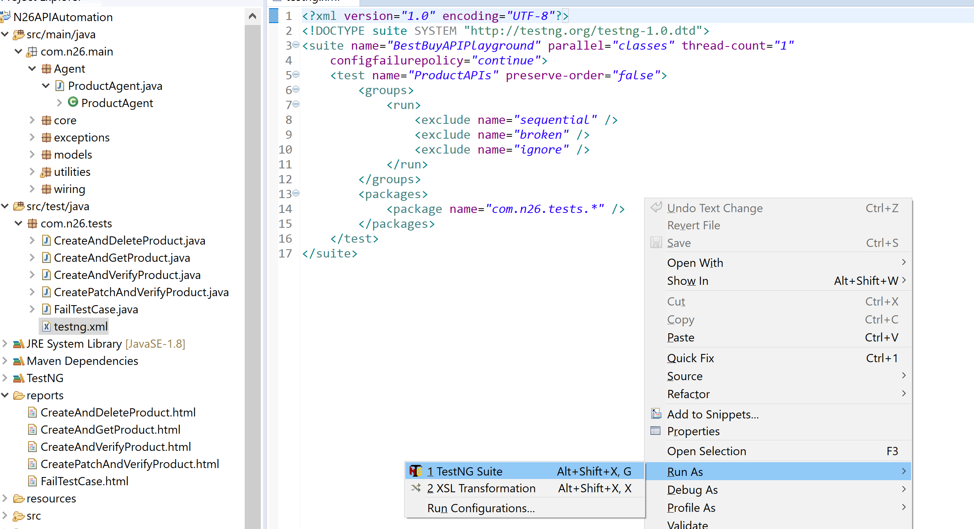

Test Data for the test cases:

Test data for the test case can be pass though the excel(With same name as test case name) in testData folder.

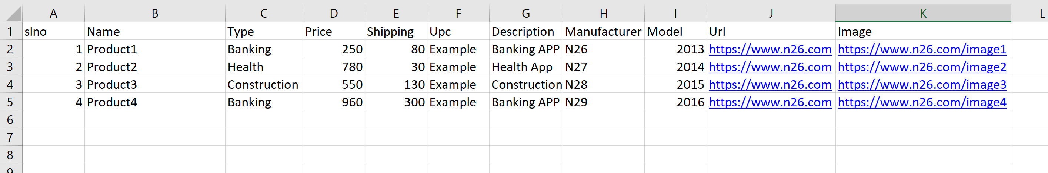

**Note:** Same test cases can be executed for different inputs by adding extra rows.

Reports:

Once the test case is executed, report for the test case will be available in **report** folder.

Ex: 1

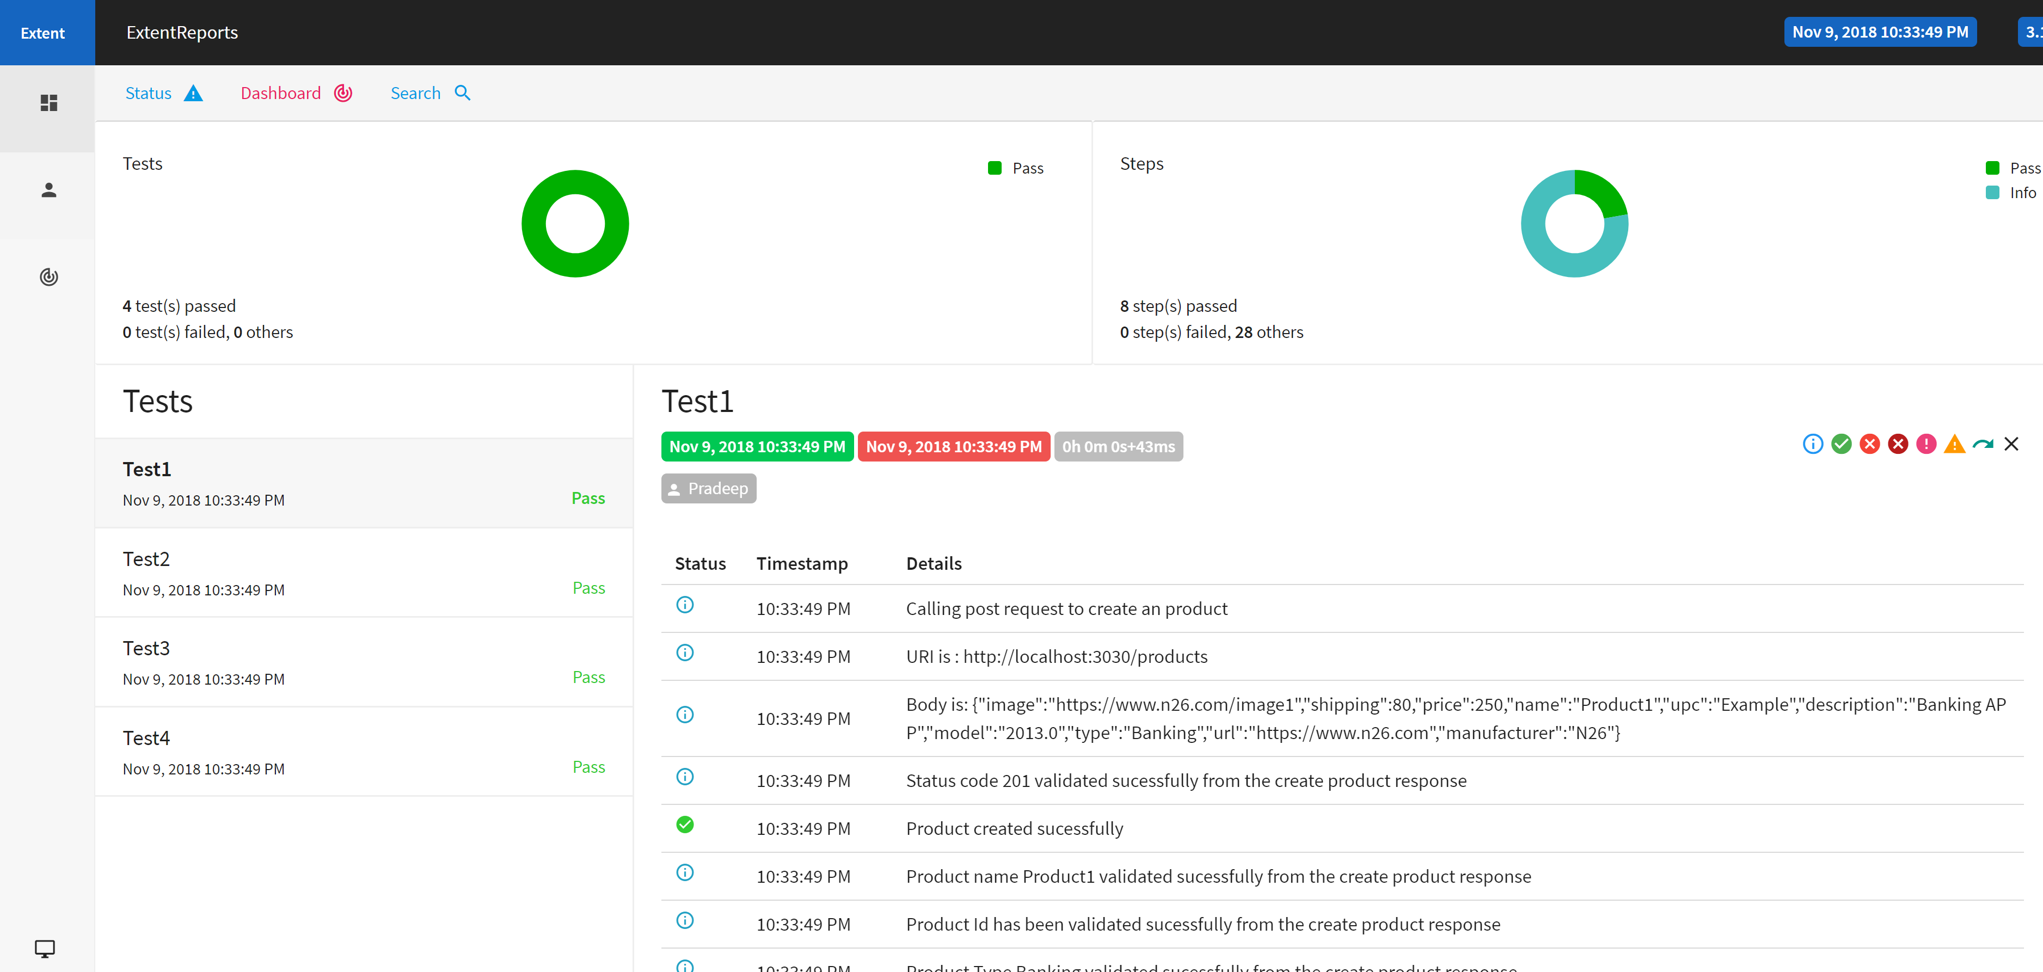

Ex: 2

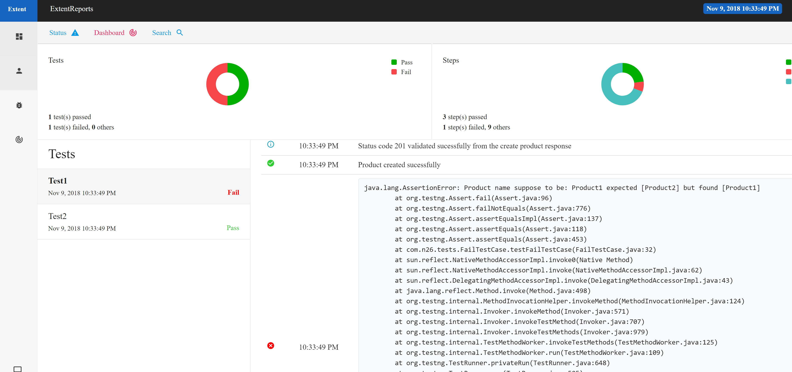

**Note:**

* Please make sure **Best Buy API playground** is up and running.
* Please make sure Best Buy API playground server and posted address given properly in config.properties

