VARCHAR2(size):
Stores character data. If data entered is less than the size mentioned, only the space required to store the data is used.
NUMBER(precision, scale):
Stores numeric data. Precision - Total number of digits allowed. Scale - Number of digits allowed after floating point. This datatype is also of variable-type in terms of memory usage. It can have a max precision of 38.
BLOB:
This is a type of Large Object datatype that can store up to 128 TB of data. BLOB is used to store multimedia data such as sound, video, images, etc.
CLOB:
This is also a type of Large Object datatype that stores long character data.
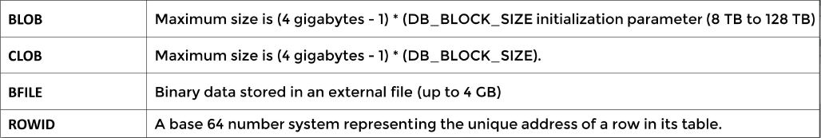
BFILE:
Also known as External Large Object. This is a datatype which stores a pointer to the actual file in the operating system which contains the binary data. With BFILE, we can also store pictures, etc. The max size of the BFILE is limited by the OS. This is also a Read-only datatype.
ROWID:
It is a base64 number that represents the unique, physical location of a row in a table. This datatype is stored as a hexadecimal string.

SELECT statement:

SELECT *|{column_name1, column_name2….} FROM table_name;
- Retrieve specific column(s) instead of all of them, to improve performance.

Column aliases:

- Used to rename the columns while obtaining them.

SELECT column_name1 alias1, column_name2 aslias2 FROM table_name;
Or
SELECT column_name1 AS alias1, column_name2 AS aslias2 FROM table_name;

Example: SELECT first_name Name, last_name Surname FROM employees;
Or
SELECT first_name AS Name, last_name as Surname FROM employees;

- If the alias contains any special character, then the alias name must be enclosed with “ ”

DUAL table:
This is a dummy table with a single column and row, used by the developers to show something.
Example:
SELECT ‘My name is Bals’ as “OUTPUT” from dual;
- This will return a table with one column named OUTPUT and a single value with the string ‘My name is Bals.

QUOTE operator:

SELECT q‘[My name is Bals]’ as “OUTPUT” from dual;

Output -> same as previous example

- Quote operator is used to make the ‘ character usable as part of the string.
- Any character like <>, {}, ‘a’, ‘A’, ‘b’, ‘B’, etc. can be used instead of [] in the quote operator.

Note: SELECT ‘I’’m learing SQL’ from dual will give the output ‘I’m learning SQL’

DISTINCT & UNIQUE operator:

- Both the operators give the same result by eliminating the duplicates from the selected data.
- DISTINCT is a standard operator and UNIQUE is a non-standard operator. UNIQUE was part of old oracle syntax and is still supported. Other DBs may not recognize the statement.
- DISTINCT keyword can be used only once in a statement and it must be written just before the first column name.

Examples:
- SELECT DISTINCT job_id FROM employees;
- This will return the unique values in the job_id column from the employees table.
- SELECT DISTINCT job_id, DISTINCT, department_id FROM employees;
- This will throw an error since DISTINCT keyword is used more than once.
- SELECT DISTINCT job_id, department_id FROM employees;
- This will return the unique combinations of the two columns.

CONCATENATION:

‘||’ is the concatenation operator. Used to join strings.

Example: SELECT first_name || ‘ ‘ || last_name AS “Full Name” FROM dual;

ARITHMETIC OPERATORS:

- +, - , * and / are the arithmetic operators in SQL.
- When a null value is given as one of the arguments for the arithmetic operators, the result will also be null.
- ‘sysdate’ gives the current system date in the date format. Adding or subtracting integer value to/from a date value also returns a date value.

