Oracle Conversion Functions:
- Conversion functions are used to convert one data type in to another.
- 2 types of conversion functions – Implicit Data Type Conversion and Explicit Data Type Conversion.
- Implicit conversion – Oracle server automatically converts some data type to the required one.
Example:
SELECT * FROM employees WHERE salary > ‘5000’;
- Here, although ‘5000’ is a string, Oracle implicitly converts it to number and performs the query’s actions. This is done via a ‘checking cycle’, which contains some steps like syntax check, semantic check, optimization, etc. Since resources are utilized in order to run this cycle, implicit conversion often results in performance loss.
- Some implicit conversions done by Oracle are:
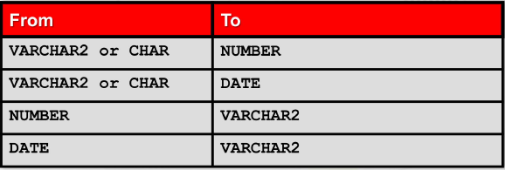
Note: Although Oracle converts some data types implicitly, it is recommended to use explicit conversion in order to avoid performance loss and problems with queries.
- Explicit conversion – Conversion functions are used explicitly. Oracle provides some conversion functions that we can use.

