How to Post Listings for Used Tires on Treadhunter.com
First go to www.treadhunter.com.
If you see “MY TREADHUNTER” on the top menu bar, click it.
If you don't see MY TREADHUNTER, click SIGN IN then enter your email address and password.

Once you are on the My TreadHunter page, there is a box called Your Stores. Click the View link next to your store name.
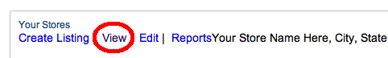
From here, the menu will have a Create Listings entry.
Click the Create Listings menu item, and you will have three choices for creating listings.

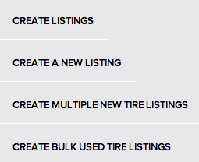
To post used tires on TreadHunter and your storefront, click the Create a New Listing button.

Create a Listing
To create a listing for a set of used tires on Treadhunter.com and your storefront, use this option then choose the quantity (1-4), the size, manufacturer, and model for the tire(s). Next enter the price (in dollars and cents) and check the Includes Mounting? box if the price includes vehicle mounting.
Now enter any warranty (in days) for the tire(s) if applicable, and the remaining tread (in 32s of an inch). If the tire set includes tires with varying treadlife, we recommend you choose the “average” tread depth of the set.
Make sure the Used option is selected under Condition, and enter a stock number for the set if you have one (this is an internal stock number).
Finally upload up to 4 images of the tires if you wish to include pictures of the tires (recommended). Then click the Create Tire Listing button to post the listing onto Treadhunter.com and your storefront.

