Using the Treadhunter Mobile App
In order to use the mobile application, you must register with Treadhunter as a tire seller. If you have not yet done so, please use this link (Tireseller Registration).
First, search for “Treadhunter” on the Apple App Store, then install the Treadhunter Mobile application on your iPhone, iPod, or iPad.
Next, launch the application from your mobile device.

Logging In
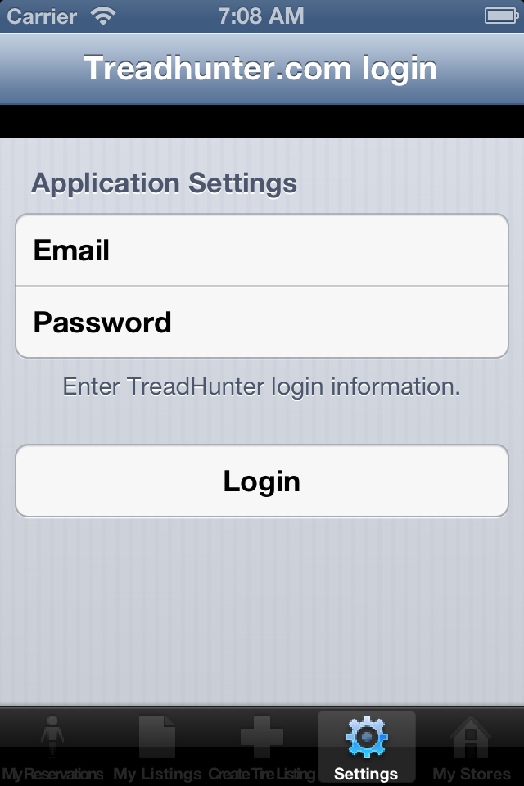
Use the email address and password from the registration process above to login with the mobile application.
The next step is to select a store. If you only have a single store, it will be listed here. Click the store name to use it for creating and editing listings, as well as viewing reservations.
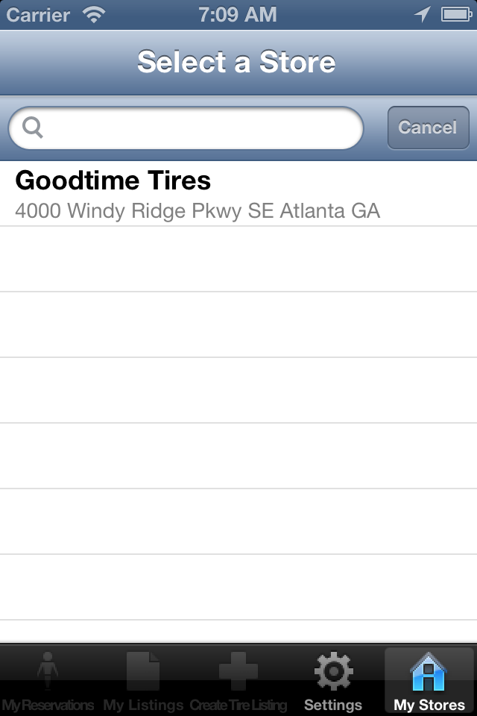

Viewing Reservations
The tabbed menu at the bottom of the application allows you to view reservations, view existing listings from Treadhunter, or create a new listing for Treadhunter.
The far left tab is Reservations; it will show you buyers who have selected to reserve your tires and their contact information.
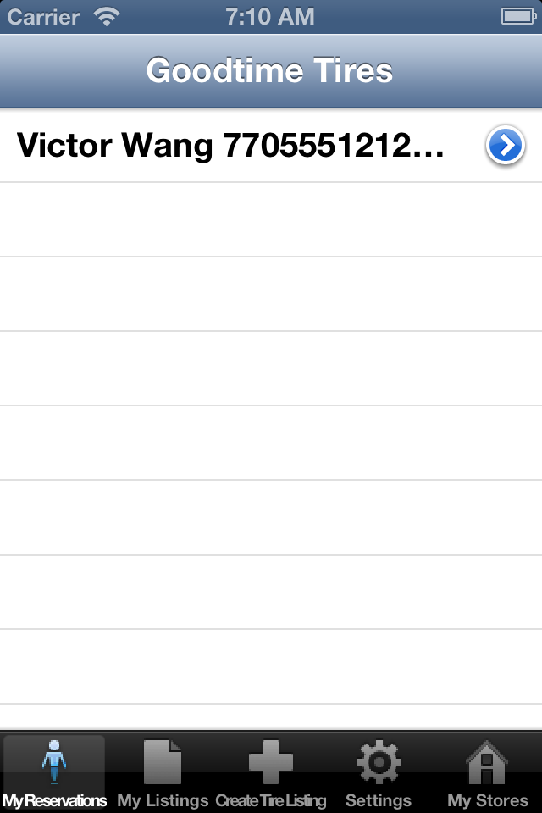

Here you can see that Victor Wang has reserved a set of tires. Click the blue arrow to see more details about Victor and the tires he has reserved.
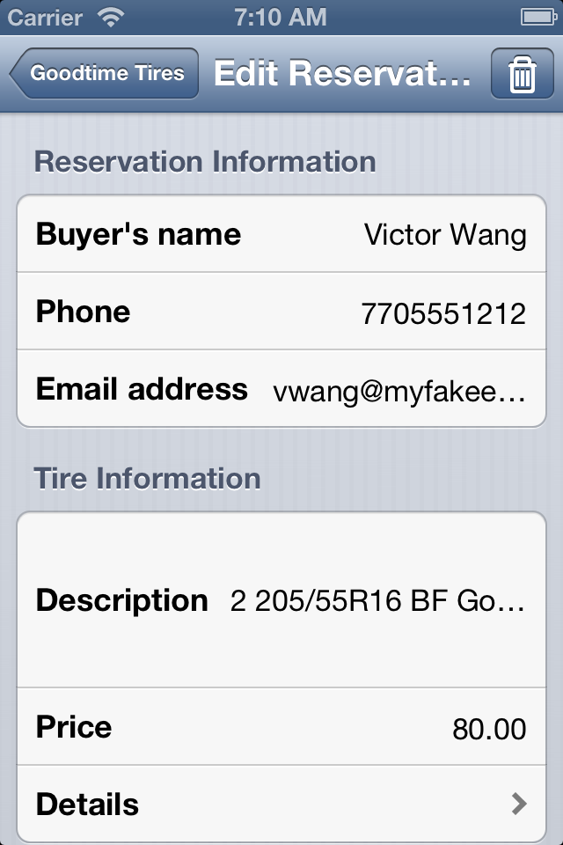
Victor's phone number is shown in the top area; his email address is also shown (though on the iPod/iPhone you may have to rotate the screen horizontally to see the whole address).
To see which tires have been reserved, click the arrow next to the Details line at the bottom.
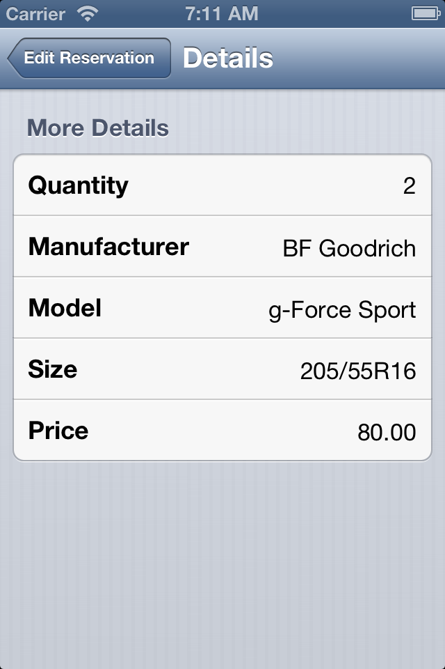
Ah, so Victor has reserved our g-Force Sport tires (2 for $80). On the Edit Reservation page, you can delete the reservation with the trash can button, doing so will send an email to the buyer that his reservation has been cancelled.

Creating a New Listing
The middle tabbed button is “Create Tire Listing”. The Treadhunter mobile app allows you to create individual listings for new or used tire sets. It does not allow you to add or edit 'generic' listings, where you have a stack of random used take-offs at a fixed price. Please use the website for this function.
Select the quantity of tires in the set (1-4). This value (along with many other below) uses a “scrolling wheel”; highlight the proper value then click the Done button.
Now enter the price. You will later be able to choose whether or not this price includes mounting; if not, enter the walk-out price. Next you'll enter the tire size. For our example tire set that is 225/65R17, you'll select 225 as the Width.
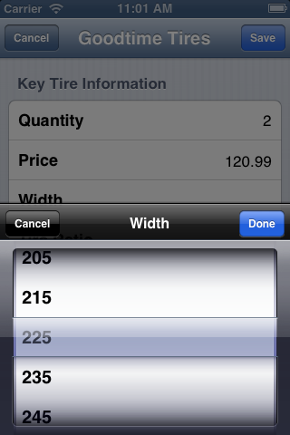
Then enter the aspect ratio and wheel diameter (65 and 17, respectively, in our example).
Now you'll select the tire manufacturer. Note that ALL manufacturers in the Treadhunter system will be displayed, even if they don't have a model in the selected size.
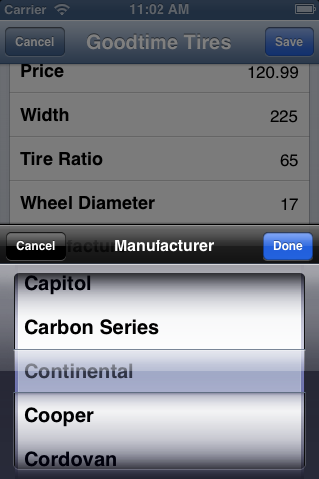
Click Done when the manufacturer is highlighted. The next attribute to select is the Tire Model. Here, only models for the selected size and manufacturer will be displayed; it may take a few seconds to load these models into the application.
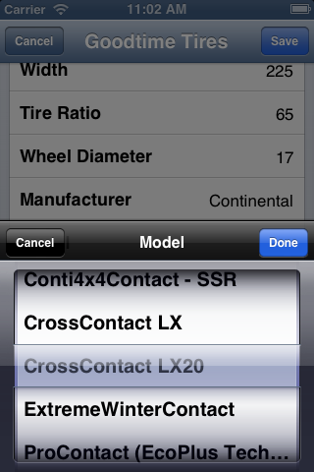
Again, click Done when the correct model is highlighted.
If the tire set is brand new, click the checkbox next to New Tire(s). If not, you should enter a remaining treadlife measured in 32nds of an inch. For example, our sample set has an average of 7/32nds” remaining tread so we simply enter “7” in the Remaining treadlife field.
The next section is titled Tire Details, where you can check Includes Mounting? if the supplied price includes mounting on the vehicle. If the set has a warranty, enter this value in the Warranty (days) field. If they are completely as-is with no warranty, you may leave this blank. Finally there is a field to specify an Internal stock # if applicable.
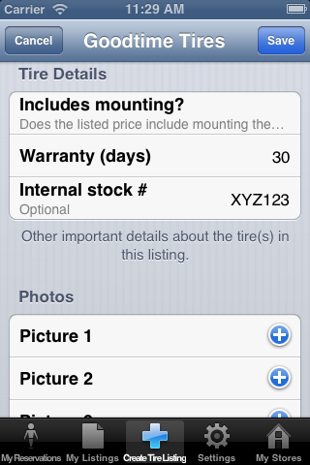
Finally, you can include up to 4 pictures with your Treadhunter listing. Click the blue + button next to a picture to select an existing picture on the mobile device or take a new picture.
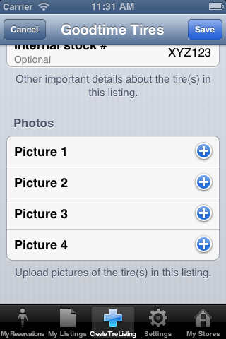
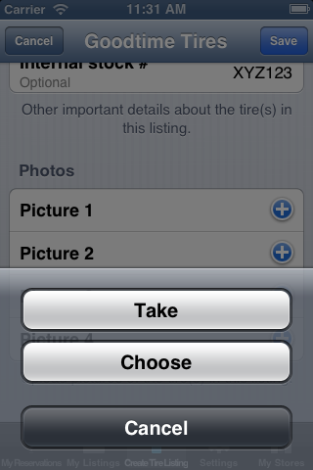
Once the pictures have been selected and all information has been provided, click the “Save” button. Depending on the speed of your Internet connection and the number and quality of the pictures, this may take a few seconds or up to a couple of minutes to upload the listing.

Once the listing has been posted to Treadhunter, you will be taken to the My Listings page where you can view, edit, or delete existing listings from the system.
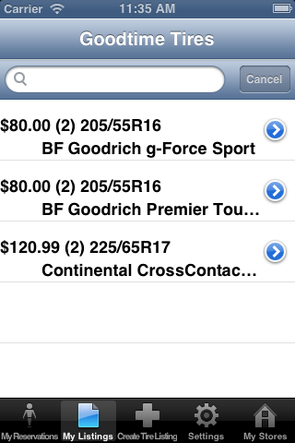

Editing Listings
From the My Listings menu tab, you can click the blue arrow button to open a listing for editing. You may edit any fields except Manufacturer and Model. Otherwise this screen works very similar to creating a new listing.
Once the listing has been appropriately updated, click the Save button to save the changes to the Treadhunter site.

