Selling Tires Privately on Treadhunter.com
First make sure you are logged into www.treadhunter.com (login link).
Once you are logged in, you will be taken to the My Treadhunter page.
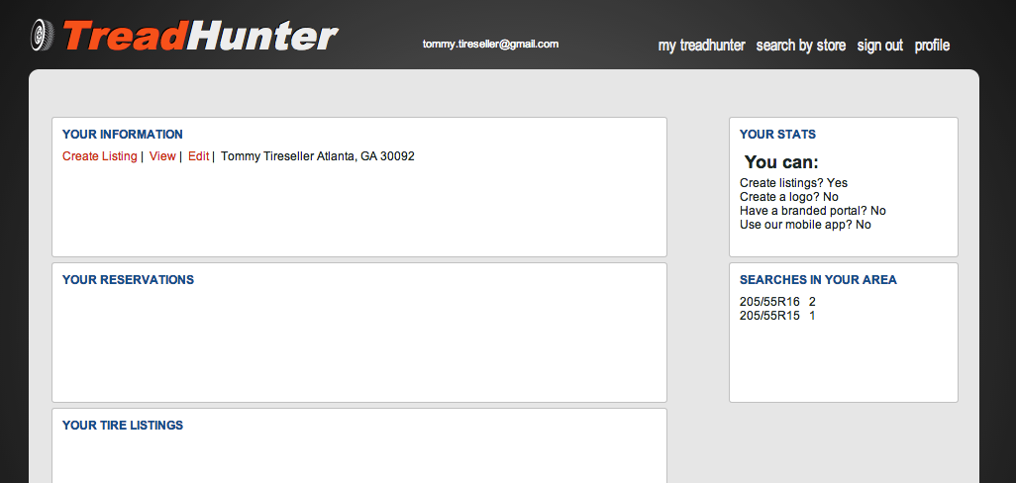
From here, you can click Create Listing to create a tire listing (see below for details).
The View link will let you see how buyers will see your home page (where they can see your public contact information and all the tire sets you've listed).
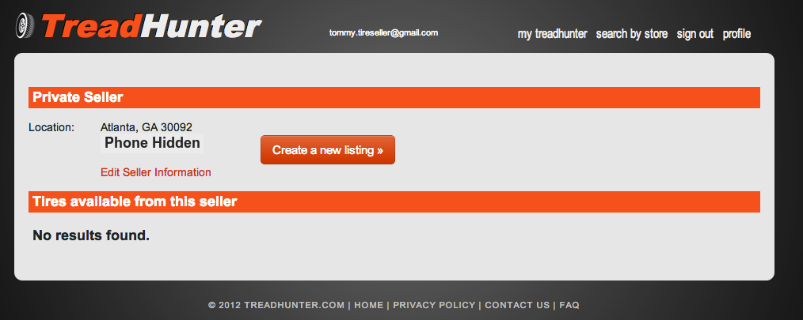
If you haven't created any listings, you will see the “No results found.” message and will need to click “Create a new listing” to post your tires to Treadhunter.com. See below for details. In addition, you can click “Edit Seller Information” to update your location or hide/unhide your phone number.

Creating Tire Listings
When you're ready to create a listing, click the Create a new listing button or link. First you'll select the quantity on-hand (up to 4), the size, manufacturer, and model of the tire, as well as the price of the whole set of tires. Click the Brand New button to indicate that the tires are not used.
Finally if you'd like to attach photos to your listing, upload them in the Upload Images section. If you do not wish to upload custom images of the tires, the default stock photos for the selected tire model will be used.
Now click the Create Tire Listing button to create the listing on Treadhunter.com.
Now you'll see the listing as it is now live on Treadhunter.com! You can Edit the listing if you need, and this includes deleting it once your tires have been sold.

