Document History
Document  Version | Date  (dd/mm/yyyy) | Comments | Author
1.0.0 | 18/02/2017 | First version. | Pradeep Singh

Contents

1 Introduction 3
1.1 Purpose 3
1.2 Scope 3
1.3 Document Ownership & Maintenance 3
1.4 Change log 3
1.5 Acronyms and Definitions 3
1.6 References 3
2 Overview 4

Introduction

Purpose
This document describes how to use Automated Diagnostics using LATTE in JLR X590 project.

Scope
This doc is aimed for all software developers.

Document Ownership & Maintenance
The North America team of Lear IEC owns & maintains this document.

Change log
See Document History in page 1.

Acronyms and Definitions
SW Software
HW Hardware
ECU Electronic Control Unit

References

Overview
This document describes how to work with Automated Diagnostics using LATTE in JLR X590. It’s presented as a list of steps and useful information. It’s recommended to read document LATTE_General_Guidelines.doc before reading this document.
- LATTE libraries are located in \latte_libs folder. You’ll find here:
  - These guidelines and the LATTE_General_Guidelines.doc
  - The newest version of the libraries, and also the older ones (the older ones must be kept always available, because some integration test scripts could be using them). Remember that inside the libraries folders (com_vX, etc) you can find a simple example of usage, and the documentation. There are also some other reference docs that can be useful.
- An additional python Script and a batch file to support LATTE libraries are located in \Diagnostic_Services\ScriptGeneratorFiles folder.We have created “LatteScriptGenerator_X590.py “ python script that extracts the data from excel and writes it in LATTE accepted format to a xxx.py file.

Tools required
You will need following tools in your computer in order to run Automated Diagnostics using LATTE :
- Python 2.6.X or 2.7.X 32 bits version
- Latte libs (com_v1,report_api_v2.0.0)
- Python script and supporting files to convert testcases in excel to LATTE scripts.
- Entire sample project is kept at following svn path:
https://pun-20-5253.corp.lear.com:8443/svn/NA_Prj_Folder/06. Working/TOOLS/X590_Automated_Diagnostics

Folder Hierarchy
X590_Automated_Diagnostics folder contains following :
- Diagnostic_Services folder :
- ScriptGeneratorFiles (Contains scripts created by IEC)
- LatteScriptGenerator_X590.py
- GenerateScript.bat
- SITS-SW-280-307-TLA.xlsm (Testcase template file)

- latte_libs folder :
- com_v1 (latte library for communication over CAN)
- report_api_v2.0.0 (latte library for generating test report in xml format)
- 00_guidelines

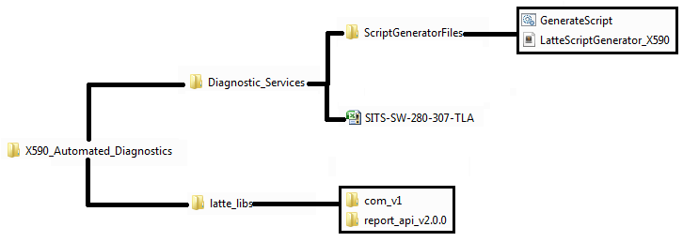

Overview of Testcase template
Testcase template SITS-SW-280-307-TLA.xlsm contains following sheets:

Change History sheet
This sheets purpose is to log changes done by people over the time
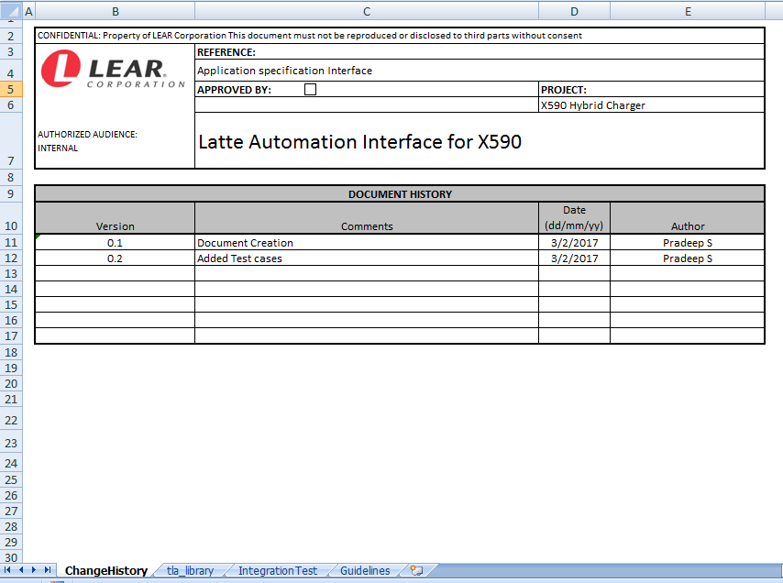

tla_library sheet
Contains Report headers and CAN/LIN configuration
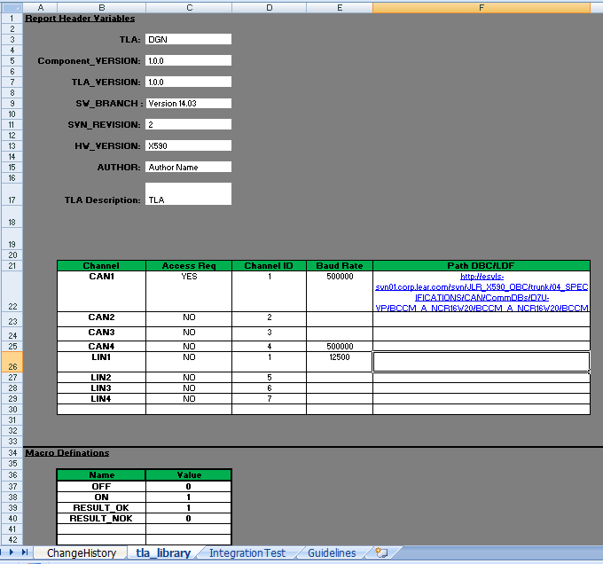

Integration Test sheet
Testcases need to be written in this sheet following the template given.
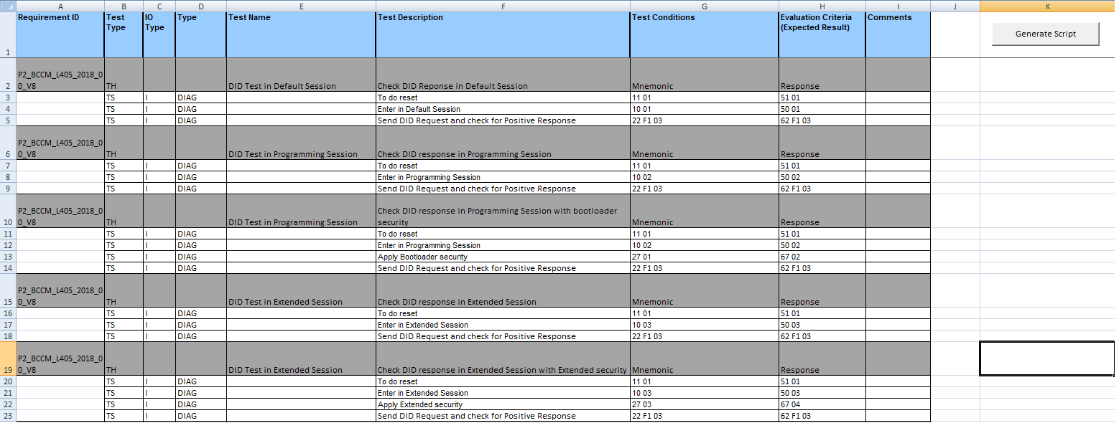

Guidelines sheet
This sheet contains guidelines regarding terms used in template
