**Business Context**

We are all aware that accidents are prone everywhere due to negligent driving or climatic conditions. An insurance company always needs to be prepared to estimate the number of accidents and the claims that they can receive at a given point time. Also understanding the pattern of claims would help the companies to frame different types of policies for the users providing better benefits and at the same time increasing the premium to the company.

**Problem Statement:**

Consider that you are a Lead Data Analyst at an Insurance Claims company that has provided you with the Car Insurance Claims dataset. You have been given a task to explore the data, create different plots and interpret useful insights/findings. Your end goal here will be to create a storyboard that you have to present to the Senior Management and the story has to have an end objective and should follow a logical flow to display that you are heading towards achieving the end objective. This will help the Senior Management in taking some decisive actions on the current claims system in place. This storyboard will be an open-ended story for you to explore various different features in the data and try to showcase different plots. Make sure to have minimum clutter in the plots, follow a consistent color scheme across all the plots, and use proper colors to highlight a specific insight. Moreover, your plots on all the dashboards should be interactive and responsive. There should be 1 dashboard that should cover the summary of the story as well as your recommendations.

**Data Dictonary:**

**Assumption Car Owner and Driver are same Amounts are in Dollars ($)**

**ID Identification Variable**

**KIDSDRIV Number of teenagers among the car owner's children who can drive a car.**

**BIRTH Date of birth of the driver**

**HOMEKIDS No of childern the car owner has**

**YOJ Years on Job. How many years has the owner of the car been working?**

**INCOME Income of the driver**

**PARENT1 Is the car owner a Single Parent**

**HOME_VAL Value of the house owned by the car owner**

**MSTATUS Marital status of the car owner**

**GENDER Gender of the driver**

**EDUCATION Maximum Education level of the driver**

**OCCUPATION Occupation of the driver**

**TRAVTIME Time taken to get to work on an average**

**CAR_USE Purpose of using the car**

**BLUEBOOK What is the worth of the car. Value of the Vehicle(in dollars)**

**CAR_TYPE Car type**

**OLDCLAIM Total claim (in past 5 years - in dollars)**

**CLM_FREQ Number of claims (in past 5 years)**

**CLM_AMT If car was in a crash, what is the currently claimed amount(in dollars)**

**CAR_AGE Age of car**

**URBANICITY Where the car is being driven primarily**

**ANS : Link for Tableau** [DVT Book6 - Pradeep Vunnam | Tableau Public](https://public.tableau.com/profile/pradeep.vunnam#!/vizhome/DVTBook6/VehicleClaimsStory?publish=yes)

**Evaluation Link:**

https://public.tableau.com/profile/abhilash2454#!/vizhome/CarInsurance_DVT_Milestone_Abhilash/AnalysisInsights

**1. Creation of multiple charts and tables for representing useful insights/findings. The charts used should be inline with the objective that you wish to convey to the Senior Management.**

[Mandatory 8 types of charts/tables from any of the following: text table, bar chart(multiple/stacked/side by side), bubble chart, treemap, Pareto chart, scatterplot, Wordcloud, line plot, histogram, boxplot, circle views, heatmap, highlighted tables. No restrictions on the upper limit of the number of charts/tables to be used]. (16)

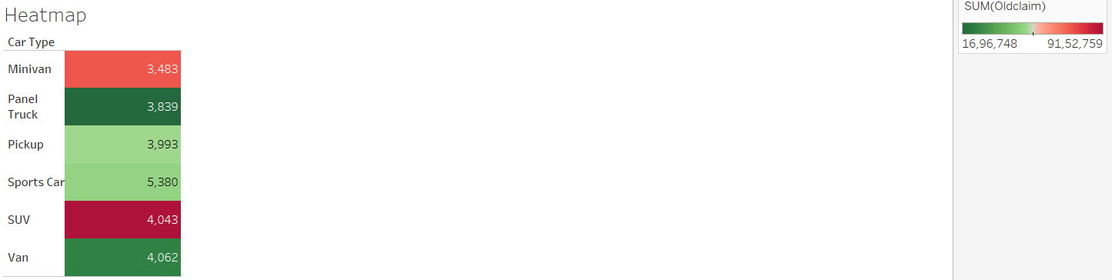

From the above chart, we can see SUV, Minivan vehicles are the most claimed vehicles, pickup and Sports Car vehicles have high claim frequency but less claim amount.

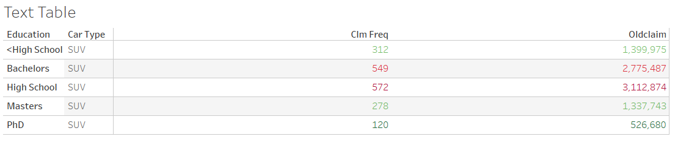

From the above chart, we can see SUV, Minivan vehicles are the most claimed vehicles and high claim frequency.

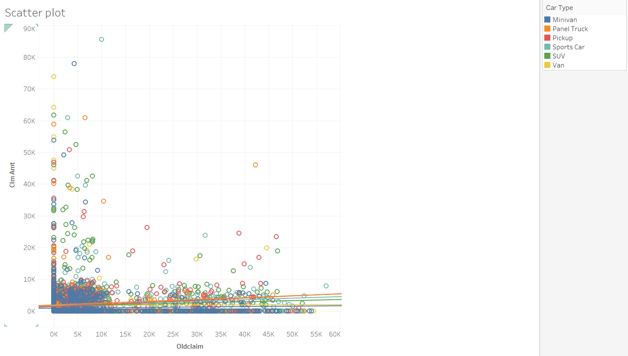

The above figure shows a scatter plot for Claims.

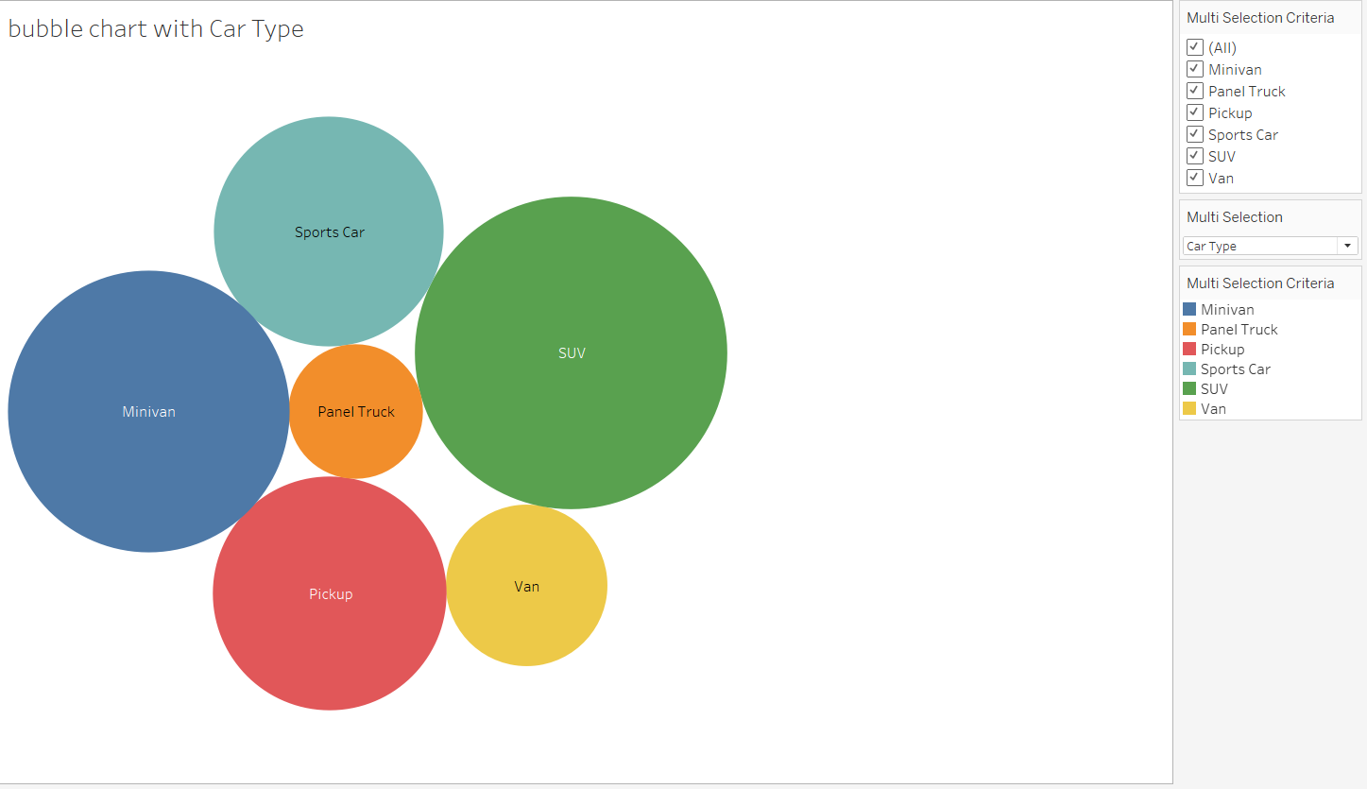

From the above Bubble chart size of the circle represents high claims

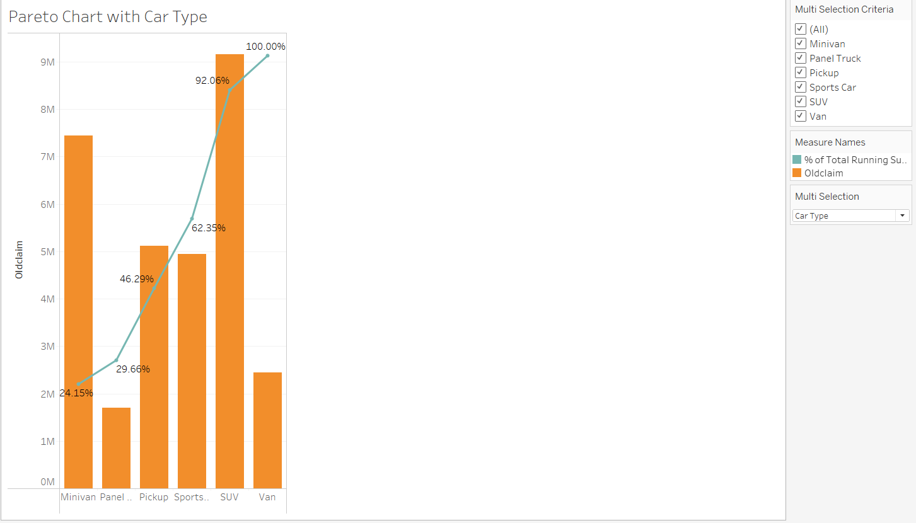

The above figure shows the Pareto chart, which shows the cumulative percentage contribution of different vehicles

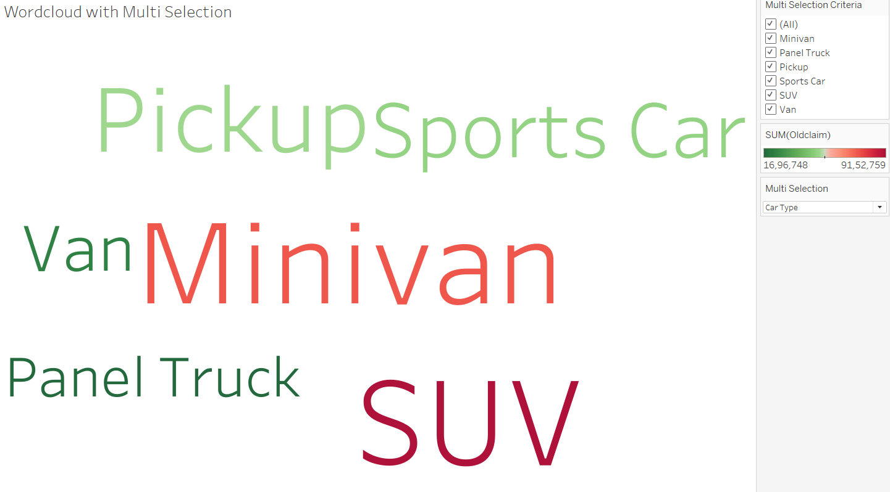

From the above figure, we can see word cloud for car type Red indicates high claims.

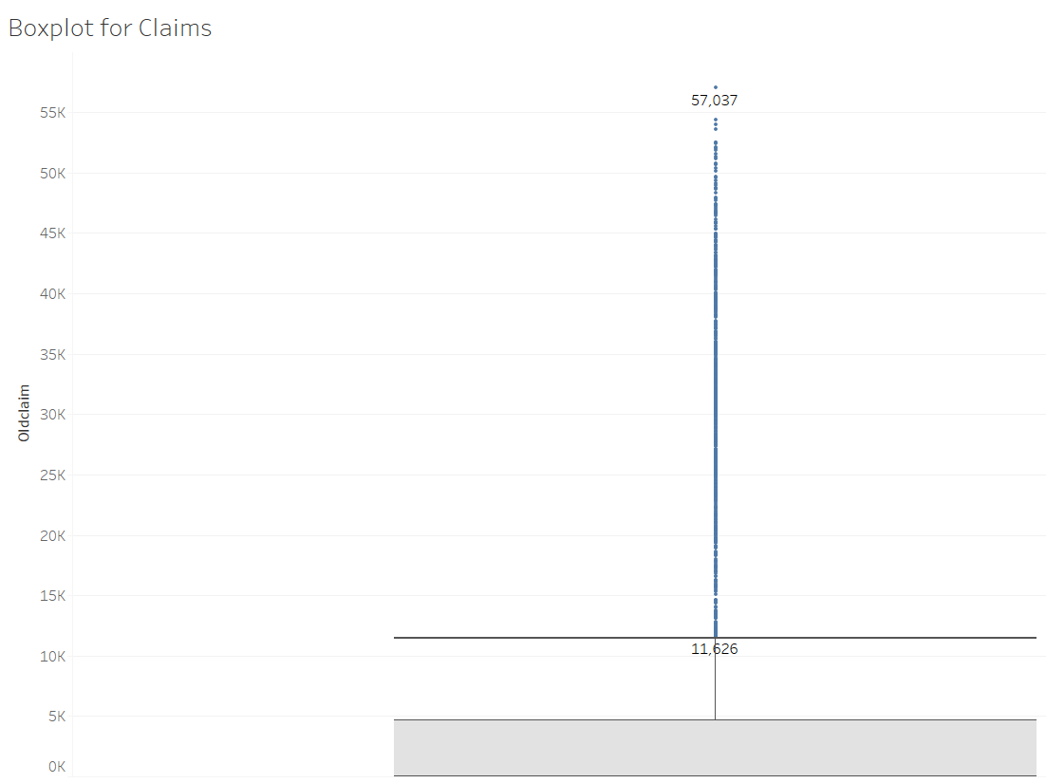

The above figure shows Boxplot for claims

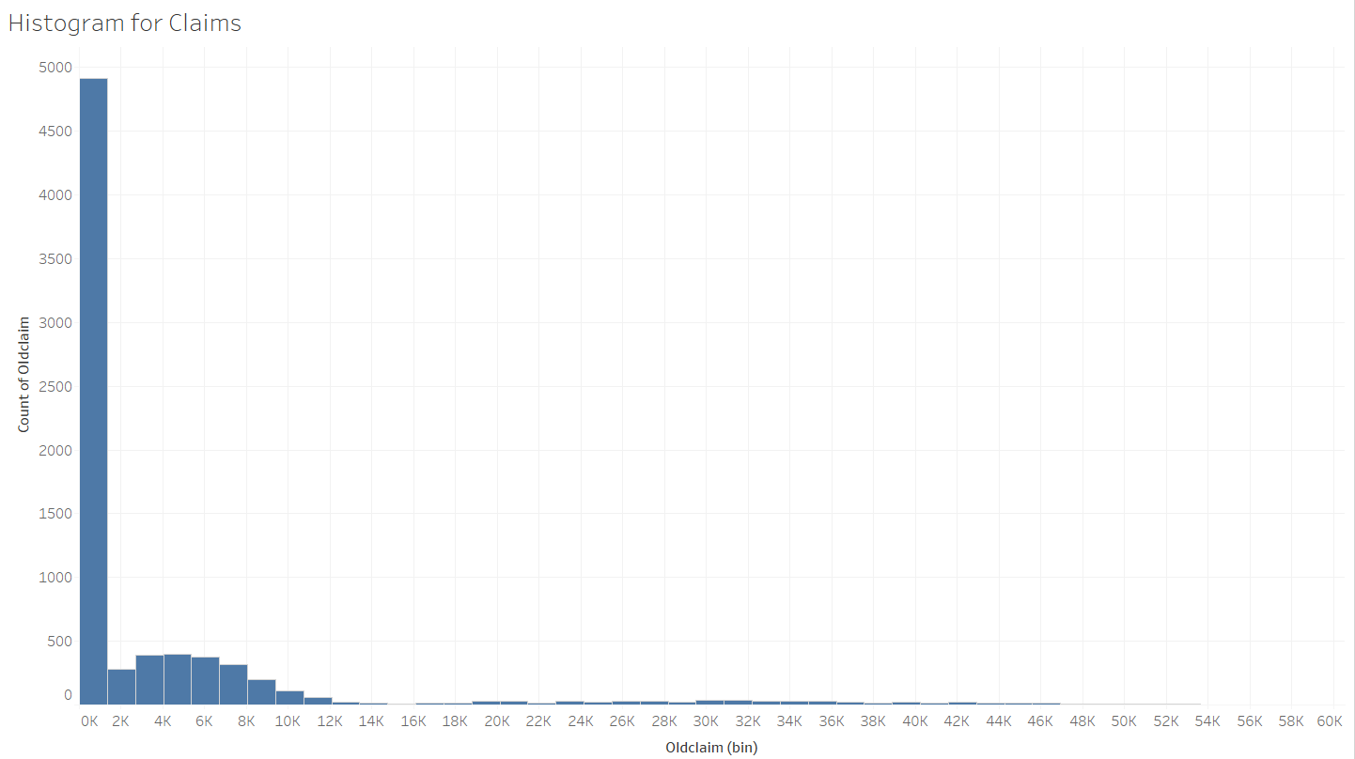

The above figure shows Histogram for claims

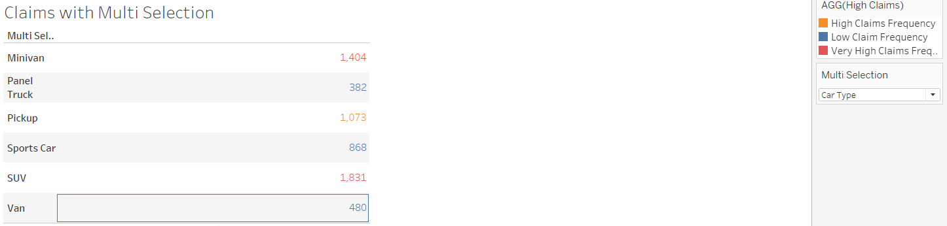

The above figure shows Table calculation with created calculation field for claims

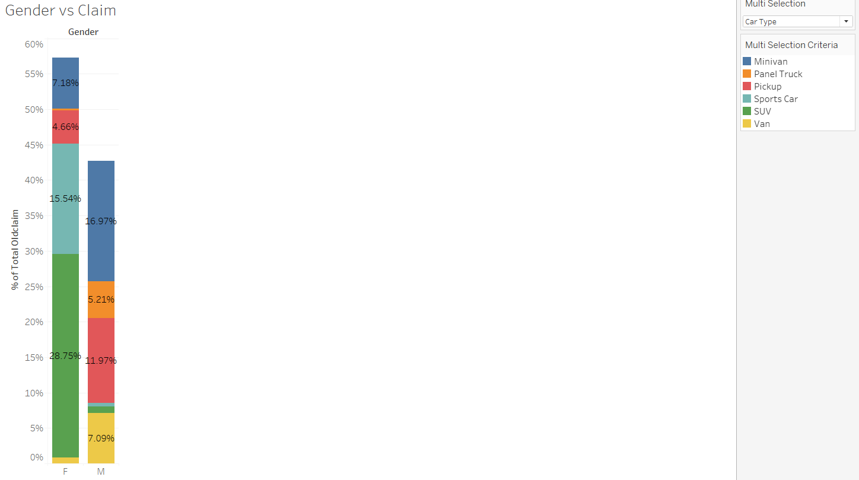

The above figure shows Barchart for Gender and claims

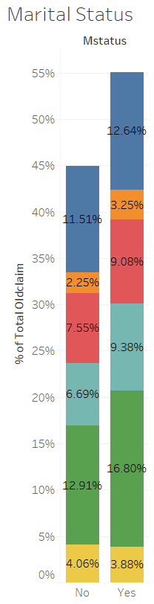

The above figure shows Bar chart for claims and Marital Status

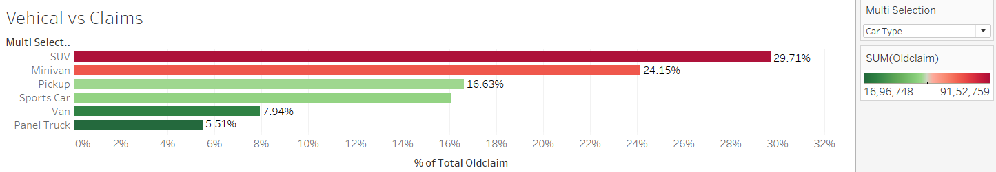

**The above figure shows percent of total for claims used quick Table calculations to get the values.**

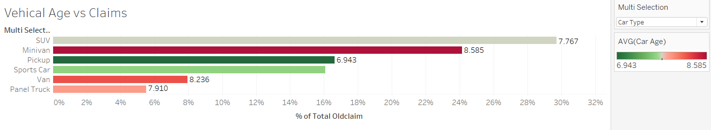

**The above figure shows the Average Age of vehicle for claims.**

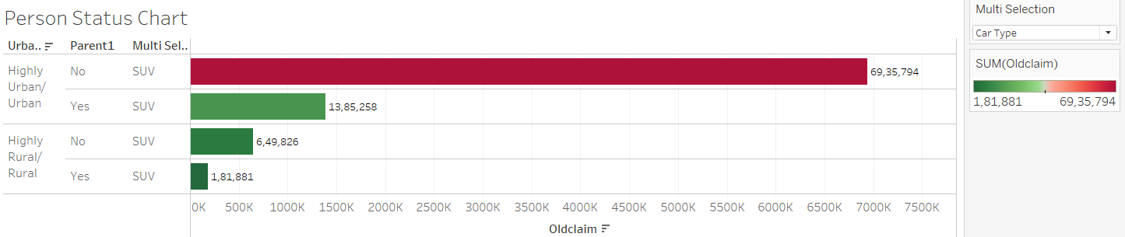

**The above figure shows Percent of total claims and people who are living in Urban and Rural areas.**

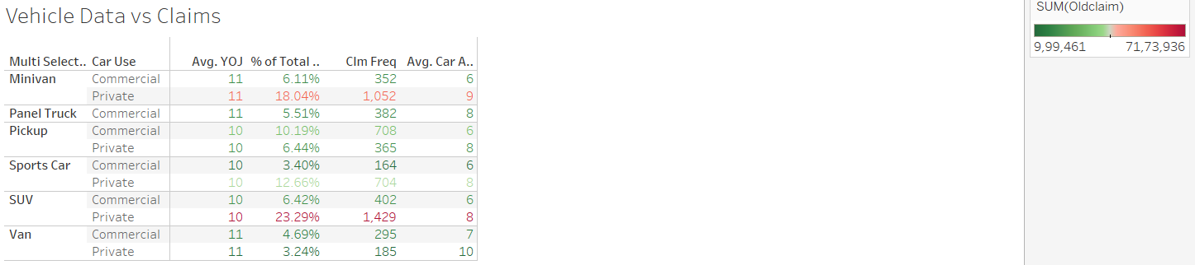

**The above figure shows the average age of vehicles for each type.**

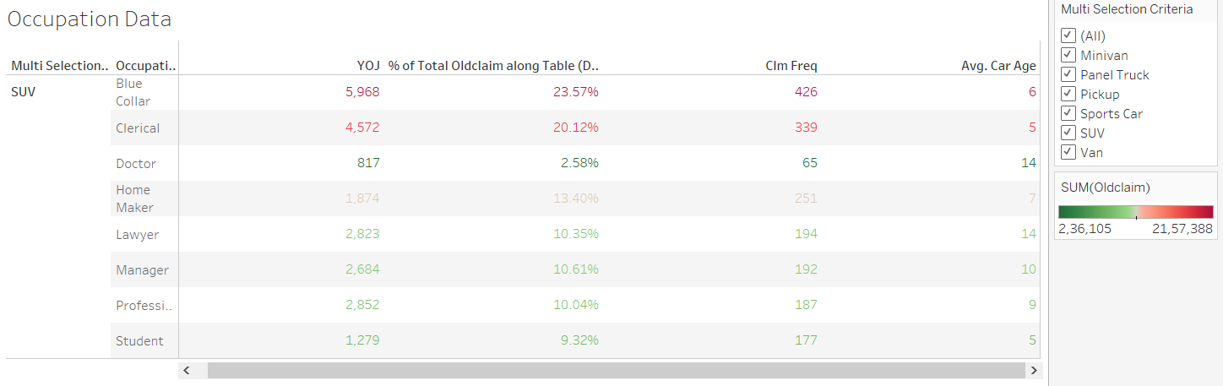

**The above figure shows percent of total for claims and people who are in different occupations used to claim.**

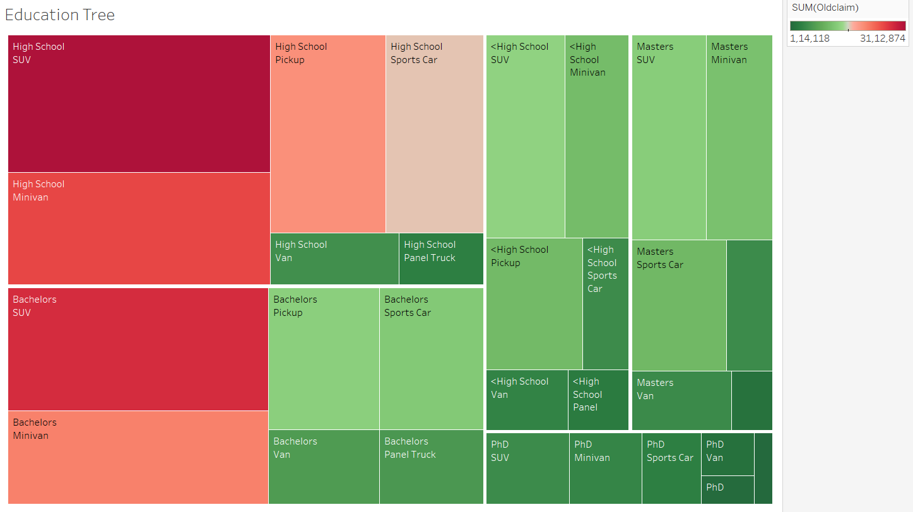

**The above figure shows a Tree map for the Education of claimed persons in the data.**

**Data Insights as shown below**

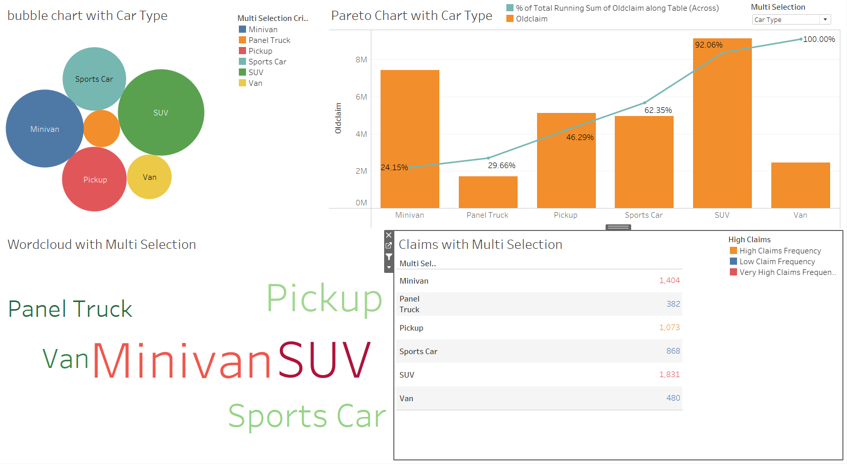

2. **Creating a calculated field. The calculated field should add some meaningful value and should be inline with your storyboard which you will create in this project. (Specify where calculated field has been used). (2)**

**” High Claims”** is created calculated field, we used this function to segregate claim frequency and divided it into 3 buckets as Very High Claims Frequency, Very Claims Frequency, Low Claims Frequency and we used this calculated field in the Claims with Multi Selection chart.

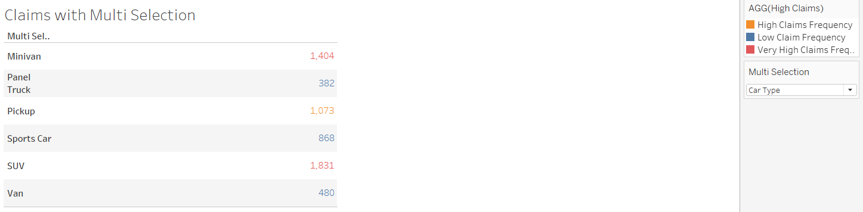

From the above chart, we can see SUV type is the most frequently used vehicle to claim.

**3. Use of filters, parameter, actions, etc in the charts. (4)**

From the parameters **“Multi Selection”** is a created parameter is used in the calculated field **“Multi Selection Criteria”** to choose different aspects to check claims in the given data.

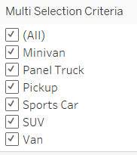

**4. Minimal clutter and consistency in use of colors across charts. (5)**

In the Charts we used Red-Green Divergence color to look into **data “Red”** color indicates high claim.

**5. Multiple Dashboards creation (10)**

At least 5 Dashboards

Primary Dashboard

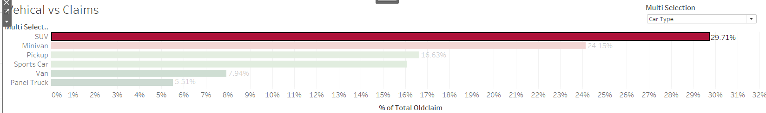

Secondary Dashboard

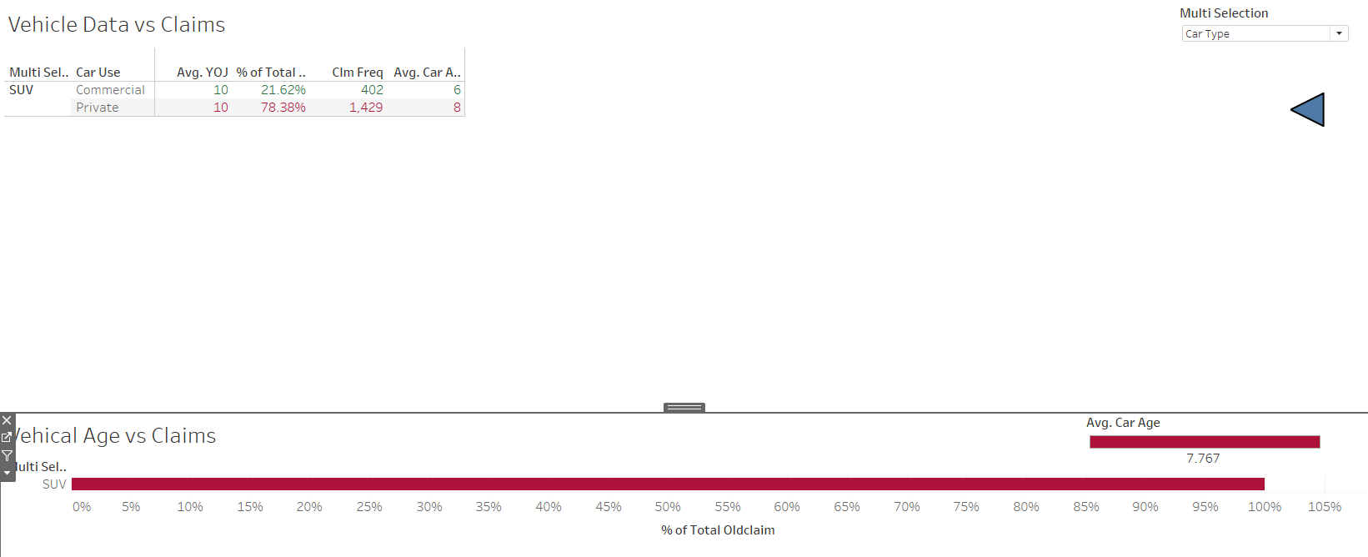

Third dashboard

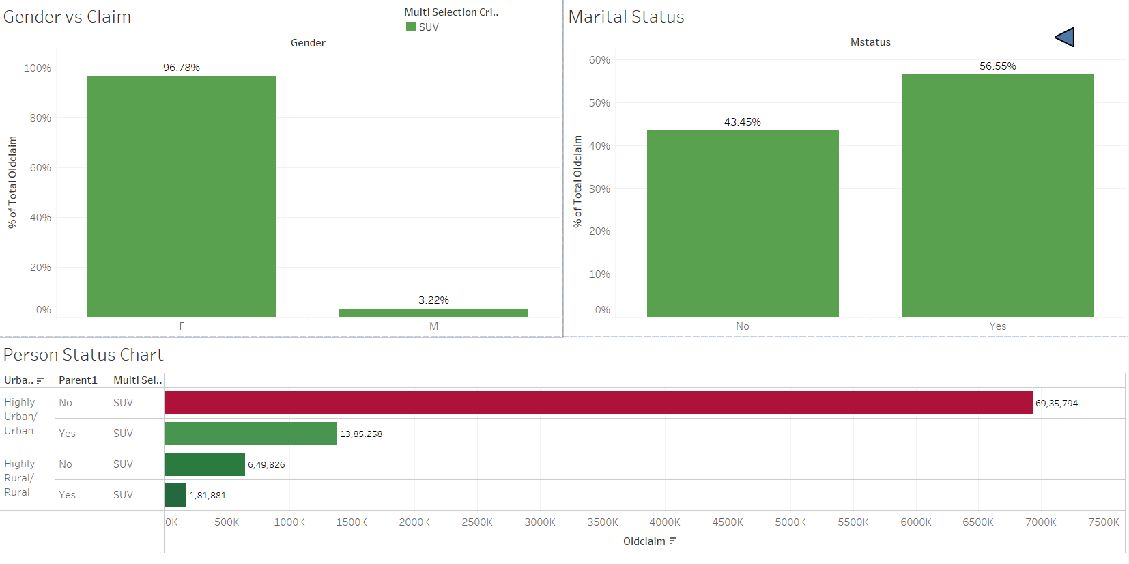

Fourth dashboard

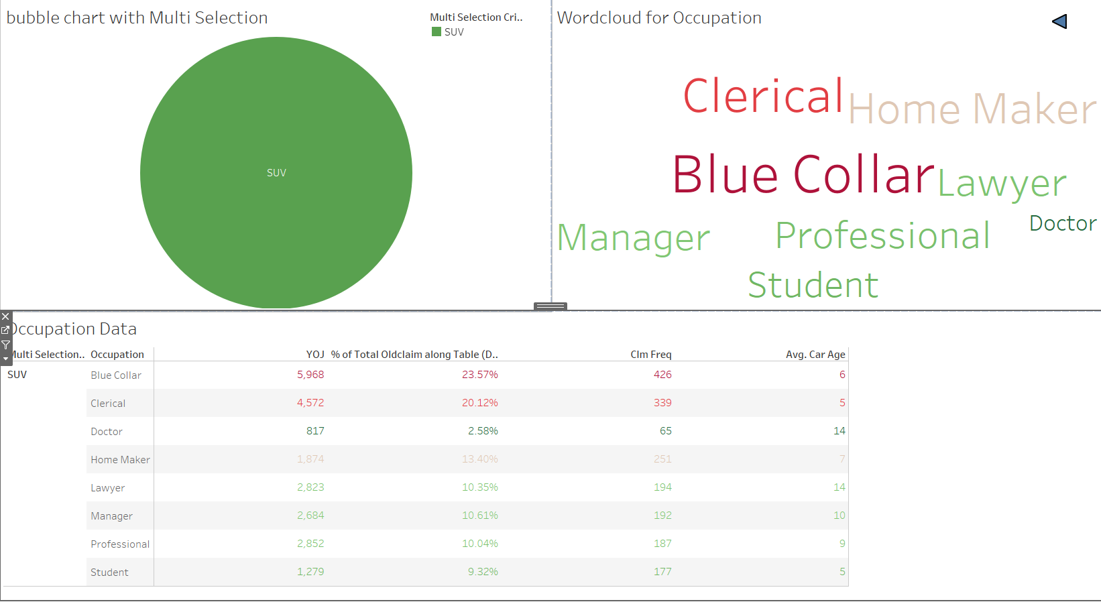

Fifth dashboard

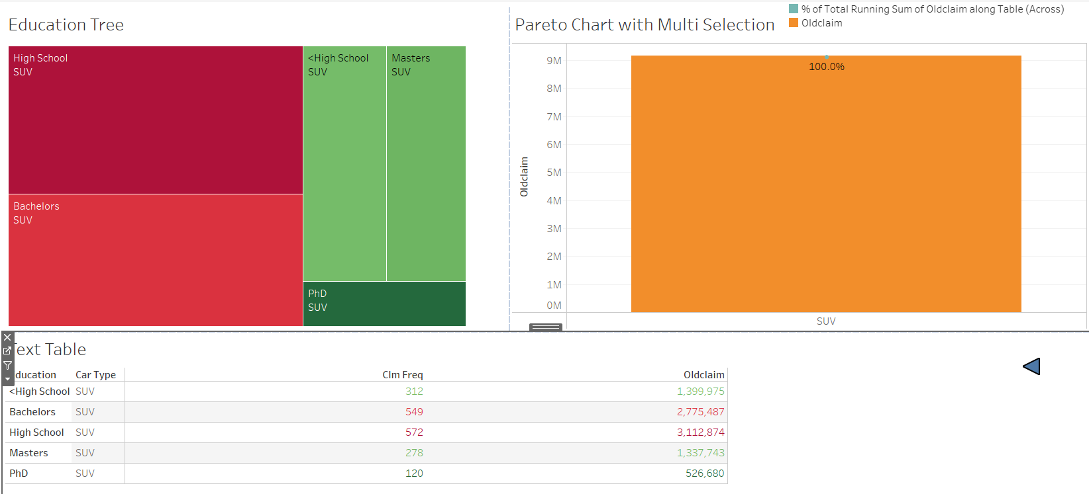

6. **Correct interpretations/insights from each type of chart created. The interpretations should be inline with the storyboard which is to be created in this project.**

These interpretations can be in the captions of the storyboard or in the plots as well. (16)

7. **Interactivity among the charts on each Dashboard. (5)**

Filters and actions are created in the dashboards to interact between charts.

**8. Storyboard Creation**

At least 1 Storyboard. (15)

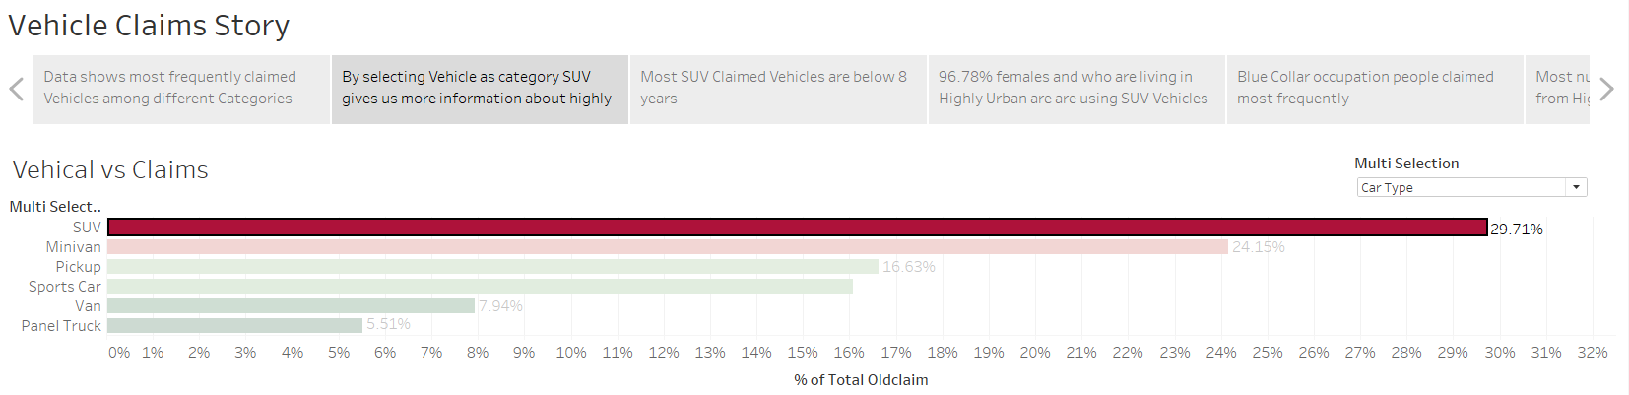

9. **Logical flow to the story represented in the storyboard. (5)**

We look at data from claims point so first we select a top claimed vehicle from the primary dashboard and we look at how data has been distributed among other dashboards by choosing different aspects like Personal details, Occupation, Education etc…

**10. 1 dashboard which will cover the summary and the recommendations from the insights to be added to the end of the storyboard**

This dashboard will be an extra dashboard apart from the mandatory 5 dashboards mentioned in the 5th part of the rubric. At least 5 summary/recommendation points from each dashboard. 1 point for the conclusion. (12)

A Recommendation Storyboard is created for this particular session.

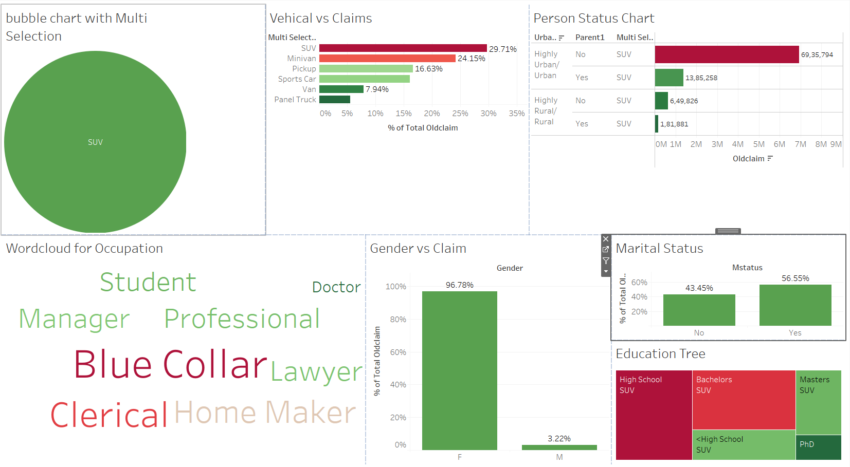

**Recommendations:**

**1.** Recommendations: For Suv and Minivan company should Provide Premium Policies.

**2.** Recommendations: Most of the SUV Vehicles are claimed between 6 to 8 years of vehicle age so the company should focus on these types of vehicles to give Premium Policies

**3.** Recommendation: Around 97% of females are using SUV for claims and they are mostly from Highly Urban areas, so the company should focus on them to give Premium Policies.

**4.** Recommendations: Blue Collar, Clerical and Home Maker are using high claims so the company should give Premium Policies to them.

**5.** Recommendation: High School, Bachelors are using high claims than others so the company should choose them to give Premium Policies.

**6.** For Panel Truck, and people who are living in rural areas and people who are well-educated company should give Promotions to increase sales.

**7.** Doctors and Students are also doing fewer claims so the company should focus on the people to give promotions to increase sales.