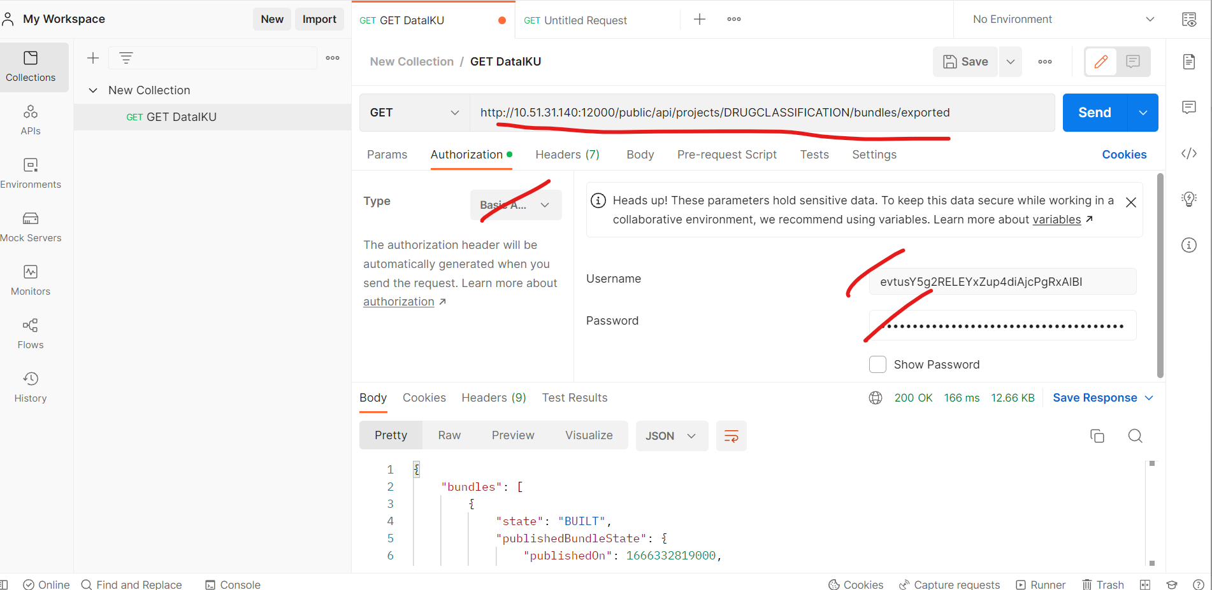

<http://10.51.31.140:12000/public/api/projects/DRUGCLASSIFICATION/bundles/exported>

<https://doc.dataiku.com/dss/api/9.0/rest/#api-services>