03-06-2026

1st Program
package mongodb;

import com.mongodb.MongoClient;
import com.mongodb.client.FindIterable;
import com.mongodb.client.MongoCollection;
import com.mongodb.client.MongoDatabase;
import com.mongodb.client.model.Filters;
import com.mongodb.client.model.Updates;
import org.bson.Document;

public class MongoCRUDExample {

public static void main(String[] args) {

// Connect to MongoDB
MongoClient mongoClient =
new MongoClient("localhost", 27017);

// Access database
MongoDatabase database =
mongoClient.getDatabase("CollegeDB");

// Access collection
MongoCollection<Document> collection =
database.getCollection("Students");

// CREATE
Document student = new Document("id", 101)
.append("name", "John")
.append("department", "CSE")
.append("cgpa", 8.7);

collection.insertOne(student);
System.out.println("Document Inserted Successfully");

// READ
System.out.println("\nStudent Records:");

FindIterable<Document> students = collection.find();

for (Document doc : students) {
System.out.println(doc.toJson());
}

// UPDATE
collection.updateOne(
Filters.eq("id", 101),
Updates.set("cgpa", 9.2)
);

System.out.println("\nDocument Updated Successfully");

// READ UPDATED RECORD
Document updatedStudent =
collection.find(Filters.eq("id", 101)).first();

System.out.println("\nUpdated Record:");
System.out.println(updatedStudent.toJson());

// DELETE
collection.deleteOne(Filters.eq("id", 101));

System.out.println("\nDocument Deleted Successfully");

// Close connection
mongoClient.close();
}
}

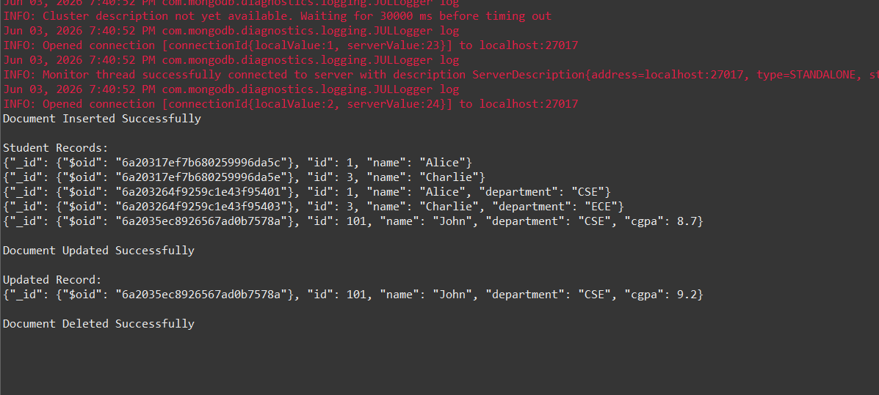

2nd Program
package mongodb;

import java.util.Arrays;

import com.mongodb.MongoClient;
import com.mongodb.client.MongoCollection;
import com.mongodb.client.MongoDatabase;
import com.mongodb.client.model.Filters;
import com.mongodb.client.model.Updates;

import org.bson.Document;

public class MongoMultiRecordExample {

public static void main(String[] args) {

// Connect to MongoDB
MongoClient mongoClient =
new MongoClient("localhost", 27017);

// Access Database
MongoDatabase database =
mongoClient.getDatabase("CollegeDB");

// Access Collection
MongoCollection<Document> collection =
database.getCollection("Students");

// ==========================
// INSERT MANY DOCUMENTS
// ==========================

collection.insertMany(Arrays.asList(
new Document("id", 1)
.append("name", "Alice")
.append("department", "CSE"),

new Document("id", 2)
.append("name", "Bob")
.append("department", "IT"),

new Document("id", 3)
.append("name", "Charlie")
.append("department", "ECE")
));

System.out.println("Multiple Documents Inserted Successfully");

// ==========================
// DISPLAY ALL RECORDS
// ==========================

System.out.println("\nAll Records:");

for (Document doc : collection.find()) {
System.out.println(doc.toJson());
}

// ==========================
// FIND SPECIFIC DOCUMENT
// ==========================

Document doc = collection.find(
Filters.eq("id", 2)
).first();

System.out.println("\nFound Record:");

if (doc != null) {
System.out.println(doc.toJson());
}

// ==========================
// UPDATE DOCUMENT
// ==========================

collection.updateOne(
Filters.eq("id", 2),
Updates.set("name", "Bobby")
);

System.out.println("\nDocument Updated Successfully");

// ==========================
// DISPLAY UPDATED DOCUMENT
// ==========================

Document updatedDoc = collection.find(
Filters.eq("id", 2)
).first();

System.out.println("\nUpdated Record:");

if (updatedDoc != null) {
System.out.println(updatedDoc.toJson());
}

// ==========================
// DELETE DOCUMENT
// ==========================

collection.deleteOne(
Filters.eq("id", 2)
);

System.out.println("\nDocument Deleted Successfully");

// ==========================
// DISPLAY REMAINING RECORDS
// ==========================

System.out.println("\nRemaining Records:");

for (Document remaining : collection.find()) {
System.out.println(remaining.toJson());
}

// Close Connection
mongoClient.close();
}
}

