

School of

Electronics and Communication Engineering

Minor Project Report on

**Hardware Implementation of Curvature Adaptive Headlight system**

|  |  |  |
| --- | --- | --- |
| **By:** |  | |
| **1.** | **Manjunath D.** | **01FE22BEI045** |
| **2.** | **Pradeep U. B.** | **01FE22BEI057** |
| **3.** | **Ayan N. Sayed** | **01FE22BEI058** |
| **4.** | **Vishwanath** | **01FE22BEC254** |

Semester: VI, 2024-2025

Under the Guidance of

**Prof. Amit R. T.**

**K.L.E SOCIETY’S**

**KLE Technological University,**

**HUBBALLI-580031**

**2024-2025**



SCHOOL OF ELECTRONICS AND COMMUNICATION ENGINEERING

CERTIFICATE

This is to certify that project entitled **“Hardware Implementation of Curvature Adaptive Headlight System ”** is a bonafide work carried out by the student team of **”Manjunath D. (01FE22BEI045), Pradeep U. B. (01FE22BEI057), Ayan N. Sayed (01FE22BEI058) and Vishwanath H. (01FE22BEC254)”**. The project report has been approved as it satisfies the requirements with respect to the minor project work prescribed by the university curriculum for BE (VI Semester) in School of Electronics and Communication Engineering of KLE Technological University for the academic year 2024- 2025.

|  |  |  |  |
| --- | --- | --- | --- |
| **Prof. Amit R. T.** | **Dr. Suneeta V Budihal** | **Dr. B. S. Anami** | |
| **Guide** | **Head of School** | | **Registrar** |
|  |  | |  |

**External Viva:**

**Name of Examiners Signature with date**

1.

2.

ACKNOWLEDGMENT

We express our wholehearted thanks for the smooth completion of our academic project entitled "Hardware Implementation of Adaptive Headlight System based on Curvature Detection Technique" at KLE Technological University, Hubballi.

We are deeply grateful to our honoured guide, Prof. Amit R. T., School of Electronics and Communication, KLE Technological University, for his precious guidance, continuous motivation, and wise inputs during the tenure of this project. His leadership was instrumental in steering our strategy and implementation.

We also express our sincere gratitude to the technical staff and faculty members of the School of Electronics and Communication for their regular support, prompt suggestions, and for rendering us the required resources to implement our project.

We thank our KLE Technological University, Hubballi, for providing us the platform and infrastructure to implement an innovative and practical solution for real-world problems in automotive systems.

Finally, we would also like to thank our families and friends for the motivation and encouragement, whose support kept us together and determined during the course of the project.

-The project team

ABSTRACT

Driving on Curved roads during night is tiring and risky because of limited visibility and blind spots. Permanent headlights provide a straight line of sight and tend not to illuminate the road in bends properly, giving less time to react for drivers. This issue is even more critical at high speeds. One approach to achieving safer night driving is presented through this project in the form of a Curvature Adaptive Headlight System. The system also adjusts the light direction according to road curve, vehicle speed, and steering maneuvers. Through cameras, sensors, and sophisticated computer vision, it illuminates more around corners, minimizes blind spots, and enables drivers to see ahead. This method not only increases safety but also highlights increased consumer interest in more intelligent and adaptive technology in contemporary cars.

# Contents

1. **Introduction** **7**
   1. Motivation 7
   2. Objectives 7
   3. Literature survey 7
   4. Problem statement 9
   5. Application in Societal Context 9
   6. Project Planning and bill of materials 9
   7. Organization of the report 10
2. **System design** **11**
   1. Functional block diagram 11
   2. Design alternatives 12
   3. Final design 12
3. **Implementation deta****ils** **13**
   1. Specifications and final system architecture 13
   2. Algorithm 14
4. **Optimization** **16**
   1. Introduction to optimization 16
   2. Types of Optimization 16
   3. Selection and justification of optimization method 17
5. **Results and discussions** **18**
   1. Result Analysis 18
   2. Discussion on optimization 18
6. **Conclusions and future scope** **20**
   1. Conclusion 20
   2. Future scope 20

**References** **21**

# List of Figures

* 1. **Functional Block Diagram 11**

**5.1 (a) & (b) Prototype Model 19**

# Chapter 1 Introduction

* 1. **Motivation**

Driving at night on winding roads can be challenging and dangerous due to poor visibility and blind spots. Fixed headlights, which always point straight ahead, often fail to light up the road properly around curves, leaving drivers with less time to react. This problem becomes even more serious at higher speeds. To make night driving safer, this project focuses on creating a Curvature Adaptive Headlight System. The system adjusts the direction of the headlights based on the curve of the road, the car’s speed, and steering movements. Using cameras, sensors, and advanced computer vision, it provides better illumination around bends, reduces blind spots, and helps drivers see what lies ahead. This approach not only enhances safety but also reflects the growing demand for smarter, more adaptive technologies in modern vehicles.

* 1. **Objectives**
* To detect curvature using Computer vision.
* To implement adjustment of Headlights with Servo motors.
* To provide Affordable, compact and reliable system.
* To improve visibility and reduce curve-related crashes  
  1. **Literature survey**

Poor visibility is a major concern in nighttime driving, which contributes to a large number of road accidents. Adaptive Front Lighting Systems (AFS) and Advanced Driver Assistance Systems (ADAS) have been proposed to improve driver visibility by dynamically adjusting headlamp orientation based on road curvature, vehicle speed, and environmental conditions [1][2]. Traditional AFS uses steering angle, yaw rate, and speed as vehicle parameters to position the beam, but these systems have lagging responses and are not very accurate, especially in sharp turns [1][3]. To overcome these limitations, several predictive and sensor-based solutions have been proposed.

A predictive AFS using image-based curvature estimation was proposed in [1], which uses LDWS instead of GPS to predict road curvature ahead. The system dynamically adjusts beam angles before the driver enters a turn by incorporating image sensor-based curvature prediction, reducing blind spots and improving reaction time. However, the use of road markings to estimate curvature has limitations in undermaintained or unstructured environments [1][4]. An analogous HiL simulation-based Adaptive Headlight System was investigated in [3], where real-time trajectory prediction was employed to improve dynamic beam control. This system uses vehicle speed, yaw rate, and slip angle to compute the road curvature so that illumination can be optimized for turns. Additionally, it features an emergency mode that reverts to conventional settings during extreme conditions to prevent driver confusion. Despite its advantages, real-world implementation remains challenging due to the complexity of sensor calibration and integration with existing vehicle electronics [3][4].

Beyond AFS, researchers have explored multi-functional safety systems integrating lane detection, adaptive headlights, and wipers to enhance driving safety. The system in [2] combines Lane Departure Warning (LDW), Adaptive Headlights, and an Adaptive Wiper System. Video processing is achieved by the Raspberry Pi and real-time decision-making using the Arduino Mega. The Lane Departure Detection System employs edge detection and Hough transforms, whereas Adaptive Headlight utilizes the road curvature, ambient light, and intensity of the rain for adjusting the orientation and intensity of headlamps dynamically. The experimental results showed high accuracy in lane detection at 99.8% and a warning rate of lane departure at 92.1%, thereby effective for highway driving. Still, image processing in real time has certain computationally intensive challenges that cannot be avoided, especially during dense traffic or unfavourable weather [2][4].

The gaps in real-time adaptability along with system integration have been pointed out by other research on the aspects of AFS and intelligent lighting systems. Traditional AFS solutions rely on driver inputs, delaying the response time and reducing accuracy in sharp curves [1][4]. Early research by Kobayashi et al. in 1997 and 1998 and Aoki in 1997 introduced basic improvements on beam control but remained unlinked to modern image recognition techniques [4]. Neumann in 2002 highlighted the need for holistic adaptation of automotive lighting for improving night visibility [4]. More recent studies by Du et al. (2011) and Fu et al. (2010) proposed intelligent vehicle control systems but failed to implement preemptive adjustments for complex road conditions [4]. To address these limitations, [4] introduced a CCD-based image recognition system, offering improved real-time adaptability and precise beam control based on varying road curvature.

Even though adaptive lighting systems have undergone significant development, there are still several real-world challenges posed, namely, hardware dependency, environmental constraints, and the necessity for robust real-time processing [1][2][3]. Future work in this regard should include the development of advanced sensor fusion techniques, machine learning-based road prediction, and cost-effective implementation to improve driving safety under various terrains and lighting conditions.

* 1. **Problem statement**

Traditional headlights are fixed in one position and cannot adapt to changes in the road, which creates blind spots on curved roads. This leads to poor visibility, especially when driving at night. The goal of this project is to use a mobile camera to dynamically calculate the road’s curvature and adjust the headlights accordingly. By doing so, drivers will have better visibility around turns, which will reduce the risk of accidents caused by inadequate lighting. The challenge lies in processing the camera data quickly and accurately to ensure the headlights adjust seamlessly in real-time.

* 1. **Application in Societal Context**

This system has the potential to make driving on curve roads, particularly at night, much safer. By improving visibility, it can reduce the number of accidents that occur due to poor lighting on turns. It can also contribute to energy-efficient lighting systems that automatically adjust based on the road's needs, saving energy when full headlight power isn’t necessary. The technology can be applied to a wide range of vehicles, from personal cars to commercial trucks, improving road safety for all types of drivers. This project also supports the ongoing push for smarter, more adaptable technologies in vehicles, contributing to the growing trend of intelligent transportation systems.

* 1. **Project Planning and bill of materials:**

This section provides an overview of the project’s timeline, resource allocation, and the materials required to implement the Curvature Adaptive Headlight System. The project is divided into the following key phases:

* **Phase 1: Research and Planning**  
  Understanding the problem, identifying the objectives, and conducting a literature survey to explore existing adaptive headlight systems.
* **Phase 2: System Design**  
  Creating the functional block diagram, deciding on design alternatives, and finalizing the architecture.
* **Phase 3: Implementation**  
  Developing the algorithm using Python and OpenCV, setting up the mobile camera input, and integrating the animation module to simulate the system.
* **Phase 4: Testing and Optimization**  
  Testing the system under various conditions and optimizing performance to achieve real-time adaptability.
* **Phase 5: Documentation**  
  Preparing the final project report and presentation materials.

**Bill of Materials:**

* **Hardware Requirements:**

•Mobile camera capable of capturing video.

•Raspberry Pi 5 for image processing tasks.

• Servo motor and LEDs for implementation.

* **Software Requirements:**

•Python (with OpenCV, Matplotlib, and other libraries).

* **Other Materials:**

•Data for testing (road videos with varying curvatures).

•Toy Car model for presentation.

**1.7 Organization of the Report**

This report is structured into the following chapters to provide a comprehensive overview of the project:

1. Introduction: Discusses the motivation, objectives, and problem statement, highlighting the significance of the Curvature Adaptive Headlight System in improving night-time driving safety.
2. System Design: Details the functional block diagram, design alternatives considered, and the final design of the system.
3. Implementation Details: Provides an in-depth explanation of the algorithm, hardware and software specifications, and the final system architecture.
4. Optimization: Explains the importance of real-time performance, types of optimizations applied, and their impact on the system’s efficiency.
5. Results and Discussions: Summarizes the system's performance, result analysis, and areas for improvement.
6. Conclusions and Future Scope: Highlights the project outcomes and proposes future enhancements to make the system more robust and practical for real-world applications.
7. References: Lists the sources and studies referred to during the project.

# Chapter 2 System design

* 1. **Functional block diagram**

The block diagram of the proposed Curvature Adaptive Headlight System shows a closed-loop vision-based control process that allows for dynamic headlight beam adjustment based on the road's curvature. The process starts with the startup of Raspberry Pi 5 and the camera to create the central processing and sensing unit. The camera constantly takes real-time video frames of the road ahead. These frames go through preprocessing operations, such as grayscale conversion, Gaussian blurring, and edge detection to identify important features. The Region of Interest (ROI) is chosen to concentrate computation on the area immediately in front of the car, where road curvature is most prominent. Through the application of the Hough Transform, lane lines are identified and processed to estimate the curvature angle of the road. The raw curvature data is filtered through a smoothing filter (e.g., moving average filter) to provide smooth and stable servo motor responses. The calculated angle is then employed to drive the servo motor, which controls the headlight direction in real time. The processed video and the angle data are also output for monitoring and logging.

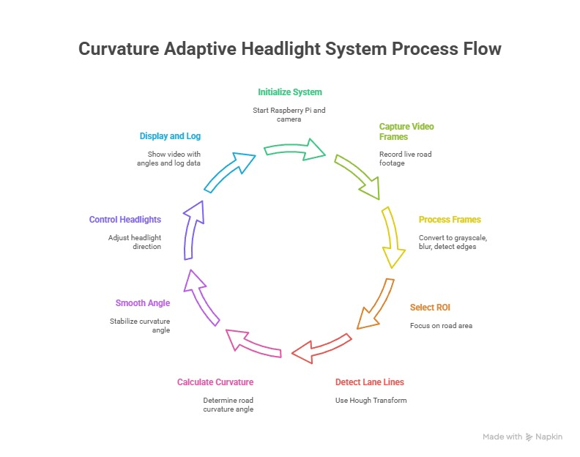

**Fig.2.1 Functional Block Diagram**

* 1. **Design alternatives**

Some of the design options were analyzed early in development to determine the most efficient and practical method for adaptive headlight control. One was to use ultrasonic or infrared (IR) sensors to find road edges; these sensors were not capable of adequate range and directional resolution for good curvature estimation. Another approach was to utilize an accelerometer and steering angle sensor to estimate vehicle orientation and steering dynamics. Though this approach would have provided immediate feedback, it brought in increased hardware complexity, synchronization issues, and added costs. Innovative methods involving LiDAR or GPS-based curvature mapping were also explored but ruled out because of cost and reliance upon external systems. After considering all avenues, a computer vision-based solution was found to be the most appropriate because of its cost-effectiveness, ability to capture visual road features well, and compatibility with current hardware platforms.

**2.3 Final design**

The overall design combines a Raspberry Pi 5, a camera module, and a servo motor in an efficient and inexpensive system able to perform real-time road curvature detection and automatic headlight adjustment. Frames of video taken by the camera are processed with OpenCV libraries to locate road edges and extract lane lines with the Hough Transform. The curvature angle is estimated from the orientation of these lines and filtered to make smooth servo motor transitions. The filtered result is translated into a pulse-width modulation (PWM) signal that actuates the servo motor, which actually varies the angle of the headlight beam. This deployment was tested on reduced-scale configurations and simulated road conditions, where it demonstrated efficient performance in tracking bends, enhancing sight on curves, and keeping pace with the vehicle path. The system itself balances the need for cost-effectiveness without a sacrifice in performance, such that it is ideal for implementation in low-cost active lighting systems or even as a prototype for potential ADAS research.

# Chapter 3 Implementation details

* 1. **Specifications and final system architecture**

| **Component** | **Description** |
| --- | --- |
| **Raspberry Pi 5** | Primary processing unit; runs Python and OpenCV for video processing |
| **Camera Module (or IP Webcam)** | Captures real-time video of the road ahead |
| **Servo Motor (SG90 or MG995)** | Rotates the headlight in response to curvature |
| **PWM Driver (optional)** | Controls motor precision if using multiple actuators |
| **Headlight (LED/Prototype Light)** | Represents beam direction control |
| **Power Supply** | 5V regulated power for Pi and peripherals |
| **Breadboard and Jumper Wires** | Circuit connections and GPIO interfacing |

The suggested system utilizes a Raspberry Pi 5 as the main controller to adaptively control a car's headlight according to real-time road curvature. A camera installed at the front of the car continuously takes video frames ahead of the car, which are processed on the Raspberry Pi by utilizing computer vision algorithms. The frames pass through grayscale conversion, blurring by the Gaussian filter, and Canny edge detection to enhance significant visual features. An Area of Interest (ROI) is chosen to focus processing on the road region. Lane lines are detected with the Hough Line Transform, from which the road curvature angle is approximated. This angle is smoothed using a moving average method for smooth motion. The smoothed angle is transformed into a PWM signal that drives a servo motor attached to the headlight. As the servo turns, the headlight beam is oriented to the road curve, enhancing safety and visibility. The system can incorporate a display interface in order to project lane lines and angle information in real time. This real-time adaptive lighting is low-cost, efficient, and well-adopted as a closed-loop system.

**Algorithm**

Hough Transform is a widely used image processing algorithm for detecting geometric shapes like lines, circles, and ellipses in digital images. For this project, the Hough Line Transform is utilized to find lane lines on the road from video frames recorded through an IP webcam.

**Working Principle:**

The standard form of a line is:



However, the Hough Transform uses the **polar form** of a line to avoid issues with vertical lines:

* Here, ρ is the perpendicular distance from the origin to the line.
* θ is the angle between the x-axis and the line’s normal vector.

Each edge point in the image votes for all possible lines that pass through it in the (ρ,θ) parameter space. The algorithm accumulates votes in an accumulator array. Peaks in this array represent the parameters of the most probable lines present in the image.

The algorithm starts by starting the Raspberry Pi system as well as its GPIO pins and attaching the camera module. After the system is started, it goes into an endless loop where video frames are captured in real time. The frame is initially converted to grayscale to minimize complexity and computation. Then a Gaussian blur is applied to eliminate noise, and the edges are detected by the Canny algorithm to mark the edges of road elements. Following preprocessing, a Region of Interest (ROI) is determined to segment the road region from the frame. In that region, the Hough Transform is used to find straight lines signifying the lane edges. The bend of the road is estimated from the orientation and position of these lines.

The raw curvature angle is then smoothed by a smoothing filter to conform to smooth changes in beam direction. The smoothed curve is converted into a PWM signal that can be used to drive the servo motor. The PWM signal is then fed to the motor, which actually turns the headlight towards the detected curvature such that the path illuminated tracks the actual trajectory of the vehicle. This loop repeats while the system is running, enabling real-time, adaptive headlight control. When shut down, the system releases the hardware resources and correctly closes the GPIO connections. This efficient algorithm is the foundation of the curvature-adaptive headlight system, providing a low-cost and feasible method for improving night vehicle safety.

# Chapter 4 Optimization

* 1. **Introduction to optimization**

Optimizations are essential for ensuring that the system can process road data and adjust the headlights and steering in real-time, providing a smooth and reliable driving experience. Without proper optimization, the system might lag or experience delays, making the headlight adjustments less accurate and potentially unsafe. By optimizing the processing of video frames from the mobile camera, the system can analyze and respond instantly to changes in the road, ensuring it adapts quickly to turns and curves. This is especially important for maintaining smooth animations that reflect the real-time changes in the vehicle’s direction and headlight positioning.

* 1. **Types of Optimization**

**Software optimization:**

Software optimization focuses on improving the algorithms and processes that drive the system. By using more efficient methods, such as faster image processing techniques and reducing unnecessary calculations, the system can work much more quickly. This includes optimizing how the system detects edges or calculating the curvature of the road. For instance, simplifying the mathematical operations or lowering the image resolution without losing key details can drastically improve the system's speed and efficiency. The aim is to make sure the system can handle video frames quickly and accurately, ensuring that the headlights adjust as needed without any noticeable delay.

**Hardware optimization:**

Hardware optimization ensures that the system can handle real-time video input with minimal delay. Since the camera feeds data constantly, the hardware must be capable of processing that data quickly. This means using high-quality cameras and powerful processors to reduce latency and ensure smooth operation. Having sufficient processing power and memory in the system also ensures that it can handle complex tasks, like lane detection and curvature calculations, without slowing down. In some cases, using specialized hardware like GPUs to handle image processing tasks can speed up the system, allowing it to work seamlessly in real time.

* 1. **Selection and justification of optimization method**

Real-time performance is vital for this system to function properly and safely. If there is any delay between the calculated curvature and the adjustment of the headlights or steering, it could cause the system to misalign with the road, leading to potential hazards. By optimizing both the software and hardware, the system can react quickly to changes, ensuring that the headlights illuminate the road effectively and the steering adjusts smoothly. This quick response is particularly important when driving through curves, where immediate and accurate headlight positioning can make a significant difference in safety. Ensuring seamless real-time performance allows the system to function as intended, improving the overall driving experience and safety at night.

# Chapter 5

**Results and discussions**

* 1. **Result Analysis**

The system successfully calculated the road's curvature in real-time and displayed the corresponding angles in the terminal. These angles were then used to adjust the animation, where both the steering and headlights moved in sync with the road’s changes. This showed that the system could effectively simulate how adaptive headlights would respond in real driving situations. The system maintained consistent performance, even with continuous camera input, and the animations accurately represented the system’s functionality. Overall, the results demonstrated the system's potential to enhance night-time driving by improving visibility around curves.

* 1. **Discussion on optimization**

While the system performed well, there are areas for improvement to make it more efficient. Using higher-quality cameras would enhance lane detection and curvature calculations, providing even more precise data for adjustments. Additionally, incorporating GPU acceleration could speed up image processing, allowing the system to make faster real-time adjustments to the headlights and steering. With these optimizations, the system could be more responsive, ensuring quicker, smoother operation. These improvements would make the system more practical and scalable for real-world applications, particularly in autonomous or semi-autonomous vehicles.

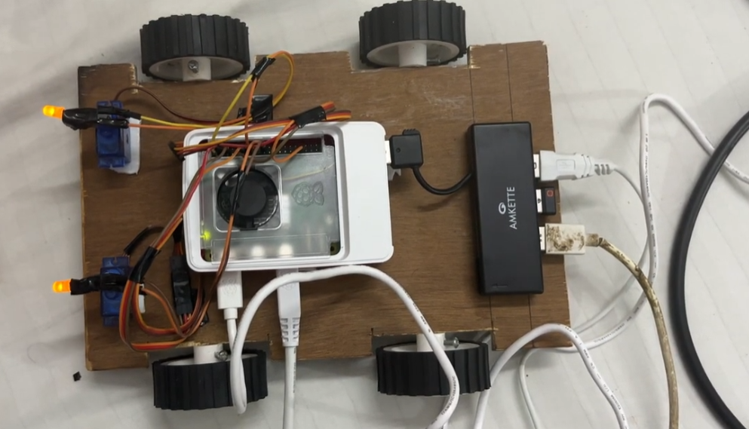

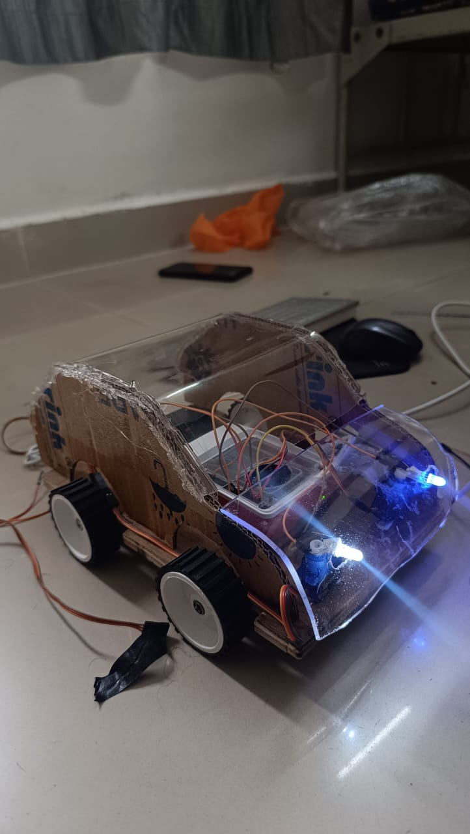

Fig. 5.1: (b) Front-Left Isometric View of Prototype Model

Fig. 5.1: (a) Prototype Model Top view

# Chapter 6

**Conclusions and future scope**

* 1. **Conclusion**

The Curvature Adaptive Headlight System successfully demonstrates how computer vision can enhance road safety by dynamically adjusting headlights based on road curvature. By providing an affordable and efficient approach to adaptive lighting, the project highlights its potential for real-world applications. The system’s use of readily available tools, such as mobile cameras and software-based solutions, makes it a practical and cost-effective option for improving visibility and reducing accidents during night-time driving.

* 1. **Future scope**

Future developments could focus on integrating the system into real vehicles with motorized headlights that physically adjust to road conditions. Enhancing the system with AI models could improve lane detection accuracy, making it more adaptable to diverse road types and weather conditions. Additionally, expanding the system to detect obstacles and respond dynamically would increase its utility in complex driving scenarios. These advancements would make the system more robust and pave the way for its implementation in modern vehicles, contributing to smarter and safer transportation solutions.

# Bibliography

* 1. Kim, K. H., Yum, D. H., Byeon, D. K., Kim, D. Y., & Lee, D. I. (2010, October). Improving driver's visual field using estimation of curvature. In ICCAS 2010 (pp. 728-731). IEEE.
  2. G. Vijay, M. N. Ramanarayan and A. P. Chavan, "Design and Integration of Lane Departure Warning, Adaptive Headlight and Wiper system for Automobile Safety," 2019 4th International Conference on Recent Trends on Electronics, Information, Communication & Technology (RTEICT), Bangalore, India, 2019.
  3. Hacibekir, T., Karaman, S., Kural, E., Ozturk, E. S., Demirci, M., & Guvenc, B. A. (2006, October). Adaptive headlight system design using hardware-in-the-loop simulation. In 2006 IEEE Conference on Computer Aided Control System Design, 2006 IEEE International Conference on Control Applications, 2006 IEEE International Symposium on Intelligent Control (pp. 915-920). IEEE.
  4. Guo, F., Xiao, H., & Tang, S. (2013, May). Research of modeling and simulation on adaptive front-lighting system for corner based on CCD. In 2013 25th Chinese Control and Decision Conference (CCDC) (pp. 3598-3602). IEEE.