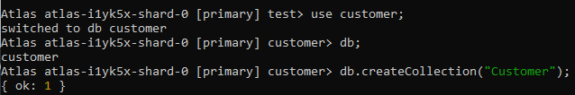

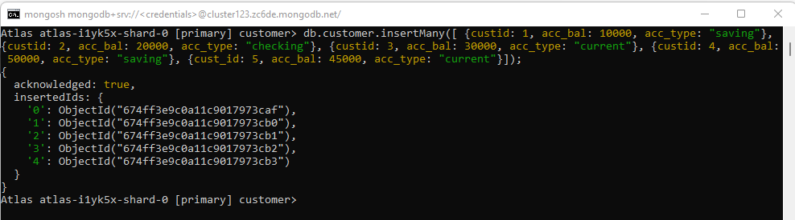

Query

1)

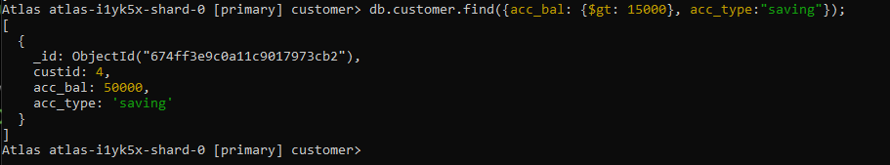

2)

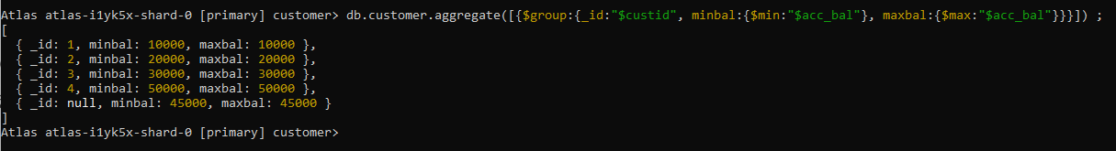

Export



Drop command

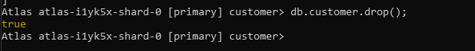

Import



Db,customer,find()

