On-Demand Car Wash

**Low Level Design (LLD)**



Date:15/07/2022

Name: Pradeep Garikapati

DOCUMENT APPROVAL

**Approvers of this document**

|  |  |  |  |  |
| --- | --- | --- | --- | --- |
| **Name** | **Department** | **Role** | **Signature** | **Date** |
|  |  |  |  |  |
|  |  |  |  |  |
|  |  |  |  |  |

**Document Change History**

|  |  |  |  |
| --- | --- | --- | --- |
| **Document Version #** | **Author** | **Date** | **Description** |
| 1.0 | Pradeep Garikapati | 15/07/2022 | On-Demand Car Wash |
|  |  |  |  |
|  |  |  |  |
|  |  |  |  |

Table of Contents

1.0 Document Purpose 4

2.0 Intended Audience 4

3.0 Project Background, Objective(s) 4

3.1Project Background 4

3.2Project Objective 4

4.0 Design Pattern 4

5.0 Solution Diagram

6.0 Solution Steps 5

7.0 Classes/function name 7

8.0 Validations 7

9.0 Data model/Tables 8

10.0 API Canvas 8

11.0 Env variables 10

12.0 Integrations 10

13.0 HTTP Status Code 10

14.0 Unit Testing 10

15.0 Request 10

16.0 Response 10

# Document Purpose

This document describes the solution for the On-demand car wash system.

# Intended Audience

The main role for an On-demand car wash system includes people who have a need to clean their car while there at home, salon, office or any other. This document is intended as a reference for the following roles and stakeholders who are interested in the On-demand car wash system.

|  |  |
| --- | --- |
| **Role** | **Nature of Engagement of Stakeholders** |
| Product Owners/SME | Key stakeholders to ensure that the architecture is aligned with business goals. |
| Business Analysts | Business analysts are one of the stakeholders who are informed of the key architectural decisions. |
| Enterprise Architects | To enforce Customer management Platform Architecture is aligned to business goals and architecture, and architectural guidelines. |
| Solution Architects | To ensure solution design and architecture are aligned to business requirements and architectural guidelines. |
| Developers | Use Technical Architecture Document as the guiding document for detail design and implantation approach to align with On-demand car wash system |

# Project Background, Objective(s)

## Project Background

On-demand car wash system provides the best car wash services at the customer’s doorstep.

## Project Objective

## To develop an On-demand car wash system that will use users to book a slot for car wash at the specified time and location. The application is featured with services like easy signup/login, edit their personal details, enter the car details for other washes, select the date, time, and add-ons or package details of wash, one-tap booking, and rating the wash service.

# Design Pattern

|  |  |  |
| --- | --- | --- |
| # | Name | Description |
| 1 | API | Using HTTP requests, we will use the respective action to trigger various operations |
| 2 | Angular | Angular is a platform and framework for building single-page client applications using HTML and TypeScript |
| 3 | SSMS | Microsoft SQL Server Management Studio (SSMS) is an integrated environment to manage a SQL Server infrastructure. |

# Solution Diagram

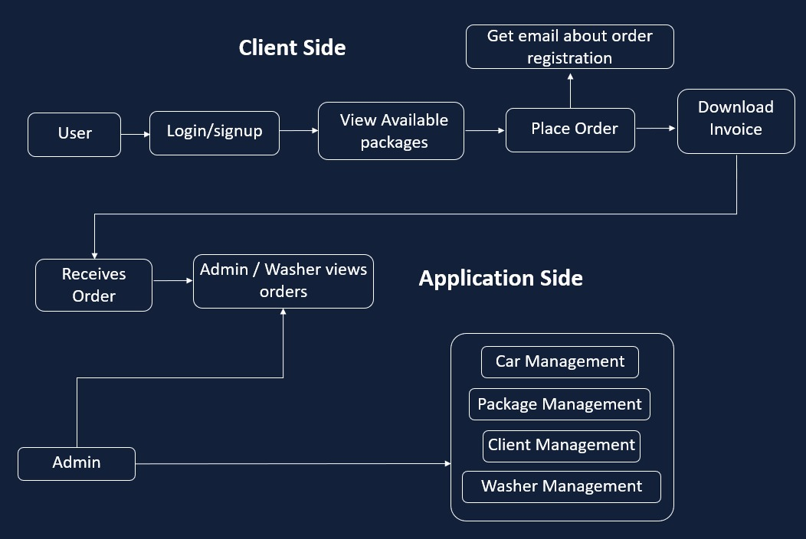

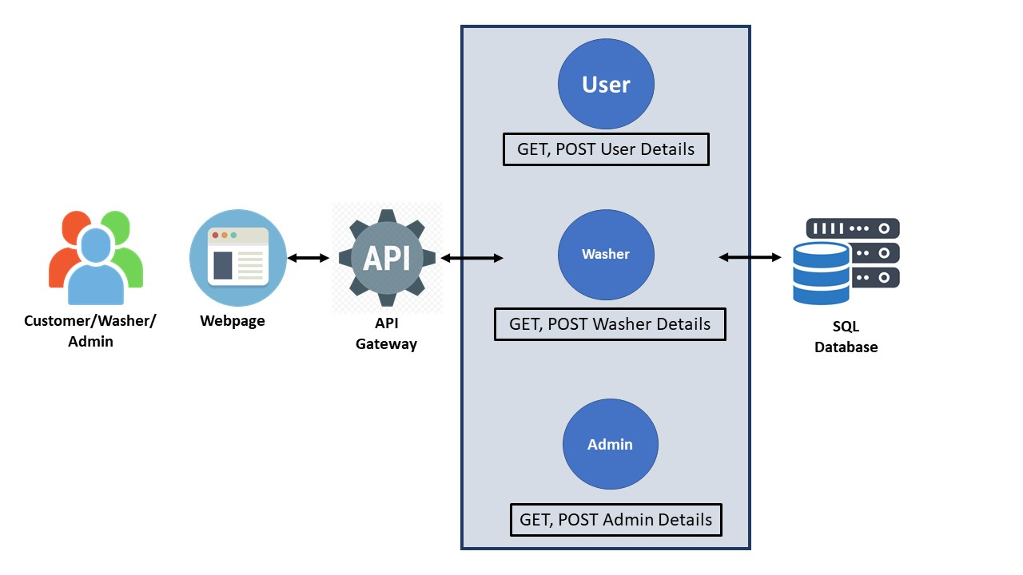

# 5.2 Use Case Diagram:

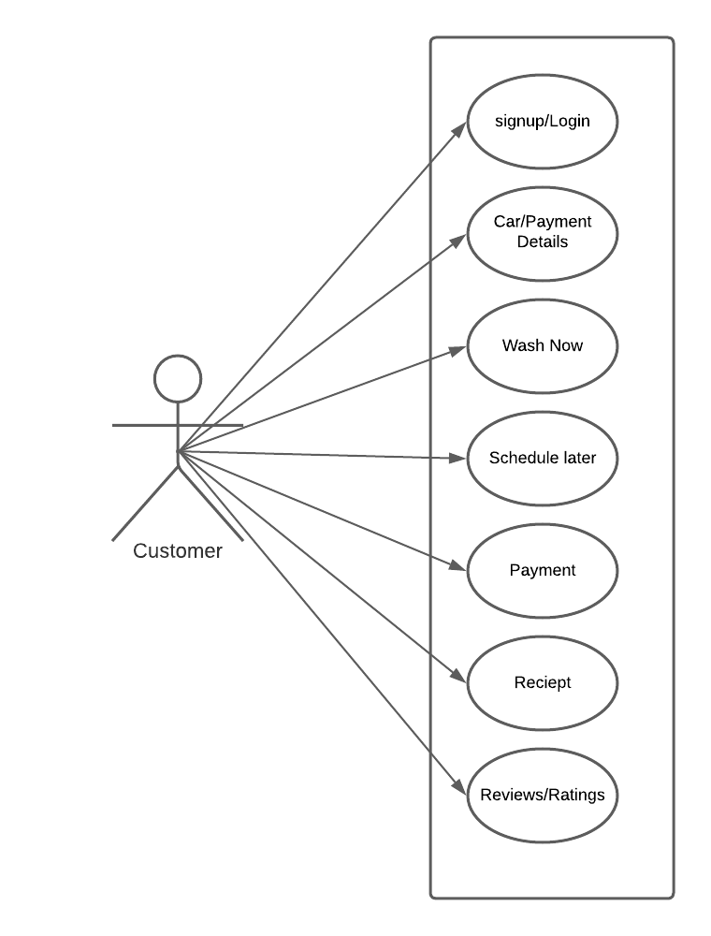

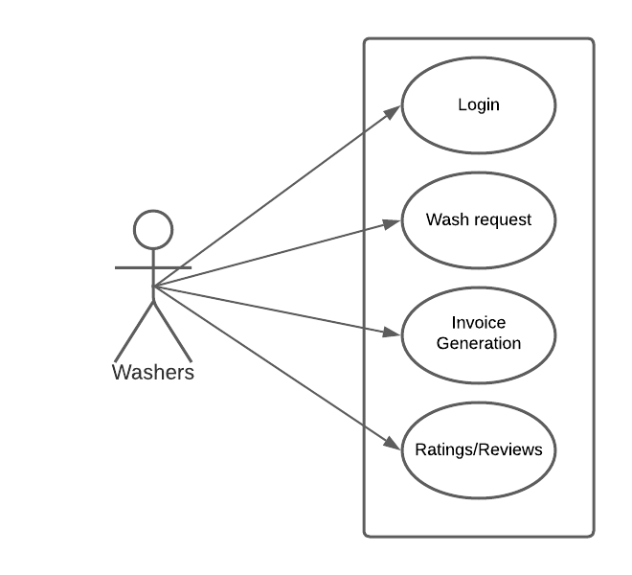

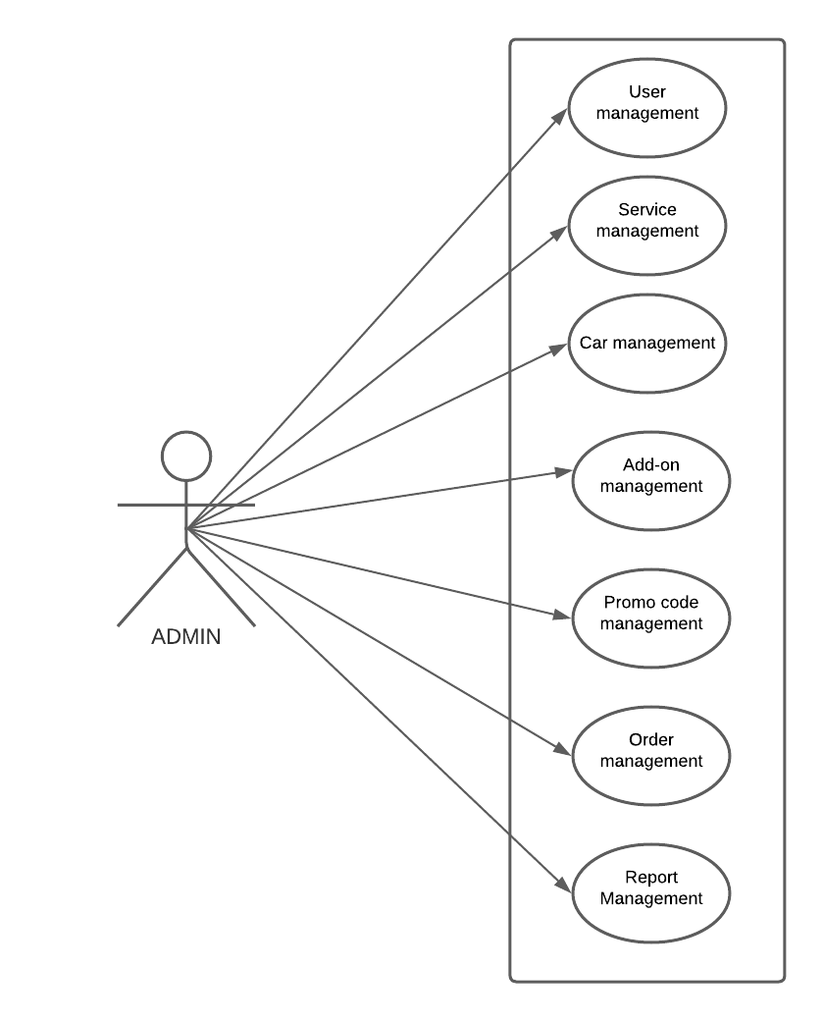

# 5.3 Hardware Requirements

1. • Requires a 2.6 GHz or faster processor. Quad core or better recommended.

# • Ethernet connection (LAN) OR a wireless adapter (Wi-Fi)

# • Hard Drive: Minimum 32 GB; Recommended 64 GB or more.

# • Memory (RAM): Minimum 4 GB; Recommended 8 GB or above.

# 5.2 Software Requirements

# • Visual studio 2022.

# •Sql server management studio (ssms).

# • Node, Angular.

# Solution Steps

**Customer Login/Signup**

1. User have to enter either the Facebook or Email Id for login button on the home page.
2. As the user clicks the Login/Signup button, the browser directs the request to is new customer.
3. API gateway does the routing and it request to new user.
4. The new user will validate if the user exists in the database or not
   1. If function returns true, user will be directed to the do the registration.
   2. If function returns false, the getUserDetails API will be called and the user will be greeted with his username and index page of the website.
5. Registration- User will enter the required details email, Phone number, car details, car image, and payment details to register.
6. The entered details will be validated by the function validateProfile().
7. On Successful validation and registration user will have to login again either using his email id or Facebook Id.
8. After login customer can book the washer to wash their car. Customer also had a option that he is not want to wash he has a option called Schedule Later.
9. If customer needs car wash then the user can confirm the booking and pay washers through their debit/credit cards.
10. After the successful car wash, washer sends payment receipt to the user.

**Washer Login**

1. Washer have to enter his login Id and password.
2. As the washer clicks on the login button, the browser directs the request to the washer login API.
3. Call reaches the API gateway.
4. API gateway does the routing and forwards the request to washer.
   1. If it returns true, the application displays the dashboard for the washer.
   2. If it returns false, the application displays the error message to the washer.

**Admin Login**

1. Admin have to enter his login Id and password.
2. As the washer clicks on the login button, the browser directs the request to the washer login API.
3. Call reaches the API gateway.
4. API gateway does the routing and forwards the request to admin.
   1. If the function returns true, the browser displays the dashboard for the admin.
   2. If the function returns false, the browser displays the error message to the admin.

# 7.0 Classes/function

|  |  |
| --- | --- |
| Class | Description |
| Customer.cs | Model holds the Customer schema details |
| userRegistration.cs | It contains the logic for the registration of new customers |
| getCustomerDetails.cs | It contains the logic for getting the details of customers |
| updateCustomer.cs | It contains the logic for updating the details of a customer |
| removeCustomer.cs | It contains the logic for deleting a customer |
| Washer.cs | Model holds the Washer schema details |
| addWasher.cs | It can add washer details |
| getWasherDetails.cs | For user can the washer details |
| updateWasher.cs | It contains the logic for updating the details of a washer |
| removeWasher.cs | It contains the logic for removing the details of a washer |
| Admin.cs | Model holds the Admin schema details |
| addAdmin.cs | It can add washer details |
| getAdminDetails.cs | For user can the washer details |
| updateAdmin.cs | It contains the logic for updating the details of a admin |
| removeAdmin.cs | It contains the logic for removing the details of a admin |
| serviceManagement.cs |  |
| addOnManagement.cs |  |
| promoManagemet.cs |  |
| carDetailsManagement.cs |  |
| paymentManagemet.cs |  |

# Validations

|  |  |  |  |  |  |
| --- | --- | --- | --- | --- | --- |
| **Customer** | | | | | |
| **Name** | **DataType** | **Key Type** | **Min Length** | **Default Value** | **Is Null** |
| ID | Int | PK | NA | Auto Increment | No |
| Name | Varchar(max) | NA | 3 | NA | No |
| Email | Varchar(max) | NA | 3 | NA | No |
| PhnNumber | Varchar(10) | NA | 10 | NA | No |
| Password | Varchar(max) | NA | 5 | NA | No |
| CarID | Varchar(max) | FK | NA | NA | yes |
| Address | Varchar(max) | NA | 10 | NA | No |
| PaymentType | Varchar(max) | NA | 3 | NA | No |
| Status | Varchar(max) | NA | 5 | NA | No |
| CarImage | Binary | NA | NA | NA | Yes |

# Data model/Table

|  |  |  |  |  |  |
| --- | --- | --- | --- | --- | --- |
| **Admin** | | | | | |
| Name | DataType | Key Type | Min Length | Default Value | Is Null |
| ID | Int | PK | NA | Auto Increment | No |
| Username | Varchar(max) | NA | 3 | NA | No |
| Password | Varchar(max) | NA | 5 | NA | No |
| Email | Varchar(max) | NA | 3 | NA | No |

|  |  |  |  |  |  |
| --- | --- | --- | --- | --- | --- |
| **Washer** | | | | | |
| Name | DataType | Key Type | Min Length | Default Value | Is Null |
| ID | Int | PK | NA | Auto Increment | No |
| Name | Varchar(max) | NA | 3 | NA | No |
| Email | Varchar(max) | NA | 3 | NA | No |
| Password | Varchar(max) | NA | 5 | NA | No |
| PhnNumber | Varchar(max) | NA | 10 | NA | No |
| Rating | Int | NA | 1 | NA | YES |
| Status | Varchar(max) | NA | 5 | NA | No |
| Review | Varchar(max) | NA | 3 | NA | YES |

|  |  |  |  |  |  |
| --- | --- | --- | --- | --- | --- |
| **Payment** | | | | | |
| Name | DataType | Key Type | Min Length | Default Value | Is Null |
| TxId | Int | PK | NA | Auto Increment | No |
| OrderId | Int | FK | NA | NA | No |
| Amount | Decimal | NA | 1 | NA | No |
| Type | Varchar(max) | NA | NA | NA | No |
| Date | Varchar(max) | NA | NA | NA | No |
| Status | Varchar(max) | NA | NA | NA | No |

|  |  |  |  |  |  |
| --- | --- | --- | --- | --- | --- |
| **CarDetails** | | | | | |
| Name | DataType | Key Type | Min Length | Default Value | Is Null |
| ID | Int | PK | NA | Auto Increment | No |
| Type | Varchar(MAX) | NA | NA | NA | No |
| Status | Varchar(MAX) | NA | NA | NA | No |

|  |  |  |  |  |  |
| --- | --- | --- | --- | --- | --- |
| **AddOn** | | | | | |
| Name | DataType | Key Type | Min Length | Default Value | Is Null |
| ID | Int | PK | NA | Auto Increment | No |
| Name | Varchar(MAX) | NA | 3 | NA | No |
| Description | Varchar(MAX) | NA | 10 | NA | Yes |
| Price | Varchar(MAX) | NA | NA | NA | No |
| Status | Varchar(MAX) | NA | NA | NA | No |

|  |  |  |  |  |  |
| --- | --- | --- | --- | --- | --- |
| **Package** | | | | | |
| Name | DataType | Key Type | Min Length | Default Value | Is Null |
| Id | Int | PK | NA | Auto Increment | No |
| Name | Varchar(MAX) | NA | 3 | NA | No |
| Description | Varchar(MAX) | NA | 10 | NA | Yes |
| Price | Varchar(MAX) | NA | NA | NA | No |
| Status | Varchar(MAX) | NA | NA | NA | No |

|  |  |  |  |  |  |
| --- | --- | --- | --- | --- | --- |
| **PromoCode** | | | | | |
| Name | DataType | Key Type | Min Length | Default Value | Is Null |
| Id | Int | PK | NA | Auto Increment | No |
| Name | Varchar(MAX) | NA | 3 | NA | No |
| Description | Varchar(MAX) | NA | 10 | NA | Yes |
| Discount | Decimal | NA | NA | NA | No |
| Status | Varchar(MAX) | NA | NA | NA | No |

|  |  |  |  |  |  |
| --- | --- | --- | --- | --- | --- |
| **Orders** | | | | | |
| Name | DataType | Key Type | Min Length | Default Value | Is Null |
| Id | Int | PK | NA | Auto Increment | No |
| Status | Varchar(MAX) | NA | NA | NA | No |
| CustId | Varchar(MAX) | FK | NA | NA | No |
| Location | Varchar(MAX) | NA | 2 | NA | No |
| WasherId | Varchar(MAX) | FK | NA | NA | No |
| PackageId | Varchar(MAX) | FK | NA | NA | No |
| AddOnId | Varchar(MAX) | FK | NA | NA | Yes |
| PromoCodeId | Varchar(MAX) | FK | NA | NA | Yes |
| Amount | Decimal | NA | 1 | NA | No |
| Date/Time | DateTime | NA | NA | NA | No |
| CustRatings | Varchar(MAX) | NA | 1 | NA | Yes |
| CustReview | Varchar(MAX) | NA | 1 | NA | Yes |
| WasherReview | Varchar(MAX) | NA | 1 | NA | Yes |

**10.0 API Canvas:**

|  |  |  |  |  |  |
| --- | --- | --- | --- | --- | --- |
| **Micro-Service** | **Path** | **Verb** | **API Description** | **Role** | **Auth** |
| Car-Wash | /users/id | GET | To get particular user details | User | True |
| Car-Wash | /users/id | PUT | To Update user details | User | True |
| Car-Wash | /users | POST | User Registration | User | True |
| Car-Wash | /users/id | DELETE | To remove user | User | True |
| Car-Wash | /users/ | GET | To get all users | None | True |
| Car-Wash | admin/id | GET | To get particular admin details | Admin | True |
| Car-Wash | /admin/id | PUT | To Update admin details | Admin | True |
| Car-Wash | /admin | POST | admin Registration | Admin | True |
| Car-Wash | /admin /id | DELETE | To remove admin | Admin | True |
| Car-Wash | /admin / | GET | To get all admins | None | True |
| Car-Wash | washer/id | GET | To get particular washer details | Washer | True |
| Car-Wash | /washer /id | PUT | To Update washer details | Washer | True |
| Car-Wash | washer | POST | washer Registration | Washer | True |
| Car-Wash | /washer /id | DELETE | To remove washer | Washer | True |
| Car-Wash | /washer / | GET | To get all washer | Washer | True |

# 11.0 ENV variables

**12.0 Integration**

N/A

# 13.0 AWS Role

# 14.0 HTTP Status Code

201 – Customer Registered

200 - Request succeeded

400 – Inputs are invalid

404 – Customer Not found

502 – Bad gateway

# 15.0 Unit Testing

# 16.0 Request

**17.0 Response:**