**M. D. P. Peiris IT17123150**

**Machine Learning Lab 01**

Flow Diagram

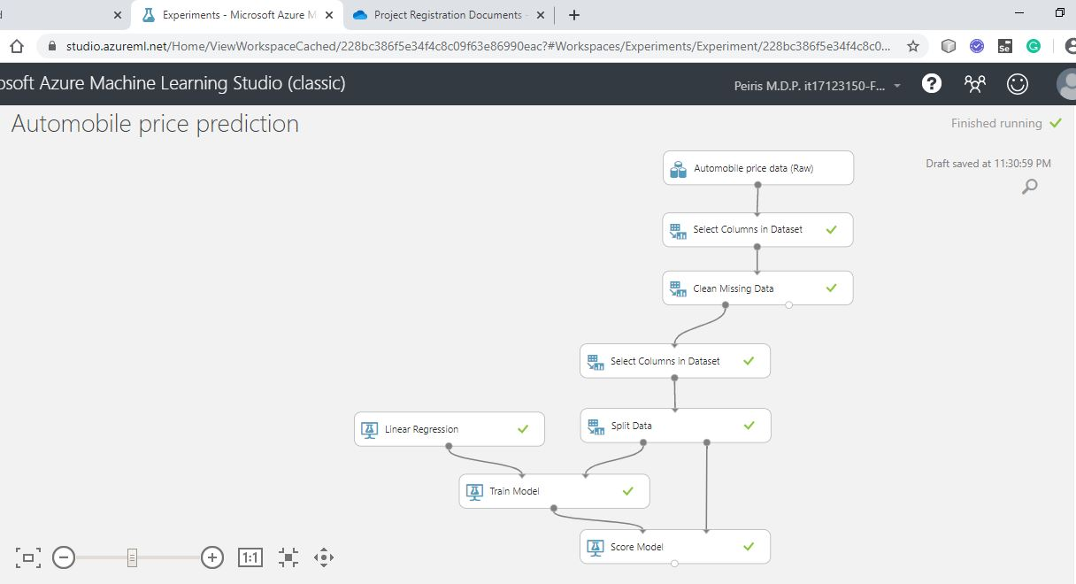Final Output

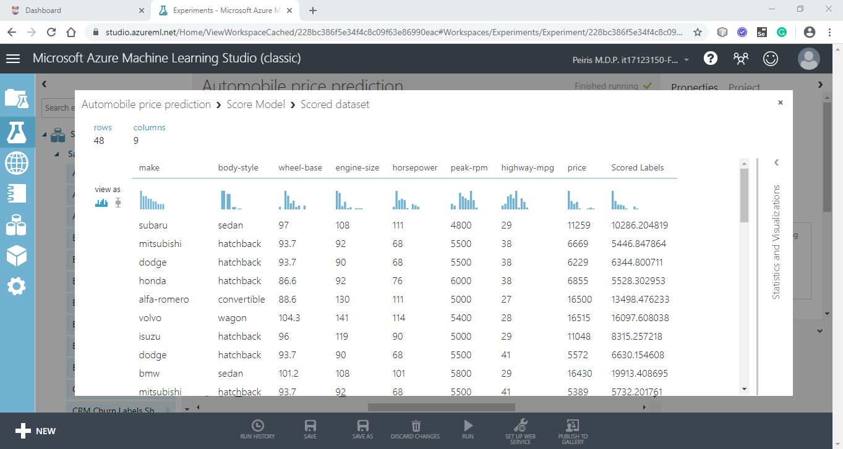URL

<https://gallery.cortanaintelligence.com/Experiment/Automobile-price-prediction-256>