R Notebook

BIS581 This assignment will look at some stock market data. Answer each question, provide your r code also. You will need to edit the line below to point it at where you saved the CSV file

my_stocks <- read.csv("stocks.csv",header=TRUE, stringsAsFactors = FALSE)

Your job first, is to ‘know your data’. Run whatever code you feel necessary to get to know your data. Add more code blocks as needed, leave this part in your document when you submit it.

str(my_stocks)

## 'data.frame': 65020 obs. of 9 variables:  
## $ exchange : chr "NYSE" "NYSE" "NYSE" "NYSE" ...  
## $ stock_symbol : chr "XL" "XL" "XL" "XL" ...  
## $ date : chr "2010-02-08" "2010-02-05" "2010-02-04" "2010-02-03" ...  
## $ stock_price_open : num 16.5 16.4 17 17.2 16.9 ...  
## $ stock_price_high : num 16.9 16.6 17 17.3 17.5 ...  
## $ stock_price_low : num 16.3 15.9 16.3 17.1 16.8 ...  
## $ stock_price_close : num 16.5 16.5 16.4 17.1 17.3 ...  
## $ stock_volume : int 4793200 4760900 6716100 2657900 4282200 3258200 4546200 4069700 3339600 4608300 ...  
## $ stock_price_adj_close: num 16.5 16.5 16.4 17.1 17.3 ...

For the questions below, show both the code used to answer along with text that shows the answer:

How many different stocks are there (by stock symbol) (5)?

# Get unique stock symbols  
unique_stocks <- unique(my_stocks$stock_symbol)  
  
# Count how many unique stock symbols there are  
num_unique_stocks <- length(unique_stocks)  
  
# result  
num_unique_stocks

## [1] 25

What are those stocks (5)?

# Get unique stock symbols  
unique_stocks <- unique(my_stocks$stock_symbol)  
  
# results  
unique_stocks

## [1] "XL" "XFJ" "XCO" "XVG" "XFB" "XOM" "XKN" "XVF" "XTO" "XJT" "XAA" "XFP"  
## [13] "XKO" "XKK" "XEC" "XRX" "XFL" "XIN" "XFH" "XKE" "XCJ" "XRM" "XEL" "XFD"  
## [25] "XFR"

Which stock had the highest single gain in a day, which day was it (10)?

my_stocks$daily_gain <- my_stocks$stock_price_close - my_stocks$stock_price_open  
  
# Find the stock with the maximum daily gain  
max_gain_row <- my_stocks[which.max(my_stocks$daily_gain), ]  
  
# result  
max_gain_row$stock_symbol

## [1] "XOM"

max_gain_row$date

## [1] "2008-10-13"

max_gain_row$daily_gain

## [1] 8.18

Which stock had the highest single loss in a day, which day was it (10)?

# Calculate daily gain  
my_stocks$daily_gain <- my_stocks$stock_price_close - my_stocks$stock_price_open  
  
# Find the stock with the largest single loss (minimum daily gain)  
min_loss_row <-my_stocks[which.min(my_stocks$daily_gain), ]  
  
# result  
min_loss_row$stock_symbol

## [1] "XOM"

min_loss_row$date

## [1] "2008-10-09"

min_loss_row$daily_gain

## [1] -9.6

Create a plot of closing price for XOM over time (5)

# Convert date column to Date type  
my_stocks$date <- as.Date(my_stocks$date)  
  
# Filter the data for XOM stock symbol  
xom_data <- subset(my_stocks, stock_symbol == "XOM")  
  
# Plot closing price over time  
plot(xom_data$date, xom_data$stock_price_close, type = "l", col = "blue",   
 main = "XOM Closing Price Over Time", xlab = "Date", ylab = "Closing Price")

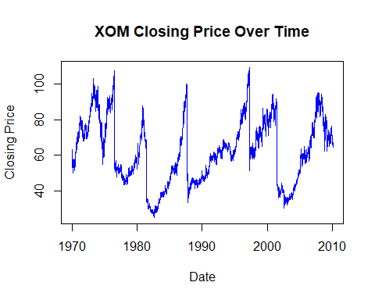

Create a plot of closing price for XKK over time (5)

# Convert date column to Date type  
my_stocks$date <- as.Date(my_stocks$date)  
  
# Filter the data for XKK stock symbol  
xkk_data <- subset(my_stocks, stock_symbol == "XKK")  
  
# Plot closing price over time  
plot(xkk_data$date, xkk_data$stock_price_close, type = "l", col = "red",   
 main = "XKK Closing Price Over Time", xlab = "Date", ylab = "Closing Price")

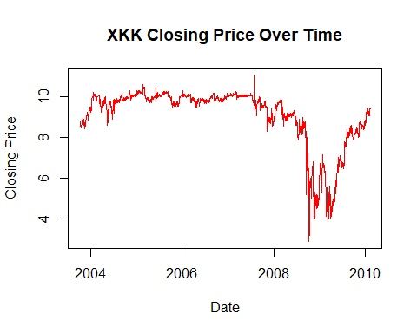

Create a plot of the change in price per day for both XOM and XKK (10)

# Calculate daily price change  
my_stocks$daily_change <- my_stocks$stock_price_close - my_stocks$stock_price_open  
  
# Filter data for XOM and XKK  
xom_data <- subset(my_stocks, stock_symbol == "XOM")  
xkk_data <- subset(my_stocks, stock_symbol == "XKK")  
  
# Plot for XOM  
plot(xom_data$date, xom_data$daily_change, type = "l", col = "blue", ylim = range(my_stocks$daily_change),  
 main = "Daily Price Change for XOM and XKK", xlab = "Date", ylab = "Daily Change")

