Customer Segmentation & Purchase Behavior Analysis
Client Project – Customer Data Analysis

Executive Summary
This report analyzes customer purchase behavior using a shopping dataset processed through MySQL/phpMyAdmin and visualized in Microsoft Power BI. The dashboard evaluates revenue, customer count, average purchase value, ratings, product categories, demographics, payment methods, seasons, locations and customer value segments.

Objectives
- Measure core business performance using revenue, customer count, average purchase and rating.
- Identify category, demographic, seasonal, payment and location-level patterns.
- Segment customers into Low Value, Medium Value and High Value groups.
- Develop actionable recommendations for marketing, retention and inventory planning.

Methodology
The dataset was reviewed in MySQL/phpMyAdmin, exported as CSV and loaded into Power BI. Calculated fields were used to group customers by age and customer value. The final report contains three dashboard pages with interactive filters for gender, product category and season.

Key Findings
- Total revenue is approximately USD 233K and the dataset contains approximately 3.9K customers.
- Clothing is the leading revenue-generating category.
- The 55+ age group contributes the highest revenue.
- High Value and Medium Value segments account for a substantial share of revenue.
- Revenue varies by location, providing a basis for market prioritization.
- Payment preferences differ across age groups and can support targeted campaign design.

Recommendations
- Introduce loyalty rewards and personalized offers for High Value customers.
- Use bundles and cross-selling to convert Medium Value customers into High Value customers.
- Apply targeted coupons to Low Value customers to improve conversion without reducing margins broadly.
- Prioritize high-performing categories and locations for inventory allocation and promotional planning.
- Create age-specific campaigns and payment-method offers based on observed customer behavior.

Dashboard Screenshots

Dashboard Page 1
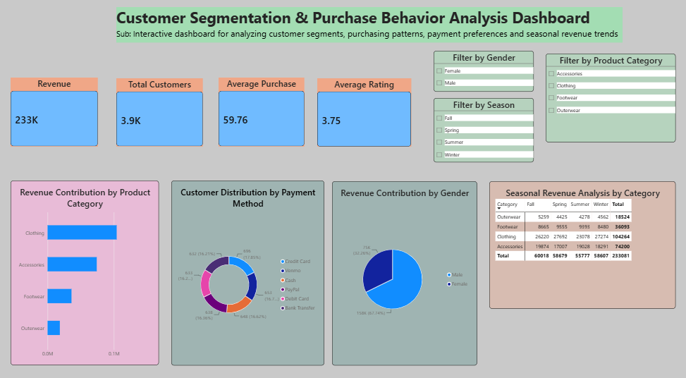

Dashboard Page 2
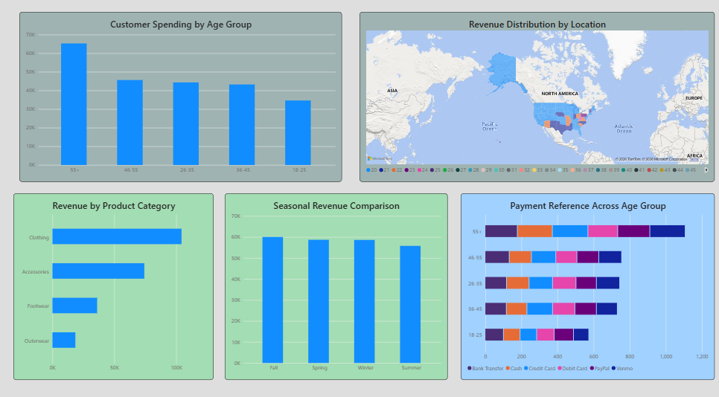

Dashboard Page 3
