**Water Quality Analysis**

**Innovation**



**Introduction:**

Water quality analysis is a critical aspect of environmental monitoring and management. It involves the assessment of various parameters to ensure that water resources meet regulatory standards and are safe for human consumption and aquatic life. With the increasing complexity of environmental challenges, there is a growing need for advanced data analytics solutions to enhance the efficiency and accuracy of water quality assessments.

IBM Cognos, a powerful business intelligence and analytic platform, has emerged as a cutting-edge tool in this field. Leveraging its capabilities, organizations can harness the power of data to gain valuable insights into water quality, enabling them to make informed decisions for conservation, regulatory compliance, and public health.

**Key Features of Water Quality Analysis :**

1. **Multi-Source Data Integration:**

IBM Cognos allows seamless integration of data from various sources, including sensors, IoT devices, laboratory tests, and historical records. This ensures a comprehensive and holistic view of water quality parameters.

1. **Real-Time Monitoring:**

The platform supports real-time data streaming and processing, enabling instant analysis of water quality metrics. This capability is crucial for timely responses to sudden changes or emergencies.

1. **Advanced Analytics and Machine Learning:**

IBM Cognos offers a range of advanced analytical techniques, including predictive modeling and machine learning algorithms. These tools can be applied to identify trends, anomalies, and potential issues in water quality data.

1. **Geospatial Visualizations:**

Geospatial analytics in IBM Cognos allows for the mapping of water quality data. This feature helps in understanding spatial patterns and correlations, which is vital for targeted interventions and resource allocation.

**5.Regulatory Compliance Reporting:**

The platform provides robust reporting capabilities, enabling organizations to generate compliance reports based on regional and international water quality standards. This ensures adherence to legal requirements.

1. **User-Friendly Dashboards:**

IBM Cognos offers customizable dashboards that can be tailored to specific user roles and preferences. This empowers stakeholders at different levels to access and interpret water quality data effortlessly.

**Water Quality Analysis**

1. **Enhanced Accuracy and Reliability:**

The advanced analytics and machine learning capabilities of IBM Cognos improve the accuracy of water quality assessments, reducing the likelihood of errors associated with manual data analysis.

**2. Timely Response to Water Quality Issues:**

Real-time monitoring and alerts enable rapid responses to any deviations from acceptable water quality standards, minimizing potential risks to public health and the environment.

**3.Optimized Resource Allocation:**

Geospatial visualizations and advanced analytics empower organizations to allocate resources efficiently by focusing efforts on areas with the greatest need for intervention.

**4.Comprehensive Reporting for Stakeholders:**

IBM Cognos simplifies the process of generating compliance reports, making it easier for organizations to communicate their water quality status to regulatory bodies, stakeholders, and the public.

**5.Long-Term Trend Analysis:**

Historical data analysis in IBM Cognos allows for the identification of long-term trends in water quality, enabling organizations to implement proactive measures for sustainable water management.

**DATA SET :**

**Source:** https://www.kaggle.com/datasets/adityakadiwal/water-potability

**Visualization:**

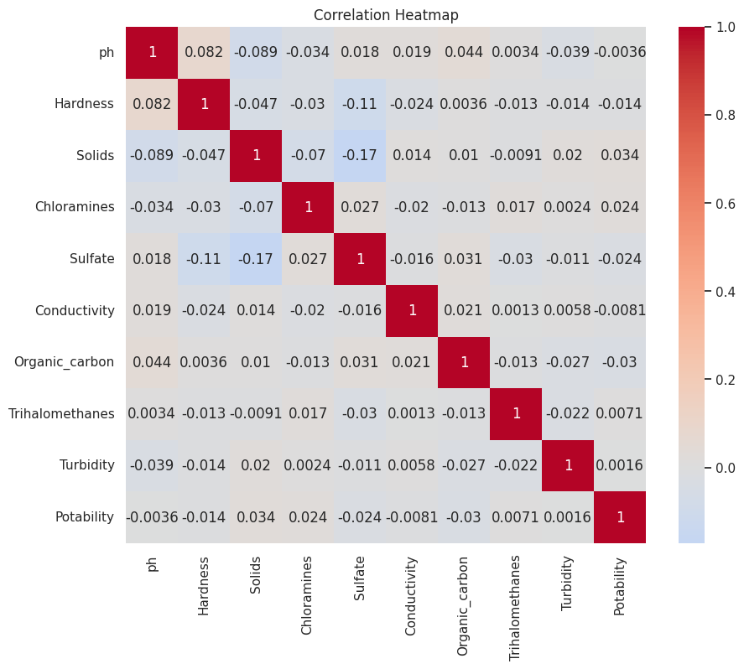

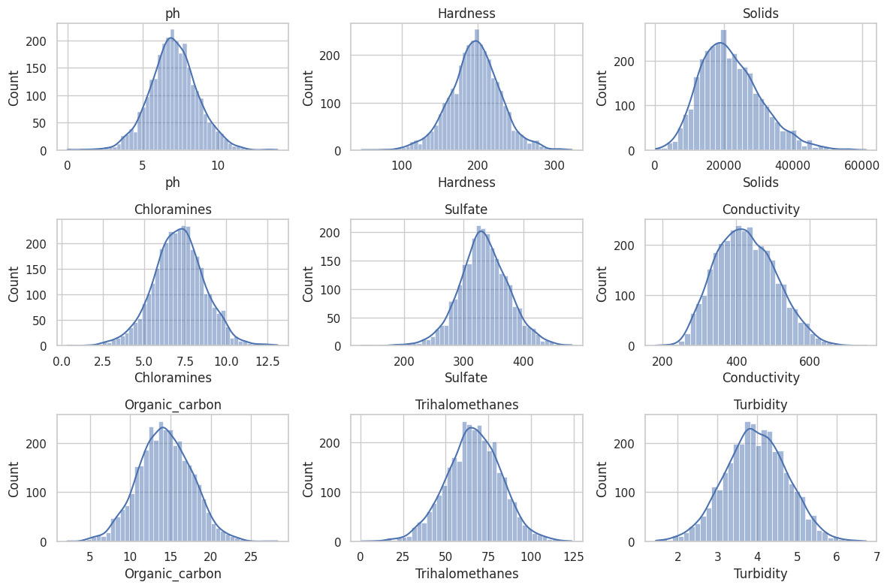

**Conclusion:**

In conclusion, IBM Cognos is a powerful tool that revolutionizes water quality analysis through its advanced analytics capabilities. By integrating data from various sources, providing real-time monitoring, and offering a range of analytical techniques, it empowers organizations to make informed decisions for the conservation and management of water resources. The platform's user-friendly interface and comprehensive reporting features ensure that stakeholders at all levels can access and interpret water quality data effectively.