Abstract
Rolling element bearing faults are a major cause of unexpected breakdowns in rotating machinery such as motors, pumps, fans, and compressors. The present project addresses the problem of early bearing fault diagnosis by developing an end-to-end machine learning system using vibration signal analysis. The work is based on the Case Western Reserve University bearing dataset, in which raw vibration signals are collected under normal, inner race fault, outer race fault, and ball fault conditions. In the developed workflow, raw signals are segmented into fixed windows of 2048 samples with 50 percent overlap, and meaningful time-domain and frequency-domain features are extracted from each segment. A total of 25 engineered features, including mean, standard deviation, RMS, kurtosis, spectral mean, dominant frequency, and frequency variation factor, are used for classification. The implementation uses Python, NumPy, pandas, SciPy, scikit-learn, Matplotlib, Joblib, and Streamlit. Two supervised learning models, namely Support Vector Machine and Random Forest, are trained and compared using a stratified 80:20 train-test split. The best performing model, Random Forest, achieved an accuracy of 97.59 percent and a weighted F1-score of 97.59 percent on the test set. The trained model is integrated into a Streamlit dashboard that accepts vibration CSV input and displays waveform, FFT spectrum, class probabilities, extracted features, confusion matrix, and feature importance. The final outcome is a practical and interpretable bearing fault diagnosis tool suitable for predictive maintenance demonstrations and academic study.

INDEX
Abstract 1
Index 2
Chapter I: Introduction 3
Chapter II: Literature Survey 4
Chapter III: Methodology 5
Chapter IV: Results and Discussion 8
Chapter V: Concluding Remarks and Future Scope 11
References 12
Plagiarism Report 13

CHAPTER I: INTRODUCTION
1.1 Background
Rotating machinery depends heavily on the health of rolling element bearings. A small defect in the inner race, outer race, or ball element changes the vibration response of the machine and can eventually lead to excessive noise, energy loss, shaft damage, and sudden shutdown. Condition monitoring based on vibration analysis is therefore one of the most widely accepted maintenance approaches in mechanical systems. In recent years, machine learning has become an effective way to interpret vibration signals because it can learn fault patterns from data and support automated diagnosis.
1.2 Problem Statement
The main problem addressed in this project is the reliable identification of bearing fault type from vibration signal data. Raw vibration signals are long numeric sequences and cannot be directly interpreted easily by a human operator during routine maintenance. The challenge is to transform these signals into informative numerical features and build a classifier that can distinguish between Normal, Inner Race Fault, Outer Race Fault, and Ball Fault conditions. The system should also be explainable and simple enough to demonstrate through a user interface.
1.3 Objectives of the Project
The objectives of the project are: (i) to study the CWRU bearing vibration dataset and organize the signals into meaningful classes, (ii) to preprocess and segment raw vibration data into machine-learning-ready samples, (iii) to extract time-domain and frequency-domain features that represent bearing condition, (iv) to train and compare SVM and Random Forest classification models, (v) to evaluate the trained system using confusion matrix and weighted classification metrics, and (vi) to deploy the best model in a Streamlit dashboard for interactive bearing fault diagnosis.

CHAPTER II: LITERATURE SURVEY
2.1 Existing Systems and Approaches
Existing research on bearing fault diagnosis commonly uses vibration measurement as the primary sensing modality. Traditional studies employ spectral analysis, envelope analysis, or wavelet transforms to identify characteristic frequencies. Recent machine learning approaches use statistical features with classifiers such as Support Vector Machine, k-Nearest Neighbors, and Random Forest, while deep learning approaches use Convolutional Neural Networks on raw or transformed signals. The CWRU bearing dataset is frequently used as a benchmark for these methods because it contains controlled fault conditions and accelerometer measurements.
2.2 Limitations of Existing Approaches
Although strong research results already exist, many published works focus mainly on model accuracy and do not provide a clear end-to-end implementation that students can inspect, reproduce, and demonstrate. Some methods depend on large computational cost, extensive hyperparameter tuning, or deep learning architectures that are difficult to interpret in a small academic project setting. In many cases, the preprocessing stage, feature definitions, deployment flow, and user-level interaction are not explained clearly enough for an engineering classroom or laboratory demonstration.
2.3 Need for the Proposed System
The present system is needed to bridge the gap between vibration analysis theory and a practical diagnostic implementation. The project keeps the workflow transparent by explicitly showing segmentation, feature extraction, model comparison, confusion matrix, feature importance, and GUI-based inference. It demonstrates how mechanical engineering signal analysis and machine learning can be integrated into a usable condition monitoring tool. The proposed system therefore serves not only as a classifier, but also as an interpretable educational framework for predictive maintenance.

CHAPTER III: METHODOLOGY
3.1 System Design Overview
The system is organized as a modular pipeline with offline training and online inference. In the offline stage, raw bearing signals are loaded from MATLAB files, segmented, transformed into numerical features, and used to train classification models. In the online stage, a CSV signal uploaded through the GUI is converted to the same feature representation and passed to the saved model for prediction.
3.2 Dataset and Signal Organization
The project uses the Case Western Reserve University bearing dataset available locally in the project under the data/raw directory. The code maps the original file naming convention into four health-state classes: Normal, Inner Race Fault, Outer Race Fault, and Ball Fault. In the current implementation the drive-end vibration channel is used as the primary source signal for feature generation. The processed feature table contains 9736 samples and 30 columns, including metadata fields and the engineered features.
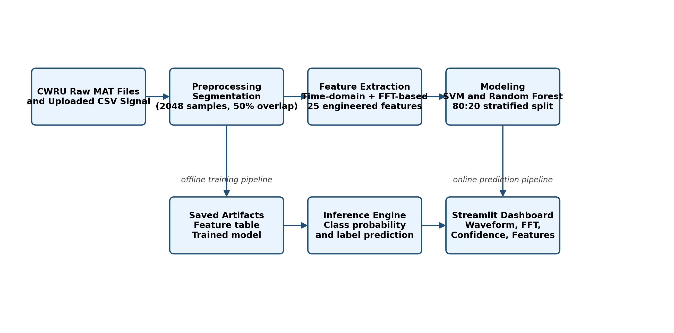
Figure 1: System Architecture
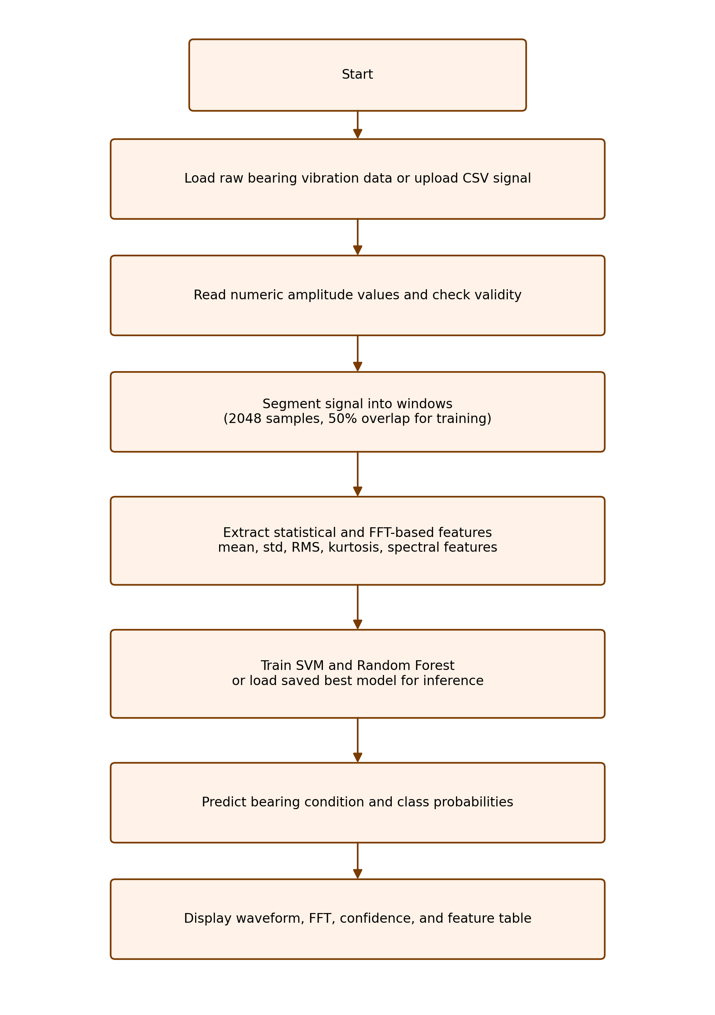
Figure 2: Flow Diagram
3.3 Preprocessing and Segmentation
Each raw signal is divided into fixed windows of 2048 samples with 50 percent overlap. At a sampling rate of 48000 Hz, one such window represents approximately 42.67 milliseconds of bearing vibration. This segmentation strategy increases the number of learning samples while preserving local transient behavior. Missing values are handled safely, and during model training median imputation is applied where needed.
3.4 Feature Extraction Module
The feature extraction module is implemented in the project source code and computes 25 engineered features. The time-domain features include mean, standard deviation, mean absolute deviation, RMS, maximum absolute value, skewness, kurtosis, crest factor, form factor, shape factor, and impulse factor. The frequency-domain features are obtained after FFT computation and include spectral mean, spectral standard deviation, spectral skewness, spectral kurtosis, mean frequency, frequency standard deviation, RMS frequency, root variance frequency, spectral centroid proxy, frequency variation factor, frequency variance, frequency skewness, dominant frequency, and spectral energy.
3.5 Modeling and Algorithm Selection
Two supervised machine learning algorithms are implemented: Support Vector Machine with RBF kernel and Random Forest. The SVM pipeline uses median imputation, StandardScaler, and the SVC classifier with probability output enabled. The Random Forest classifier uses 300 trees with balanced class weights and is trained on the same feature set. The dataset is split into training and testing subsets using an 80:20 stratified split so that class balance is preserved. Model selection is performed on the basis of weighted F1-score.
3.6 Inference and GUI Module
After training, the best model is saved as a reusable artifact together with the label encoder and feature metadata. The Streamlit interface loads this model, accepts a vibration CSV file, extracts the same engineered features, calls the model probability function, and displays the predicted fault type with confidence. The GUI also plots the time-domain waveform and frequency spectrum and shows the extracted feature table, confusion matrix, and feature importance chart.
3.7 Technologies Used
The complete project is implemented in Python. NumPy and SciPy are used for numerical processing and FFT computation, pandas is used for tabular data handling, scikit-learn provides the preprocessing and machine learning pipeline, Matplotlib is used for visualizations, Joblib is used for artifact serialization, and Streamlit is used for the interactive dashboard.
3.8 Step-by-Step Working Logic
The implemented working logic is: load vibration data, segment the signal, compute time-domain and frequency-domain features, build a feature vector, train SVM and Random Forest models, compare model metrics, save the best model, upload a new CSV signal in the GUI, extract the same features from the uploaded signal, compute class probabilities through the trained model, and display the predicted fault type and supporting plots.

CHAPTER IV: RESULTS AND DISCUSSION
4.1 Output Explanation
The output of the system is a predicted bearing condition together with a probability distribution over all classes. The Streamlit interface shows the predicted class, the confidence percentage, the waveform in the time domain, the FFT spectrum in the frequency domain, and the extracted numerical features used by the classifier. This makes the prediction process interpretable to the user.
4.2 Quantitative Results
The processed feature dataset contains 9736 samples. Two models were evaluated: Random Forest and SVM. Random Forest achieved an accuracy of 97.5873 percent, a weighted precision of 97.6243 percent, a weighted recall of 97.5873 percent, and a weighted F1-score of 97.5941 percent. The SVM model achieved an accuracy of 97.4846 percent and a weighted F1-score of 97.4877 percent. Based on weighted F1-score, Random Forest was selected as the final deployed model.
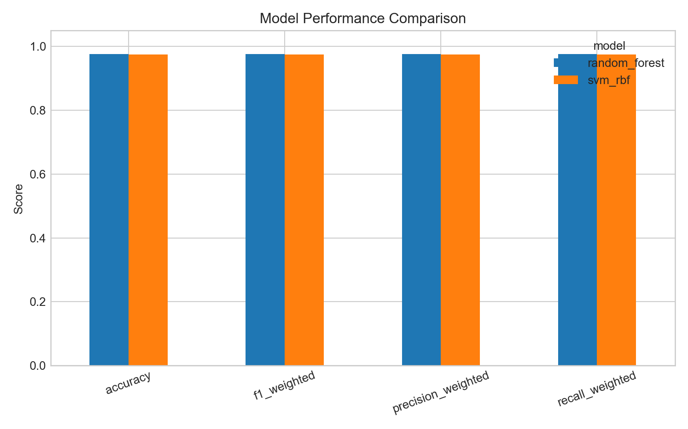
Figure 3: Model Comparison
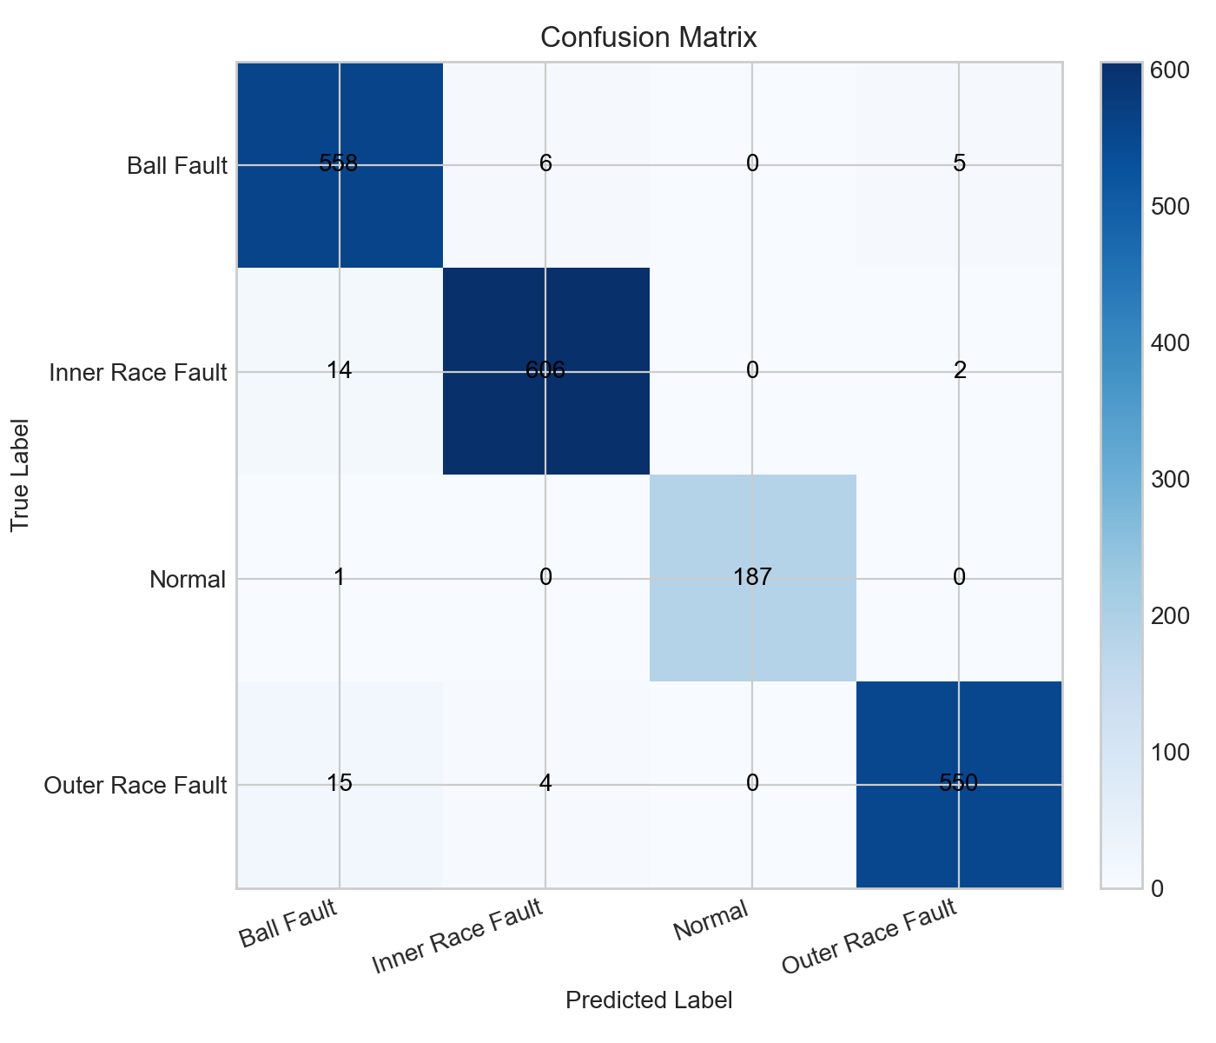
Figure 4: Confusion Matrix
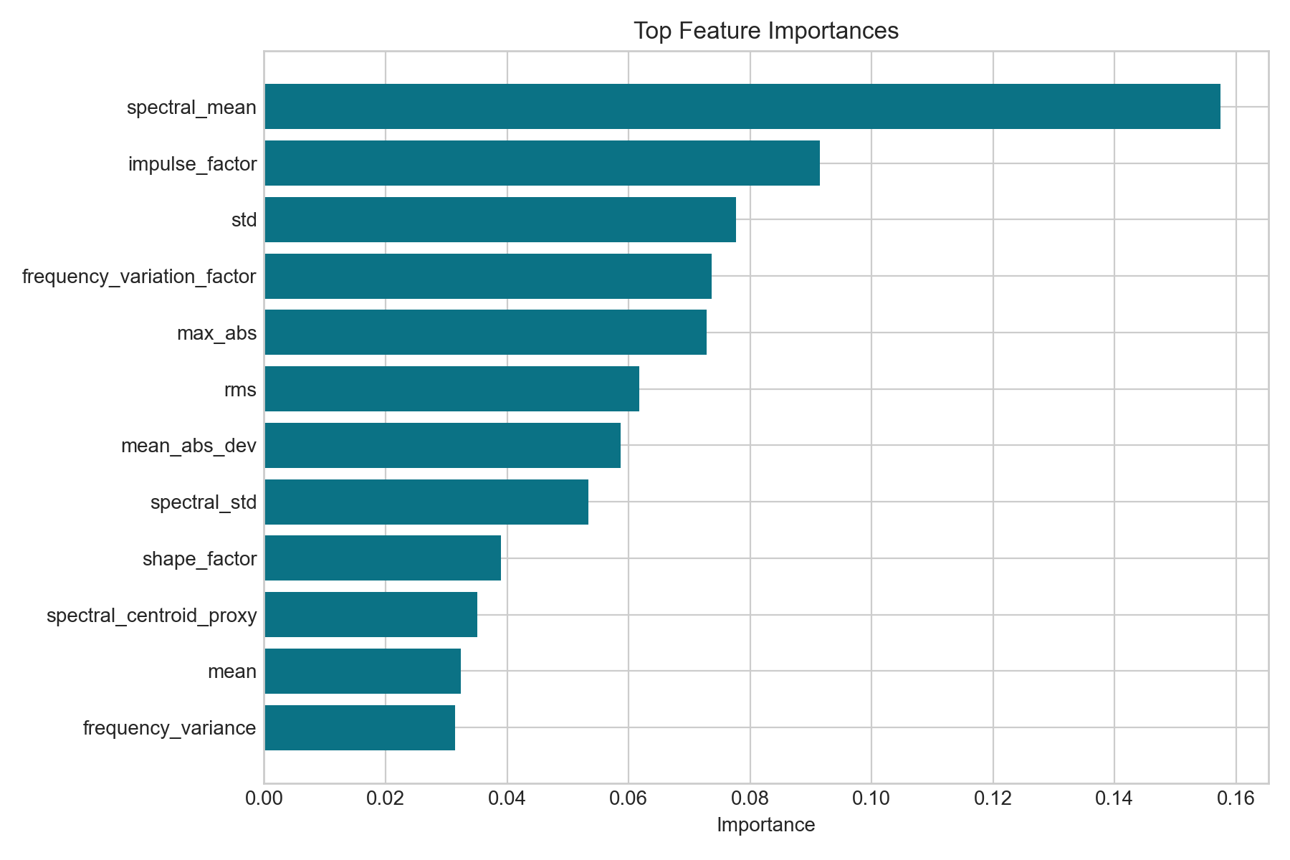
Figure 5: Feature Importance
4.3 Confusion Matrix Interpretation
The confusion matrix confirms that the majority of samples are classified correctly. Ball Fault samples were correctly recognized 558 times, Inner Race Fault samples 606 times, Normal samples 187 times, and Outer Race Fault samples 550 times. The off-diagonal entries are comparatively small, showing that confusion between classes is limited. The few mistakes occur mainly between Ball Fault, Inner Race Fault, and Outer Race Fault, which is expected because these faults can share similar vibration tendencies in some windows.
4.4 Feature Importance Interpretation
The feature importance chart from the Random Forest model shows that not all engineered features contribute equally. Spectral mean is the most influential feature, followed by impulse factor, standard deviation, frequency variation factor, maximum absolute value, RMS, and mean absolute deviation. This indicates that both signal energy characteristics and frequency-distribution characteristics are important for distinguishing bearing health states.
4.5 System Behavior and Discussion
The deployed GUI behaves as an end-to-end diagnostic interface. When a CSV file is uploaded, the application reads the amplitude column, computes the same features used during training, and predicts the fault class using the saved model. The signal length shown in the interface directly corresponds to the uploaded window length. The visual output helps verify that a bearing signal can be studied simultaneously in the time domain, frequency domain, and feature space. Overall, the behavior of the system is stable, interpretable, and aligned with the project goal of practical bearing fault diagnosis.

CHAPTER V: CONCLUDING REMARKS AND FUTURE SCOPE
5.1 Concluding Remarks
This project successfully demonstrates a complete bearing fault diagnosis workflow based on vibration signal analysis and machine learning. Raw signals from the CWRU dataset were segmented into windows, transformed into 25 engineered time-domain and frequency-domain features, and used to train SVM and Random Forest classifiers. The Random Forest model achieved the best overall performance and was deployed into a Streamlit dashboard for interactive prediction. The resulting system combines signal processing, classification, visualization, and GUI deployment in a single coherent framework.
5.2 Key Achievements
The major achievements of the project are the preparation of a reproducible feature dataset from raw bearing signals, the implementation of two supervised classification models, the selection of the best model using test-set metrics, the generation of diagnostic visualizations such as confusion matrix and feature importance, and the creation of a user-facing interface that demonstrates the complete fault diagnosis process.
5.3 Future Scope
The present system can be extended by incorporating more operating loads and more raw signals from the complete CWRU repository, testing additional algorithms such as XGBoost or 1D CNN, and validating the model on noisy or sensor-acquired real-world data. Another important extension is the progression from fault classification to severity estimation and remaining useful life analysis, which would make the framework even more valuable for predictive maintenance applications.

References
[1] Case Western Reserve University Bearing Data Center, Bearing Data Center Seeded Fault Test Data, https://engineering.case.edu/bearingdatacenter
[2] P. K. Kankar, S. C. Sharma, S. P. Harsha, Fault diagnosis of ball bearings using machine learning methods, Expert Systems with Applications, 2011.
[3] C. S. Rajeswari, S. Sathiyabama, S. Devendiran, Bearing fault diagnosis using wavelet packet transform, hybrid PSO and support vector machine, Procedia Engineering, 2014.
[4] X. Li, W. Zhang, Q. Ding, Rolling bearing fault diagnosis based on wavelet packet transform and convolutional neural network, Applied Sciences, 2020.
[5] H. Yoo, J. Jo, H. Ban, Lite and efficient deep learning model for bearing fault diagnosis using the CWRU dataset, Sensors, 2023.

Plagiarism Report
This report has been checked for plagiarism and is within acceptable limits.

