DATA-598-WI20-week4

Pradeep Prabhakar

07 February, 2020

Loading the tidyverse library:

library(tidyverse)

We are using the Starwars dataset, which has 87 rows and 13 columns.

A scatterplot of mass and height of humans in starwars:

starwars %>%  
 filter(species == "Human")%>% ggplot()+aes(x=height,y=mass)+geom_point()

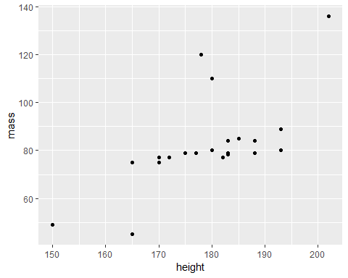

A ggplot of starwars stuff

A table containing key attributes of humans in starwars:

starwars%>%  
 filter(species == "Human")%>%  
 select(name,height,mass,homeworld)%>%  
 knitr::kable(caption = "A knitr kable table of starwars data")

A knitr kable table of starwars data

|  |  |  |  |
| --- | --- | --- | --- |
| name | height | mass | homeworld |
| Luke Skywalker | 172 | 77.0 | Tatooine |
| Darth Vader | 202 | 136.0 | Tatooine |
| Leia Organa | 150 | 49.0 | Alderaan |
| Owen Lars | 178 | 120.0 | Tatooine |
| Beru Whitesun lars | 165 | 75.0 | Tatooine |
| Biggs Darklighter | 183 | 84.0 | Tatooine |
| Obi-Wan Kenobi | 182 | 77.0 | Stewjon |
| Anakin Skywalker | 188 | 84.0 | Tatooine |
| Wilhuff Tarkin | 180 | NA | Eriadu |
| Han Solo | 180 | 80.0 | Corellia |
| Wedge Antilles | 170 | 77.0 | Corellia |
| Jek Tono Porkins | 180 | 110.0 | Bestine IV |
| Palpatine | 170 | 75.0 | Naboo |
| Boba Fett | 183 | 78.2 | Kamino |
| Lando Calrissian | 177 | 79.0 | Socorro |
| Lobot | 175 | 79.0 | Bespin |
| Mon Mothma | 150 | NA | Chandrila |
| Arvel Crynyd | NA | NA | NA |
| Qui-Gon Jinn | 193 | 89.0 | NA |
| Finis Valorum | 170 | NA | Coruscant |
| Shmi Skywalker | 163 | NA | Tatooine |
| Mace Windu | 188 | 84.0 | Haruun Kal |
| Gregar Typho | 185 | 85.0 | Naboo |
| Cordé | 157 | NA | Naboo |
| Cliegg Lars | 183 | NA | Tatooine |
| Dormé | 165 | NA | Naboo |
| Dooku | 193 | 80.0 | Serenno |
| Bail Prestor Organa | 191 | NA | Alderaan |
| Jango Fett | 183 | 79.0 | Concord Dawn |
| Jocasta Nu | 167 | NA | Coruscant |
| Raymus Antilles | 188 | 79.0 | Alderaan |
| Finn | NA | NA | NA |
| Rey | NA | NA | NA |
| Poe Dameron | NA | NA | NA |
| Padmé Amidala | 165 | 45.0 | Naboo |

Using the external Rscript code to print the summary of numeric columns in the starwars data

## height mass birth_year   
## Min. : 66.0 Min. : 15.00 Min. : 8.00   
## 1st Qu.:167.0 1st Qu.: 55.60 1st Qu.: 35.00   
## Median :180.0 Median : 79.00 Median : 52.00   
## Mean :174.4 Mean : 97.31 Mean : 87.57   
## 3rd Qu.:191.0 3rd Qu.: 84.50 3rd Qu.: 72.00   
## Max. :264.0 Max. :1358.00 Max. :896.00   
## NA's :6 NA's :28 NA's :44

In-text citations:

(Barba 2018) in the article “Terminologies for reproducible research” attempts to inventory the contradictory definitions for reproducibility vs replicability across various disciplines.

(Ram 2013) in the article “Git can facilitate greater reproducibility and increased transparency in science” talks about the power of Git through some use cases.

## References cited

Barba, Lorena A. 2018. “Terminologies for Reproducible Research.” *arXiv Preprint arXiv:1802.03311*.

Ram, Karthik. 2013. “Git Can Facilitate Greater Reproducibility and Increased Transparency in Science.” *Source Code for Biology and Medicine* 8 (1): 7.