**1 AIM: -Install Android Studio and Run Hello World App.**

**Xml:**

**<?xml version="1.0" encoding="utf-8"?>**

**<androidx.constraintlayout.widget.ConstraintLayout xmlns:android[="http://schemas.android.com/apk/res/android"](http://schemas.android.com/apk/res/android)****xmlns:app[="http://schemas.android.com/apk/res](http://schemas.android.com/apk/res-auto)**[**-auto"**](http://schemas.android.com/apk/res-auto) **xmlns:tools[="http://schemas.android.com/tools"](http://schemas.android.com/tools)****android:layout_width="match_parent" android:layout_height="match_parent" tools:context=".MainActivity">**

**<TextView android:id="@+id/textView" android:layout_width="match_parent" android:layout_height="wrap_content" android:text="4428-Aditya Vishwakarma" android:textColor="@color/black" android:gravity="center" tools:ignore="MissingConstraints" />**

**<TextView android:layout_width="wrap_content" android:layout_height="wrap_content" android:text="Hello World!" android:textColor="@color/black" android:textSize="34sp"**

**app:layout_constraintBottom_toBottomOf="parent" app:layout_constraintLeft_toLeftOf="parent" app:layout_constraintRight_toRightOf="parent" app:layout_constraintTop_toTopOf="parent" />**

**</androidx.constraintlayout.widget.ConstraintLayout>**

**Java-**

**package com.example.helloworld;**

**import androidx.appcompat.app.AppCompatActivity; import android.os.Bundle;**

**public class MainActivity extends AppCompatActivity {**

# @Override

**protected void onCreate(Bundle savedInstanceState) { super.onCreate(savedInstanceState); setContentView(R.layout.*activity_main*);**

**}**

**}**

**output:**

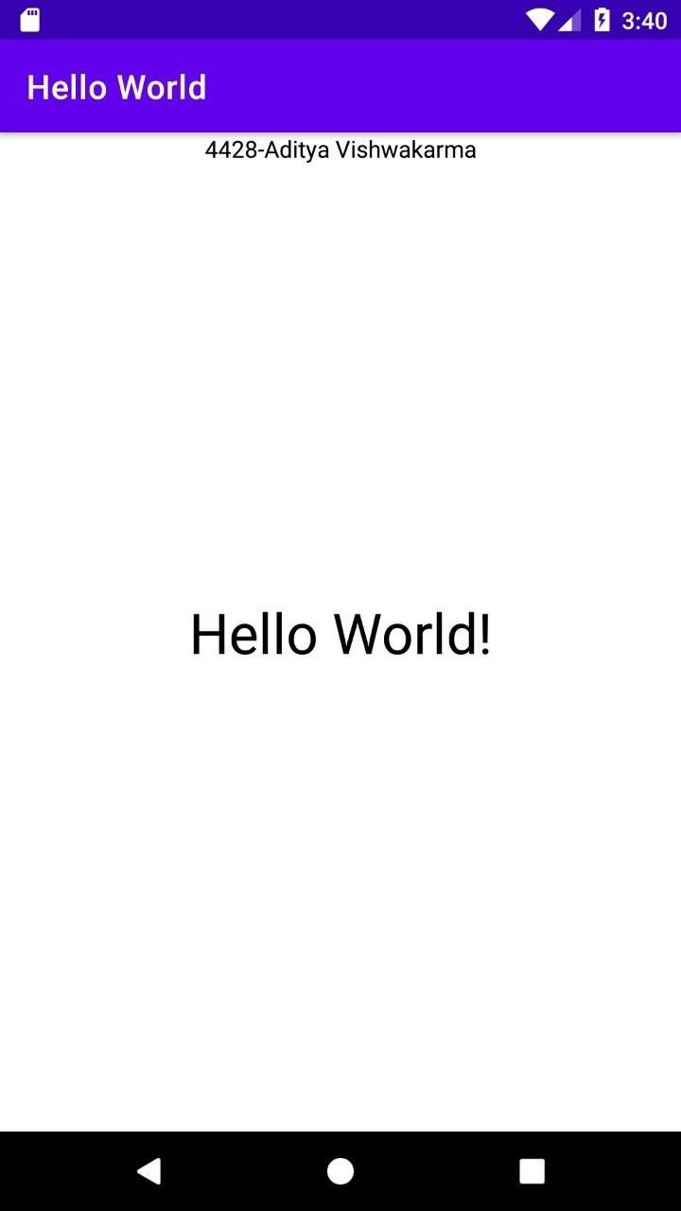

**2**

**Aim: Create an android app with Interactive User Interface.**

**Activity_Main.xml**

**Dummy:**

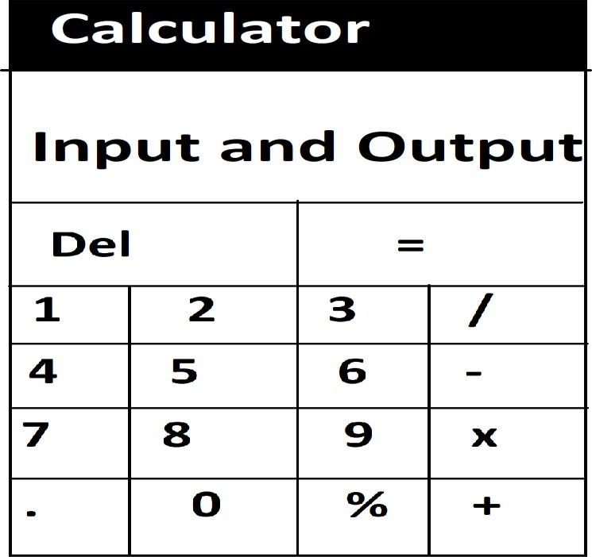

**Xml:**

**<?xml version="1.0" encoding="utf-8"?>**

**<LinearLayout xmlns:android="**[**http://schemas.android.com/apk/res/android"**](http://schemas.android.com/apk/res/android) **xmlns:tools="**[**http://schemas.android.com/tools"**](http://schemas.android.com/tools) **android:layout_width="match_parent" android:layout_height="match_parent"**

**android:background="#ADD8E6" android:orientation="vertical"**

**tools:context="com.example.myapplication.MainActivity"**

**>**

**<TextView android:id="@+id/tv"**

**android:layout_width="match_parent" android:layout_height="43dp" android:textAlignment="center" android:textSize="20sp" android:text="4428 Aditya Vishwakarma" android:textColor="@color/black"/>**

**<LinearLayout**

**android:layout_width="match_parent"**

**android:layout_height="wrap_content" android:layout_weight="0.3" android:orientation="horizontal">**

**<TextView android:id="@+id/display"**

**android:layout_width="match_parent" android:layout_height="match_parent "android:background="#ecf0f1" android:textSize="30sp" />**

**</LinearLayout>**

**<LinearLayout android:layout_width="match_parent" android:layout_height="wrap_content" android:layout_weight="0.2" android:orientation="horizontal">**

**<Button**

**android:id="@+id/buttonDel" android:layout_width="wrap_content" android:layout_height="match_parent**

**"android:layout_margin="1dp"**

**android:layout_weight="0.25" android:background="@drawable/button"**

**android:text="Del" android:textColor="#ecf0f1" android:textSize="20sp" />**

**<Button**

**android:id="@+id/buttoneql" android:layout_width="wrap_content" android:layout_height="match_parent" android:layout_margin="1dp" android:layout_weight="0.25" android:background="@drawable/button"**

**android:text="=" android:textColor="#ecf0f1" android:textSize="30sp" />**

**</LinearLayout>**

**<LinearLayout android:layout_width="match_parent" android:layout_height="wrap_content" android:layout_weight="0.2" android:orientation="horizontal">**

**<Button**

**android:id="@+id/button1" android:layout_width="wrap_content" android:layout_height="match_parent" android:layout_margin="1dp" android:layout_weight="0.25" android:background="@drawable/selector"**

**android:text="1" android:textColor="#ecf0f1" android:textSize="20sp" />**

**<Button**

**android:id="@+id/button2" android:layout_width="wrap_content" android:layout_height="match_parent" android:layout_margin="1dp" android:layout_weight="0.25" android:background="@drawable/selector"**

**android:text="2" android:textColor="#ecf0f1" android:textSize="20sp" />**

**<Button**

**android:id="@+id/button3" android:layout_width="wrap_content" android:layout_height="match_parent**

**"android:layout_margin="1dp"**

**a ndroid:layout_weight="0.25" android:background="@drawable/selector"**

**android:text="3" android:textColor="#ecf0f1" android:textSize="20sp" />**

**<Button**

**android:id="@+id/buttondiv" android:layout_width="wrap_content" android:layout_height="match_parent" android:layout_margin="1dp" android:layout_weight="0.25"**

**android:background="@drawable/operator_selector" android:text="/"**

**android:textColor="#ecf0f1" android:textSize="30sp" />**

**</LinearLayout>**

**<LinearLayout android:layout_width="match_parent" android:layout_height="wrap_content" android:layout_weight="0.2" android:orientation="horizontal">**

**<Button**

**android:id="@+id/button4" android:layout_width="wrap_content" android:layout_height="match_parent" android:layout_margin="1dp" android:layout_weight="0.25" android:background="@drawable/selector"**

**android:text="4" android:textColor="#ecf0f1" android:textSize="20sp" />**

**<Button**

**android:id="@+id/button5" android:layout_width="wrap_content" android:layout_height="match_parent" android:layout_margin="1dp" android:layout_weight="0.25" android:background="@drawable/selector"**

**android:text="5" android:textColor="#ecf0f1" android:textSize="20sp" />**

**<Button**

**android:id="@+id/button6" android:layout_width="wrap_content" android:layout_height="match_parent**

**"android:layout_margin="1dp"**

**android:layout_weight="0.25" android:background="@drawable/selector" android:text="6" android:textColor="#ecf0f1" android:textSize="20sp" />**

**<Button**

**android:id="@+id/buttonsub" android:layout_width="wrap_content" android:layout_height="match_parent" android:layout_margin="1dp" android:layout_weight="0.25" android:background="@drawable/operator_selector" android:text="-"**

**android:textColor="#ecf0f1" android:textSize="30sp" />**

**</LinearLayout>**

**<LinearLayout android:layout_width="match_parent" android:layout_height="wrap_content" android:layout_weight="0.2" android:orientation="horizontal">**

**<Button**

**android:id="@+id/button7" android:layout_width="wrap_content" android:layout_height="match_parent" android:layout_margin="1dp" android:layout_weight="0.25" android:background="@drawable/selector"**

**android:text="7" android:textColor="#ecf0f1" android:textSize="20sp" />**

**<Button**

**android:id="@+id/button8" android:layout_width="wrap_content" android:layout_height="match_parent" android:layout_margin="1dp" android:layout_weight="0.25" android:background="@drawable/selector"**

**android:text="8" android:textColor="#ecf0f1" android:textSize="20sp" />**

**<Button**

**android:id="@+id/button9" android:layout_width="wrap_content" android:layout_height="match_parent**

**"android:layout_margin="1dp"**

**a ndroid:layout_weight="0.25" android:background="@drawable/selector"**

**android:text="9" android:textColor="#ecf0f1" android:textSize="20sp" />**

**<Button**

**android:id="@+id/buttonmul" android:layout_width="wrap_content" android:layout_height="match_parent" android:layout_margin="1dp" android:layout_weight="0.25"**

**android:background="@drawable/operator_selector" android:text="x" android:textColor="#ecf0f1" android:textSize="30sp" />**

**</LinearLayout>**

**<LinearLayout android:layout_width="match_parent" android:layout_height="wrap_content" android:layout_weight="0.2" android:orientation="horizontal">**

**<Button**

**android:id="@+id/buttonDot" android:layout_width="wrap_content" android:layout_height="match_parent" android:layout_margin="1dp" android:layout_weight="0.25" android:background="@drawable/selector"**

**android:text="." android:textColor="#ecf0f1" android:textSize="20sp" />**

**<Button**

**android:id="@+id/button0" android:layout_width="wrap_content" android:layout_height="match_parent" android:layout_margin="1dp" android:layout_weight="0.25" android:background="@drawable/selector" android:text="0" android:textColor="#ecf0f1" android:textSize="20sp" />**

**<Button**

**android:id="@+id/Remainder"**

**android:layout_width="wrap_content" android:layout_height="match_parent "android:layout_margin=1dp;**

**android:layout_weight="0.25"**

**android:background="@drawable/operator_selector" android:text="%"**

**android:textColor="#ecf0f1" android:textSize="30sp" />**

**<Button**

**android:id="@+id/buttonadd" android:layout_width="wrap_content" android:layout_height="match_parent" android:layout_margin="1dp" android:layout_weight="0.25"**

**android:background="@drawable/operator_selector" android:text="+"**

**android:textColor="#ecf0f1" android:textSize="30sp" />**

**</LinearLayout>**

**</LinearLayout>**

**MainActivity.java ackage com.example.myapplication;**

**import androidx.appcompat.app.AppCompatActivity;**

**import android.os.Bundle; import android.view.View; import android.widget.Button;**

**import android.widget.TextView;**

**public class MainActivity extends AppCompatActivity {**

**double input1 = 0, input2 = 0;TextView edt1; boolean Addition, Subtract, Multiplication, Division, mRemainder, decimal;**

**Button button0, button1, button2, button3, button4, button5, button6, button7, button8,button9, buttonAdd, buttonSub, buttonMul, buttonDivision, buttonEqual, buttonDel, buttonDot, Remainder;**

**@Override**

**protected void onCreate(Bundle savedInstanceState)**

**{super.onCreate(savedInstanceState);**

**setContentView(R.layout.activity_main);**

**button0 = (Button) findViewById(R.id.button0); button1 = (Button) findViewById(R.id.button1); button2 = (Button) findViewById(R.id.button2);**

**button3 = (Button) findViewById(R.id.button3); button4 = (Button) findViewById(R.id.button4); button5 = (Button) findViewById(R.id.button5); button6 = (Button) findViewById(R.id.button6); button7 = (Button) findViewById(R.id.button7); button8 = (Button) findViewById(R.id.button8); button9 = (Button) findViewById(R.id.button9); buttonDot = (Button) findViewById(R.id.buttonDot); buttonAdd = (Button) findViewById(R.id.buttonadd); buttonSub = (Button) findViewById(R.id.buttonsub); buttonMul = (Button) findViewById(R.id.buttonmul); buttonDivision = (Button) findViewById(R.id.buttondiv); Remainder = (Button) findViewById(R.id.Remainder); buttonDel = (Button) findViewById(R.id.buttonDel); buttonEqual = (Button) findViewById(R.id.buttoneql);**

**edt1 = (TextView) findViewById(R.id.display);**

**button1.setOnClickListener(new View.OnClickListener() {**

**@Override**

**public void onClick(View v) { edt1.setText(edt1.getText() +**

**"1");**

**}**

**});**

**button2.setOnClickListener(new View.OnClickListener() {**

**@Override**

**public void onClick(View v) {**

**edt1.setText(edt1.getText() +**

**"2");**

**}**

**});**

**button3.setOnClickListener(new View.OnClickListener() {**

**@Override**

**public void onClick(View v) {**

**edt1.setText(edt1.getText() +**

**"3");**

**}**

**});**

**button4.setOnClickListener(new View.OnClickListener() {**

**@Override**

**public void onClick(View v) {**

**edt1.setText(edt1.getText() +**

**"4");**

**}**

**});**

**button5.setOnClickListener(new View.OnClickListener() {**

**@Override**

**public void onClick(View v) {**

**edt1.setText(edt1.getText() +**

**"5");**

**}**

**});**

**button6.setOnClickListener(new View.OnClickListener() {**

**@Override**

**public void onClick(View v) {**

**edt1.setText(edt1.getText() +**

**"6");**

**}**

**});**

**button7.setOnClickListener(new View.OnClickListener() {**

**@Override public void onClick(View v) {**

**edt1.setText(edt1.getText() +**

**"7");**

**}**

**});**

**button8.setOnClickListener(new View.OnClickListener() {**

**@Override public void onClick(View v) {**

**edt1.setText(edt1.getText() +**

**"8");**

**}**

**});**

**button9.setOnClickListener(new View.OnClickListener() {**

**@Override**

**public void onClick(View v) {**

**edt1.setText(edt1.getText() +**

**"9");**

**}**

**});**

**button0.setOnClickListener(new View.OnClickListener() {**

**@Override**

**public void onClick(View v) {**

**edt1.setText(edt1.getText() +**

**"0");**

**}**

**});**

**buttonAdd.setOnClickListener(new View.OnClickListener() {**

**@Override**

**public void onClick(View v) {**

**if (edt1.getText().length() != 0) { nput1 = Float.parseFloat(edt1.getText() + "");**

**Addition = true;**

**decimal = false;**

**edt1.setText(null);**

**}**

**}**

**});**

**buttonSub.setOnClickListener(new View.OnClickListener() {**

**@Override**

**public void onClick(View v) { if (edt1.getText().length() != 0) {**

**input1 = Float.parseFloat(edt1.getText() + ""); Subtract = true; decimal = false;**

**edt1.setText(null**

**);**

**}**

**}**

**});**

**buttonMul.setOnClickListener(new View.OnClickListener() {**

**@Override**

**public void onClick(View v) { if (edt1.getText().length() != 0) {**

**input1 = Float.parseFloat(edt1.getText() + ""); Multiplication = true; decimal = false;**

**edt1.setText(null**

**);**

**}**

**}**

**});**

**buttonDivision.setOnClickListener(new View.OnClickListener() {**

**@Override**

**public void onClick(View v) { if (edt1.getText().length() != 0) {**

**input1 = Float.parseFloat(edt1.getText() + ""); Division = true;**

**decimal = false;**

**edt1.setText(null**

**);**

**}**

**}**

**});**

**Remainder.setOnClickListener(new View.OnClickListener() {**

**@Override**

**p ublic void onClick(View v) { if (edt1.getText().length() != 0) {**

**input1 = Float.parseFloat(edt1.getText() + ""); mRemainder = true;**

**decimal = false;**

**edt1.setText(null**

**);**

**}**

**}**

**});**

**buttonEqual.setOnClickListener(new View.OnClickListener() {**

**@Override**

**public void onClick(View v) {**

**if (Addition || Subtract || Multiplication || Division ||**

**mRemainder) {input2 = Float.parseFloat(edt1.getText() + "");**

**}**

**if (Addition) {**

**edt1.setText(input1 + input2 +**

**"");Addition = false;**

**}**

**if (Subtract) {**

**edt1.setText(input1 - input2 +**

**"");Subtract = false;**

**}**

**if (Multiplication) {**

**edt1.setText(input1 * input2 +**

**"");Multiplication = false;**

**}**

**if (Division) {**

**edt1.setText(input1 / input2 +**

**"");Division = false;**

**}**

**if (mRemainder) {**

**edt1.setText(input1 % input2 + ""); mRemainder = false;**

**}**

**}**

**});**

**buttonDel.setOnClickListener(new View.OnClickListener() {**

**@Override**

**public void onClick(View v) {**

**edt1.setText(""); input1 = 0.0; input2 = 0.0;**

**}**

**});**

**buttonDot.setOnClickListener(new View.OnClickListener() {**

**@Override**

**public void onClick(View v) {if**

**(decimal) {**

**//do nothing or you can show the error**

**} else {**

**edt1.setText(edt1.getText() + "."); decimal = true;**

**}**

**}**

**});**

**}**

**}**

**color.xml**

**<?xml version="1.0" encoding="utf-8"?>**

**<resources>**

**<color name="colorPrimary">#3F51B5</color>**

**<color name="colorPrimaryDark">#303F9F</color>**

**<color name="colorAccent">#FF4081</color>**

**<color name="selected">#f1c40f</color>**

**<color name="btn_clr">#e67e22</color>**

**<color name="operator_btn_clr">#3498db</color>**

**<color name="green">#2ecc71</color>**

**<color name="black">#000000</color>**

**</resources> styles.xml**

**<?xml version="1.0" encoding="utf-8"?>**

**<resources>**

**<style name="AppTheme" parent="Theme.AppCompat.Light.DarkActionBar">**

**<item name="colorPrimary">@color/colorPrimary</item>**

**<item name="colorPrimaryDark">@color/colorPrimaryDark</item>**

**<item name="colorAccent">@color/colorAccent</item>**

**</style>**

**</resources>**

**Themes.xml**

**<resources xmlns:tools="**[**http://schemas.android.com/tools">**](http://schemas.android.com/tools)

**<!-- Base application theme. -->**

**<style name="Theme.MyApplication" parent="Theme.MaterialComponents.DayNight.DarkActionBar">**

**<!-- Primary brand color. -->**

**<item name="colorPrimary">@color/colorPrimary</item>**

**<item name="colorPrimaryVariant">@color/colorPrimaryDark</item>**

**<item name="colorOnPrimary">@color/btn_clr</item>**

**<!-- Secondary brand color. -->**

**<item name="colorSecondary">@color/design_default_color_on_secondary</item>**

**<item name="colorSecondaryVariant">@color/selected</item>**

**<item name="colorOnSecondary">@color/btn_clr</item>**

**<!-- Status bar color. -->**

**<item name="android:statusBarColor" tools:targetApi="l">?attr/colorPrimaryVariant</item>**

**<!-- Customize your theme here. -->**

**</style>**

**</resources> Output:**

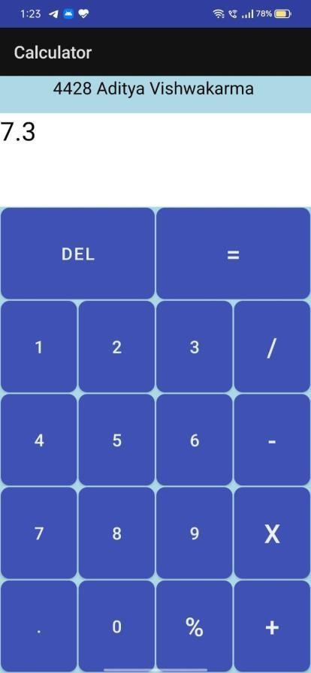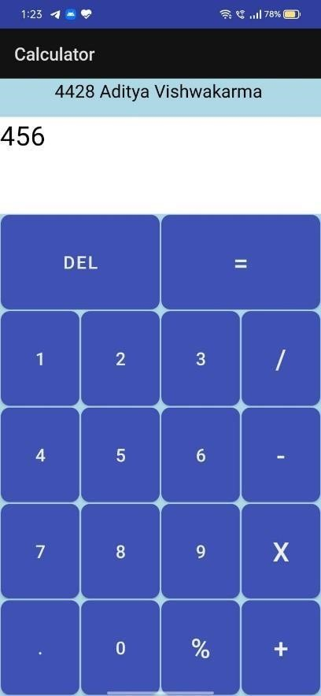

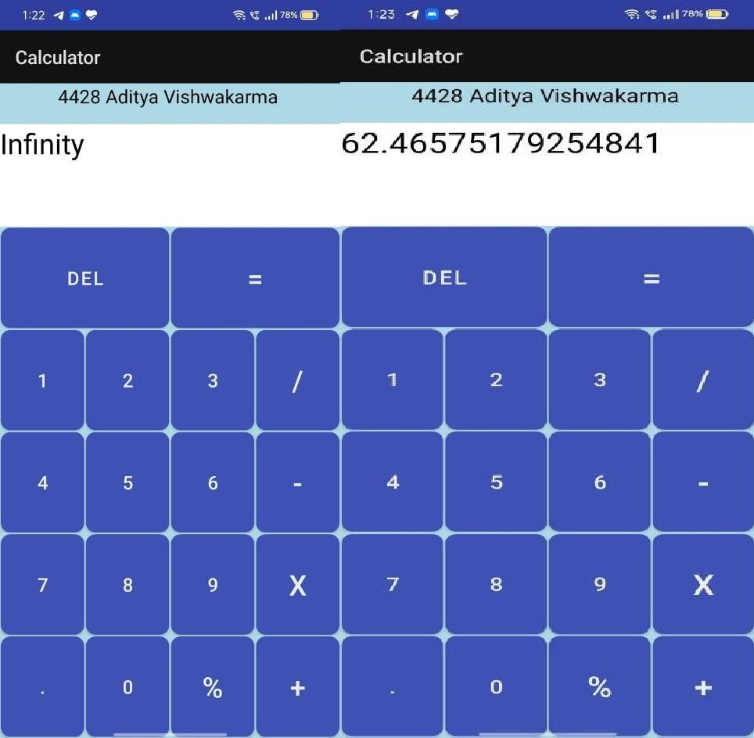

**3**

**Aim:**

**Xml:**

**<?xml version="1.0" encoding="utf-8"?>**

**<RelativeLayout xmlns:android[="http://schemas.android.com/apk/res/android"](http://schemas.android.com/apk/res/android)****xmlns:app[="http://schemas.android.com/apk/res](http://schemas.android.com/apk/res-auto)**[**-auto"**](http://schemas.android.com/apk/res-auto) **xmlns:tools[="http://schemas.android.com/tools"](http://schemas.android.com/tools)****android:layout_width="match_parent" android:layout_height="match_parent" android:layout_centerInParent="true" android:gravity="center" android:padding="20dp" tools:context=".MainActivity">**

**<TextView android:id="@+id/myname" android:layout_width="390dp" android:layout_height="wrap_content" android:layout_alignParentStart="true" android:layout_alignParentTop="true" android:layout_alignParentEnd="true"**

**android:layout_marginTop="-168dp" android:layout_marginEnd="1dp" android:paddingStart="20dp" android:paddingTop="20dp" android:paddingEnd="20dp" android:paddingBottom="20dp"**

**android:text="4429-Satyam Prajapati" />**

**<EditText android:id="@+id/editTextName" android:layout_width="match_parent" android:layout_height="wrap_content" android:ems="10"**

**android:hint="Enter Your Text" android:inputType="textPersonName" android:paddingStart="20dp" android:paddingTop="20dp" android:paddingEnd="20dp" android:paddingBottom="20dp" />**

**<Button android:id="@+id/btnClickHere" android:layout_width="wrap_content" android:layout_height="wrap_content" android:layout_below="@id/editTextName" android:paddingStart="20dp" android:paddingTop="20dp" android:paddingEnd="20dp" android:paddingBottom="20dp" android:text="Button" />**

**<TextView android:id="@+id/textName" android:layout_width="wrap_content" android:layout_height="wrap_content" android:layout_below="@id/btnClickHere" android:paddingStart="20dp" android:paddingTop="20dp" android:paddingEnd="20dp" android:paddingBottom="20dp" android:text="TextView" />**

**</RelativeLayout>**

**Java: package com.example.tv; import androidx.appcompat.app.AppCompatActivity;**

**import android.os.Bundle; import android.view.View; import android.widget.Button; import android.widget.EditText; import android.widget.TextView; public class MainActivity extends AppCompatActivity {**

**EditText editTextName;**

**Button btnClickHere;**

**TextView textName;**

# @Override

**protected void onCreate(Bundle savedInstanceState) { super.onCreate(savedInstanceState); setContentView(R.layout.*activity_main*);**

**editTextName=(EditText) findViewById(R.id.*editTextName*); btnClickHere=(Button) findViewById(R.id.*btnClickHere*); textName=(TextView) findViewById(R.id.*textName*);**

**btnClickHere.setOnClickListener(new View.OnClickListener() {**

# @Override

**public void onClick(View v) {**

**String name=editTextName.getText().toString(); textName.setText(name);**

**}**

**});**

**}**

**}**

**output:**

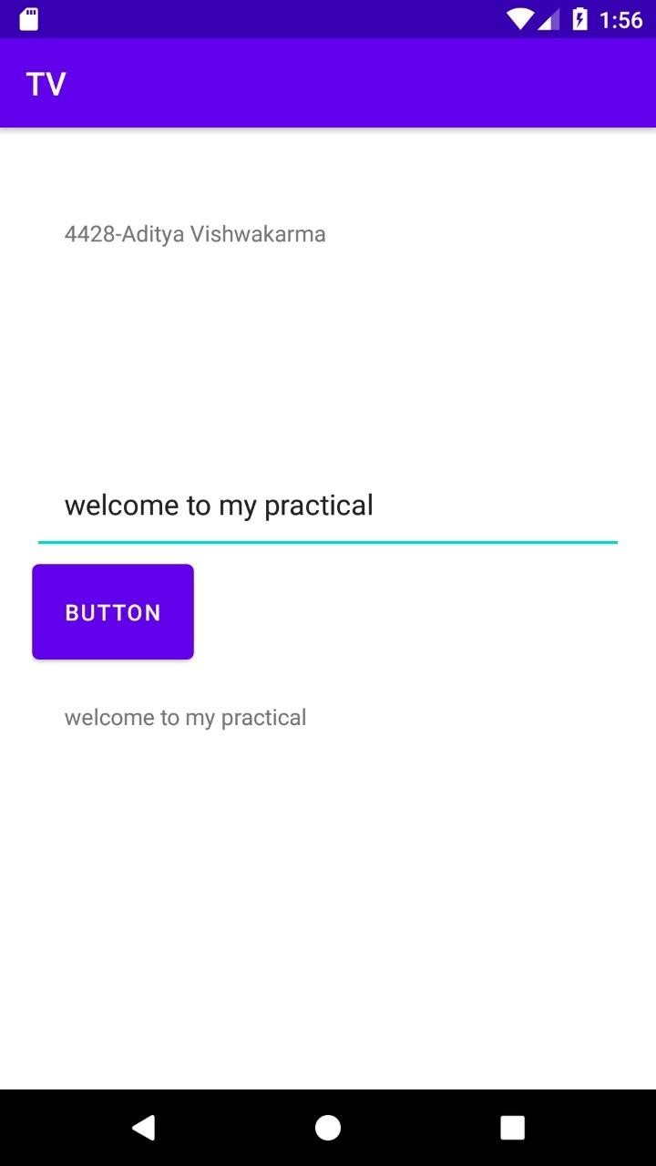

**4**

**Aim:**

**Xml -1:**

**<?xml version="1.0" encoding="utf-8"?>**

**<androidx.constraintlayout.widget.ConstraintLayout xmlns:android[="http://schemas.android.com/apk/res/android"](http://schemas.android.com/apk/res/android)****xmlns:app[="http://schemas.android.com/apk/res](http://schemas.android.com/apk/res-auto)**[**-auto"**](http://schemas.android.com/apk/res-auto) **xmlns:tools[="http://schemas.android.com/tools"](http://schemas.android.com/tools)****android:layout_width="match_parent" android:layout_height="match_parent" android:background="#1C77BF"**

**tools:context=".MainActivity">**

**<TextView android:id="@+id/Tv" android:layout_width="wrap_content" android:layout_height="wrap_content" android:text="4428-Aditya Vishwakarma" android:gravity="center"**

**tools:ignore="MissingConstraints" />**

**<TextView android:id="@+id/tvFirstPage" android:layout_width="wrap_content" android:layout_height="wrap_content" android:text="First Page" android:textSize="36sp"**

**app:layout_constraintBottom_toBottomOf="parent" app:layout_constraintLeft_toLeftOf="parent" app:layout_constraintRight_toRightOf="parent" app:layout_constraintTop_toTopOf="parent" />**

**</androidx.constraintlayout.widget.ConstraintLayout>**

**Xml-2:**

**<?xml version="1.0" encoding="utf-8"?>**

**<androidx.constraintlayout.widget.ConstraintLayout xmlns:android[="http://schemas.android.com/apk/res/android"](http://schemas.android.com/apk/res/android)****xmlns:app[="http://schemas.android.com/apk/res](http://schemas.android.com/apk/res-auto)**[**-auto"**](http://schemas.android.com/apk/res-auto) **xmlns:tools[="http://schemas.android.com/tools"](http://schemas.android.com/tools)****android:layout_width="match_parent" android:layout_height="match_parent" android:background="#1C77BF" tools:context=".SecondActivity">**

**<TextView android:id="@+id/tv" android:layout_width="wrap_content" android:layout_height="wrap_content" android:text="4428-Aditya Vishwakarma" android:gravity="center" tools:ignore="MissingConstraints" />**

**<TextView android:id="@+id/Tv" android:layout_width="wrap_content" android:layout_height="wrap_content" android:text="Second Page" android:textSize="36sp"**

**app:layout_constraintBottom_toBottomOf="parent" app:layout_constraintLeft_toLeftOf="parent" app:layout_constraintRight_toRightOf="parent" app:layout_constraintTop_toTopOf="parent" />**

**</androidx.constraintlayout.widget.ConstraintLayout>**

**Java-1:**

**package com.example.lc; import androidx.appcompat.app.AppCompatActivity;**

**import android.content.Intent; import android.os.Bundle; import android.view.View; import android.widget.TextView; import android.widget.Toast; public class MainActivity extends AppCompatActivity {**

# @Override

**protected void onCreate(Bundle savedInstanceState) { super.onCreate(savedInstanceState); setContentView(R.layout.*activity_main*);**

**Toast.*makeText*(this, "onCreate", Toast.*LENGTH_SHORT*).show(); TextView textView = findViewById(R.id.*tvFirstPage*);**

**textView.setOnClickListener(new View.OnClickListener() {**

# @Override

**public void onClick(View v) { Intent intent = new**

**Intent(MainActivity.this,SecondActivity.class); startActivity(intent);**

**}**

**});**

**}**

**@Override protected void onStart(){ super.onStart();**

**Toast.*makeText*(this, "onStart", Toast.*LENGTH_SHORT*).show(); }**

# @Override

**protected void onResume(){ super.onResume();**

**Toast.*makeText*(this, "onResume", Toast.*LENGTH_SHORT*).show(); }**

# @Override

**protected void onPause(){ super.onPause();**

**Toast.*makeText*(this, "onPause", Toast.*LENGTH_SHORT*).show(); }**

# @Override

**protected void onStop(){ super.onStop();**

**Toast.*makeText*(this, "onStop", Toast.*LENGTH_SHORT*).show(); }**

# @Override

**protected void onRestart(){ super.onRestart();**

**Toast.*makeText*(this, "onRestart", Toast.*LENGTH_SHORT*).show(); }**

# @Override

**protected void onDestroy(){ super.onDestroy();**

**Toast.*makeText*(this, "onDestroy", Toast.*LENGTH_SHORT*).show(); }**

**}**

**java-2:**

**package com.example.lc; import androidx.appcompat.app.AppCompatActivity;**

**import android.os.Bundle; import android.view.Gravity; import android.widget.Toast; public class SecondActivity extends AppCompatActivity {**

# @Override

**protected void onCreate(Bundle savedInstanceState) { super.onCreate(savedInstanceState); setContentView(R.layout.*activity_second*);**

**Toast toast=Toast.*makeText*(this,"secondonStart",Toast.*LENGTH_SHORT*); toast.setGravity(Gravity.*CENTER*,0,0); toast.show();**

**}**

# @Override

**protected void onStart(){ super.onStart();**

**Toast toast=Toast.*makeText*(this,"secondonStart",Toast.*LENGTH_SHORT*); toast.setGravity(Gravity.*CENTER*,0,0); toast.show();**

**}**

# @Override

**protected void onResume(){ super.onResume();**

**Toast toast=Toast.*makeText*(this,"secondonResume",Toast.*LENGTH_SHORT*); toast.setGravity(Gravity.*CENTER*,0,0); toast.show();**

**}**

# @Override

**protected void onPause(){ super.onPause();**

**Toast toast=Toast.*makeText*(this,"secondonPause",Toast.*LENGTH_SHORT*); toast.setGravity(Gravity.*CENTER*,0,0); toast.show();**

**}**

# @Override

**protected void onStop(){ super.onStop();**

**Toast toast=Toast.*makeText*(this,"secondonStop",Toast.*LENGTH_SHORT*); toast.setGravity(Gravity.*CENTER*,0,0); toast.show();**

**}**

# @Override

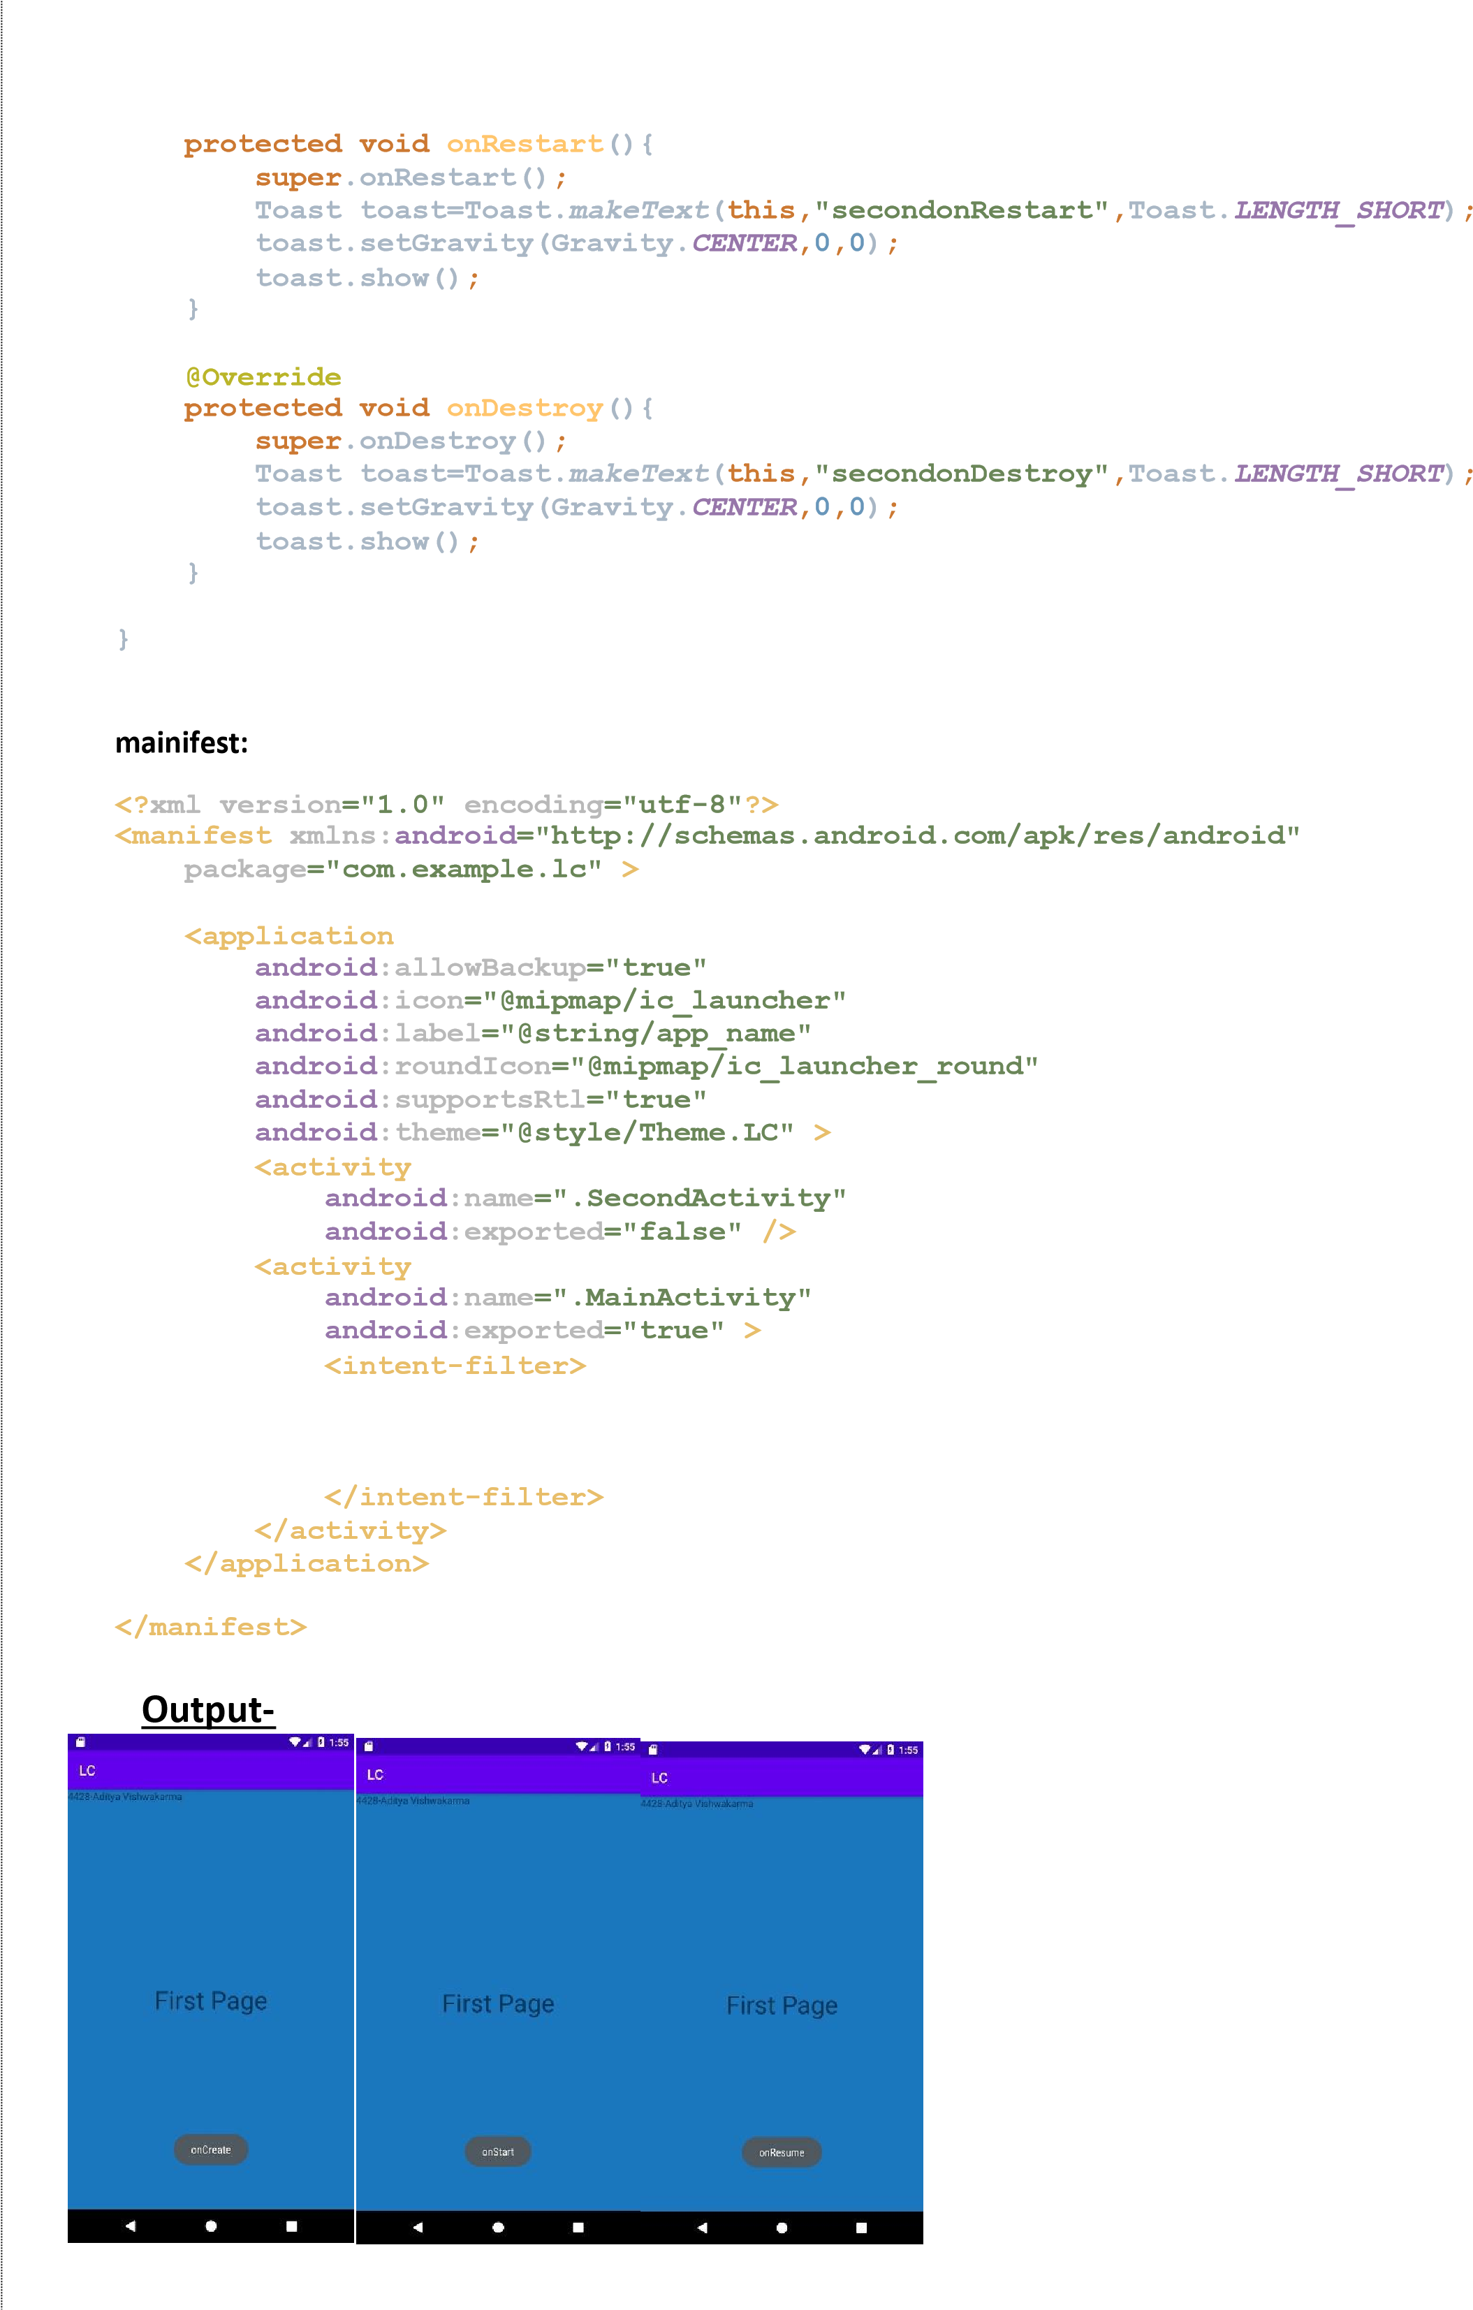**<action android:name="android.intent.action.MAIN" />**

**<category android:name="android.intent.category.LAUNCHER"/>**

**After**

**Click**

**ON**

**Second**

**Page:**

After

Click

on

Back

Button

:

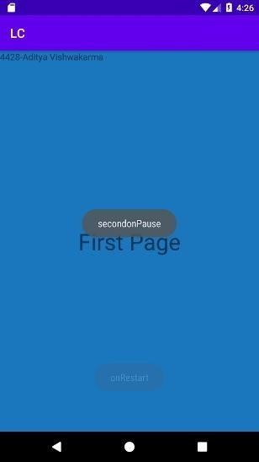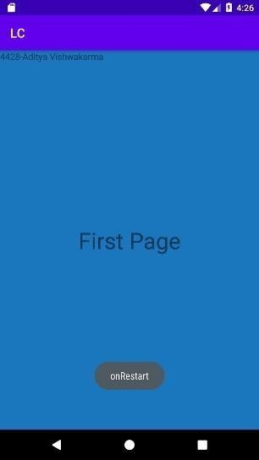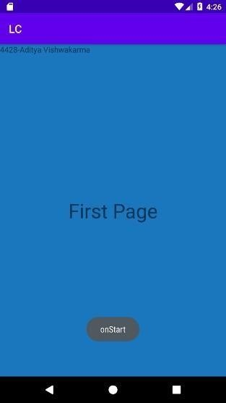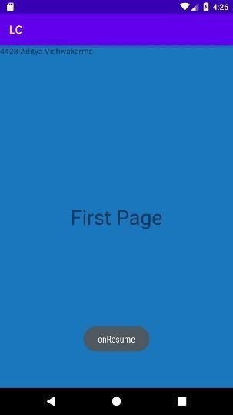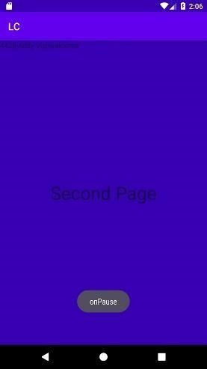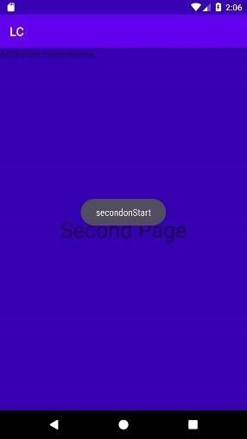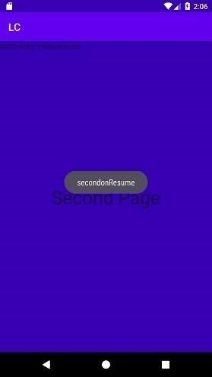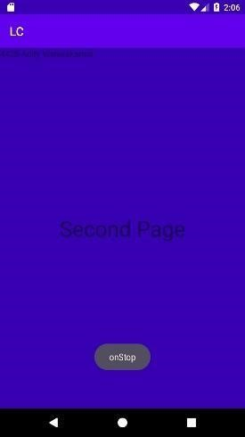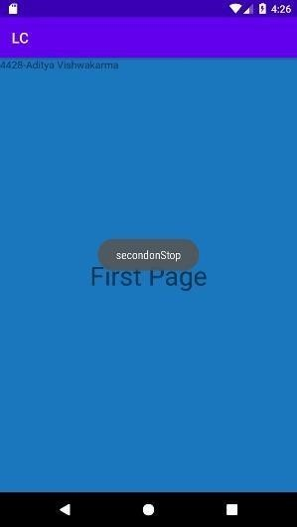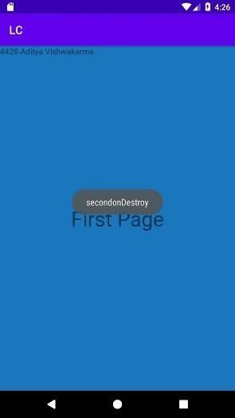

**5**

**Aim:**

**Xml:**

**<?xml version="1.0" encoding="utf-8"?>**

**<LinearLayout xmlns:android[="http://schemas.android.com/apk/res/android"](http://schemas.android.com/apk/res/android)****xmlns:app[="http://schemas.android.com/apk/res](http://schemas.android.com/apk/res-auto)**[**-auto"**](http://schemas.android.com/apk/res-auto) **xmlns:tools[="http://schemas.android.com/tools"](http://schemas.android.com/tools)****android:layout_width="match_parent" android:layout_height="match_parent" tools:context=".MainActivity" android:orientation="vertical" android:background="#ADD8E6"**

**android:layout_margin="20dp">**

**<TextView android:id="@+id/textView" android:layout_width="match_parent" android:layout_height="wrap_content" android:text="4429-Satyam Prajapati" android:textColor="@color/black" android:gravity="center"/>**

**<EditText android:id="@+id/name" android:layout_width="match_parent" android:layout_height="wrap_content" android:inputType="textPersonName" android:textSize="20dp" android:hint="NAME"/>**

**<EditText android:id="@+id/number" android:layout_width="match_parent" android:layout_height="wrap_content" android:inputType="number" android:textSize="20dp" android:hint="PHONE"/>**

**<EditText android:id="@+id/email" android:layout_width="match_parent" android:layout_height="wrap_content" android:inputType="textEmailAddress" android:textSize="20dp" android:hint="EMAIL ADDRESS"/>**

**<EditText android:id="@+id/password" android:layout_width="match_parent" android:layout_height="wrap_content" android:inputType="textPassword" android:textSize="20dp" android:hint="PASSWORD"/>**

**<LinearLayout android:layout_width="match_parent" android:layout_height="wrap_content" android:orientation="horizontal">**

**<TextView**

**android:layout_width="wrap_content" android:layout_height="wrap_content" android:text="D.O.B. :" android:textSize="20dp" />**

|  |  |
| --- | --- |
|  |  |
| **<!--** | **<EditText-->** |
| **<!--** | **android:id="@+id/dob"-->** |
| **<!--** | **android:layout_width="wrap_content"-->** |
| **<!--** | **android:layout_height="wrap_content"-->** |
| **<!--** | **android:textSize="20dp"-->** |
| **<!--** | **android:hint="Double-Click to select"/>-->** |

**<EditText android:id="@+id/dob" android:layout_width="wrap_content" android:layout_height="wrap_content" android:layout_weight="1" android:ems="10" android:inputType="date" android:hint="01/01/2021"**

**/>**

**</LinearLayout>**

**<RadioGroup android:id="@+id/rg" android:layout_width="wrap_content" android:layout_height="wrap_content" android:layout_marginTop="30dp">**

**<TextView android:layout_width="wrap_content" android:layout_height="wrap_content" android:text="Gender" android:textSize="20dp" />**

**<RadioButton android:id="@+id/r1" android:layout_width="wrap_content" android:layout_height="wrap_content" android:text="Male" android:textSize="20dp" />**

**<RadioButton android:id="@+id/r2" android:layout_width="wrap_content" android:layout_height="wrap_content" android:text="Female" android:textSize="20dp" />**

**</RadioGroup>**

**<LinearLayout android:layout_width="match_parent" android:layout_height="wrap_content" android:orientation="horizontal">**

**<TextView android:layout_width="wrap_content" android:layout_height="wrap_content" android:text="I AM " android:textSize="20dp"/>**

**<Spinner android:id="@+id/sp" android:layout_width="wrap_content" android:layout_height="wrap_content"**

**tools:ignore="SpeakableTextPresentCheck,TouchTargetSizeCheck"></Spinner>**

**</LinearLayout>**

**<Button android:id="@+id/bb"**

**android:layout_width="wrap_content" android:layout_height="wrap_content" android:textSize="30dp" android:text="DISPLAY" android:layout_marginTop="30dp" android:layout_gravity="center"/>**

**</LinearLayout>**

**Java:**

**package com.example.keyboardinputs; import androidx.appcompat.app.AppCompatActivity;**

**import android.app.AlertDialog; import android.app.DatePickerDialog; import android.content.DialogInterface; import android.os.Bundle; import android.view.View; import android.widget.Adapter; import android.widget.AdapterView; import android.widget.ArrayAdapter; import android.widget.Button; import android.widget.DatePicker; import android.widget.EditText; import android.widget.RadioButton; import android.widget.RadioGroup; import android.widget.Spinner; import android.widget.Toast;**

**import java.util.Calendar;**

**public class MainActivity extends AppCompatActivity implements AdapterView.OnItemSelectedListener {**

**String TAG = "MainActivity";**

**String date,mspinner;**

**String data[] ={"STUDENT" , "WORKING" , "SENIOR CITIZEN"} ;**

**EditText name,email,phone,dob;**

**Spinner sp;**

**RadioGroup rg;**

**RadioButton r; String rb; int rr;**

**Button b1;**

**DatePickerDialog.OnDateSetListener mDataListner;**

# @Override

**protected void onCreate(Bundle savedInstanceState) { super.onCreate(savedInstanceState); setContentView(R.layout.*activity_main*);**

**name=(EditText) findViewById(R.id.*name*); phone=(EditText) findViewById(R.id.*number*); email=(EditText) findViewById(R.id.*email*); dob=(EditText) findViewById(R.id.*dob*); sp=(Spinner) findViewById(R.id.*sp*);**

**rg = (RadioGroup) findViewById(R.id.*rg*); b1=(Button) findViewById(R.id.*bb*);**

**dob.setOnClickListener(new View.OnClickListener() { @Override**

**public void onClick(View v) {**

**Calendar cal =Calendar.*getInstance*();**

# // Calendar cal = Calendar.getInstance();

**int year = cal.get(Calendar.*YEAR*); int month = cal.get(Calendar.*MONTH*); int day = cal.get(Calendar.*DAY_OF_MONTH*);**

**DatePickerDialog dialog =new**

**DatePickerDialog(MainActivity.this,R.style.*Theme_AppCompat_DayNight_Dialog_Min Width*,mDataListner,**

**year,month,day);**

**dialog.show();**

**}**

**});**

**mDataListner = (datePicker, year, month, day) -> { month=month+1;**

**date=day+"/"+month+"/"+year; dob.setText(date);**

**};**

**sp.setOnItemSelectedListener(this); ArrayAdapter aa = new**

**ArrayAdapter(this,R.layout.support_simple_spinner_dropdown_item,data);**

**aa.setDropDownViewResource(R.layout.support_simple_spinner_dropdown_item); sp.setAdapter(aa);**

**b1.setOnClickListener(new View.OnClickListener() {**

## @Override

**public void onClick(View v) { rr = rg.getCheckedRadioButtonId(); if (rr !=-1)**

**{ r=(RadioButton)findViewById(rr); rb=r.getText().toString();**

**}**

**AlertDialog.Builder myalert = new**

**AlertDialog.Builder(MainActivity.this);**

**myalert.setTitle("Alert");**

**myalert.setMessage("Click Ok to continue or else cancel");**

**myalert.setNegativeButton("cancel", new**

**DialogInterface.OnClickListener() {**

## @Override

**public void onClick(DialogInterface dialog, int which) { Toast.*makeText*(MainActivity.this,"YOU**

**CANCELLED",Toast.*LENGTH_LONG*).show();**

**}**

**});**

**myalert.setPositiveButton("OK",new**

**DialogInterface.OnClickListener() {**

## @Override

**public void onClick(DialogInterface dialog, int which) {**

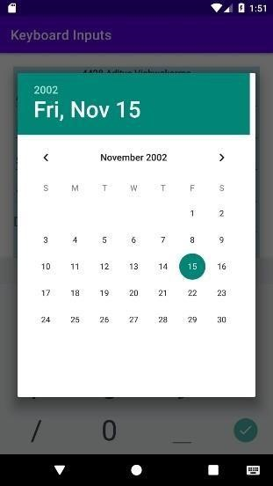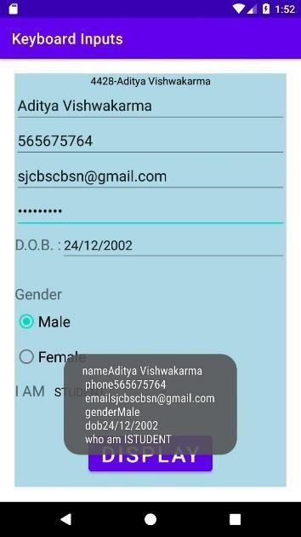**String Display = "name"+name.getText().toString()+"\n  phone"+phone.getText().toString()+**

**}**

**})**

**;**

**}**

**@Override**

**long**

**id)**

**{**

**}**

**@Override**

**}**

**}**

**output:**

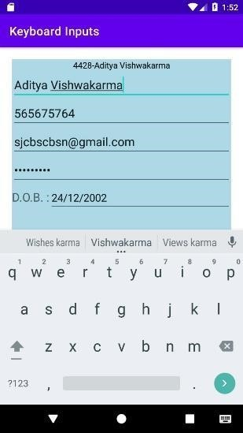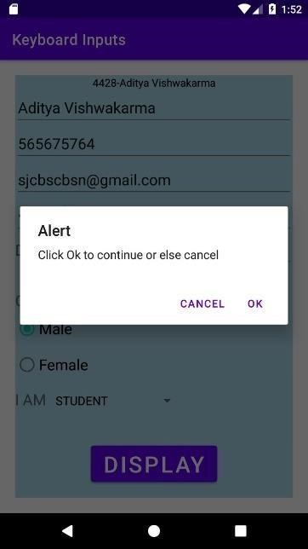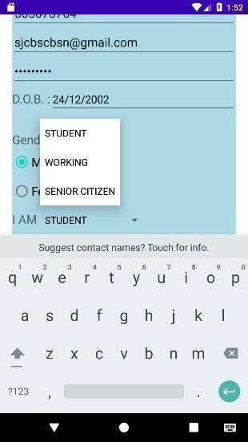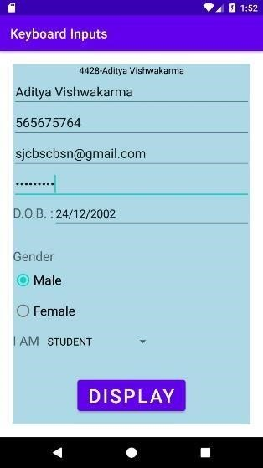

**"\n email"+ email.getText().toString()+"\n**

**gender"+rb+"\n dob"+date+"\n who am I"+mspinner;**

**Toast.*makeText*(MainActivity.this,Display,Toast.*LENGTH_LONG*).show();**

**} }); myalert.show();**

**public void onItemSelected(AdapterView<?> parent, View view, int position, mspinner = sp.getSelectedItem().toString();**

**public void onNothingSelected(AdapterView<?> parent) {**

**Practical no-6**

**Aim-Create an android app that demonstrates the use of an Options Menu.**

**Activity_main.xml:**

**<?xml version="1.0" encoding="utf-8"?>**

**<LinearLayout**

**xmlns:android="**[**http://schemas.android.com/apk/res/android"**](http://schemas.android.com/apk/res/android) **xmlns:app="**[**http://schemas.android.com/apk/res-auto"**](http://schemas.android.com/apk/res-auto) **xmlns:tools="**[**http://schemas.android.com/tools"**](http://schemas.android.com/tools) **android:layout_width="match_parent" android:layout_height="match_parent" tools:context=".MainActivity">**

**<TextView android:layout_width="wrap_content" android:layout_height="wrap_content" android:text="4428-Aditya Vishwakarma" app:layout_constraintBottom_toBottomOf="parent" app:layout_constraintLeft_toLeftOf="parent" app:layout_constraintRight_toRightOf="parent" app:layout_constraintTop_toTopOf="parent" />**

**</LinearLayout> Java:**

**package com.example.optionsmenu;**

**import androidx.annotation.NonNull;**

**import androidx.appcompat.app.AppCompatActivity;**

**import android.os.Bundle; import android.view.Menu; import android.view.MenuInflater; import android.view.MenuItem; import android.widget.Toast; public class MainActivity extends AppCompatActivity {**

## @Override

**protected void onCreate(Bundle savedInstanceState) { super.onCreate(savedInstanceState); setContentView(R.layout.*activity_main*);**

**}**

## @Override

**public boolean onCreateOptionsMenu(Menu menu) { MenuInflater inflater = getMenuInflater(); inflater.inflate(R.menu.*testmenu*,menu); return true;**

**}**

## @Override

**public boolean onOptionsItemSelected(@NonNull MenuItem item) { switch (item.getItemId()){ case R.id.*item1*:**

**Toast.*makeText*(this, "Item 1 is selected",**

**Toast.*LENGTH_SHORT*).show();**

**return true;**

**case R.id.*item2*:**

**Toast.*makeText*(this, "Item 2 is selected",**

**Toast.*LENGTH_SHORT*).show(); return true;**

**case R.id.*item3*:**

**Toast.*makeText*(this, "Item 3 is selected",**

**Toast.*LENGTH_SHORT*).show(); return true;**

**case R.id.*subitem1*:**

**Toast.*makeText*(this, "Sub Item 1 is selected",**

**Toast.*LENGTH_SHORT*).show(); return true;**

**case R.id.*subitem2*:**

**Toast.*makeText*(this, "Sub Item 2 is selected",**

**Toast.*LENGTH_SHORT*).show();**

**return true;**

**default:return super.onOptionsItemSelected(item); }**

**}**

**}**

**test./xml**

**<?xml version="1.0" encoding="utf-8"?>**

**<menu xmlns:android[="http://schemas.android.com/apk/res/android"](http://schemas.android.com/apk/res/android)****xmlns:app[="http://schemas.android.com/apk/res](http://schemas.android.com/apk/res-auto)**[**-auto">**](http://schemas.android.com/apk/res-auto)

**<item android:id="@+id/item1"**

**android:icon="@drawable/ic_baseline_notifications" android:title="item1" app:showAsAction="ifRoom"/>**

**<item android:id="@+id/item2" android:title="item2" app:showAsAction="never"/>**

**<item android:id="@+id/item3" android:title="item3" app:showAsAction="never">**

**<menu>**

**<item android:id="@+id/subitem1" android:title="sub item1"/>**

**<item android:id="@+id/subitem2" android:title="sub item2"/>**

**</menu>**

**</item>**

**</menu>**

**Output:**

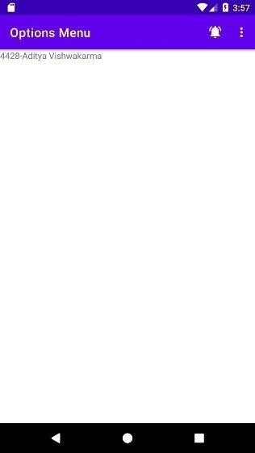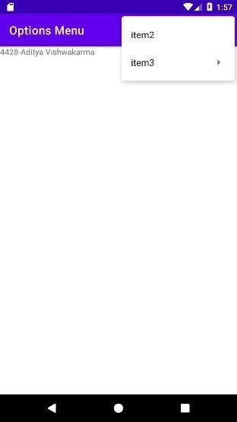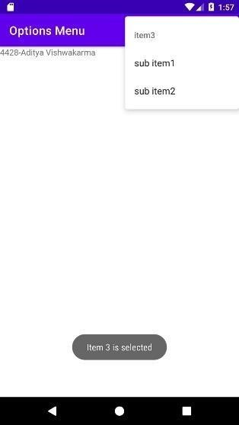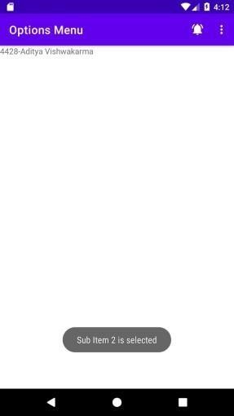

**After Click on Bell:**

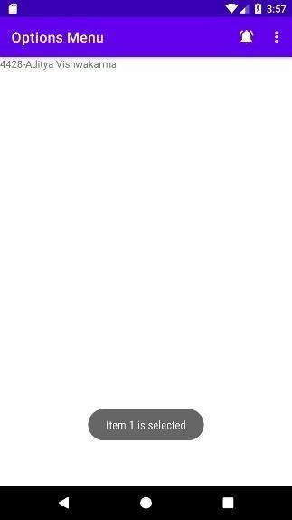

**7**

**Aim:**

**Androidmanifest.xml:**

**<?xml version="1.0" encoding="utf-8"?>**

**<manifest xmlns:android[="http://schemas.android.com/apk/res/android"](http://schemas.android.com/apk/res/android)****package="com.example.screennavigation">**

**<application android:allowBackup="true" android:icon="@mipmap/ic_launcher" android:label="@string/app_name" android:roundIcon="@mipmap/ic_launcher_round" android:supportsRtl="true"**

**android:theme="@style/Theme.ScreenNavigation">**

**<activity android:name=".DeshBoard" android:exported="false" />**

**<activity android:name=".MainActivity" android:exported="true">**

**<intent-filter>**

**<action android:name="android.intent.action.MAIN" />**

**<category android:name="android.intent.category.LAUNCHER"/>**

**</intent-filter>**

**</activity>**

**</application>**

**</manifest>**

# Themes.xml

**<resources xmlns:tools[="http://schemas.android.com/tools"](http://schemas.android.com/tools)**[**>**](http://schemas.android.com/tools)

**<!-- Base application theme. -->**

**<style name="Theme.ScreenNavigation" parent="Theme.MaterialComponents.DayNight.DarkActionBar">**

**<!-- Primary brand color. -->**

**<item name="colorPrimary">@color/purple_500</item>**

**<item name="colorPrimaryVariant">@color/purple_700</item>**

**<item name="colorOnPrimary">@color/white</item>**

**<!-- Secondary brand color. -->**

**<item name="colorSecondary">@color/teal_200</item>**

**<item name="colorSecondaryVariant">@color/teal_700</item>**

**<item name="colorOnSecondary">@color/black</item>**

**<!-- Status bar color. -->**

**<item name="android:statusBarColor" tools:targetApi="l">?attr/colorPrimaryVariant</item>**

**<!-- Customize your theme here. -->**

**</style> </resources>**

**MainActivity.java package com.example.screennavigation;**

**import androidx.annotation.NonNull; import androidx.appcompat.app.AppCompatActivity; import android.content.Intent; import android.os.Bundle; import android.view.MenuItem;**

**import com.google.android.material.bottomnavigation.BottomNavigationView;**

**public class MainActivity extends AppCompatActivity {**

**@Override**

**protected void onCreate(Bundle savedInstanceState) { super.onCreate(savedInstanceState); setContentView(R.layout.*activity_main*);**

**//Initialization**

**BottomNavigationView bottomNavigationView=findViewById(R.id.*bottom_navigation*);**

**bottomNavigationView.setSelectedItemId(R.id.*home*);**

**bottomNavigationView.setOnNavigationItemReselectedListener(new**

**BottomNavigationView.OnNavigationItemReselectedListener() {**

**@Override public void onNavigationItemReselected(@NonNull MenuItem item)**

**{**

**MenuItem menuItem = null;**

**final boolean b1 = false; switch**

**(menuItem.getItemId()){ case R.id.*deshboard*:**

**startActivity(new Intent(getApplicationContext()**

**,DeshBoard.class)); overridePendingTransition(0,0); return; case**

**R.id.*home*:**

**return;**

**case R.id.*about*:**

**startActivity(new Intent(getApplicationContext()**

**,About.class)); overridePendingTransition(0,0); return;**

**}**

**}**

**});**

**}**

**}**

# About.java

**package com.example.screennavigation;**

**import androidx.annotation.NonNull;**

**import androidx.appcompat.app.AppCompatActivity;**

**import android.content.Intent; import android.os.Bundle; import android.view.MenuItem;**

**import com.google.android.material.bottomnavigation.BottomNavigationView; public class About extends AppCompatActivity {**

**@Override**

**protected void onCreate(Bundle savedInstanceState) { super.onCreate(savedInstanceState); setContentView(R.layout.*activity_about*);**

**//Initialization**

**BottomNavigationView bottomNavigationView=findViewById(R.id.*bottom_navigation*);**

**bottomNavigationView.setSelectedItemId(R.id.*about*);**

**bottomNavigationView.setOnNavigationItemReselectedListener(new**

**BottomNavigationView.OnNavigationItemReselectedListener() {**

**@Override public void onNavigationItemReselected(@NonNull MenuItem item)**

**{**

**MenuItem menuItem = null; switch (menuItem.getItemId()){ case R.id.*deshboard*:**

**startActivity(new Intent(getApplicationContext()**

**,DeshBoard.class)); overridePendingTransition(0,0);**

**return;**

**case R.id.*home*:**

**startActivity(new Intent(getApplicationContext()**

**,MainActivity.class));**

**overridePendingTransition(0,0);**

**return;**

**case R.id.*about*:**

**return;**

**}**

**}**

**});**

**}**

**DeshBoard.java:**

**package com.example.screennavigation;**

**import androidx.annotation.NonNull; import androidx.appcompat.app.AppCompatActivity;**

**import android.content.Intent; import android.os.Bundle; import android.view.MenuItem;**

**import com.google.android.material.bottomnavigation.BottomNavigationView; public class DeshBoard extends AppCompatActivity {**

**@Override**

**protected void onCreate(Bundle savedInstanceState) { super.onCreate(savedInstanceState); setContentView(R.layout.*activity_desh_board*);**

**//Initialization**

**BottomNavigationView bottomNavigationView=findViewById(R.id.*bottom_navigation*);**

**bottomNavigationView.setSelectedItemId(R.id.*deshboard*);**

**bottomNavigationView.setOnNavigationItemReselectedListener(new BottomNavigationView.OnNavigationItemReselectedListener() {**

**@Override public void onNavigationItemReselected(@NonNull MenuItem item)**

**{**

**MenuItem menuItem = null; switch (menuItem.getItemId()){ case R.id.*deshboard*: return; case R.id.*home*:**

**startActivity(new Intent(getApplicationContext()**

**,MainActivity.class)); overridePendingTransition(0,0); return;**

**case R.id.*about*:**

**startActivity(new Intent(getApplicationContext()**

**,About.class));**

**overridePendingTransition(0,0);**

**return;**

**}**

**}**

**});**

**}**

**activity_Main.xml:**

**<?xml version="1.0" encoding="utf-8"?>**

**<RelativeLayout xmlns:android[="http://schemas.android.com/apk/res/android"](http://schemas.android.com/apk/res/android)****xmlns:app[="http://schemas.android.com/apk/res](http://schemas.android.com/apk/res-auto)**[**-auto"**](http://schemas.android.com/apk/res-auto) **xmlns:tools[="http://schemas.android.com/tools"](http://schemas.android.com/tools)**

**android:layout_width="match_parent" android:layout_height="match_parent" tools:context=".MainActivity">**

**<TextView android:layout_width="wrap_content" android:layout_height="wrap_content" android:text="Home" android:textSize="50sp" android:textStyle="bold"**

**android:layout_centerInParent="true" />**

**<com.google.android.material.bottomnavigation.BottomNavigationView android:layout_width="match_parent" android:layout_height="wrap_content" android:id="@+id/bottom_navigation"**

**app:itemBackground="@color/design_default_color_primary" app:itemTextColor="@drawable/selector" app:itemIconTint="@drawable/selector" app:menu="@menu/menu_nevigation" android:layout_alignParentBottom="true"/>**

**</RelativeLayout>**

# activity_About.xml

**?xml version="1.0" encoding="utf-8"?>**

**<RelativeLayout xmlns:android[="http://schemas.android.com/apk/res/android"](http://schemas.android.com/apk/res/android)****xmlns:app[="http://schemas.android.com/apk/res](http://schemas.android.com/apk/res-auto)**[**-auto"**](http://schemas.android.com/apk/res-auto) **xmlns:tools[="http://schemas.android.com/tools"](http://schemas.android.com/tools)****android:layout_width="match_parent"**

**android:layout_height="match_parent" tools:context=".About">**

**<TextView android:layout_width="wrap_content" android:layout_height="wrap_content" android:layout_centerInParent="true"**

**android:text="About" android:textSize="50sp" android:textStyle="bold" />**

**<com.google.android.material.bottomnavigation.BottomNavigationView android:layout_width="match_parent" android:layout_height="wrap_content" android:id="@+id/bottom_navigation"**

**app:itemBackground="@color/design_default_color_primary" app:itemTextColor="@drawable/selector" app:itemIconTint="@drawable/selector" app:menu="@menu/menu_nevigation" android:layout_alignParentBottom="true"/>**

# </RelativeLayout> activity_DashBoard.xml

**?xml version="1.0" encoding="utf-8"?>**

**<RelativeLayout xmlns:android[="http://schemas.android.com/apk/res/android"](http://schemas.android.com/apk/res/android)****xmlns:tools[="http://schemas.android.com/tools"](http://schemas.android.com/tools)****xmlns:app[="http://schemas.android.com/apk/res](http://schemas.android.com/apk/res-auto)**[**-auto"**](http://schemas.android.com/apk/res-auto) **android:layout_width="match_parent" android:layout_height="match_parent" tools:context=".DeshBoard">**

**<TextView android:layout_width="258dp" android:layout_height="wrap_content" android:layout_centerInParent="true" android:text="DashBoard" android:textSize="50sp" android:textStyle="bold" />**

**<com.google.android.material.bottomnavigation.BottomNavigationView android:layout_width="match_parent" android:layout_height="wrap_content" android:id="@+id/bottom_navigation" app:itemBackground="@color/design_default_color_primary" app:itemTextColor="@drawable/selector" app:itemIconTint="@drawable/selector" app:menu="@menu/menu_nevigation" android:layout_alignParentBottom="true"/>**

**</RelativeLayout>**

**Build.gradle:**

**plugins { id 'com.android.application'**

**}**

**android { compileSdk 31**

**defaultConfig { applicationId "com.example.screennavigation" minSdk 21 targetSdk 31**

**versionCode 1 versionName "1.0"**

**testInstrumentationRunner "androidx.test.runner.AndroidJUnitRunner" }**

**buildTypes { release { minifyEnabled false**

**proguardFiles getDefaultProguardFile('proguard-android-**

**optimize.txt'), 'proguard-rules.pro'**

**} }**

**compileOptions { sourceCompatibility JavaVersion.*VERSION_1_8* targetCompatibility JavaVersion.*VERSION_1_8***

**}**

**}**

**dependencies {**

**implementation 'androidx.appcompat:appcompat:1.4.0' implementation 'com.google.android.material:material:1.4.0' implementation 'androidx.constraintlayout:constraintlayout:2.1.2' implementation 'com.google.android.material:material:1.0.0'**

**//noinspection GradleCompatible**

**implementation 'com.android.support:design:28.0.0' //noinspection GradleCompatible,GradleCompatible implementation 'com.android.support:support-v4:28.0.0' testImplementation 'junit:junit:4.+'**

**androidTestImplementation 'androidx.test.ext:junit:1.1.3'**

**androidTestImplementation 'androidx.test.espresso:espresso-core:3.4.0'**

**}**

**Output:**

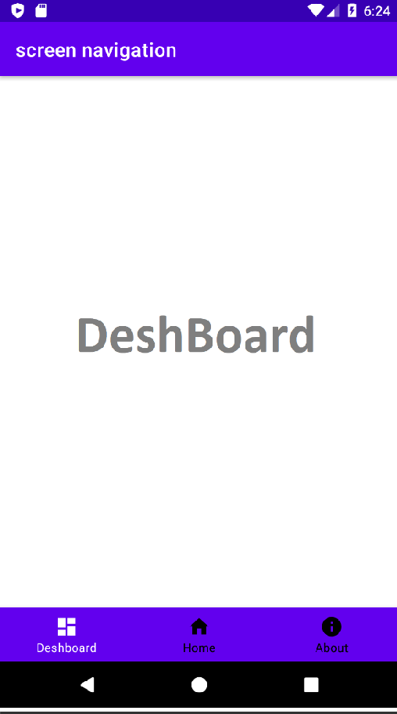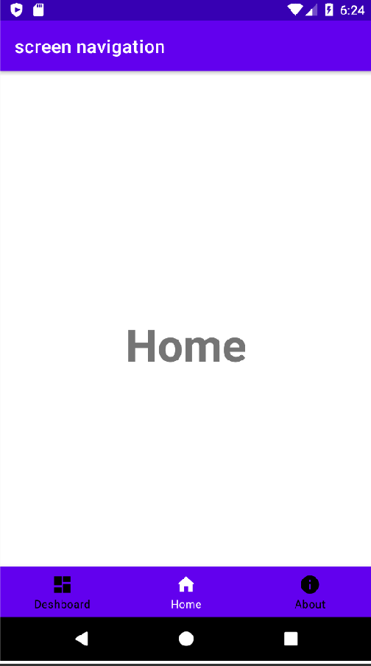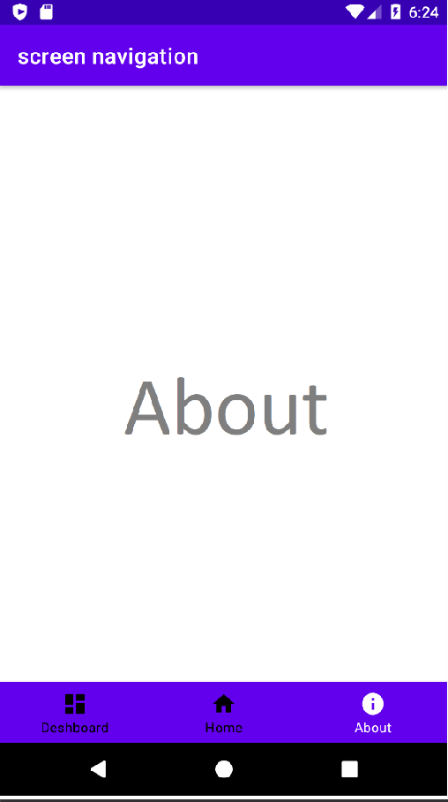

***Practical No. 8***

**Aim: Create an android app to Connect to the Internet and use BroadcastReceiver**

**AndroidManifest.xml**

**<?xml version="1.0" encoding="utf-8"?>**

**<manifest xmlns:android="**[**http://schemas.android.com/apk/res/android"**](http://schemas.android.com/apk/res/android) **package="com.example.prac8">**

**<uses-permission android:name="android.permission.INTERNET" />**

**<uses-permission android:name="android.permission.ACCESS_NETWORK_STATE" />**

**<application android:allowBackup="true" android:icon="@mipmap/ic_launcher "android:label="@string/app_name" android:roundIcon="@mipmap/ic_launcher_round" android:supportsRtl="true" android:theme="@style/Theme.Prac8">**

**<activity android:name=".MainActivity" android:exported="true">**

**<intent-filter>**

**<action android:name="android.intent.action.MAIN" />**

**<category android:name="android.intent.category.LAUNCHER" />**

**</intent-filter>**

**</activity>**

**<receiver android:name=".ConnectivityReceiver" android:enabled="true" android:exported="true">**

**<intent-filter>**

**<action android:name="android.net.conn.CONNECTIVITY_CHANGE" />**

**</intent-filter>**

**</receiver>**

**</application>**

**</manifest>**

***activity_main.xml***

**<?xml version="1.0" encoding="utf-8"?>**

**<androidx.coordinatorlayout.widget.CoordinatorLayo ut xmlns:android="**[**http://schemas.android.com/apk/res/ android"**](http://schemas.android.com/apk/res/android) **xmlns:app="**[**http://schemas.android.com/apk/res- auto"**](http://schemas.android.com/apk/res-auto) **xmlns:tools="**[**http://schemas.android.com/tools"**](http://schemas.android.com/tools) **android:layout_width="match_parent" android:layout_height="match_parent" tools:context=".MainActivity">**

**<com.google.android.material.appbar.AppBarLayout android:layout_width="match_parent" android:layout_height="wrap_content" android:theme="@style/AppTheme.PopupOverlay">**

**<androidx.appcompat.widget.Toolbar android:id="@+id/toolbar" android:layout_width="match_parent" android:layout_height="?attr/actionBarSize" android:background="?attr/colorPrimary" app:popupTheme="@style/AppTheme.PopupOverlay"**

**/>**

**</com.google.android.material.appbar.AppBarLayout>**

**<LinearLayout android:layout_width="match_parent"**

**android:layout_height="match_parent" android:orientation="vertical" android:padding="50dp"**

**app:layout_behavior="@string/appbar_scrolling_view_behavior">**

**<TextView android:layout_width="match_parent" android:layout_height="wrap_content"**

**android:text="Turn on/off wifi to notify the app about connection status." />**

**<Button**

**android:id="@+id/btn_check" android:layout_width="wrap_content" android:layout_height="wrap_content" android:layout_marginTop="20dp" android:text="Check Connection" />**

**</LinearLayout>**

**<com.google.android.material.floatingactionbutton.FloatingActionButton android:id="@+id/fab" android:layout_width="wrap_content" android:layout_height="wrap_content" android:layout_gravity="bottom|end" android:src="@drawable/ic_launcher_background"**

**/>**

**</androidx.coordinatorlayout.widget.CoordinatorLayout>**

***MainActivity.java***

**package com.example.prac8;**

**import androidx.appcompat.app.AppCompatActivity;import android.graphics.Color; import android.os.Bundle; import android.view.View; import android.widget.Button; import android.widget.TextView;**

**import androidx.appcompat.widget.Toolbar;**

**import com.google.android.material.snackbar.Snackbar;**

**public class MainActivity extends AppCompatActivity implements ConnectivityReceiver.ConnectivityReceiverListener {**

**@Override**

**protected void onCreate(Bundle savedInstanceState) { super.onCreate(savedInstanceState);**

**setContentView(R.layout.activity_main);**

**Toolbar toolbar = (Toolbar) findViewById(R.id.toolbar);**

**setSupportActionBar(toolbar);**

**Button btnCheck = (Button) findViewById(R.id.btn_check); checkConnection(); btnCheck.setOnClickListener(new View.OnClickListener() {**

**@Override**

**public void onClick(View v) {**

**// Manually checking internet connectioncheckConnection();**

**}**

**});**

**}**

**// Method to manually check connection statusprivate void checkConnection() { boolean isConnected = ConnectivityReceiver.isConnected(); showSnack(isConnected);**

**}**

**// Showing the status in Snackbar**

**private void showSnack(boolean isConnected) {**

**String message; int color;**

**if (isConnected) {**

**message = "Good! Connected to**

**Internet";color = Color.WHITE;**

**} else {**

**message = "Sorry! Not connected to internet";color = Color.RED;**

**}**

**Snackbar snackbar = Snackbar.make(findViewById(R.id.fab), message,**

**Snackbar.LENGTH_LONG);**

**View sbView = snackbar.getView();**

**TextView textView = (TextView) sbView.findViewById(R.id.snackbar_text); textView.setTextColor(color);**

**snackbar.show();**

**}**

**@Override**

**protected void onResume() { super.onResume();**

**MyApplication.getInstance().setConnectivityListener(this);**

**}**

**@Override**

**public void onNetworkConnectionChanged(boolean isConnected) { showSnack(isConnected);**

**}**

**public void setSupportActionBar(Toolbar toolbar) {**

**}**

**}**

***ConnectivityReciever.java***

**package com.example.prac8;**

**import android.content.BroadcastReceiver; import android.content.Context;**

**import android.content.Intent;**

**import android.net.ConnectivityManager;import android.net.NetworkInfo;**

**public class ConnectivityReceiver extends BroadcastReceiver {**

**public static ConnectivityReceiverListener connectivityReceiverListener; public ConnectivityReceiver() {**

**super();**

**}**

**@Override**

**public void onReceive(Context context, Intent arg1) {**

**ConnectivityManager cm = (ConnectivityManager) context**

**.getSystemService(Context.CONNECTIVITY_SERVICE);NetworkInfo activeNetwork = cm.getActiveNetworkInfo(); boolean isConnected**

**= activeNetwork != null**

**&& activeNetwork.isConnectedOrConnecting(); if (connectivityReceiverListener != null) {**

**connectivityReceiverListener.onNetworkConnectionChanged(isConnected);**

**}**

**}**

**public static boolean isConnected() {**

**ConnectivityManager cm = (ConnectivityManager) MyApplication.getInstance().getApplicationContext()**

**.getSystemService(Context.CONNECTIVITY_SERVICE); NetworkInfo activeNetwork = cm.getActiveNetworkInfo(); return activeNetwork != null**

**&& activeNetwork.isConnectedOrConnecting();**

**}**

**public interface ConnectivityReceiverListener { void onNetworkConnectionChanged(boolean isConnected);**

**}**

**}**

**public static synchronized MyApplication getInstance() { return mInstance;**

**}**

**public void setConnectivityListener(ConnectivityReceiver.ConnectivityReceiverListener listener) { ConnectivityReceiver.connectivityReceiverListener = listener;**

**}**

**<string name="app_name">Prac8</string>**

**</resources>**

***style.xml***

**<?xml version="1.0" encoding="utf-8"?>**

**<resources>**

**<style name="NoActionBar">**

**<item name="windowActionBar">false</item>**

**<item name="windowNoTitle">true</item>**

**</style>**

**<style name="AppTheme.AppBarOverlay" parent="ThemeOverlay.AppCompat.Dark.ActionBar"**

**/>**

**<style name="AppTheme.PopupOverlay" parent="ThemeOverlay.AppCompat.Light" />**

**</resources>**

***Output***

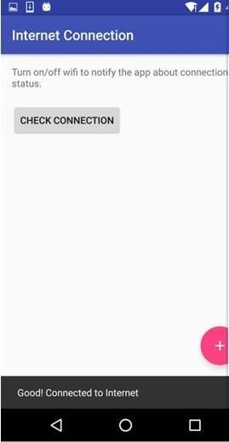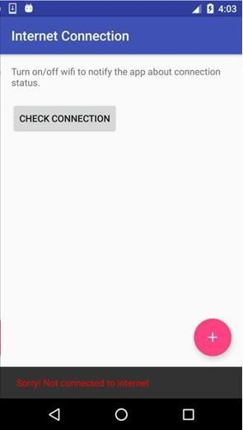

|  |  |  |
| --- | --- | --- |
| **Name-Aditya Vishwakarma DIV-B** | **Roll no-4428** | **class-SyBsc-CS** |
| **Practical no-9**      **Aim: Create an android app to show Notifications and Alarm manager.**        **Source code:**      **MainActivity.java**  **package com.example.prac9;**      **import android.annotation.SuppressLint; import android.app.AlarmManager; import android.app.PendingIntent; import android.app.TimePickerDialog; import android.content.Intent;**  **import android.icu.text.UnicodeSetSpanner;**      **import android.support.v7.app.AppCompatActivity;import android.os.Bundle; import android.util.Log; import android.view.View;**      **import android.widget.Button; import** | |  |

**52**

|  |  |  |
| --- | --- | --- |
| **Name-Aditya Vishwakarma DIV-B**    **android.widget.EditText; import android.widget.TextView; import android.widget.Toast; import java.util.Calendar; public class MainActivity extends AppCompatActivity { private EditText mSetTime ,mSetTime2; private Button mSendNotification,mSendNotification2;private int mHour,mMinte;**  **@Override**      **protected void onCreate(Bundle savedInstanceState) { super.onCreate(savedInstanceState); setContentView(R.layout.activity_main); mSetTime = findViewById(R.id.editTexttime); final Calendar calendar = Calendar.getInstance(); mSetTime2 = findViewById(R.id.editTexttime2); mSendNotification2 = findViewById(R.id.buttonsend2); mSendNotification = findViewById(R.id.Sentnptification); mSendNotification.setOnClickListener(v -> {**  **String getsetTime = mSetTime.getText().toString();** | **Roll no-4428** | **class-SyBsc-CS** |
| **53 Name-Aditya Vishwakarma DIV-B Roll no-4428 class-SyBsc-CS**    **// Checking if editText is**  **Empty. if(getsetTime.matches("")) {**  **Toast.makeText(this,"You did not set time!", Toast.LENGTH_LONG).show();**      **}else {**    **int time = Integer.parseInt(mSetTime.getText().toString());**  **}**  **});**      **String getsetTime2 = mSetTime2.getText().toString();**      **// Checking if editText is**  **Empty.if**  **(getsetTime2.matches("")){**  **Toast.makeText(this,"Select Time!",Toast.LENGTH_LONG).show();**      **}else {**      **Log.d("time in Millis",String.valueOf(calendar.getTimeInMillis()));**      **String getsetTime2 = mSetTime2.getText().toString();**      **// Checking if editText is**  **Empty.if**  **(getsetTime2.matches("")){**  **Toast.makeText(this,"Select Time!",Toast.LENGTH_LONG).show();**      **}else {** | | |

**4**

|  |
| --- |
| **Name-Aditya Vishwakarma DIV-B Roll no-4428 class-SyBsc-CS**      **Log.d("time in Millis",String.valueOf(calendar.getTimeInMillis()));**      **Intent intent = new Intent(MainActivity.this, Notification2.class);**      **PendingIntent p1=PendingIntent.getBroadcast(getApplicationContext(),0, intent,0); AlarmManager a=(AlarmManager)getSystemService(ALARM_SERVICE);**  **a.set(AlarmManager.RTC,calendar.getTimeInMillis(),p1);**  **}**    **});**    **}**      **private void updateTime(int hours, int mins) {String timeSet = ""; if (hours > 12) { hours -= 12; timeSet = "PM";**  **} else if (hours == 0)**    **{hours += 12; timeSet = "AM";**  **} else if (hours ==**  **12)timeSet =**  **"PM";**  **else**      **timeSet = "AM"; String** |

**55**

|  |  |  |
| --- | --- | --- |
| **Name-Aditya Vishwakarma DIV-B** | **Roll no-4428** | **class-SyBsc-CS** |
| **minutes = ""; if**  **(mins < 10) minutes = "0" + mins;else**  **minutes = String.valueOf(mins);**      **String aTime = new StringBuilder().append(hours).append(':')**      **.append(minutes).append("**  **").append(timeSet).toString();mSetTime2.setText(aTime);**  **}**      **}**      **activity_main.xml**    **<?xml version="1.0" encoding="utf-8"?>**      **<android.support.constraint.ConstraintLayout xmlns:andr**[**oid="http**](http://schemas.android.com/apk/res/android)**:/**[**/schemas.android.com/apk/res/android"**](http://schemas.android.com/apk/res/android) **xmlns:app=**[**"http://schemas.android.com/apk/res- auto"**](http://schemas.android.com/apk/res-auto) **xmlns:t**[**ools="htt**](http://schemas.android.com/tools)**p:/**[**/schemas.android.com/tools"**](http://schemas.android.com/tools) **android:layout_width="match_parent" android:layout_height="match_parent" tools:context=".MainActivity" tools:layout_editor_absoluteY="81dp">**  **<Button** | |  |

**56**

|  |  |  |
| --- | --- | --- |
| **Name-Aditya Vishwakarma DIV-B** | **Roll no-4428** | **class-SyBsc-CS** |
| **android:id="@+id/Sentnptification" android:layout_width="wrap_content" android:layout_height="wrap_content" android:layout_marginLeft="29dp" android:layout_marginStart="29dp" android:layout_marginTop="25dp" android:text="@string/send_notification" app:layout_constraintStart_toStartOf="@+id/editTextti m"**  **app:layout_constraintTop_toBottomOf="@+id/editTexttime" />**  **<EditText android:id="@+id/editTexttime" android:layout_width="wrap_conten**  **t"**  **android:layout_height="wrap_conten t"android:layout_marginTop="48dp" android:ems="10" android:hint="@string/time_in_seconds" android:inputType="number" app:layout_constraintEnd_toEndOf="parent" app:layout_constraintStart_toStartOf="parent" app:layout_constraintTop_toTopOf="parent" />**  **<EditText**    **android:id="@+id/editTexttime2" android:layout_width="wrap_content"** | |  |

**57**

|  |  |
| --- | --- |
| **Name-Aditya Vishwakarma DIV-B Roll no-4428**        **android:layout_height="wrap_content" android:layout_marginTop="50dp" android:ems="10" android:hint="@string/time" android:inputType="textPersonName" app:layout_constraintEnd_toEndOf="parent" app:layout_constraintStart_toStartOf="parent" app:layout_constraintTop_toBottomOf="@+id/Sentnptification" />**  **<Button android:id="@+id/buttonsend2" android:layout_width="wrap_content" android:layout_height="wrap_content" android:layout_marginLeft="29dp" android:layout_marginStart="29dp" android:layout_marginTop="34dp" android:text="@string/send_notification2" app:layout_constraintStart_toStartOf="@+id/editTexttime2" app:layout_constraintTop_toBottomOf="@+id/editTexttime2"**  **/>**  **</android.support.constraint.ConstraintLayout>**      **Notification.java**  **package com.example.prac9;** | **class-SyBsc-CS** |

**58**

|  |  |  |
| --- | --- | --- |
| **Name-Aditya Vishwakarma DIV-B** | **Roll no-4428** | **class-SyBsc-CS** |
| **import android.app.NotificationManager; import android.app.PendingIntent; import android.content.BroadcastReceiver; import android.content.Context;**  **import android.content.Intent; import android.support.v4.app.NotificationCompat; public class Notification extends BroadcastReceiver { private static final int NOTIFICATION_ID = 0;**  **@Override**  **public void onReceive(Context context, Intent intent) {**  **NotificationManager notificationManager = (NotificationManager) context.getSystemService(Context.NOTIFICATION_SERVICE);**    **//Create the content intent for the notification, which launches this activityIntent contentIntent = new Intent(context, MainActivity.class);**  **PendingIntent contentPendingIntent = PendingIntent.getActivity**  **(context, NOTIFICATION_ID, contentIntent,**  **PendingIntent.FLAG_UPDATE_CURRENT);**    **//Build the notification**  **NotificationCompat.Builder builder = new NotificationCompat.Builder(context)**  **.setSmallIcon(R.drawable.ic_notification)**  **. setContentTitle(context.getString(R.string.notification_title))**  **. setContentText(context.getString(R.string.notification_text))** | |  |

**59**

|  |  |
| --- | --- |
| **Name-Aditya Vishwakarma DIV-B Roll no-4428**    **.setContentIntent(contentPendingIntent)**      **.setAutoCancel(true)**      **.setPriority(NotificationCompat.PRIORITY_HIGH)**      **.setDefaults(NotificationCompat.DEFAULT_ALL);**      **//Deliver the notification notificationManager.notify(NOTIFICATION_ID, builder.build());**  **}**      **}**      **Notification2.java import android.app.NotificationManager; import android.app.PendingIntent;**  **import android.content.BroadcastReceiver;**      **import android.content.Context; import android.content.Intent; import android.support.v4.app.NotificationCompat; public class Notification2 extends BroadcastReceiver { private static final int NOTIFICATION_ID = 1;**  **@Override**  **public void onReceive(Context context, Intent**    **intent) {** | **class-SyBsc-CS** |

**60**

|  |
| --- |
| **Name-Aditya Vishwakarma DIV-B Roll no-4428 class-SyBsc-CS**    **NotificationManager notificationManager = (NotificationManager) context.getSystemService(Context.NOTIFICATION_SERVICE);**  **//Create the content intent for the notification, which launches this activityIntent contentIntent = new Intent(context, MainActivity.class);**  **PendingIntent contentPendingIntent = PendingIntent.getActivity**      **(context, NOTIFICATION_ID, contentIntent,**  **PendingIntent.FLAG_UPDATE_CURRENT);**  **//Build the notification**      **NotificationCompat.Builder builder = new NotificationCompat.Builder(context)**      **.setSmallIcon(R.drawable.ic_notification2)**      **.setContentTitle(context.getString(R.string.notification_title))**      **.setContentText(context.getString(R.string.notification_text))**      **.setContentIntent(contentPendingIntent)**    **setAutoCancel(true)**      **.setPriority(NotificationCompat.PRIORITY_HIGH)**      **.setDefaults(NotificationCompat.DEFAULT_ALL);** |

**61**

|  |
| --- |
| **Name-Aditya Vishwakarma DIV-B Roll no-4428 class-SyBsc-CS**    **//Deliver the notification notificationManager.notify(NOTIFICATION_ID, builder.build());**  **}**  **}**    **AndroidManifest.xml**  **<?xml version="1.0" encoding="utf-8"?>**      **<manifest xmlns:android=**[**"http://schemas.android.com/apk/res/android"**](http://schemas.android.com/apk/res/android) **package="com.example.prac9">**  **<application android:allowBackup="true" android:icon="@mipmap/ic_launcher**  **"android:label="@string/app_name" android:roundIcon="@mipmap/ic_launcher_round"android:supportsRtl="true" android:theme="@style/AppTheme">**  **<activity android:name=".MainActivity">**      **<intent-filter>**      **<action android:name="android.intent.action.MAIN" />**      **<category android:name="android.intent.category.LAUNCHER" />**      **</intent-filter>**      **</activity>** |

**62**

|  |  |  |
| --- | --- | --- |
| **Name-Aditya Vishwakarma DIV-B**        **<receiver android:name=".Notification" android:enabled="true" android:exported="false">**  **</receiver>**      **<receiver android:name=".Notification2" android:enabled="true"**      **android:exported="false">**      **</receiver>**      **</application>**  **</manifest>**      **colors.xml**    **<?xml version="1.0" encoding="utf-8"?>**      **<resources>**      **<color name="colorPrimary">#3F51B5</color>** | **Roll no-4428** | **class-SyBsc-CS** |

**63**

|  |  |  |
| --- | --- | --- |
| **Name-Aditya Vishwakarma DIV-B** | **Roll no-4428** | **class-SyBsc-CS** |
| **<color name="colorPrimaryDark">#303F9F</color>**      **<color name="colorAccent">#FF4081</color>**      **</resources>**      **strings.xml**    **<resources>**      **<string name="app_name">Simple Notification app</string>**      **<string name="set_time">Set Time</string>**      **<string name="send_notification">Send Notification</string>**      **<string name="time_in_seconds">Time in seconds</string>**      **<string name="notification_title">This is Alert!</string>**      **<string name="notification_text">From Alarm Example!</string>**      **<string name="time">Time</string>**      **<string name="send_notification2">Send Notification</string>**      **</resources>**      **styles.xml** | |  |

**64**

**Name-Aditya Vishwakarma DIV-B Roll no-4428 class-SyBsc-CS**

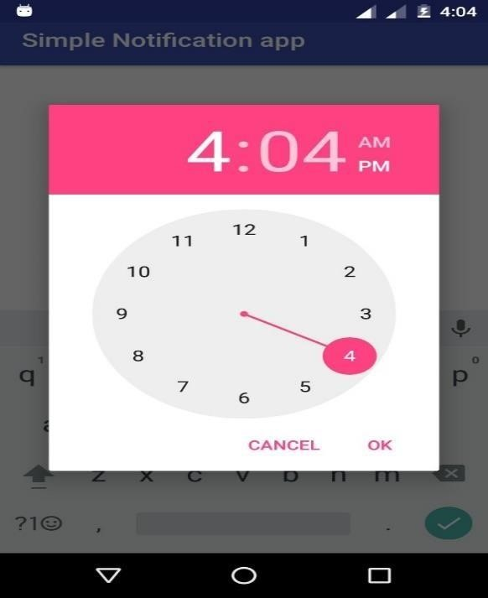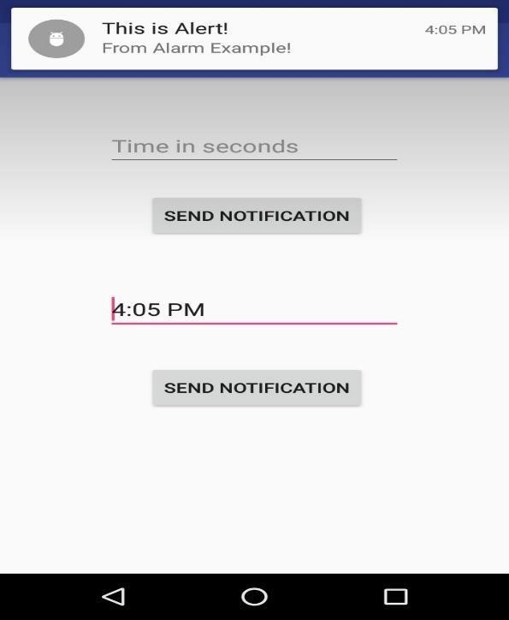

**<resources>**

**<style name="AppTheme" parent="Theme.AppCompat.Light.DarkActionBar">**

**<!-- Customize your theme here. -->**

**<item name="colorPrimary">@color/colorPrimary</item>**

**<item name="colorPrimaryDark">@color/colorPrimaryDark</item>**

**<item name="colorAccent">@color/colorAccent</item>**

**</style>**

**</resources>**

**Output:**

**65**

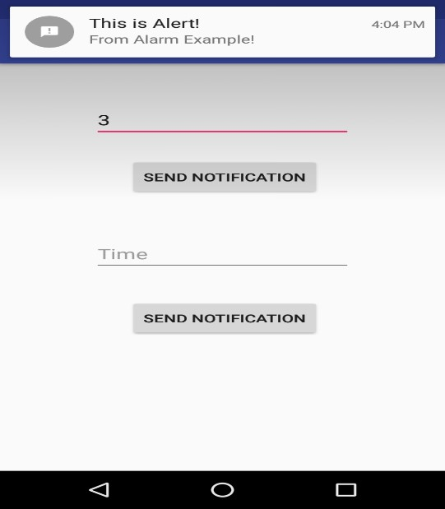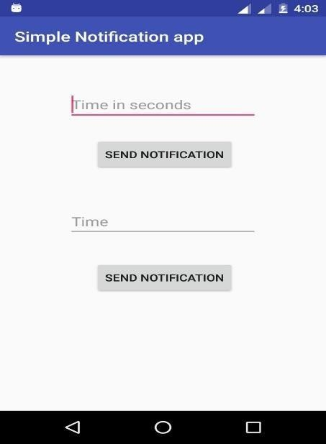 **Name-Aditya Vishwakarma DIV-B Roll no-4428 class-SyBsc-CS**

**66**

67

Name

-

Aditya

Vishwakarma

DIV

-

B

Roll

no

-

4428

class

-

SyBsc

-

CS

**Practical**

**no**

**-**

**10**

**Aim**

**-**

Create

an

android

app

to

save

user

data

in

a

database

and

use

of

different

queries.

SQLiteDemo

CRUD operations

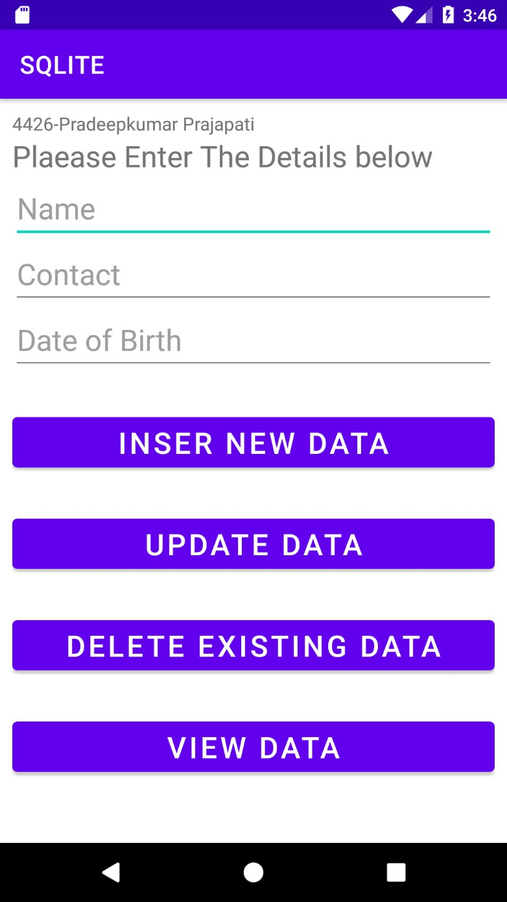

**activity_main.xml:**

**<?xml version="1.0" encoding="utf-8"?>**

**<RelativeLayout xmlns:android[="http://schemas.android.com/apk/res/android"](http://schemas.android.com/apk/res/android)****xmlns:app[="http://schemas.android.com/apk/res](http://schemas.android.com/apk/res-auto)**[**-auto"**](http://schemas.android.com/apk/res-auto) **xmlns:tools[="http://schemas.android.com/tools"](http://schemas.android.com/tools)****android:layout_width="match_parent" android:layout_height="match_parent" android:padding="10dp" tools:context=".MainActivity">**

**<TextView android:layout_width="wrap_content" android:layout_height="wrap_content" android:text="4428-Aditya Vishwakarma" android:textSize="15dp"**

**android:layout_marginBottom="10dp" />**

|  |  |
| --- | --- |
| **<!--** | **4457-Basant Mandal-->** |
| **<!--** | **4429-Satyam Prajapati-->** |
| **<!--** | **4428-Aditya Vishwakarma-->** |

**<TextView android:id="@+id/texttitle" android:layout_width="wrap_content" android:layout_height="wrap_content" android:text="Plaease Enter The Details below" android:textSize="24dp" android:layout_marginTop="20dp" tools:ignore="MissingConstraints" />**

**<EditText android:id="@+id/name" android:layout_width="match_parent" android:layout_height="wrap_content" android:hint="Name"**

**android:inputType="textPersonName" android:textSize="24dp" tools:ignore="MissingConstraints" android:layout_below="@+id/texttitle" />**

**<EditText android:id="@+id/contact" android:layout_width="match_parent" android:layout_height="wrap_content" android:hint="Contact" android:inputType="number" android:textSize="24dp" tools:ignore="MissingConstraints" android:layout_below="@+id/name" />**

**<EditText android:id="@+id/dob"**

**android:layout_width="match_parent" android:layout_height="wrap_content" android:hint="Date of Birth" android:inputType="number" android:textSize="24dp" tools:ignore="MissingConstraints" android:layout_below="@+id/contact"/>**

**<Button android:id="@+id/btnInsert"**

|  |  |  |
| --- | --- | --- |
| **Name-Aditya Vishwakarma** | **DIV-B Roll no-4428** | **class-SyBsc-CS** |
| **android:layout_width="match_parent" android:layout_height="wrap_content" android:textSize="24dp" android:text="Inser New Data" android:layout_marginTop="30dp" android:layout_below="@+id/dob" tools:ignore="MissingConstraints" />**    **<Button android:id="@+id/btnUpdate" android:layout_width="match_parent" android:layout_height="wrap_content" android:textSize="24dp" android:text="Update Data" android:layout_marginTop="30dp" android:layout_below="@+id/btnInsert" tools:ignore="MissingConstraints" />**    **<Button android:id="@+id/btnDelete" android:layout_width="match_parent" android:layout_height="wrap_content" android:textSize="24dp"**  **android:text="Delete Existing Data" android:layout_marginTop="30dp" android:layout_below="@+id/btnUpdate" tools:ignore="MissingConstraints" />**    **<Button android:id="@+id/btnView" android:layout_width="match_parent" android:layout_height="wrap_content" android:textSize="24dp" android:text="View Data" android:layout_marginTop="30dp" android:layout_below="@+id/btnDelete" tools:ignore="MissingConstraints" />**        **</RelativeLayout>**      **MainActivity.java**    **package com.example.sqlite;**  **import androidx.appcompat.app.AlertDialog; import androidx.appcompat.app.AppCompatActivity;**  **import android.database.Cursor; import android.os.Bundle; import android.view.View; import android.widget.Button; import android.widget.EditText; import android.widget.Toast; public class MainActivity extends AppCompatActivity {**  **EditText name, contact, dob;**  **Button insert,update ,delete ,view ;**  **DBHelper DB;** | |  |

**69**

## @Override

**protected void onCreate(Bundle savedInstanceState) { super.onCreate(savedInstanceState); setContentView(R.layout.*activity_main*);**

**name = findViewById(R.id.*name*); contact = findViewById(R.id.*contact*); dob = findViewById(R.id.*dob*);**

**insert = findViewById(R.id.*btnInsert*); update = findViewById(R.id.*btnUpdate*); delete = findViewById(R.id.*btnDelete*); view = findViewById(R.id.*btnView*); DB = new DBHelper(this);**

**insert.setOnClickListener(new View.OnClickListener() {**

## @Override

**public void onClick(View v) {**

**String nameTXT = name.getText().toString();**

**String contactTXT = contact.getText().toString(); String dobTXT = dob.getText().toString();**

**Boolean checkinsertdata =**

**DB.insertuserdata(nameTXT,contactTXT,dobTXT); if(checkinsertdata==true)**

**Toast.*makeText*(MainActivity.this,"New Entry Not Inserted",**

**Toast.*LENGTH_SHORT*).show(); else**

**Toast.*makeText*(MainActivity.this,"New Entry Inserted", Toast.*LENGTH_SHORT*).show();**

**}**

**});**

**update.setOnClickListener(new View.OnClickListener() {**

## @Override

**public void onClick(View v) {**

**String nameTXT = name.getText().toString();**

**String contactTXT = contact.getText().toString(); String dobTXT = dob.getText().toString();**

**Boolean checkupdatedata =**

**DB.updateuserdata(nameTXT,contactTXT,dobTXT); if(checkupdatedata==true)**

**Toast.*makeText*(MainActivity.this,"Entry Updated",**

**Toast.*LENGTH_SHORT*).show(); else**

**Toast.*makeText*(MainActivity.this,"New Entry Not Updated", Toast.*LENGTH_SHORT*).show();**

**}**

**});**

**delete.setOnClickListener(new View.OnClickListener() {**

## @Override

**public void onClick(View v) {**

**String nameTXT = name.getText().toString();**

**Boolean checkdeletedata = DB.deletedata(nameTXT); if(checkdeletedata==true)**

**Toast.*makeText*(MainActivity.this,"Entry Delete",**

**Toast.*LENGTH_SHORT*).show(); else**

**Toast.*makeText*(MainActivity.this,"Entry Not Deleted",**

**Toast.*LENGTH_SHORT*).show();**

**}**

**});**

**view.setOnClickListener(new View.OnClickListener() {**

## @Override

**public void onClick(View v) { Cursor res = DB.getdata(); if(res.getCount()==0){**

**Toast.*makeText*(MainActivity.this,"NO Enter**

**Exists",Toast.*LENGTH_SHORT*).show(); return;**

**}**

**StringBuffer buffer=new StringBuffer(); while (res.moveToNext()){ buffer.append("Name :" +res.getString(0)+"\n"); buffer.append("Contact :" +res.getString(1)+"\n"); buffer.append("Date of Birth :" +res.getString(2)+"\n\n");**

**}**

**AlertDialog.Builder builder=new**

**AlertDialog.Builder(MainActivity.this); builder.setCancelable(true); builder.setTitle("User Enteries"); builder.setMessage(buffer.toString()); builder.show();**

**}**

**});**

**} }**

# DBHelper.java

**package com.example.sqlite;**

**import android.content.ContentValues; import android.content.Context; import android.database.Cursor;**

**import android.database.sqlite.SQLiteDatabase; import android.database.sqlite.SQLiteOpenHelper;**

**import androidx.annotation.Nullable;**

**public class DBHelper extends SQLiteOpenHelper { public DBHelper(Context context) { super(context, "Userdata.db", null, 1); }**

## @Override

**public void onCreate(SQLiteDatabase DB) {**

**DB.execSQL("create Table Userdetails(name TEXT primary key,contact Text,dob TEXT)");**

**}**

## @Override

**public void onUpgrade(SQLiteDatabase DB, int oldVersion, int newVersion) { DB.execSQL("drop Table if exists Userdetails"); }**

**public Boolean insertuserdata(String name, String contact, String dob) {**

**SQLiteDatabase DB = this.getWritableDatabase(); ContentValues contentValues = new ContentValues(); contentValues.put("name", name); contentValues.put("contact", contact); contentValues.put("dob", dob);**

**long result = DB.insert("Userdetails", null, contentValues); if (result == -1) { return false;**

**} else { return true;**

**}**

**}**

**public Boolean updateuserdata(String name, String contact, String dob) {**

**SQLiteDatabase DB = this.getWritableDatabase();**

**ContentValues contentValues = new ContentValues();**

**contentValues.put("contact", contact); contentValues.put("dob", dob);**

**Cursor cursor = DB.rawQuery("Select * from Userdetails where name =**

**?", new String[]{name}); if (cursor.getCount() > 0) { long result = DB.update("Userdetails", contentValues, "name?", new**

**String[]{name}); if (result == -1) { return false;**

**} else { return true;**

**}**

**} else { return false;**

**}**

**}**

**public Boolean deletedata(String name)**

**{**

**SQLiteDatabase DB = this.getWritableDatabase();**

**Cursor cursor = DB.rawQuery("Select * from Userdetails where name**

**= ?", new String[]{name});**

**if (cursor.getCount() > 0) { long result = DB.delete("Userdetails", "name?", new**

**String[]{name}); if (result == -1) { return false;**

**} else { return true;**

**}**

**}else { return false;**

**}**

**}**

**public Cursor getdata()**

**{**

**SQLiteDatabase DB = this.getWritableDatabase();**

**Cursor cursor = DB.rawQuery("Select * from Userdetails ",null); return cursor;**

**}**

**}**

**Aditya Vishwakarma**

**OUTPUT:**

**Fill data Insert**

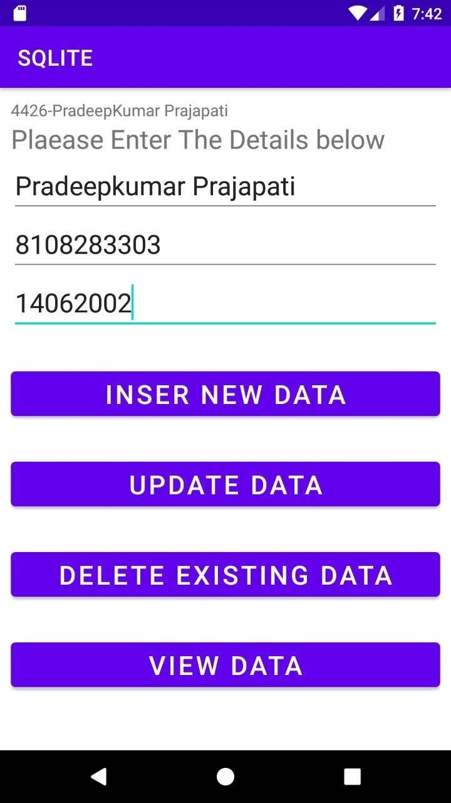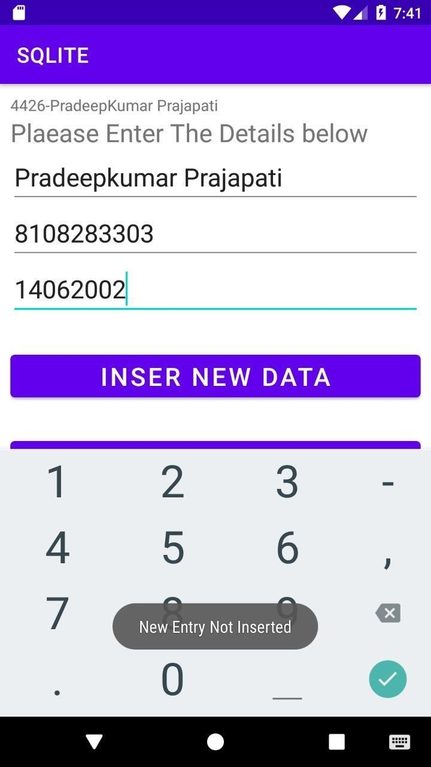

**73**

# View Update

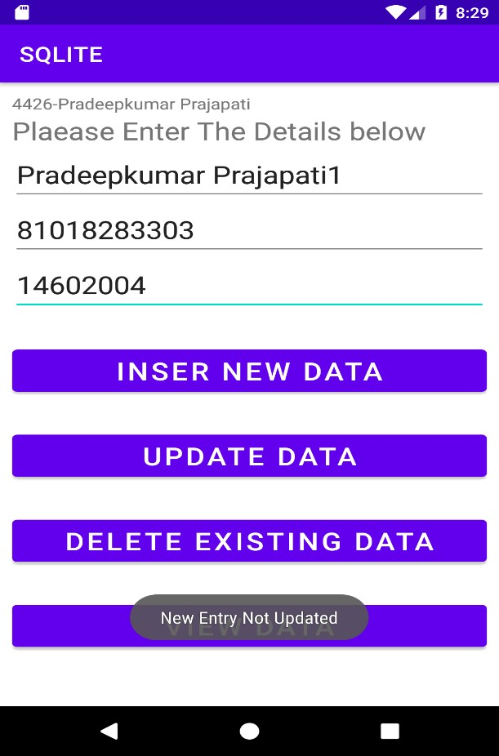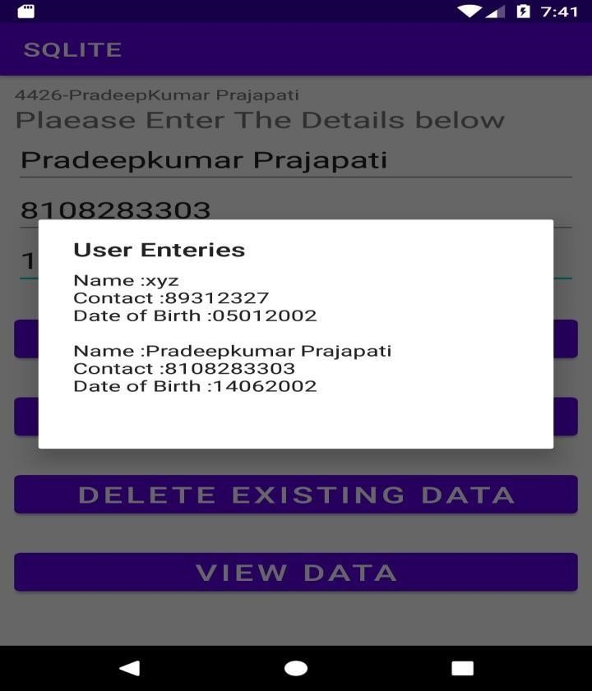

# Delete

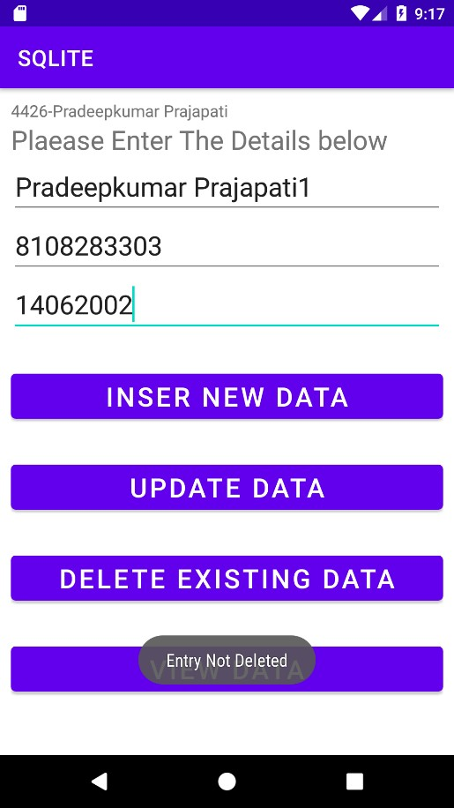

**74**

**SCREEN NEVIGATION (3)**

**XML-**

**<?xml version="1.0" encoding="utf-8"?>  
<LinearLayout xmlns:android="http://schemas.android.com/apk/res/android"  
 xmlns:app="http://schemas.android.com/apk/res-auto"  
 xmlns:tools="http://schemas.android.com/tools"  
 android:layout_width="match_parent"  
 android:layout_height="match_parent"  
 android:orientation="vertical"   
 tools:context=".MainActivity">  
  
 <FrameLayout  
 android:layout_width="match_parent"  
 android:layout_height="0dp"  
 android:layout_weight="1"  
 android:id="@+id/fragment"  
 />  
  
 <com.google.android.material.bottomnavigation.BottomNavigationView  
 android:id="@+id/bottom_nevigation"  
 android:layout_width="match_parent"  
 android:layout_height="wrap_content"  
 android:background="?android:windowBackground"  
 app:menu="@menu/bn_menu" />  
  
</LinearLayout>**

**JAVA-**

**package com.example.email1;  
  
import androidx.annotation.NonNull;  
import androidx.appcompat.app.AppCompatActivity;  
import androidx.fragment.app.Fragment;  
  
import android.content.Intent;  
import android.os.Bundle;  
import android.view.MenuItem;  
  
import com.google.android.material.bottomnavigation.BottomNavigationView;  
  
import java.util.ArrayDeque;  
import java.util.Deque;  
  
public class MainActivity extends AppCompatActivity {  
  
 BottomNavigationView bottomNavigationView;  
 Deque<Integer> integerDeque = new ArrayDeque<>(3);  
 boolean flag =true;  
  
 @Override  
 protected void onCreate(Bundle savedInstanceState) {  
 super.onCreate(savedInstanceState);  
 setContentView(R.layout.*activity_main*);  
  
 bottomNavigationView = findViewById(R.id.*bottom_nevigation*);  
  
 //home  
 integerDeque.push(R.id.*bn_home*);  
 //load  
 loadFragment(new HomeFragment());  
 //default  
 bottomNavigationView.setSelectedItemId(R.id.*bn_home*);  
  
 bottomNavigationView.setOnNavigationItemSelectedListener(  
 new BottomNavigationView.OnNavigationItemSelectedListener() {  
 @Override  
 public boolean onNavigationItemSelected(@NonNull MenuItem item) {  
 //select Item id  
 int id = item.getItemId();  
  
 if(integerDeque.contains(id)){  
 if(id == R.id.*bn_home*){  
 if(integerDeque.size()!=1){  
 if (flag){  
 integerDeque.addFirst(R.id.*bn_home*);  
 flag= false;  
  
 }  
 }  
 }  
 integerDeque.remove(id);  
 }  
 integerDeque.push(id);  
 loadFragment(getFragment(item.getItemId()));  
 return true;  
 }  
  
 }  
 );  
 }  
  
 private Fragment getFragment(int itemId) {  
 switch (itemId){  
 case R.id.*bn_dashboard*:  
 bottomNavigationView.getMenu().getItem(0).setChecked(true);  
 return new DashboardFragment();  
 case R.id.*bn_home*:  
 bottomNavigationView.getMenu().getItem(1).setChecked(true);  
 return new HomeFragment();  
 case R.id.*bn_notification*:  
 bottomNavigationView.getMenu().getItem(2).setChecked(true);  
 return new NotificationFragment();  
 }  
 bottomNavigationView.getMenu().getItem(1).setChecked(true);  
 return new HomeFragment();  
 }  
  
 private void loadFragment(Fragment fragment) {  
 getSupportFragmentManager()  
 .beginTransaction()  
 .replace(R.id.*fragment*,fragment,fragment.getClass().getSimpleName())  
 .commit();  
 }  
 @Override  
 public void onBackPressed(){  
 integerDeque.pop();  
 if(!integerDeque.isEmpty()){  
 loadFragment(getFragment(integerDeque.peek()));  
  
 }  
 else {  
 finish();  
 }  
 }  
}**

**HOME-XML**

**<?xml version="1.0" encoding="utf-8"?>  
<RelativeLayout xmlns:android="http://schemas.android.com/apk/res/android"  
 xmlns:tools="http://schemas.android.com/tools"  
 android:layout_width="match_parent"  
 android:layout_height="match_parent"  
 tools:context=".HomeFragment">  
  
 <!-- *TODO: Update blank fragment layout* -->  
 <TextView  
 android:layout_width="wrap_content"  
 android:layout_height="wrap_content"  
 android:text="Home"  
 android:textSize="50dp"  
 android:textStyle="bold"  
 android:layout_centerInParent="true"  
 android:gravity="center"/>  
  
</RelativeLayout>**

**JAVA-**

**package com.example.email1;  
  
import android.os.Bundle;  
  
import androidx.fragment.app.Fragment;  
  
import android.view.LayoutInflater;  
import android.view.View;  
import android.view.ViewGroup;  
  
*/**  
 * A simple {@link Fragment} subclass.  
 * Use the {@link HomeFragment#newInstance} factory method to  
 * create an instance of this fragment.  
 */*public class HomeFragment extends Fragment {  
  
 // *TODO: Rename parameter arguments, choose names that match* // the fragment initialization parameters, e.g. ARG_ITEM_NUMBER  
 private static final String *ARG_PARAM1* = "param1";  
 private static final String *ARG_PARAM2* = "param2";  
  
 // *TODO: Rename and change types of parameters* private String mParam1;  
 private String mParam2;  
  
 public HomeFragment() {  
 // Required empty public constructor  
 }  
  
 */**  
 * Use this factory method to create a new instance of  
 * this fragment using the provided parameters.  
 *  
 * @param param1 Parameter 1.  
 * @param param2 Parameter 2.  
 * @return A new instance of fragment HomeFragment.  
 */* // *TODO: Rename and change types and number of parameters* public static HomeFragment newInstance(String param1, String param2) {  
 HomeFragment fragment = new HomeFragment();  
 Bundle args = new Bundle();  
 args.putString(*ARG_PARAM1*, param1);  
 args.putString(*ARG_PARAM2*, param2);  
 fragment.setArguments(args);  
 return fragment;  
 }  
  
 @Override  
 public void onCreate(Bundle savedInstanceState) {  
 super.onCreate(savedInstanceState);  
 if (getArguments() != null) {  
 mParam1 = getArguments().getString(*ARG_PARAM1*);  
 mParam2 = getArguments().getString(*ARG_PARAM2*);  
 }  
 }  
  
 @Override  
 public View onCreateView(LayoutInflater inflater, ViewGroup container,  
 Bundle savedInstanceState) {  
 // Inflate the layout for this fragment  
 return inflater.inflate(R.layout.*fragment_home*, container, false);  
 }  
}**

**Dashboard Xml-**

**?xml version="1.0" encoding="utf-8"?>  
<RelativeLayout xmlns:android="http://schemas.android.com/apk/res/android"  
 xmlns:tools="http://schemas.android.com/tools"  
 android:layout_width="match_parent"  
 android:layout_height="match_parent"  
 tools:context=".DashboardFragment">  
  
 <!-- *TODO: Update blank fragment layout* -->  
 <TextView  
 android:layout_width="wrap_content"  
 android:layout_height="wrap_content"  
 android:text="DashBoard"  
 android:textSize="50dp"  
 android:textStyle="bold"  
 android:layout_centerInParent="true"  
 android:gravity="center"/>  
  
</RelativeLayout>**

**Java-**

**package com.example.email1;  
  
import android.os.Bundle;  
  
import androidx.fragment.app.Fragment;  
  
import android.view.LayoutInflater;  
import android.view.View;  
import android.view.ViewGroup;  
  
*/**  
 * A simple {@link Fragment} subclass.  
 * Use the {@link DashboardFragment#newInstance} factory method to  
 * create an instance of this fragment.  
 */*public class DashboardFragment extends Fragment {  
  
 // *TODO: Rename parameter arguments, choose names that match* // the fragment initialization parameters, e.g. ARG_ITEM_NUMBER  
 private static final String *ARG_PARAM1* = "param1";  
 private static final String *ARG_PARAM2* = "param2";  
  
 // *TODO: Rename and change types of parameters* private String mParam1;  
 private String mParam2;  
  
 public DashboardFragment() {  
 // Required empty public constructor  
 }  
  
 */**  
 * Use this factory method to create a new instance of  
 * this fragment using the provided parameters.  
 *  
 * @param param1 Parameter 1.  
 * @param param2 Parameter 2.  
 * @return A new instance of fragment DashboardFragment.  
 */* // *TODO: Rename and change types and number of parameters* public static DashboardFragment newInstance(String param1, String param2) {  
 DashboardFragment fragment = new DashboardFragment();  
 Bundle args = new Bundle();  
 args.putString(*ARG_PARAM1*, param1);  
 args.putString(*ARG_PARAM2*, param2);  
 fragment.setArguments(args);  
 return fragment;  
 }  
  
 @Override  
 public void onCreate(Bundle savedInstanceState) {  
 super.onCreate(savedInstanceState);  
 if (getArguments() != null) {  
 mParam1 = getArguments().getString(*ARG_PARAM1*);  
 mParam2 = getArguments().getString(*ARG_PARAM2*);  
 }  
 }  
  
 @Override  
 public View onCreateView(LayoutInflater inflater, ViewGroup container,  
 Bundle savedInstanceState) {  
 // Inflate the layout for this fragment  
 return inflater.inflate(R.layout.*fragment_dashboard*, container, false);  
 }  
}**

**Notification Xml-**

**<?xml version="1.0" encoding="utf-8"?>  
<RelativeLayout xmlns:android="http://schemas.android.com/apk/res/android"  
 xmlns:tools="http://schemas.android.com/tools"  
 android:layout_width="match_parent"  
 android:layout_height="match_parent"  
 tools:context=".NotificationFragment">  
  
 <!-- *TODO: Update blank fragment layout* -->  
 <TextView  
 android:layout_width="match_parent"  
 android:layout_height="match_parent"  
 android:text="Notification"  
 android:textSize="50dp"  
 android:textStyle="bold"  
 android:layout_centerInParent="true"  
 android:gravity="center"/>  
  
</RelativeLayout>**

**Java-**

**package com.example.email1;  
  
import android.os.Bundle;  
  
import androidx.fragment.app.Fragment;  
  
import android.view.LayoutInflater;  
import android.view.View;  
import android.view.ViewGroup;  
  
*/**  
 * A simple {@link Fragment} subclass.  
 * Use the {@link NotificationFragment#newInstance} factory method to  
 * create an instance of this fragment.  
 */*public class NotificationFragment extends Fragment {  
  
 // *TODO: Rename parameter arguments, choose names that match* // the fragment initialization parameters, e.g. ARG_ITEM_NUMBER  
 private static final String *ARG_PARAM1* = "param1";  
 private static final String *ARG_PARAM2* = "param2";  
  
 // *TODO: Rename and change types of parameters* private String mParam1;  
 private String mParam2;  
  
 public NotificationFragment() {  
 // Required empty public constructor  
 }  
  
 */**  
 * Use this factory method to create a new instance of  
 * this fragment using the provided parameters.  
 *  
 * @param param1 Parameter 1.  
 * @param param2 Parameter 2.  
 * @return A new instance of fragment NotificationFragment.  
 */* // *TODO: Rename and change types and number of parameters* public static NotificationFragment newInstance(String param1, String param2) {  
 NotificationFragment fragment = new NotificationFragment();  
 Bundle args = new Bundle();  
 args.putString(*ARG_PARAM1*, param1);  
 args.putString(*ARG_PARAM2*, param2);  
 fragment.setArguments(args);  
 return fragment;  
 }  
  
 @Override  
 public void onCreate(Bundle savedInstanceState) {  
 super.onCreate(savedInstanceState);  
 if (getArguments() != null) {  
 mParam1 = getArguments().getString(*ARG_PARAM1*);  
 mParam2 = getArguments().getString(*ARG_PARAM2*);  
 }  
 }  
  
 @Override  
 public View onCreateView(LayoutInflater inflater, ViewGroup container,  
 Bundle savedInstanceState) {  
 // Inflate the layout for this fragment  
 return inflater.inflate(R.layout.*fragment_notification*, container, false);  
 }  
}**

**//create in res file**

**bn_menu-xml-**

**<?xml version="1.0" encoding="utf-8"?>  
<menu xmlns:android="http://schemas.android.com/apk/res/android">  
  
 <item  
 android:id="@+id/bn_dashboard"  
 android:title="Dashboard"  
 android:icon="@drawable/ic_dashboard"/>  
  
 <item  
 android:id="@+id/bn_home"  
 android:title="Home"  
 android:icon="@drawable/ic_home"/>  
  
 <item  
 android:id="@+id/bn_notification"  
 android:title="Notification"  
 android:icon="@drawable/ic_notification"/>  
  
</menu>**

**Email**

**Xml-**

**<?xml version="1.0" encoding="utf-8"?>  
<LinearLayout xmlns:android="http://schemas.android.com/apk/res/android"  
 xmlns:app="http://schemas.android.com/apk/res-auto"  
 xmlns:tools="http://schemas.android.com/tools"  
 android:layout_width="match_parent"  
 android:layout_height="match_parent"  
 android:orientation="vertical"  
 android:gravity="center"  
 android:padding="20dp"  
 tools:context=".MainActivity">  
  
 <LinearLayout  
 android:layout_width="match_parent"  
 android:layout_height="wrap_content"  
 android:padding="10dp"  
 android:background="@drawable/bg_round">  
  
 <TextView  
 android:layout_width="50dp"  
 android:layout_height="wrap_content"  
 android:text="To"  
 android:textSize="20sp"  
 android:gravity="center"  
 />  
  
 <EditText  
 android:layout_width="match_parent"  
 android:layout_height="wrap_content"  
 android:id="@+id/et_to"  
 android:background="@android:color/transparent"  
 />  
  
  
 </LinearLayout>  
  
 <EditText  
 android:layout_width="match_parent"  
 android:layout_height="wrap_content"  
 android:id="@+id/et_subject"  
 android:hint="Subject"  
 android:padding="10dp"  
 android:layout_marginTop="10dp"  
 android:background="@drawable/bg_round"/>  
  
 <EditText  
 android:layout_width="match_parent"  
 android:layout_height="0dp"  
 android:layout_weight="1"  
 android:id="@+id/et_message"  
 android:hint="Message"  
 android:padding="10dp"  
 android:gravity="top"  
 android:layout_marginTop="10dp"  
 android:background="@drawable/bg_round"/>  
  
 <Button  
 android:layout_width="wrap_content"  
 android:layout_height="wrap_content"  
 android:id="@+id/bt_send"  
 android:text="Send"  
 android:textSize="25dp"  
 android:textColor="@color/black"  
 android:background="@drawable/bg_round"  
  
 />  
  
</LinearLayout>**

**Java-**

**package com.example.email2;  
  
import androidx.appcompat.app.AppCompatActivity;  
  
import android.content.Intent;  
import android.net.Uri;  
import android.os.Bundle;  
import android.text.Editable;  
import android.view.View;  
import android.widget.Button;  
import android.widget.EditText;  
  
import java.net.URI;  
  
public class MainActivity extends AppCompatActivity {  
  
 EditText etTo,etSubject,etMessage;  
 Button btnSend;  
  
 @Override  
 protected void onCreate(Bundle savedInstanceState) {  
 super.onCreate(savedInstanceState);  
 setContentView(R.layout.*activity_main*);  
  
 etTo=findViewById(R.id.*et_to*);  
 etSubject = findViewById(R.id.*et_subject*);  
 etMessage = findViewById(R.id.*et_message*);  
 btnSend=findViewById(R.id.*bt_send*);  
  
 btnSend.setOnClickListener(new View.OnClickListener() {  
 @Override  
 public void onClick(View v) {  
 Intent intent = new Intent(Intent.*ACTION_VIEW*,  
 Uri.*parse*("mailto:"+etTo.getText().toString()));  
 intent.putExtra(Intent.*EXTRA_SUBJECT*,etSubject.getText().toString());  
 intent.putExtra(Intent.*EXTRA_TEXT*,etMessage.getText().toString());  
 startActivity(intent);  
 }  
 });  
 }  
}**

**res/drawable/**

**//create**

**<?xml version="1.0" encoding="utf-8"?>  
<shape xmlns:android="http://schemas.android.com/apk/res/android"  
 android:shape="rectangle">  
  
 <solid android:color="@android:color/transparent"/>  
 <corners android:radius="10dp"/>  
 <stroke android:width="2dp"  
 android:color="@android:color/black"/>  
  
</shape>**

**Alert-**

**Xml-**

**<?xml version="1.0" encoding="utf-8"?>  
<androidx.constraintlayout.widget.ConstraintLayout xmlns:android="http://schemas.android.com/apk/res/android"  
 xmlns:app="http://schemas.android.com/apk/res-auto"  
 xmlns:tools="http://schemas.android.com/tools"  
 android:layout_width="match_parent"  
 android:layout_height="match_parent"  
 tools:context=".MainActivity">  
  
 <Button  
 android:layout_width="wrap_content"  
 android:layout_height="wrap_content"  
 android:id="@+id/button"  
 android:text="Close app"  
 app:layout_constraintBottom_toBottomOf="parent"  
 app:layout_constraintLeft_toLeftOf="parent"  
 app:layout_constraintRight_toRightOf="parent"  
 app:layout_constraintTop_toTopOf="parent" />  
  
  
  
</androidx.constraintlayout.widget.ConstraintLayout>**

**Java-**

**package com.example.ams;  
  
import androidx.appcompat.app.AlertDialog;  
import androidx.appcompat.app.AppCompatActivity;  
  
import android.content.DialogInterface;  
import android.os.Bundle;  
import android.view.View;  
import android.widget.Button;  
import android.widget.Toast;  
  
public class MainActivity extends AppCompatActivity {  
  
 Button closeButton;  
 AlertDialog.Builder builder;  
  
 @Override  
 protected void onCreate(Bundle savedInstanceState) {  
 super.onCreate(savedInstanceState);  
 setContentView(R.layout.*activity_main*);  
  
 closeButton = (Button) findViewById(R.id.*button*);  
 builder = new AlertDialog.Builder(this);  
 closeButton.setOnClickListener(new View.OnClickListener() {  
 @Override  
 public void onClick(View v) {  
  
 builder.setMessage(R.string.*dialog_message*) .setTitle(R.string.*dialog_title*);  
  
 builder.setMessage("Do you want to close this application ?")  
 .setCancelable(false)  
 .setPositiveButton("Yes", new DialogInterface.OnClickListener() {  
 public void onClick(DialogInterface dialog, int id) {  
 finish();  
 Toast.*makeText*(getApplicationContext(),"you choose yes action for alertbox",  
 Toast.*LENGTH_LONG*).show();  
 }  
 })  
 .setNegativeButton("No", new DialogInterface.OnClickListener() {  
 public void onClick(DialogInterface dialog, int id) {  
 // Action for 'NO' Button  
 dialog.cancel();  
 Toast.*makeText*(getApplicationContext(),"you choose no action for alertbox",  
 Toast.*LENGTH_LONG*).show();  
 }  
 });  
 //Creating dialog box  
 AlertDialog alert = builder.create();  
 //Setting the title manually  
 alert.setTitle("AlertDialogExample");  
 alert.show();  
 }  
 });  
 }  
  
  
}**

**string-**

**<resources>  
 <string name="app_name">AMS</string>  
 <string name="dialog_message">Welcome to Alert Dialog</string>  
 <string name="dialog_title">Javatpoint Alert Dialog</string>  
  
</resources>**

**calculator**

**Activity.xml**

**<?xml version="1.0" encoding="utf-8"?>  
<LinearLayout xmlns:android="http://schemas.android.com/apk/res/android"  
 xmlns:app="http://schemas.android.com/apk/res-auto"  
 xmlns:tools="http://schemas.android.com/tools"  
 android:id="@+id/activity_main"  
 android:layout_width="match_parent"  
 android:layout_height="match_parent"  
  
 tools:context=".MainActivity"  
 android:orientation="vertical"  
 android:gravity="top"  
 android:textAlignment="center"  
 android:background="@color/black"  
 android:weightSum="1"  
 tools:ignore="RtlCompat">  
  
  
 <EditText  
  
 android:layout_width="match_parent"  
 android:layout_height="wrap_content"  
 android:hint="Enter First Number"  
 android:textColorHint="@color/white"  
 android:textColor="@color/white"  
 android:ems="10"  
 android:id="@+id/editOp1"  
 android:textSize="18sp"  
 android:gravity="center_horizontal"  
 android:layout_marginBottom="5dp"  
 android:visibility="visible"  
 tools:ignore="MissingConstraints" />  
  
 <EditText  
 android:layout_width="match_parent"  
 android:hint="Enter First Number"  
 android:textColor="@color/white"  
 android:layout_height="wrap_content"  
 android:textColorHint="@color/white"  
 android:ems="10"  
 android:id="@+id/editOp2"  
 android:textSize="18sp"  
 android:gravity="center_horizontal"  
 android:elevation="1dp"  
 tools:ignore="MissingConstraints" />  
  
 <LinearLayout  
 android:orientation="horizontal"  
 android:layout_width="match_parent"  
 android:layout_height="wrap_content"  
 tools:ignore="MissingConstraints">  
  
 <Button  
 android:text="+"  
 android:layout_width="78dp"  
 android:layout_height="wrap_content"  
 android:id="@+id/btnadd"  
 android:layout_weight="0.03" />  
  
 <Button  
 android:text="-"  
 android:layout_width="78dp"  
 android:layout_height="wrap_content"  
 android:id="@+id/btnsub"  
 android:layout_weight="0.03" />  
  
 <Button  
 android:text="*"  
 android:layout_width="78dp"  
 android:layout_height="wrap_content"  
 android:id="@+id/btnmul"  
 android:layout_weight="0.03"/>  
  
 <Button  
 android:text="/"  
 android:layout_height="wrap_content"  
 android:id="@+id/btndiv"  
 android:layout_width="78dp"  
 android:layout_weight="0.03" />  
  
 <Button  
 android:text="Clear"  
 android:layout_width="80dp"  
 android:layout_height="wrap_content"  
 android:id="@+id/btnclr"  
 android:layout_weight="0.03" />  
 </LinearLayout>  
  
  
 <EditText  
 android:layout_width="match_parent"  
 android:layout_height="wrap_content"  
 android:inputType="number"  
 android:ems="10"  
 android:textColor="@color/white"  
 android:textColorHint="@color/white"  
 android:id="@+id/result"  
 android:textSize="18sp"  
 android:hint="Result"  
 android:gravity="center_horizontal"  
 tools:ignore="MissingConstraints" />  
</LinearLayout>**

**MainActivity.java**

**package com.example.calcu;  
  
import androidx.appcompat.app.AppCompatActivity;  
  
import android.os.Bundle;  
import android.view.View;  
import android.widget.Button;  
import android.widget.EditText;  
import android.widget.TextView;  
import android.widget.Toast;  
  
public class MainActivity extends AppCompatActivity {  
  
  
 private EditText opr1;  
 private EditText opr2;  
 private Button btnadd;  
 private Button btnsub;  
 private Button btnmul;  
 private Button btndiv;  
 private Button btnclr;  
 private TextView txtresult;  
  
 @Override  
 protected void onCreate(Bundle savedInstanceState) {  
 super.onCreate(savedInstanceState);  
 setContentView(R.layout.*activity_main*);  
 opr1 = (EditText) findViewById(R.id.*editOp1*);  
 opr2 = (EditText) findViewById(R.id.*editOp2*);  
 btnadd = (Button) findViewById(R.id.*btnadd*);  
 btnsub = (Button) findViewById(R.id.*btnsub*);  
 btnmul = (Button) findViewById(R.id.*btnmul*);  
 btndiv = (Button) findViewById(R.id.*btndiv*);  
 btnclr = (Button) findViewById(R.id.*btnclr*);  
 txtresult= (TextView) findViewById(R.id.*result*);  
 // Addition  
 btnadd.setOnClickListener(new View.OnClickListener() {  
 @Override  
 public void onClick(View v) {  
 if((opr1.getText().length()>0) && (opr2.getText().length()>0))  
 {  
 double oper1= Double.*parseDouble*(opr1.getText().toString());  
 double oper2 = Double.*parseDouble*(opr2.getText().toString());  
 String result = String.*valueOf*(oper1 + oper2);  
 txtresult.setText(Double.*toString*(Double.*parseDouble*(result)));  
 Toast.*makeText*(MainActivity.this,result,Toast.*LENGTH_LONG*).show();  
 }  
 else{  
 Toast toast= Toast.*makeText*(MainActivity.this,"Enter The Required Numbers",Toast.*LENGTH_LONG*);  
 toast.show();  
 }  
 }  
 });  
 //Subtraction  
 btnsub.setOnClickListener(new View.OnClickListener() {  
 @Override  
 public void onClick(View v) {  
 if((opr1.getText().length()>0) && (opr2.getText().length()>0))  
 {  
 double oper1 = Double.*parseDouble*(opr1.getText().toString());  
 double oper2 = Double.*parseDouble*(opr2.getText().toString());  
 String result = String.*valueOf*(oper1 - oper2);  
 txtresult.setText(Double.*toString*(Double.*parseDouble*(result)));  
 Toast.*makeText*(MainActivity.this,result,Toast.*LENGTH_LONG*).show();  
 }  
 else{  
 Toast toast= Toast.*makeText*(MainActivity.this,"Enter The Required Numbers",Toast.*LENGTH_LONG*);  
 toast.show();  
 }  
  
 }  
 });  
 // Multiplication  
 btnmul.setOnClickListener(new View.OnClickListener() {  
 @Override  
 public void onClick(View v) {  
 if((opr1.getText().length()>0) && (opr2.getText().length()>0))  
 {  
 double oper1 = Double.*parseDouble*(opr1.getText().toString());  
 double oper2 = Double.*parseDouble*(opr2.getText().toString());  
 String result = String.*valueOf*(oper1 * oper2);  
 txtresult.setText(Double.*toString*(Double.*parseDouble*(result)));  
 Toast.*makeText*(MainActivity.this,result,Toast.*LENGTH_LONG*).show();  
 }  
 else{  
 Toast toast= Toast.*makeText*(MainActivity.this,"Enter The Required Numbers",Toast.*LENGTH_LONG*);  
 toast.show();  
 }  
 }  
 });  
 // Division  
 btndiv.setOnClickListener(new View.OnClickListener() {  
 @Override  
 public void onClick(View v) {  
 if((opr1.getText().length()>0) && (opr2.getText().length()>0))  
 {  
 double oper1 = Double.*parseDouble*(opr1.getText().toString());  
 double oper2 = Double.*parseDouble*(opr2.getText().toString());  
 String result = String.*valueOf*(oper1 / oper2);  
 txtresult.setText(Double.*toString*(Double.*parseDouble*(result)));  
 Toast.*makeText*(MainActivity.this,result,Toast.*LENGTH_LONG*).show();  
 }  
 else{  
  
 Toast toast= Toast.*makeText*(MainActivity.this,"Enter The Required Numbers",Toast.*LENGTH_LONG*);  
 toast.show();  
 }  
 }  
 });  
// Reset Feilds  
 btnclr.setOnClickListener(new View.OnClickListener() {  
 @Override  
 public void onClick(View v) {  
 opr1.setText("");  
 opr2.setText("");  
 txtresult.setText("0.00");  
 opr1.requestFocus();  
 }  
 });  
  
 }  
}**

**Video player**

**Java**

**package com.example.videoplay;**

**import androidx.appcompat.app.AppCompatActivity;**

**import android.net.Uri;**

**import android.os.Bundle;**

**import android.widget.MediaController;**

**import android.widget.VideoView;**

**public class MainActivity extends AppCompatActivity {**

**@Override**

**protected void onCreate(Bundle savedInstanceState) {**

**super.onCreate(savedInstanceState);**

**setContentView(R.layout.activity_main);**

**VideoView videoView =findViewById(R.id.videoView);**

**String vPath = "android.resource://"+getPackageName()+"/raw/unit2";**

**// String onlinePath ="https://www.youtube.com/watch?v=MHEqomJZYuQ.mp4";**

**Uri videoURI = Uri.parse(vPath);**

**// Uri onlineVideoURI = Uri.parse(onlinePath);**

**videoView.setVideoPath(vPath);**

**// videoView.setVideoURI(onlineVideoURI);**

**// videoView.setVideoURI(videourl);**

**videoView.start();**

**MediaController mediaController = new MediaController(this);**

**videoView.setMediaController(mediaController);**

**mediaController.setAnchorView(videoView);**

**}**

**}**

**Activity.xml**

**<?xml version="1.0" encoding="utf-8"?>**

**<LinearLayout**

**xmlns:android="http://schemas.android.com/apk/res/android"**

**xmlns:app="http://schemas.android.com/apk/res-auto"**

**xmlns:tools="http://schemas.android.com/tools"**

**android:layout_width="match_parent"**

**android:layout_height="match_parent"**

**android:orientation="horizontal"**

**tools:context=".MainActivity">**

**<!-- <LinearLayout-->**

**<!-- android:layout_width="wrap_content"-->**

**<!-- android:layout_height="wrap_content">-->**

**<VideoView**

**android:id="@+id/videoView"**

**android:layout_width="match_parent"**

**android:layout_height="250dp"/>**

**<!--</LinearLayout>-->**

**</LinearLayout>**