**ABSTRACT**

The project is entitled web application” **PURE ORGANIC BAZAAR”**, which was created with the Python Flask framework, is to give customers a smooth online shopping experience for fresh and organic product. Our platform provides a large selection of products, such as vegetables, grain, spinach, and oils, with an emphasis on encouraging healthy living. With the convenience of **'cash on delivery',** customers can browse, choose products and purchase the things they want with ease by navigating via the internet. Users may also manage their accounts, see goods, add things to cart, place orders, and keep track of their transactions via the platform's user and admin functions. Admins can use capabilities like order tracking, product management, and customer profile viewing in the interim. Come along as we embrace a better way of living with PURE.

**CONTENTS**

|  |  |  |
| --- | --- | --- |
| **S.No** | **Chapters** | **Page no** |
| **1.** | Project Description   * 1. Introduction   2. Existing System   3. Proposed System      1. Hardware Specification   1.3.2 Software Specification | **1**  **2**  **4** |
| **2.** | Logical Development  2.1 Architectural Design  2.2 DFDs | **5**  **6** |
| **3.** | Database Design  3.1. Tables Design  3.2. Data Dictionary  3.3. Relationship Diagram | **9**  **11**  **12** |
| **4.** | Program Design | **13** |
| **5.** | Testing  5.1 Unit Testing  5.2 Integration Testing:  5.3 System Testing  5.4 Validation Testing | **18**  **20**  **22** |
| **6.** | Conclusion | **24** |
| **7.** | References | **25** |
| **8.** | Appendix  8.1. Source Code  8.2. O/P Screens | **26**  **112** |

**1.Project Description**

* 1. **Introduction**

The "PURE ORGANIC A BAZAAR" website is a powerful tool created to transform the way people buy for fresh and organic goods online. This project, which aims to encourage healthy living, makes use of the Flask framework in Python to give users an intuitive and smooth interface.The application's key features are its user authentication and registration features, which let users make accounts, safely log in, and use customised features like managing orders and seeing profiles. The website also provides a thorough inventory of organic products that is arranged for simple browsing, guaranteeing that users can quickly locate what they need.Features like order placing, secure payment methods, and a virtual shopping cart further improve the shopping experience and guarantee a simple and convenient transaction process.

* 1. **Existing System**

In the existing system, the checkout process for purchasing organic products online was often convoluted and time-consuming. Users faced multiple steps, including navigating through various pages and providing extensive information, which led to a disjointed and frustrating experience. This lack of streamlined checkout processes resulted in abandoned carts and reduced customer satisfaction.

**Disadvantages:**

**1.Limited Selection:**

Many existing online platforms offer a limited selection of organic products, making it challenging for customers to find all their desired items in one place.

**2.Complex Checkout Processes:**

Existing systems often had cumbersome checkout processes, requiring users to navigate through multiple pages and input extensive information before completing their purchases**.**

**3.Lack of Personalisation:**

Without user accounts, customers had no way to personalise their shopping experience, track their orders, or view their purchase history.

**1**

**4.Limited Administrative Tools:**

For administrators, managing products, orders, and customer profiles was often manual and time-consuming, lacking efficient tools to streamline these processes.

**5.Security Concerns:**

Some existing platforms faced security vulnerabilities, putting users' personal and financial information at risk during transactions.

* 1. **Proposed System**

The "PURE ORGANIC BAZAAR" web application proposes a solution to the fragmented and cumbersome checkout process encountered in the existing system. By implementing a user-friendly interface and streamlined checkout flow, the proposed system aims to enhance the overall shopping experience for customers. Features such as a single-page checkout, saved user profiles, and secure payment options contribute to a seamless and efficient process, reducing abandoned carts and improving customer satisfaction. With the proposed system, users can enjoy a hassle-free purchasing experience, ultimately leading to increased engagement and retention on the platform.

**Advantages:**

**1.Streamlined Checkout Process:**

The proposed system offers a simplified and user-friendly checkout process, reducing the number of steps required for users to complete their purchases. This streamlined approach minimises friction and enhances the overall shopping experience.

**2.Enhanced User Experience:**

With features such as saved user profiles and personalised recommendations, the proposed system provides users with a tailored and seamless shopping experience. This contributes to increased user satisfaction and encourages repeat visits to the platform.

**2**

3.**Improved Efficiency:**

By implementing a single-page checkout and integrating secure payment options, the proposed system improves the efficiency of the purchasing process. This reduces the likelihood of abandoned carts and ensures smoother transactions for both users and administrators.

**4.Increased Security:**

The proposed system prioritizes the security of user information and financial transactions. By utilizing encryption protocols and adhering to industry best practices, the system minimises the risk of data breaches and enhances user trust and confidence in the platform.

**5.Higher Conversion Rates:**

With a more intuitive and efficient checkout process, the proposed system is expected to result in higher conversion rates for completed purchases. This translates to increased revenue and improved business performance for the "PURE ORGANIC BAZAAR" platform.

**3**

**1.3.1Hardware Specification**

* Processor**:** AMD PRO A4-4350B R4 2.50 GHz
* Installed RAM**:** 4.00 GB
* Hard disk**:** 500 GB
* Keyboard**:** Standard keyboard
* Monitor**:** 15-inch color monito

**1.3.2 Software Specification**

* Operating System**:** Windows OS
* System type**:** 64-bit operating system, x64-based processor
* Editor**:** Visual Studio Code
* Framework**:** Flask
* Front End**:** HTML,CSS and Java Scripts
* Back End**:** Python,MySQL

**4**

**2.Logical Development**

**2.1 Architectural Design**

A system architecture is a conceptual model that outlines the structure of a system. The application follows a three-tier architecture consisting of a presentation tier (client-side interface), an application tier (Flask-based server-side logic), and a data tier (database management). This design ensures separation of concerns, scalability, maintainability, and allows for easy changes and updates to the various components of the system. Additionally, full facilitate communication between client and server components, allowing for seamless data exchange and interaction.

Pure Organic Bazaar



Admin

User

register

Login

Available Add products

login

Update Product

Update profile

order booking view status

All products view

Add to cart



Customer details view

Order buy

**5**

Database stored

MySQL

**2.2 DFDs**

**Level 0:**

The DFD Level 0 diagram showcases the flow of data between these components, illustrating how users and administrators interact with the system and how data is stored and retrieved from the database to facilitate various functionalities.

Pure Organic

Bazaar

Database

**6**

**Level 1:**

**Admin**

Database  
store

**7**

**Level 2:**

**User**

Database

store

**8**

Customer details view profile

**3. Database Design**

**3.1. Tables Design**



A table is a data structure that organizes information into rows and columns. You can use it to store and display data in a structured format. For example, the database stores data in tables. so that you can quickly access information from a particular row. Tables are often used on websites to display multiple rows of data on a page. Databases often contain multiple tables, each designed for a specific purpose. For example, a corporate database may contain separate tables for each user, customer, and supplier. Each table can contain its own set of fields, depending on the data you need to store. In a database table, each field is considered a column and eachentry (or record) is considered a row. You can access specific values ​​from a table by requesting data from a single column and row.

**Table Name: User Register**

|  |  |  |  |
| --- | --- | --- | --- |
| **Field Name** | **Data Type** | **Size** | **Constraints** |
| id | int | 5 | Primary key |
| Name | varchar | 10 | Not null |
| Phone | int | 10 | Not null |
| Email | varchar | 40 | Not null |
| Address | varchar | 60 | Not null |
| Password | Varchar | 20 | Not null |

**Table Name:Admin**

|  |  |  |  |
| --- | --- | --- | --- |
| **Field Name** | **Data Type** | **Size** | **Constraints** |
| Username | Varchar | 30 | Not null |
| password | varchar | 20 | Not null |

**9**

**Table Name: Add_product**

|  |  |  |  |
| --- | --- | --- | --- |
| **Field Name** | **Data Type** | **Size** | **Constraints** |
| Id | int | 50 | Primary key |
| Name | varchar | 30 | Not null |
| quality | varchar | 20 | Not null |
| price | varchar | 10 | Not null |
| description | longtext | 100 | Not null |
| Image | longtext | 100 | Not null |
| type | varchar | 30 | Not null |

**Table Name: Cart**

|  |  |  |  |
| --- | --- | --- | --- |
| **Field Name** | **Data Type** | **Size** | **Constraints** |
| Cart id | int | 10 | Not null |
| Product id | int | 100 | Not null |
| Kg\liter | varchar | 50 | Not null |
| Customer id | varchar | 20 | Not null |
| status | varchar | 10 | Not null |
| Delivery datetime | datetime | null | Not null |

**10**

**3.2. Data Dictionary:**

|  |  |  |  |  |  |
| --- | --- | --- | --- | --- | --- |
| **Field Name** | | **Field Type** | **Size** | **Constraints** | **Sample values** |
| id | | int | 5 | Primary key | 01 |
| Name | | varchar | 10 | Not null | arun |
| Phone | | int | 10 | Not null | 9721818533 |
| Email | | varchar | 40 | Not null | Arun@gmail.com |
| Address | | varchar | 60 | Not null | 7/2 main trichy |
| Password | | Varchar | 20 | Not null | 123@ |
| Username | | Varchar | 30 | Not null | Arun |
| quality | | varchar | 20 | Not null | high |
| price | | varchar | 10 | Not null | 200.0 |
| description | | longtext | 100 | Not null | Product is nature |
| Image | | longtext | 100 | Not null | image |
| type | | varchar | 30 | Not null | categories |
| Product id | int | 100 | Not null | 001 |
| Kg\liter | varchar | 50 | Not null | 10 |
| Customer id | varchar | 20 | Not null | 12 |
| status | varchar | 10 | Not null | 0/1 |
| Deliverydatetime | datetime | 10 | Not null | 12/4/2024 02:00 PM |

**11**

**3.3. Relationship Diagram:**

Register

user

Add products

Update

Admin

login

View products

Customer details view profile

Products order booking view status

Select products

add to cart

Order buy

Reject

(user)

confirm

**12**

**4.PROGRAM DESIGN**

The program design of the "PURE ORGANIC BAZAAR" project includes the logical organization and structure of the software code base with an emphasis on modularization, abstraction, and encapsulation. Using the Python Flask framework, your backend logic is divided into separate modules or packages, each responsible for a specific functionality such as user authentication, product management, or order processing. Object-oriented programming principles are used to define classes and methods that promote code reusability and maintainability. Additionally, appropriate error handling mechanisms and exception handling strategies are implemented to ensure the robustness and reliability of the software. The goal of this project is to achieve implementation clarity, efficiency, and scalability through thoughtful program design.

**13**

**4.1MODULES:**

The modules used in this project are:

**4.1.1User:**

* User Login
* Sing up
* View profile
* Update profile
* Product view
* Cart
* Order
* Logout

**4.1.2Admin:**

* Admin login
* Add products
* View all products
* Edit products
* View booking status
* Customer profile view
* Logout

**14**

**4.2 MODULE DESCRIPTION**

**User Login:**

   The gives registered users the option to safely access their accounts by entering their password and username. Before allowing access to customized features like managing carts, seeing profiles, and placing orders, this module makes sure that authentication has been completed.

**Sing up:**

  The allows new users to register for accounts by entering their name, email address, and password. This module provides easy registration to use the platform's services and guarantees the accuracy of user data.

**View profile:**

The provide consumers access to their account details, which include preferences, id, name, phone number, email, and personal data. This module makes it easier for users to access important account information, which improves user experience.

**Update profile:**

Allows users to modify their profile information, id, name, phone number ,email, such as changing passwords, updating contact details, or adding delivery addresses. This module ensures that user profiles remain accurate and up-to-date to facilitate smooth transactions**.**

**Products view:**

Presents users with a catalog of available products, categorized for easy navigation. This module showcases the range of organic items offered by the platform, enabling users to browse and select products according to their preferences and needs. The product view drop down and filter categories available products just view speciation.

**Cart:**

Provides users with a virtual shopping cart where they can add, remove, or modify selected items before proceeding to checkout. This module facilitates a convenient shopping experience by allowing users to review and manage their selected items before making a purchase.

**15**

**Order:**

Enables users to place orders for selected items, specifying delivery are date and time preferences and cash on Delivery methods. This module facilitates the seamless completion of transactions, ensuring that users receive their desired products in a timely manner.

**Logout:**

Allows users to securely user account logout of their accounts, terminating their current session and ensuring the security of their personal information. This module helps maintain user privacy and security by providing a clear mechanism for ending user sessions.If the logout return page home page referce.

**Admin login:**

Grants authorized personnel access to administrative functionalities and privileged features of the platform. This module ensures secure authentication and access control for administrators responsible for managing the system.

**Add product:**

` Allows administrators to add new products to the platform's catalog, specifying details such as name, description, price ,qulity and image availability. This module facilitates the expansion of the product offerings to meet customer demands.

**View all products:**

Enables administrators to view a comprehensive list of all products available on the platform. This module provides administrators with an overview of the current inventory, facilitating effective management and decision-making.The products drop down filter type categories function. The product view drop down and filter categories available products just view speciation.

**16**

**Edit product:**

Allows administrators to modify existing product information, such as updating prices, descriptions, or availability status. This module ensures that product details remain accurate and up-to-date to provide users with reliable information. If the not available products delete option function speciation

**View Booking Status:**

Provides administrators with insights into the status of customer orders, including pending, processed, and Reject and confirm completed orders. This module facilitates order management and tracking, ensuring efficient handling of customer requests.

**Customer Profile View:**

Allows administrators to view detailed profiles of registered customers, including contact information, id, name, phone number, email and preferences. This module enables administrators to better understand customer behavior and tailor services to meet their needs.

**Logout:**

Allows users to securely log out of their accounts, terminating their current session and ensuring the security of their personal information. This module helps maintain user privacy and security by providing a clear mechanism for ending user sessions. If the logout return page are home page referce.

**17**

**5. TESTING**

**5.1 Unit Testing:**

**5.1.1Checkout Process:**

Test that the checkout process proceeds smoothly without errors.Test various scenarios, such as adding/removing items from the cart, applying discounts, and selecting shipping options. Verify that the final order summary accurately reflects the selected items and total price.

**5.1.2 User Profile Management:**

Test the functionality to create, update, and view user profiles.Verify that user information is saved correctly and can be retrieved without errors.Test edge cases such as invalid input or data validation errors.

**5.1.3 Product Catalog:**

Test the display of products in the catalog, ensuring that all items are listed correctly with accurate descriptions and prices.Verify that users can navigate through different categories and search for specific products.Test pagination and sorting functionality to ensure proper display of products.

**5.1.4 Cart Management:**

Test adding, removing, and updating items in the shopping cart. Verify that the cart total is calculated accurately based on the selected items and quantities.Test edge cases such as adding out-of-stock items or exceeding the maximum quantity allowed.

**5.1.5 Authentication and Authorization**:

Test user login and registration functionalities.Verify that only authenticated users can access certain features such as viewing profiles, placing orders, and accessing account settings.Test different user roles, such as regular users and administrators, to ensure proper access control.

**18**

**5.1.6 Order Processing:**

Test the functionality to place and process orders.Verify that orders are recorded correctly in the system and that users receive confirmation emails.Test scenarios such as order cancellations, refunds, and order status updates.

**5.1.7 Security:**

Test for security vulnerabilities such as SQL injection, cross-site scripting (XSS), and cross-site request forgery Verify that sensitive user data is properly encrypted and protected. Test authentication mechanisms to ensure they cannot be bypassed or exploited.

**5.1.8 Error Handling:**

Test how the system handles errors and exceptions, such as invalid inputs or server failures. Verify that appropriate error messages are displayed to users and logged for debugging purposes. Test scenarios where the system encounters unexpected issues, such as network timeouts or database errors.

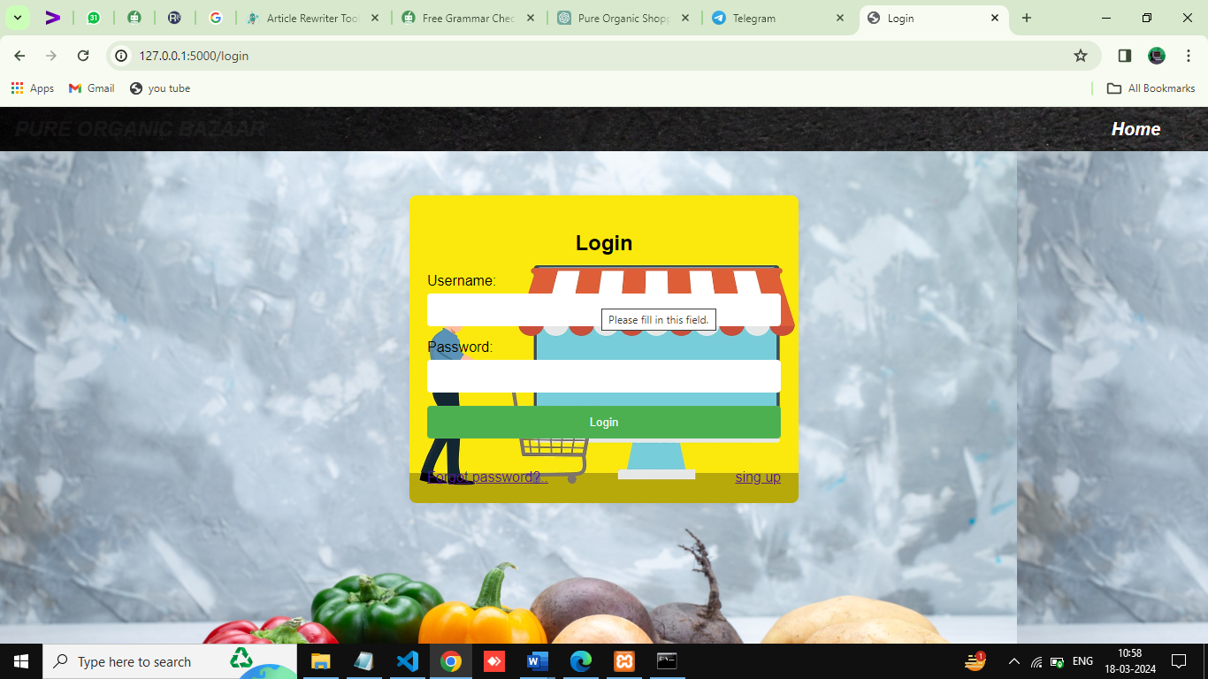

**5.1 user unit testing**

**19**

**5.2 Integration Testing:**

**5.2.1 user Authentication and Profile Management Integration:**

Verify seamless transition between user authentication and profile management.Ensure user profiles are accurately updated upon registration or modification.Test proper redirection to login pages for unauthorized profile accesses.

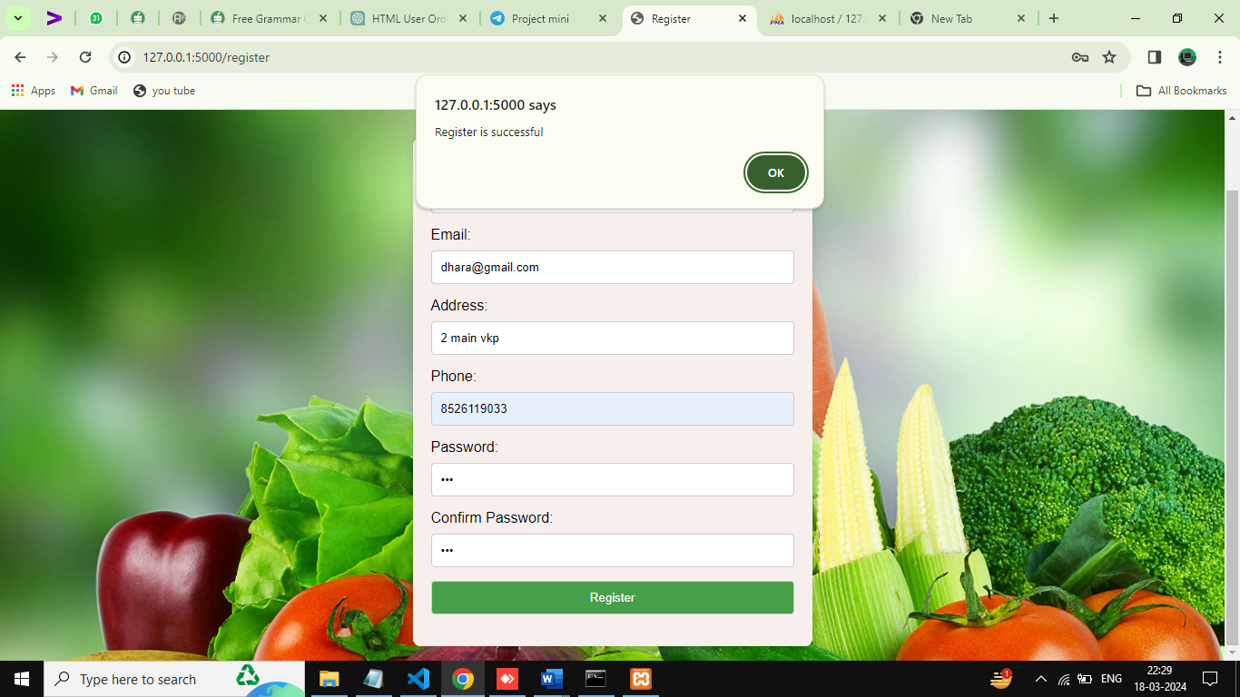

**User Register Integration**

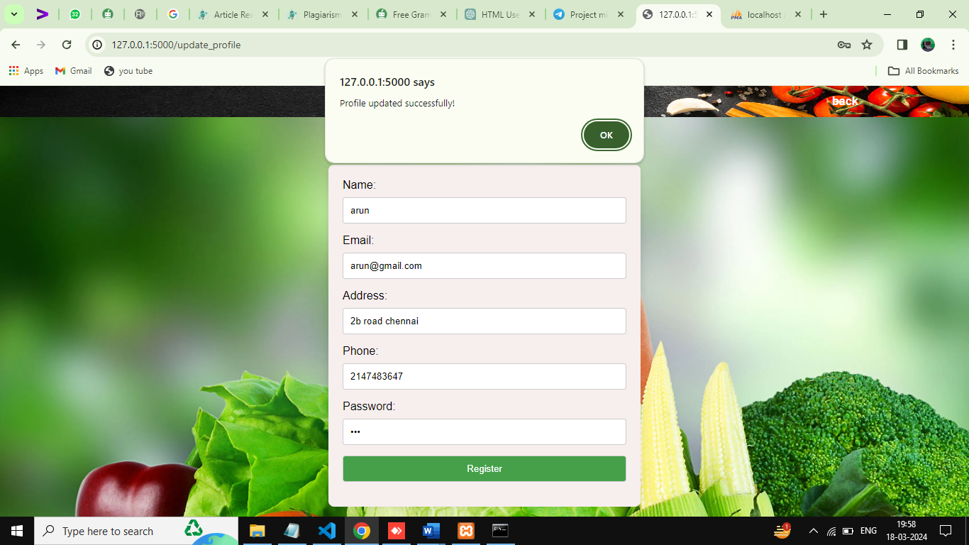

**Profile update Integration**

**20**

**5.2.2Product Catalog and Cart Management Integration:**

Confirm smooth interaction between product catalog and cart management modules.Validate accurate addition and removal of items from the cart.Ensure synchronization of cart updates with product catalog listing

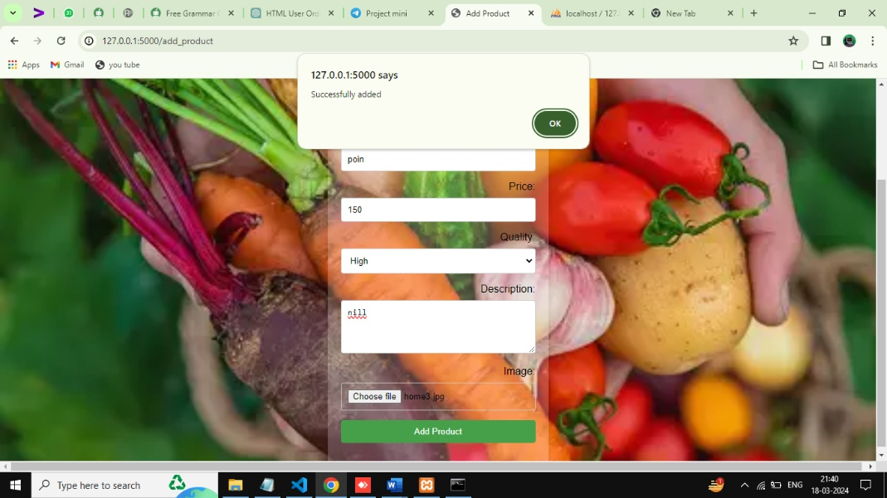

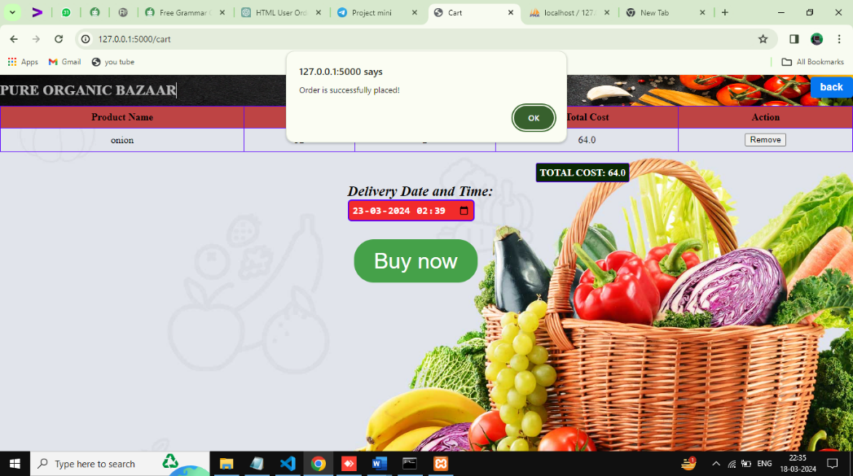**Product catalog Integration**

**Cart Management Integration:**

**21**

**5.3 System Testing:**

System testing involves testing the entire integrated system as a whole to ensure that it meets the specified requirements and functions correctly in its intended environment. It focuses on evaluating the system's behavior and performance across various scenarios to identify any defects or deviations from expected outcomes. This testing phase verifies the system's compliance with functional, non-functional, and business requirements, including usability, reliability, performance, security, and compatibility. System testing encompasses different techniques such as functional testing, usability testing, performance testing, security testing, and compatibility testing to validate the system's overall quality and readiness for deployment.

**5.4 Validation Testing:**

Validation testing is the process of evaluating the final product to ensure that it meets the customer's requirements and expectations. In the context of the "PURE ORGANIC BAZAAR" project, validation testing involves confirming that the web application fulfills its intended purpose of providing a smooth online shopping experience for organic products. This testing phase focuses on assessing whether the implemented features and functionalities align with the stakeholders' needs and specifications. Validation testing verifies that the system meets user requirements, is user-friendly, and delivers the desired value to customers. It typically involves end-to-end testing, user acceptance testing (UAT), and customer feedback collection to validate the system's overall functionality, usability, and satisfaction.

**22**

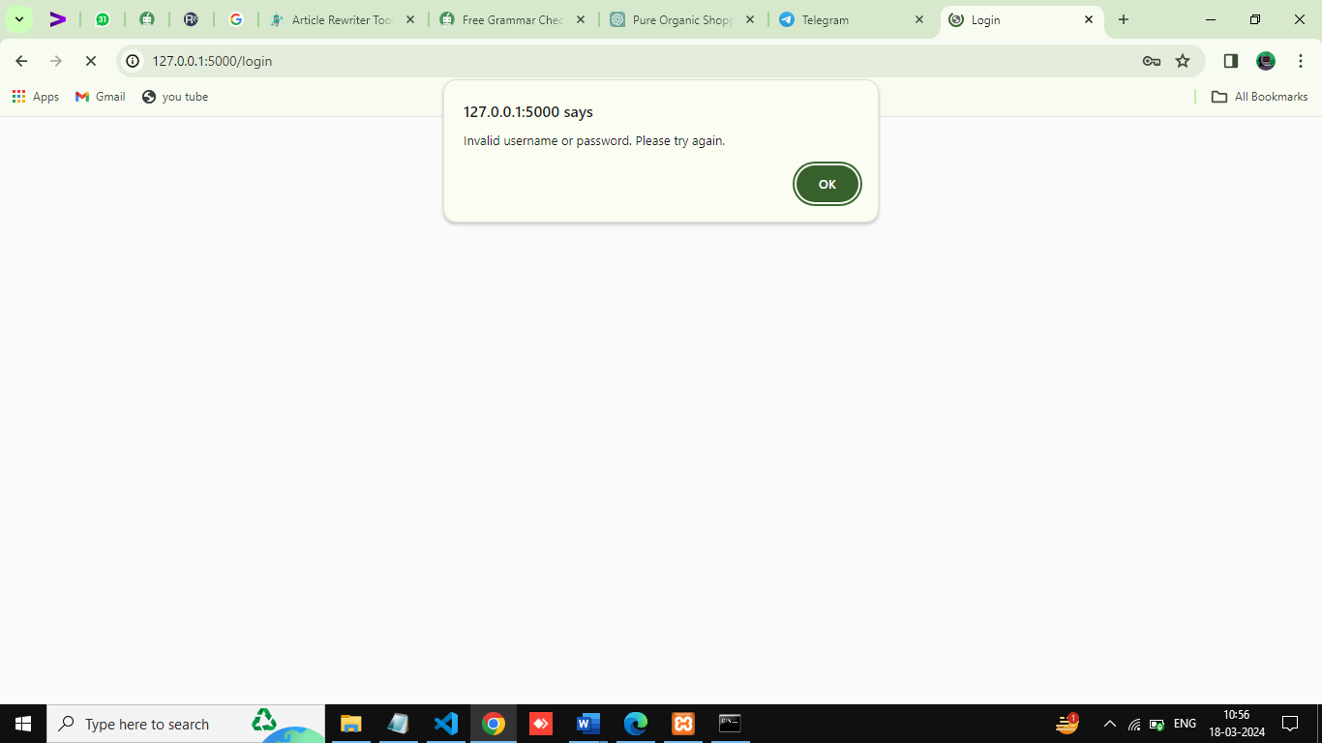

**5.4 validation testing (user)**

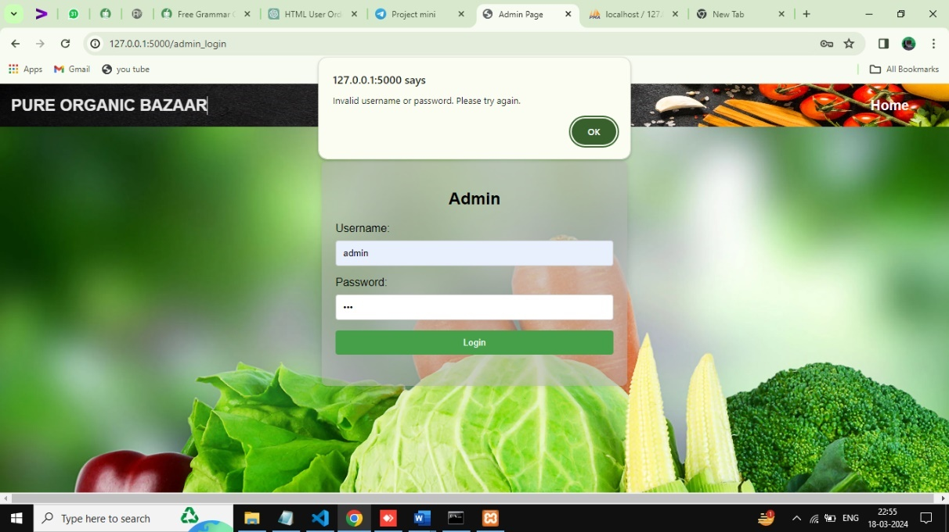

**5.4 validation testing (Admin)**

**23**

**6.Conclusion**

In conclusion, the "PURE ORGANIC BAZAAR" web application embodies a significant advancement in the realm of online shopping, particularly in the domain of organic products. Leveraging the Python Flask framework, the project has successfully developed a robust platform that prioritizes user experience, convenience, and health consciousness. Through seamless integration of features like user authentication, product catalog management, and secure checkout processes, the application offers a streamlined and intuitive shopping experience for customers. Extensive testing, including unit testing, integration testing, and validation testing, has been conducted to ensure the functionality, reliability, and adherence to user requirements of the system.

By addressing pain points encountered in existing systems, such as fragmented checkout processes and limited product selections, "PURE ORGANIC BAZAAR" strives to redefine the online shopping landscape, particularly for those seeking organic and fresh produce. The project's commitment to promoting healthy living is evident through its emphasis on organic products and user-friendly interface. Furthermore, the integration of user authentication and profile management ensures personalized experiences for users, enhancing customer satisfaction and loyalty.With its comprehensive approach to system development and rigorous testing methodologies, the "PURE ORGANIC BAZAAR" project is poised to deliver significant value to users and administrators alike. By embracing innovation and customer-centric design principles, this project sets a new standard for online shopping platforms, offering not only convenience but also a commitment to healthier lifestyles. As the project moves forward, it holds the potential to further revolutionize the way individuals shop for organic products, fostering a culture of sustainability and well-being in the digital marketplace.

**24**

**8. References**

1. Flask official documentation

2.Building Web Apps with Python and Flask” by Saurabh Agarwal:

3.“Flask Web Development, 2nd Edition” by Miguel Grinberg:

4.“Building Web Apps with Python and Flask” by Malhar Lath

5.Heinold, Brian. "A practical introduction to Python programming." (2021)

6. Kneusel, Ronald T. Practical deep learning: A Python-based introduction. No Starch Press, 2021.

7. Dhruv, Akshit J., Reema Patel, and Nishant Doshi. "Python: the most advanced programming language for computer science applications." Science and Technology Publications, Lda (2021): 292-299.

8. Sundnes, Joakim. Introduction to scientific programming with Python. Springer Nature, 2020,

9. Hill, Christian. Learning scientific programming with Python. Cambridge University Press, 2020.

**WEBSITE REFERENCES:**

1. https://medium.com/javarevisited/10-free-python-tutorials-and-courses-from- googlemicrosoft-and-coursera-for-beginners-96b9ad20b4e6

2. https://www.bestcolleges.com/bootcamps/guides/learn-python-free/

3. https://www.programiz.com/python-programming

4. https://realpython.com/

5. https://www.codecademy.com/learn/learn-python

**25**