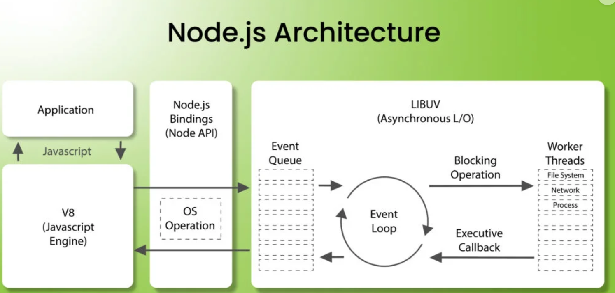

### **Node.js Architecture (Summary)**

Node.js uses an **event-driven, non-blocking I/O** model to handle multiple tasks concurrently with a **single-threaded event loop**.

#### **Key Components:**

1. **Single-Threaded Event Loop**: Handles requests one by one.
2. **Non-Blocking I/O**: Manages tasks like file reads and database queries without blocking execution.
3. **Libuv**: C++ library for handling asynchronous tasks and the thread pool.
4. **V8 Engine**: Compiles JavaScript to machine code for fast execution.
5. **Event-Driven**: Uses callbacks, promises, and async/await to manage asynchronous operations.

#### **Advantages:**

* **Scalable** for I/O-heavy tasks.
* **Fast** and efficient.
* Ideal for real-time applications like chat or APIs.

#### **Limitation:**

* Not ideal for **CPU-intensive tasks**.

4o