SMART BULB USING IOT
Abstract:
Internet of Things (IoT) links smart objects to the internet. It can enable exchange of data in a more secure way. Rapid adaptations of Smart City and Internet of Things technologies are assisting in urban planning to ensure sustainable cities and lifestyles. Life is made simpler and more productive through IOT. As the Wi-Fi hotspots are increasingly becoming common in the recent times, the existing infrastructure can be used to develop a cost effective solution to enable the existing appliances with IOT.

Introduction
To enhance the lifestyle of people through the provision of different services, smart home or automated home comes into picture. The main objective of this project is to operate home devices smartly through an android app using IoT (Internet Of Things). IoT is the network of “things” or physical objects which includes electronics, software, sensors, actuators and network connectivity. All these things collect and transfer data between themselves. IoT has increased significantly in the last few years since it has added a new dimension to the world of information and communication technologies. For digitalizing home appliances such as lighting, heating, security, audio, video etc. IoT in home automation is the best commercial solution these days. With the increasing use of personal computing, media players, android mobile phones etc. people have more knowledge about these technologies and are more comfortable with its use. Thus home automation will be easily accepted by the people.
Embedded system implementation

Introduction:
An embedded system is one kind of a computer system mainly designed to perform several tasks like to access, process, store and also control the data in various electronics-based systems. Embedded systems are a combination of hardware and software where software is usually known as firmware that is embedded into the hardware. One of its most important characteristics of these systems is, it gives the o/p within the time limits. Embedded systems support to make the work more perfect and convenient. So, we frequently use embedded systems in simple and complex devices too. The applications of embedded systems mainly involve in our real life for several devices like microwave, calculators, TV remote control, home security and neighborhood traffic control systems, etc.

User interface

Embedded system

Hardware
Software

Inputs
Output

Link to other systems

Fig: Overview of embedded system

Embedded system:

Embedded system includes mainly two sections , they are

1. Hardware
2. Software

Serial communication ports

Application specific circuits

Power supply and oscillator circuits
Timers
Processor
Interrupt controller
Parallel ports
Memory
Output devices interfacing
Input devices interfacing
and driver circuits

Block diagram of embedded system

Embedded System Hardware:
As with any electronic system, an embedded system requires a hardware platform on which it performs the operation. Embedded system hardware is built with a microprocessor or microcontroller. The embedded system hardware has elements like input output (I/O) interfaces, user interface, memory and the display. Usually, an embedded system consists of:
- Power Supply
- Processor
- Memory
- Timers
- Serial communication ports
- Output/Output circuits
- System application specific circuits
Embedded systems use different processors for its desired operation. some of the processors used are
1. Microprocessor
2. Microcontroller
3. Digital signal processor
Microprocessor vs. Microcontroller
Microprocessor
- CPU on a chip.
- We can attach required amount of ROM, RAM and I/O ports.
- Expensive due to external peripherals.
- Large in size
- general-purpose

Microcontroller
- Computer on a chip
- fixed amount of on-chip ROM, RAM, I/O ports
- Low cost.
- Compact in size.
- Specific –purpose

Embedded System Software:
The embedded system software is written to perform a specific function. It is typically written in a high level format and then compiled down to provide code that can be lodged within a non-volatile memory within the hardware. An embedded system software is designed to keep in view of the three limits:
- Availability of system memory
- Availability of processor’s speed
- When the system runs continuously, there is a need to limit power dissipation for events like stop, run and wake up.
Bringing software and hardware together for embedded system:
To make software to work with embedded systems we need to bring software and hardware together .for this purpose we need to burn our source code into microprocessor or microcontroller which is a hardware component and which takes care of all operations to be done by embedded system according to our code.
Generally we write source codes for embedded systems in assembly language, but the processors run only executable files. The process of converting the source code representation of your embedded software into an executable binary image involves three distinct steps:
- Each of the source files must be compiled or assembled into an object file.
- All of the object files that result from the first step must be linked together to produce a single object file, called the re-locatable program.
- Physical memory addresses must be assigned to the relative offsets within the re-locatable program in a process called relocation.
The result of the final step is a file containing an executable binary image that is ready to run on the embedded system.

Source code

Linker
Locator
Assembler
Executable file

Processor

Flow of burning source code to processor

Applications:
Embedded systems have different applications. A few select applications of embedded systems are smart cards, telecommunications, satellites, missiles, digital consumer electronics, computer networking, etc.
Embedded Systems in Automobiles
- Motor Control System
- Engine or Body Safety
- Robotics in Assembly Line
- Mobile and E-Com Access
Embedded systems in Telecommunications
- Mobile computing
- Networking
- Wireless Communications
Embedded Systems in Smart Cards
- Banking
- Telephone
- Security Systems
Implementation flow:
Stage 1:
Considering the problems of existing methods and giving solution to that problem by considering the basic requirements for our proposed system
Stage 2:
Considering the hardware requirement for the proposed system
For this we need to select the below components:
1. Microcontroller
2. Inputs for the proposed system (ex: sensors, drivers etc..,)
3. Outputs (ex: relays, loads)
Stage 3:
After considering hardware requirements, now we need to check out the software requirements. Based on the microcontroller we select there exists different software for coding, compiling, debugging. we need to write source code for that proposed system based on our requirements and compile, debug the code in that software .
After completing all the requirements of software and hardware we need to bring both together to work our system. For this we need to burn our source code into microcontroller, after burning our source code to microcontroller then connect all input and output modules as per our requirement.

Existing system:
In the existing system, home appliances are controlled through Bluetooth, Zigbee and other devices. But they are limited to certain area. In the proposed system we have designed so as to control home appliances from anywhere in the world.
DTMF can also be used but it won’t come for practically and also not reliable.
Proposed system:
In the proposed system, we are using NodeMCU Wi-Fi module. We will create a separate host server for the Wi-Fi Module to control the home appliances wirelessly. Here we are controlling the appliances with the help of Adafruit server through NodeMCU.

Block Diagram:

Power Supply

Relay

Node MCU

Bulb
Adafruit server

Fig: block diagram

Hardware requirements
POWER SUPPLY

WHAT IS A POWER SUPPLY?

A power supply is a device which delivers an exact voltage to another device as per its needs.There are many power supplies available today in the market like regulated, unregulated, variable etc, and the decision to pick the correct one depends entirely on what device you are trying to operate with the power supply. Power supplies, often called power adapters, or simply adapters, are available in various voltages, with varying current capacities, which is nothing but the maximum capacity of a power supply to deliver current to a load (Load is the device you are trying to supply power to).

WHY MAKE ONE YOURSELF?

`One would ask himself, “Why do I make it myself, when it available in the market?” Well, the answer is- even if you buy one, it is bound to stop working in a while (and believe me, power supplies stop working without any prior indication, one day they’ll work, the next day they’ll just stop working!). So, if you build one yourself, you will always know how to repair it, as you will know exactly what component/part of the circuit is doing what. And further, knowing how to build one, will allow you to repair the ones you have already bought, without wasting your money on a new one.

WHAT YOU NEED?

- Copper wires, with at least 1A current carrying capacity for AC mains
- Step Down Transformer
- 1N4007 Silica Diodes (×4)
- 1000µF Capacitor
- 10µF Capacitor
- Voltage regulator (78XX) (XX is the output voltage reqd. I’ll explain this concept later)
- Soldering iron
- Solder
- General Purpose PCB
- Adapter jack (to provide the output voltage to a device with a particular socket)
- 2 Pin plug

Optional
  - LED (for indication)
  - Resistor (Value explained later)
  - Heat Sink for The Voltage Regulator (For higher current outputs)
  - SPST Switch

SOME BASIC CONCEPTS RELATED TO POWER SUPPLIES

Transformers
Transformers are devices which step down a relatively higher AC input Voltage into a lower AC output voltage. To find the input and output terminals of a transformer is very tricky. Refer to the following illustration or the internet to understand where what is.
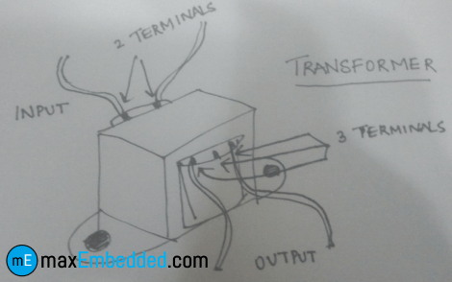
I/O Terminals of a Transformer
Basically, there are two sides in a transformer where the coil winding inside the transformer ends. Both ends have two wires each (unless you are using a center-tapped transformer for full wave rectification). On the transformer, one side will have three terminals and the other will have two. The one with the three terminals is the stepped down output of the transformer, and the one with the two terminals is where the input voltage is to be provided.

Voltage Regulators
The 78XX series of voltage regulators is a widely used range of regulators all over the world. The XX denotes the voltage that the regulator will regulate as output, from the input voltage. For instance, 7805, will regulate the voltage to 5V. Similarly, 7812 will regulate the voltage to 12V. The thing to remember with these voltage regulators is that they need at least 2 volts more than their output voltage as input. For instance, 7805 will need at least 7V, and 7812, at least 14 volts as inputs. This excess voltage which needs to be given to voltage regulators is called Dropout Voltage.
NOTE: The input pin is denoted as ‘1’, ground as ‘2’ and output as ‘3’.

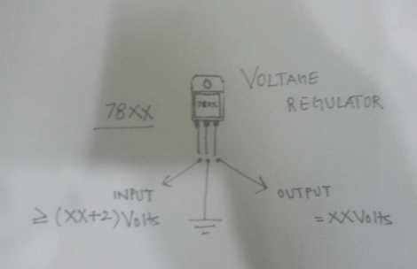
Voltage Regulator Schematic

Diode Bridge
A bridge rectifier consists of an assembly of four ordinary diodes, by means of which we can convert AC Voltage into DC Voltage. It is found to be the best model for AC to DC conversion, over Full wave and Half wave rectifiers. You can use any model you want, but I use this for the sake of high efficiency (If you are using the full wave rectifier model, you’ll need a center-tapped transformer, and you will only be able to use half of the transformed voltage).

One thing to note about diodes is that they drop about 0.7V each when operated in forward bias. So, in bridge rectification we will drop 1.4V because at one instant two diodes are conducting and each will drop 0.7V. In case of Full wave rectifier, only 0.7V will be dropped.
So how does this drop affect us? Well, this comes in handy while choosing the correct step down voltage for the transformer. See, our voltage regulator needs 2 Volts more than its output voltage. For the sake of explanation, let’s assume that we are making a 12V adapter. So the voltage regulator needs at least 14 Volts as input.

So the output of the diodes (which goes into the voltage regulator) will have to be more than or equal to 14 Volts. Now for the diodes’ input voltage. They’ll drop 1.4 Volts in total, so the input to them has to be greater than or equal to 14.0 + 1.4 = 15.4Volts. So I would probably use a 220 to 18 Volt step down transformer for that.
So basically, the transformer step down voltage should be at least 3.4V more than the desired Power Supply output.

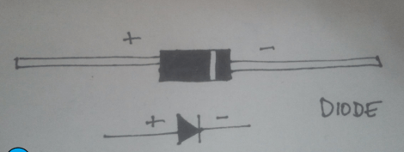
Schematic and Illustration of a Diode

Filter Circuit

We filter, at the output of the voltage rectifier in order to get the smoothest DC Voltage as possible, from our adapter, for which we use capacitors. Capacitors are the simplest current filters available, they let AC current pass through and block DC, so they are used in parallel to the output. Furthermore, if there is a ripple in the input or output, a capacitor rectifies it by discharging the charge stored in it.

HOW TO BUILD IT?
Here is the circuit diagram for the Power Supply:
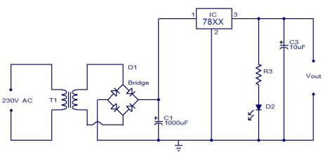
Circuit Diagram

How it works
The AC mains are fed to the transformer, which steps down the 230 Volts to the desired voltage. The bridge rectifier follows the transformer thus converting AC voltage into a DC output and through a filtering capacitor feeds it directly into the input (Pin 1) of the voltage regulator. The common pin (Pin 2) of the voltage regulator is grounded. The output (Pin 3) of the voltage regulator is first filtered by a capacitor, and then the output is taken.
Make the circuit on a general purpose PCB and use a 2 Pin (5A) plug to connect the transformer input to the AC mains via insulated copper wires.
NodeMCU:
Introduction to NodeMCU
NodeMCU is an open-source firmware and development kit that plays a vital role in designing your own IoT product using a few Lua script lines.
Multiple GPIO pins on the board allow you to connect the board with other peripherals and are capable of generating PWM, I2C, SPI, and UART serial communications.
- The interface of the module is mainly divided into two parts including both Firmware and Hardware where former runs on the ESP8266 Wi-Fi SoC and later is based on the ESP-12 module.
The firmware is based on Lua – A scripting language that is easy to learn, giving a simple programming environment layered with a fast scripting language that connects you with a well-known developer community.
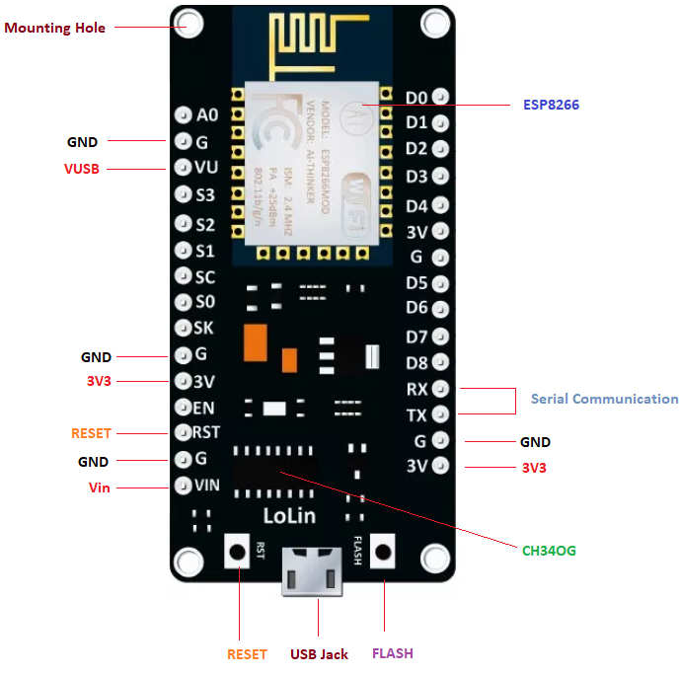
And open source firmware gives you the flexibility to edit, modify and rebuilt the existing module and keep changing the entire interface until you succeed in optimizing the module as per your requirements.
- USB to UART converter is added on the module that helps in converting USB data to UART data which mainly understands the language of serial communication.
Instead of the regular USB port, MicroUSB port is included in the module that connects it with the computer for dual purposes: programming and powering up the board.
- The board incorporates status LED that blinks and turns off immediately, giving you the current status of the module if it is running properly when connected with the computer.
The ability of module to establish a flawless WiFi connection between two channels makes it an ideal choice for incorporating it with other embedded devices like Raspberry Pi.
NodeMCU Pinout:
NodeMCU comes with a number of GPIO Pins. Following figure shows the Pinout of the board.
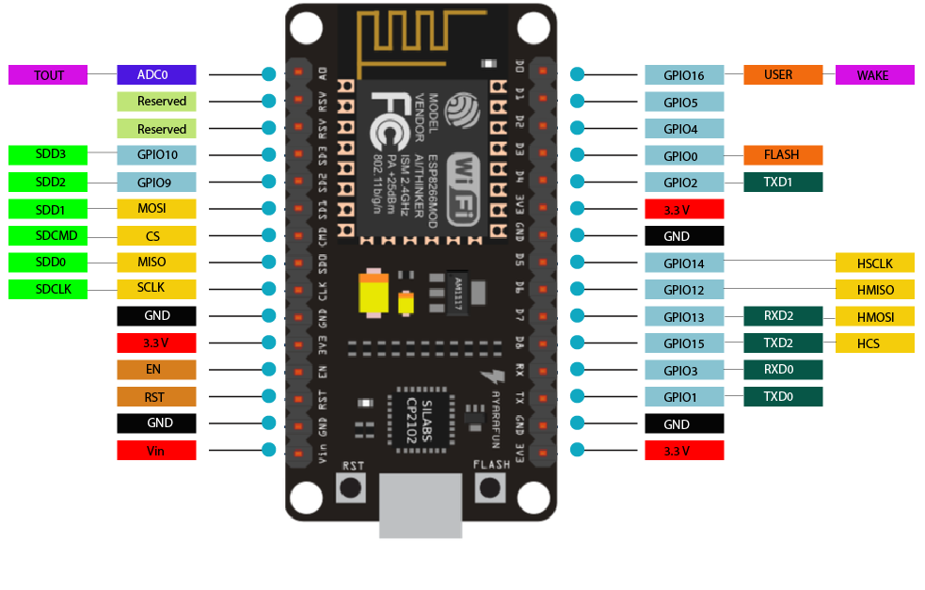
- There is a candid difference between VIN and VU where former is the regulated voltage that may stand somewhere between 7 to 12 V while later is the power voltage for USB that must be kept around 5 V.
Features:
- Open-source
- Arduino-like hardware
- Status LED
- MicroUSB port
- Reset/Flash buttons
- Interactive and Programmable
- Low cost
- ESP8266 with inbuilt wifi
- USB to UART converter
- GPIO pins
As mentioned above, a cable supporting micro USB port is used to connect the board. As you connect the board with a computer, LED will flash. You may need some drivers to be installed on your computer if it fails to detect the NodeMCU board. You can download the driver from this page.
Note: We use Arduino IDE software for programming this module. It is important to note that the pin configuration appearing on the board is different from the configuration we use to program the board on the software i.e. when we write code for targeting pin 16 on the Arduino IDE, it will actually help is laying out the communication with the D0 pin on the module.
Following figure the shows the pin configuration to use in Arduino IDE.
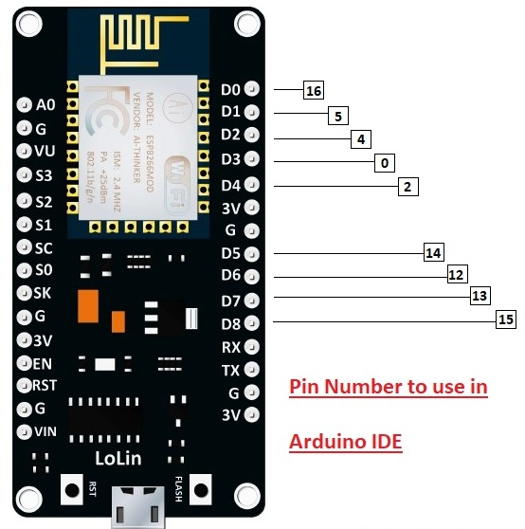
How to Power NodeMCU
You can see from the pinout image above, there are five ground pins and three 3V3 pins on the board. The board can be powered up using the following three ways.
USB Power. It proves to an ideal choice for loading programs unless the project you aim to design requires separate interface i.e. disconnected from the computer.
Provide 3.3V. This is another great option to power up the module. If you have your own off-board regulator, you can generate an instant power source for your development kit.
Power Vin. This is a voltage regulator that comes with the ability to support up to 800 mA. It can handle somewhere between 7 to 12 V. You cannot power the devices operating at 3.3 V, as this regulator unable to generate as low as 3.3V.
Applications:
NodeMCU V3 is mainly used in the WiFi Applications which most of the other embedded modules fail to process unless incorporated with some external WiFi protocol. Following are some major applications used for NodeMCU V3.
- Internet Smoked Alarm
- VR Tracker
- Octopod
- Serial Port Monitor
- ESP Lamp
- Incubator Controller
- IoT home automation
- Security Alarms

Relay:
What is a relay?
A relay is an electromagnetic switch that is used to turn on and turn off a circuit by a low power signal, or where several circuits must be controlled by one signal.
Most of the high end industrial application devices have relays for their effective working. Relays are simple switches which are operated both electrically and mechanically. Relays consist of an electromagnet and also a set of contacts. The switching mechanism is carried out with the help of the electromagnet. There are also other operating principles for its working. But they differ according to their applications. Most of the devices have the application of relays.
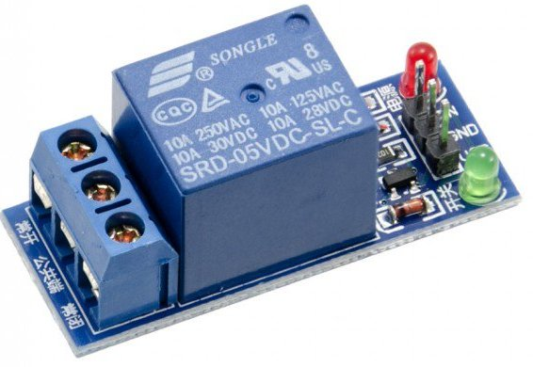

Pin Diagram:

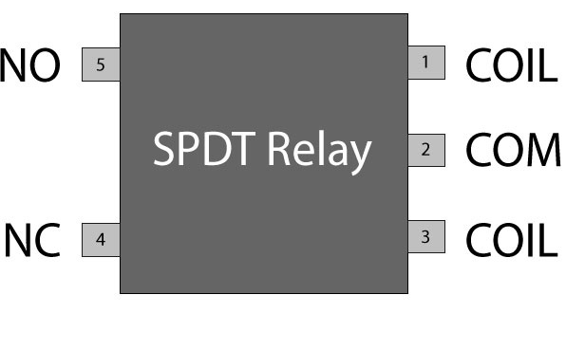
Why is a relay used?
The main operation of a relay comes in places where only a low-power signal can be used to control a circuit. It is also used in places where only one signal can be used to control a lot of circuits. The application of relays started during the invention of telephones. They played an important role in switching calls in telephone exchanges. They were also used in long distance telegraphy. They were used to switch the signal coming from one source to another destination. After the invention of computers they were also used to perform Boolean and other logical operations. The high end applications of relays require high power to be driven by electric motors and so on. Such relays are called contactors.

Relay Design
- There are only four main parts in a relay. They are
- Electromagnet
- Movable Armature
- Switch point contacts
- Spring
The figures given below show the actual design of a simple relay.
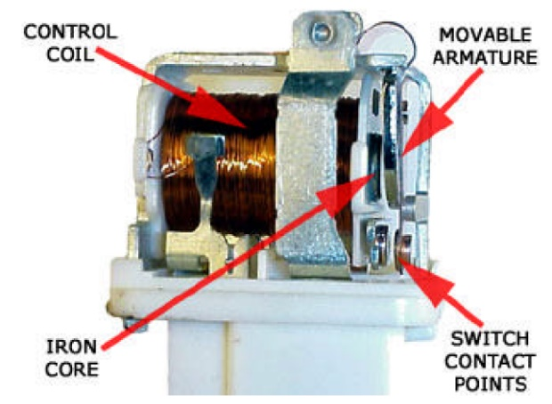
Relay Construction
It is an electro-magnetic relay with a wire coil, surrounded by an iron core. A path of very low reluctance for the magnetic flux is provided for the movable armature and also the switch point contacts.
The movable armature is connected to the yoke which is mechanically connected to the switch point contacts. These parts are safely held with the help of a spring. The spring is used so as to produce an air gap in the circuit when the relay becomes de-energized.

How relay works?
The relay function can be better understood by explaining the following diagram given below.
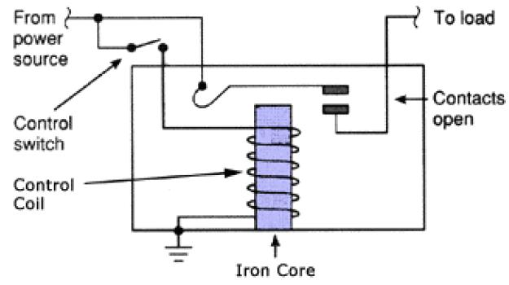
Relay Design
The diagram shows an inner section diagram of a relay. An iron core is surrounded by a control coil. As shown, the power source is given to the electromagnet through a control switch and through contacts to the load. When current starts flowing through the control coil, the electromagnet starts energizing and thus intensifies the magnetic field. Thus the upper contact arm starts to be attracted to the lower fixed arm and thus closes the contacts causing a short circuit for the power to the load. On the other hand, if the relay was already de-energized when the contacts were closed, then the contact move oppositely and make an open circuit.
As soon as the coil current is off, the movable armature will be returned by a force back to its initial position. This force will be almost equal to half the strength of the magnetic force. This force is mainly provided by two factors. They are the spring and also gravity.
Relays are mainly made for two basic operations. One is low voltage application and the other is high voltage. For low voltage applications, more preference will be given to reduce the noise of the whole circuit. For high voltage applications, they are mainly designed to reduce a phenomenon called arcing.

SOFTWARE REQUIREMENTS
Introduction to Arduino IDE
IDE stands for “Integrated Development Environment”: it is official software introduced by
Arduino.cc that is mainly used for editing, compiling and uploading the code in the Arduino Device. Almost all Arduino modules are compatible with this software that is an open source and is readily available to install and start compiling the code on the go.
In this article, we will introduce the Software, how we can install it, and make it ready for developing applications using Arduino modules.
Arduino IDE Definition
1. Arduino IDE is open source software that is mainly used for writing and compiling the code into the Arduino Module.
2. It is official Arduino software, making code compilation too easy that even a common person with no prior technical knowledge can get their feet wet with the learning process.
3. It is easily available for operating systems like MAC, Windows, and Linux and runs on the Java Platform that comes with inbuilt functions and commands that play a vital role for debugging, editing and compiling the code in the environment.
4. A range of Arduino modules available including Arduino Uno, Arduino Mega, Arduino Leonardo, Arduino Micro and many more.
5. Each of them contains a microcontroller on the board that is actually programmed and accepts the information in the form of code.
6. The main code, also known as a sketch, created on the IDE platform will ultimately generate a Hex File which is then transferred and uploaded in the controller on the board.
7. The IDE environment mainly contains two basic parts: Editor and Compiler where former is used for writing the required code and later is used for compiling and uploading the code into the given Arduino Module.
8. This environment supports both C and C++ languages.
How to get Arduino IDE
We can download the Software from Arduino main website. As I said earlier, the software is available for common operating systems like Linux, Windows, and MACos, we select to download the correct software version that is easily compatible with our operating system.
Details on IDE: The IDE environment is mainly distributed into three sections
• 1. Menu Bar
• 2. Text Editor
• 3. Output Pane
As we download and open the IDE software, it will appear like an image below.
Fig:Arduino IDE page
The bar appearing on the top is called Menu Bar that comes with five different options as follow
- File – You can open a new window for writing the code or open an existing one. Following table shows the number of further subdivisions the file option is categorized into.
Fig: File bar
And at the end of compilation, it will show you the hex file it has generated for the recent sketch that will send to the Arduino Board for the specific task you aim to achieve.

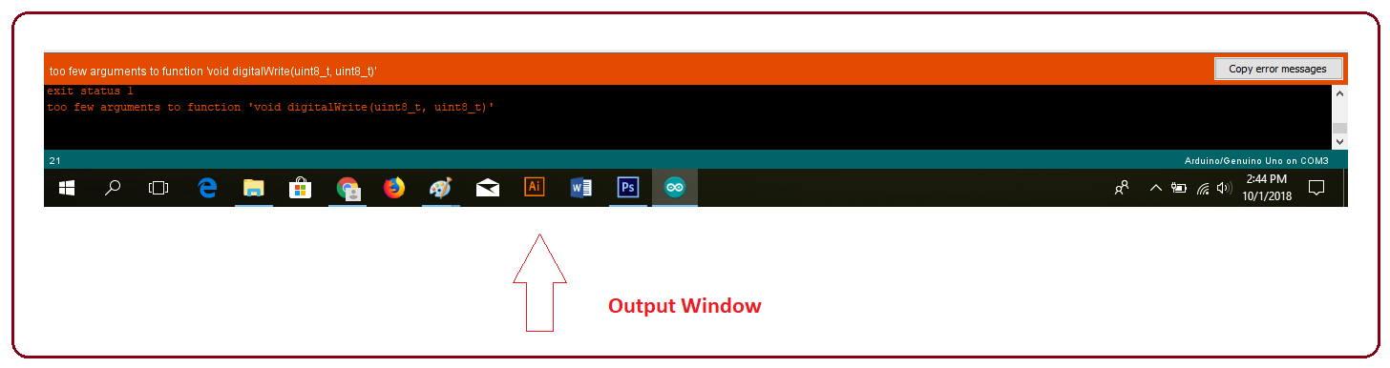

Fig: hex file for recent file
Edit – Used for copying and pasting the code with further modification for font
- Sketch – For compiling and programming
- Tools – Mainly used for testing projects. The Programmer section in this panel is used for burning a boot loader to the new microcontroller.
- Help – In case you are feeling skeptical about software, complete help is available from getting started to troubleshooting.

The main screen below show how to select a program from examples ie: Bink.cc

Fig: selecting program
Libraries
Libraries are very useful for adding the extra functionality into the Arduino Module. There is a list of libraries you can add by clicking the Sketch button in the menu bar and going to Include Library.

Fig: Libraries
As you click the Include Library and Add the respective library it will on the top of the sketch with a #include sign. Suppose, I Include the EEPROM library, Temperature sensors DHT11/22, LCD or I2C library it will appear on the text editor as
#include <EEPROM.h>.
#include <dht.h>
#include <I2Cdev.h>
Most of the libraries are preinstalled and come with the Arduino software. However, we can also download them from the external sources.
Making Pins as Input or Output
The digitalRead and digitalWrite commands are used for addressing and making the Arduino pins as an input and output respectively.
These commands are text sensitive i.e. you need to write them down the exact way they are given like digitalWrite starting with small “d” and write with capital “W”. Writing it down with Digitalwrite or digitalwritewon’t be calling or addressing any function.
Example : if we want to use Pin D13 as output , the code will be; pinMode(13, OUTPUT); followed by digitalWrite(13,HIGH);
If we want to use Pin D13 as input, the code will be : pinMode(13, INPUT);followed by x=digitalRead(13);
Selecting Board of Arduino
In order to upload the sketch, we need to select the relevant board we are using and the ports for that operating system. As we click the Tools on the Menu, it will open like the figure below.
Fig: selecting a board

Just we go to the “Board” section and select the board we would like to work on. Similarly, COM1, COM2, COM4, COM5, COM7 or higher are reserved for the serial and USB board. We can look for the USB serial device in the ports section of the Windows Device Manager.
Following figure shows the COM4 that we have used for my project, indicating the Arduino Uno with COM4 port at the right bottom corner of the screen.
Fig: showing Arduino connected port

- After correct selection of both Board and Serial Port, click the verify and then upload button appearing in the upper left corner of the six button section or you can go to the Sketch section and press verify/compile and then upload.
- The sketch is written in the text editor and is then saved with the file extension .ino. It is important to note that the recent Arduino Modules will reset automatically as you compile and press the upload button the IDE software, however, older version may require the physical reset on the board.
- As we upload the code, TX and RX LEDs will blink on the board, indicating the desired program is running successfully.

Note: The port selection criteria mentioned above is dedicated for Windows operating system only, you can check this Guide if you are using MAC or Linux.
The amazing thing about this software is that no prior arrangement or bulk of mess is required to install this software, you will be writing your first program within 2 minutes after the installation of the IDE environment.

Using Serial Monitor
Fig: serial monitor

Example of test serial monitor on program test2.cc
Boot loader
As we go to the Tools section, we will find a boot loader at the end. It is very helpful to burn the code directly into the controller, setting us free from buying the external burner to burn the required code.
Fig: Boot loader

When we buy the new Arduino Module, the bootloader is already installed inside the controller. However, if we intend to buy a controller and put in the Arduino module, we need to burn the bootloader again inside the controller by going to the Tools section and selecting the burn bootloader.
The Program Structure
Declarations
Variables
Whenever you’re using Arduino, you need to declare global variables and instances to be used later on. In a nutshell, a variable allows you to name and store a value to be used in the future. For example, you would store data acquired from a sensor in order to use it later. To declare a variable you simply define its type, name and initial value.
It’s worth mentioning that declaring global variables isn’t an absolute necessity. However, it’s advisable that you declare your variables to make it easy to utilize your values further down the line.
Instances
In software programming, a class is a collection of functions and variables that are kept together in one place. Each class has a special function known as a constructor, which is used to create an instance of the class. In order to use the functions of the class, we need to declare an instance for it.
Setup ()
Every Arduino sketch must have a setup function. This function defines the initial state of the Arduino upon boot and runs only once.
Here we’ll define the following:
1. Pin functionality using the pinMode function
2. Initial state of pins
3. Initialize classes

4. Initialize variables
5. Code logic

Loop ()
The loop function is also a must for every Arduino sketch and executes once setup() is complete. It is the main function and as its name hints, it runs in a loop over and over again. The loop describes the main logic of your circuit.
Serial Plotter
Arduino serial plotter is another component of the Arduino IDE, which allows you to generate a real-time graph of your serial data. The serial plotter makes it much easier for you to analyze your data through a visual display. You’re able to create graphs, negative value graphs, and conduct waveform analysis.
Fig: Serial plotter

Applications:
- Used in homes, offices, industrial areas etc.,
- Control home electrical system using phone.
- Switch Module’s outputs to directly drive loads like bulbs, Lamps, Sockets, Television, and Fans etc.
Advantages:
- Smart and secure.
- Controlling home appliances from anywhere in the world.
- There is no need for extra training of that person who is using it.
- It is a robust and easy to use system.

Conclusion
It is evident from this project work that an individual control home automation system can be cheaply made from low-cost locally available components and can be used to control multifarious home appliances ranging from the security lamps, the television to the air conditioning system and even the entire house lighting system. And better still, the components required are so small and few that they can be packaged into a small inconspicuous container. The designed home automation system was tested a number of times and certified to control different home appliances used in the lighting system, air conditioning system, home entertainment system and many more . Hence, this system is scalable and flexible.
Future scope:
In the coming years, fully automated smart homes will surely become a reality as the home automation is developing rapidly. Due to good user convenience, smart homes are appealing a wide range of people all over the globe. The User can check for the electricity usage, the condition of his devices and get notification accordingly.

References
[1] Y. Liu, "Study on Smart Home System Based on Internet of Things Technology," in Informatics and Management Science IV. vol. 207, W. Du, Ed., ed: Springer London, 2013, pp. 73-81.
[2] M. A. Al-Qutayri and J. S. Jeedella, "Integrated Wireless Technologies for Smart Homes Applications," in Smart Home Systems, M. A. Al-Qutayri, Ed., ed: InTech, 2010.
[3] C. Chiu-Chiao, H. Ching Yuan, W. Shiau-Chin, and L. Cheng-Min, "Bluetooth-Based Android Interactive Applications for Smart Living," in Innovations in Bioinspired Computing and Applications (IBICA), 2011 Second International Conference on, 2011, pp. 309-312.
[4] Anushri Aware, SonaliVaidya,PriyankaAshture, VarshaGaiwal, “Home Automation using Android App and Cloud Network”, International Journal of Engineering Research and General Science Volume 3, Issue 3, May-June, 2015.
[5] Prachi T. Deokar, Dr. Manoj S. Nagmode, “Cloud Server Based Home Automation System Using Android Phone”, (IJIRSE) International Journal of Innovative Research in Science & Engineering
[6] Fukuoka-shi, "Design and Implementation of Improved Authentication System for Android Smartphone Users".

