Load Balancer

Task:
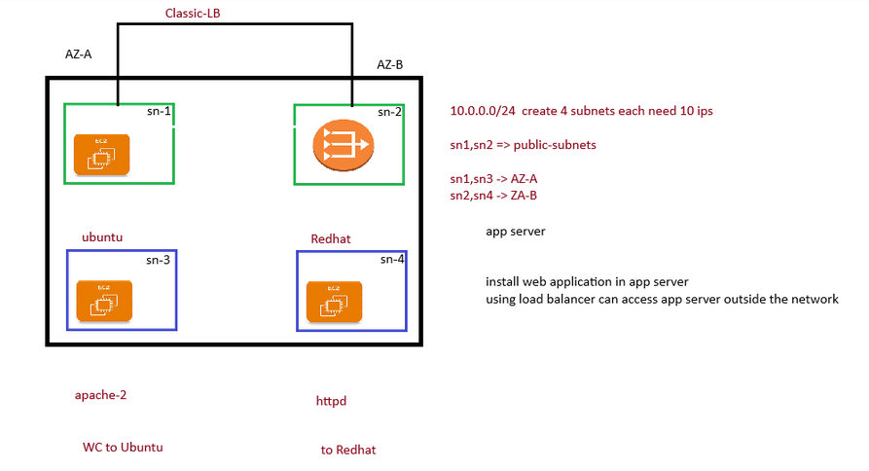
Creating VPC:

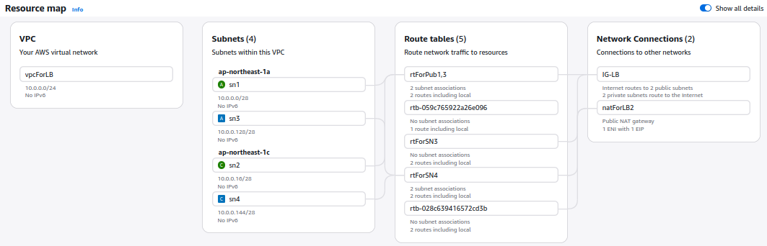
Instence:

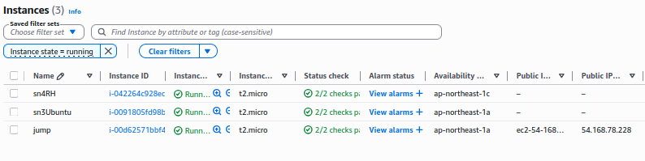
Terminal Output:

┌─[pradeeshkumar@Blackarch ~/Downloads]
└─$ ssh -i key.pem ubuntu@54.168.78.228
Welcome to Ubuntu 24.04.4 LTS (GNU/Linux 6.17.0-1007-aws x86_64)

* Documentation: https://help.ubuntu.com
* Management: https://landscape.canonical.com
* Support: https://ubuntu.com/pro

System information as of Mon Apr 20 16:25:02 UTC 2026

System load: 0.0 Processes: 107
Usage of /: 27.0% of 6.71GB Users logged in: 0
Memory usage: 22% IPv4 address for enX0: 10.0.0.8
Swap usage: 0%

Expanded Security Maintenance for Applications is not enabled.

0 updates can be applied immediately.

Enable ESM Apps to receive additional future security updates.
See https://ubuntu.com/esm or run: sudo pro status

The list of available updates is more than a week old.
To check for new updates run: sudo apt update

Last login: Mon Apr 20 12:36:23 2026 from 157.51.3.92
To run a command as administrator (user "root"), use "sudo <command>".
See "man sudo_root" for details.

ubuntu@ip-10-0-0-8:~$ curl 10.0.0.133
WCto ubuntu
ubuntu@ip-10-0-0-8:~$ curl 10.0.0.152
WC to RH
ubuntu@ip-10-0-0-8:~$

Load Balancer:
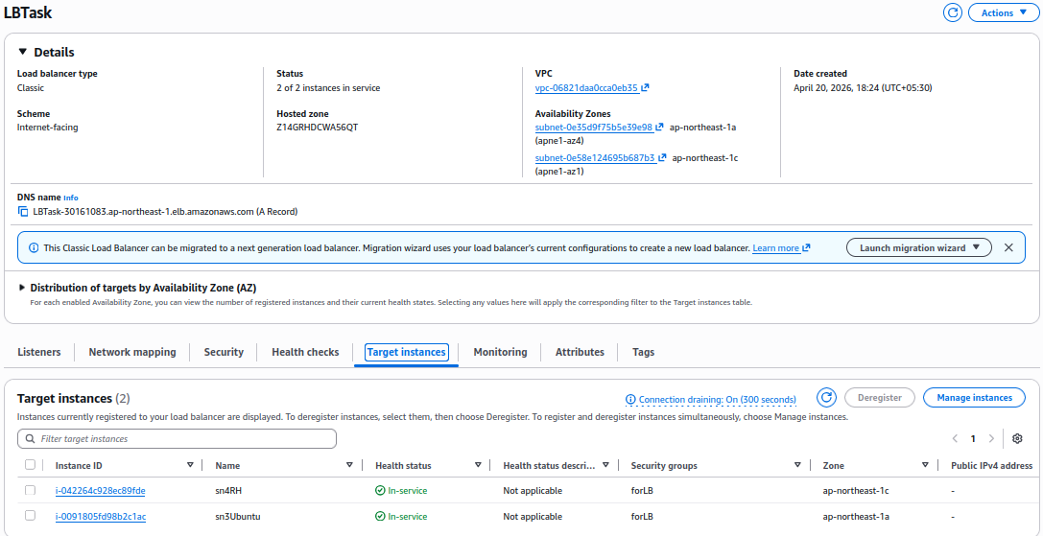
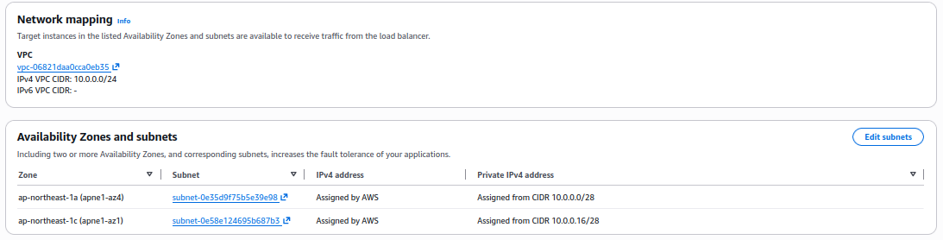
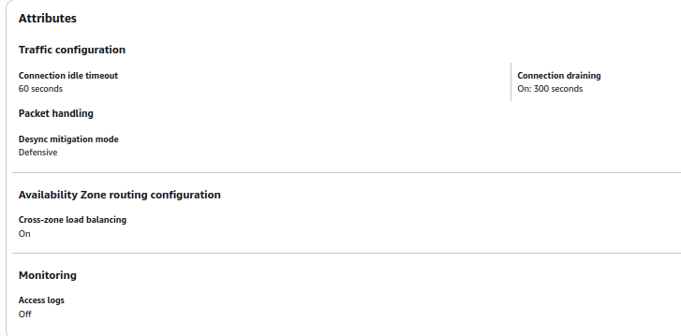
ubunthuServer:
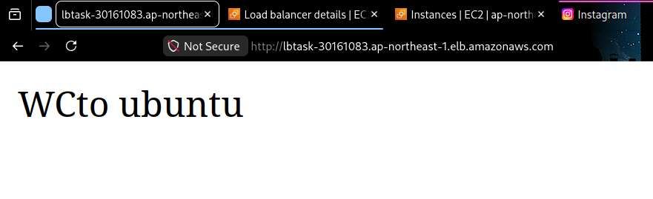
RH server:

