NAT GateWay Task

Task:

create vpc-172.18.0.0/24 with 4 subnets each need 30 ips
sn1,sn2 public subnets
sn3,sn4 private subnets
sn1,sn3 -AZ-A
sn2,sn4 - AZ-B
sn1- jump server
sn2 - nat gateway
sn3 - ubuntu - app-1 install apache2
sn4 - redhat - app-2 install httpd
==================================================================

creating VPC and subnets:

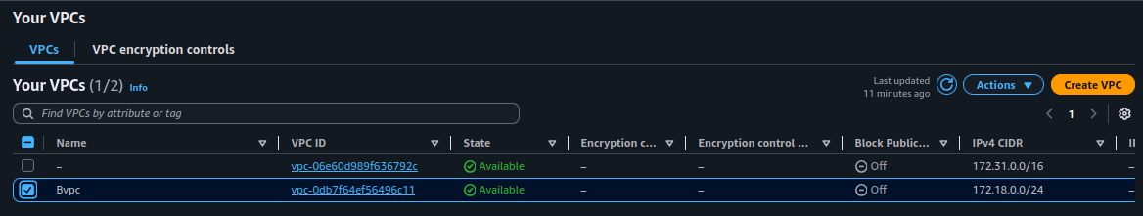
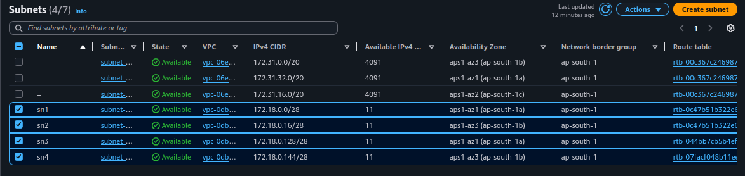
Nat Gateway:
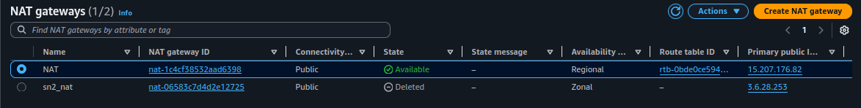

Route Table:

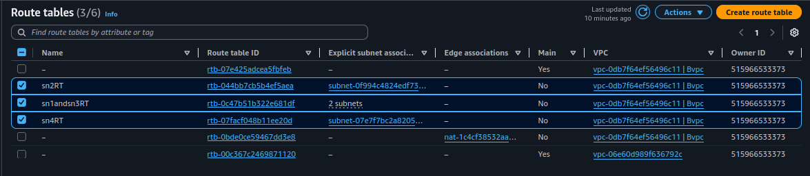
Instance:

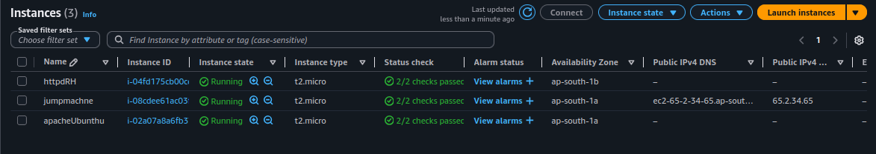
┌─[pradeeshkumar@Blackarch ~/Downloads]
└─$ history
1 cd Downloads/
2 ssh -i "Key.pem" ubuntu@ec2-65-2-34-65.ap-south-1.compute.amazonaws.com
ubuntu@ip-172-18-0-8:~$ history
1 nano pri.pem
2 chmod 400 pri.pem
3 ssh -i "pri.pem" ubuntu@172.18.0.141
ubuntu@ip-172-18-0-141:~$ history
1 sudo apt update && sudo apt install apache2
2 systemctl status apache2
3 curl localhost
4 nano pri.pem
5 sudo chmod 400 pri.pem
6 ssh -i "Key.pem" ec2-user@172.18.0.149
7 ls -l
8 ssh -i "pri.pem" ec2-user@172.18.0.149
[ec2-user@ip-172-18-0-149 ~]$ history
1 sudo yum update && sudo yum install httpd -y
2 systemctl status httpd
3 sudo systemctl start httpd
4 curl localhost
5 histoty
6 history
[ec2-user@ip-172-18-0-149 ~]$
9 history
ubuntu@ip-172-18-0-141:~$
4 history
ubuntu@ip-172-18-0-8:~$
3 history

┌─[pradeeshkumar@Blackarch ~/Downloads]
└─$

Connection to 172.18.0.141 closed.

