VPC Peering

Creating VPC and subnets:

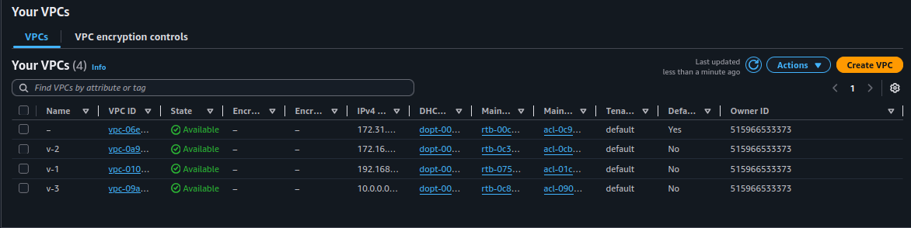
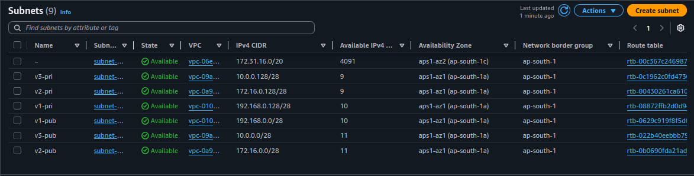
creating EC2 instence :

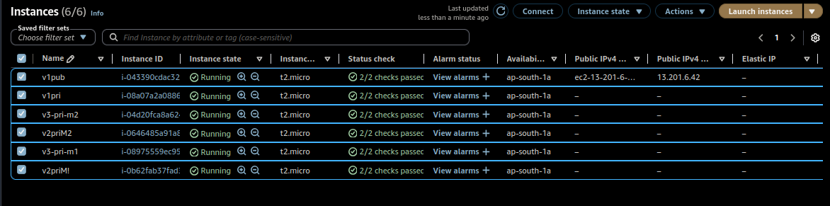

Task:

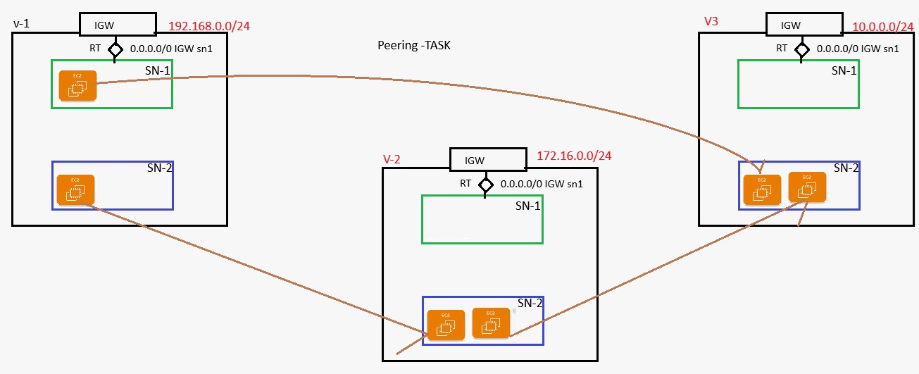
Peering VPCs:
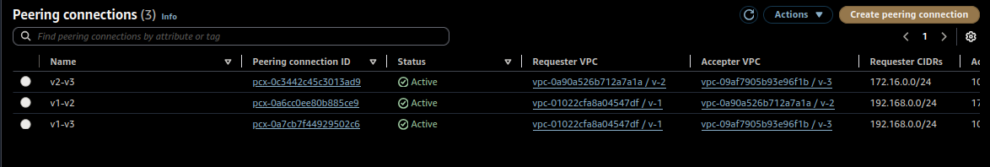
IP address:

v1-sn1-m1(pub) pub:54.236.37.246 pri:192.168.0.6
v1-sn2-m2 192.168.0.141
v2-sn2-m1 172.16.0.142
v2-sn2-m2 172.16.0.138
v3-sn2-m1 10.0.0.140
v3-sn2-m2 10.0.0.137

Terminal Output:
┌─[pradeeshkumar@Blackarch ~/Downloads]
└─$ ssh -i newkey.pem ubuntu@54.236.37.246
The authenticity of host '54.236.37.246 (54.236.37.246)' can't be established.
ED25519 key fingerprint is: SHA256:UWCGLNRZpbhjO1i64Xz8bFlmuo0PcK39N7rXJ2YN/kg
This key is not known by any other names.
Are you sure you want to continue connecting (yes/no/[fingerprint])? yes
Warning: Permanently added '54.236.37.246' (ED25519) to the list of known hosts.
Welcome to Ubuntu 24.04.4 LTS (GNU/Linux 6.17.0-1007-aws x86_64)

* Documentation: https://help.ubuntu.com
* Management: https://landscape.canonical.com
* Support: https://ubuntu.com/pro

System information as of Mon Apr 20 10:06:32 UTC 2026

System load: 0.0 Processes: 106
Usage of /: 26.3% of 6.71GB Users logged in: 0
Memory usage: 10% IPv4 address for enX0: 192.168.0.6
Swap usage: 0%

Expanded Security Maintenance for Applications is not enabled.

0 updates can be applied immediately.

Enable ESM Apps to receive additional future security updates.
See https://ubuntu.com/esm or run: sudo pro status

The list of available updates is more than a week old.
To check for new updates run: sudo apt update

The programs included with the Ubuntu system are free software;
the exact distribution terms for each program are described in the
individual files in /usr/share/doc/*/copyright.

Ubuntu comes with ABSOLUTELY NO WARRANTY, to the extent permitted by
applicable law.

To run a command as administrator (user "root"), use "sudo <command>".
See "man sudo_root" for details.

ubuntu@ip-192-168-0-6:~$ nano key.pem
ubuntu@ip-192-168-0-6:~$ sudo chmod 400 key.pem
ubuntu@ip-192-168-0-6:~$ ssh -i key.pem ubuntu@192.168.0.141
The authenticity of host '192.168.0.141 (192.168.0.141)' can't be established.
ED25519 key fingerprint is SHA256:y0BsLlAiHP0yPycMd/N86wz21Wg/tfC58CaPxAC8AGo.
This key is not known by any other names.
Are you sure you want to continue connecting (yes/no/[fingerprint])? yes
Warning: Permanently added '192.168.0.141' (ED25519) to the list of known hosts.
Welcome to Ubuntu 24.04.4 LTS (GNU/Linux 6.17.0-1007-aws x86_64)

* Documentation: https://help.ubuntu.com
* Management: https://landscape.canonical.com
* Support: https://ubuntu.com/pro

System information as of Mon Apr 20 10:07:46 UTC 2026

System load: 0.0 Processes: 108
Usage of /: 26.3% of 6.71GB Users logged in: 0
Memory usage: 10% IPv4 address for enX0: 192.168.0.141
Swap usage: 0%

Expanded Security Maintenance for Applications is not enabled.

0 updates can be applied immediately.

Enable ESM Apps to receive additional future security updates.
See https://ubuntu.com/esm or run: sudo pro status

The list of available updates is more than a week old.
To check for new updates run: sudo apt update

The programs included with the Ubuntu system are free software;
the exact distribution terms for each program are described in the
individual files in /usr/share/doc/*/copyright.

Ubuntu comes with ABSOLUTELY NO WARRANTY, to the extent permitted by
applicable law.

To run a command as administrator (user "root"), use "sudo <command>".
See "man sudo_root" for details.

ubuntu@ip-192-168-0-141:~$ ls
ubuntu@ip-192-168-0-141:~$ nano key.pem
ubuntu@ip-192-168-0-141:~$ chmod 400 key.pem
ubuntu@ip-192-168-0-141:~$ ssh -i key.pem ubuntu@172.16.0.142
The authenticity of host '172.16.0.142 (172.16.0.142)' can't be established.
ED25519 key fingerprint is SHA256:/aWNwVeMf2qbjOhLGigktK99SGrebxmlh+yHm7PXYNU.
This key is not known by any other names.
Are you sure you want to continue connecting (yes/no/[fingerprint])? yes
Warning: Permanently added '172.16.0.142' (ED25519) to the list of known hosts.
Welcome to Ubuntu 24.04.4 LTS (GNU/Linux 6.17.0-1007-aws x86_64)

* Documentation: https://help.ubuntu.com
* Management: https://landscape.canonical.com
* Support: https://ubuntu.com/pro

System information as of Mon Apr 20 10:12:44 UTC 2026

System load: 0.08 Processes: 107
Usage of /: 26.3% of 6.71GB Users logged in: 0
Memory usage: 10% IPv4 address for enX0: 172.16.0.142
Swap usage: 0%

Expanded Security Maintenance for Applications is not enabled.

0 updates can be applied immediately.

Enable ESM Apps to receive additional future security updates.
See https://ubuntu.com/esm or run: sudo pro status

The list of available updates is more than a week old.
To check for new updates run: sudo apt update

The programs included with the Ubuntu system are free software;
the exact distribution terms for each program are described in the
individual files in /usr/share/doc/*/copyright.

Ubuntu comes with ABSOLUTELY NO WARRANTY, to the extent permitted by
applicable law.

To run a command as administrator (user "root"), use "sudo <command>".
See "man sudo_root" for details.

ubuntu@ip-172-16-0-142:~$ nano key.pem
ubuntu@ip-172-16-0-142:~$ chmod 400 key.pem
ubuntu@ip-172-16-0-142:~$ ssh -i key.pem ubuntu@172.16.0.138
The authenticity of host '172.16.0.138 (172.16.0.138)' can't be established.
ED25519 key fingerprint is SHA256:WwE0mE32pZ1EQLVGmASGXvhNQz8PaSf22no0OEbwD2E.
This key is not known by any other names.
Are you sure you want to continue connecting (yes/no/[fingerprint])? yes
Warning: Permanently added '172.16.0.138' (ED25519) to the list of known hosts.
Welcome to Ubuntu 24.04.4 LTS (GNU/Linux 6.17.0-1007-aws x86_64)

* Documentation: https://help.ubuntu.com
* Management: https://landscape.canonical.com
* Support: https://ubuntu.com/pro

System information as of Mon Apr 20 10:14:05 UTC 2026

System load: 0.08 Processes: 108
Usage of /: 26.3% of 6.71GB Users logged in: 0
Memory usage: 10% IPv4 address for enX0: 172.16.0.138
Swap usage: 0%

Expanded Security Maintenance for Applications is not enabled.

0 updates can be applied immediately.

Enable ESM Apps to receive additional future security updates.
See https://ubuntu.com/esm or run: sudo pro status

The list of available updates is more than a week old.
To check for new updates run: sudo apt update

The programs included with the Ubuntu system are free software;
the exact distribution terms for each program are described in the
individual files in /usr/share/doc/*/copyright.

Ubuntu comes with ABSOLUTELY NO WARRANTY, to the extent permitted by
applicable law.

To run a command as administrator (user "root"), use "sudo <command>".
See "man sudo_root" for details.

ubuntu@ip-172-16-0-138:~$ nano key.pem
ubuntu@ip-172-16-0-138:~$ chmod 400 key.pem
ubuntu@ip-172-16-0-138:~$ ssh -i key.pem ubuntu@10.0.0.137
The authenticity of host '10.0.0.137 (10.0.0.137)' can't be established.
ED25519 key fingerprint is SHA256:V70lH5LudpTlx7lY/t6p6/ichCdMAP4vo7QmTqUasGg.
This key is not known by any other names.
Are you sure you want to continue connecting (yes/no/[fingerprint])? yes
Warning: Permanently added '10.0.0.137' (ED25519) to the list of known hosts.
Welcome to Ubuntu 24.04.4 LTS (GNU/Linux 6.17.0-1007-aws x86_64)

* Documentation: https://help.ubuntu.com
* Management: https://landscape.canonical.com
* Support: https://ubuntu.com/pro

System information as of Mon Apr 20 10:19:02 UTC 2026

System load: 0.0 Processes: 107
Usage of /: 26.3% of 6.71GB Users logged in: 0
Memory usage: 10% IPv4 address for enX0: 10.0.0.137
Swap usage: 0%

Expanded Security Maintenance for Applications is not enabled.

0 updates can be applied immediately.

Enable ESM Apps to receive additional future security updates.
See https://ubuntu.com/esm or run: sudo pro status

The list of available updates is more than a week old.
To check for new updates run: sudo apt update

The programs included with the Ubuntu system are free software;
the exact distribution terms for each program are described in the
individual files in /usr/share/doc/*/copyright.

Ubuntu comes with ABSOLUTELY NO WARRANTY, to the extent permitted by
applicable law.

To run a command as administrator (user "root"), use "sudo <command>".
See "man sudo_root" for details.

ubuntu@ip-10-0-0-137:~$ nano key.pem
ubuntu@ip-10-0-0-137:~$ chmod 400 key.pem
ubuntu@ip-10-0-0-137:~$ ssh -i key.pem ubuntu@10.0.0.140
The authenticity of host '10.0.0.140 (10.0.0.140)' can't be established.
ED25519 key fingerprint is SHA256:ZxoeN2VfhlSzH/CDBUccPGYitc2T31u+mytfKhBNX8M.
This key is not known by any other names.
Are you sure you want to continue connecting (yes/no/[fingerprint])? yes
Warning: Permanently added '10.0.0.140' (ED25519) to the list of known hosts.
Welcome to Ubuntu 24.04.4 LTS (GNU/Linux 6.17.0-1007-aws x86_64)

* Documentation: https://help.ubuntu.com
* Management: https://landscape.canonical.com
* Support: https://ubuntu.com/pro

System information as of Mon Apr 20 10:20:48 UTC 2026

System load: 0.0 Processes: 107
Usage of /: 26.3% of 6.71GB Users logged in: 0
Memory usage: 10% IPv4 address for enX0: 10.0.0.140
Swap usage: 0%

Expanded Security Maintenance for Applications is not enabled.

0 updates can be applied immediately.

Enable ESM Apps to receive additional future security updates.
See https://ubuntu.com/esm or run: sudo pro status

The list of available updates is more than a week old.
To check for new updates run: sudo apt update

The programs included with the Ubuntu system are free software;
the exact distribution terms for each program are described in the
individual files in /usr/share/doc/*/copyright.

Ubuntu comes with ABSOLUTELY NO WARRANTY, to the extent permitted by
applicable law.

nanTo run a command as administrator (user "root"), use "sudo <command>".
See "man sudo_root" for details.

oubuntu@ip-10-0-0-140:~$ nano key.pem
ubuntu@ip-10-0-0-140:~$ chmod 400 key.pem
ubuntu@ip-10-0-0-140:~$ ssh -i key.pem ubuntu@192.168.0.6
The authenticity of host '192.168.0.6 (192.168.0.6)' can't be established.
ED25519 key fingerprint is SHA256:UWCGLNRZpbhjO1i64Xz8bFlmuo0PcK39N7rXJ2YN/kg.
This key is not known by any other names.
Are you sure you want to continue connecting (yes/no/[fingerprint])? yes
Warning: Permanently added '192.168.0.6' (ED25519) to the list of known hosts.
Welcome to Ubuntu 24.04.4 LTS (GNU/Linux 6.17.0-1007-aws x86_64)

* Documentation: https://help.ubuntu.com
* Management: https://landscape.canonical.com
* Support: https://ubuntu.com/pro

System information as of Mon Apr 20 10:21:38 UTC 2026

System load: 0.03 Processes: 114
Usage of /: 27.0% of 6.71GB Users logged in: 1
Memory usage: 11% IPv4 address for enX0: 192.168.0.6
Swap usage: 0%

Expanded Security Maintenance for Applications is not enabled.

0 updates can be applied immediately.

Enable ESM Apps to receive additional future security updates.
See https://ubuntu.com/esm or run: sudo pro status

The list of available updates is more than a week old.
To check for new updates run: sudo apt update

Last login: Mon Apr 20 10:06:33 2026 from 157.51.3.92
ubuntu@ip-192-168-0-6:~$ ping 10.0.0.140
PING 10.0.0.140 (10.0.0.140) 56(84) bytes of data.
64 bytes from 10.0.0.140: icmp_seq=1 ttl=64 time=0.377 ms
64 bytes from 10.0.0.140: icmp_seq=2 ttl=64 time=0.400 ms
^C
--- 10.0.0.140 ping statistics ---
2 packets transmitted, 2 received, 0% packet loss, time 1006ms
rtt min/avg/max/mdev = 0.377/0.388/0.400/0.011 ms
ubuntu@ip-192-168-0-6:~$

