AWS TASK

DATE:10/04/2026

Task:
create vpc 192.168.0.0/24 with 4 subnets each need 10 ips
sn1,sn2 are public subnets
sn3,sn4 are private subnets

sn1,sn3 in AZ-A
sn2,sn4 in AZ-B
------------------------------------------------------------------------------------------------------

Creating a VPC 192.168.0.0/24:

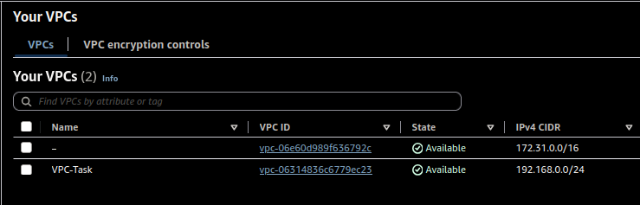
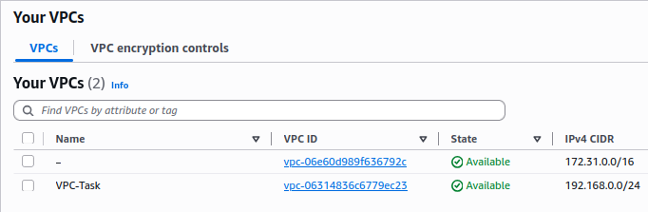
Creating 4 subnets each needs 10 ips:

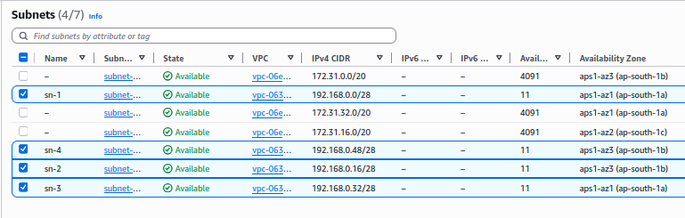

creating Interner getway and Route table to make sn-1 and sn-2 are public:

Internet gateway:
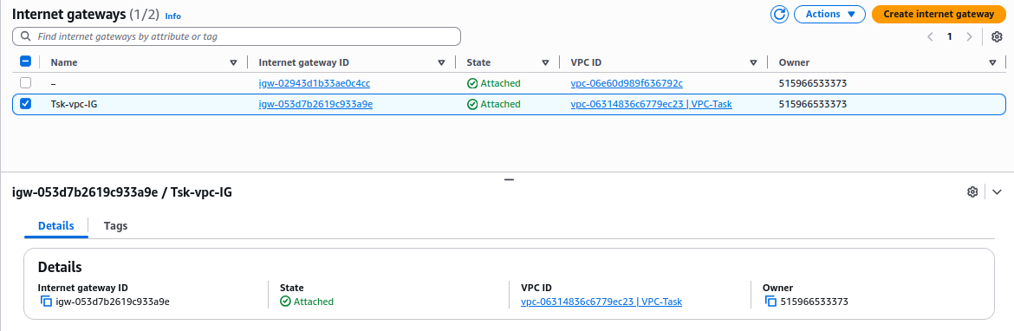
Route Table:
