EBS TASK

create the VPC:

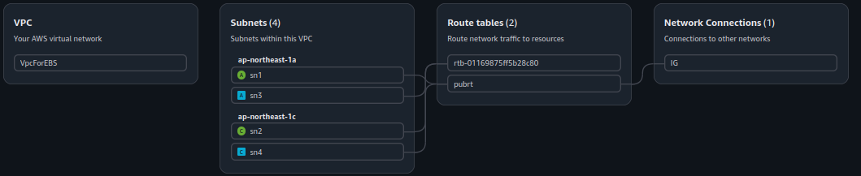
Create the instence:

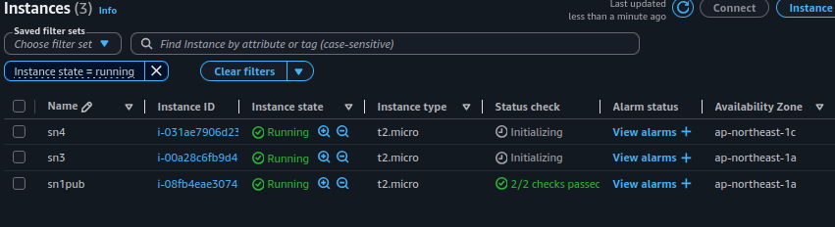
create EBS and attach to EC2:
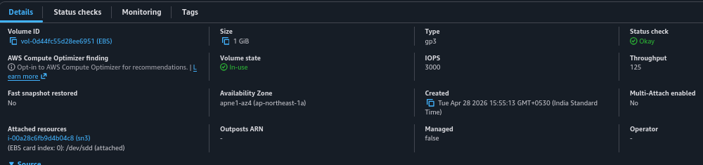
connecting to EC2:

┌─[pradeeshkumar@Blackarch ~/Downloads]
└─$ ssh -i "key.pem" ubuntu@43.207.214.180
The authenticity of host '43.207.214.180 (43.207.214.180)' can't be established.
ED25519 key fingerprint is: SHA256:dt7tN5ewYve36ql9gbRwP5Flj4glmPINLIeZFzxAWh8
This host key is known by the following other names/addresses:
~/.ssh/known_hosts:37: 43.207.84.97
Are you sure you want to continue connecting (yes/no/[fingerprint])? yes
Warning: Permanently added '43.207.214.180' (ED25519) to the list of known hosts.
Welcome to Ubuntu 26.04 LTS (GNU/Linux 7.0.0-1004-aws x86_64)

* Documentation: https://docs.ubuntu.com
* Management: https://landscape.canonical.com
* Support: https://ubuntu.com/pro

System information as of Tue Apr 28 11:54:09 UTC 2026

System load: 0.21 Processes: 113
Usage of /: 30.5% of 6.61GB Users logged in: 0
Memory usage: 22% IPv4 address for enX0: 10.0.0.14
Swap usage: 0%

Expanded Security Maintenance for Applications is not enabled.

0 updates can be applied immediately.

Enable ESM Apps to receive additional future security updates.
See https://ubuntu.com/esm or run: sudo pro status

The list of available updates is more than a week old.
To check for new updates run: sudo apt update

Last login: Tue Apr 28 10:21:13 2026 from 157.51.138.95
ubuntu@ip-10-0-0-14:~$ ls
key.pem
ubuntu@ip-10-0-0-14:~$ ssh -i "key.pem" ubuntu@10.0.0.41
Welcome to Ubuntu 26.04 LTS (GNU/Linux 7.0.0-1004-aws x86_64)

* Documentation: https://docs.ubuntu.com
* Management: https://landscape.canonical.com
* Support: https://ubuntu.com/pro

System information as of Tue Apr 28 11:56:34 UTC 2026

System load: 0.25 Processes: 114
Usage of /: 30.5% of 6.61GB Users logged in: 0
Memory usage: 22% IPv4 address for enX0: 10.0.0.41
Swap usage: 0%

Expanded Security Maintenance for Applications is not enabled.

0 updates can be applied immediately.

Enable ESM Apps to receive additional future security updates.
See https://ubuntu.com/esm or run: sudo pro status

The list of available updates is more than a week old.
To check for new updates run: sudo apt update
Failed to connect to https://changelogs.ubuntu.com/meta-release. Check your Internet connection or proxy settings

Last login: Tue Apr 28 10:22:21 2026 from 10.0.0.14
ubuntu@ip-10-0-0-41:~$ ls
drive
ubuntu@ip-10-0-0-41:~$ lsblk
NAME MAJ:MIN RM SIZE RO TYPE MOUNTPOINTS
loop0 7:0 0 28.2M 1 loop /snap/amazon-ssm-agent/13009
loop1 7:1 0 74M 1 loop /snap/core22/2411
loop2 7:2 0 48.4M 1 loop /snap/snapd/26382
xvda 202:0 0 8G 0 disk
├─xvda1 202:1 0 6.9G 0 part /
├─xvda13 202:13 0 1023M 0 part /boot
├─xvda14 202:14 0 4M 0 part
└─xvda15 202:15 0 106M 0 part /boot/efi
xvdd 202:48 0 1G 0 disk
ubuntu@ip-10-0-0-41:~$ sudo mkfs.ext4 /dev/xvdd
mke2fs 1.47.2 (1-Jan-2025)
Creating filesystem with 262144 4k blocks and 65536 inodes
Filesystem UUID: 5668a791-5fbb-40d0-96db-a589e9901863
Superblock backups stored on blocks:
32768, 98304, 163840, 229376

Allocating group tables: done
Writing inode tables: done
Creating journal (8192 blocks): done
Writing superblocks and filesystem accounting information: done
ubuntu@ip-10-0-0-41:~$ sudo mount /dev/xvdd ./drive/
ubuntu@ip-10-0-0-41:~$ cd drive/
ubuntu@ip-10-0-0-41:~/drive$ sudo touch pro.txt
ubuntu@ip-10-0-0-41:~/drive$ ls
lost+found pro.txt
ubuntu@ip-10-0-0-41:~/drive$

Taking the snapshot and create a volume in another AZ:

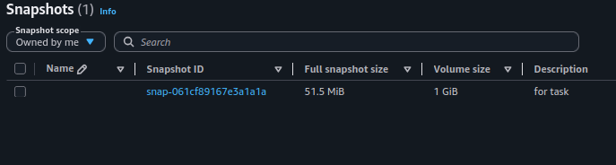
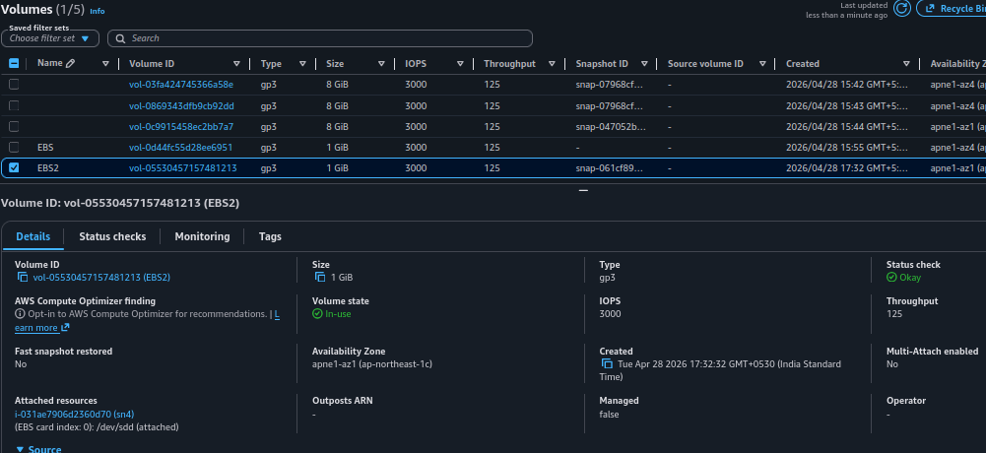
From there:

ubuntu@ip-10-0-0-41:~$ nano key.pem
ubuntu@ip-10-0-0-41:~$ sudo chmod 400 key.pem
ubuntu@ip-10-0-0-41:~$ ssh -i key.pem ec2-user@10.0.0.62
The authenticity of host '10.0.0.62 (10.0.0.62)' can't be established.
ED25519 key fingerprint is: SHA256:UNKpzp+o1kcLEiV+n+mcVvxoeftqdLOWDP+mCn0u+k4
This key is not known by any other names.
Are you sure you want to continue connecting (yes/no/[fingerprint])? yes
Warning: Permanently added '10.0.0.62' (ED25519) to the list of known hosts.
** WARNING: connection is not using a post-quantum key exchange algorithm.
** This session may be vulnerable to "store now, decrypt later" attacks.
** The server may need to be upgraded. See https://openssh.com/pq.html
, #_
~\_ ####_ Amazon Linux 2023
~~ \_#####\
~~ \###|
~~ \#/ ___ https://aws.amazon.com/linux/amazon-linux-2023
~~ V~' '->
~~~ /
~~._. _/
_/ _/
_/m/'
[ec2-user@ip-10-0-0-62 ~]$ lsblk
NAME MAJ:MIN RM SIZE RO TYPE MOUNTPOINTS
xvda 202:0 0 8G 0 disk
├─xvda1 202:1 0 8G 0 part /
├─xvda127 259:0 0 1M 0 part
└─xvda128 259:1 0 10M 0 part /boot/efi
xvdd 202:48 0 1G 0 disk
[ec2-user@ip-10-0-0-62 ~]$ mkdir drive
[ec2-user@ip-10-0-0-62 ~]$ sudo mount /dev/xvdd /home/ec2-user/drive/
[ec2-user@ip-10-0-0-62 ~]$ ls drive/
lost+found pro.txt
[ec2-user@ip-10-0-0-62 ~]$

To increase the volume size modify the volume config:

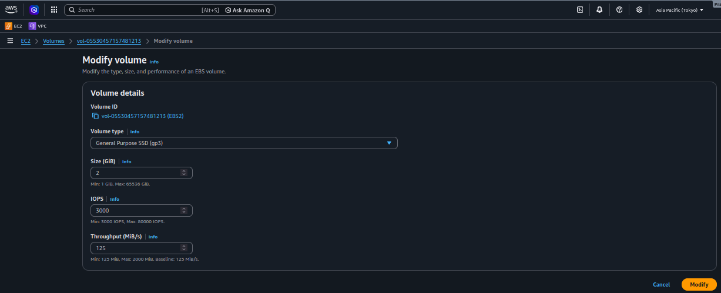

[ec2-user@ip-10-0-0-62 ~]$ lsblk
NAME MAJ:MIN RM SIZE RO TYPE MOUNTPOINTS
xvda 202:0 0 8G 0 disk
├─xvda1 202:1 0 8G 0 part /
├─xvda127 259:0 0 1M 0 part
└─xvda128 259:1 0 10M 0 part /boot/efi
xvdd 202:48 0 1G 0 disk
[ec2-user@ip-10-0-0-62 ~]$ mkdir drive
[ec2-user@ip-10-0-0-62 ~]$ sudo mount /dev/xvdd /home/ec2-user/drive/
[ec2-user@ip-10-0-0-62 ~]$ ls drive/
lost+found pro.txt
[ec2-user@ip-10-0-0-62 ~]$ lsblk
NAME MAJ:MIN RM SIZE RO TYPE MOUNTPOINTS
xvda 202:0 0 8G 0 disk
├─xvda1 202:1 0 8G 0 part /
├─xvda127 259:0 0 1M 0 part
└─xvda128 259:1 0 10M 0 part /boot/efi
xvdd 202:48 0 2G 0 disk /home/ec2-user/drive
[ec2-user@ip-10-0-0-62 ~]$

