Inkline Blog Platform
React + Firebase College Project Documentation
Prepared for project handoff and presentation

Project Overview
Inkline is a modern blog platform where public users can browse, search, filter, and read posts. The admin can sign in and manage blog posts through a protected dashboard.

Technology Stack
- React + Vite
- Tailwind CSS
- React Router
- Firebase Authentication
- Cloud Firestore
- Firebase Hosting ready

Main Features
- Home page showing latest blog posts
- Blog listing page with search and category filtering
- Single blog details page
- Firebase admin login
- Protected admin dashboard
- Create, edit, delete, publish, and unpublish posts
- Responsive layout for mobile, tablet, and desktop
- Loading states, error messages, cards, navbar, footer, and hover effects

Firebase Configuration
The project is connected to the provided Firebase web app. Configuration is stored in frontend/.env and frontend/.env.example.
VITE_FIREBASE_PROJECT_ID=inkline-d699b
VITE_FIREBASE_AUTH_DOMAIN=inkline-d699b.firebaseapp.com
VITE_FIREBASE_STORAGE_BUCKET=inkline-d699b.firebasestorage.app
VITE_FIREBASE_MEASUREMENT_ID=G-6KZYESRENS

How to Run
cd blog-platform/frontend
npm install
npm run dev
Open http://localhost:5173 in the browser.

How to Seed Sample Posts
Create an admin user in Firebase Authentication first, then place the same email/password in frontend/.env.
cd blog-platform/frontend
npm run seed

Admin Login
Use the admin account created in Firebase Authentication. Example credentials used by the seed script:
Email: admin@example.com
Password: Admin@12345

Firestore Collection
Collection name: blogs
- title
- slug
- shortDescription
- content
- category
- authorName
- coverImageUrl
- createdAt
- updatedAt
- published

Screenshots

Home Page
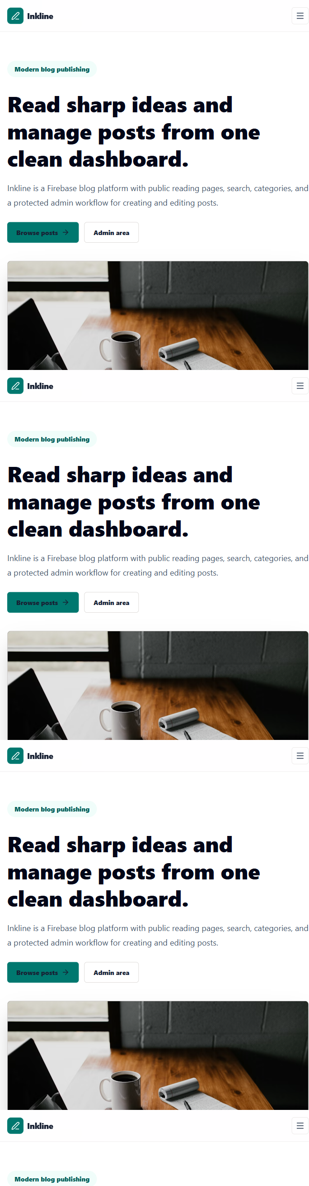

Blog Listing Page
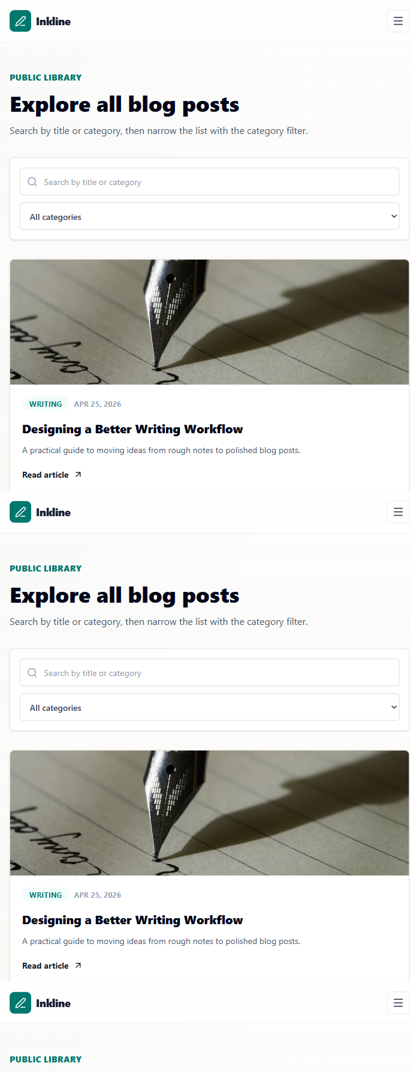

Blog Details Page
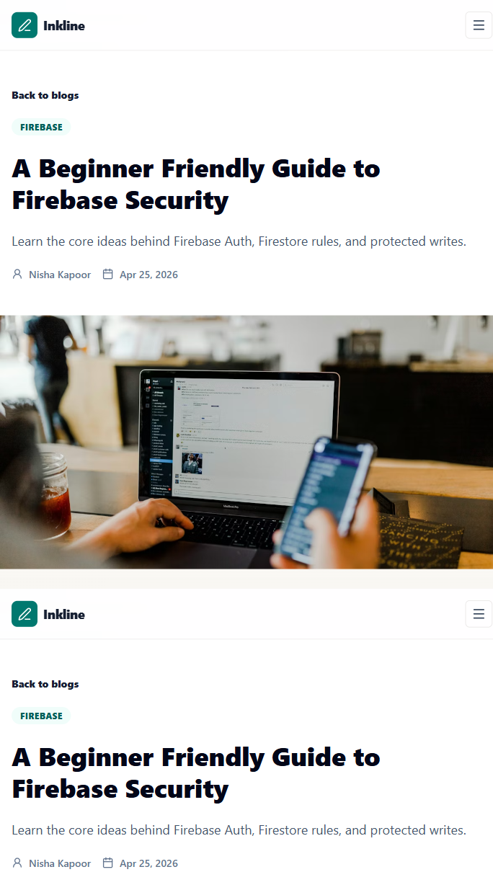

Admin Login Page
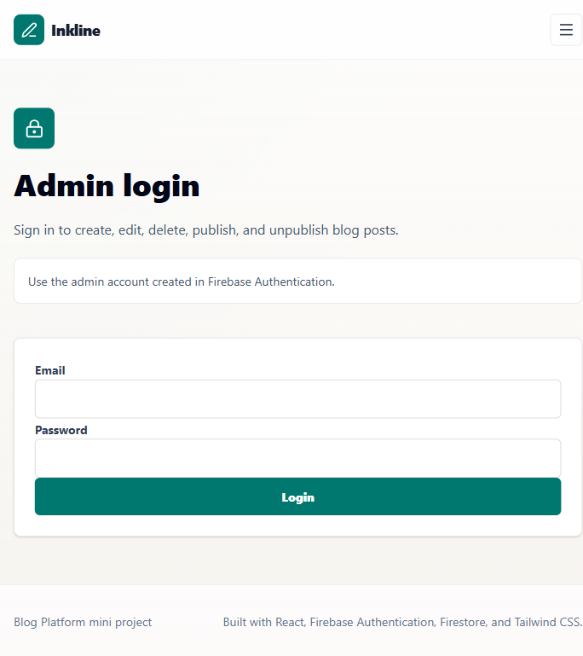

Admin Dashboard
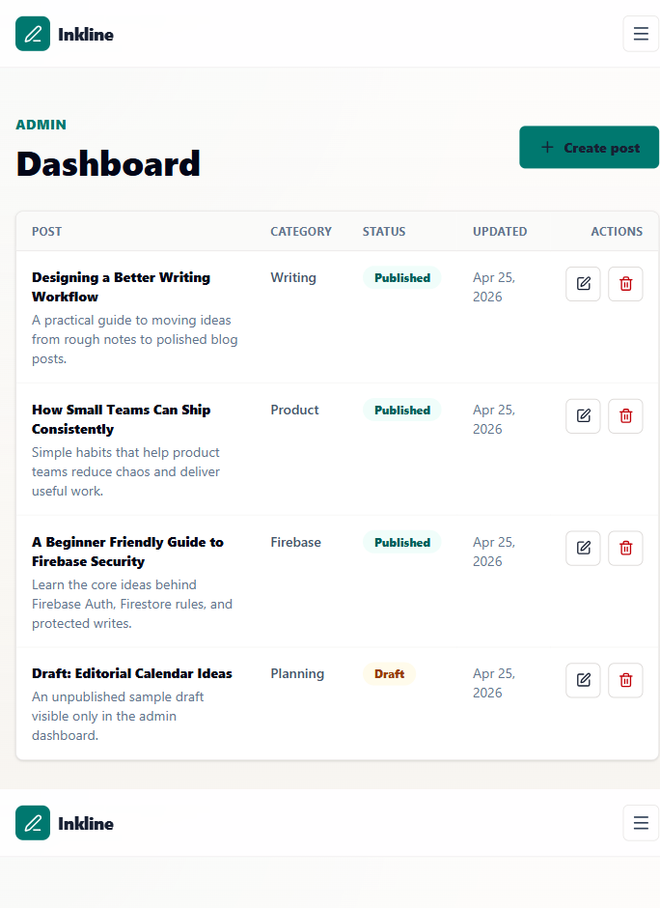

Verification
The following checks were completed after Firebase connection and cleanup preparation:
- npm run lint passed
- npm run build passed
- Browser screenshots captured with no console errors in UI demo mode

