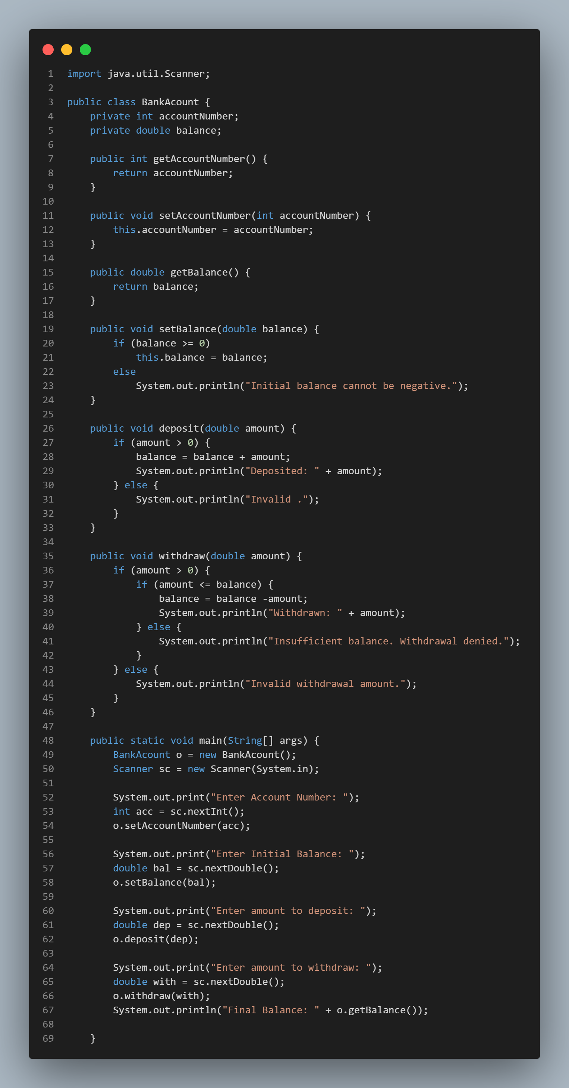

Enter Account Number: 731622

Enter Initial Balance: 200

Enter amount to deposit: 100

Deposited: 100.0

Enter amount to withdraw: 450

Insufficient balance. Withdrawal denied.

Final Balance: 300.0