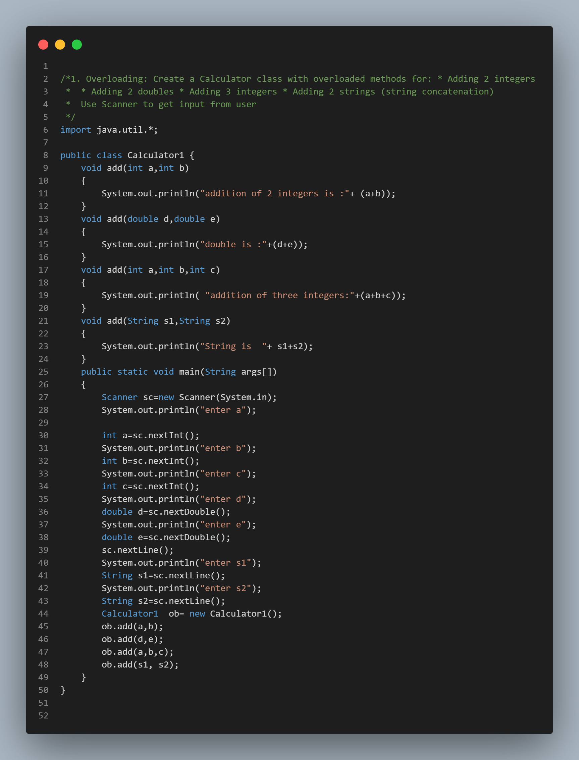

Output:  
enter a

12 enter b 2 enter c

3

enter d

12.89

enter e

10.2

enter s1

Good

enter s2

Morning

addition of 2 integers is :14

double is :23.09

addition of three integers:17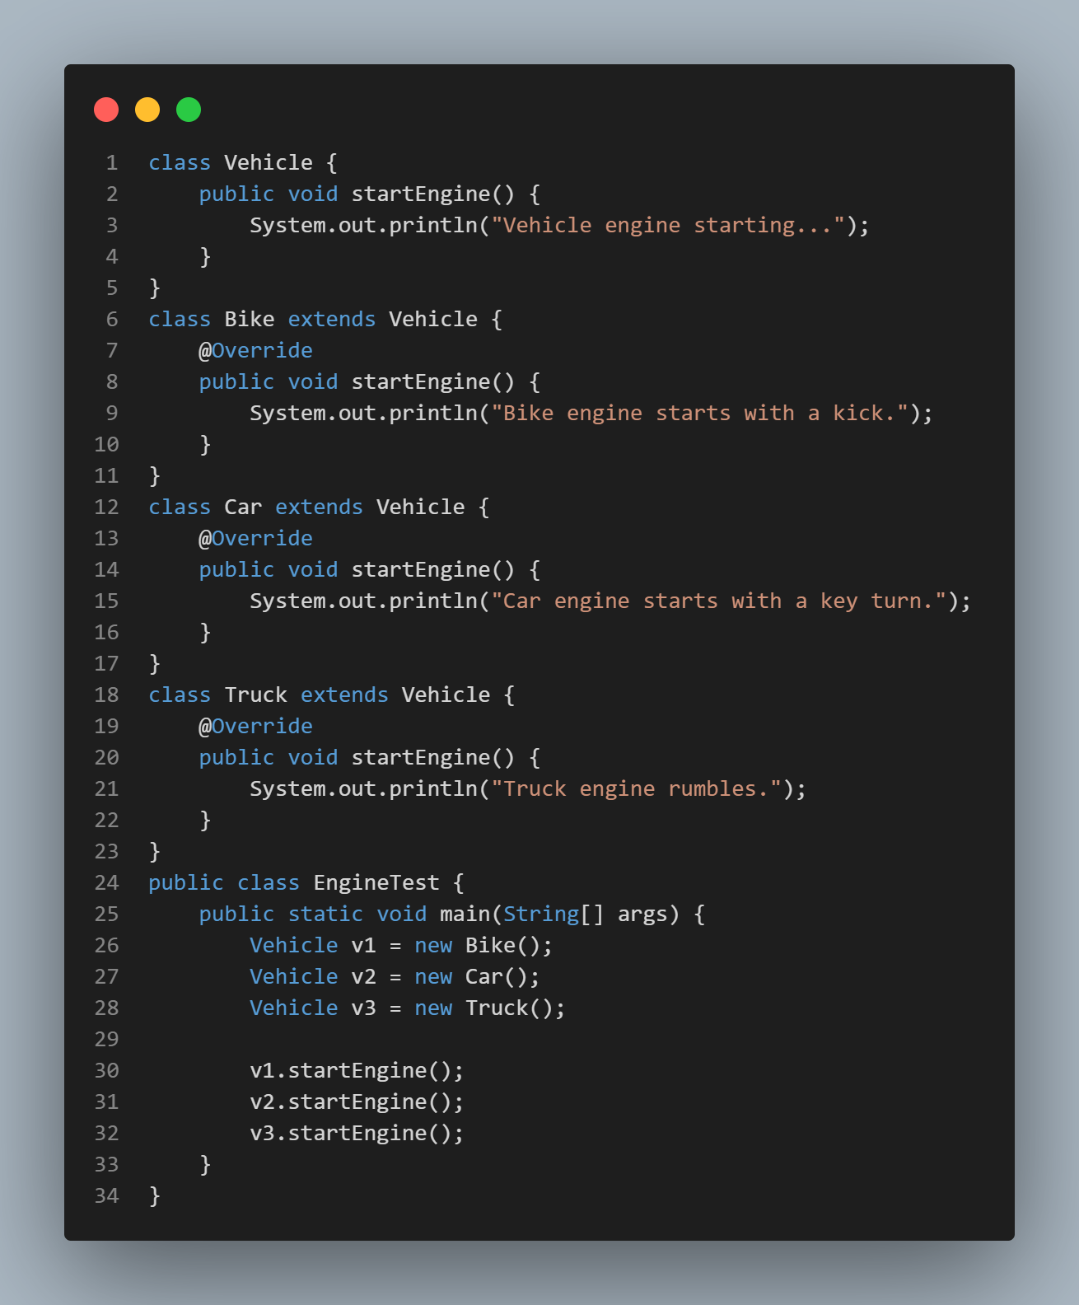

output:

Bike engine starts with a kick.

Car engine starts with a key turn.

Truck engine rumbles.