**Multi-Container Flask Application with PostgreSQL Using Docker Compose**

**Step 1: Download Docker .**

***Sudo apt install docker-compose-plugin***

**Step 2: Clone the git repository and move to directory cd Flask-Docker**

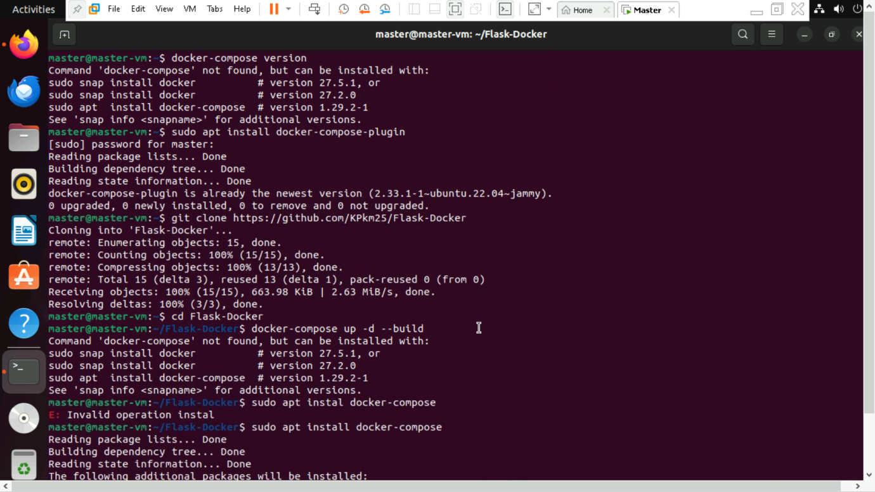

**Step 3: Before build the containers login to docker hub using command *“docker login”.* Build and start the containers using *docker-compose up -d –build.***

**Step 4: Verify the running containers using *“docker ps”.* It used to verify whether web and db is there or not.**

Step 5: Test the application.

http://localhost:5000/ → Should return "Flask App with PostgreSQL!"

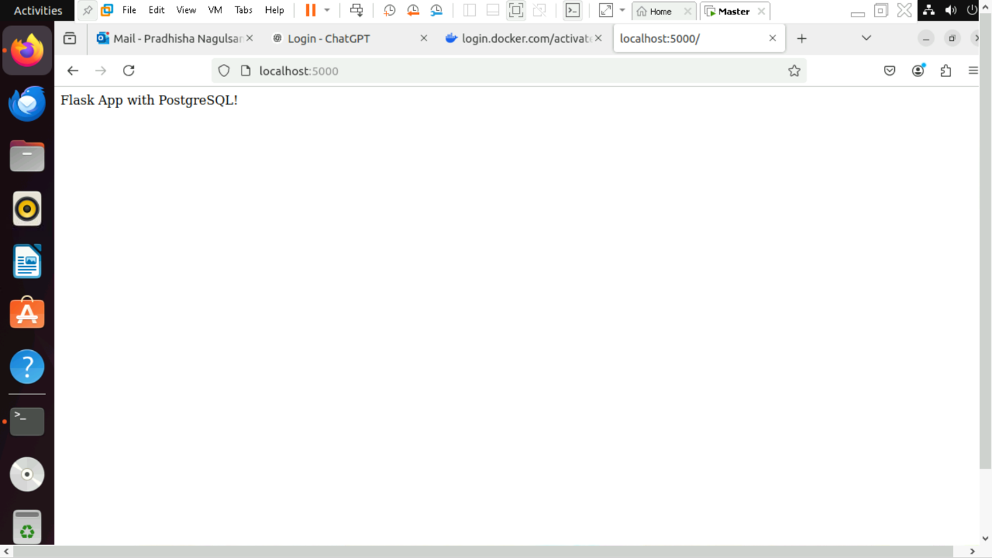

http://localhost:5000/db → Should confirm database connection.

