Experiment No:- 05 Date: 20-05-2026
Creating a three-tier application using ASP .Net and Database
Aim: Creating a three-tier application using ASP .Net and Database
Theory:
A three-tier application separates a web application into three logical layers: presentation layer, application or business logic layer, and database layer. This separation makes the system easier to understand, maintain, test, and extend.
In this project, the presentation layer is built using ASP.NET Web Forms pages, master pages, CSS, and server controls. The pages collect input from customers and administrators and display dashboards, booking forms, service lists, and booking history.
The application layer is developed in C# using Business Logic Layer classes. These classes validate rules such as duplicate customer email checking, past-date booking prevention, login processing, dashboard counts, and booking status updates.
The database layer uses MySQL. It stores administrator login details, customer information, services, and booking records. The project uses ADO.NET with MySql.Data and parameterized queries to communicate with the database.
Project Name: SmartWash - Car Wash Booking Management System
Three-Tier Architecture Used in the Project:
1. Presentation Layer: ASP.NET Web Forms pages inside the Pages folder, Site.Master, Admin.Master, CSS/style.css, and validation controls.
2. Application Layer: C# BLL classes inside App_Code/BLL such as CustomerBLL, BookingBLL, ServiceBLL, and AdminBLL.
3. Database Layer: C# DAL classes inside App_Code/DAL, DBHelper.cs, Database/SmartWashDB.sql, and MySQL database SmartWashDB.
Important Features:
1. Customer registration and login with duplicate email validation.
2. Admin login and dashboard showing total customers, bookings, pending bookings, and services.
3. Service listing and wash booking with date, time, vehicle type, and selected service.
4. Booking history for customers.
5. Admin booking management with approve, complete, and reject status actions.
6. Three-tier separation using ASP.NET pages, C# BLL/DAL classes, and MySQL tables.
Web.config - Database Connection
<connectionStrings>
<add name="SmartWashDB"
connectionString="Server=localhost;Database=SmartWashDB;Uid=root;Pwd=root;"
providerName="MySql.Data.MySqlClient" />
</connectionStrings>
DBHelper.cs
private static string connectionString =
ConfigurationManager.ConnectionStrings["SmartWashDB"].ConnectionString;
public static MySqlConnection GetConnection()
{
return new MySqlConnection(connectionString);
}
public static DataTable ExecuteQuery(string query, MySqlParameter[] parameters = null)
{
DataTable dt = new DataTable();
using (MySqlConnection conn = GetConnection())
using (MySqlCommand cmd = new MySqlCommand(query, conn))
{
if (parameters != null) cmd.Parameters.AddRange(parameters);
conn.Open();
using (MySqlDataAdapter da = new MySqlDataAdapter(cmd))
{
da.Fill(dt);
}
}
return dt;
}
SmartWashDB.sql
CREATE DATABASE IF NOT EXISTS SmartWashDB;
USE SmartWashDB;
CREATE TABLE IF NOT EXISTS Admins (
AdminID INT AUTO_INCREMENT PRIMARY KEY,
Username VARCHAR(50) NOT NULL UNIQUE,
Password VARCHAR(100) NOT NULL
);
INSERT IGNORE INTO Admins (Username, Password) VALUES ('admin', 'admin123');
CREATE TABLE IF NOT EXISTS Customers (
CustomerID INT AUTO_INCREMENT PRIMARY KEY,
FullName VARCHAR(100) NOT NULL,
Email VARCHAR(100) NOT NULL UNIQUE,
Phone VARCHAR(15) NOT NULL,
VehicleNumber VARCHAR(20) NOT NULL,
Password VARCHAR(100) NOT NULL,
CreatedAt DATETIME DEFAULT CURRENT_TIMESTAMP
);
CREATE TABLE IF NOT EXISTS Services (
ServiceID INT AUTO_INCREMENT PRIMARY KEY,
ServiceName VARCHAR(100) NOT NULL,
Price DECIMAL(18, 2) NOT NULL,
Duration INT NOT NULL,
Description TEXT
);
CREATE TABLE IF NOT EXISTS Bookings (
BookingID INT AUTO_INCREMENT PRIMARY KEY,
CustomerID INT NOT NULL,
ServiceID INT NOT NULL,
BookingDate DATE NOT NULL,
BookingTime VARCHAR(20) NOT NULL,
VehicleType VARCHAR(50) NOT NULL,
Status VARCHAR(20) NOT NULL DEFAULT 'Pending',
CreatedAt DATETIME DEFAULT CURRENT_TIMESTAMP,
FOREIGN KEY (CustomerID) REFERENCES Customers(CustomerID),
FOREIGN KEY (ServiceID) REFERENCES Services(ServiceID)
);
CustomerBLL.cs - Duplicate Email Validation
public bool RegisterCustomer(Customer customer)
{
if (customerDAL.CheckEmailExists(customer.Email))
{
throw new Exception("Email already exists.");
}
return customerDAL.RegisterCustomer(customer);
}
CustomerDAL.cs - Register Customer
string query = "INSERT INTO Customers (FullName, Email, Phone, VehicleNumber, Password) " +
"VALUES (@FullName, @Email, @Phone, @VehicleNumber, @Password)";
MySqlParameter[] parameters = new MySqlParameter[]
{
new MySqlParameter("@FullName", customer.FullName),
new MySqlParameter("@Email", customer.Email),
new MySqlParameter("@Phone", customer.Phone),
new MySqlParameter("@VehicleNumber", customer.VehicleNumber),
new MySqlParameter("@Password", customer.Password)
};
int rowsAffected = DBHelper.ExecuteNonQuery(query, parameters);
BookingBLL.cs - Booking Date Validation
public bool CreateBooking(Booking booking)
{
if (booking.BookingDate < DateTime.Today)
{
throw new Exception("Cannot book a wash in the past.");
}
return bookingDAL.CreateBooking(booking);
}
BookWash.aspx.cs - Create Booking
Customer customer = (Customer)Session["CustomerUser"];
Booking newBooking = new Booking
{
CustomerID = customer.CustomerID,
ServiceID = Convert.ToInt32(ddlServices.SelectedValue),
BookingDate = calBookingDate.SelectedDate,
BookingTime = ddlTime.SelectedValue,
VehicleType = rblVehicleType.SelectedValue,
Status = "Pending"
};
bool success = bookingBLL.CreateBooking(newBooking);
ManageBookings.aspx.cs - Admin Booking Status Update
if (e.CommandName == "ApproveBooking")
{
bll.UpdateBookingStatus(bookingId, "Approved");
}
else if (e.CommandName == "CompleteBooking")
{
bll.UpdateBookingStatus(bookingId, "Completed");
}
else if (e.CommandName == "RejectBooking")
{
bll.UpdateBookingStatus(bookingId, "Rejected");
}
AdminDashboard.aspx.cs - Dashboard Counts
lblTotalCustomers.Text = customerBLL.GetTotalCustomersCount().ToString();
lblTotalBookings.Text = bookingBLL.GetTotalBookingsCount().ToString();
lblPendingBookings.Text = bookingBLL.GetPendingBookingsCount().ToString();
lblTotalServices.Text = serviceBLL.GetTotalServicesCount().ToString();
Output:
Admin Panel
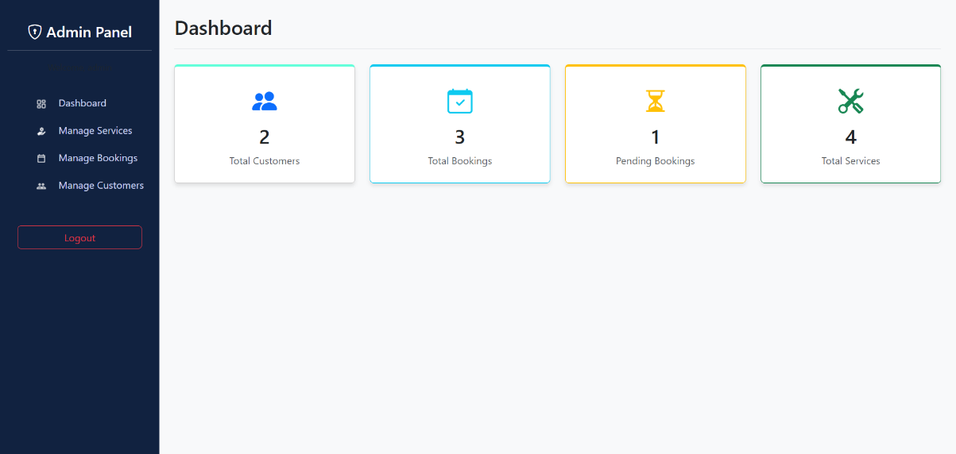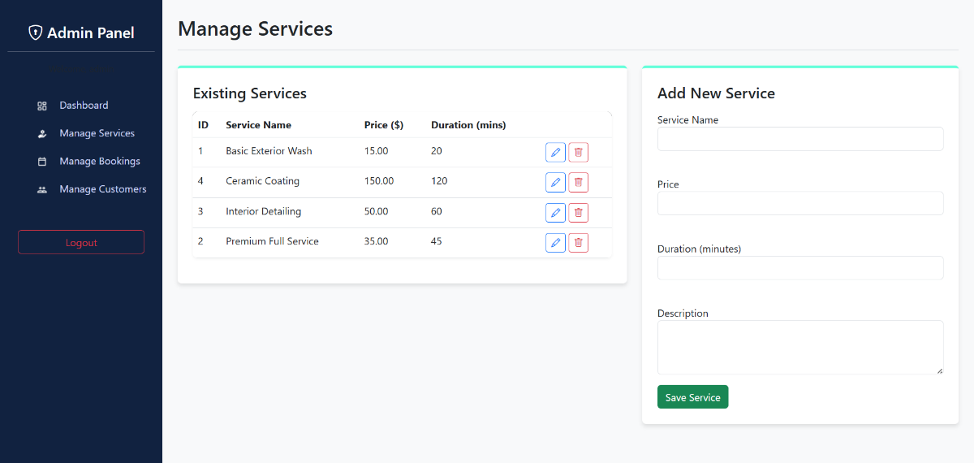

Customer Dashboard
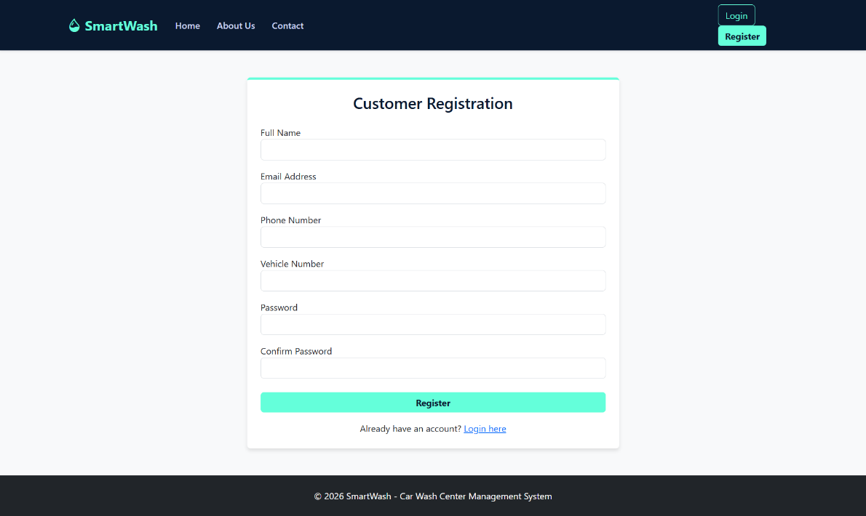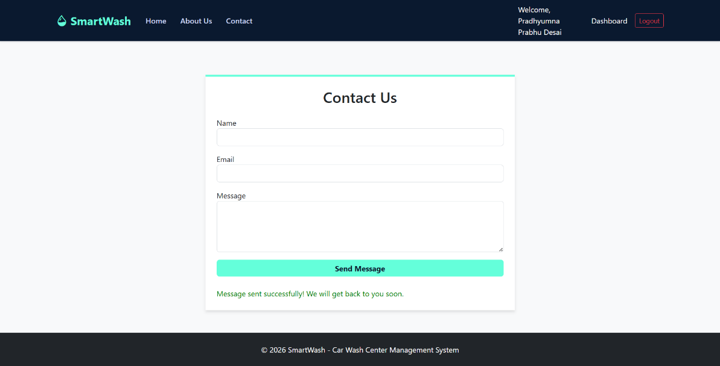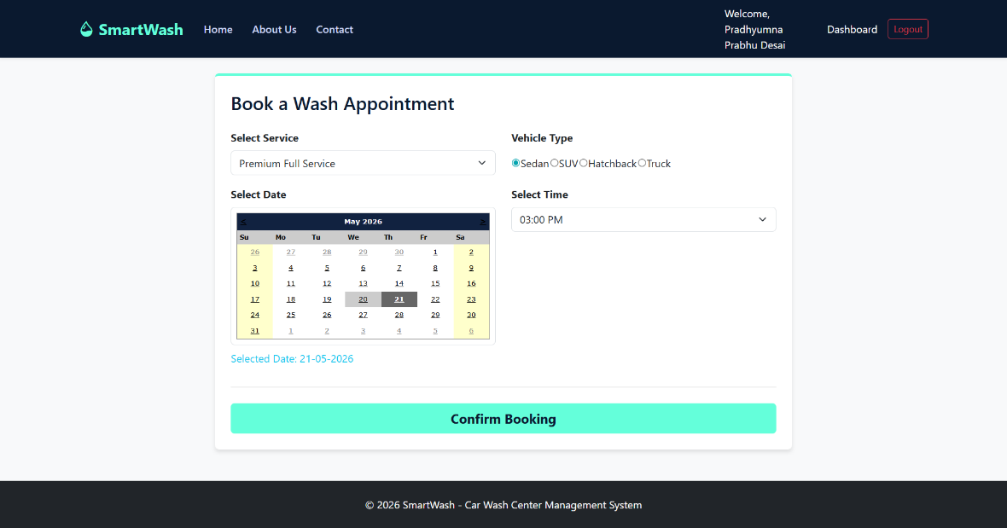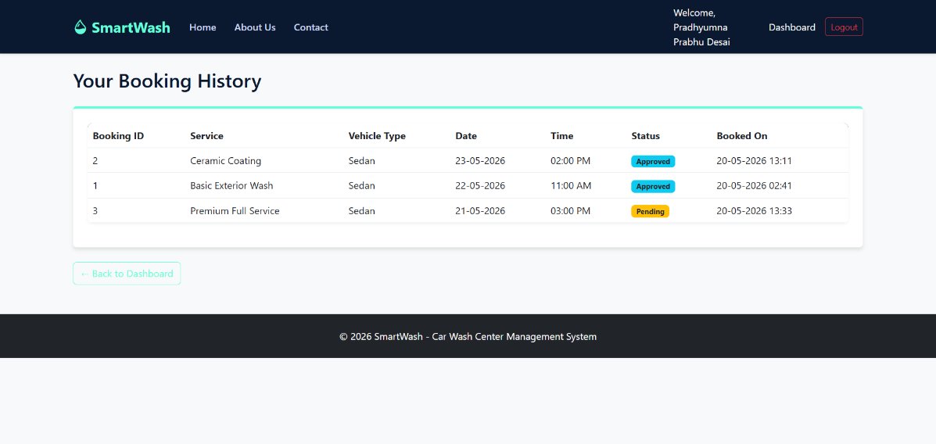

Conclusion:
A three-tier application using ASP.NET, C#, and MySQL database was successfully implemented.

