Understand the Competition Landscape
Objective
Learn what world-class line follower and maze-solving robots look like.
Comparison Table
Team / Robot [1, 2, 3] | Competition | Speed (Max / Avg) | Weight | MCU | Sensors | Motor | Fan (Suction)
Hayabusa2.2 (Hayato Nomura) | All Japan Robotracer (2023 Winner) | ~4.9 m/s (Avg) / >7 m/s (Top) | ~110 g | STM32 F4/F7 | 16+ IR Phototransistors | Maxon / Faulhaber Coreless | Yes (EDF)
Red Comet (Min7.1 / Kojima) | All Japan Micromouse (Classic) | ~3.5 m/s (Maze Run) | 90–100 g | STM32 / Renesas RX | 4–6 IR Distance Sensors | Faulhaber 1717 | Yes
Pixel Prowler | Technoxian (2025 Winner) | ~2.5 m/s | < 500 g | STM32 / Teensy | 8–12 Analog IR Array | High-Speed N20 (1000+ RPM) | No
Team ProBot | RoboCup Junior Rescue Line | ~0.5 – 1.2 m/s | ~1.2 kg | Arduino Mega / ESP32 | Line + Colour + Ultrasonic | Pololu Metal Gear (25mm) | No
Robojunkies | IIT Techfest (Meshmerize) | ~1.0 m/s | ~300 g | Arduino Nano / STM32 | 8 Channel IR Array | N20 (600-1000 RPM) | No

Detailed Study of Competition Classes
1. Japanese Line Follower (Robotracer) [1]
This is the "Formula 1" of line following. The goal is pure speed on a known course (after one mapping lap). [1]
- Engineering Focus: Traction and path optimization.
- Key Tech:
  - Suction Fans (EDF): These robots use high-power Electric Ducted Fans (EDF) to create a vacuum seal, pulling the robot down onto the track. This increases tire grip (downforce) by 4-5x without adding mass, allowing for cornering accelerations of >4G.
  - Processing: They calculate the radius of every curve during the "search lap" and pre-calculate the maximum theoretical speed for every millimetre of the track for the "fast run."
  - Wheel Diameter: Typically, small (12mm – 24mm) to keep the centre of gravity low and maximize torque.
2. All Japan Micromouse (Classic vs. Half-Size)
While "Micromouse" is a maze-solving contest, the technology overlaps heavily with line followers (Robotracers). [1, 2]
- Classic Size: Robots are ~10x10 cm. Top speeds reach 3–5 m/s on straights.
- Half-Size: Robots are ~5x5 cm. These are even faster relative to their size, often completing a 3m x 3m maze in under 4 seconds.
- Sensors: Unlike line followers, they use LiDAR or side-facing IR distance sensors to detect walls, not floor lines. [1]
3. Technoxian & IIT Techfest [1]
These competitions are often student-focused and emphasize accessibility over the raw budget/physics limits of the Japanese leagues. [1]
- Technoxian (Fastest Line Follower): Focuses on straight-line speed and basic curve handling. Robots often use N20 gear motors or entry-level coreless motors. [1, 2]
- IIT Techfest (Meshmerize): A hybrid of line following and maze solving. The robot must map a grid of lines (nodes) to find the shortest path.
  - Constraint: Often limits voltage (e.g., 12V or 24V) and size (22cm cube), which prevents the use of the high-end drone motors seen in Japan. [1, 2, 3]
4. RoboCup Junior (Rescue Line) [1]
Speed is secondary to reliability and task completion.
- Task: Follow a line, overcome obstacles (speed bumps, seesaws), and identify "victims" (silver/black balls). [1, 2, 3, 4]
- Robot Specs:
  - Heavier: Rugged chassis (LEGO or custom aluminum) to survive obstacles.
  - Complex Sensing: Cameras (OpenMV, Pixy) are common for identifying victim colors and green shortcut markers, unlike the pure IR arrays of speed racers.

Details about each Top Teams and their Bot:
Hayabusa2.2 is a championship-winning autonomous line-following robot built by developer Hayato Nomura from the team/organization reRo. The robot won 1st place at the 2023 All Japan Student Robotrace Contest and later secured 2nd place at the prestigious open-category 44th All Japan Micromouse Contest (Robotrace Division) held by the New Technology Foundation.
Technical Specifications
According to official technical data from the competition registries, Hayabusa2.2 features the following parameters :
- Microcontroller: 32-bit ARM-based architecture.
- Dimensions: 140 mm (Length) x 110 mm (Width) x 45 mm (Height).
- Weight: 130 grams.
- Downforce Mechanism: High-speed internal suction fan system to maximize tire grip against the track surface during tight cornering.
- Official Time (Student Championship): 4.871 seconds.
- Official Time (All Japan Open): 5.677 seconds.
Ref.: https://www.ntf.or.jp/mouse/micromouse2023/Robot/AllJapan/TechRT65.html
Y.T. Ref.: https://youtu.be/e7ytrjYB_Ek?si=HT9Ehb5vGbxFjMmv
Check Ref. Link for more specific details about the components.
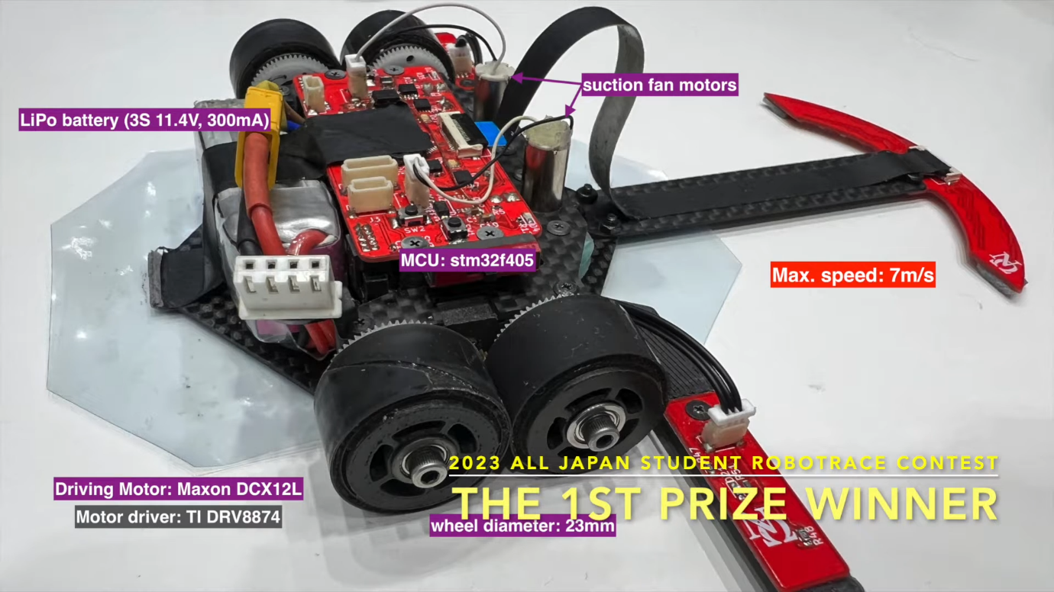
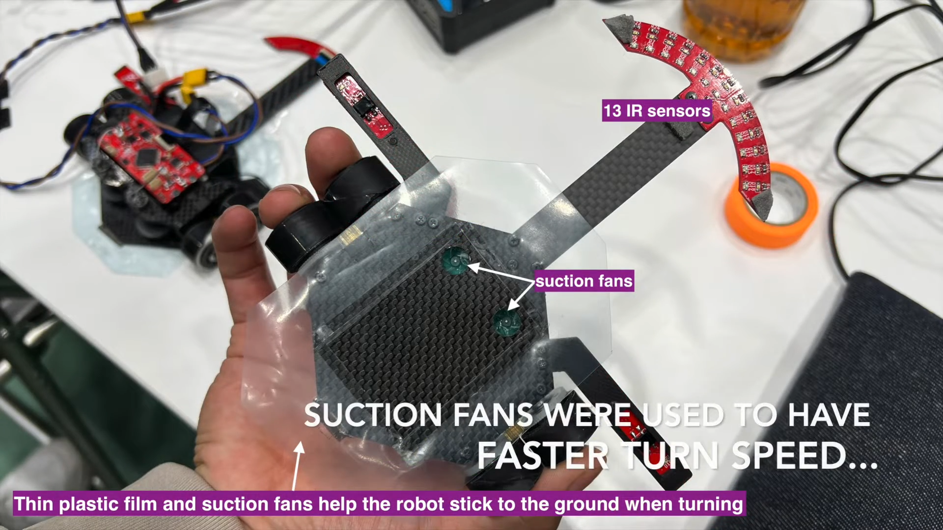
Kinematics: Speed, RPM, and Wheel Selection
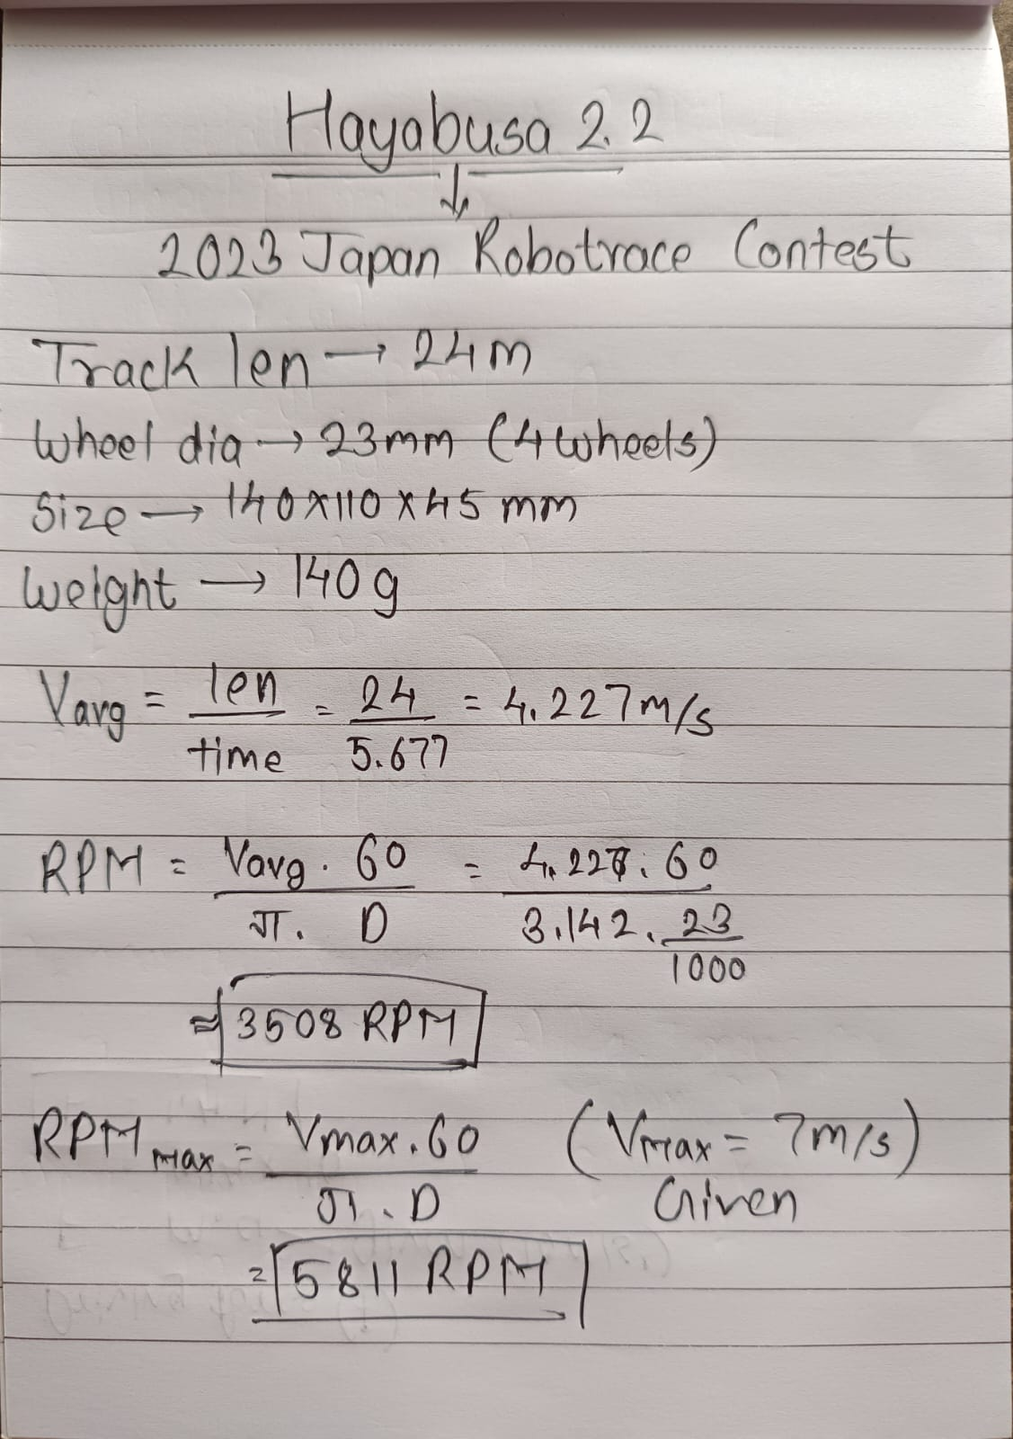
Driving Force (F):
F = m. a ----(Given a=10m/s²)
F = 0.14 x 10
F = 1.4 N
Cornering Vector Control:
The table dictates a maximum turning velocity of 2.0 m/s. This is handled smoothly using a 13-element infrared line-sensor array and 1 ICM20648 gyro sensor managed by a high-frequency PID loop inside the 32-bit ARM Cortex architecture.
Suction Physics:
The team integrated an active suction fan vacuum system. This mechanism sucks air from beneath the chassis to artificially multiply tire normal force N, preventing the lightweight 140g body from breaking traction and slipping sideways at its 2.0 m/s cornering limits.
Electrical: Power Density and Battery Architecture
- Battery Chemistry & Configuration: Lithium-Polymer (3S / 3 Cells in Series).
- Operating Voltage & Capacity: 11.4 V with a capacity of 300 mAh
- Required Discharge C-Rating:
The dual Maxon DCX12L drive motors combined with the high-current suction fan pull a massive continuous current draw. To safely provide an estimated peak system surge of roughly 10 Amperes without suffering from extreme voltage sag, we calculate the required continuous battery output rating:
$$Req. C-Rating = \frac{Peak Current Draw}{Battery Capacity \left( Ah \right)}= \frac{10A}{0.3 Ah}=33.3 C$$
Suction Fan Assembly
According to the technical dataset notes, Hayabusa2.2 features an entirely custom self-built suction mechanism rather than an off-the-shelf single unit fan.
Gyro Sensor Component
The single, high-performance on-board gyro sensor utilized by Hayabusa2.2 is the TDK InvenSense ICM-20648.
- What it does: This is a specialized, low-noise, high-performance 6-axis Inertial Measurement Unit (IMU). It features a dedicated Embedded Motion Processor (DMP) that natively handles complex tracking vectors. [1]
- Why it was chosen: At cornering speeds reaching 2.0 m/s, standard consumer-grade gyros fail due to chassis vibrations caused by high-RPM tires and the suction fan. The ICM-20648 provides severe anti-vibration robustness and an ultra-precise ±2000°/sec full-scale range to keep the robot stabilized during abrupt orientation transitions.
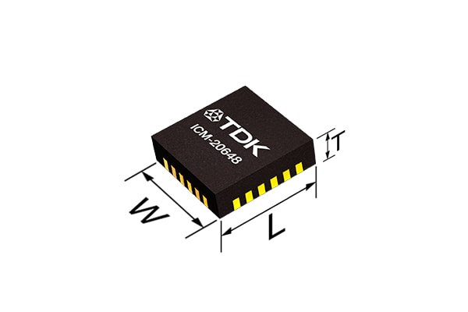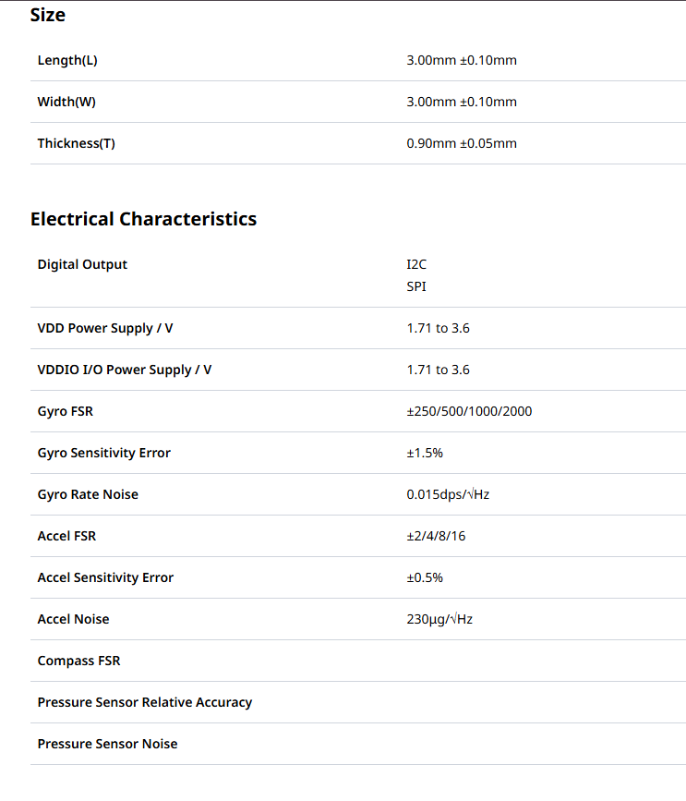
Ref: https://product.tdk.com/en/search/sensor/mortion-inertial/imu/info?part_no=ICM-20648
Motors Used
DCX 12 L Ø12 mm, CLL precious metal brushes, ball bearings
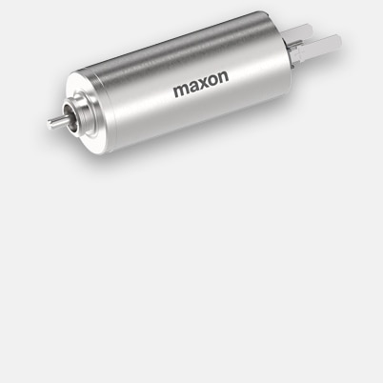
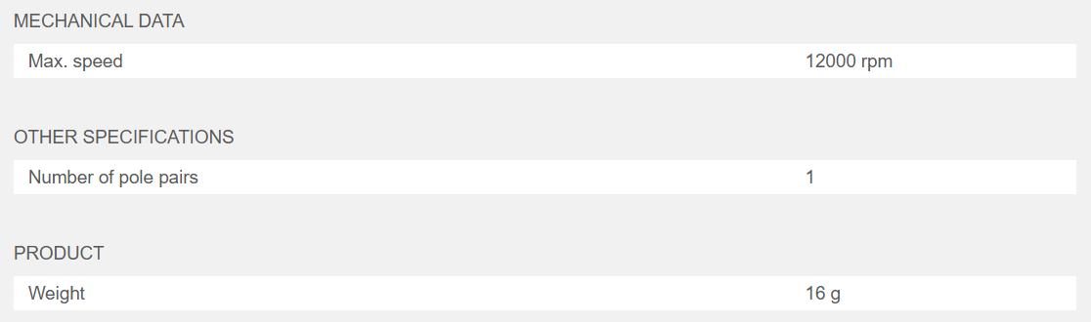
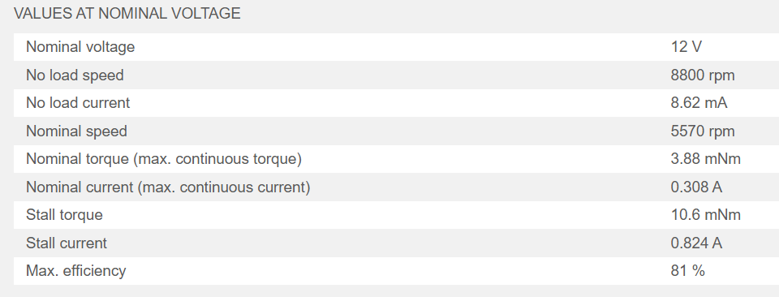
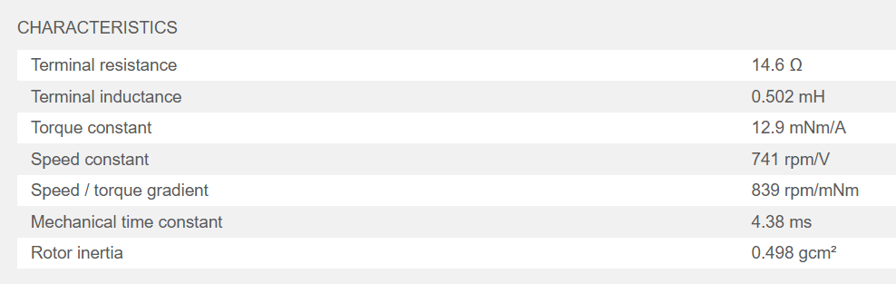

Semreh - Advanced Line-Follower Robot
The Semreh V2 is the latest iteration of high-performance line-follower robot, developed by Tamandutech, the robotics team of the Federal University of ABC (UFABC) from Brazil.
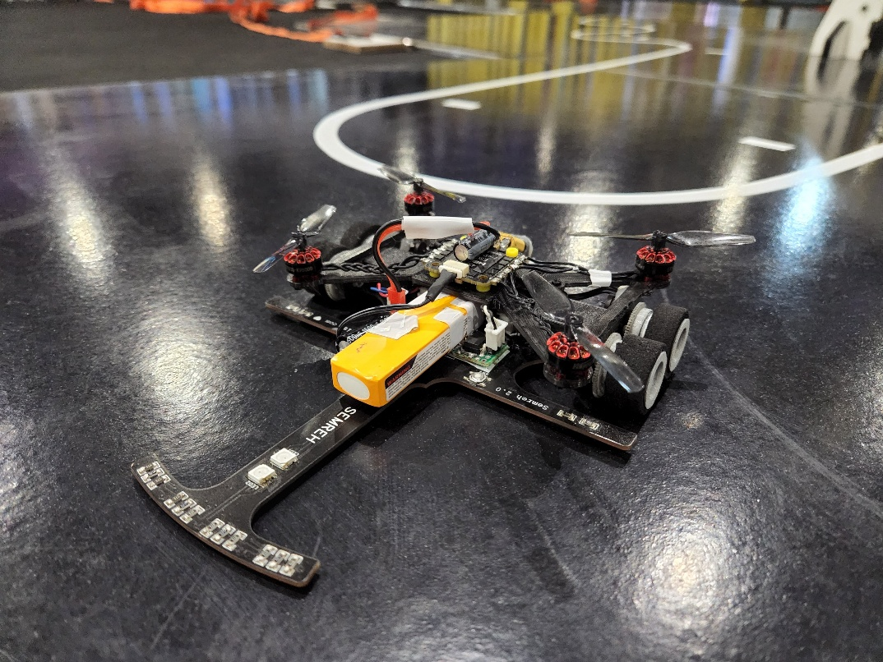
Hardware
- ESP32-WROOM-32 Module
- ADC - MCP3008
- 8x QRE1113 as main sensors
- PCB 1.6mm as Chassis
- ESC 4in1 BlHeli 15A
- 4x Brushless Motors 1103 8000kv to increase down force.
- 2x 1020 Coreless Motor for Locomotion.
- LiPo 3S 350 mAh 70C
For the ESP32 Pinout Check the website - https://oshwlab.com/tt_linefollower/tt_linefollower_semreh

Summary of the technical challenges faced by the Tamandutech team and the specific solutions they implemented for the Semreh robot:
Motor Overvolting Challenge
- Challenge: The original 6V N20 motors needed more speed and acceleration, but running them on 2S (7.4V) or 3S (11.1V) batteries risked burning them out.
- Solution: The team experimented with removing the voltage regulators entirely. They discovered the N20 motors could safely handle the overvoltage, resulting in major speed gains.
Motor Driver Tripping
- Challenge: Upgrading to 1020 coreless motors caused extreme current draw during tight turns and zigzags. This triggered the safety protection on their TB6612 H-Bridge driver, causing the robot to shut down.
- Solution: They built a custom H-Bridge module from scratch on a perforated board using two more powerful RZ7886 H-Bridge ICs to handle the high current.
Lack of Integrated Gearbox [1]
- Challenge: Unlike the N20 motors, the new 1020 coreless drone motors did not come with pre-attached gearboxes to manage torque and speed.
- Solution: The team designed a custom, lightweight reduction system using nylon gears bonded to 3D-printed structures. [1]
Encoder Placement
- Challenge: The coreless motor setup lacked a native slot or shaft to easily attach wheel encoders for tracking movement.
- Solution: They attached standard Pololu encoders to the chassis using hot glue and connected them to the main wheel axis via an additional gear. [1]
Check the Project Logs for more detailed explanation of above summary - Ref.: https://hackaday.io/project/202208-semreh-advanced-line-follower-robot
Red Comet is a historic champion robot built by Masakazu Utsunomiya—not Hirokazu Kojima or Ng Beng Kiat—which famously won 1st Place at the 2017 All Japan Micromouse Contest (Classic Division). Conversely, Min7.1 is an entirely different, world-record-breaking mouse developed by Singaporean engineer Ng Beng Kiat, while "Kojima" refers to Hirokazu Kojima, a powerhouse developer legendary for his dominance in the Half-Size Micromouse division.
The 2017 All Japan Micromouse Contest is widely remembered for a historic tactical masterclass executed by Utsunomiya’s Red Comet. [1, 2]
- The Mind-Bending Strategy: Most contestants programmed their robots to optimize for the geometrically shortest path (which spanned 13.9 meters and packed 57 sharp turns). Red Comet's search algorithm realized that straight-line acceleration yields higher speeds than constant deceleration for tight cornering.
- The Longest, Fastest Route: It intentionally chose the longest path through the maze—a massive 19.4-meter route. While it was 5.5 meters longer, it only contained 45 turns. Red Comet put its hammer down on the straights, winning 1st place with a final speed run of 7.284 seconds, beating the runner-up by a mere 131 milliseconds.
- Hardware Features: Weighing just 30.2 grams and driven by a Renesas MCU, it was an incredibly lightweight, early adapter of miniature internal suction fan mechanisms to stay glued to the track.
Red Comet is extremely small size mouse equipped with 4 wheels and suction fan. My previous mouse (APEC 2015) is heavy and big. To improve this, I reconsider all parts. Most mechanical parts (include gears) were made by home CNC & lathe. As a result, this mouse is 1/4 lighter and smaller than previous model. The advantage of this small mouse can turn quickly with small torque and reduce the risk of bump into wall.
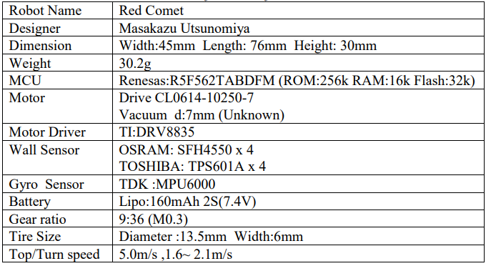
Ref.: http://micromouseusa.com/wp-content/uploads/2018/03/APEC18P.pdf
Y.T. Ref.: https://www.youtube.com/watch?v=LAYdXIREK2I

Component selection interacts with vehicle dynamics, along with engineering strategies to maximize performance:
1. Actuator Dynamics (N20 Motors & TB6612FNG)
Your motors and driver dictate how fast the robot can accelerate and change direction. [1, 2, 3, 4]
- Torque vs. Speed: N20 motors come in various gear ratios (e.g., 10:1 to 100:1). For high-speed competitions, aim for a ratio that yields 600 to 1000 RPM at your operating voltage. Lower ratios provide speed but risk stalling during aggressive corrective turns. [1, 2, 3]
- Driver Current Limits: The TB6612FNG handles about 1.2A continuous (3.2A peak) per channel. High-RPM N20 motors can draw close to this peak when stalling or reversing hard during rapid steering corrections. [1, 2, 3]
- Dynamic Braking: Utilize the TB6612FNG's "Short Brake" mode (setting both motor inputs high) rather than "Coast" mode. Braking dramatically reduces overshoot when transitioning from a sharp turn back to a straight line. [1, 2]
Short Brake Mode vs. Coast Mode
The TB6612FNG H-bridge motor driver controls motors by switching internal transistors to dictate current flow. How you turn off or change these inputs changes how the motor stops: [1, 2, 3]

Coast Mode (Disconnect) Short Brake Mode (Short Circuit)
+V ---- [X] (Open) +V ---- [X] (Open)
| |
Motor ( M ) Motor ( M )
| |
GND ---- [X] (Open) GND ---- [/] (Closed) <---+ Shorted
[/] (Closed) <---+ Together

Coast Mode (Free Wheeling)
- How it works: The H-bridge opens all its internal switches. It completely disconnects power from the motor.
- The Physics: The motor is left to spin freely. It only slows down due to external mechanical friction in the gears and the rubber tires. [1, 2, 3]
- The Result: The robot rolls forward for a long distance after the command is sent. In high-speed lines, this causes severe overshoot when entering corners.
Short Brake Mode (Active Braking)
- How it works: The H-bridge connects both terminals of the motor together to the Ground (or both to Power), while disconnecting the main voltage source. [1, 2]
- The Physics (Back-EMF): A spinning motor acts like a generator. Shorting the terminals forces the motor's own generated current to loop back into its windings in the reverse direction. This creates an immediate counter-electromotive force (Back-EMF) that opposes the rotation. [1, 2, 3]
- The Result: The motor stops almost instantly. This gives your PID loop aggressive control to snap the robot back onto a straight line after a sharp turn.
2. Tire Dynamics and Traction
Traction is the bottleneck of high-speed vehicle dynamics. Without it, your control loop calculations are useless.
- Lateral Slip: At high speeds, centrifugal force Fc = (mv²)/R will cause your rubber tires to slide outward on sharp curves. Clean your rubber tires with isopropyl alcohol before runs to maximize the coefficient of friction (μ).
- Wheel Diameter: Larger tires increase your top linear speed (v = ω ⋅ r) but decrease acceleration torque and raise your Center of Mass (CoM). Stick to a 20mm to 34mm diameter for N20 motors to maintain a good torque-to-speed balance.
Wheel Diameter, Linear Speed, Torque, and CoM
Changing your wheel diameter alters the fundamental mechanical leverage of your robot.

Small Wheel (e.g., 20mm) Large Wheel (e.g., 34mm)
High Torque / Low Speed Low Torque / High Speed
r = 10mm r = 17mm
+---+ +-------+
| | | |
+---+ +-------+
Low Center of Mass Higher Center of Mass

- Linear Speed (\(v = \omega \cdot r\)): Linear speed (\(v\)) is how fast the robot moves forward across the floor. Angular velocity (\(\omega \)) is how fast the motor shaft spins (RPM). If the motor spins at a fixed 800 RPM, a larger radius (\(r\)) covers more ground per single rotation, meaning a higher top speed.
- Acceleration Torque (\(\tau = F \cdot r\)): Torque (\(\tau \)) is the twisting force of your N20 motor. The force pushed against the floor to accelerate the robot is \(F = \tau / r\). Because radius (\(r\)) is in the denominator, a larger wheel reduces the forward force. This means a larger wheel takes longer to accelerate from a dead stop or change directions. [1]
- Center of Mass (CoM) Rise: The Center of Mass is the single theoretical point where all the robot's weight is perfectly balanced. The motor axle sits exactly at the radius (\(r\)) distance above the floor. Increasing the wheel diameter raises the motor axle, raising the chassis, and pushing the CoM higher. A high CoM makes the robot prone to tipping over or sliding outward during high-speed turns due to centrifugal forces.
3. Centre of Mass (CoM) and Geometry
The physical layout of your chassis determines its stability and agility.
- Low CoM: Mount the heavy components—the LiPo battery and the MP1584 buck converter—as low as possible. A low CoM minimizes weight transfer, preventing the inner wheel from lifting and losing traction during hard cornering.
- Wheelbase Width: A wider tracking width (distance between drive wheels) provides better stability but requires a higher yaw moment to turn. A narrower tracking width turns faster but increases the risk of tipping or spinning out. [1]
Yaw Moment and Wheelbase Width
What is Yaw Moment?
Yaw is the rotation of the robot around its vertical axis (spinning left or right on the floor). The Yaw Moment is the rotational torque required to make the robot turn. [1, 2]
$Yaw Torque =Force of Wheels x \frac{Wheelbase Width}{2}$
A wider tracking width means your drive wheels sit further away from the center pivot point. This increases the mechanical resistance (moment of inertia) to spinning, meaning the motors have to push much harder to initiate a turn.
<------ Wide Wheelbase ------> <-- Narrow Wheelbase -->
High Stability / Slow Turn Low Stability / Fast Turn
[Tire] [Tire] [Tire] [Tire]
o CoM o o CoM o
Determining the Best Wheelbase Width
To find the optimal width for a high-speed N20 robot, aim for a "Square or Slightly Wide" aspect ratio, where the tracking width is roughly equal to or slightly larger than the distance from the rear axle to the front sensor array.

- Calculate the Traction Limit: Test your rubber tires to find their friction coefficient µ
- Geometrical Rule of Thumb: For N20-scale racing bots, a wheelbase width between 80mm and 110mm is standard.
- If your bot spins out or rolls over: Widen the tracking width or lower your battery.
- If your bot feels heavy and sluggish entering turns: Narrow the tracking width to lower the yaw moment, allowing the N20 motors to pivot the chassis instantly.

4. Sensor Array Dynamics (Look-Ahead Distance)
Your 16-sensor and 8-sensor arrays act as the robot's "eyes." Their physical placement creates a critical time delay in your control system. [1]
- Look-Ahead Distance: Mount your primary sensor array (likely the 16-sensor array) well forward of the drive wheels. This creates a spatial "look-ahead." At high speeds, it gives the Arduino Nano time to process the error and change motor speeds before the centre of mass reaches the turn.
- Dual Array Strategy: Position the 16-sensor array in the very front for fine path tracking. Use the 8-sensor array closer to the wheel axis or perpendicular to the front array to catch extreme angles, intersections, or 90-degree acute turns.

5. Control Loop Optimization (Arduino Nano)
High-speed dynamics require rapid processing to prevent the robot from "hunting" (oscillating across the line).
- Processing Bottleneck: The Arduino Nano (ATmega328P @ 16MHz) must read up to 24 analog/digital sensor pins, compute a PID algorithm, and update the PWM registers. Use digital I/O reading methods (like direct port manipulation) rather than slow analogRead() or digitalRead() functions to maximize your loop frequency.
- Sampling Rate: Ensure your control loop runs consistently (e.g., every 1 to 2 milliseconds). If the robot travels at 2 m/s and your loop takes 10ms to execute, the robot moves 2cm blindly between corrections, causing violent instability. [1]

Dual Array Strategy
The Dual Array Strategy uses two completely separate rows of IR sensors at different distances from the pivot point to handle distinct navigation problems.
[16-Sensor Array] <--- Front Look-Ahead (Fine PID Tracking)
|
| (Long Carbon Fiber Boom)
|
[8-Sensor Array] <--- Intersections & Acute 90° Turns
[Left] [Right]
Wheel Wheel
- Front 16-Sensor Array: Placed far forward on an extended boom. Because it enters a turn before the body of the robot, it acts as a "predictive" sensor. It handles the fine-grained, high-speed proportional tracking on smooth, winding curves.
- Rear/Perpendicular 8-Sensor Array: Mounted closer to the drive wheels. When the robot approaches a sudden 90-degree corner, a cross-intersection, or an acute angle, the front array will fly completely off the line and register blank space. The second 8-sensor array stays over the line to tell the Arduino Nano exactly where the intersection or sharp boundary is, preventing the robot from getting lost.

Not Much References and Bots were found related to this Dual-Array Strategy. The Given reference examples are by GPT.
Reference Teams and Competitive Bots
This layout is highly visible in elite international competitions like Robotchallenge, All Japan Robot Tournament, and top university robotics leagues:
- Team Minotaur / Polish Line Followers (e.g., "Shock" or "Grom" style designs): These European-style competitive bots feature ultra-long front carbon fiber structures holding a highly dense primary array, with a secondary wide-set array closer to the wheel axis specifically to trigger braking profiles for intersections.
- Mexican and Colombian Robotics Leagues (e.g., Team Pumas UNAM, High-Speed LFRs): These designs utilize a distinct dual-deck array setup to navigate complex geometric paths at speeds exceeding ( 3m/s ). They program the rear array to temporarily override the main PID tracking loop whenever 90-degree grid lines are crossed.

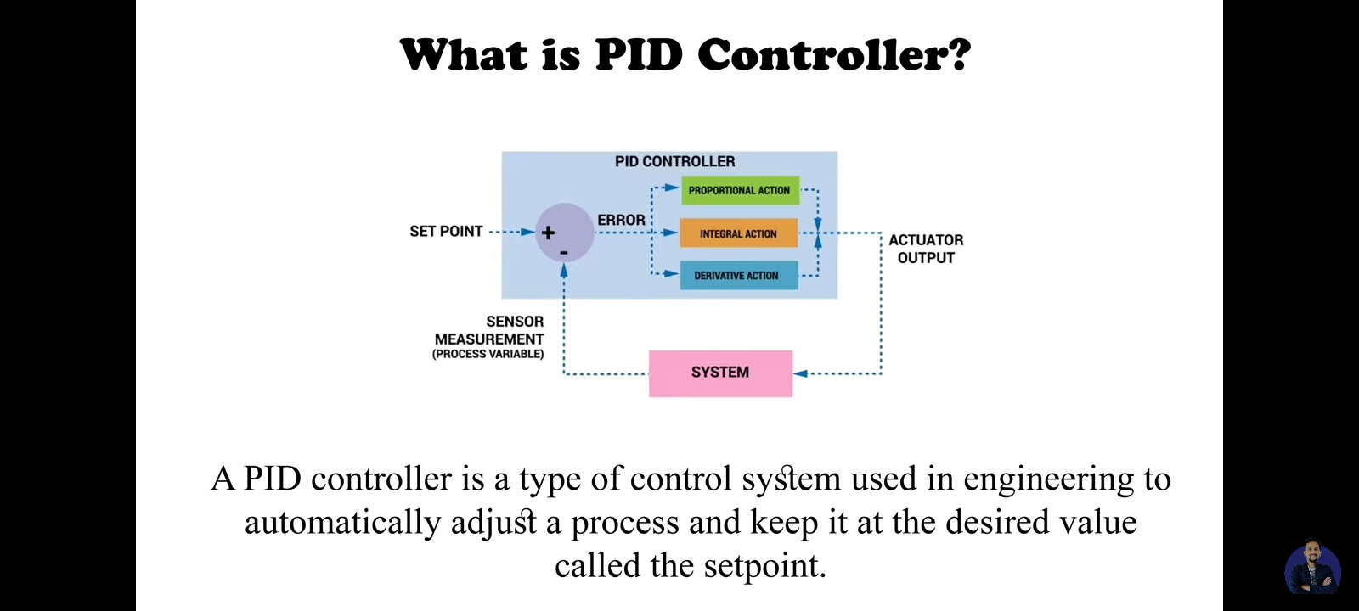
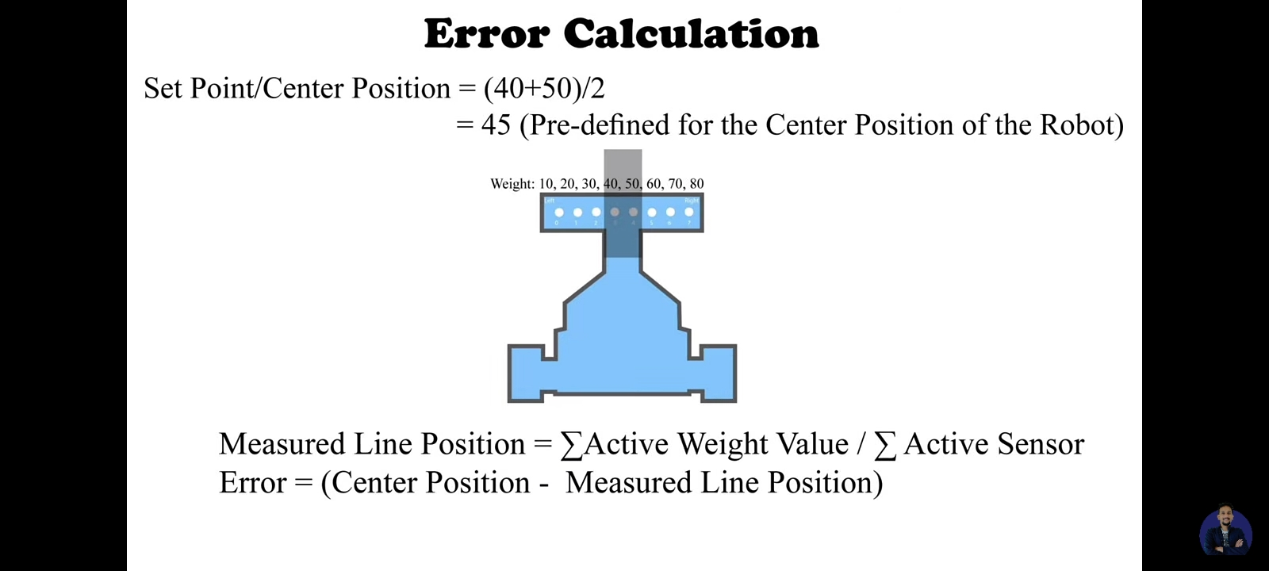
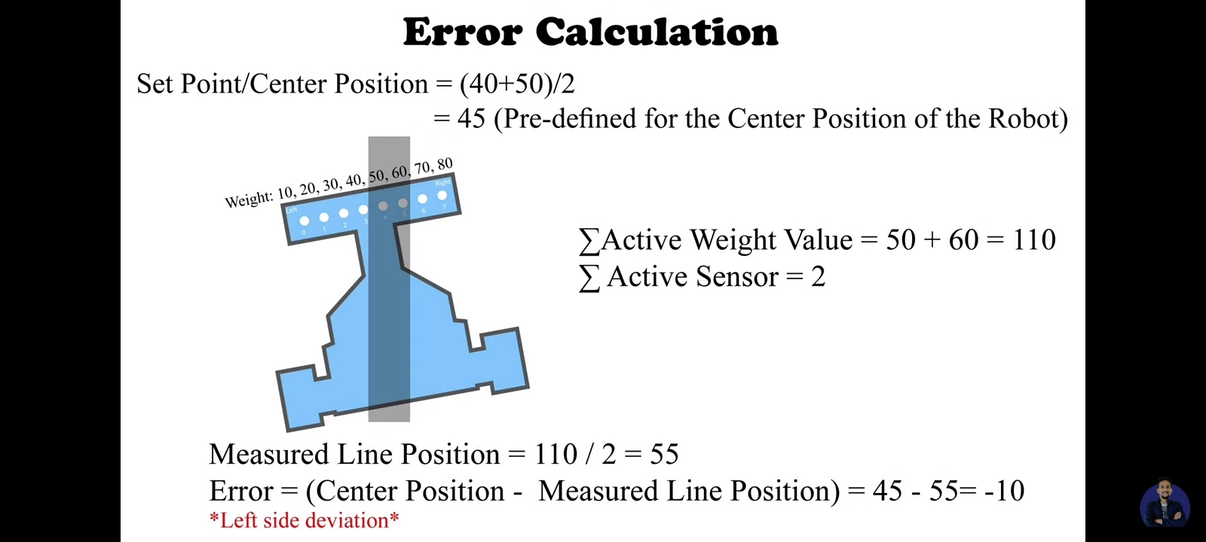
Negative Error
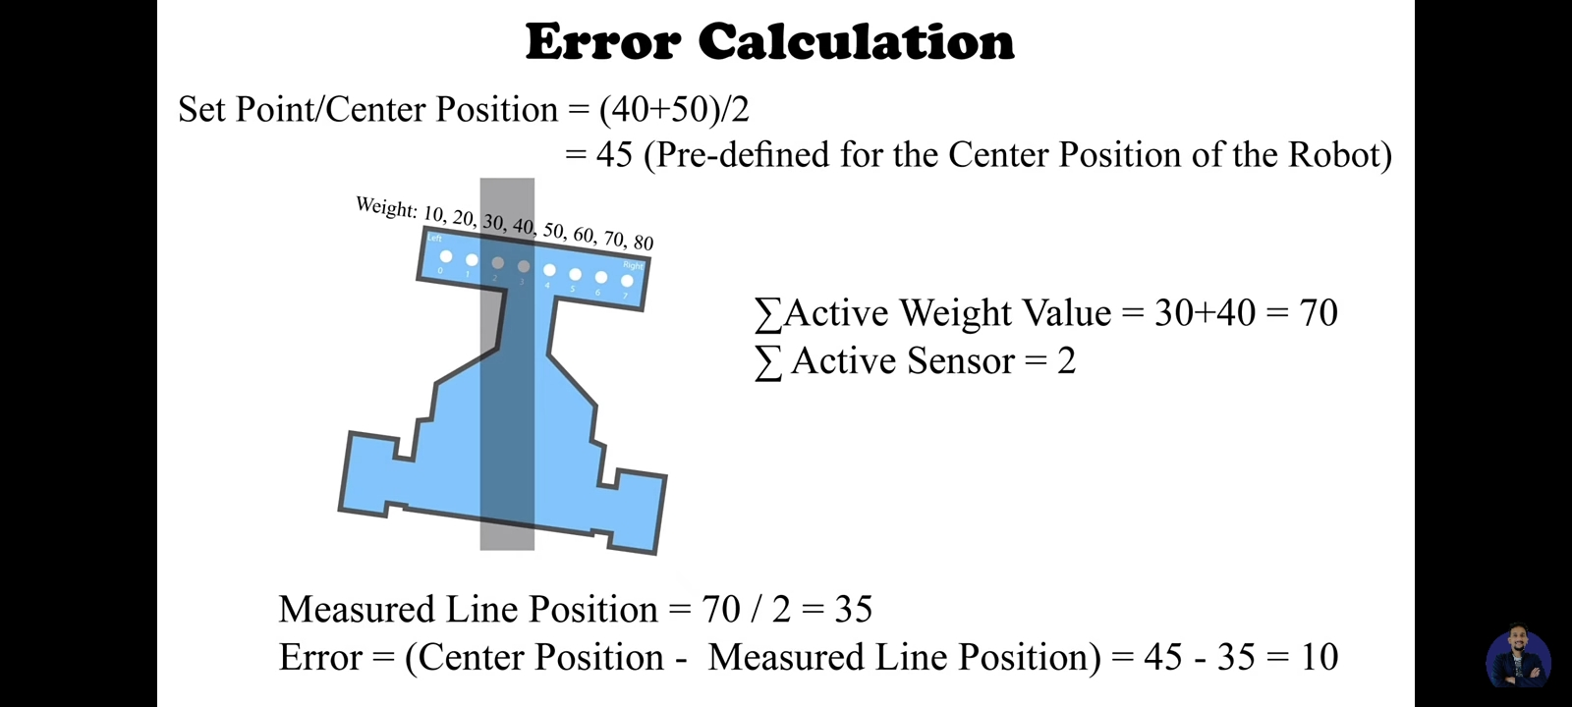
Positive Error
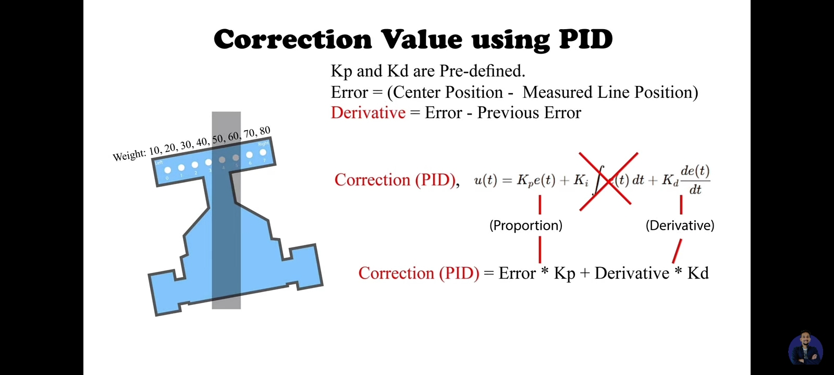
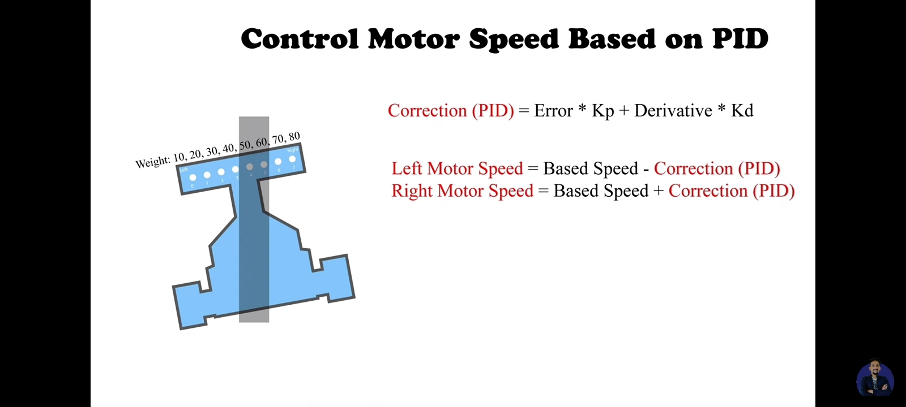
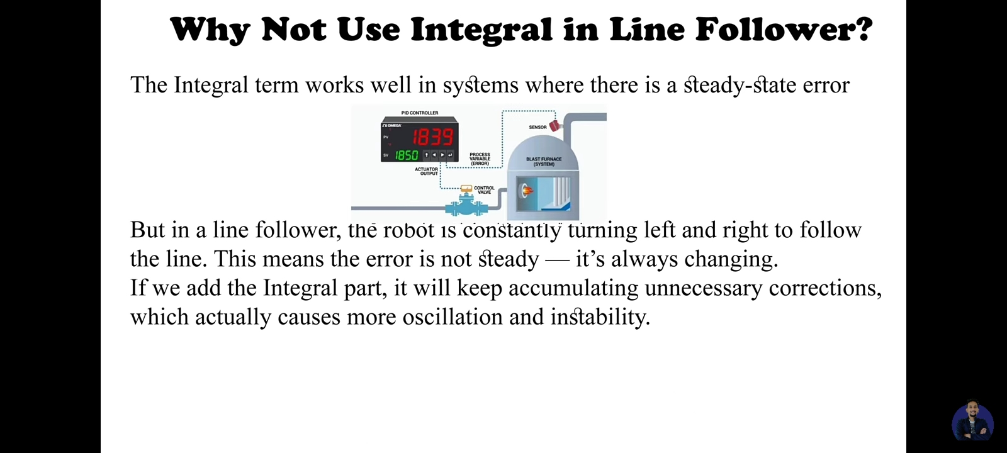
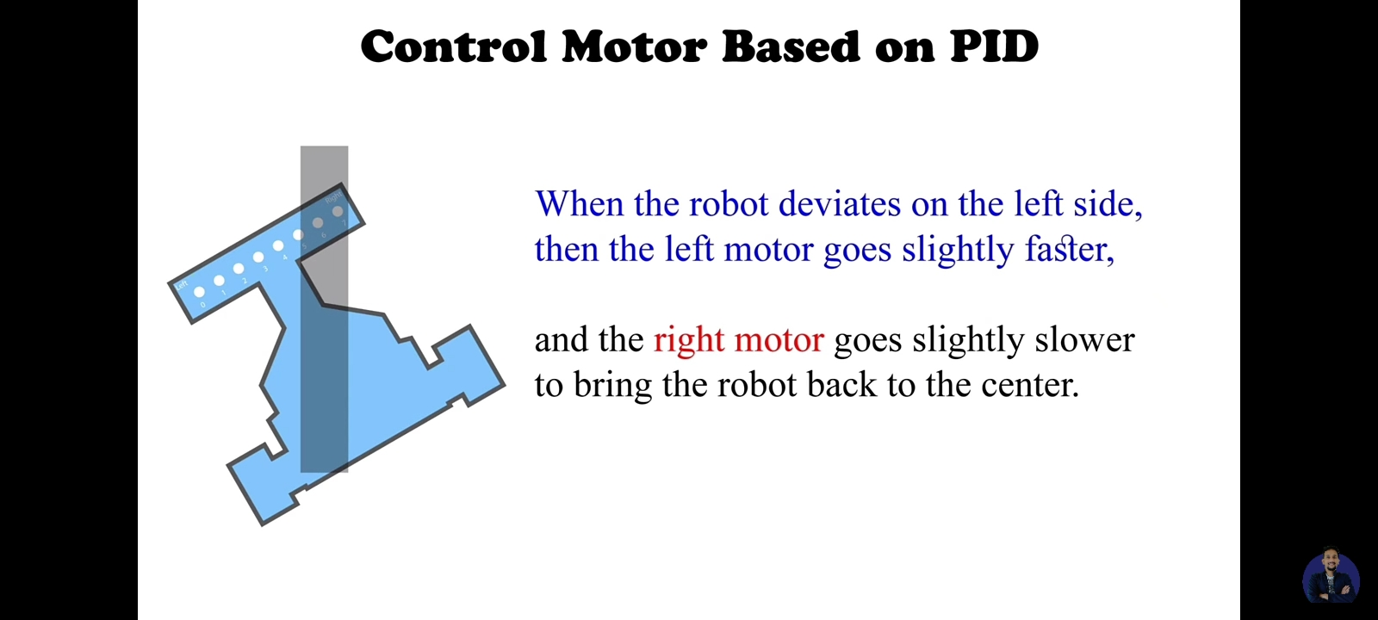
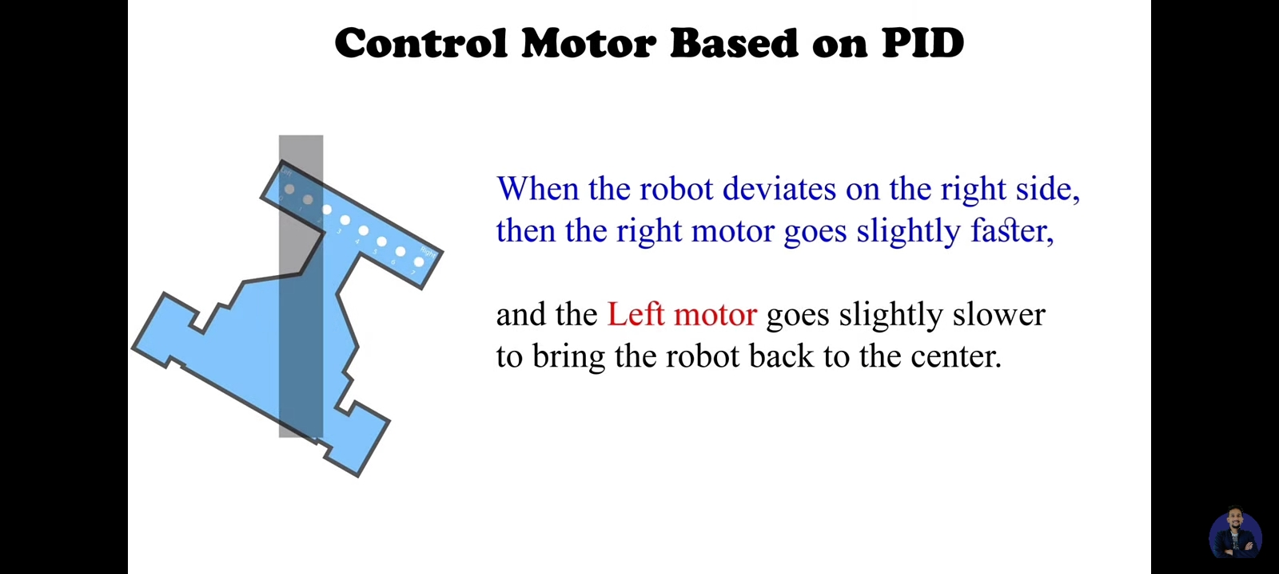
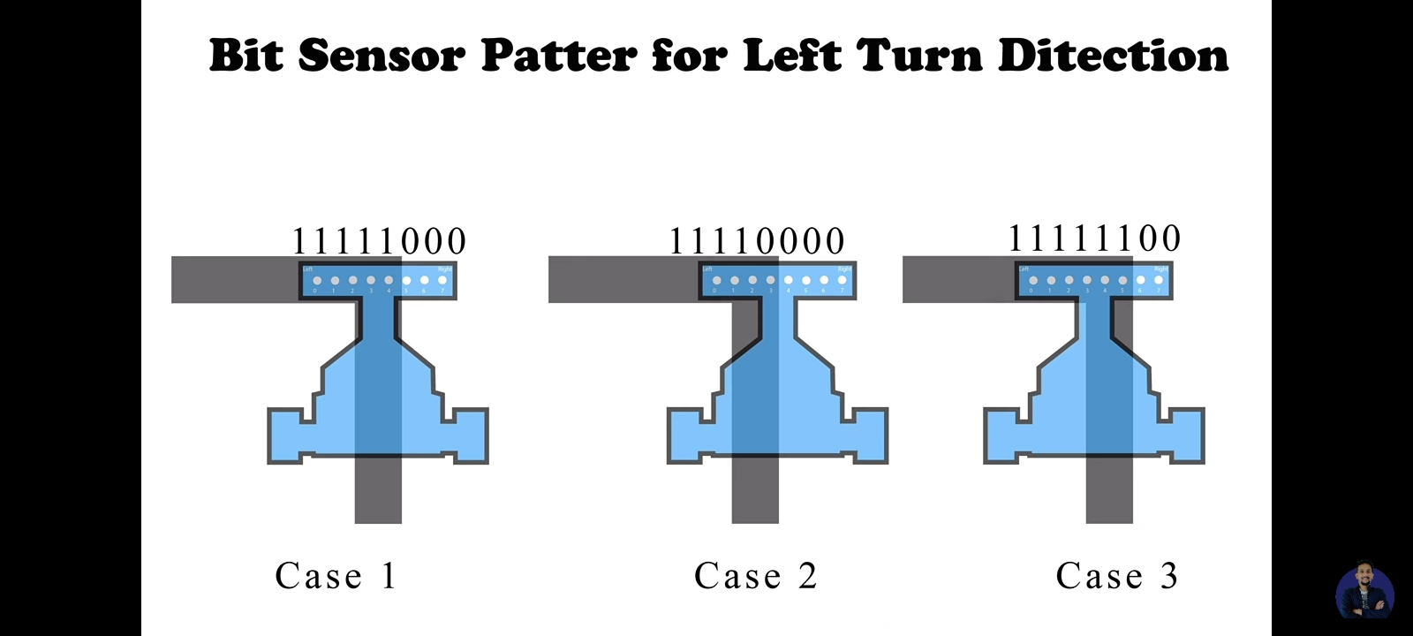
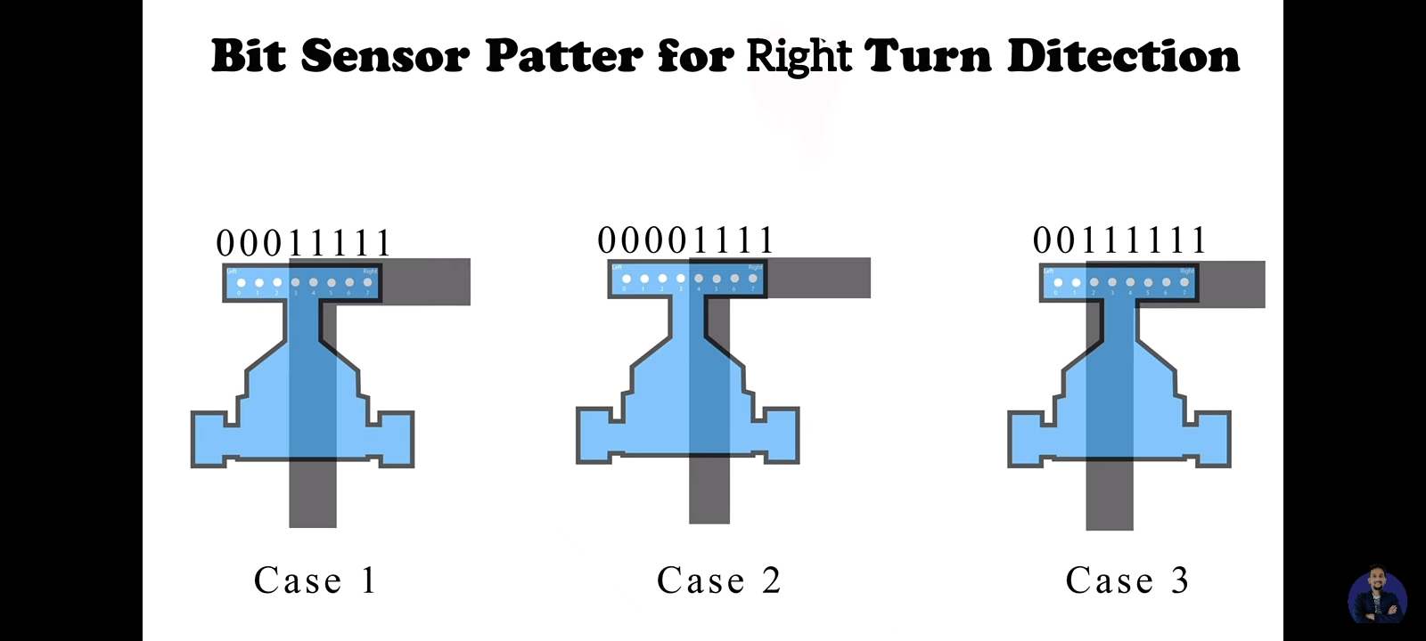
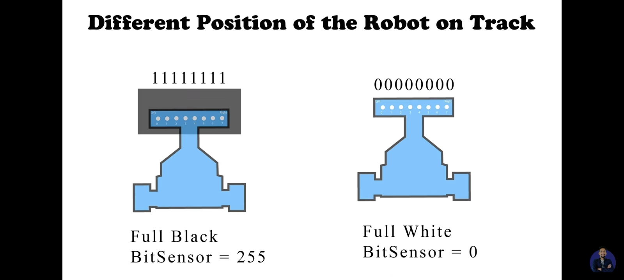
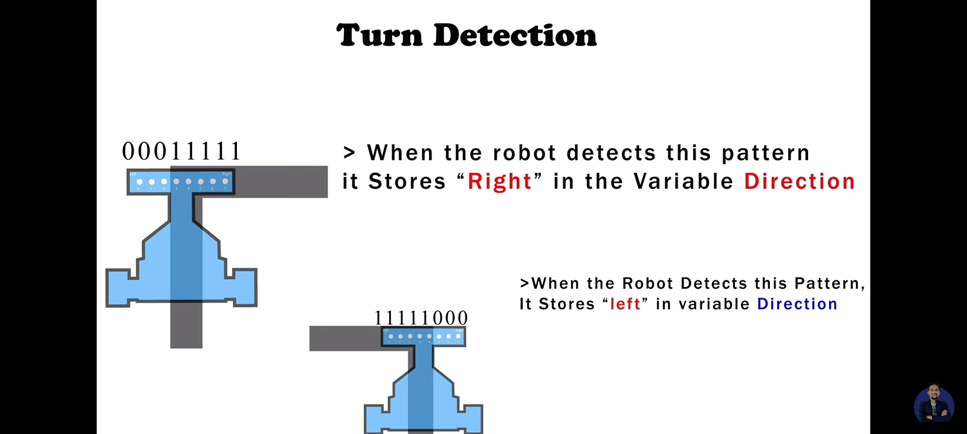
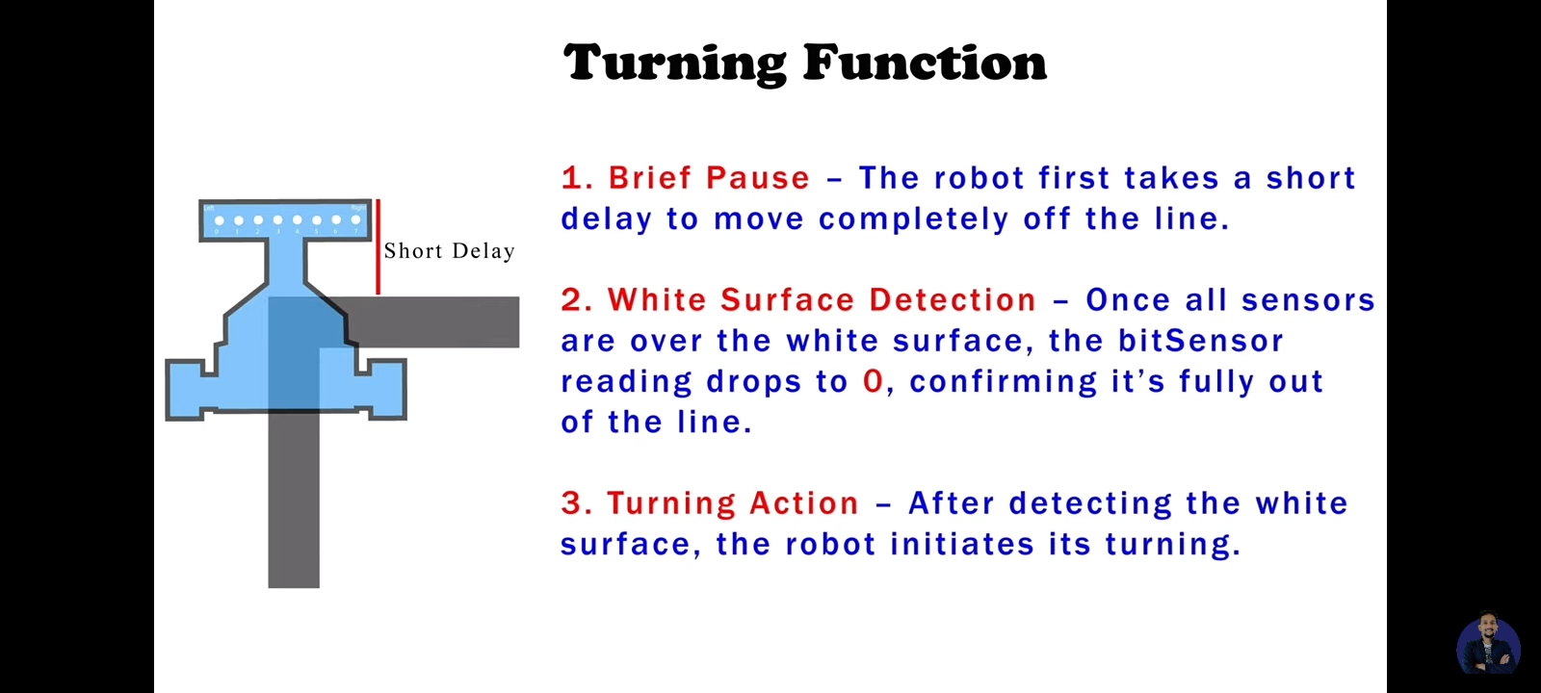
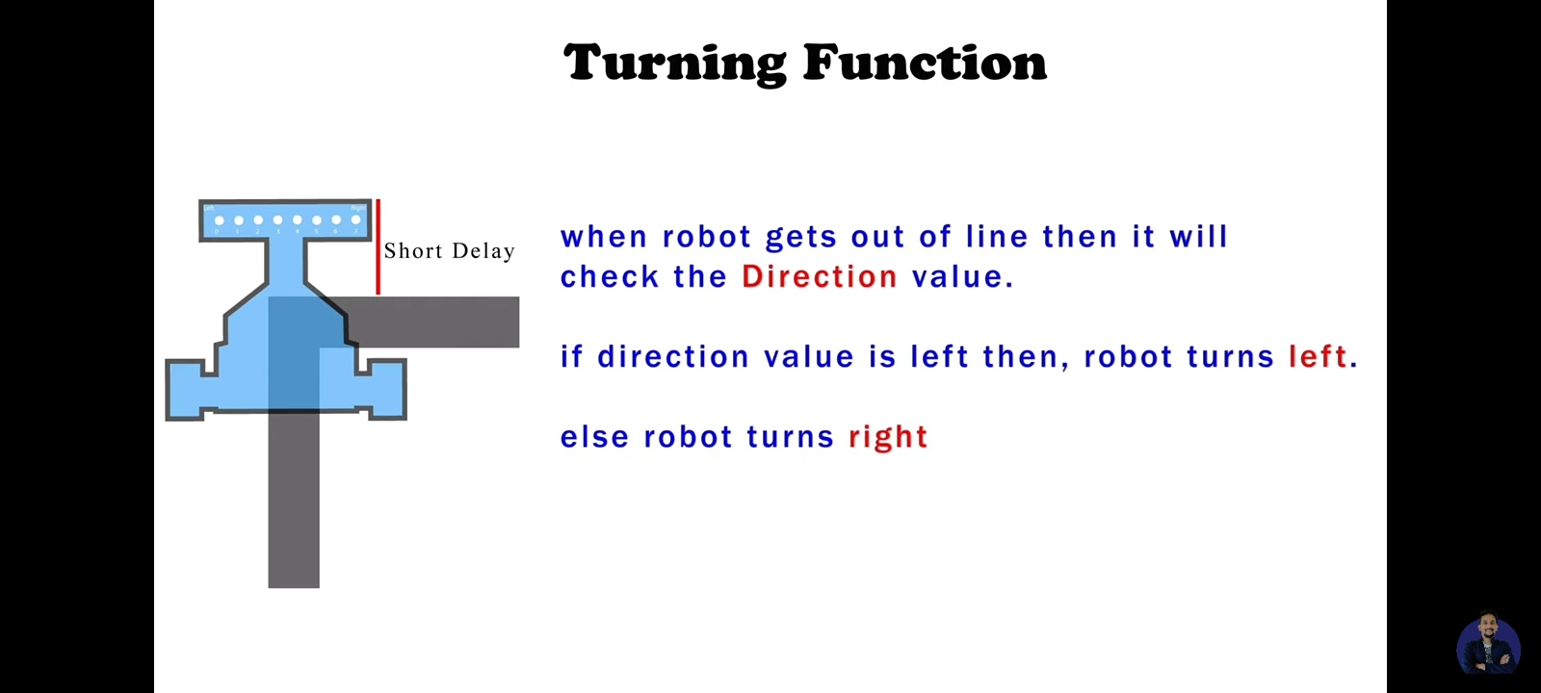
Small Impeller Fan for coreless motor
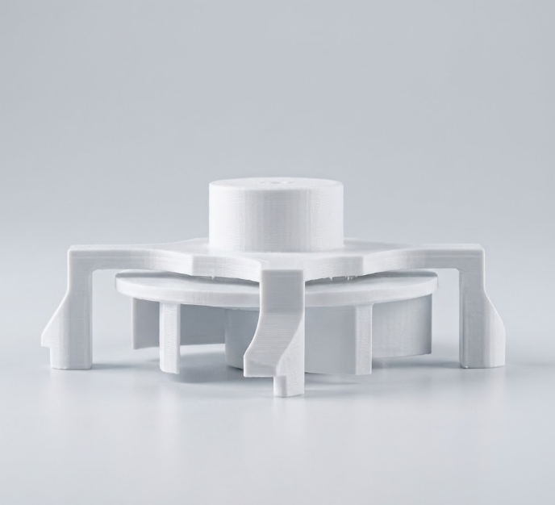
Can be used Best with 1020 coreless motor and 8520 coreless motor with some changes. Material PETG.
Physics-Based Point of View & Formulations
To understand the immense impact, look at the classic friction and centripetal force equations.
1. The Friction Limit (Without Suction)
On a flat track, the maximum frictional force ( F_{f} ) preventing a standard robot's tires from sliding sideways is governed by the normal force (N), which relies entirely on gravity (g) and the robot's physical mass (m):
N_{normal} = m. g
F_{f} = µ. N_{normal} = µ. m. g
(Where (µ) is the coefficient of friction between the rubber/silicone tire and the wooden/plastic track).

2. The Suction Force Formula
The artificial downforce (F_{suction}) generated by the vacuum is a product of the surface area of the vacuum chamber (A)and the pressure differential (ΔP):
ΔP = P_{atm} - P_{v}
F_{suction} = ΔP. A
3. The New Friction Limit (With Suction)
With the fan activated, the new total Normal Force (\(N_{\text{total}}\)) becomes the sum of gravity and suction. The mass of the robot stays exactly the same, but its grip skyrockets:
\(N_{\text{total}}=(m\cdot g)+F_{\text{suction}}\)
\(F_{f_{\text{new}}}=\mu \cdot \left((m\cdot g)+F_{\text{suction}}\right)\)
4. Maximum Cornering Velocity Comparison
When a robot rounds a curve of radius \(R\), the sideways centripetal force (\(F_{c}\)) pulling it off the track is:
\(F_{c}=\frac{m\cdot v^{2}}{R}\)
To prevent a crash, the maximum frictional force must be greater than or equal to the centripetal force (\(F_f \ge F_c\)).
- Without Suction Max Speed:
\(\frac{m\cdot v^{2}}{R}=\mu \cdot m\cdot g\implies v_{\text{max}}=\sqrt{\mu \cdot g\cdot R}\)
Observation: Mass cancels out completely. You cannot make a normal robot corner faster by making it heavier or lighter. You are mechanically bottlenecked by gravity (\(g\)) and tire stickiness (\(\mu \)).
- With Suction Max Speed:
\(\frac{m\cdot v^{2}}{R}=\mu \cdot (m\cdot g+F_{\text{suction}})\implies v_{\text{max}}=\sqrt{\mu \cdot R\cdot \left(g+\frac{F_{\text{suction}}}{m}\right)}\)
Observation: Mass (\(m\)) is now in the denominator of the suction ratio! To achieve maximum cornering speed, you must make the physical robot as lightweight as humanly possible (\(m \to 0\)) while maximizing the suction force (\(F_{\text{suction}} \to \infty\)). This is exactly why Hayabusa2.2 was engineered to weigh a mere 140 grams.

In a line-following robot, balancing speed determines how fast the robot finishes the track, while torque determines how quickly it can turn and correct its course.
Feature | Arduino Nano (ATmega328P) | ESP8266 (NodeMCU) | ESP32 (WROOM-32) | STM32 (ARM Cortex-M Series)
Architecture | 8-bit AVR | 32-bit Tensilica L106 | 32-bit Xtensa Dual-Core | 32-bit ARM Cortex-M
Clock Speed | 16 MHz | 80 / 160 MHz | 240 MHz | 72 MHz to 480+ MHz (Varies)
Analog Pins (ADC) | 8 (10-bit resolution) | 1 (10-bit resolution) | 18 (12-bit resolution)* | Up to 24+ (12-bit or 16-bit)
Hardware Timers | Basic (3 timers) | Software/Limited | Advanced (High Res) | Industrial Grade (Highly Precise)
LFR Capability | Creates a processing bottleneck; struggles to compute PID and read multiple sensors at 1-2 ms loop frequencies. | Poor for LFRs. Only 1 analog pin makes it impossible to read IR sensor arrays without an external multiplexer. | Excellent processing power. *Note: Its internal ADCs are notoriously non-linear, often requiring external ADCs for precise IR tracking. | The gold standard for professional racers. Provides highly deterministic, high-speed execution without wireless stack overhead.

