**||Overview of IT||**

1. **What Is Software? What is Software engineering?**

* Software is a Set of Instructions / commands to execute that we can fill but not touch that’s call **Software**.
* For Example: Clock, calculator, Notepad etc.
* **Software Engineering** is Programing, Developing, Testing with the given Software.

1. **Explain types of software**

* Software has Five types 1.) **System Software** 2.) **Application Software** 3.) **Driver Software** 4.) **Middleware** 5.) **Programming software**
* **1) System Software:**

System software is that types of software who come with operating system.

E.g. Clock, Media player, calculator, Notepad…

* **2) Application Software:**

Software Develops by Developer that’s called Application Software.

E.g. twitter, GitHub, snapchat…

* **3) Driver Software:**

Driver software that allows your computer’s operating system to communicate with a hardware device.

E.g. USB, DVD, Headphone…

* **4) Middleware:**

Middleware is software that make bridges between operating system and other applications.

E.g. database middleware, application server middleware

* **5) Programming software:**

Programming software is a tool for creating computer code. Programming software & tool allows to develop, write, test and debug other software programs.

E.g. Turbo c, Eclipse, sublime…

1. **What is Software development Life-Cycle.**

* **Software development life-cycle (SDLC)** is only about planning, Design, Developing, Testing & Maintenance is called Software development Life-Cycle.
* **Life-Cycle**

* **Planning:**

Planning is the First stage of SDLC.

the project scope, objectives, requirements, and constraints. It also includes establishing a project timeline, budget, and resources.

* **Analysis:**

In this stage stakeholders gather and analyze user requirements, business needs, and system specifications.

The goal is to understand what the software should accomplish and how it will meet the needs of end-users.

* **Design:**

Design is the third stage of SDLC. In this stage developers analyze requirements and identify the best solutions to create the software architecture, data structures, user interfaces, and other technical specifications.

* **IMPLEMENTATION:**

In This stage. developers write the actual code for the software based on the design specifications.

This stage involves programming, unit testing, and integrating individual components into a cohesive system.

* **Testing:**

The testing stage involves verifying that the software functions correctly and meets the specified requirements.

Testing activities may include unit testing, integration testing, system testing, performance testing, and user acceptance testing.

* **MAINTENANCE:**

In this stage Developer Deliver the software may require ongoing maintenance to fix bugs, add new features, or make other enhancements based on user feedback.

1. **What is DFD? Create a DFD diagram on Flipkart**

* **DFD(Data Flow Diagram)** is introduce the Flow of data of system Or Progress of your product.
* It’s also gives input and output entry’s itself.
* DFD if graphical tool and useful for communicating with users.

* **Diagram of Flip Kart**

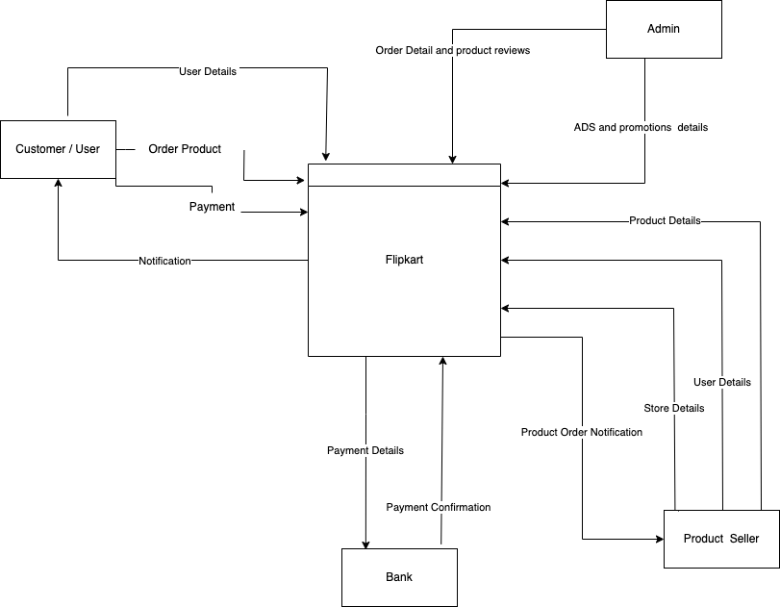

**Fig: Level 0 DFD of Flipkart Shopping System**

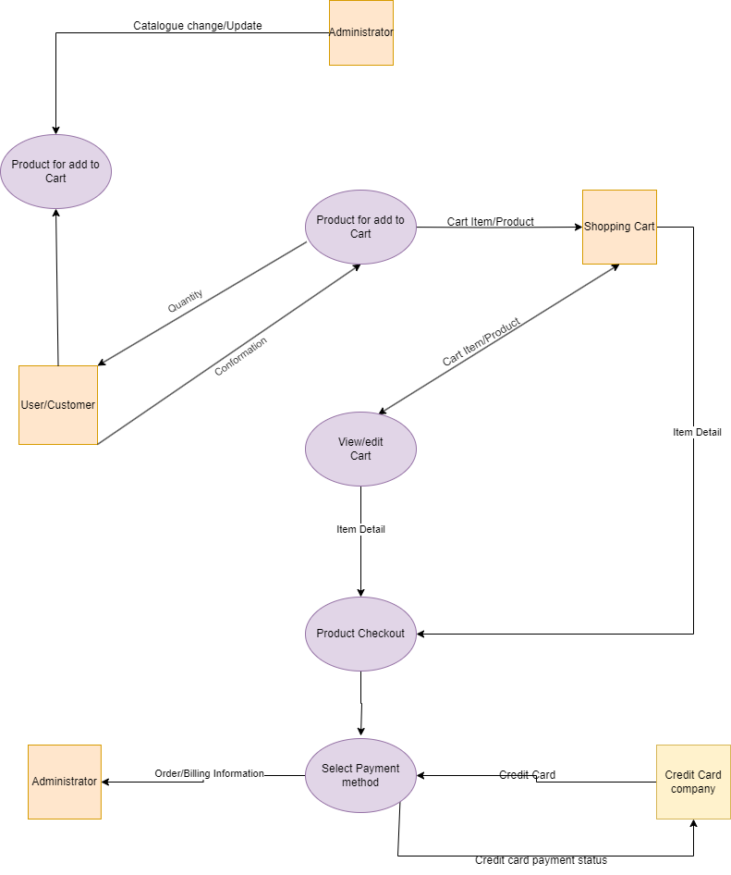

**Fig: Level 1 DFD of Flipkart Add To Cart System**

1. **What is Flow chart? Create a flowchart to make addition of two numbers**

* A flowchart is a diagram that show the steps and sequences of a process or workflow.
* Create a flowchart of 10 + 20

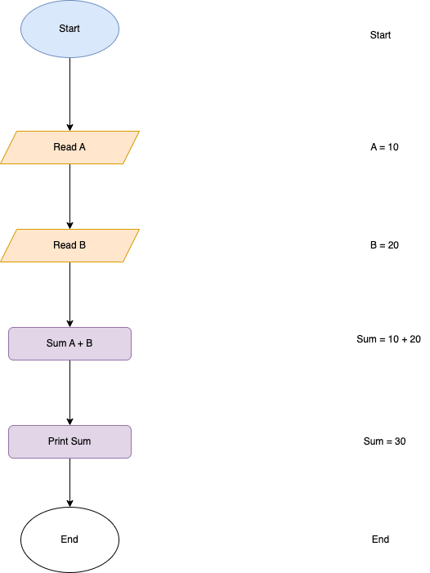

**Fig: Flowchart Of Addition of Two Num**

1. **What is Use case Diagram? Create a use-case on bill payment on Paytm.**

* Use case Diagram is the way to developer can show client to how users perform the website.
* Use case show a user’s point of view, and that shows start to end all process how work website step by step.
* 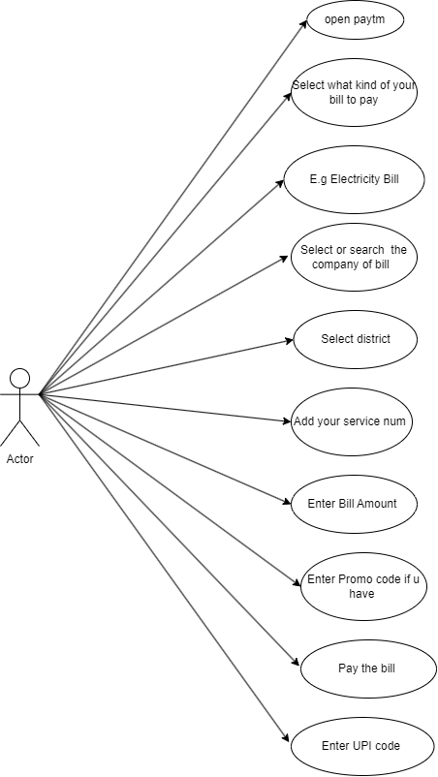**Create a use case on bill payment on Paytm**

**Fig: Use-Case Diagram of bill payment on Paytm**