Unit 3: Data Link Layer (DLL)
Complete Long-Term Notes for BSc CSIT Computer Networks
Covers: DLL functions, LLC/MAC, framing, flow control, error detection/correction, ALOHA, Ethernet, WLAN, virtual circuit, Frame Relay, ATM, HDLC, PPP.
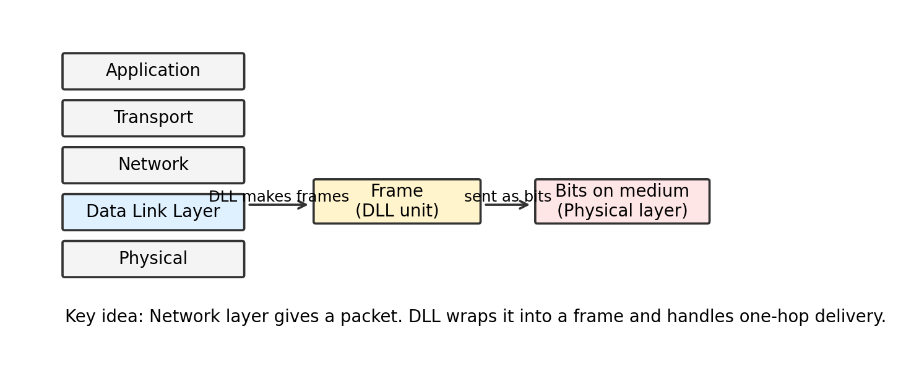
Where the Data Link Layer sits in the network stack.
How to use this document: read the First Principles parts to understand the idea, then use the Exam-Angle boxes/tables to write answers in your notebook. The diagrams are included so that the chapter becomes visual, not just text.

Study Roadmap / Contents
- 3.1 Functions of Data Link Layer
- 3.2 LLC and MAC sublayers
- 3.3 Framing and Flow Control
- 3.4 Error Detection and Correction
- 3.5 Channel Allocation: ALOHA and Slotted ALOHA
- 3.6 Ethernet Standards: 802.3, 802.4, 802.5
- 3.7 Wireless LAN: Spread Spectrum, Bluetooth, Wi-Fi
- 3.8 Virtual Circuit Switching, Frame Relay, ATM
- 3.9 DLL Protocols: HDLC and PPP
- Final quick revision tables and likely TU exam questions

3.1 Functions of Data Link Layer (DLL)
Real-world hook: imagine sending a parcel from your house to a nearby courier office. The full journey may be long, but this particular step is only one hop. The Data Link Layer is responsible for this one-hop movement: from one directly connected device to the next.
The Data Link Layer is the second layer of the OSI model. It accepts packets from the Network Layer and converts them into frames that can be sent over the physical medium. Its main concern is not the full source-to-destination internet route; that is mainly the job of the Network Layer. DLL focuses on reliable and organized node-to-node delivery over a single link.

DLL performs one-hop delivery by converting packets into frames.

Core idea: packet, frame, and bit
Unit | Layer | Simple meaning | Example
Packet | Network Layer | Data unit used for logical end-to-end routing. | IP packet
Frame | Data Link Layer | Packet wrapped with DLL header/trailer for one-hop delivery. | Ethernet frame, Wi-Fi frame
Bit | Physical Layer | Electrical/optical/radio signal representation. | 0/1 voltage or radio modulation

Major functions of DLL
Function | What it does
Framing | Divides the raw bit stream into meaningful frames so the receiver knows where one message starts and ends.
Physical addressing | Adds source and destination MAC addresses so delivery can happen on a local link or LAN.
Flow control | Prevents a fast sender from overwhelming a slow receiver.
Error control | Detects damaged frames and may correct or retransmit them depending on the protocol.
Access control | Decides which device may use the shared medium at a particular time.
Link management | Establishes, maintains, and releases link-level connections in some protocols.
Reliable delivery on a link | Some DLL protocols use acknowledgements and retransmissions to make a noisy link more dependable.

Important boundary: DLL does not generally guarantee that data reaches the final destination across the entire internet. It handles the local hop. Routers then repeat similar local-hop delivery on the next link.

Exam-Angle
- If asked “functions of DLL”, write framing, physical addressing, flow control, error control, and access control first. These are the high-value points.
- Mention that DLL provides node-to-node delivery, while Network Layer provides source-to-destination logical routing. This distinction makes the answer stronger.

3.2 Overview of LLC and MAC
The Data Link Layer is often divided into two sublayers: Logical Link Control (LLC) and Media Access Control (MAC). The easiest way to see it is this: LLC talks upward to the Network Layer; MAC talks downward to the physical medium.
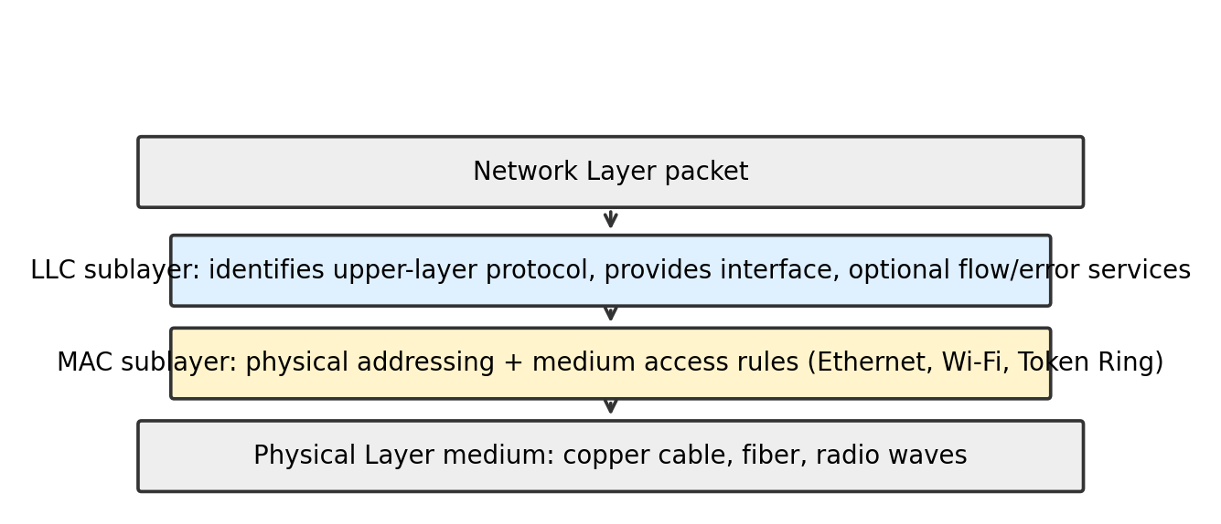
LLC handles upper-layer interface; MAC handles medium access and MAC addressing.

Logical Link Control (LLC)
LLC is the upper sublayer of DLL. It provides a common interface to the Network Layer, even when different MAC technologies are used below, such as Ethernet or Wi-Fi.
- Identifies which Network Layer protocol is being carried, such as IPv4 or IPv6.
- May provide flow control and error control services depending on the implementation.
- Makes the upper layers less dependent on the exact LAN technology.

Media Access Control (MAC)
MAC is the lower sublayer of DLL. It deals with the practical problem of using the medium. If many devices share the same channel, MAC rules decide who gets to transmit and when.
- Adds source and destination MAC addresses.
- Controls access to shared media using methods such as CSMA/CD, CSMA/CA, token passing, or ALOHA.
- Defines frame format for technologies such as Ethernet and Wi-Fi.
Aspect | LLC | MAC
Position | Upper DLL sublayer | Lower DLL sublayer
Main role | Interface with Network Layer | Access to physical medium
Addressing | Usually not responsible for physical MAC addresses | Uses source/destination MAC addresses
Examples | IEEE 802.2 LLC | Ethernet 802.3, Wi-Fi 802.11
Focus | Logical service and protocol identification | Local delivery and medium sharing

Exam-Angle
- For “LLC vs MAC”, draw two boxes: LLC above MAC. Then compare role, position, and examples.
- Write that LLC provides a uniform service to the Network Layer, while MAC manages physical addressing and access to the medium.

3.3 Framing and Flow Control Mechanisms
Real-world hook: if someone reads a long sentence without spaces, you cannot know where one word ends and the next begins. Framing is the networking version of adding boundaries, labels, and checks around data.

Framing
Framing is the process of dividing a stream of bits into manageable units called frames. The sender adds a header and usually a trailer around the data. The receiver uses this structure to extract the original packet correctly.
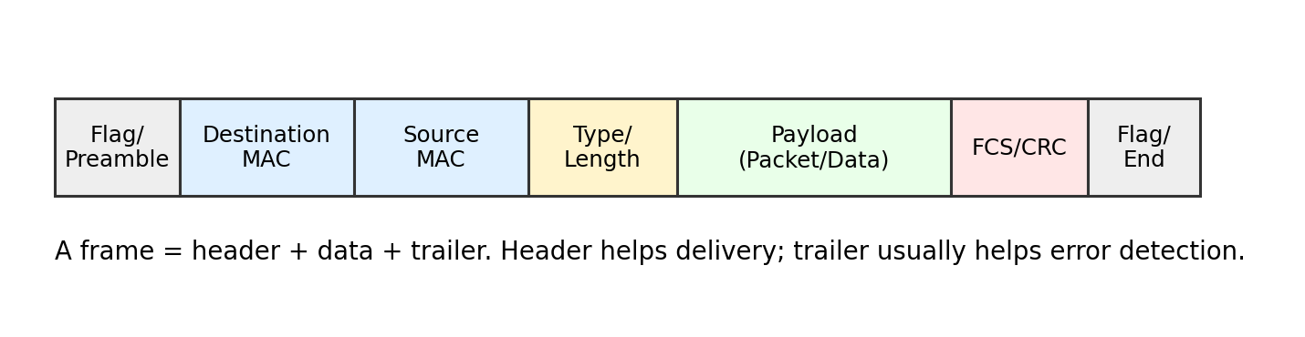
A general frame structure. Actual fields differ by protocol.
Why framing is needed: physical links send raw bits. Without frame boundaries, the receiver cannot know where one data unit starts, where it ends, whether it belongs to it, or whether it was damaged.
Method | How it works | Advantage | Limitation
Character count | Header stores the number of characters/bytes in the frame. | Simple. | If count field is corrupted, receiver loses synchronization.
Flag bytes with byte stuffing | Special flag byte marks start/end. If flag appears in data, an escape byte is inserted. | Works well for byte-oriented data. | Extra stuffing overhead.
Flag bits with bit stuffing | Special bit pattern such as 01111110 marks boundary. Sender inserts 0 after five consecutive 1s in data. | Useful for bit-oriented protocols like HDLC. | Receiver must remove stuffed bits.
Physical layer coding violations | Uses signal patterns that are not valid data symbols to mark boundaries. | Efficient in some physical encodings. | Depends on physical encoding scheme.

Example: Bit stuffing in HDLC-like framing
Flag pattern: 01111110
Rule at sender: after five consecutive 1s in data, insert one 0.
Rule at receiver: after five consecutive 1s, remove the next 0 if it is stuffed.

Data before stuffing: 01111110111110
Data after stuffing : 011111010111110
Reason: prevents data from accidentally looking like the flag.

Flow Control
Flow control prevents the sender from sending frames faster than the receiver can process or store them. It is needed because the sender and receiver may have different processing speeds, buffer sizes, and link conditions.
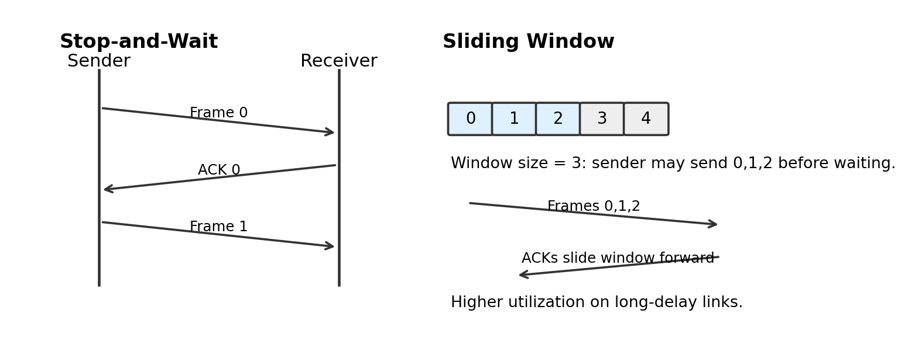
Stop-and-Wait sends one frame at a time; Sliding Window allows multiple outstanding frames.
Two important DLL flow control mechanisms are Stop-and-Wait and Sliding Window.
Mechanism | Working idea | Strength | Weakness
Stop-and-Wait | Sender sends one frame and waits for ACK before sending next. | Very simple and easy to implement. | Poor utilization when propagation delay is high.
Sliding Window | Sender can send multiple frames before waiting, limited by window size. | Much better link utilization. | More complex; requires sequence numbers and buffering.

Stop-and-Wait sender logic
1. Send frame with sequence number 0 or 1.
2. Start timer.
3. If ACK arrives before timeout, send next frame.
4. If timeout occurs, retransmit the same frame.
5. Use sequence number to detect duplicate frames.
Sliding Window idea
Window size = number of frames sender can send without waiting.
If window size is 4, sender may send frames 0, 1, 2, 3.
When ACK for frame 0 arrives, window slides forward and frame 4 becomes sendable.

Stop-and-Wait vs Sliding Window
Point | Stop-and-Wait | Sliding Window
Frames in transit | Only one | Multiple
Efficiency | Low on long-delay links | High
Complexity | Low | Higher
Sequence numbers | Usually 1 bit is enough | Multiple bits needed
Use case | Simple/noisy/low-speed links | High-speed networks

Exam-Angle
- For framing, TU-style answers often expect definition plus methods: character count, byte stuffing, bit stuffing, and coding violation.
- For flow control, compare Stop-and-Wait and Sliding Window. Include ACK, timeout, sequence number, and buffer idea.

3.4 Error Detection and Correction Techniques
Real-world hook: when a teacher checks an answer sheet, they do not trust every copied number blindly. They use patterns and checks. Error detection/correction does the same for bits that may have changed during transmission.
Errors happen because physical signals face noise, interference, attenuation, faulty hardware, or collision. A bit 0 may become 1, or 1 may become 0. The Data Link Layer adds extra redundant bits so the receiver can detect, and sometimes correct, such errors.

Types of errors
Error type | Meaning | Example
Single-bit error | Only one bit changes. | 1011001 becomes 1010001
Burst error | Two or more bits in a data unit are affected. | Several nearby bits are damaged due to noise burst

Error detection vs error correction
Concept | Meaning | Common techniques
Error detection | Receiver only knows that an error occurred. | Parity, Checksum, CRC
Error correction | Receiver can locate and correct error without retransmission. | Hamming code, some forward error correction methods

1) Parity Check
A parity bit is an extra bit added to make the number of 1s either even or odd.
- Even parity: total number of 1s including parity bit must be even.
- Odd parity: total number of 1s including parity bit must be odd.
- Simple parity can detect odd number of bit errors, but it cannot reliably detect even number of errors and cannot correct errors.
Data: 1011001 has four 1s.
Even parity bit = 0, because total 1s already even.
Transmitted: 10110010

If receiver counts odd number of 1s, it detects an error.

2) Two-Dimensional Parity
In two-dimensional parity, data bits are arranged in rows and columns. A parity bit is calculated for each row and each column. This can detect many burst errors and can correct a single-bit error by finding the row and column where parity fails.

3) Checksum
Checksum treats data as a sequence of numbers, adds them, and sends the complement of the sum. The receiver performs the same addition and checks whether the result matches the expected pattern. It is widely used in upper-layer protocols too, but the basic idea is simple: summarize data with a small verification value.
Simple checksum idea
Sender:
divide data into fixed-size words
sum all words using wrap-around carry
complement the sum
send data + checksum
Receiver:
sum all received words including checksum
if result is all 1s, accept; otherwise detect error

4) Cyclic Redundancy Check (CRC)
CRC is one of the strongest common error detection methods in data link protocols. It treats the bit string like a binary polynomial and divides it by a generator polynomial. The remainder becomes the CRC bits, also called FCS in many frame formats.
You do not need to fear the word polynomial here. In practical DLL questions, CRC division is performed using XOR division, not normal decimal subtraction.
CRC sender logic
Given data D and generator G of length r+1:
1. Append r zeros to D.
2. Divide D with appended zeros by G using XOR division.
3. Take the r-bit remainder R.
4. Transmit D + R.

Receiver logic
1. Divide received bit string by the same G.
2. If remainder is 0, accept as no detected error.
3. If remainder is non-zero, error is detected.

5) Hamming Code
Hamming code is an error-correcting code. It can usually correct a single-bit error and detect some multiple-bit errors, depending on the variant. The key idea is to place parity bits at positions that are powers of 2: 1, 2, 4, 8, 16, and so on.
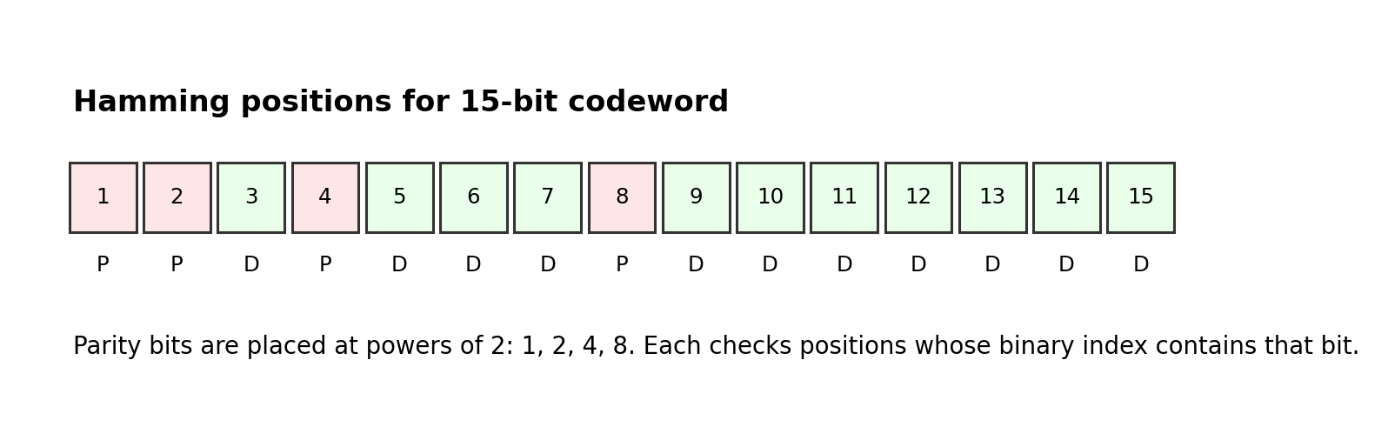
For a 15-bit Hamming codeword, parity bits are at positions 1, 2, 4, and 8.
For a codeword position number, write its binary form. A parity bit checks all positions whose binary representation contains the corresponding bit.
Parity bit | Checks positions in a 15-bit codeword
P1 at position 1 | 1, 3, 5, 7, 9, 11, 13, 15
P2 at position 2 | 2, 3, 6, 7, 10, 11, 14, 15
P4 at position 4 | 4, 5, 6, 7, 12, 13, 14, 15
P8 at position 8 | 8, 9, 10, 11, 12, 13, 14, 15

This is why for 7-bit Hamming codeword, parity bits are at 1, 2, 4 and check groups such as P1: 1,3,5,7; P2: 2,3,6,7; P4: 4,5,6,7. For 15-bit codeword, add P8 and extend the same binary-position logic.

How many parity bits are needed?
For m data bits and r parity bits, single-error correction requires:
2^r >= m + r + 1
where:
m = number of data bits
r = number of parity bits
+1 represents the no-error condition
Example: for 11 data bits, r = 4 works because 2^4 = 16 and m + r + 1 = 11 + 4 + 1 = 16. Total codeword length is 15 bits.
Technique | Detects error? | Corrects error? | Best point | Weak point
Parity | Yes, limited | No | Very simple | Misses even number of bit errors
2D parity | Yes | Single-bit correction possible | Better burst detection | More overhead
Checksum | Yes | No | Simple for software | Weaker than CRC for many patterns
CRC | Yes, strong | No | Excellent detection for frames | Requires generator and XOR division
Hamming code | Yes | Yes, usually single-bit | Corrects without retransmission | Extra parity bits and complexity

Exam-Angle
- CRC numerical problems are common: show append zeros, XOR division, remainder, and transmitted codeword.
- Hamming code questions usually expect parity positions 1,2,4,8,... and the formula 2^r >= m + r + 1. For 15-bit codeword, parity groups are exactly P1, P2, P4, P8 as shown above.

3.5 Channel Allocation Techniques: ALOHA and Slotted ALOHA
Real-world hook: many students want to speak in a group discussion. If everyone speaks whenever they want, voices overlap. Channel allocation is the rule system that decides how multiple devices share one communication channel.
When many stations share the same medium, the DLL/MAC layer must solve the multiple access problem: who can transmit, when, and what happens if two transmit at the same time?
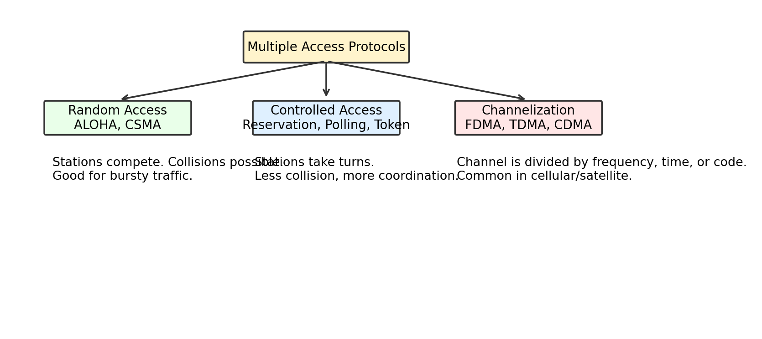
Taxonomy of common multiple access protocols.

Pure ALOHA
Pure ALOHA is the simplest random access protocol. A station transmits whenever it has data. If a collision occurs, the station waits for a random time and retransmits.
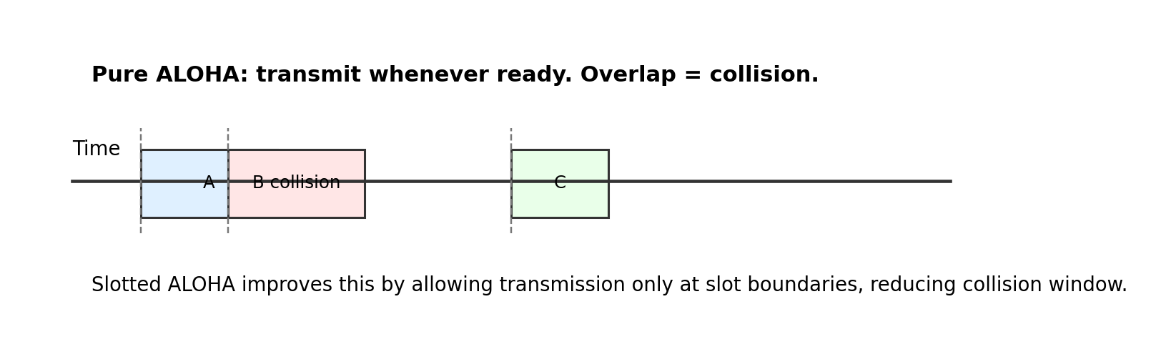
In Pure ALOHA, overlapping frames collide.
Pure ALOHA logic
1. If a station has a frame, transmit immediately.
2. Listen/wait for acknowledgement.
3. If ACK is received, transmission is successful.
4. If no ACK, assume collision or loss.
5. Wait for random backoff time and retransmit.
Vulnerable time in Pure ALOHA is 2 x frame transmission time, because another frame starting within one frame time before or after can overlap and cause collision. Maximum theoretical throughput is about 18.4%.

Slotted ALOHA
Slotted ALOHA improves Pure ALOHA by dividing time into equal slots. A station may transmit only at the beginning of a slot. This reduces the collision window.
Slotted ALOHA logic
1. Time is divided into slots equal to one frame time.
2. A station with data waits for the next slot boundary.
3. It transmits at the beginning of the slot.
4. If collision occurs, it waits random number of slots and tries again.
Vulnerable time in Slotted ALOHA is 1 x frame transmission time. Maximum theoretical throughput is about 36.8%, roughly double Pure ALOHA.
Feature | Pure ALOHA | Slotted ALOHA
Transmission time | Any time | Only at slot boundaries
Synchronization | Not required | Required
Vulnerable time | 2T | T
Max throughput | About 18.4% | About 36.8%
Collision chance | Higher | Lower
Complexity | Very simple | Slightly more complex

Other channel allocation ideas
Technique | Core idea | Example/Use
FDMA | Divide channel by frequency bands. | Radio/cellular systems
TDMA | Divide channel by time slots. | Digital telephony, satellite
CDMA | Users share same time/frequency but use different codes. | 3G cellular concepts
Polling | Central controller asks each station in turn. | Master-slave networks
Token passing | Only station holding token can transmit. | Token Ring, Token Bus

Exam-Angle
- ALOHA answers should include working, collision, random backoff, vulnerable time, and throughput comparison.
- For channel allocation, classify into random access, controlled access, and channelization.

3.6 Ethernet Standards: 802.3 CSMA/CD, 802.4 Token Bus, 802.5 Token Ring
Real-world hook: a shared road needs traffic rules. Ethernet, Token Bus, and Token Ring are different traffic-rule systems for local area networks.

IEEE 802 family in one view
Standard | Name | Medium access method | Topology idea | Status today
802.3 | Ethernet | CSMA/CD in classic shared Ethernet; switched Ethernet today | Bus/star with switches | Dominant LAN technology
802.4 | Token Bus | Token passing on logical bus | Physical bus, logical ring | Historically important, mostly obsolete
802.5 | Token Ring | Token passing around ring | Ring/star-wired ring | Historically important, mostly obsolete

802.3 Ethernet and CSMA/CD
Ethernet is the most widely used wired LAN technology. Classic shared Ethernet used CSMA/CD: Carrier Sense Multiple Access with Collision Detection.
- Carrier Sense: listen before transmitting.
- Multiple Access: many stations share the same medium.
- Collision Detection: while transmitting, detect if another station also transmitted.
- If collision occurs, send jam signal, stop, wait random backoff time, and retransmit.
CSMA/CD simplified algorithm
1. Listen to the medium.
2. If idle, start transmitting.
3. While transmitting, monitor for collision.
4. If collision detected:
send jam signal
stop transmitting
wait random backoff time
try again
5. If no collision, frame is successfully sent.
Modern switched Ethernet usually does not need CSMA/CD in the same way because each switch port is a separate collision domain and full-duplex links allow simultaneous send/receive. Still, CSMA/CD remains important for understanding classic Ethernet.

Ethernet frame format
Field | Typical size | Purpose
Preamble + SFD | 8 bytes | Synchronization and start frame delimiter
Destination MAC | 6 bytes | Receiver hardware address
Source MAC | 6 bytes | Sender hardware address
Type/Length | 2 bytes | Identifies payload type or length
Data + padding | 46 to 1500 bytes | Payload; padding if too small
FCS | 4 bytes | CRC-based error detection

802.4 Token Bus
Token Bus uses a physical bus but organizes stations into a logical ring. A small control frame called a token circulates. Only the station holding the token can transmit.
- No collisions because only token holder transmits.
- Useful for deterministic access, meaning predictable waiting time.
- More complex than Ethernet and not common today.

802.5 Token Ring
Token Ring connects stations in a ring-like logical order. The token circulates around the ring. A station must capture the token before sending data, then releases it after transmission.
- Controlled access, so collisions are avoided.
- Predictable performance under heavy load.
- Failure of ring components can affect network unless bypass mechanisms exist.
Point | Ethernet 802.3 | Token Bus 802.4 | Token Ring 802.5
Access type | Contention/random | Controlled/token | Controlled/token
Collision | Possible in classic shared Ethernet | Avoided | Avoided
Delay | Can vary under load | More predictable | More predictable
Complexity | Lower | Higher | Higher
Modern relevance | Very high | Low | Low

Exam-Angle
- For Ethernet, explain CSMA/CD steps and Ethernet frame fields.
- For 802.4 and 802.5, focus on token passing and collision-free controlled access.

3.7 Wireless LAN: Spread Spectrum, Bluetooth, Wi-Fi
Real-world hook: wired Ethernet is like talking through a private pipe. Wireless is like speaking in an open room where many people may hear, interrupt, or interfere. That is why wireless MAC is more careful.

Spread Spectrum
Spread spectrum spreads a signal over a wider frequency band than the minimum required. This makes communication more resistant to interference, noise, and eavesdropping. It is important in wireless systems.
Type | How it works | Key idea
FHSS - Frequency Hopping Spread Spectrum | Signal rapidly hops among many frequency channels according to a pattern. | Avoid staying on one noisy frequency.
DSSS - Direct Sequence Spread Spectrum | Each data bit is combined with a faster chip sequence. | Spreads each bit across a wider band.

Bluetooth
Bluetooth is a short-range wireless technology used for personal area networks. It connects devices such as headphones, keyboards, phones, and watches. Classic Bluetooth uses frequency hopping to reduce interference in the crowded 2.4 GHz band.
- Designed for short range and low power.
- Uses master/slave or central/peripheral style organization depending on Bluetooth version/context.
- Common for audio, peripherals, and IoT-like devices.

Wi-Fi / Wireless LAN
Wi-Fi is based on IEEE 802.11 standards. Unlike classic Ethernet, Wi-Fi generally cannot use collision detection effectively because a wireless device may not hear collision while transmitting. So Wi-Fi uses CSMA/CA: Carrier Sense Multiple Access with Collision Avoidance.
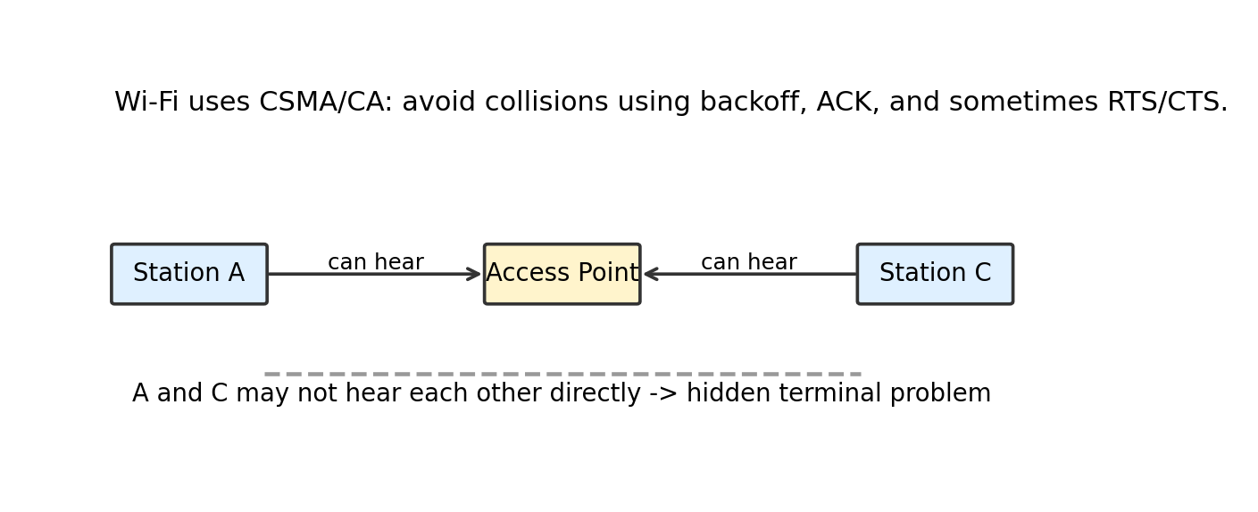
Hidden terminal problem: stations may not hear each other but can still collide at the access point.
Why CSMA/CD is difficult in wireless:
- Wireless radios often cannot transmit and listen for collision at the same time on the same channel.
- The hidden terminal problem occurs when two stations cannot hear each other but both can reach the access point.
- Signal strength decreases with distance, making collision detection unreliable.
CSMA/CA simplified algorithm
1. Sense the channel.
2. If busy, wait until it becomes idle.
3. Wait an additional random backoff time.
4. Transmit the frame.
5. Receiver sends ACK if frame is received correctly.
6. If no ACK, sender assumes collision/loss and retries later.
RTS/CTS is an optional mechanism used to reduce hidden-terminal collisions. RTS means Request To Send; CTS means Clear To Send. A station asks permission before sending a larger data frame.
Feature | Bluetooth | Wi-Fi
Network type | Personal Area Network | Wireless Local Area Network
Range | Short | Longer than Bluetooth
Power use | Usually lower | Usually higher
Main use | Headphones, keyboard, device pairing | Internet/LAN access
MAC idea | Frequency hopping and connection management | CSMA/CA with ACK/backoff

Exam-Angle
- For WLAN, explain why CSMA/CD is not suitable and why CSMA/CA is used.
- For spread spectrum, write FHSS and DSSS with one-line working differences.

3.8 Virtual Circuit Switching, Frame Relay, and ATM
Real-world hook: before a bus trip, the route may be fixed: Buspark -> City A -> City B -> destination. After that, every passenger follows the same route. Virtual circuit switching works similarly: set up a logical path first, then send data through that path.

Virtual Circuit Switching
Virtual circuit switching is a packet/frame switching approach where a logical connection is established before data transfer. All frames belonging to that connection follow the same path through the network.
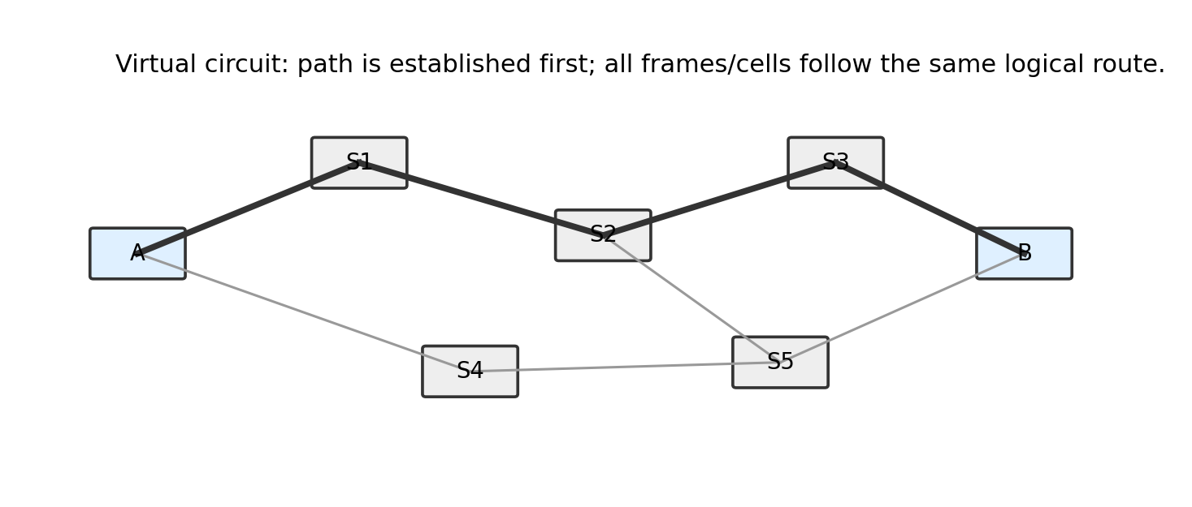
A virtual circuit creates a logical path before data transfer.
- Setup phase: path is established and identifiers are assigned.
- Data transfer phase: frames/cells follow the established path.
- Teardown phase: connection is released after communication ends.
Virtual circuit | Datagram switching
Connection-oriented | Connectionless
Path setup before data transfer | No prior path setup
All packets follow same route | Packets may follow different routes
Less per-packet routing decision after setup | Each packet routed independently
Example concepts: Frame Relay, ATM | Example: IP packet switching

Frame Relay
Frame Relay is a high-speed WAN technology based on virtual circuits. It was designed for relatively reliable digital links, so it removed much of the heavy error correction used in older networks. This made it faster and simpler.
- Uses virtual circuits: PVC (Permanent Virtual Circuit) and SVC (Switched Virtual Circuit).
- Identifies virtual circuits using DLCI - Data Link Connection Identifier.
- Performs minimal error checking and relies on higher layers for recovery.
- Suitable historically for connecting LANs over WAN links.
Term | Meaning
PVC | Permanent Virtual Circuit; preconfigured long-term logical connection.
SVC | Switched Virtual Circuit; established dynamically when needed.
DLCI | Identifier used in Frame Relay to identify a virtual circuit on a local link.
CIR | Committed Information Rate; guaranteed average data rate by provider.

ATM - Asynchronous Transfer Mode
ATM is a cell-switching technology. Instead of variable-size frames, ATM uses fixed-size cells of 53 bytes: 5-byte header and 48-byte payload. Fixed size makes switching predictable and useful for voice, video, and data integration.
ATM cell format
Total size: 53 bytes
Header : 5 bytes
Payload : 48 bytes
- Connection-oriented and virtual-circuit based.
- Uses fixed-size cells, not variable-size packets.
- Designed for high-speed networks and quality of service support.
- Important historically and conceptually, although not common in normal LAN use today.
Point | Frame Relay | ATM
Data unit | Variable-size frame | Fixed-size 53-byte cell
Connection type | Virtual circuit | Virtual circuit
Error control | Minimal | Header error control; recovery generally higher layer
Strength | Efficient WAN frame switching | Predictable switching and QoS support
Historical use | WAN interconnection | Backbone, voice/video/data integration

Exam-Angle
- For virtual circuit switching, always write setup, data transfer, and teardown phases.
- For ATM, remember 53-byte cell = 5-byte header + 48-byte payload. This exact number is frequently asked.

3.9 DLL Protocols: HDLC and PPP
Real-world hook: two people can communicate only if they agree on a format: how to start, how to end, how to mark errors, and how to identify the message type. HDLC and PPP are such agreed formats for data link communication.
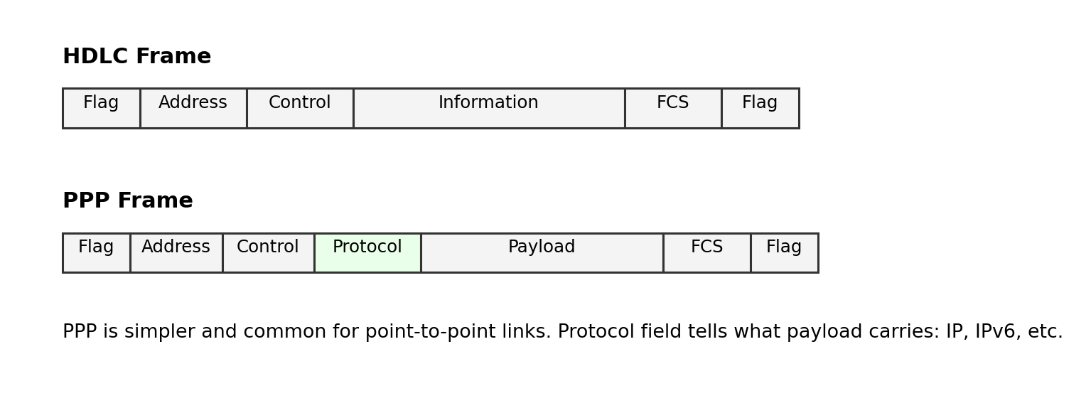
HDLC and PPP frame structures.

HDLC - High-Level Data Link Control
HDLC is a bit-oriented data link protocol. It supports reliable communication over point-to-point and multipoint links. It uses flags for frame boundaries and bit stuffing to prevent confusion between data and flag pattern.
- Bit-oriented protocol.
- Uses flag pattern 01111110 at beginning and end of frame.
- Uses bit stuffing.
- Supports different frame types: I-frame, S-frame, and U-frame.
- Uses FCS for error detection.
HDLC frame field | Purpose
Flag | Marks start/end of frame; usually 01111110
Address | Identifies secondary station, mainly in multipoint links
Control | Defines frame type and sequence/control information
Information | Carries user data; present mainly in I-frames
FCS | Frame Check Sequence for error detection

HDLC frame type | Full name | Purpose
I-frame | Information frame | Carries user data and sequence numbers.
S-frame | Supervisory frame | Flow/error control, ACK/NAK-like functions.
U-frame | Unnumbered frame | Link management and control.

PPP - Point-to-Point Protocol
PPP is a data link protocol used to carry network layer packets over point-to-point links. It is simpler than HDLC in many ways and was widely used in dial-up links, leased lines, and PPPoE contexts.
- Works on point-to-point links.
- Encapsulates multiple Network Layer protocols using the Protocol field.
- Uses LCP for link establishment, configuration, and testing.
- Uses NCPs to configure Network Layer protocols such as IP.
- Supports authentication methods such as PAP and CHAP in many implementations.
PPP component | Meaning
Encapsulation | Frame format for carrying packets over point-to-point link.
LCP - Link Control Protocol | Establishes, configures, tests, and terminates the link.
NCP - Network Control Protocol | Configures Network Layer protocols such as IP.
Authentication | Optional identity verification using PAP/CHAP.

Point | HDLC | PPP
Type | Bit-oriented data link protocol | Point-to-point data link protocol
Standard usage | General data link control | Internet point-to-point links
Protocol identification | Not as flexible in basic HDLC | Protocol field identifies payload type
Authentication | Not core feature | Supports PAP/CHAP
Configuration | Less internet-focused | LCP + NCP support

Exam-Angle
- For HDLC, remember flag, address, control, information, FCS, flag; and I/S/U frame types.
- For PPP, remember three parts: encapsulation, LCP, and NCP. Mention optional authentication for a better answer.

Final Quick Revision: Whole DLL Chapter

One-page concept map in words
Data Link Layer takes packets from Network Layer and turns them into frames for one-hop delivery. It uses framing to mark boundaries, MAC addressing to identify local devices, flow control to protect receiver buffers, error control to detect/correct damaged frames, and access control to share the medium. LLC gives a logical interface upward; MAC handles addressing and channel access downward.

High-yield comparison table
Topic | Must-remember points
DLL functions | Framing, physical addressing, flow control, error control, access control.
LLC vs MAC | LLC = upper interface/protocol identification; MAC = lower addressing/access to medium.
Framing | Character count, byte stuffing, bit stuffing, coding violation.
Flow control | Stop-and-Wait simple but inefficient; Sliding Window efficient but complex.
Error detection | Parity, checksum, CRC. CRC is strongest common frame error detection.
Error correction | Hamming code; parity positions at 1,2,4,8,...
ALOHA | Pure ALOHA transmits anytime; Slotted ALOHA transmits at slot boundaries.
Ethernet | 802.3, CSMA/CD in classic Ethernet, frame has MAC addresses and FCS.
Wi-Fi | 802.11, CSMA/CA because collision detection is hard in wireless.
ATM | Fixed 53-byte cell: 5-byte header + 48-byte payload.
HDLC | Flag 01111110, bit stuffing, I/S/U frames.
PPP | Point-to-point protocol: encapsulation + LCP + NCP.

Likely TU-style questions and answer hints
Question | What to include
Explain the functions of Data Link Layer. | Define DLL as node-to-node delivery layer and explain framing, addressing, flow control, error control, access control.
Differentiate LLC and MAC. | Use table: position, role, addressing, examples, focus.
Explain framing methods. | Define framing and explain character count, byte stuffing, bit stuffing, physical coding violation.
Compare Stop-and-Wait and Sliding Window flow control. | Discuss frames in transit, ACK, timeout, utilization, complexity.
Explain CRC with example. | Show append zeros, XOR division, remainder, transmitted codeword, receiver check.
Explain Hamming code. | Mention parity bits at powers of 2, formula 2^r >= m+r+1, syndrome locates error.
Compare Pure ALOHA and Slotted ALOHA. | Include transmission time, synchronization, vulnerable time 2T vs T, throughput 18.4% vs 36.8%.
Explain CSMA/CD. | Carrier sense, collision detection, jam signal, random backoff.
Why does Wi-Fi use CSMA/CA instead of CSMA/CD? | Mention cannot listen while transmitting reliably, hidden terminal, collision avoidance with ACK/backoff.
Explain Frame Relay and ATM. | Frame Relay uses virtual circuits/DLCI; ATM uses fixed 53-byte cells and QoS support.
Compare HDLC and PPP. | HDLC bit-oriented with I/S/U frames; PPP point-to-point with protocol field, LCP, NCP, authentication.

Notebook-ready short definitions
Term | Definition
Frame | A DLL data unit formed by adding header and trailer to a network-layer packet.
MAC address | A hardware address used for local delivery inside a LAN.
FCS | Frame Check Sequence; error detection field usually based on CRC.
ACK | Acknowledgement sent by receiver to confirm successful frame reception.
Collision | Condition where two or more stations transmit on shared medium at overlapping time and corrupt the signal.
Backoff | Random waiting time before retransmission after collision or failed transmission.
Token | A control frame that grants permission to transmit in token-based networks.
Virtual circuit | A logical connection/path established before data transfer.
DLCI | Frame Relay identifier for a virtual circuit on a local link.
LCP | PPP protocol used to establish, configure, and terminate point-to-point links.
NCP | PPP protocol family used to configure network-layer protocols.

Mini self-test
- Which DLL function creates boundaries around data?
A. Routing B. Framing C. Encryption D. Congestion control
Answer: B
- Which sublayer controls access to a shared medium?
A. LLC B. MAC C. IP D. TCP
Answer: B
- Which method is strongest for common frame error detection?
A. Simple parity B. CRC C. Character count D. Token passing
Answer: B
- In a 15-bit Hamming codeword, parity bits are at:
A. 1,2,3,4 B. 2,4,6,8 C. 1,2,4,8 D. 1,3,5,7
Answer: C
- ATM cell size is:
A. 48 bytes B. 53 bytes C. 64 bytes D. Variable
Answer: B

