Unit 4: Network Layer
Complete, exam-ready and long-term reference notes for BSc CSIT Computer Networks
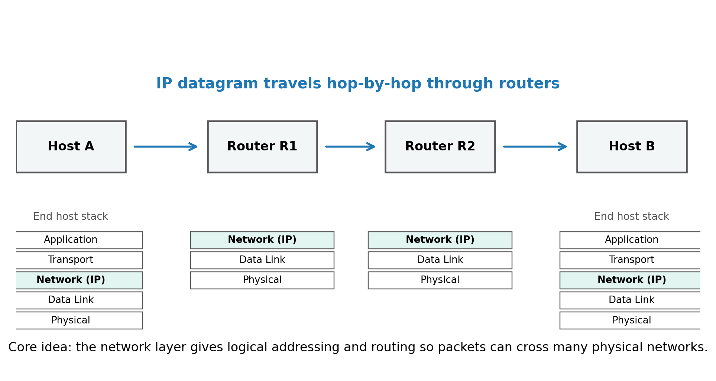
Figure 1. Network layer position and responsibility in an end-to-end communication path.
How to use this document
- Read in order first: addressing -> subnetting -> routing -> protocols -> security. The topics depend on each other.
- For exam answers: start with a definition, draw a small diagram, explain functions/fields/steps, then give one example.
- For practical skill: practice subnetting, longest-prefix match, ping/traceroute interpretation, and routing table reading.

Quick Table of Contents
1. 4.1 Introduction and Functions of the Network Layer
2. 4.2 IPv4 Addressing and Subnetting
3. 4.3 Classful and Classless Addressing
4. 4.4 IPv6 Addressing and its Features
5. 4.5 IPv4 and IPv6 Datagram Formats
6. 4.6 Comparison of IPv4 and IPv6 Addressing
7. 4.7 Example Addresses: Unicast, Multicast and Broadcast
8. 4.8 Routing: definition, types, algorithms and protocols
9. 4.9 IPv4 to IPv6 Transition Mechanisms
10. 4.10 ICMP, ICMPv6 and NATing
11. 4.11 Overview of Network Traffic Analysis
12. 4.12 Security Concepts: Firewall and Router Access Control
13. Exam-ready summaries, commands, formulas, glossary and references

One-sentence core idea
The network layer is the part of networking that gives every device a logical address and decides how packets move from a source network to a destination network across routers.

One best analogy
Think of the network layer like a national postal system: the IP address is the destination address on the envelope, routers are sorting centers, routing tables are the sorting rules, and each hop moves the envelope closer to the destination.

4.1 Introduction and Functions of the Network Layer

First-principles idea
A single physical network can deliver frames only inside its own local area, such as one Ethernet LAN or one Wi-Fi network. The internet is not one physical network; it is a huge collection of many networks connected by routers. The network layer exists to make communication possible across those different networks.

Definition
The network layer is Layer 3 of the OSI model. It is responsible for logical addressing, packet forwarding, routing, fragmentation-related decisions, and basic error-reporting support through protocols such as ICMP.

PDU name
The Protocol Data Unit at the network layer is usually called a packet or datagram. In IP, the exact term is IP datagram.

Major functions
Function | Meaning | Simple example
Logical addressing | Assigns addresses that identify source and destination hosts across networks. | IPv4: 192.168.1.10, IPv6: 2001:db8::10
Routing | Chooses the path from source network to destination network. | A router selects next-hop R2 because it has the best route to 10.10.0.0/16.
Forwarding | Moves a packet from an incoming interface to the correct outgoing interface. | Packet arrives on eth0, leaves through eth1.
Internetworking | Connects multiple physical networks into one logical internet. | Ethernet LAN -> router -> ISP network -> destination network.
Fragmentation handling | IPv4 routers may fragment packets if allowed; IPv6 routers do not fragment packets. | IPv4 packet larger than MTU may be split, unless DF bit is set.
Error reporting and diagnostics | Reports problems and supports tools like ping and traceroute. | ICMP Destination Unreachable, ICMP Time Exceeded.
Traffic control basics | Supports fields used for QoS and priority handling. | DSCP/Traffic Class field can mark priority.

Forwarding vs routing
Concept | Question it answers | Where it happens | Time scale
Forwarding | Where should this particular packet go next? | Data plane of the router | Very fast, per packet
Routing | What paths should be learned and installed in the routing table? | Control plane of routers/routing protocols | Slower, when topology or policy changes

Important devices and terms
- Host: An end device such as a laptop, phone, server or printer.
- Router: A Layer 3 device that forwards packets between different networks.
- Interface: A network connection on a host or router. Each Layer 3 interface usually has an IP address.
- Next hop: The next router or destination interface to which a packet should be sent.
- Routing table: A table containing destination prefixes and next-hop/outgoing-interface information.
- Default route: A route used when no more specific route matches. In IPv4 it is 0.0.0.0/0; in IPv6 it is ::/0.
- Longest prefix match: When multiple routes match, the router chooses the route with the longest network prefix, because it is the most specific.

4.2 IPv4 Addressing and Subnetting

What an IPv4 address is
IPv4 uses a 32-bit logical address. For human readability, the 32 bits are written as four decimal octets separated by dots. Each octet has 8 bits and ranges from 0 to 255.
Binary form: 11000000.10101000.00000001.00001010
Decimal form: 192.168.1.10
CIDR form: 192.168.1.10/24

Network part and host part
An IP address has two logical parts: the network prefix identifies the network, and the host part identifies a device inside that network. The subnet mask tells where the network part ends and the host part begins.
CIDR | Subnet mask | Network bits | Host bits | Addresses per subnet | Usable hosts in common LANs
/8 | 255.0.0.0 | 8 | 24 | 2^24 = 16,777,216 | 16,777,214
/16 | 255.255.0.0 | 16 | 16 | 2^16 = 65,536 | 65,534
/24 | 255.255.255.0 | 24 | 8 | 2^8 = 256 | 254
/26 | 255.255.255.192 | 26 | 6 | 2^6 = 64 | 62
/30 | 255.255.255.252 | 30 | 2 | 2^2 = 4 | 2
/32 | 255.255.255.255 | 32 | 0 | 1 | 1 host route

Important note: In ordinary IPv4 LAN subnets, network address and broadcast address are not assigned to hosts. That is why usable hosts are usually 2^host_bits - 2. Exceptions exist, such as /31 point-to-point links and /32 host routes.

Subnetting from first principles
Subnetting means dividing one large IP network into smaller networks. We do this by borrowing bits from the host part and using those borrowed bits as extra network bits.
1. Start with the given network and prefix length.
2. Decide how many subnets or hosts are required.
3. Borrow enough host bits to create the required number of subnets.
4. Calculate the new prefix length.
5. Find the block size in the interesting octet.
6. List network address, first usable address, last usable address and broadcast address for each subnet.

Subnetting formulas
Host bits = 32 - prefix_length
Total addresses in a subnet = 2^(host bits)
Usable hosts in ordinary IPv4 subnet = 2^(host bits) - 2
Number of subnets after borrowing b bits = 2^b
New prefix = old prefix + borrowed bits
Block size = 256 - subnet mask value in the interesting octet

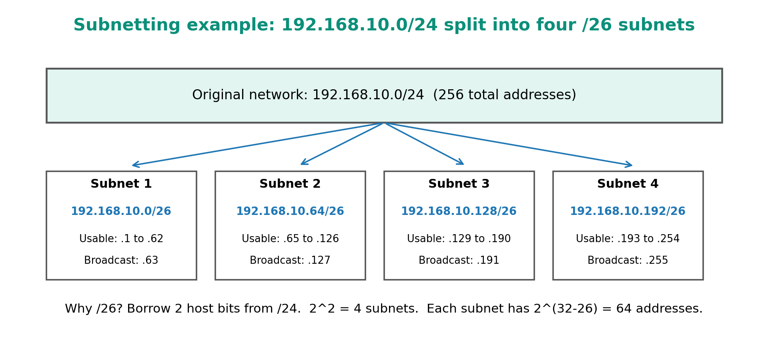
Figure 2. A /24 network divided into four equal /26 subnets.

Worked example 1: split 192.168.10.0/24 into 4 equal subnets
Step | Calculation | Result
1 | Need 4 subnets. 2^2 = 4, so borrow 2 bits. | Borrowed bits = 2
2 | Old prefix /24 + 2 borrowed bits. | New prefix = /26
3 | Host bits = 32 - 26 = 6. | Addresses per subnet = 2^6 = 64
4 | Usable hosts = 64 - 2. | 62 usable hosts per subnet
5 | Mask for /26 is 255.255.255.192. Block size = 256 - 192. | Block size = 64

Subnet | Network address | First usable | Last usable | Broadcast
1 | 192.168.10.0/26 | 192.168.10.1 | 192.168.10.62 | 192.168.10.63
2 | 192.168.10.64/26 | 192.168.10.65 | 192.168.10.126 | 192.168.10.127
3 | 192.168.10.128/26 | 192.168.10.129 | 192.168.10.190 | 192.168.10.191
4 | 192.168.10.192/26 | 192.168.10.193 | 192.168.10.254 | 192.168.10.255

Worked example 2: find the network of 172.16.35.77/20
A /20 mask is 255.255.240.0. The interesting octet is the third octet because 240 is not 255 or 0. Block size = 256 - 240 = 16. The third octet value is 35. The nearest lower multiple of 16 is 32. Therefore:
IP address: 172.16.35.77/20
Subnet mask: 255.255.240.0
Network address: 172.16.32.0
Broadcast: 172.16.47.255
Usable range: 172.16.32.1 to 172.16.47.254

VLSM: Variable Length Subnet Masking
VLSM means using different subnet sizes inside the same original network. It saves addresses because large departments get larger subnets and small departments get smaller subnets.
Requirement | Needed hosts | Smallest fitting subnet | Usable hosts
Lab A | 100 | /25 | 126
Lab B | 50 | /26 | 62
Office | 25 | /27 | 30
Point-to-point link | 2 | /30 | 2

VLSM rule: allocate the largest required subnet first. This avoids address-space fragmentation.

4.3 Classful and Classless Addressing

Classful addressing
In early IPv4, addresses were divided into fixed classes. The class was determined by the first octet. This was simple but wasteful because organizations often received blocks much larger than needed.
Class | First octet range | Default mask | Purpose | Key note
A | 1 to 126 | 255.0.0.0 (/8) | Very large networks | 127.x.x.x is reserved for loopback.
B | 128 to 191 | 255.255.0.0 (/16) | Medium networks | Large but less wasteful than Class A.
C | 192 to 223 | 255.255.255.0 (/24) | Small networks | Common in older LAN examples.
D | 224 to 239 | No normal host mask | Multicast | Used for group communication.
E | 240 to 255 | Reserved | Experimental/reserved | Not used as normal public host addresses.

Special IPv4 address ranges
Range | Meaning | Example use
10.0.0.0/8 | Private IPv4 range | Large internal enterprise network
172.16.0.0/12 | Private IPv4 range | Internal network with many subnets
192.168.0.0/16 | Private IPv4 range | Home and small-office networks
127.0.0.0/8 | Loopback | 127.0.0.1 means this same machine
169.254.0.0/16 | Link-local/APIPA | Automatic address when DHCP fails
0.0.0.0/0 | Default route | Matches any IPv4 destination
255.255.255.255 | Limited broadcast | Broadcast only on local network segment

Classless addressing: CIDR
Classless Inter-Domain Routing, usually called CIDR, removed the strict class boundaries. Instead of saying Class A/B/C, we write a prefix length such as /13, /21, /27 or /30. CIDR made address allocation more flexible and made route aggregation possible.
Classful thinking | Classless/CIDR thinking
The first octet decides the default network size. | The prefix length decides the network size.
Class A/B/C boundaries are fixed. | Any prefix length can be used, such as /19 or /27.
Often wastes addresses. | Allows efficient allocation and VLSM.
Less suitable for modern internet routing. | Supports route summarization and scalable routing.

Route summarization example
Four routes:
192.168.0.0/24
192.168.1.0/24
192.168.2.0/24
192.168.3.0/24

Can be summarized as:
192.168.0.0/22

Why? /22 covers 192.168.0.0 through 192.168.3.255.

4.4 IPv6 Addressing and its Features
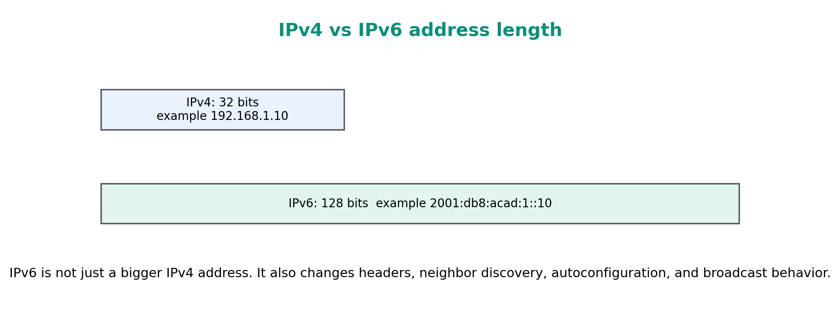
Figure 3. IPv6 uses 128-bit addresses compared with IPv4 32-bit addresses.

Why IPv6 was needed
- IPv4 has only 32-bit address space, which is too small for the number of modern internet-connected devices.
- NAT reduced the urgency of address exhaustion but also weakened the original end-to-end internet model.
- IPv6 provides a much larger address space and simplifies some parts of packet processing.

IPv6 notation
IPv6 addresses are 128 bits. They are written as eight groups of hexadecimal numbers separated by colons. Each group represents 16 bits.
Full form:
2001:0db8:0000:0000:0000:ff00:0042:8329

Compressed form:
2001:db8::ff00:42:8329

IPv6 compression rules
1. Leading zeros inside a group can be removed. Example: 0db8 becomes db8.
2. One continuous sequence of all-zero groups can be replaced with double colon ::.
3. The double colon :: can be used only once in one address, otherwise the expansion becomes ambiguous.

Common IPv6 address types and ranges
Type | Typical prefix / example | Meaning
Unspecified | :: | Means no address. Used before a device has an address.
Loopback | ::1 | Refers to the same device, like 127.0.0.1 in IPv4.
Global unicast | 2000::/3 | Publicly routable IPv6 address space.
Link-local | fe80::/10 | Valid only on the local link; used heavily by Neighbor Discovery.
Unique local | fc00::/7, commonly fd00::/8 | Private-like internal IPv6 address space.
Multicast | ff00::/8 | One-to-many group communication. IPv6 has no broadcast.
Documentation | 2001:db8::/32 | Used in examples and teaching material.

IPv6 features
Feature | Explanation
Huge address space | 128-bit addresses provide extremely large address capacity.
Simplified base header | IPv6 base header is fixed 40 bytes, making router processing more predictable.
No router fragmentation | Routers do not fragment IPv6 packets. The sender performs Path MTU Discovery.
Extension headers | Optional information is placed in extension headers instead of variable-length base header options.
SLAAC | Stateless Address Autoconfiguration allows a host to form an IPv6 address using router advertisements.
Neighbor Discovery | ICMPv6 Neighbor Discovery replaces ARP and supports router discovery.
No broadcast | IPv6 uses multicast and anycast instead of broadcast.
IPsec support in standards | IPv6 standards include IPsec support, but real-world use still depends on configuration and policy.

IPv6 address assignment methods
- Manual/static: Administrator assigns the IPv6 address manually.
- SLAAC: Host learns the network prefix from router advertisement and creates its own interface address.
- DHCPv6: A DHCPv6 server provides addresses and/or additional configuration.
- EUI-64 style interface ID: A method to form interface ID from MAC address, now often avoided for privacy.
- Privacy extensions: Hosts can generate temporary addresses to reduce tracking by stable interface IDs.

4.5 IPv4 and IPv6 Datagram Formats

What a datagram contains
An IP datagram has a header and data. The header contains control information used by routers and end hosts. The data part carries the upper-layer segment, such as a TCP segment or UDP datagram.
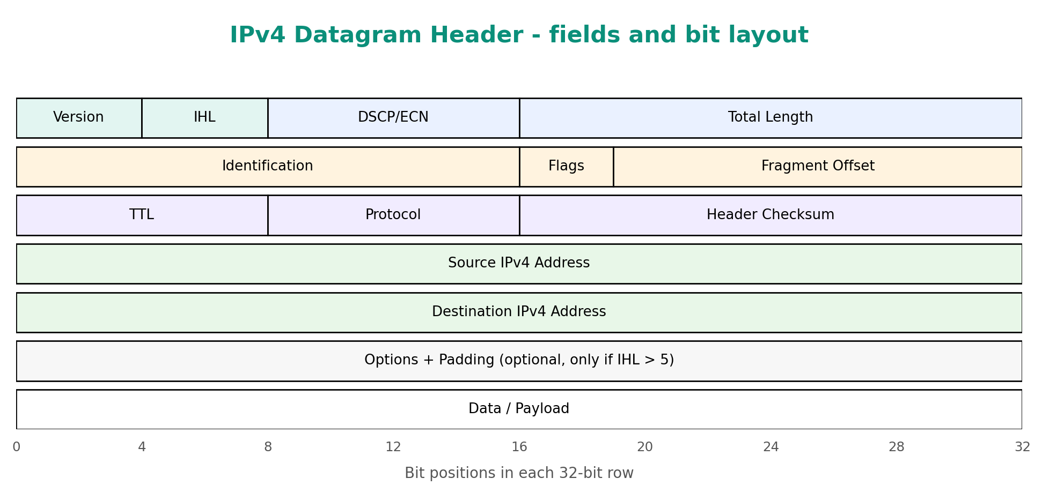
Figure 4. IPv4 datagram header fields.

IPv4 header fields explained
Field | Meaning
Version | IP version. For IPv4, value is 4.
IHL | Internet Header Length. Tells header length because IPv4 options can make the header variable length.
DSCP/ECN | Used for quality of service marking and congestion notification.
Total Length | Total size of IPv4 datagram including header and data.
Identification, Flags, Fragment Offset | Used for IPv4 fragmentation and reassembly.
TTL | Time To Live. Decremented at each router; packet is discarded when it reaches 0. Prevents infinite loops.
Protocol | Identifies the upper-layer protocol, such as TCP, UDP or ICMP.
Header Checksum | Error-checking value for IPv4 header only. Recomputed by every router because TTL changes.
Source Address | IPv4 address of sender.
Destination Address | IPv4 address of receiver.
Options | Optional control information. Rare in normal traffic because it slows processing.

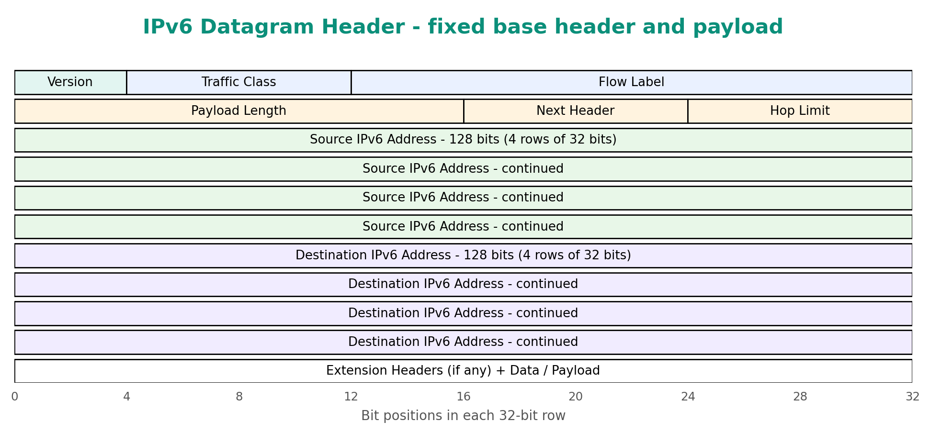
Figure 5. IPv6 base header fields.

IPv6 header fields explained
Field | Meaning
Version | IP version. For IPv6, value is 6.
Traffic Class | Similar role to DSCP/ECN in IPv4; used for priority and QoS marking.
Flow Label | Can label packets belonging to the same flow for special handling.
Payload Length | Length of the payload after the 40-byte base header.
Next Header | Identifies the next header: an extension header or an upper-layer protocol.
Hop Limit | IPv6 equivalent of TTL. Decremented by each router.
Source Address | 128-bit IPv6 address of sender.
Destination Address | 128-bit IPv6 address of receiver.

IPv4 fragmentation vs IPv6 fragmentation
Topic | IPv4 | IPv6
Who can fragment? | Sender and routers can fragment if fragmentation is allowed. | Only the sender fragments. Routers do not fragment.
Header support | Fragmentation fields are in the base header. | Fragmentation uses an extension header.
Path MTU Discovery | Useful but not always required. | Essential for efficient operation.
If packet too large | Router may fragment, or drop if DF bit is set. | Router drops and sends ICMPv6 Packet Too Big.

4.6 Comparison of IPv4 and IPv6 Addressing
Feature | IPv4 | IPv6
Address length | 32 bits | 128 bits
Notation | Dotted decimal, e.g., 192.168.1.10 | Hexadecimal colon notation, e.g., 2001:db8::10
Header size | Variable, usually 20 bytes without options | Fixed base header of 40 bytes
Broadcast | Supported | Not supported; multicast/anycast are used instead
ARP | Used to map IPv4 to MAC addresses | Replaced by ICMPv6 Neighbor Discovery
Fragmentation | Routers may fragment | Routers do not fragment
Checksum in IP header | Has IPv4 header checksum | No base-header checksum
Private/internal ranges | RFC1918 private ranges such as 192.168.0.0/16 | Unique local addresses such as fd00::/8 are commonly used
Configuration | Manual, DHCP, APIPA | Manual, SLAAC, DHCPv6
NAT dependence | Common because of address shortage | Not fundamentally required because address space is huge
Security | IPsec can be used but is not inherent to every connection | IPsec support is included in standards, but use still depends on configuration

Key exam point
Do not write that IPv6 is faster simply because it has bigger addresses. IPv6 can simplify some routing and header processing, but real speed depends on network design, routing, devices, MTU, DNS, firewall policy and ISP support.

4.7 Example Addresses: Unicast, Multicast and Broadcast

Address delivery types
Type | Meaning | IPv4 example | IPv6 example
Unicast | One sender to one receiver. | 192.168.1.10 | 2001:db8::10
Broadcast | One sender to all hosts on the local broadcast domain. | 192.168.1.255 or 255.255.255.255 | Not available in IPv6
Multicast | One sender to a selected group of receivers. | 224.0.0.1 | ff02::1
Anycast | One sender to the nearest member of a group, according to routing. | Possible but less visible in IPv4 | Common concept in IPv6 and DNS/CDN routing

More examples
IPv4 unicast host: 192.168.1.25/24
IPv4 network address: 192.168.1.0/24
IPv4 directed broadcast: 192.168.1.255
IPv4 limited broadcast: 255.255.255.255
IPv4 multicast: 224.0.0.1
IPv6 loopback: ::1
IPv6 link-local: fe80::1
IPv6 multicast all nodes: ff02::1
IPv6 documentation: 2001:db8::/32

Broadcast domain note
A router normally separates broadcast domains. A broadcast sent inside one LAN is not forwarded to other networks by default. This is one reason routers control traffic better than switches alone.

4.8 Routing

4.8.1 Introduction and Definition
Routing is the process of selecting paths in a network so that packets can travel from source to destination. A router uses its routing table to choose the next hop for each packet.

Routing table basics
Destination prefix | Next hop | Outgoing interface | Metric
192.168.1.0/24 | Directly connected | LAN | 0
10.10.0.0/16 | 192.168.1.1 | LAN | 10
172.16.0.0/12 | 192.168.1.254 | LAN | 20
0.0.0.0/0 | ISP gateway | WAN | 100

Longest-prefix match example
Routing table has:
10.0.0.0/8 -> R1
10.1.0.0/16 -> R2
10.1.2.0/24 -> R3
0.0.0.0/0 -> ISP

Destination packet: 10.1.2.55
Matching routes: /8, /16, /24, /0
Chosen route: 10.1.2.0/24 -> R3
Reason: /24 is the longest and most specific prefix.

4.8.2 Types of Routing

Static vs dynamic routing
Type | Meaning | Advantages | Limitations | Best use
Static routing | Routes are manually configured by administrator. | Simple, predictable, low overhead, secure when small. | Does not automatically adapt to failures. | Small networks, default routes, backup routes.
Dynamic routing | Routers learn routes automatically using routing protocols. | Scales better, adapts to topology changes. | More CPU/memory/bandwidth use; needs careful configuration. | Medium to large networks and ISPs.

Unicast vs multicast routing
Type | Goal | Example
Unicast routing | Deliver packets from one source to one destination. | User opens a website; packets route to one web server IP.
Multicast routing | Deliver packets from one source to many receivers in a multicast group. | Live streaming or routing protocol discovery messages.

Link-state vs distance-vector routing
Topic | Distance Vector | Link State
Main idea | Router tells neighbors its distance to networks. | Router learns topology and computes shortest paths.
Knowledge | Knows what neighbors advertise. | Builds a map of the network area.
Algorithm family | Bellman-Ford style. | Dijkstra SPF style.
Convergence | Generally slower; can suffer loops/count-to-infinity. | Generally faster and more stable.
Examples | RIP. | OSPF, IS-IS.

Interior vs exterior routing
Type | Meaning | Protocols
Interior Gateway Protocol (IGP) | Routing inside one autonomous system or organization. | RIP, OSPF, IS-IS, EIGRP
Exterior Gateway Protocol (EGP) | Routing between autonomous systems on the internet. | BGP

Autonomous System (AS)
An Autonomous System is a network or group of networks under one administrative control with a common routing policy. ISPs, universities, large companies and cloud providers often operate one or more AS numbers.

4.8.3 Path Computation Algorithms: Bellman-Ford and Dijkstra
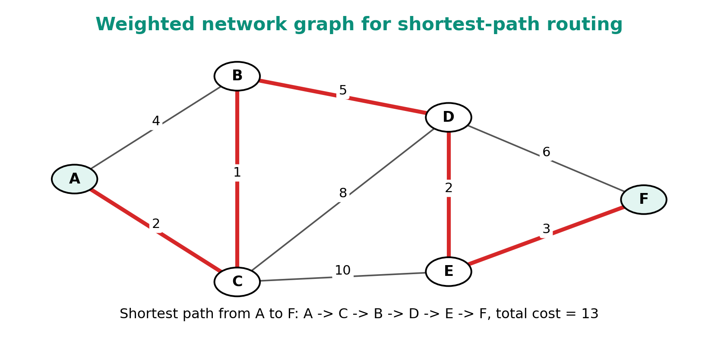
Figure 6. Weighted graph used to understand shortest-path routing.

Dijkstra shortest path algorithm
Dijkstra calculates the shortest path from one source node to all other nodes when link costs are non-negative. Link-state protocols such as OSPF use the SPF idea based on Dijkstra.
Dijkstra idea:
1. Mark the source node distance as 0 and all others as infinity.
2. Pick the unvisited node with the smallest tentative distance.
3. Relax its neighbors: if going through this node gives a smaller cost, update the cost.
4. Mark this node as visited.
5. Repeat until all nodes are visited or the destination is reached.

Dijkstra pseudocode
for each node v:
distance[v] = infinity
previous[v] = none

distance[source] = 0
unvisited = all nodes

while unvisited is not empty:
u = unvisited node with smallest distance[u]
remove u from unvisited

for each neighbor v of u:
alt = distance[u] + cost(u, v)
if alt < distance[v]:
distance[v] = alt
previous[v] = u

Bellman-Ford algorithm
Bellman-Ford repeatedly relaxes edges. It can work even with negative edge weights and can detect negative cycles in general graph theory. In routing, distance-vector protocols use the Bellman-Ford style idea: each router updates its best distance using information from neighbors.
Bellman-Ford idea:
1. Set source distance to 0 and all other distances to infinity.
2. Repeat V - 1 times, where V is the number of vertices:
for every edge (u, v) with cost w:
if distance[u] + w < distance[v]:
distance[v] = distance[u] + w
3. Optional: check once more. If any distance still improves, a negative cycle exists.

Algorithm comparison
Point | Dijkstra | Bellman-Ford
Routing style relation | Link-state routing. | Distance-vector routing.
Main input | Complete topology map inside an area. | Neighbor distance information.
Speed | Usually faster for normal positive weights. | Usually slower because updates are iterative.
Negative weights | Not suitable for negative weights. | Can handle negative weights and detect negative cycles in general graphs.
Routing example | OSPF SPF calculation. | RIP-like distance updates.

Count-to-infinity problem
Distance-vector protocols can temporarily believe bad routes because routers learn indirectly from neighbors. If a route fails, neighbors may keep telling each other that a destination is reachable through the other one. This creates slow convergence called the count-to-infinity problem.
- Split horizon: Do not advertise a route back out the interface from which it was learned.
- Route poisoning: Advertise failed routes with an infinite metric.
- Hold-down timer: Wait before accepting unstable route updates.

4.8.4 Routing Protocols: RIP, OSPF and BGP

Routing protocol comparison
Protocol | Type | Metric / decision basis | Scope | Important facts
RIP | Distance-vector IGP | Hop count | Inside small networks | Max usable hop count is 15; 16 means unreachable. Simple but slow for large networks.
OSPF | Link-state IGP | Cost, often based on bandwidth | Inside an organization/AS | Uses areas, LSAs and Dijkstra SPF. Scales better than RIP.
BGP | Path-vector EGP | Policy and path attributes, not only shortest path | Between autonomous systems | Uses AS_PATH and policies. Core protocol of internet inter-domain routing.

RIP - Routing Information Protocol
- Protocol family: Distance-vector IGP.
- Metric: Hop count. Each router crossed adds one hop.
- Maximum: 15 hops is the maximum reachable metric; 16 means unreachable.
- Strength: Very simple to understand and configure.
- Weakness: Poor scalability and slower convergence compared with modern link-state protocols.

OSPF - Open Shortest Path First
- Protocol family: Link-state IGP.
- Metric: Cost, commonly based on interface bandwidth.
- Core idea: Routers flood Link-State Advertisements so each router can build the same topology database for an area.
- Algorithm: Dijkstra SPF computes the shortest-path tree.
- Area concept: Large OSPF networks are divided into areas. Area 0 is the backbone area.
- Strength: Faster convergence and better scalability than RIP in enterprise networks.

BGP - Border Gateway Protocol
- Protocol family: Path-vector EGP.
- Where used: Between autonomous systems, especially between ISPs and large organizations.
- Transport: BGP sessions run over TCP.
- Decision style: Policy-based. It does not simply choose the path with fewest routers.
- Important attribute: AS_PATH shows the autonomous systems a route has crossed and helps prevent loops.
- Why it matters: BGP is a major protocol that makes the global internet routing system possible.

Simple configuration-style examples
These are simplified examples to make the idea concrete. Exact syntax depends on router vendor and OS.
Static default route idea:
ip route 0.0.0.0 0.0.0.0 192.168.1.1

RIP idea:
router rip
version 2
network 192.168.1.0
network 10.0.0.0

OSPF idea:
router ospf 1
network 192.168.1.0 0.0.0.255 area 0

BGP idea:
router bgp 65001
neighbor 203.0.113.2 remote-as 65002

Do not memorize commands blindly. Understand the intention: each protocol needs to know which networks/interfaces participate and who its neighbors are.

4.9 Overview of IPv4 to IPv6 Transition Mechanisms

Why transition mechanisms are needed
IPv4 and IPv6 are different network-layer protocols. An IPv4-only host cannot directly communicate with an IPv6-only host without some transition mechanism. Because the whole internet cannot change overnight, transition mechanisms allow both protocols to coexist.
Mechanism | Basic idea | When useful | Limitation
Dual stack | Devices run both IPv4 and IPv6. | Best when network and ISP support both. | Requires maintaining two protocol stacks.
Tunneling | IPv6 packet is carried inside an IPv4 packet, or vice versa. | Connecting IPv6 islands through IPv4 infrastructure. | Adds overhead and can complicate MTU/troubleshooting.
Translation | A translator converts between IPv4 and IPv6 packets. | IPv6-only client needs to reach IPv4 service. | Some protocols/apps may break because addresses are changed.
NAT64 + DNS64 | DNS64 creates synthetic IPv6 records; NAT64 translates IPv6 client traffic to IPv4 server traffic. | IPv6-only networks accessing IPv4 internet. | Works best for client-initiated traffic and DNS-based access.
DS-Lite | IPv4 traffic is tunneled through IPv6 ISP network to carrier-grade NAT. | ISPs moving core networks to IPv6 while customers still need IPv4. | Customer may not have normal public IPv4 inbound access.

Best practical strategy
For a modern network, the clean target is dual-stack first, then gradually prefer IPv6 while keeping IPv4 for services and users that still need it. Translation and tunneling are useful but should not become permanent complexity unless necessary.

4.10 Overview of ICMP, ICMPv6 and NATing

ICMP: Internet Control Message Protocol
ICMP is a network-layer support protocol used for error reporting and diagnostics. It does not carry application data like TCP or UDP. It tells hosts and routers about network problems or diagnostic replies.
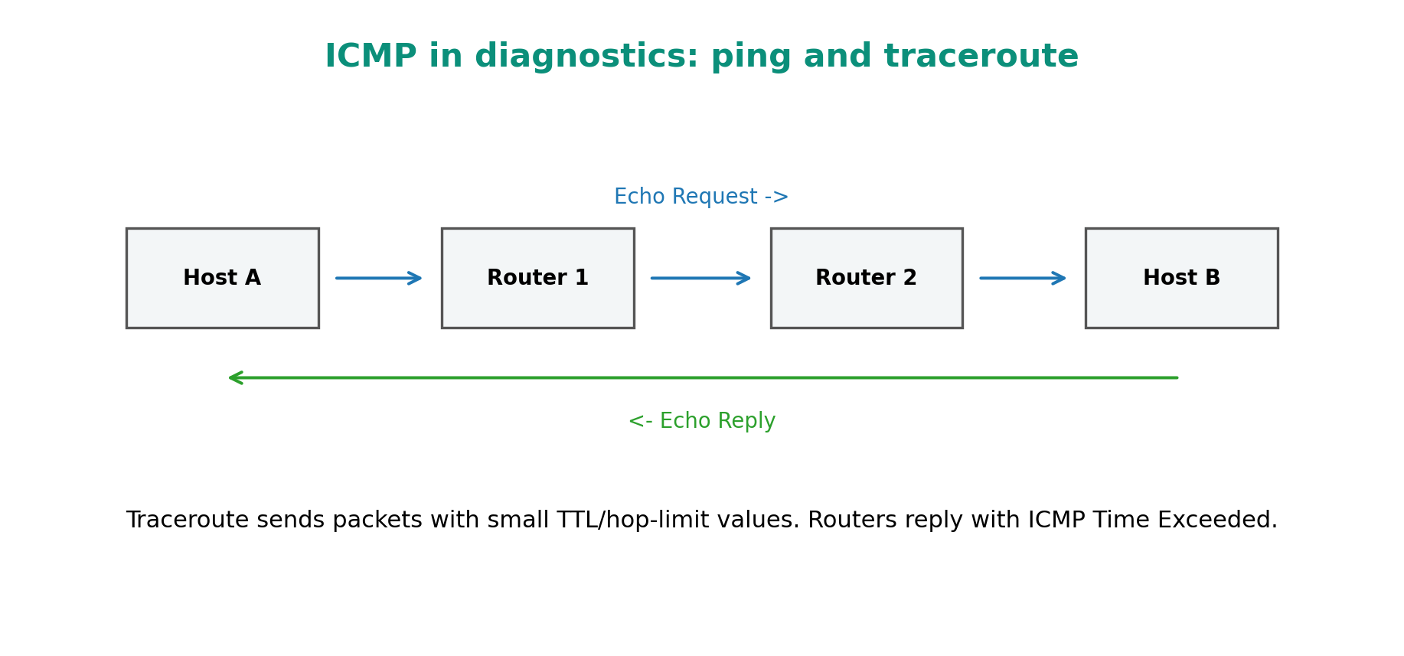
Figure 7. ICMP Echo Request/Reply and Time Exceeded use in diagnostics.
ICMP message / use | Meaning
Echo Request and Echo Reply | Used by ping to test reachability and round-trip time.
Destination Unreachable | Packet could not be delivered to destination/network/port.
Time Exceeded | TTL/hop limit reached 0; used by traceroute to discover path.
Redirect | Router tells host about a better next hop on the local network.

ICMPv6 is more essential than ICMPv4
In IPv6, ICMPv6 is not only for ping and errors. It also supports Neighbor Discovery, router discovery, address resolution, duplicate address detection and Path MTU Discovery.
ICMPv6 function | Purpose
Neighbor Solicitation / Advertisement | Find a neighbor MAC address and verify reachability. Replaces ARP.
Router Solicitation / Advertisement | Hosts discover routers and learn IPv6 prefix information.
Packet Too Big | Supports Path MTU Discovery because IPv6 routers do not fragment packets.
Duplicate Address Detection | Checks whether an IPv6 address is already used on the link.

NATing: Network Address Translation
NAT changes IP address information in packet headers. The most common form in homes and offices is Source NAT with PAT, where many private IPv4 devices share one public IPv4 address by using different port numbers.
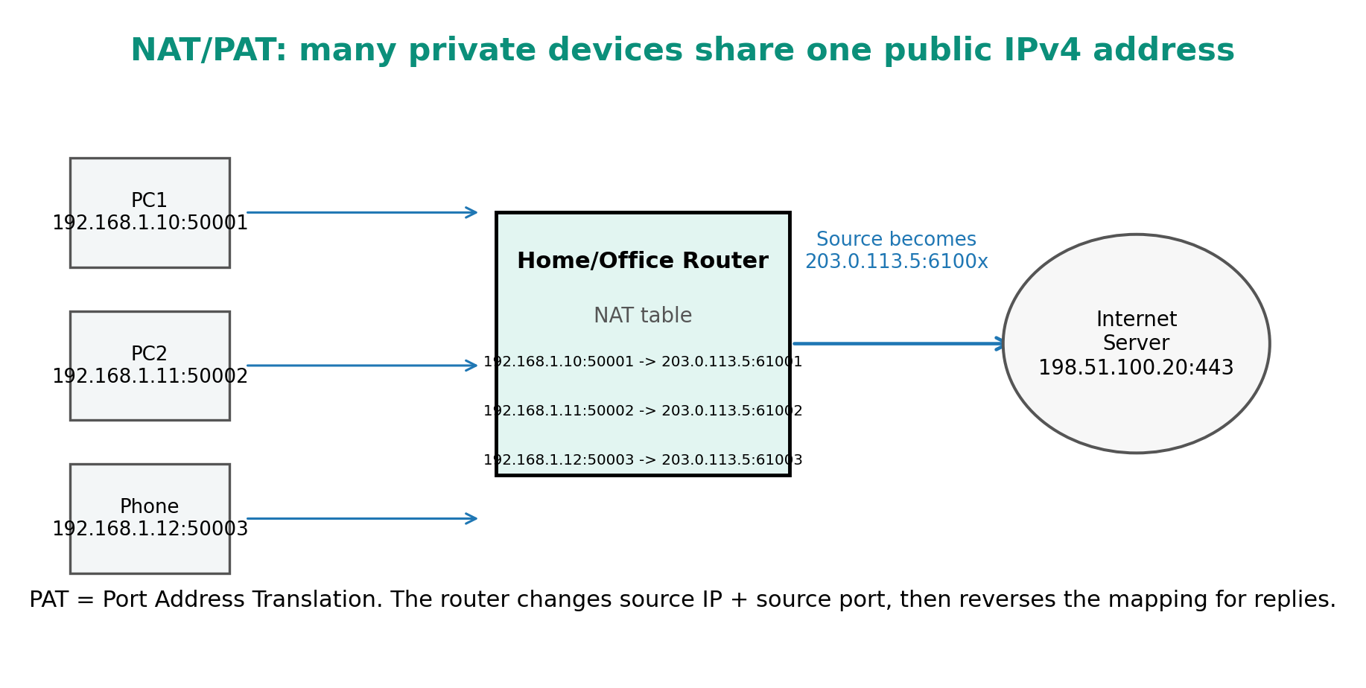
Figure 8. NAT/PAT translation of private IPv4 addresses to one public IPv4 address.
NAT type | Meaning | Example
Static NAT | One private address is mapped to one public address permanently. | Internal server 192.168.1.10 maps to 203.0.113.10.
Dynamic NAT | Private hosts use a pool of public addresses temporarily. | A company has a public pool and assigns as needed.
PAT / NAT overload | Many private hosts share one public IP using different ports. | Home router with many devices behind one ISP public IP.
Destination NAT / Port forwarding | Inbound public address/port is translated to an internal server. | 203.0.113.5:80 forwards to 192.168.1.20:80.
Carrier-Grade NAT | ISP performs NAT for many customers. | Users share public IPv4 at ISP level.

NAT advantages and disadvantages
Advantages | Disadvantages
Conserves public IPv4 addresses. | Breaks the pure end-to-end addressing model.
Hides internal addressing structure from outside. | Can make inbound hosting, peer-to-peer, VoIP and gaming harder.
Simple for home/small office internet sharing. | Requires translation state; troubleshooting can be harder.
Can work with private IPv4 ranges. | NAT itself is not a complete security solution; firewall rules are still needed.

4.11 Overview of Network Traffic Analysis

Definition
Network traffic analysis means observing and interpreting network traffic to understand performance, troubleshoot problems, detect attacks and plan capacity. It can use full packet captures, flow summaries, logs, counters and alerts.

What can be analyzed
Data source | What it contains | Example tools / sources
Packet capture | Full packet headers and sometimes payload. | Wireshark, tcpdump
Flow records | Conversation summaries: source, destination, ports, bytes, time. | NetFlow, sFlow, IPFIX
Device counters | Interface errors, drops, utilization. | Router/switch counters, SNMP
Logs | Firewall decisions, DNS queries, authentication events. | Firewall logs, server logs, SIEM
Active tests | Synthetic measurements such as ping/traceroute. | ping, traceroute, mtr

Key metrics
Metric | Meaning | Why it matters
Bandwidth | Maximum capacity of a link. | A 100 Mbps link cannot carry 1 Gbps without congestion.
Throughput | Actual achieved data rate. | Shows real performance experienced by users.
Latency | Time taken for data to travel from source to destination. | High latency makes interactive apps slow.
Jitter | Variation in delay. | Bad for voice/video calls.
Packet loss | Packets dropped or not delivered. | Causes retransmissions and poor quality.
Utilization | Percentage of link capacity being used. | High sustained utilization can indicate bottleneck.

Basic troubleshooting workflow
1. Check local IP address, subnet mask, gateway and DNS configuration.
2. Ping the loopback address to verify local TCP/IP stack.
3. Ping local gateway to verify LAN connectivity.
4. Ping a public IP to verify internet reachability without DNS dependency.
5. Use DNS lookup to test name resolution.
6. Use traceroute to locate where the path fails or becomes slow.
7. Check firewall/NAT/routing rules if traffic reaches some networks but not others.
Useful commands:
Windows: ipconfig /all
Linux: ip addr
Test reachability: ping 8.8.8.8
Trace path: tracert 8.8.8.8 (Windows)
Trace path: traceroute 8.8.8.8 (Linux)
DNS check: nslookup example.com
Sockets/routes: netstat -rn, ss -tulpen, ip route

Ethical note
Traffic analysis should be done only on networks you own, administer or have permission to test. Packet captures can contain private data such as addresses, cookies, tokens and unencrypted content.

4.12 Security Concepts: Firewall and Router Access Control

Why network-layer security matters
Routers and firewalls sit at important traffic boundaries. A wrong route or weak access control rule can expose private systems, allow attacks, or break service availability.
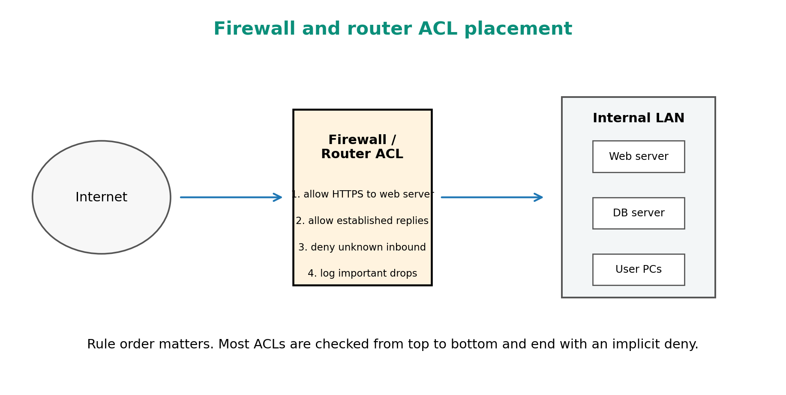
Figure 9. Firewall/router ACLs filter traffic between networks.

Firewall basics
Firewall type | What it checks | Example
Packet-filtering firewall | IP addresses, ports, protocol and direction. | Block inbound TCP port 23.
Stateful firewall | Tracks connection state and allows replies for permitted connections. | Allow outbound web browsing and return traffic.
Application/proxy firewall | Understands application-layer behavior. | HTTP proxy filtering web requests.
Next-generation firewall | Combines stateful filtering with application awareness, IDS/IPS and identity features. | Enterprise perimeter firewall.
Host firewall | Runs on a single device. | Windows Defender Firewall, Linux ufw/nftables.

Router Access Control List (ACL)
An ACL is an ordered set of permit/deny rules used by routers or firewalls to control traffic. Rules are usually checked from top to bottom. The first matching rule is applied. Many ACL systems end with an implicit deny, meaning unmatched traffic is blocked.

Standard vs extended ACL idea
ACL type | Checks | Example use
Standard ACL | Usually checks source IP only. | Block a source network from accessing a router.
Extended ACL | Checks source, destination, protocol and ports. | Allow LAN users to access web server on TCP 443 but block other inbound traffic.

ACL design principles
- Least privilege: Allow only what is required.
- Specific before general: Put narrow permit/deny rules before broad rules.
- Document every rule: Write why the rule exists.
- Avoid accidental lockout: When controlling router management access, keep a tested admin path.
- Log important drops: Logging helps investigation, but excessive logging can overload devices.
- Review regularly: Old rules often become security risks.

Simplified ACL examples
Goal: allow internal LAN to browse web; block unknown inbound traffic.

permit tcp 192.168.1.0/24 any destination-port 80
permit tcp 192.168.1.0/24 any destination-port 443
permit established return traffic
deny any any log

Goal: allow only admin PC to SSH into router.

permit tcp 192.168.1.50 router-management-ip destination-port 22
deny tcp any router-management-ip destination-port 22 log

Firewall vs NAT
Point | Firewall | NAT
Main purpose | Permit or deny traffic according to security policy. | Translate IP addresses and/or ports.
Security role | Direct security control. | Can hide internal addresses, but not a complete security policy.
Example | Block inbound SSH from internet. | Translate 192.168.1.10 to public IP 203.0.113.5.

Exam-Ready Summary and Answer Templates

High-yield definitions
Term | Short definition
Network layer | OSI Layer 3 responsible for logical addressing, routing and packet forwarding across networks.
IP address | Logical Layer 3 address identifying a host/interface in a network.
Subnet mask | Value that separates network bits from host bits in IPv4.
CIDR | Classless notation using prefix length, such as 192.168.1.0/24.
Router | Layer 3 device that forwards packets between networks using a routing table.
Routing | Process of selecting paths through a network.
Forwarding | Actual per-packet movement from input interface to output interface.
Default route | Route used when no more specific route matches.
ICMP | Support protocol for network-layer errors and diagnostics.
NAT | Translation of IP addresses/ports, commonly used to share public IPv4.
Firewall | Security system that filters traffic based on rules and state.

5-mark answer template: Functions of Network Layer
Definition:
The network layer is Layer 3 of the OSI model. It enables delivery of packets from a source host to a destination host across multiple interconnected networks.

Main functions:
1. Logical addressing using IPv4/IPv6 addresses.
2. Routing path selection from source network to destination network.
3. Forwarding packets from incoming interface to outgoing interface.
4. Internetworking different physical networks.
5. Fragmentation handling and MTU-related decisions.
6. Error reporting and diagnostics through ICMP/ICMPv6.

Conclusion:
Without the network layer, communication would mostly remain limited to a local physical network.

5-mark answer template: IPv4 vs IPv6
IPv4 uses 32-bit dotted-decimal addresses such as 192.168.1.10.
IPv6 uses 128-bit hexadecimal colon-separated addresses such as 2001:db8::10.

Major differences:
- IPv4 header is variable length; IPv6 base header is fixed 40 bytes.
- IPv4 supports broadcast; IPv6 does not use broadcast.
- IPv4 uses ARP; IPv6 uses ICMPv6 Neighbor Discovery.
- IPv4 routers may fragment packets; IPv6 routers do not fragment.
- NAT is very common in IPv4; IPv6 usually avoids NAT because of large address space.

IPv6 was introduced mainly to solve IPv4 address exhaustion and improve long-term internet scalability.

Subnetting exam checklist
- Write the given network and prefix clearly.
- Calculate host bits = 32 - prefix.
- Calculate required borrowed bits if number of subnets is given.
- Write the new subnet mask.
- Find block size in the interesting octet.
- List network address, usable range and broadcast address.
- Double-check that subnets do not overlap.

Common mistakes to avoid
- Confusing routing with forwarding. Routing builds/selects paths; forwarding moves each packet.
- Writing that switches route IP packets. Normal switches work mainly at Layer 2; routers work at Layer 3.
- Forgetting that IPv6 has no broadcast.
- Using 2^host_bits as usable hosts without subtracting 2 for ordinary IPv4 LAN subnets.
- Thinking NAT is the same as firewall. NAT translates; firewall filters.
- Forgetting longest-prefix match in routing table questions.
- Saying BGP chooses shortest path only. BGP is policy-based and uses path attributes.

Quick Reference: Formulas, Ranges and Protocol Facts

Subnetting quick formulas
Host bits = 32 - prefix
Total addresses = 2^(host bits)
Usable hosts = 2^(host bits) - 2 [ordinary IPv4 LAN subnet]
Subnets after borrowing b bits = 2^b
Block size = 256 - mask value in interesting octet
New prefix = old prefix + borrowed bits

Private IPv4 ranges
Range | CIDR | Common use
10.0.0.0 to 10.255.255.255 | 10.0.0.0/8 | Large private networks
172.16.0.0 to 172.31.255.255 | 172.16.0.0/12 | Medium/large private networks
192.168.0.0 to 192.168.255.255 | 192.168.0.0/16 | Home/small office networks

Routing protocol memory table
Protocol | Category | Algorithm idea | Metric / basis | Best memory hook
RIP | Distance-vector IGP | Bellman-Ford style | Hop count | Simple, max 15 hops
OSPF | Link-state IGP | Dijkstra SPF | Cost | Builds topology map inside an AS
BGP | Path-vector EGP | Policy/path attributes | AS_PATH and many attributes | Connects autonomous systems on the internet

Glossary
Term | Meaning
ARP | Address Resolution Protocol. Maps IPv4 address to MAC address on a local network.
AS | Autonomous System. A network under one administrative routing policy.
CIDR | Classless Inter-Domain Routing. Prefix-length based addressing such as /24.
Datagram | A self-contained packet with enough header information to be routed.
Default gateway | Router used by a host to reach networks outside the local subnet.
Hop | One router-to-router or host-to-router step in a path.
IGP | Interior Gateway Protocol, used inside an organization/AS.
EGP | Exterior Gateway Protocol, used between ASes.
MTU | Maximum Transmission Unit. Maximum frame payload size a link can carry.
Next hop | The next router/interface to send a packet toward.
Prefix | Network portion of an IP address, written as /n.
SLAAC | IPv6 Stateless Address Autoconfiguration.
TTL/Hop Limit | Field decremented by routers to prevent endless loops.

Practice Questions for Mastery

Concept questions
1. Why is the network layer needed if the data link layer already delivers frames?
2. Differentiate routing and forwarding with one example.
3. Explain logical addressing with IPv4 and IPv6 examples.
4. Why did IPv6 remove broadcast?
5. Why does a router use longest-prefix match?
6. Compare RIP, OSPF and BGP in terms of type, metric and scope.
7. Explain why NAT is not equal to firewall security.
8. How does traceroute use TTL/hop limit and ICMP?

Subnetting practice
1. Divide 192.168.20.0/24 into 8 equal subnets. Find new prefix, block size and usable range of first two subnets.
2. Find network address and broadcast address for 172.16.50.100/20.
3. A department needs 60 hosts. What is the smallest ordinary IPv4 subnet prefix that can support it?
4. A network 10.0.0.0/24 must support 100, 50, 25 and 10 hosts. Allocate subnets using VLSM.

Answers - quick check
1) 192.168.20.0/24 into 8 subnets:
Borrow 3 bits because 2^3 = 8. New prefix /27.
Block size = 32. First subnet: 192.168.20.0/27, usable .1-.30, broadcast .31.
Second subnet: 192.168.20.32/27, usable .33-.62, broadcast .63.

2) 172.16.50.100/20:
/20 mask = 255.255.240.0. Block size in third octet = 16.
50 falls in 48-63 block.
Network = 172.16.48.0, broadcast = 172.16.63.255.

3) 60 hosts:
Need 2^h - 2 >= 60. h = 6 gives 62 usable. Prefix = 32 - 6 = /26.

4) VLSM order:
100 hosts -> /25, 50 hosts -> /26, 25 hosts -> /27, 10 hosts -> /28.
Allocate largest first from 10.0.0.0/24.

Recommended References for Long-Term Study
- Behrouz A. Forouzan, Data Communications and Networking - very student-friendly for addressing, routing and protocols.
- Andrew S. Tanenbaum and David J. Wetherall, Computer Networks - deeper conceptual treatment.
- RFC 791 - Internet Protocol (IPv4).
- RFC 8200 - Internet Protocol, Version 6 (IPv6).
- RFC 792 - ICMP for IPv4.
- RFC 4443 - ICMPv6.
- RFC 1918 - Private IPv4 address allocation.
- RFC 4632 - Classless Inter-domain Routing (CIDR).
- RFC 2328 - OSPF Version 2.
- RFC 4271 - Border Gateway Protocol 4 (BGP-4).

Final mental model
Data link layer moves frames inside one local network. The network layer moves packets across many networks. IP addressing names the destination, routing chooses the path, forwarding moves each packet to the next hop, and protocols such as ICMP, OSPF, RIP and BGP support diagnosis and route learning.

