SOC Week 2 Report
Date: 2025-09-29

Alert Priority Levels:
Security alerts are prioritized based on severity, impact, and urgency.
- Critical: Active exploitation or major service disruption (e.g., ransomware encryption, CVSS ≥ 9).
- High: Unauthorized access to sensitive systems or data exfiltration.
- Medium: Suspicious activity that could lead to compromise (e.g., multiple failed logins).
- Low: Informational or benign events.
The Common Vulnerability Scoring System (CVSS) helps quantify risk using base, temporal, and environmental metrics.
Incident Classification:
- Incidents are categorized to help analysts respond efficiently.
- Common types include malware, phishing, DDoS, insider threats, and data exfiltration.
Frameworks like MITRE ATT&CK map attacker behaviors to standardized techniques (e.g., T1566 – Phishing).
- Classification also involves contextual details such as affected hosts, user accounts, timestamps, and IOCs (Indicators of Compromise).
- Consistent classification improves correlation, reporting, and automation within SOC workflows.

Incident Response Lifecycle:
Effective incident response follows the six-phase NIST model:
- Preparation: Build response plans, playbooks, and train staff.
- Identification: Detect and validate suspicious activity.
- Containment: Isolate affected systems to stop further spread.
- Eradication: Remove the root cause (e.g., malware cleanup).
- Recovery: Restore normal operations and monitor stability.
- Lessons Learned: Document actions taken, update defenses, and improve detection rules.
This lifecycle ensures a structured, repeatable process for handling security events and minimizing impact.
Objectives:
Develop skills to assess and prioritize alerts using standardized criteria for efficient SOC operations.

CVSS specification and user guide and calculator:
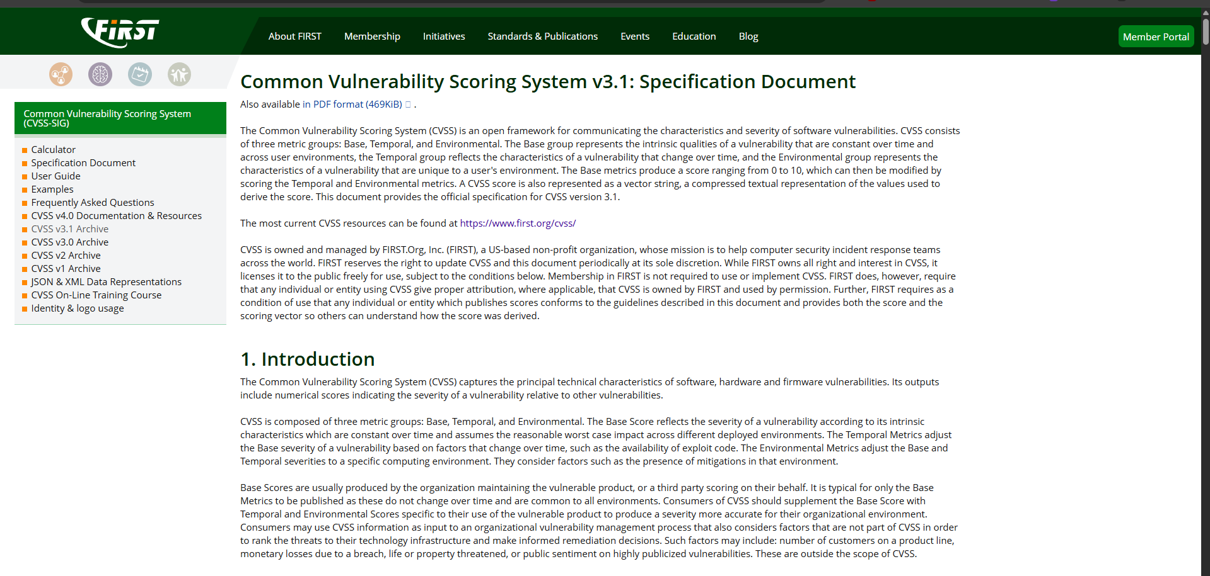

Severity Rating Scale:

Rating | CVSS Score
None | 0.0
Low | 0.1 - 3.9
Medium | 4.0 - 6.9
High | 7.0 - 8.9
Critical | 9.0 - 10.0

priority rule you can compute in one column:
- If CVSS ≥ 9.0 OR Asset = Production AND Exploit Likelihood = High → Critical
- Else if CVSS ≥ 7.0 OR Business Impact = High → High
- Else if CVSS ≥ 4.0 → Medium
- Else Low
Log4Shell:
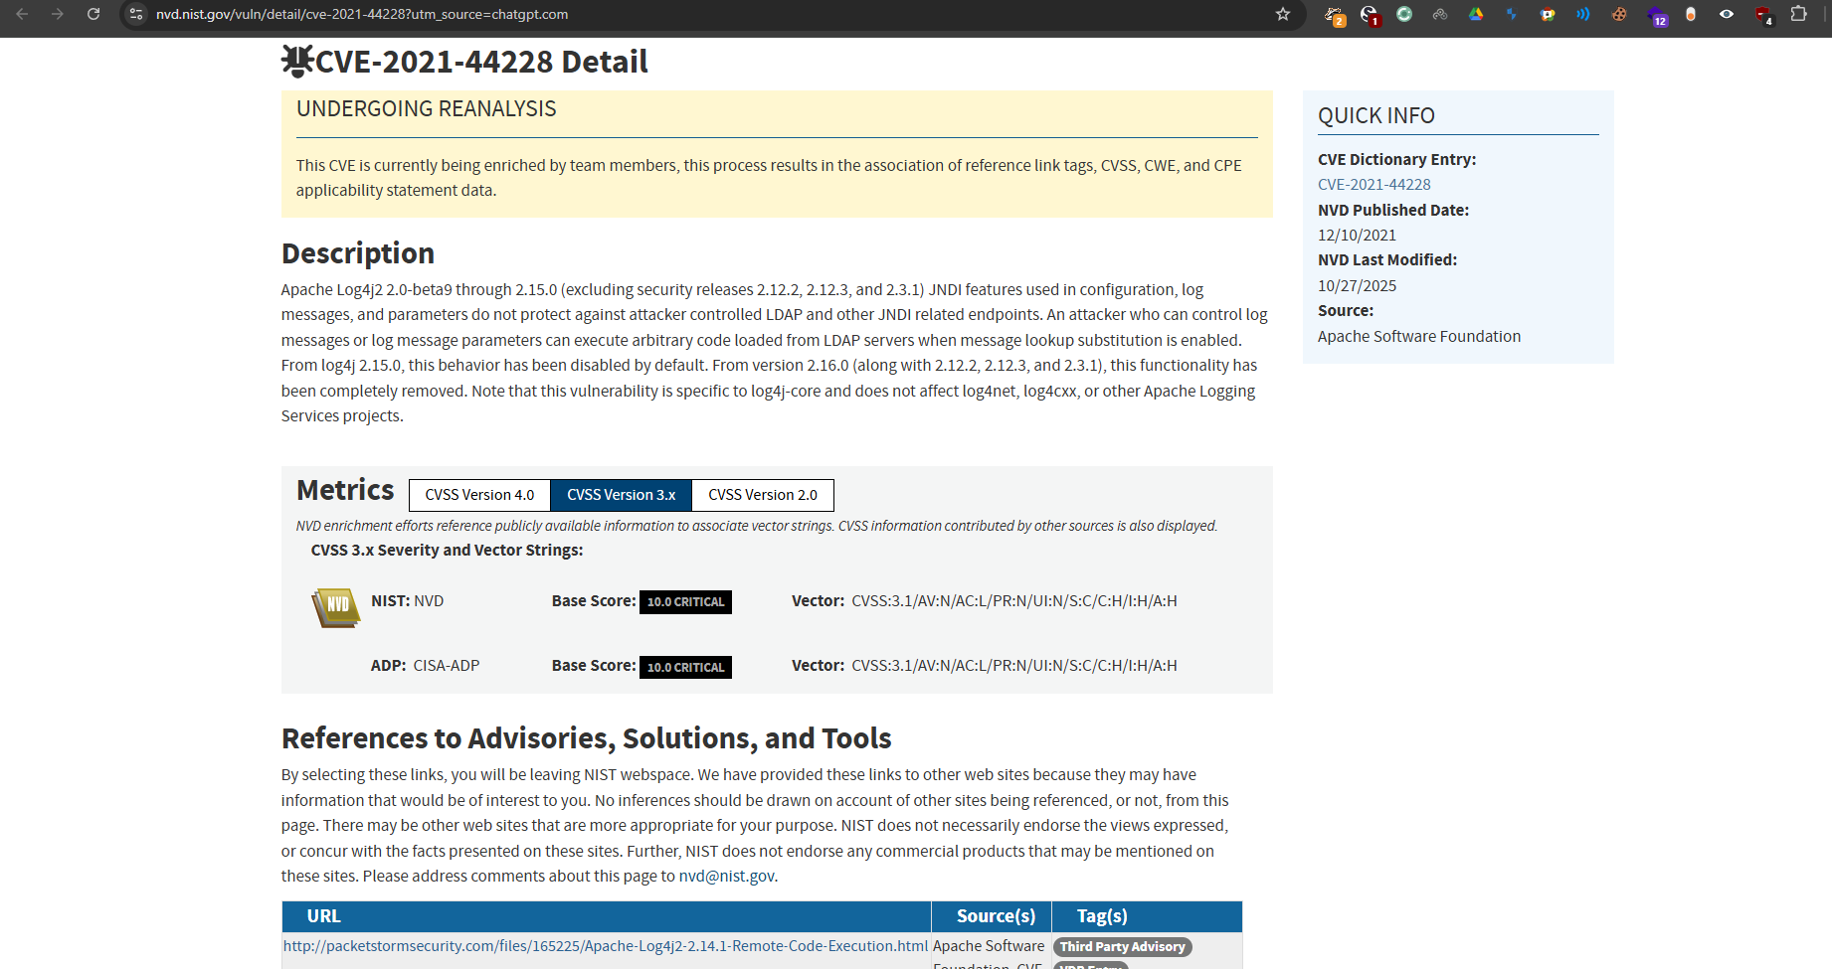

Alert Prioritization Table:
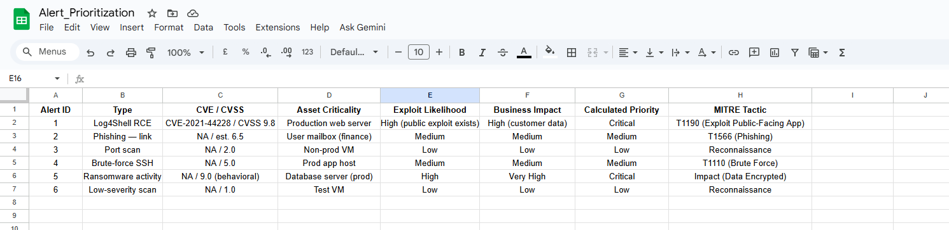
Create a pie chart for Critical, High, Medium, Low.
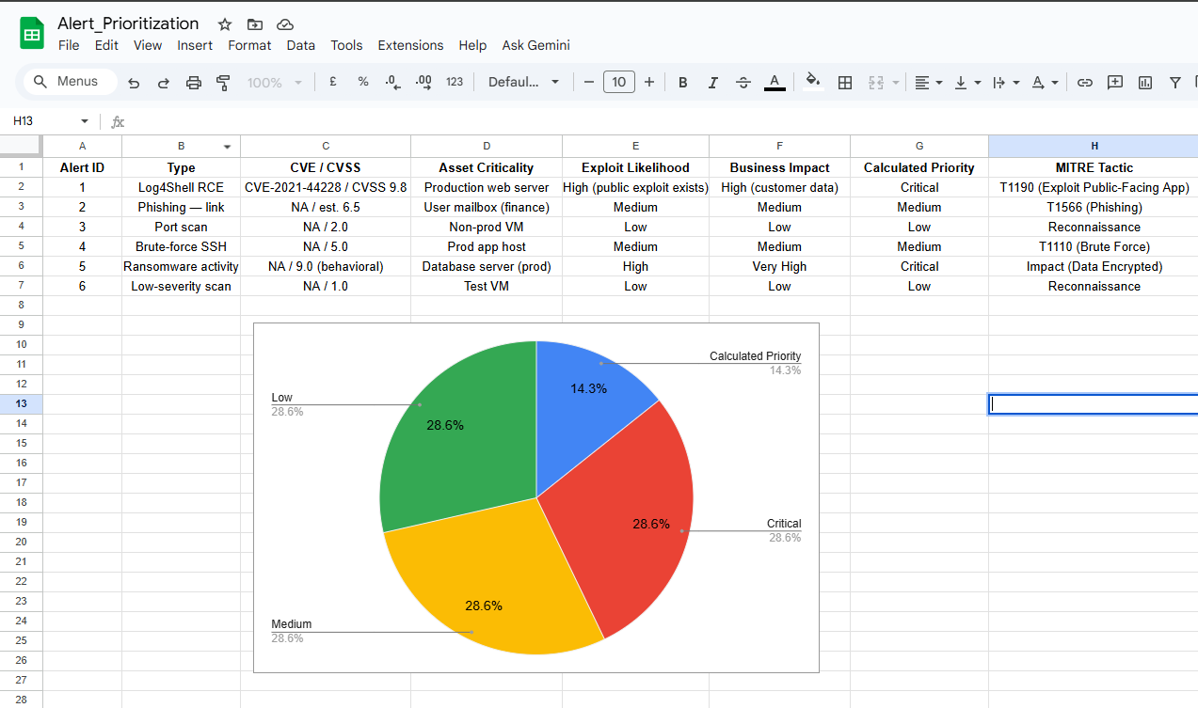

Setup of TheHive is successful
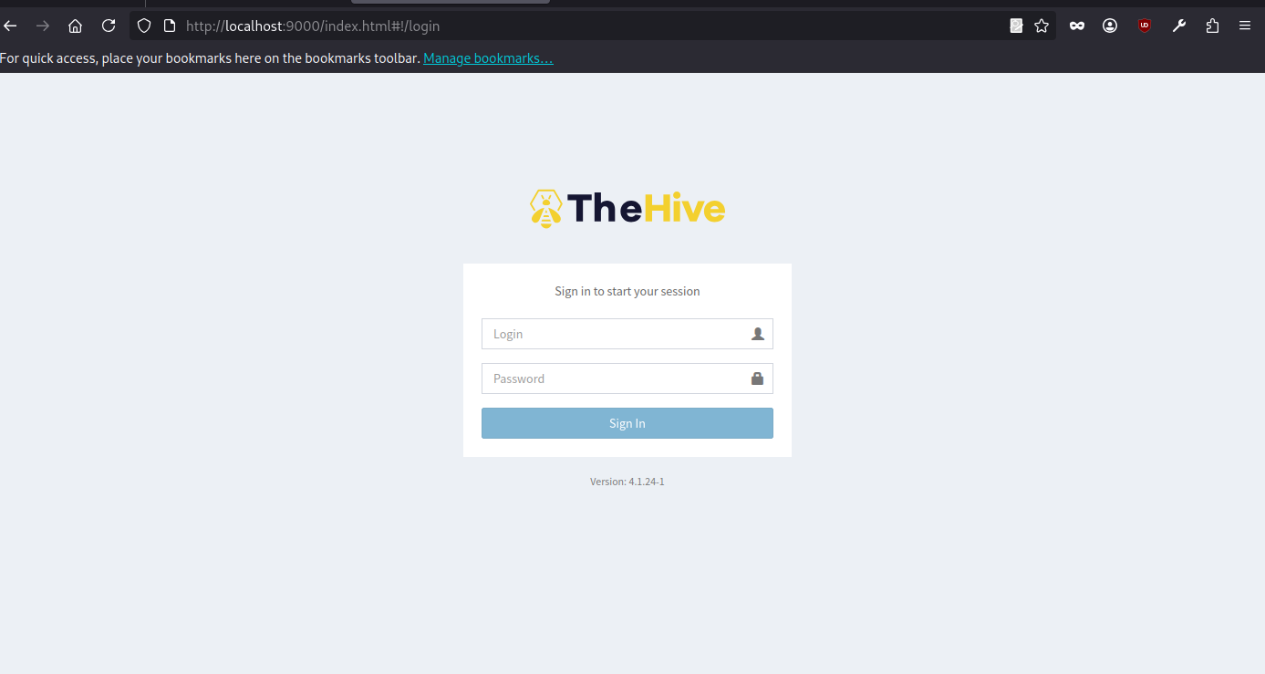
Alert Triage Practice:
Tools: Wazuh
Triage Simulation:
Analyze a mock alert (e.g., “Brute-force SSH Attempts”) in Wazuh
Simulate failed SSH login attempts :
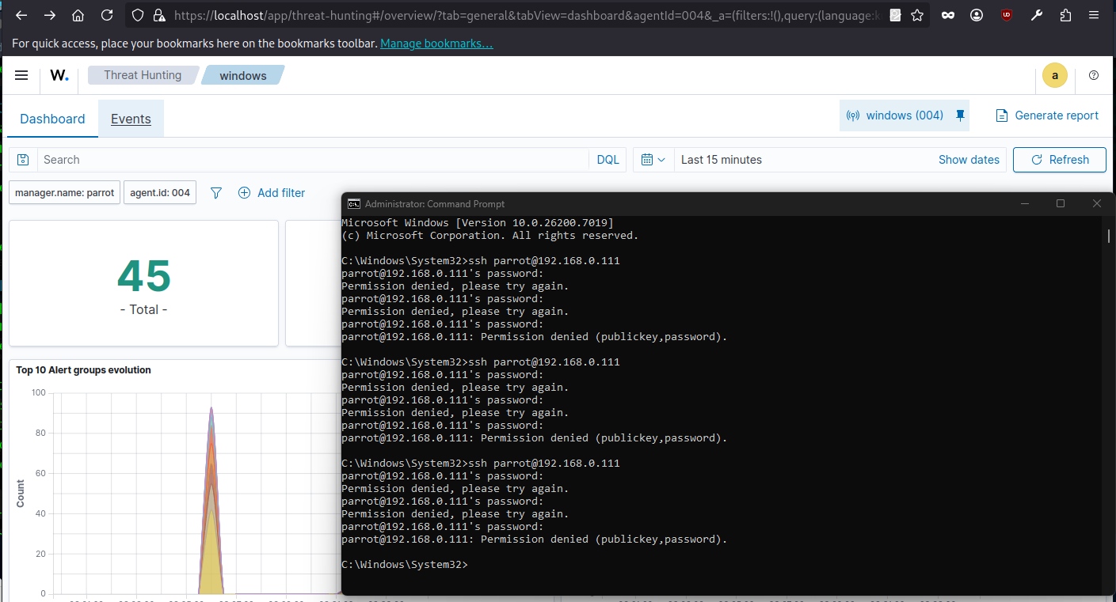

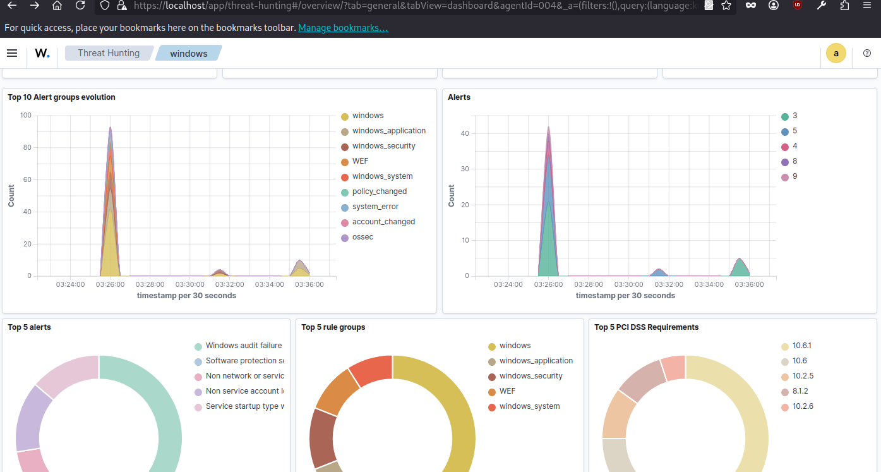
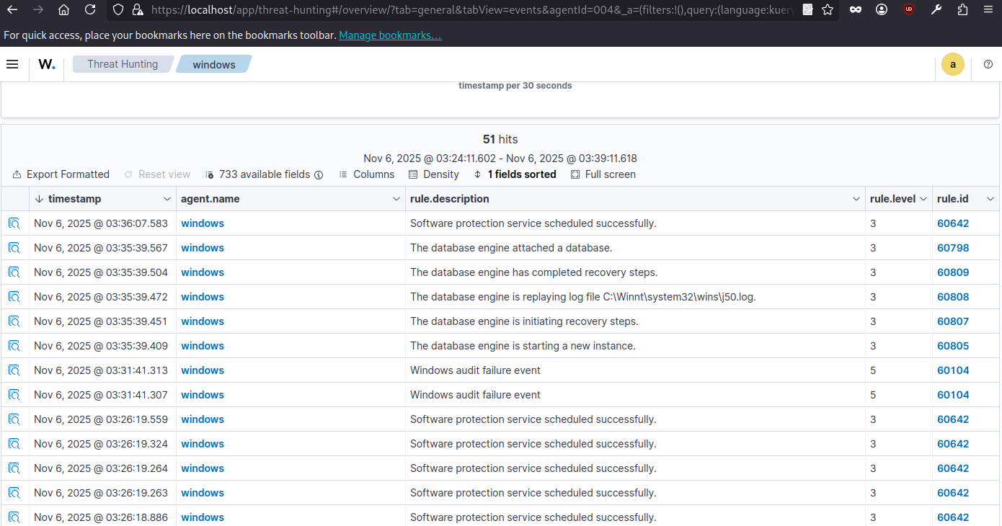
Alert is created by Wazuh dashboard for failed logins.
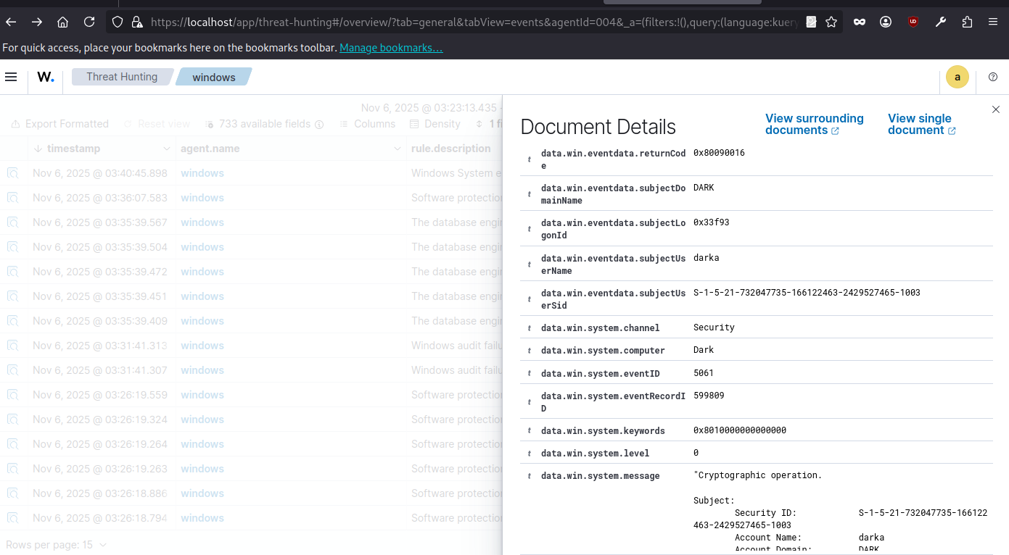

SSH_Attempts_alert_table:
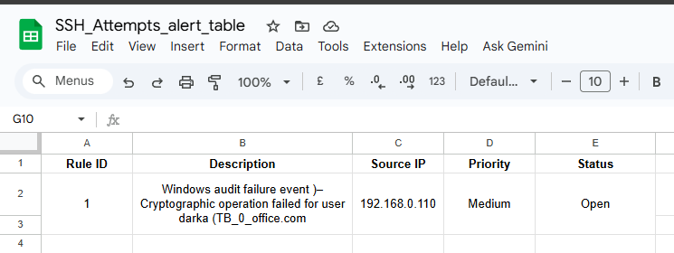

Priority: rule.level is 5 → This is Medium (rule level 10 = Critical, 5 = Medium, 3 = Low, 15 = High depending on your SOC mapping).

Threat Intelligence Validation:
Check for IP address 192.168.0.110
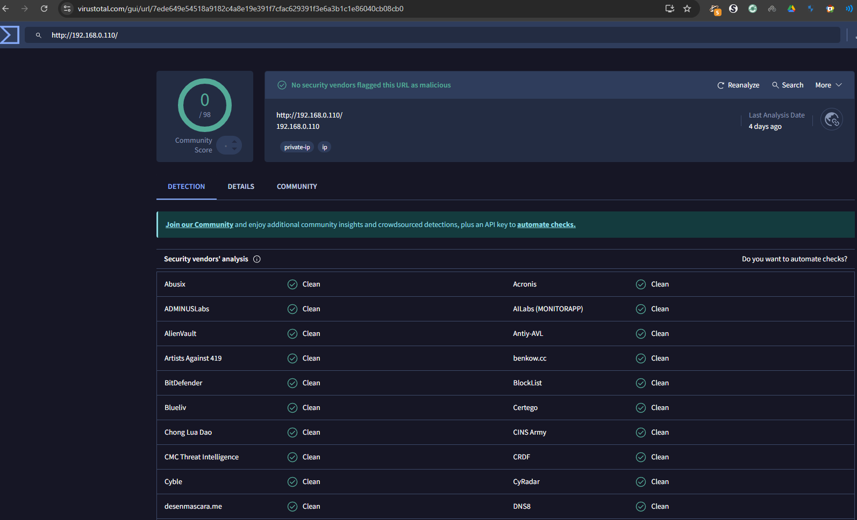

Result:
This is private/internal IP so Virustotal services show this no malicious activity.
Document IOC validation:
Checked source IP 192.168.0.110 on VirusTotal. No malicious activity was reported; likely internal network activity from the Windows VM. The cryptographic key TB_0_office.com is a legitimate user key. Alert is safe and flagged as Medium priority for monitoring.

Incident Ticket: Draft a ticket in TheHive with fields:
Title: [Critical] Ransomware Detected on Server-X
Description: Indicators: [File: crypto_locker.exe], [IP: 192.168.1.50]
Priority: Critical
Assignee: SOC Analyst
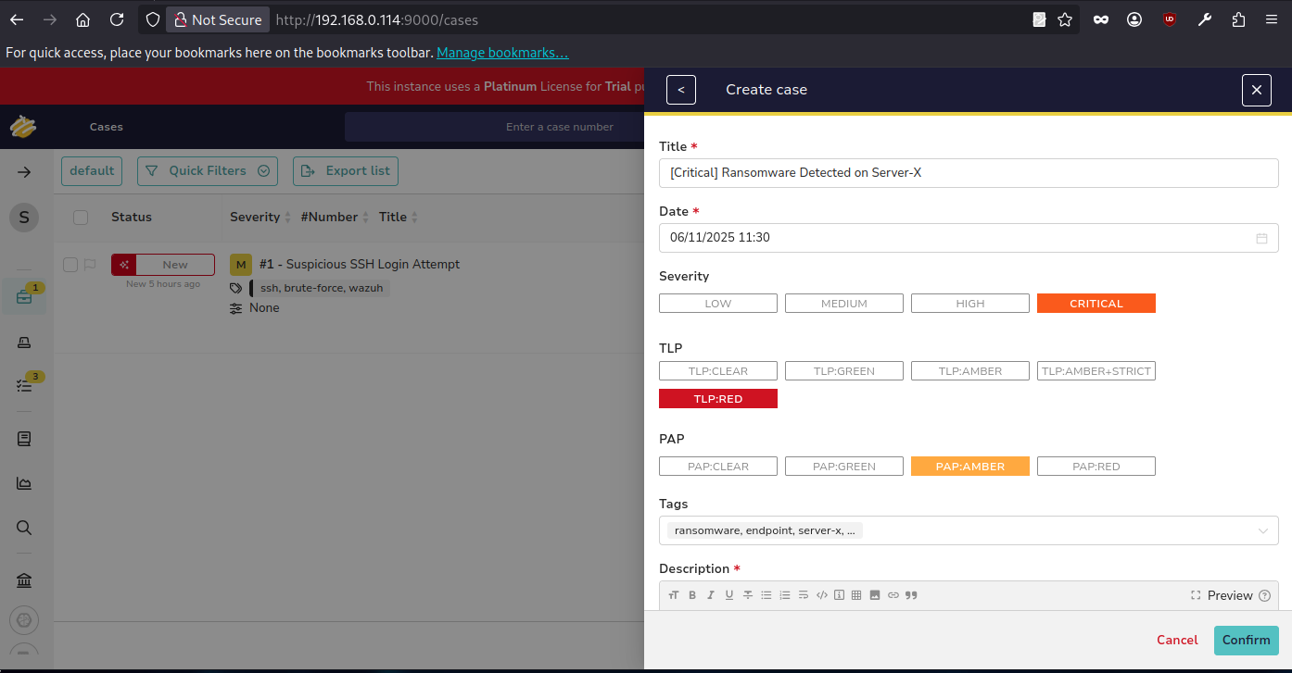
Adding task for ransomware detection
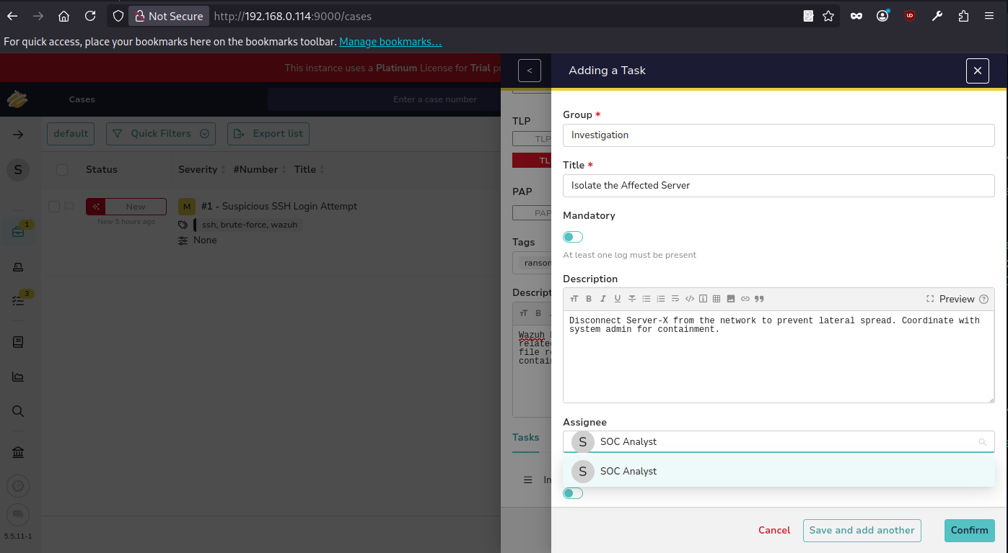
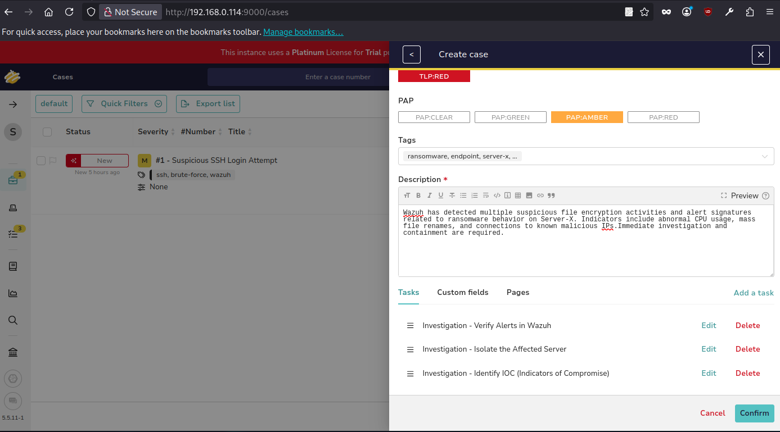
Task created successfully

Task added successfully.
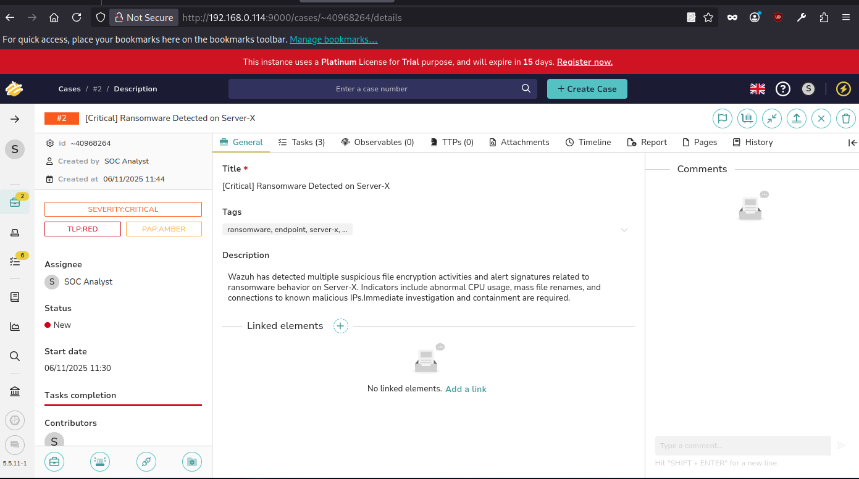
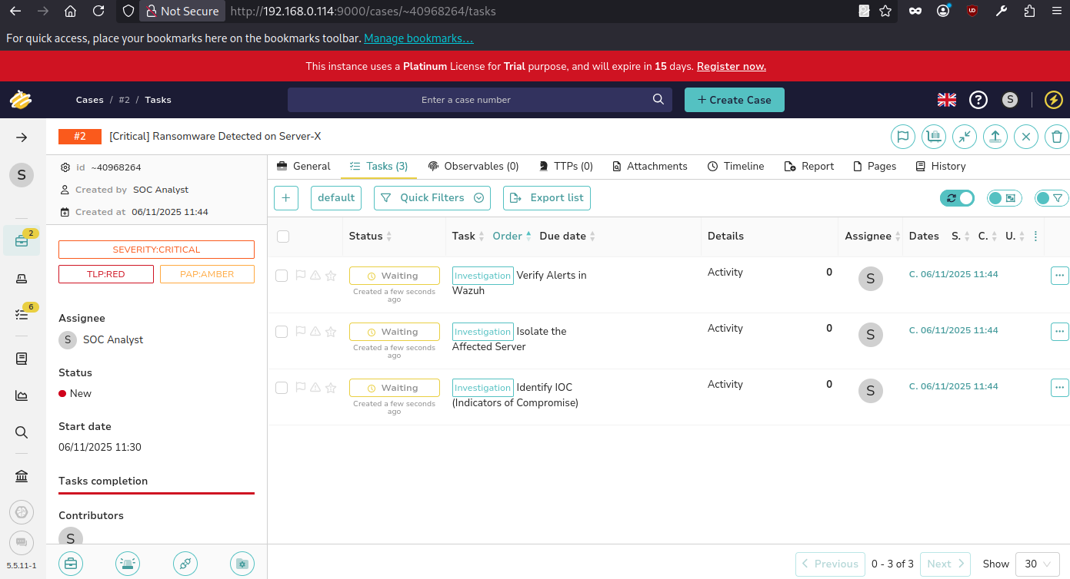

Case created successfully in thehive.
Evidence Preservation Activities:
Tools: Velociraptor, FTK Imager.
Tasks: Practice evidence preservation and chain-of-custody documentation.
Evidence Collection Command:
Network Connections
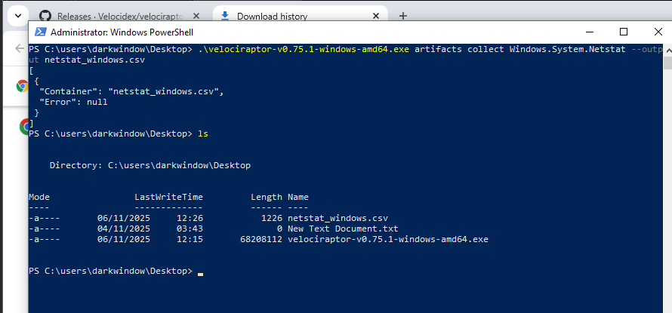

Memory Acquisition:
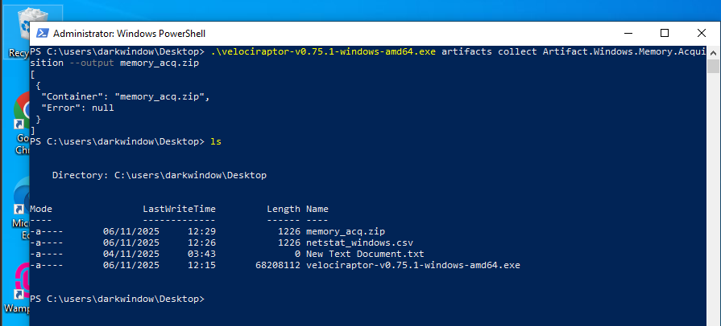
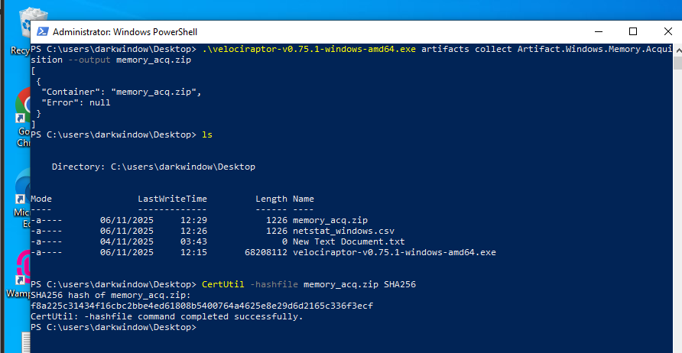

Item | Description | Collected By | Date | Hash Value
Memory Dump | Memory capture of Server-X (Velociraptor output: memory_acq.zip) | SOC Analyst | 2025-11-06 | f8a225c31434f16cbc2bbe4ed61808b5400764a4625e8e29d6d2165c336f3ecf
Netstat CSV | Network connections from Windows VM (Windows.System.Netstat) | SOC Analyst | 2025-11-06 | a13e81f3d4d246a64fc64f0e375d9ceb0268577d74d73697035dbadcfaddba16

Response Documentation Activities:
Tasks: Create incident response templates, document investigation steps, create checklists, and conduct a mock post-mortem.
document a mock phishing incident:
1. Executive Summary:
On 2025-11-08, a suspicious phishing email was reported by a user. The email contained a link to a fake login page. Immediate actions were taken to investigate and contain the threat.
2. Timeline:
Timestamp Action
2025-11-08 14:00:00 Isolated affected endpoint
2025-11-08 14:30:00 Collected memory dump
2025-11-08 15:00:00 Checked email headers
2025-11-08 15:30:00 Validated link with VirusTotal
2025-11-08 16:00:00 Notified users and SOC team
3. Impact Analysis:
The phishing email targeted 1 employee. No malware was installed, and no credentials were compromised. The impact was low, but monitoring continued to ensure no further attempts.
4. Remediation Steps:
- Isolated the affected endpoins.
- Blocked the malicious sender in the email system
- Validated the link through VirusTotal
- Updated SOC monitoring rules
5. Lessons Learned:
- Always validate suspicious emails quickly
- Maintain an updated checklist for phishing investigations
- Evidence collection (memory, logs) is essential for documentation
- Quick escalation prevents further risk
Post-Mortem Summary:
"The phishing incident showed that quick detection and isolation can prevent compromise. Lessons learned include validating suspicious emails, using evidence collection for documentation, and maintaining a standard checklist for future phishing events. Process improvements were made for faster incident handling and communication within the SOC."

Capstone Project: Full Alert-to-Response Cycle Activities:
Tools: Metasploit, Wazuh, CrowdSec, Google Docs.
Tasks: Simulate an attack, detect, triage, respond, and document.
Attack Simulation:
Exploit a Metasploitable2 vulnerability with Metasploit
vsftpd backdoor: use exploit/unix/ftp/vsftpd_234_backdoor
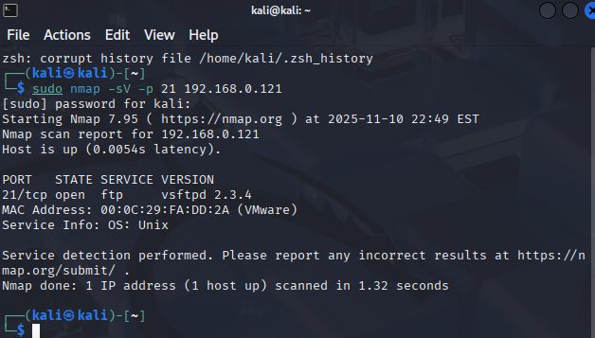
scan Metasploitable machine for vulnerable 21 port
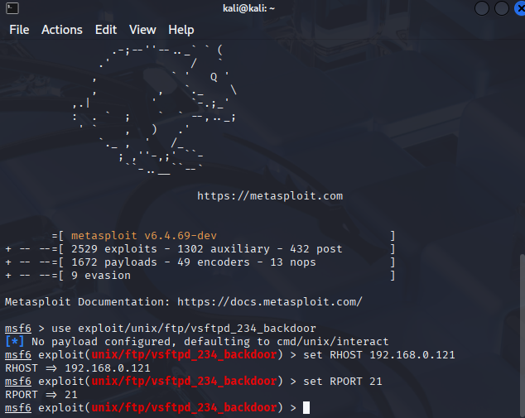
set RHOST = 192.168.0.122
Set RPORT = 21
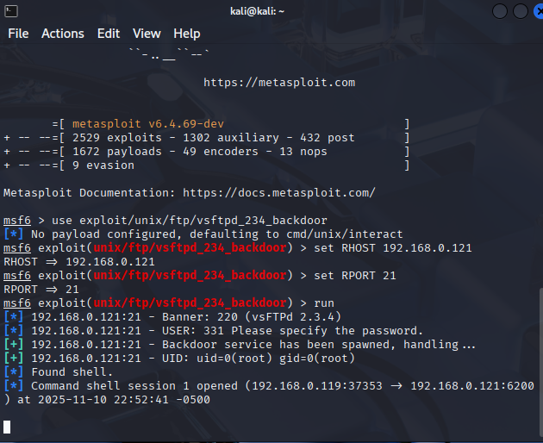
The exploit executed successfully on Metasploit machine.
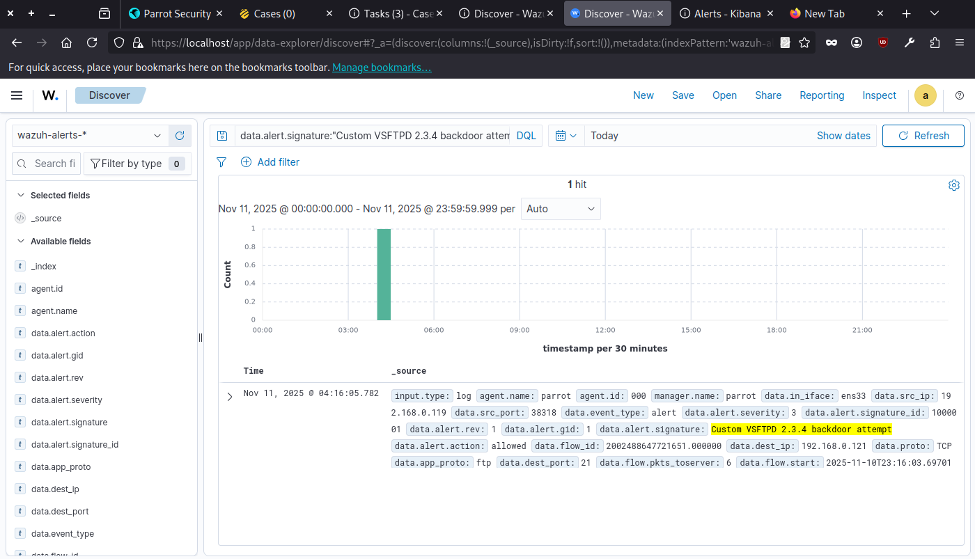
The alert is created in the wazuh dashboard.
Timestamp | Source IP | Alert Description | MITRE Technique
2025-11-10 04:16:05 | 192.168.0.119 | Custom VSFTPD 2.3.4 backdoor attempt | T1190

Response:
We blocked the attacker’s IP with CrowdSec.
Verify with a ping test.
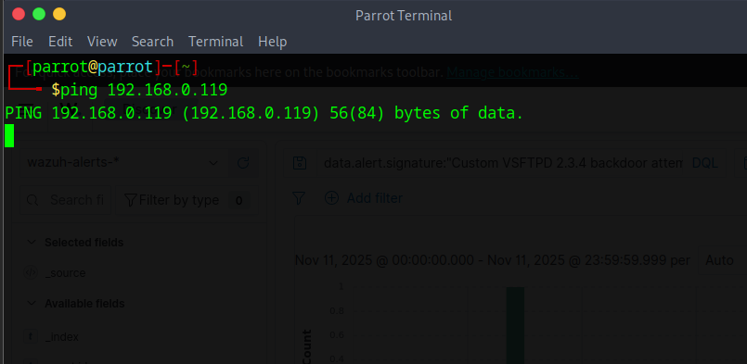
Reporting:
Executive Summary:
On 2025-11-10 at 04:16:05 UTC, the lab detection stack (Suricata + Wazuh) recorded exploitation attempts targeting VSFTPD 2.3.4 on host 192.168.0.121. The signature matched known VSFTPD 2.3.4 backdoor behavior (custom Suricata rule). Source IP 192.168.0.119 (Kali test VM) issued FTP commands containing the backdoor username and attempted remote execution. Suricata generated alerts which were ingested by Wazuh and recorded in /var/ossec/logs/alerts/alerts.log.
Timeline:
• 2025-11- 04:16:05— Suricata detected custom VSFTPD backdoor attempt from 192.168.0.119 → 192.168.0.118:21.
• 2025-11-10 04:17:00— Wazuh ingested Suricata alert.
• 2025-11-10 04:17:10— Incident contained: IP 192.168.0.119 added to iptables DROP on Parrot host. Evidence (Suricata logs, Wazuh alerts, pcap) collected and archived.
Recommendations:

- Harden or remove vulnerable vsftpd service; if required, replace with a patched FTP
- server. Implement automated active response (Wazuh → iptables or CrowdSec) to block offending IPs for a configurable period.
- Expand logging retention and centralize Suricata eve.json with reduced verbosity (alerts only) to avoid decoder issues.
- Run post‑incident host forensic checks and re-image the VM if persistence is suspected.

Stakeholder Briefing:
On Nov 11, our lab IDS detected an exploit attempt against an outdated FTP service on a test virtual machine. We immediately blocked the attacker’s IP at the network level and captured logs and network data for review. No lateral movement or data exfiltration was observed. Recommended next steps: isolate or reimage the vulnerable VM, remove the outdated FTP service, and enable automated blocking so similar attacks are contained automatically. I will prepare a short remediation plan and timeline if you want the lab restored to a safe baseline.

Reference:
- https://www.first.org/cvss/v3-1/specification-document
- CVSS v3.1 Specification: https://www.first.org/cvss/v3-1/specification-document
- NIST SP 800-61 Rev 2, Computer Security Incident Handling Guide
- MITRE ATT&CK Framework: https://attack.mitre.org/
- SANS Incident Handler's Handbook

