Sakila DVD Rental Data Analysis

1. Project Overview
This project analyzes the Sakila DVD Rental database using Power BI to generate insights on customers, films, inventory, staff performance, and store operations.

2. Objective
Analyze rental and revenue performance
Understand customer behavior
Identify top films and categories
Evaluate staff and store performance
Build interactive dashboard

3. Significance
Power BI helps convert raw rental data into interactive dashboards for better decision-making.

4. Data Dictionary
Rental → rental_id, rental_date
Payment → amount, payment_date
Customer → customer_id, country
Film → film_title, category
Inventory → inventory_id, stock
Staff → staff_id
Store → store_id

5. ER Diagram
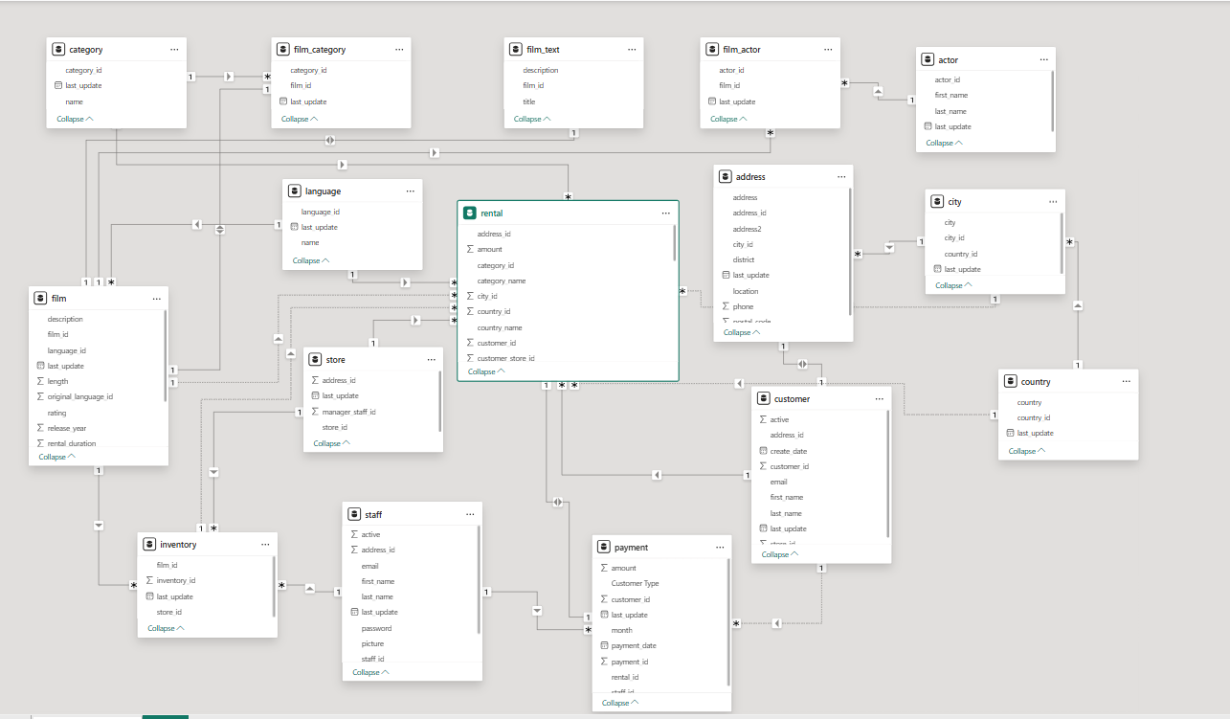Fact Tables: Rental, Payment
Dimension Tables: Customer, Film, Category, Staff, Store
Relationships: One-to-Many

6. Steps to Connect Data
Open Power BI
Click Get Data
Load tables
Create relationships in Model View
Clean data in Power Query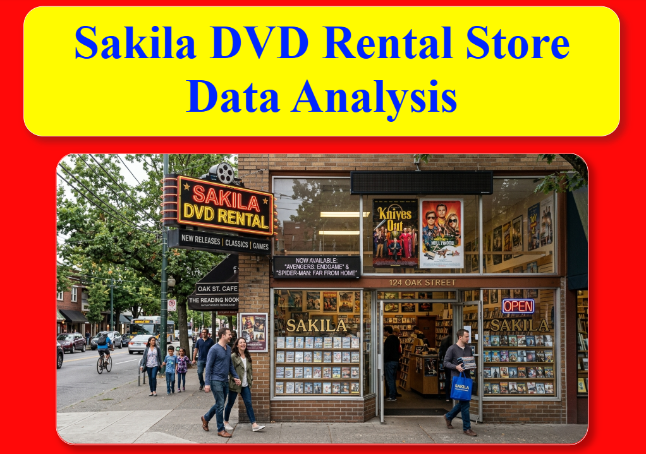
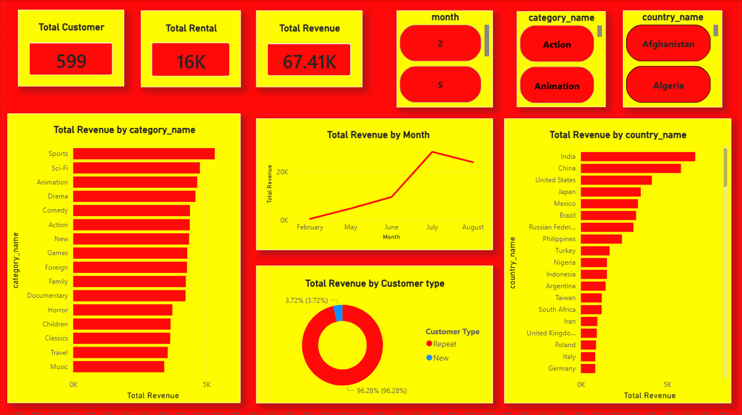
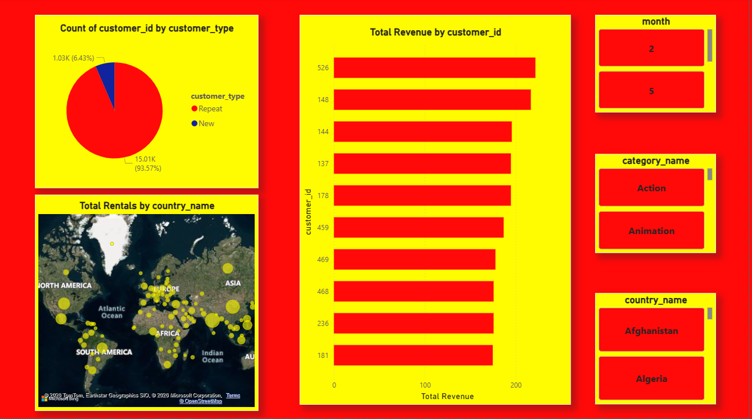
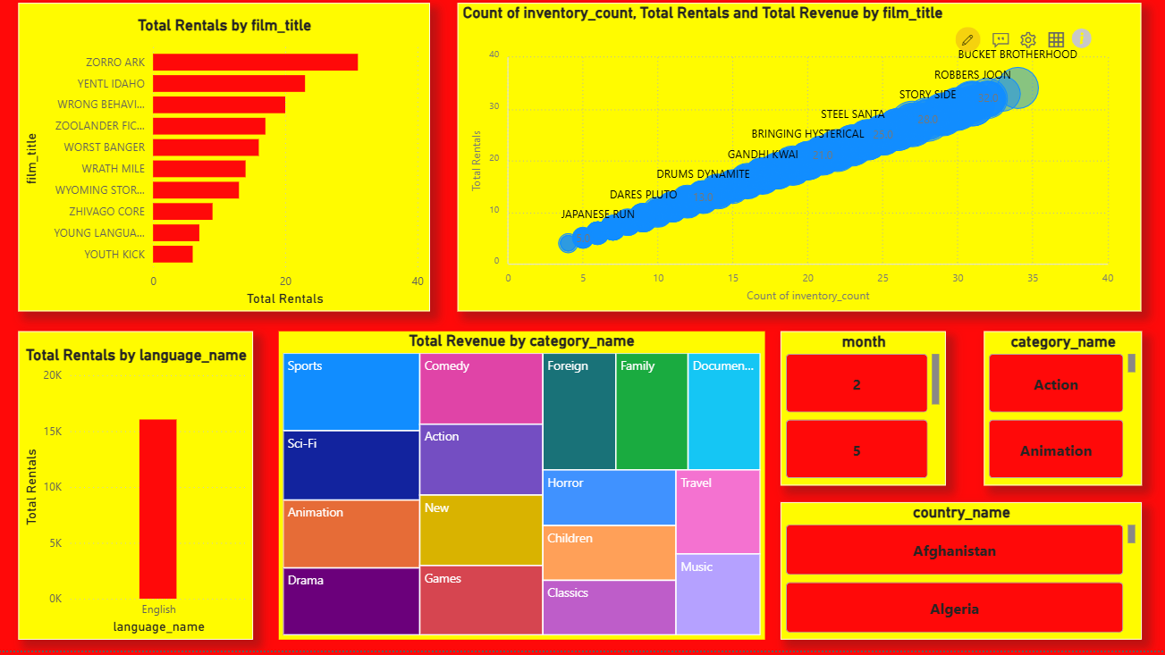
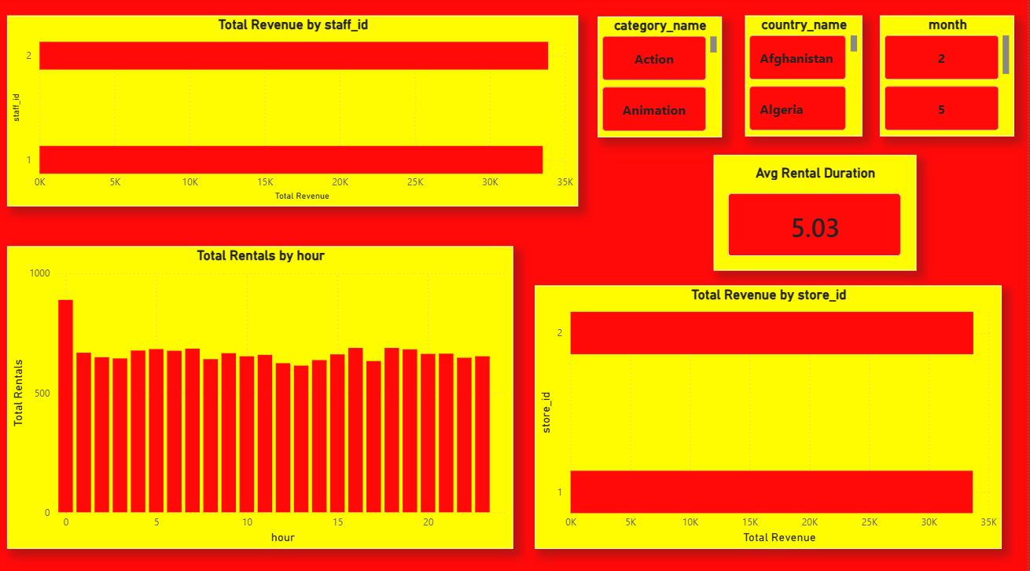

7. Problem Statement, Solution & Insights
Problem: Lack of visibility into rental and revenue performance
Solution: Built interactive dashboard
Insights:
• High repeat customers
• Certain categories dominate rentals
• Inventory impacts demand
• Revenue trends vary over time

8. Conclusion
The dashboard provides insights into customer behavior, film performance, and business operations enabling data-driven decisions.

