Q. How to create a new partition and mount it?

Ans:
1. list the availabel HDD by using fdisk -l or cat /proc/partitions.

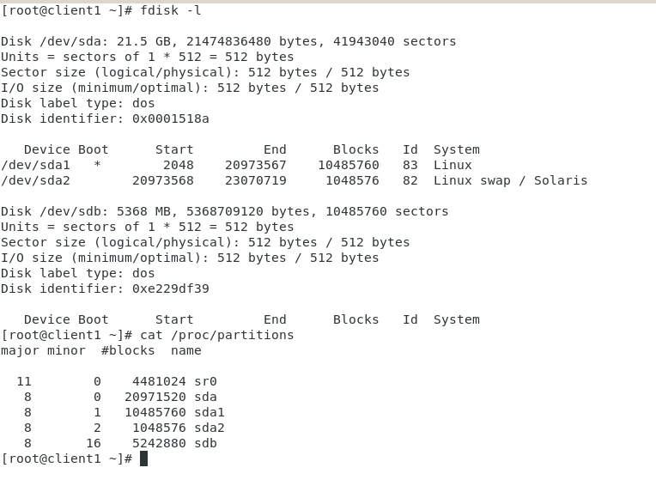

2. Run fdisk <disk device name> , from which you wants to create the partition.

type n to create new partition

type the partition type p(primary) or e(extended)

type the partion number. Otherwise press enter for default number

press enter for default first sector

give the size of the partition, which you wants to create as last sector. Exa: +1G # for 1 gb

type w and press enter to write the chenges to partition table

Run the partprobe command with the disk device name as an argument to force a re-load of its partition table.

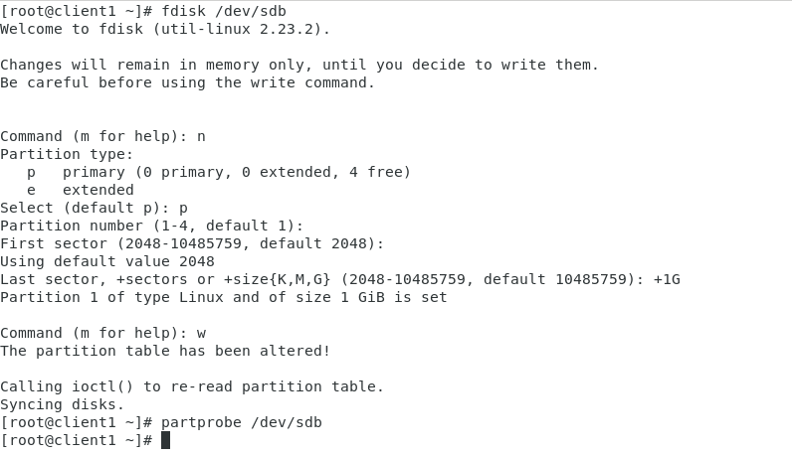

3. List the partitions of the disk device.

Exa: fdisk /dev/sdb

then type p for print and press enter.
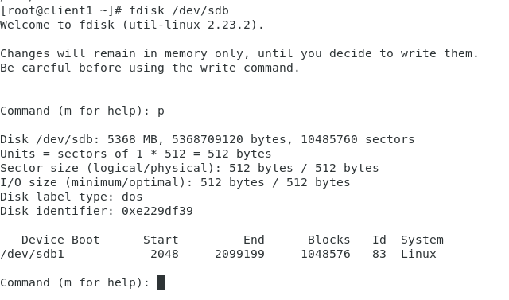

4. now format the created partition.

Syntax: mkfs.<file_system_type> <disk device>

Exa: mkfs.xfs /dev/sdb1

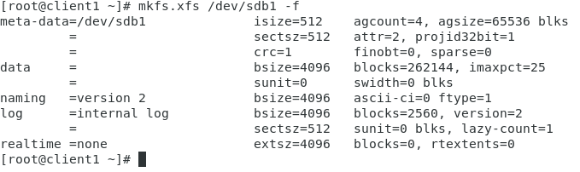

Note: here -f used for frocefully format. You can run without -f.

Note: here we have used xfs as file system. You can use as per your requirement like ext4, etc...

5. Create a directory and mount the directory with the newly created partition.

Create directory: mkdir /home/pradeep/personal

Mount the device to directory

Syntax: mount <device_name> <directory_name with path>

Exa: mount /dev/sdb1 /home/pradeep/personal

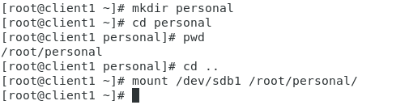

Note: This mount is temperary. Once we will reboot the system it will unmount automatic.

Note: use command df -h to list the used disk space and mount device .

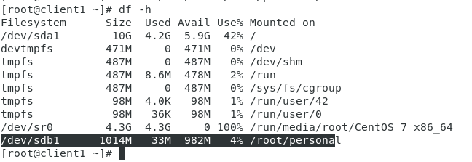

Q. How to mount permanently.

Ans:

For mounting permanently we needs to enter the details of mountin in fstab file.

syntax: <UUID_of_device> <destination_directory_with_path> <File_system_type> defaults 0 0

1. How we will get the UUID of device.

Ans: Use blkid command to get the UUID of device.

Syntax: blkid <device_name>

Exa: blkid /dev/sdb1

Then edit the fstab file and make an entry for your device.

Exa: vim /etc/fstab

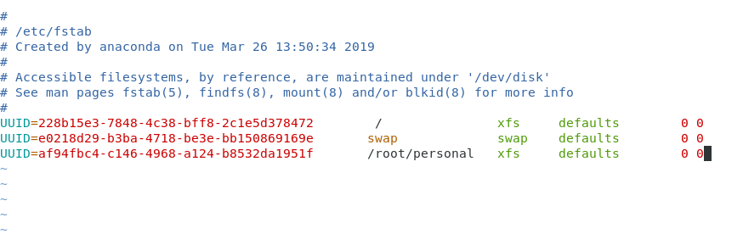

Note: We can mount with device name insted of UUID. But prefer UUID

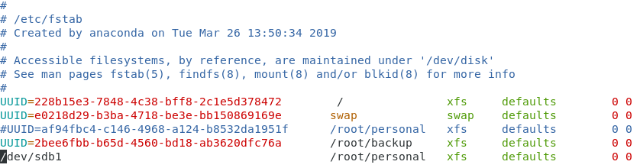

Note: check the mount is listed or not using df -h command. I its not in list then execute mount -a command.

Q. How to create logical volume?

Ans:
1. create the partitions

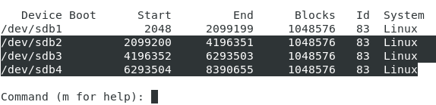
Note: Here I have created 3 partitions.

2. Make those three partitions LVM compatable by changing the partition ID to 8e

Q. How to change the partition ID?

i. use command fdisk <device_name>. # Here its /dev/sdb

Exa: fdisk /dev/sdb

ii. type t and press enter for chenging the partion ID

iii. give the partion number.(Here its 2 , 3 & 4) # We can give ony one number at a time.

iv. type 8e as Hex code and press enter. # type L and press enter to list all Hex code.

Note: fallow the same step and make all three partition LVM compatable.

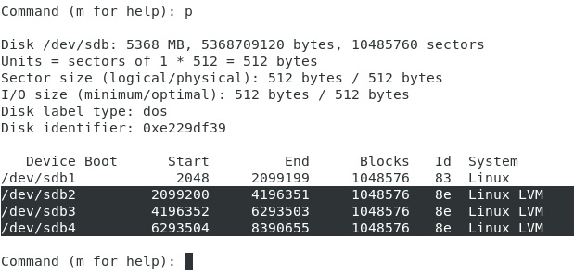

Then type w and press enter to write to partition table and execute partprobe /dev/sdb command.

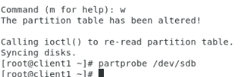

3. Create the physical volume using those three partitions.

i. Use command pvcreate to create physical volume.

Exa: pvcreate /dev/sdb2 # We can also give multiple partion at atime.
Exa: pvcreate /dev/{sdb2,sdb3,sdb4}

Note: Use command pvdisplay to list all physical volume

4. Create volume group usisng multiple physical volume.
Syntax: vgcreate <volume_group_name> <physical_volumes>

Exa: vgcreate data /dev/{sdb2,sdb3,sdb4} # Use vgdisplay to list volume groups

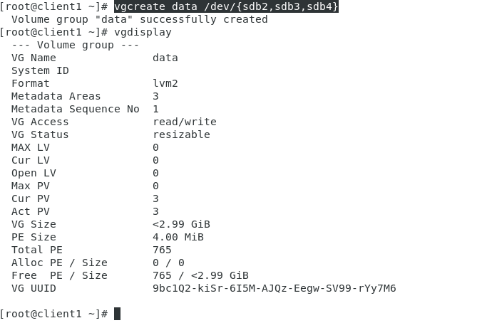
Note: Here VG size is 3GB.

Note: We can use physical volume from different disk.

Exa: vgcreata data /dev/sdb2 /dev/sdc1 /dev/sdd4

5. Create the logical volume using volume group data.

Syntax: lvcreate --name <lv_name> -L <lv_size> <vg_name>

Here -L to provide logical volume size. We can use -n insted --name.

lv = Logical Volume
vg = Volume Group

Note: We can use lvdisplay command to list Logical volumes

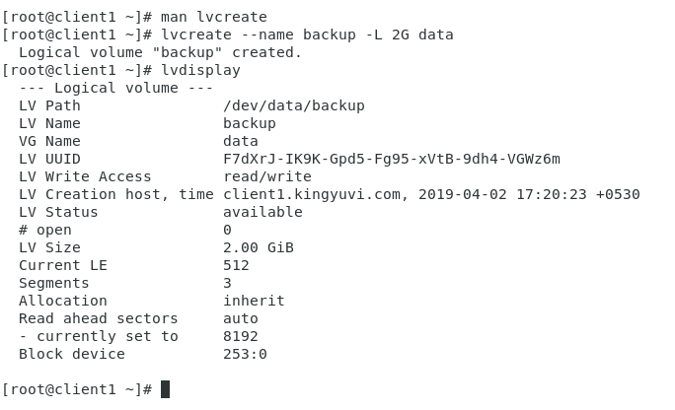
Note: Here I have created 2 GB logical volume.

6. Format the Logical volume

Exa: mkfs.xfs /dev/data/backup
or
mkfs -t xfs /dev/data/backup

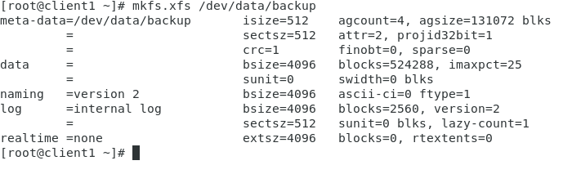
7. Mount the logical volume to directory.

Ans:
i. Create a directory

ii. Get the UUID of the logical volume

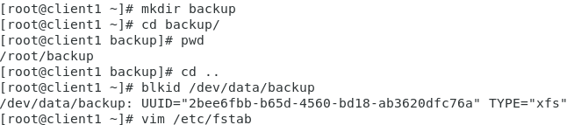

iii. Mount the volume to directory

mount /dev/data/backup /root/backup
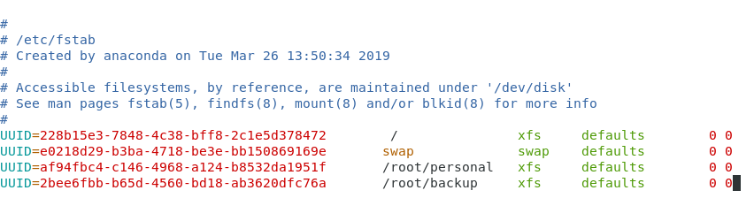

iv. Execute mount -a command

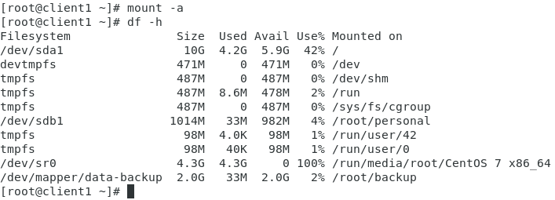

Q. How to list the disk volumes with file system types?

Ans:
df -hT

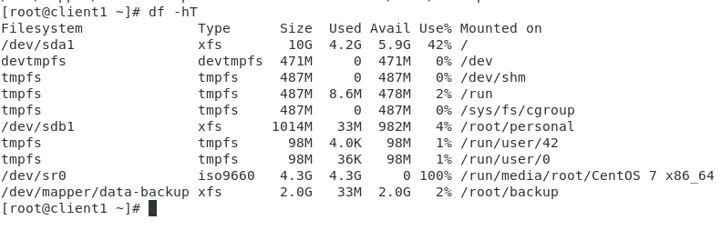

Q. How to extend Logical volume?

Ans:
i. Execute the lvextend command

Exa: lvextend -L +200M /dev/data/backup

Note: here -L for descrive the size and + to add specified size to existing size. If we don’t mention the + , then it will make the volume size as specified. Exa: 200 MB

Note: If we will execute the command lvdisply or df -h , Still it will display the old size. To enlarge the filesystem we needs to run below command.

xfs_growfs /dev/mapper/data-backup

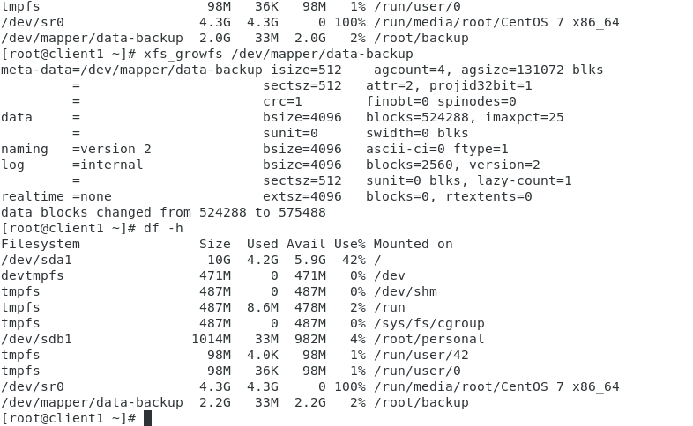

Q. How to extend(add Physical volume to existing volume group) the existing volume group size?

Ans:

i. 1st create the partition and then create the private volume

Note: I have created the partition form new HDD and private voleume(/dev/sdc1)

ii. Execute the vgextend command

syntax: vgextend <vg_name> <pv_name>

Exa: vgextend data /dev/sdc1

