Q. AWS ec2 instancee connection timeout issue?

Ans:

add or enable ServerAliveInterval (by default it’s commented with value 0) and type the value in seconds like below.in sshd_config file (/etc/ssh/sshd_config)

ServerAliveInterval 50

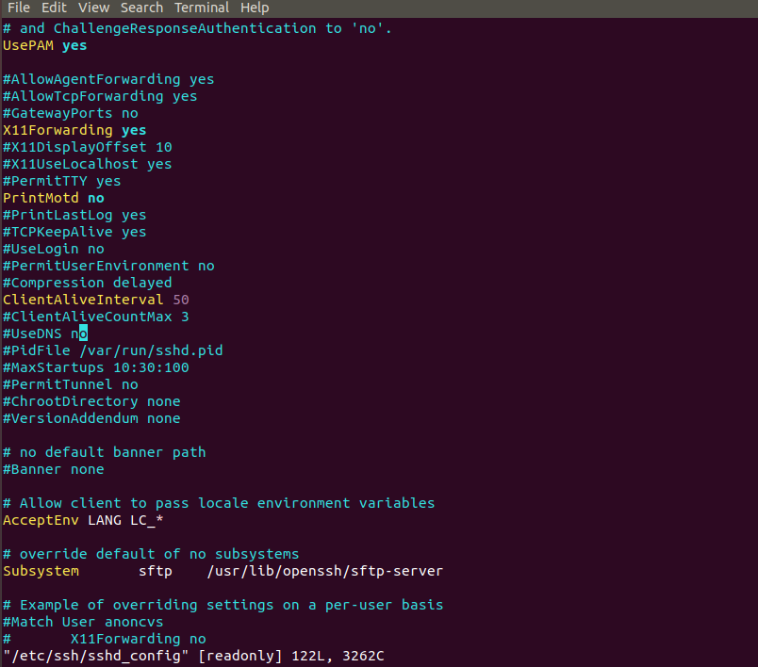

Amazon AWS usually drops your connection after only 60 or 120 seconds of inactivity, so this option will ping the server every 50 seconds and keep you connected indefinitely.

Q. How to install Vmware pro in ubuntu?

Ans:
Download VMware Workstation 15 Pro for Linux Make the Downloaded File Executable

Exa: sudo chmod +x Vmware-Workstation-Full-15.0.3-12422535.x86_64.bundle

Install Dependencies
sudo apt-get -y install gcc make linux-headers-$(uname -r) dkms

Execute the Installer Wizard
sudo ~/Downloads/Vmware-Workstation-Full-15.0.3-12422535.x86_64.bundle

Q. How to copy file from one system to another?
Ans:
scp <file_name> <username@IP>:<dest_path>

scp part14.mp4 hp@192.168.0.67:/home/hp/Downloads

Q. How to map the windows share folder in ubuntu?

Select other location – type smb:<shared_path> in Connect to server – click connect

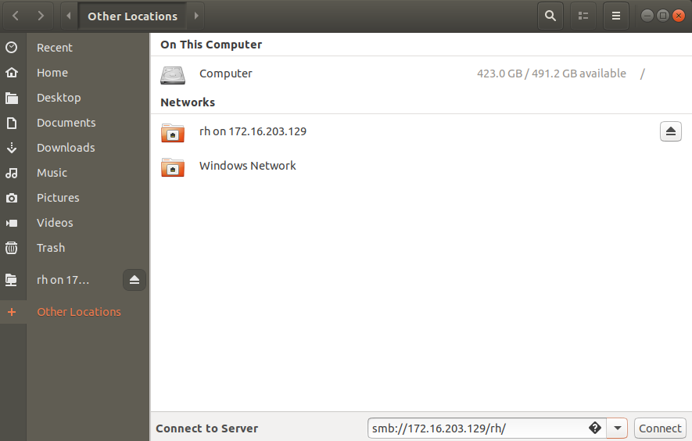

Q. How to switch the runleve?

Ans:

1st list all currently loaded and available targets by using systemctl list-units -t target command.

Then change to requare runlevel or default target by using systemctl set-default <target_name>

Exa:
systemctl set-default graphical.target # equals runlevel 5
systemctl set-default multi-user.target # equals to runlevel 3

then reboot

Q. How to install Gnome GUI(graphical.target) if not available?

Ans:

yum groupinstall "GNOME Desktop" "Graphical Administration Tools" "Server with GUI"

then set default target and reboot

Q. How to break the root password in Redhat7 & CentOS7?

Ans:
press and hold the shift key to go to grub menu.

reboot the system – press the e on first boot entry - From the grub options, find the line that starts with “linux16” and go to the end of it and type rd.break - the press ctrl+x to boot the system with configured option.

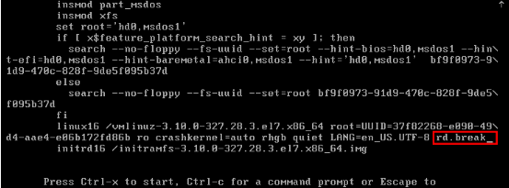

Then remount the root file system in rw mode using mount -o remount,rw /sysroot command

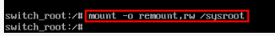

Then change into a chroot jail so that /sysroot is used as the root of the file system. This is required so that any further commands we run will be in regards to /sysroot. This is done by running ‘chroot /sysroot’.

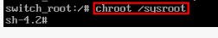

Then after we can reset the password using passwd command.

Then create the .autorelabel file if you are using selinux, else skip this step

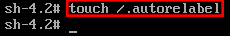

then type exit and press enter – exit press enter – so it will exit and reboot the system.

Q. How to break the root password in ubuntu?

Ans:

1. press and hold the shift key to go to grub menu.

2. Once the GRUB page appears, quickly select the “*Advanced options for Ubuntu”

3. Now press e to edit the commands.

Find the line beginning with “Linux.” After, look for “ro,” and change it “rw.” Add init=/bin/bash at the end of the line.

4. then press ctrl+x – then select the geniric mode and press enter

5. Mount your root filesystem in read-write mode:

mount -n -o remount,rw /

6. You can now reset your lost root password by using the following command:
passwd root
Once you are done, type:
exec /sbin/init

to exit the prompt and reboot the computer.

Error:
sorry passwords do not match
passwd authentication token manipulation error

Solution:
sudo pam-auth-update

