LangChain Framework — Classroom Teaching Notes
Topic: Introduction to an LLM application-development framework and its six core components

Overview
Today's class looks at LangChain, a framework built to make it easier to build software powered by large language models (LLMs). It lets a developer stitch together big, complex systems while writing far less code, because it takes care of connecting the moving parts — the model, the prompt, memory, external data sources, and so on — behind the scenes.
The framework can be broken down into six core building blocks: Models, Prompts, Chains, Memory, Indexes, and Agents. We'll go through each one with an example, so the practical use is just as clear as the theory.
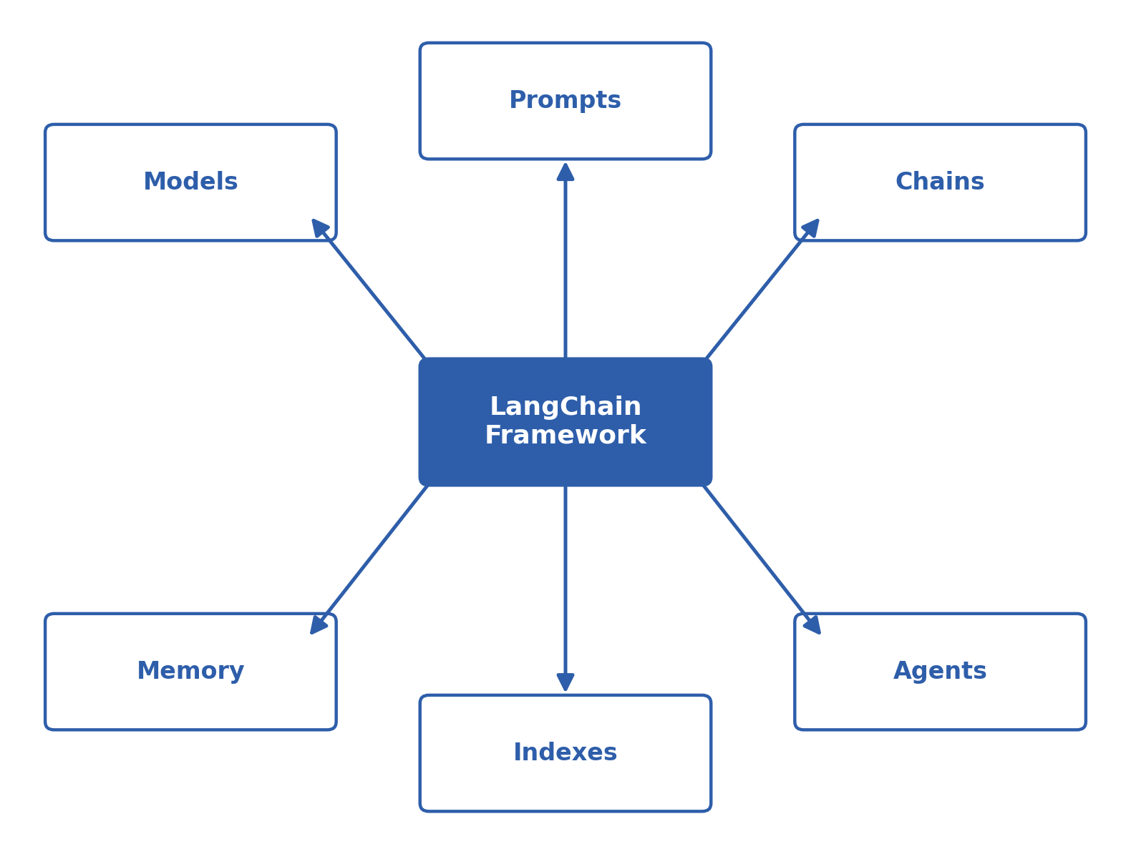
Figure 1: The six components sit around the LangChain core

1. Why LangChain Is Needed
- LangChain is an open-source framework whose whole purpose is to simplify the process of building LLM-powered applications.
- Without it, a developer has to hand-wire the interaction between every component themselves — workable for a toy project, but painful once the system grows.
- Take an app that lets a user 'chat with a PDF' — building that from scratch, end to end, is a substantial undertaking on its own.
- LangChain hands you ready-made building blocks for exactly this kind of work, so a pipeline comes together faster and in a far more organized way.
- One of its stand-out qualities is that it isn't locked to any single provider — switching from OpenAI to Google or another model is often just a couple of lines of code.

2. Models

Why this component matters
The Models component is the point where LangChain actually talks to a real AI model — which is why it's fair to call it the foundation of the whole framework. NLP has historically wrestled with two hard problems: first, genuinely understanding what a user means, and second, generating a reply that actually fits the context. Large language models trained on massive datasets have gone a long way toward solving both.

The size problem
- A capable LLM can easily weigh in above 100 GB, which makes running it on an ordinary laptop or a small company's server impractical.
- This is why API-based access became the norm — with something like the OpenAI API, the model runs on the provider's servers and we simply send a request.
- The catch is that every provider's API works a little differently, meaning fresh code for every integration — which is exactly where the need for standardization came from.

How LangChain solves it
- LangChain offers one standard interface, so plugging in a different LLM provider becomes a small, mechanical change rather than a rewrite.
- Example: moving from OpenAI to Anthropic is often just one or two lines of code.
- Language models: take text in and return text out — the shape behind most chatbots.
- Embedding models: take text in and return a numeric vector out, used for similarity search and related tasks.
LangChain already has integrations for providers like OpenAI, Anthropic, Mistral, IBM, and Hugging Face, and each model's supported features — tool calling, JSON output, local execution, multimodal support — are listed in the documentation.

3. Prompts
A prompt is simply the input we hand the model, and the model's output is built entirely on top of it. Even a small wording change can shift the result completely — which is exactly why 'prompt engineering' has grown into a discipline of its own.
- LangChain's prompt component lets you build templates that are dynamic, reusable, and effective.
- Example: a template where the user supplies only the topic and tone, and the rest of the prompt — already written — fills in those blanks automatically.
- Role-based prompts: setting system-level and user-level instructions separately, so the model's behaviour stays predictable.
- Few-shot prompting: showing the model a handful of worked examples first, then asking it to classify a new input the same way — for instance, sorting customer-support tickets into categories.

4. Chains
Chains let you link several steps into a full pipeline, where the output of one step automatically becomes the input of the next.
- Sequential chain: steps run one after another — translate an English text into Hindi, then summarize that translation.
- Parallel chain: the same input is sent to several models or processes at once, and the results are merged afterward.
- Conditional chain: the path taken depends on a condition — a positive review triggers a thank-you email, a complaint routes to the support team instead.
In short, chains remove the manual work of wiring one step's output into the next step's input, turning the whole process into something automatic and orderly.
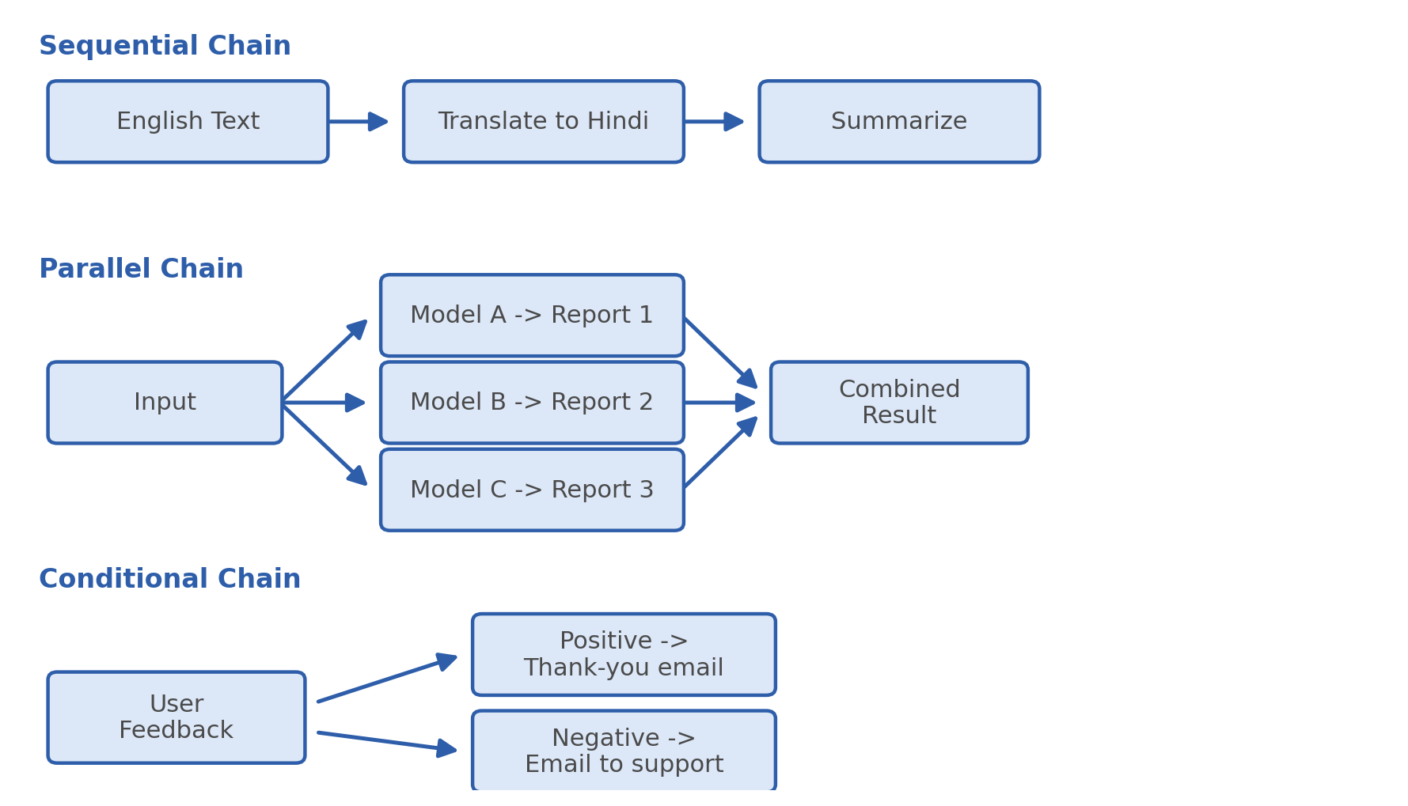
Figure 2: Sequential, parallel, and conditional chains

5. Indexes
Indexes connect an application to external sources of knowledge — a PDF, a website, or a company database. This is what lets us query data the model was never trained on, such as an organization's private documents.

Four main parts
- Document loader: pulls data in from its original source.
- Text splitter: breaks large documents into smaller chunks.
- Vector store: converts each chunk into a vector and stores it.
- Retriever: searches for the vectors closest to the user's query and returns the matching content.
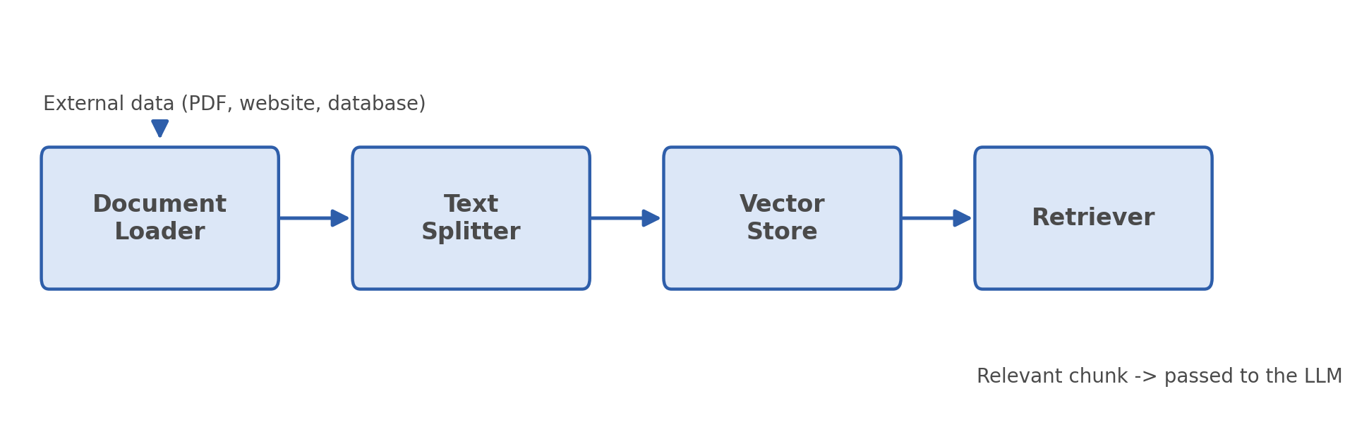
Figure 3: The indexing pipeline, from raw document to relevant chunk

Worked example
Imagine a company's 1,000-page policy manual sitting in Google Drive. It gets loaded, split into smaller pieces, and each piece is converted into a vector and stored. When a user asks a question, the retriever finds the most relevant chunk and hands it to the model, which then answers based on that exact content.

6. Memory
By default, every LLM API call is stateless — the model has no memory of the previous exchange. That's a real limitation for a chatbot, since the entire conversation would otherwise need to be resent every single time.
The Memory component solves exactly this — it holds on to the conversation history so the model keeps its context.
- Conversation buffer memory: stores the entire conversation as-is.
- Window memory: keeps only the most recent N exchanges.
- Summary-based memory: condenses the whole conversation into a summary and passes that along instead.
- Custom memory: stores specific details separately, like a user's preferences.

7. Agents
The Agents component is what makes it possible to build AI agents that go beyond conversation — they can reason through a problem and actually get something done.

Chatbot vs. agent
- A chatbot only converses, while an agent can carry out a task on your behalf — checking a flight price or booking a ticket, for example.

Key capabilities
- Reasoning: breaking a complex question down into smaller steps.
- Tool access: the ability to call external tools, such as a calculator or a weather API.

How it works — an example
A user asks: 'Find today's temperature in Delhi and multiply it by 3.' The agent recognizes this needs two steps — first fetch the temperature, then do the multiplication. It calls a weather API to get the temperature (say, 25°C), then uses a calculator tool to compute 25 × 3 = 75.
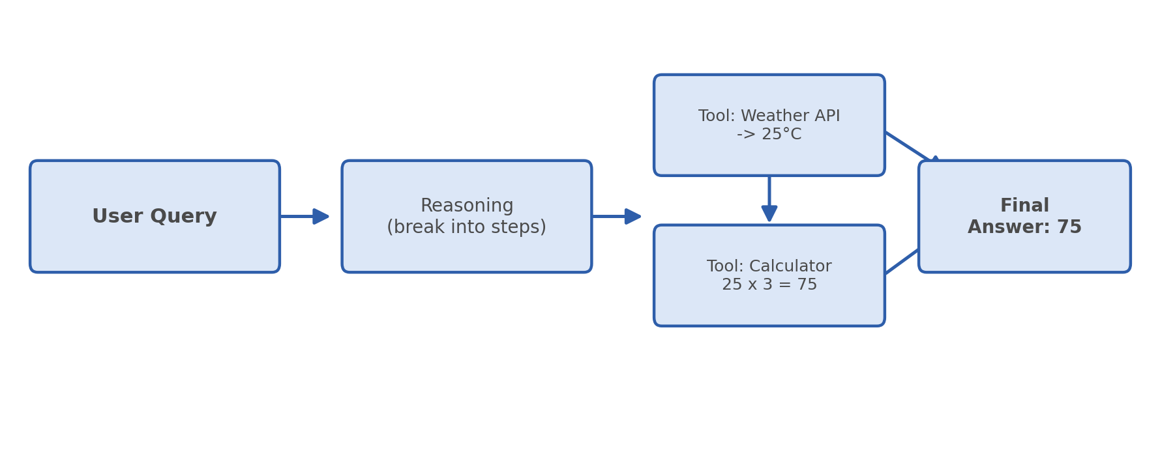
Figure 4: An agent breaking a query into reasoning + tool calls

Summary and Key Takeaways
This chapter walked through LangChain's six core components, each of which makes building LLM-powered applications simpler and more effective:
- Models: bring different AI models onto one common interface, removing integration headaches.
- Prompts: the basis of every exchange with the model, with a direct effect on the output.
- Chains: link multiple steps into an automated pipeline.
- Indexes: connect external or private data to the model.
- Memory: gives conversations continuity, improving the chatbot experience.
- Agents: go beyond a chatbot by reasoning and using tools to actually complete tasks.
In short, LangChain is a model-agnostic framework that standardizes the API layer and ties together prompting, pipelines, external data, and memory in an organized way — making it possible to build sophisticated AI applications with far less time and code. Future classes will dig into each of these components further, through hands-on examples and projects.

