**Tutorial 01 to do in class – Remember to upload the repo link to Teams**

**FIRST COMPLETE THE ENTIRE TUTORIAL (IGNORE THE ACTIVITES) – AT THE END, COMPLETE THE PROPOSED ACTIVITIES**

**Before starting (create a new Laravel project):**

Open your Terminal, and in a location of your choice (you can use the *xampp/htdocs/* location if you want), execute the following:

|  |
| --- |
| **Execute in Terminal** |

composer create-project laravel/laravel laravelcourse "10.*" --prefer-dist

The previous command creates a new Laravel 10.* project inside the *laravelcourse* folder. Next, in your Terminal, move to the *laravelcourse* folder, and run the application with the following:

|  |
| --- |
| **Execute in Terminal** |

cd laravelcourse  
php artisan serve

If the installation and setup were successful, you could open the Laravel development server link in your browser (<http://127.0.0.1:8000/>). You should see your Laravel 10 application.

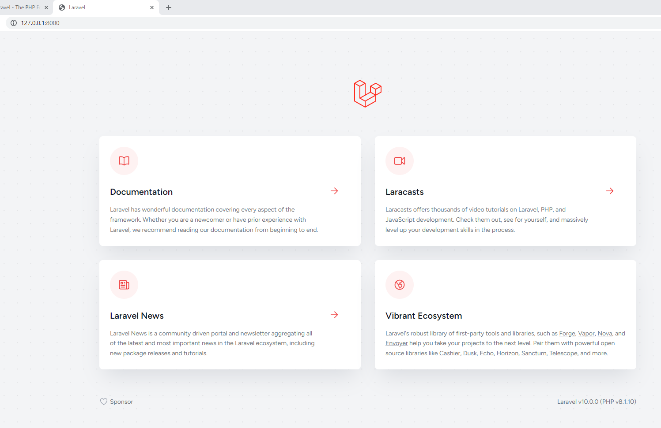

Laravel 10 default page.

**A. A “clean” hello world version**

**Controller**

* Go to *app/http/Controllers/* and create a file *HomeController.php* with the next content (or replace its content if the file already exists):

|  |
| --- |
| **Add Entire Code** |

<?php

namespace App\Http\Controllers;

use Illuminate\View\View;

class HomeController extends Controller

{

public function index(): View

{

return view('home.index');

}

}

**Views**

* Go to *resources/views/* and create a folder *layouts*
* Go to *resources/views/layouts* and create a file *app.blade.php* with the following content:

|  |
| --- |
| **Add Entire Code** |

<!doctype html>

<html lang="en">

<head>

<meta charset="utf-8" />

<meta name="viewport" content="width=device-width, initial-scale=1" />

**<link href="https://cdn.jsdelivr.net/npm/bootstrap@5.3.0-alpha1/dist/css/bootstrap.min.css" rel="stylesheet" crossorigin="anonymous" />**

**<link href="{{ asset('/css/app.css') }}" rel="stylesheet" />**

<title>**@yield('title', 'Online Store')**</title>

</head>

<body>

<!-- header -->

<nav class="navbar navbar-expand-lg navbar-dark bg-secondary py-4">

<div class="container">

<a class="navbar-brand" href="#">Online Store</a>

<button class="navbar-toggler" type="button" data-bs-toggle="collapse" data-bs-target="#navbarNavAltMarkup"

aria-controls="navbarNavAltMarkup" aria-expanded="false" aria-label="Toggle navigation">

<span class="navbar-toggler-icon"></span>

</button>

<div class="collapse navbar-collapse" id="navbarNavAltMarkup">

<div class="navbar-nav ms-auto">

<a class="nav-link active" href="#">Home</a>

<a class="nav-link active" href="#">About</a>

</div>

</div>

</div>

</nav>

<header class="masthead bg-primary text-white text-center py-4">

<div class="container d-flex align-items-center flex-column">

<h2>**@yield('subtitle', 'A Laravel EAFIT App')**</h2>

</div>

</header>

<!-- header -->

<div class="container my-4">

**@yield('content')**

</div>

<!-- footer -->

<div class="copyright py-4 text-center text-white">

<div class="container">

<small>

Copyright - <a class="text-reset fw-bold text-decoration-none" target="_blank"

href="https://twitter.com/danielgarax">

Daniel Correa

</a>

</small>

</div>

</div>

<!-- footer -->

**<script src="https://cdn.jsdelivr.net/npm/bootstrap@5.3.0-alpha1/dist/js/bootstrap.bundle.min.js" crossorigin="anonymous">**

</script>

</body>

</html>

* Go to *resources/views/* and create a folder *home*
* Go to *resources/views*/home and create a file *index.blade.php* with the following content:

|  |
| --- |
| **Add Entire Code** |

@extends('layouts.app')

@section('title', 'Home Page - Online Store')

@section('content')

<div class="text-center">

Welcome to the application

</div>

@endsection

**Routes**

* In *routes/web.php*, make the following changes in **bold**.

|  |
| --- |
| **Modify Bold Code** |

…

**~~Route::get('/', function () {~~**

**~~return view('welcome');~~**

**~~});~~**

**Route::get('/', 'App\Http\Controllers\HomeController@index')->name("home.index");**

**CSS**

* Go to *public/* and create a folder *css*
* Go to *public/css* and create a file *app.css* with the following content:

|  |
| --- |
| **Add Entire Code** |

.bg-secondary {

background-color: #2c3e50 !important;

}

.copyright {

background-color: #1a252f;

}

.bg-primary {

background-color: #1abc9c !important;

}

nav{

font-weight: 700;

}

.img-card{

height: 18vw;

object-fit: cover;

}

**Run the application**

In the Terminal, go to the project directory, and execute the following:

|  |
| --- |
| **Execute in Terminal** |

php artisan serve

**You should see the application running.**

**B. An About page**

**Views**

* Go to *resources/views/home* and create a file *about.blade.php* with the following content:

|  |
| --- |
| **Add Entire Code** |

@extends('layouts.app')

@section('title', **$title**)

@section('subtitle', **$subtitle**)

@section('content')

<div class="container">

<div class="row">

<div class="col-lg-4 ms-auto">

<p class="lead">**{{ $description }}**</p>

</div>

<div class="col-lg-4 me-auto">

<p class="lead">**{{ $author }}**</p>

</div>

</div>

</div>

@endsection

**Updating links in Header**

Now that we have the proper routes, controller, and views, let’s include the links in the header. In *resources/views/layouts/app.blade.php*, make the following changes in **bold**.

|  |
| --- |
| **Modify Bold Code** |

<!doctype html>

...

<body>

<!-- header -->

<nav class="navbar navbar-expand-lg navbar-dark bg-secondary py-4">

<div class="container">

<a class="navbar-brand" href="**{{ route('home.index') }}**">Online Store</a>

<button class="navbar-toggler" type="button" data-bs-toggle="collapse" data-bs-target="#navbarNavAltMarkup"

aria-controls="navbarNavAltMarkup" aria-expanded="false" aria-label="Toggle navigation">

<span class="navbar-toggler-icon"></span>

</button>

<div class="collapse navbar-collapse" id="navbarNavAltMarkup">

<div class="navbar-nav ms-auto">

<a class="nav-link active" href="**{{ route('home.index') }}**">Home</a>

<a class="nav-link active" href="**{{ route('home.about') }}**">About</a>

</div>

</div>

</div>

</nav>

...

**Routes**

* In *routes/web.php*, make the following changes in **bold**.

|  |
| --- |
| **Modify Bold Code** |

…

Route::get('/', 'App\Http\Controllers\HomeController@index')->name("home.index");

**Route::get('/about', function () {**

**$data1 = "About us - Online Store";**

**$data2 = "About us";**

**$description = "This is an about page ...";**

**$author = "Developed by: Your Name";**

**return view('home.about')->with("title", $data1)**

**->with("subtitle", $data2)**

**->with("description", $description)**

**->with("author", $author);**

**})->name("home.about");**

**Run the application**

In the Terminal, go to the project directory, and execute the following:

|  |
| --- |
| **Execute in Terminal** |

php artisan serve

**Click the “about link” in the header, and you should see the application running.**

**Activity 1**

* Take a look of the previous routes. Do you have any comment? We will discuss it the next class.

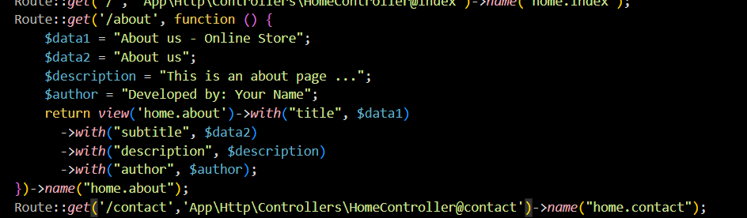

Esta parte donde se ubica la ruta del about, contiene una function que debería ser propia de los controladores si hiciéramos eso con todas las rutas tendríamos un archivo que haría mucho ruido.

**Activity 2**

* Create a “/contact” section in which you display the application email, address, and phone number. Use fake information.

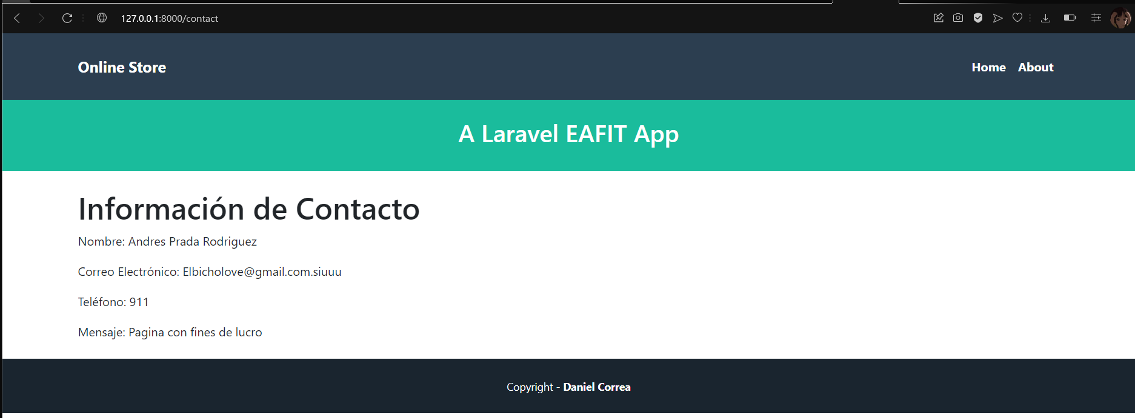

**C. Show products**

**Controller**

* Go to *app/Http/Controllers* and create a file *ProductController.php* with the following content:

|  |
| --- |
| **Add Entire Code** |

<?php

namespace App\Http\Controllers;

use Illuminate\Http\Request;

use Illuminate\View\View;

class ProductController extends Controller

{

public static $products = [

["id"=>"1", "name"=>"TV", "description"=>"Best TV"],

["id"=>"2", "name"=>"iPhone", "description"=>"Best iPhone"],

["id"=>"3", "name"=>"Chromecast", "description"=>"Best Chromecast"],

["id"=>"4", "name"=>"Glasses", "description"=>"Best Glasses"]

];

public function index(): View

{

$viewData = [];

$viewData["title"] = "Products - Online Store";

$viewData["subtitle"] = "List of products";

$viewData["products"] = ProductController::$products;

return view('product.index')->with("viewData", $viewData);

}

public function show(string $id) : View

{

$viewData = [];

$product = ProductController::$products[$id-1];

$viewData["title"] = $product["name"]." - Online Store";

$viewData["subtitle"] = $product["name"]." - Product information";

$viewData["product"] = $product;

return view('product.show')->with("viewData", $viewData);

}

}

***Product index view***

In *resources/views/*, create a subfolder *product*. Then, in *resources/views/product*, create a new file *index.blade.php* and fill it with the following code.

|  |
| --- |
| **Add Entire Code** |

@extends('layouts.app')

@section('title', $viewData["title"])

@section('subtitle', $viewData["subtitle"])

@section('content')

<div class="row">

**@foreach ($viewData["products"] as $product)**

**<div class="col-md-4 col-lg-3 mb-2">**

**<div class="card">**

**<img src="https://laravel.com/img/logotype.min.svg" class="card-img-top img-card">**

**<div class="card-body text-center">**

**<a href="{{ route('product.show', ['id'=> $product["id"]]) }}"**

**class="btn bg-primary text-white">{{ $product["name"] }}</a>**

**</div>**

**</div>**

**</div>**

**@endforeach**

</div>

@endsection

***Product show view***

In *resources/views/product*, create a new file *show.blade.php* and fill it with the following code.

|  |
| --- |
| **Add Entire Code** |

@extends('layouts.app')

@section('title', $viewData["title"])

@section('subtitle', $viewData["subtitle"])

@section('content')

<div class="card mb-3">

<div class="row g-0">

<div class="col-md-4">

**<img src="https://laravel.com/img/logotype.min.svg" class="img-fluid rounded-start">**

</div>

<div class="col-md-8">

<div class="card-body">

<h5 class="card-title">

**{{ $viewData["product"]["name"] }}**

</h5>

<p class="card-text">**{{ $viewData["product"]["description"] }}**</p>

</div>

</div>

</div>

</div>

@endsection

**Modifying routes**

In *routes/web.php*, make the following changes in **bold**.

|  |
| --- |
| **Modify Bold Code** |

…

**Route::get('/products', 'App\Http\Controllers\ProductController@index')->name("product.index");**

**Route::get('/products/{id}', 'App\Http\Controllers\ProductController@show')->name("product.show");**

**Run the application**

In the Terminal, go to the project directory, and execute the following:

|  |
| --- |
| **Execute in Terminal** |

php artisan serve

**Go to the (“/products”) route and you should see the application running.**

You can also click a specific product to see its information.

**Activity 3**

* Add the (“/products”) route as a new menu option (in the header navbar).

**Activity 4**

* Add prices for each product and display the information in the product.show view.

**Activity 5**

* Modify the show method. If the product number entered by the URL is not valid, redirect the user to the home page (“home.index”) route. <https://laravel.com/docs/10.x/responses#redirecting-named-routes>. Be careful, you should include this in the method response: (*View | RedirectResponse*). And include the next code at the top of the file *use Illuminate\Http\RedirectResponse;*
* Texto

  Descripción generada automáticamente

**Activity 6**

* Add a conditional in the “product.show” view. If the price of a product is greater than 100, display the product name in red <https://laravel.com/docs/10.x/blade#if-statements>.

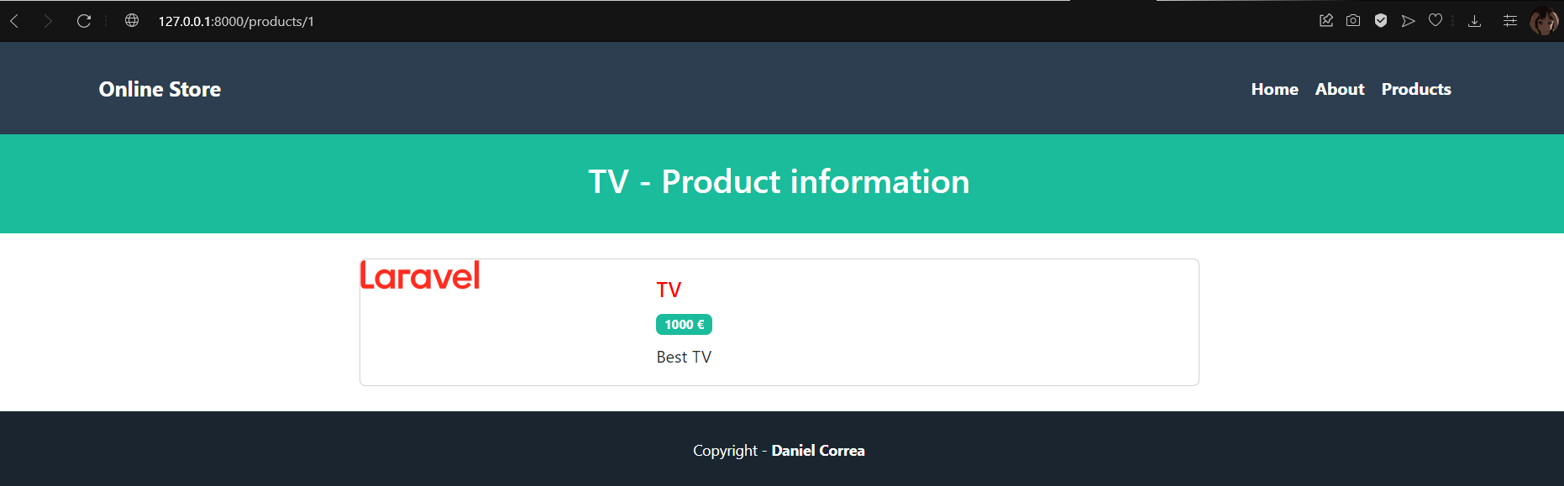

**D. Product creation (simulation)**

**Controller**

* In *app/Http/Controllers/ProductController.php*, make the following changes in **bold**.

|  |
| --- |
| **Modify Bold Code** |

…

**public function create(): View**

**{**

**$viewData = []; //to be sent to the view**

**$viewData["title"] = "Create product";**

**return view('product.create')->with("viewData",$viewData);**

**}**

**public function save(Request $request)**

**{**

**$request->validate([**

**"name" => "required",**

**"price" => "required"**

**]);**

**dd($request->all());**

**//here will be the code to call the model and save it to the database**

**}**

}

**Routes**

* In *routes/web.php*, make the following changes in **bold**. (check the route order, it matters).

|  |
| --- |
| **Modify Bold Code** |

…

Route::get('/products', 'App\Http\Controllers\ProductController@index')->name("product.index");

**Route::get('/products/create', 'App\Http\Controllers\ProductController@create')->name("product.create");**

**Route::post('/products/save', 'App\Http\Controllers\ProductController@save')->name("product.save");**

Route::get('/products/{id}', 'App\Http\Controllers\ProductController@show')->name("product.show");

**Views**

* Go to *resources/views/product*, create a file *create.blade.php* with the next content:

|  |
| --- |
| **Add Entire Code** |

@extends('layouts.app')

@section("title", $viewData["title"])

@section('content')

<div class="container">

<div class="row justify-content-center">

<div class="col-md-8">

<div class="card">

<div class="card-header">Create product</div>

<div class="card-body">

**@if($errors->any())**

**<ul id="errors" class="alert alert-danger list-unstyled">**

**@foreach($errors->all() as $error)**

**<li>{{ $error }}</li>**

**@endforeach**

**</ul>**

**@endif**

**<form method="POST" action="{{ route('product.save') }}">**

**@csrf**

**<input type="text" class="form-control mb-2" placeholder="Enter name" name="name" value="{{ old('name') }}" />**

**<input type="text" class="form-control mb-2" placeholder="Enter price" name="price" value="{{ old('price') }}" />**

**<input type="submit" class="btn btn-primary" value="Send" />**

**</form>**

</div>

</div>

</div>

</div>

</div>

</div>

@endsection

**Run the application**

In the Terminal, go to the project directory, and execute the following:

|  |
| --- |
| **Execute in Terminal** |

php artisan serve

**Go to the (“/products/create”) route and you should see the application running.**

**Activity 7**

* Try to understand the previous code. Add a new product but leave the name empty (and click send). Then, leave the price empty. Then, enter the two fields.



El formulario esta bien diseñado el problema es que no tenemos una base de datos para mandar la información, todo esta quemado en código.

**Activity 8**

* Modify the previous code to only allow numbers greater than zero for the prices. DO NOT USE ifs. <https://laravel.com/docs/10.x/validation#available-validation-rules>.

**Activity 9**

* If the info entered by the form is valid. Then display a message saying, “Product created”. **Note:** create a new view (which uses the layout system).

**Activity 10**

* Add a new menu option in the header (app layout), that links to the “/products/create” page.

**Note:** create a repo with all this code (called LaravelTutorials) and upload the repo link to the corresponding Teams Assignment.