**Implement the android/ios app**

1. Login Page

Create Login Page given below in screenshot

a. Remember Me (optional)

b. Registration Button will go to Registration Page.(info is given below)

c. On Submit Show the information like name, gender which is stored in database.

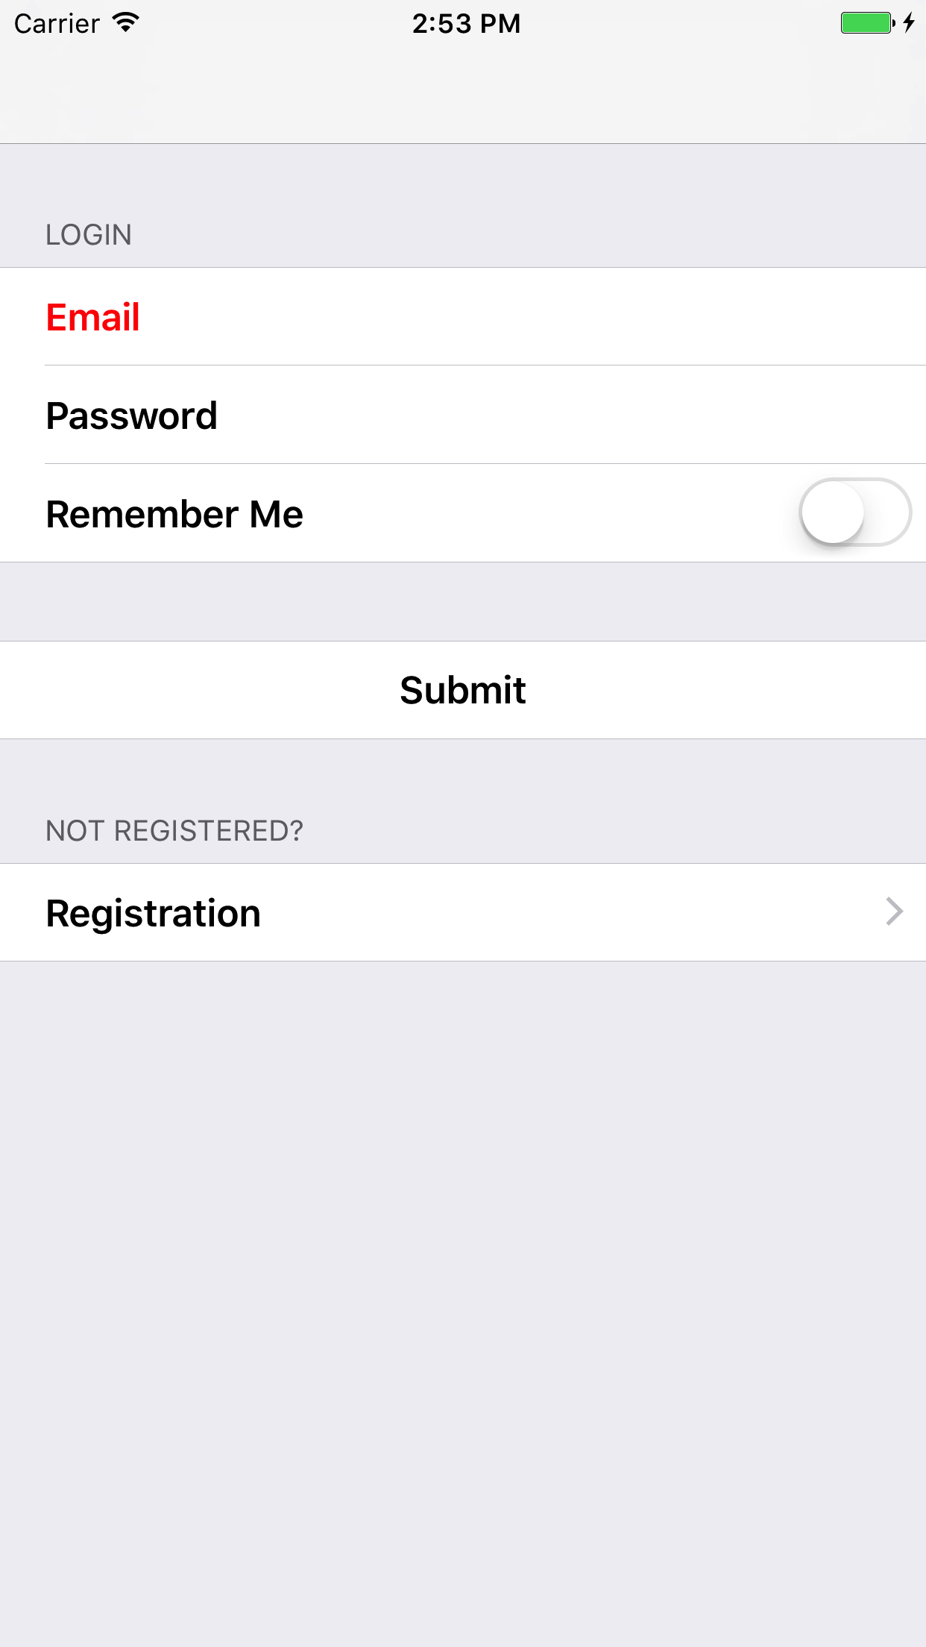

Fig. Login Page

2.Create the registration page as given following in Screenshot.

a. Each Field should be shown in a listview( Email,Password,etc)

b. Gender input type should be PICKER.

c. User can add image(From Gallery as well as Camera) on Profile photo .

d. On Submit,Insert the info into database.

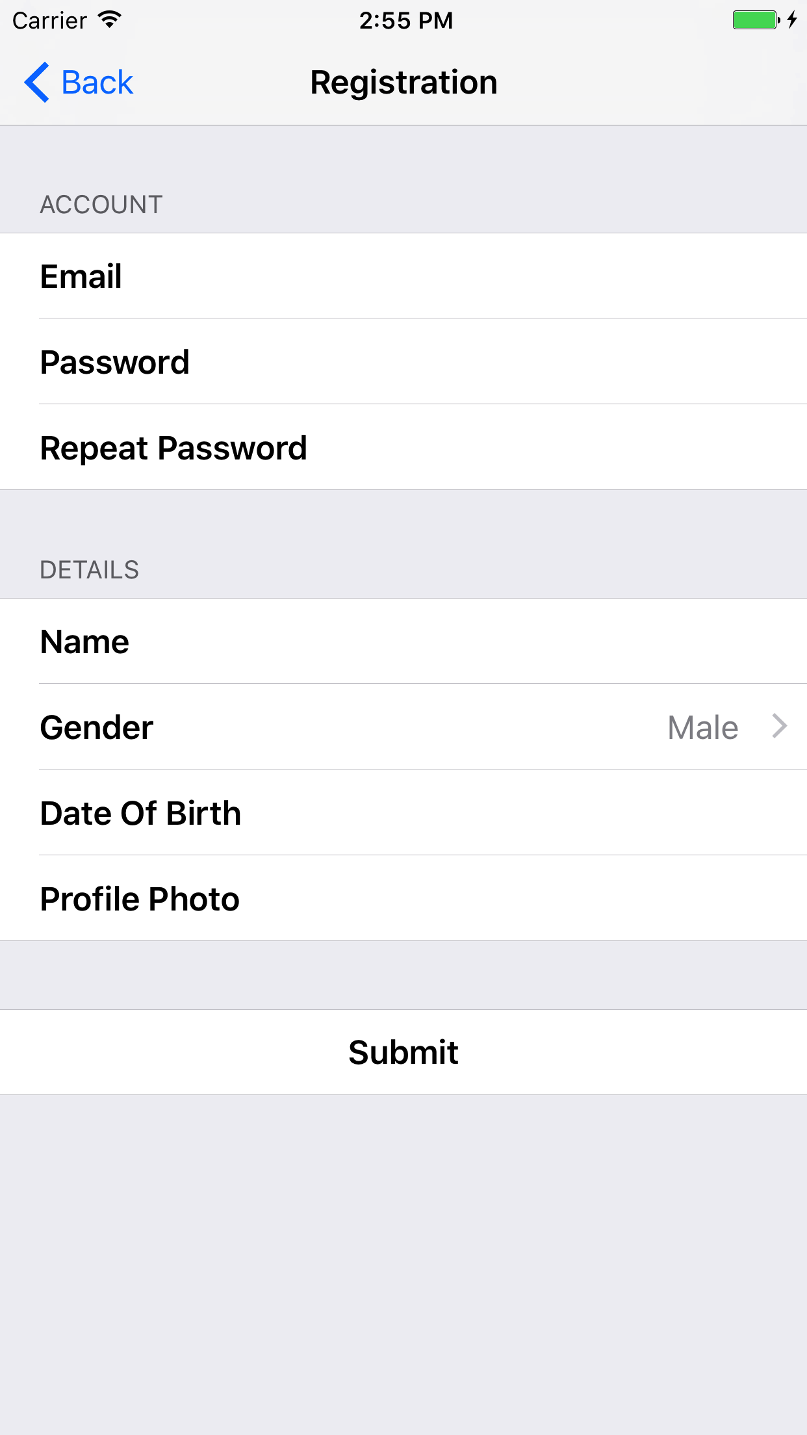

Fig. Registration Page