Name: Pradnya Wakode
PRN: 123B1B231
Div: D
Subject: Full stack Development Lab
Assignment 6
Assignment : Online Portal Development using Node.js, Express, and NoSQL
A. Node.js: The Runtime Environment
Node.js is an open-source, cross-platform runtime built on the Chrome V8 engine. Its core advantage is the Single-Threaded Event Loop and Non-blocking I/O, which allows the server to handle thousands of concurrent connections without the overhead of thread management. In an e-commerce or booking context, this ensures that the server remains responsive even during high-traffic events like flash sales or peak booking hours.
B. Express.js: The Backend Framework
Express is a "unopinionated" web framework that provides a robust set of tools for building web applications.
- Routing: It maps incoming HTTP requests (GET, POST, etc.) to specific controller logic.
- Middleware: It allows for modular processing of requests, such as verifying user credentials or parsing incoming JSON data before it reaches the final application logic.
C. NoSQL and MongoDB: Flexible Data Storage
Unlike traditional relational databases, MongoDB is a document-oriented NoSQL database that stores data in BSON (Binary JSON) format.
- Schema Flexibility: Used items (cars, bikes) often have varying attributes; NoSQL allows for dynamic fields without requiring a rigid table structure.
- High Availability: MongoDB supports replica sets, ensuring that the application remains functional even if a database node fails.
- Mongoose ODM: Mongoose is used to provide a schema-based solution for application data, handling validation and casting directly within the Node.js environment.
3. Application Architecture
The application follows a Three-Tier Architecture:
- Presentation Layer (Frontend): Developed with HTML, CSS, and JavaScript, it captures user input and displays data fetched from the server.
- Logic Layer (Backend): The Express server processes business logic, such as calculating prices or checking appointment slots.
- Data Layer (Database): MongoDB persists user accounts, item listings, and transaction history.
4. Implementation Components
I. RESTful API Endpoints
Communication between the frontend and backend is facilitated through REST APIs:
- GET /api/items: To browse available cars, bikes, or appointment slots.
- POST /api/bookings: To submit a new purchase request or book an appointment.
- PUT /api/items/:id: To update item details or mark a slot as "unavailable".
II. Authentication and Security
- Password Hashing: The system uses bcrypt to securely hash passwords before they are stored in the database.
- JWT (JSON Web Tokens): Upon a successful login, the server issues a JWT. This token is sent with every subsequent request to identify the user and their permissions (e.g., student, customer, or admin).
III. File and Data Handling
- Multer Middleware: For e-commerce portals, Multer handles the upload of item images (e.g., photos of used cars) or PDF documents for verification.
- Static Assets: Express is configured to serve these uploaded files and other static assets from a public directory.
- 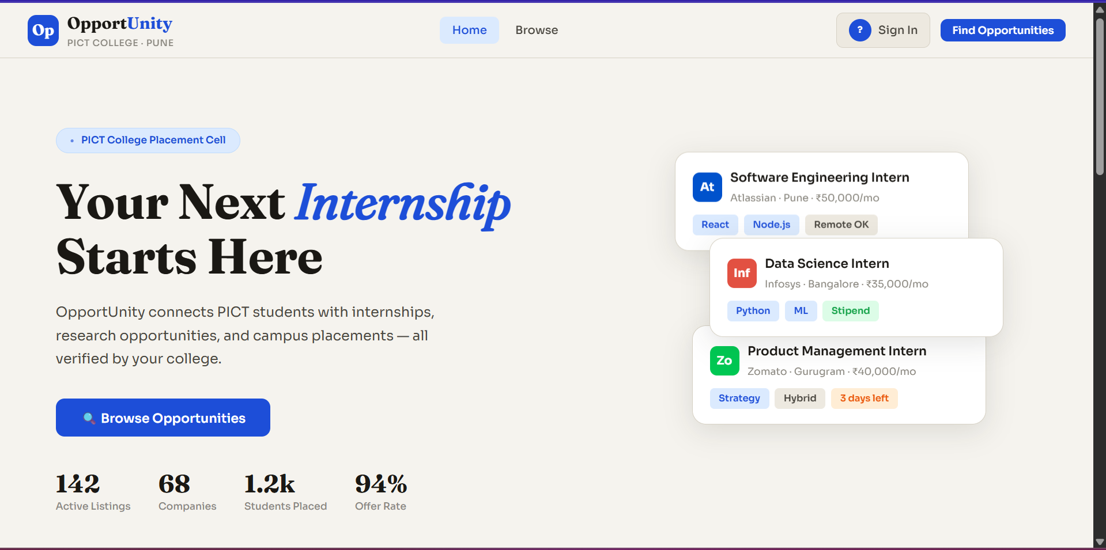
- 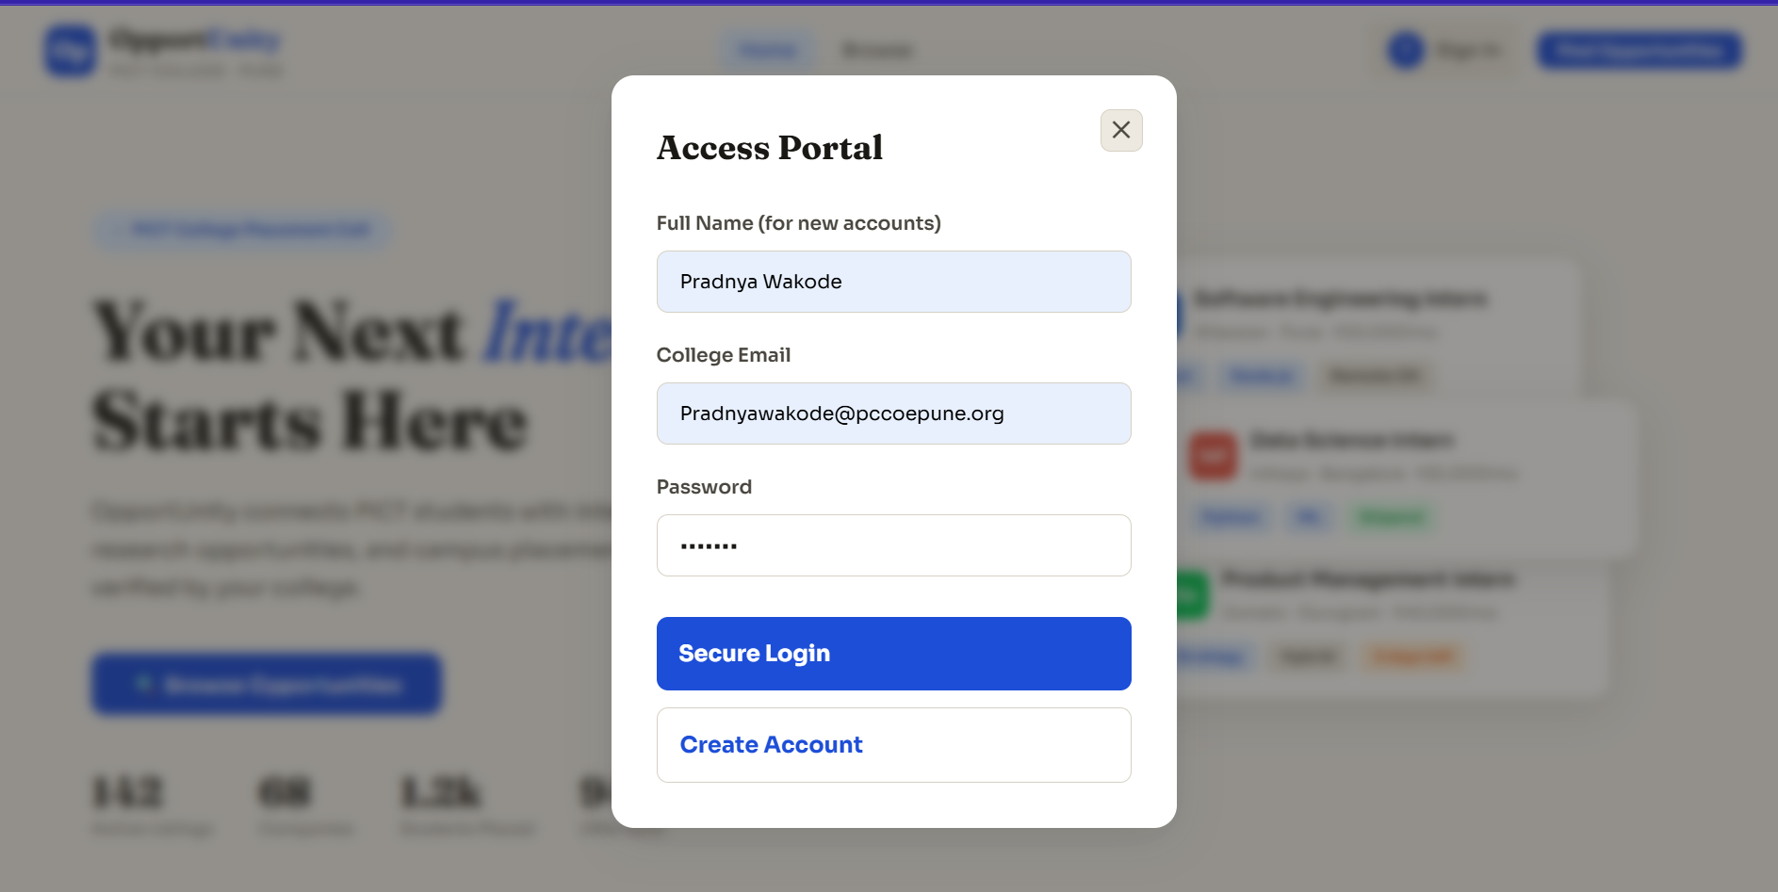
- 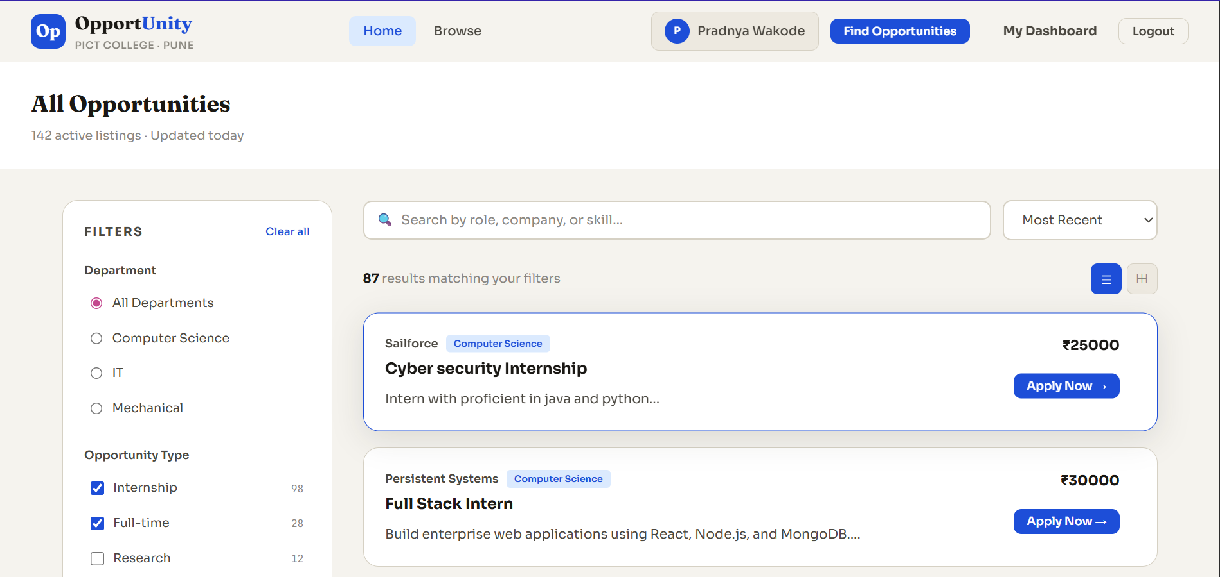

Results:
Admin Portal:
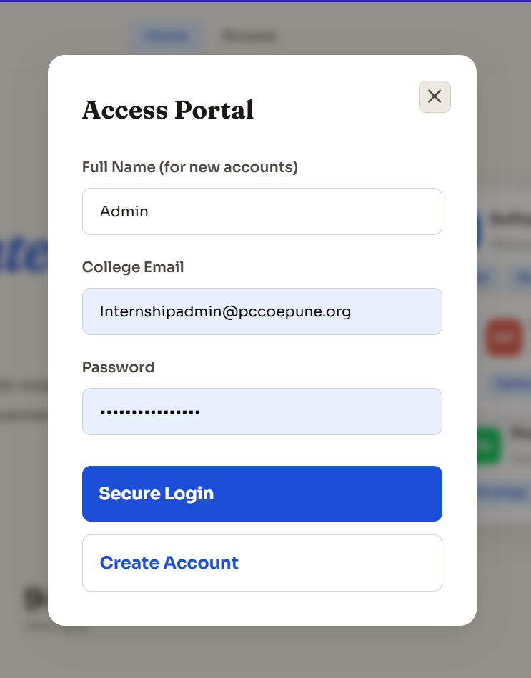
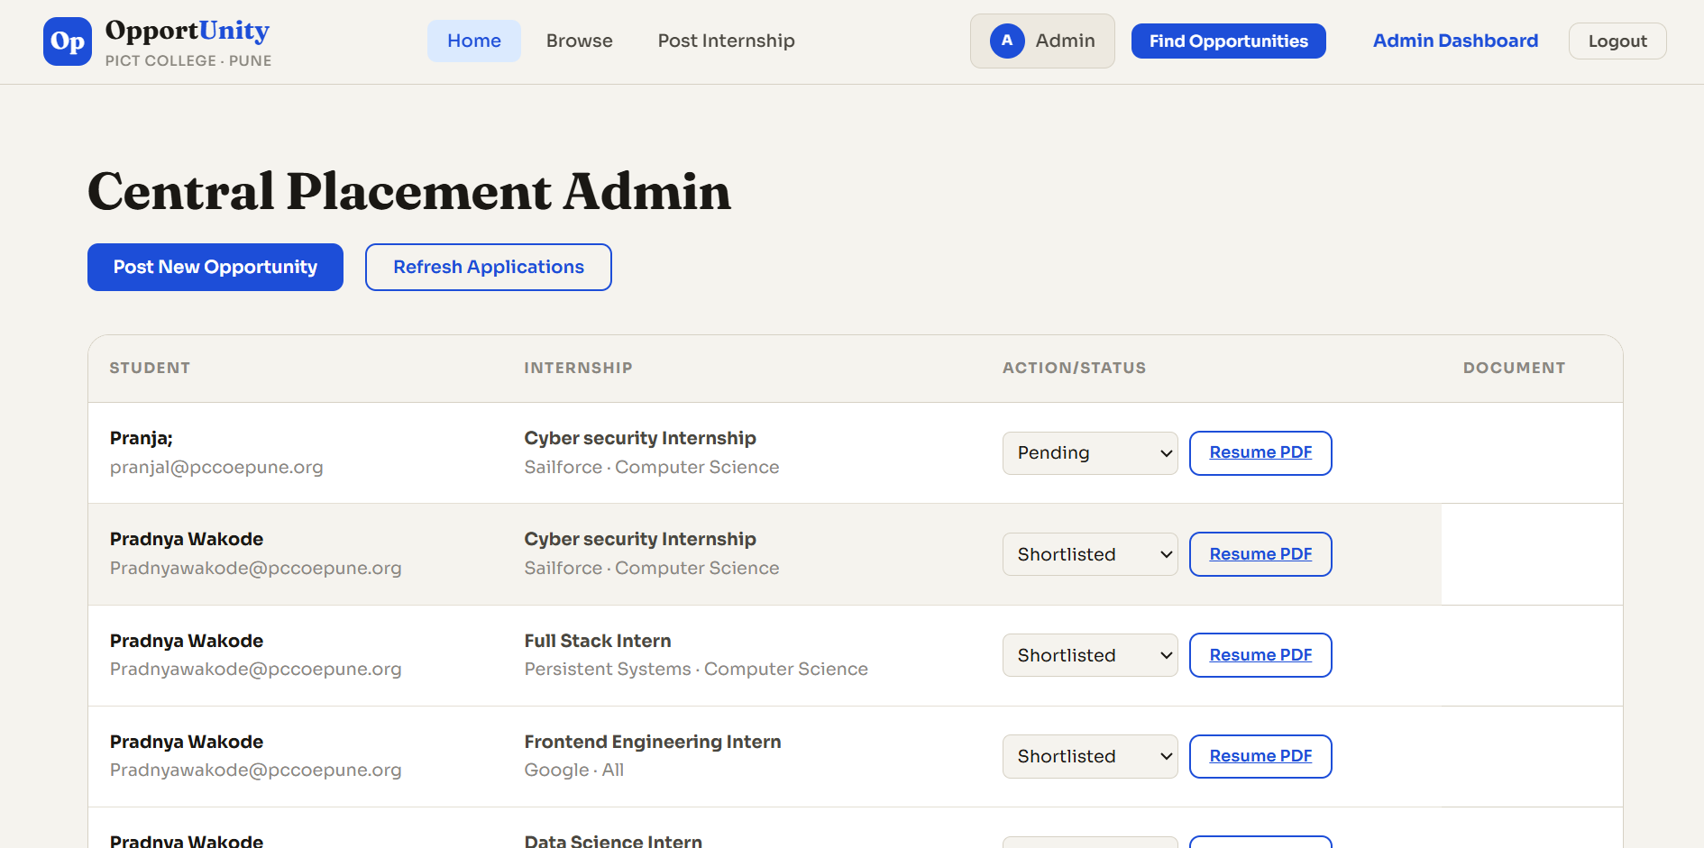
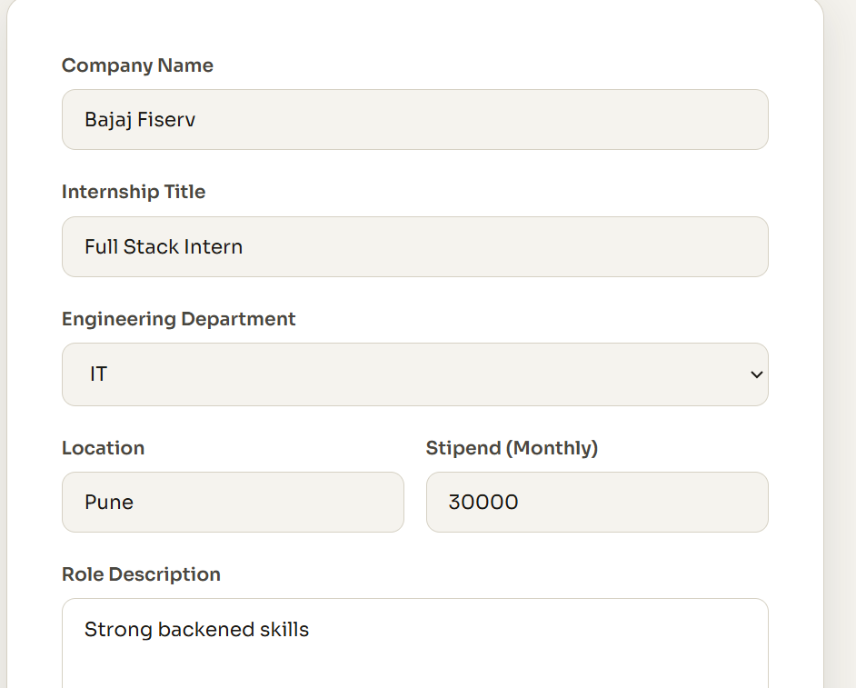
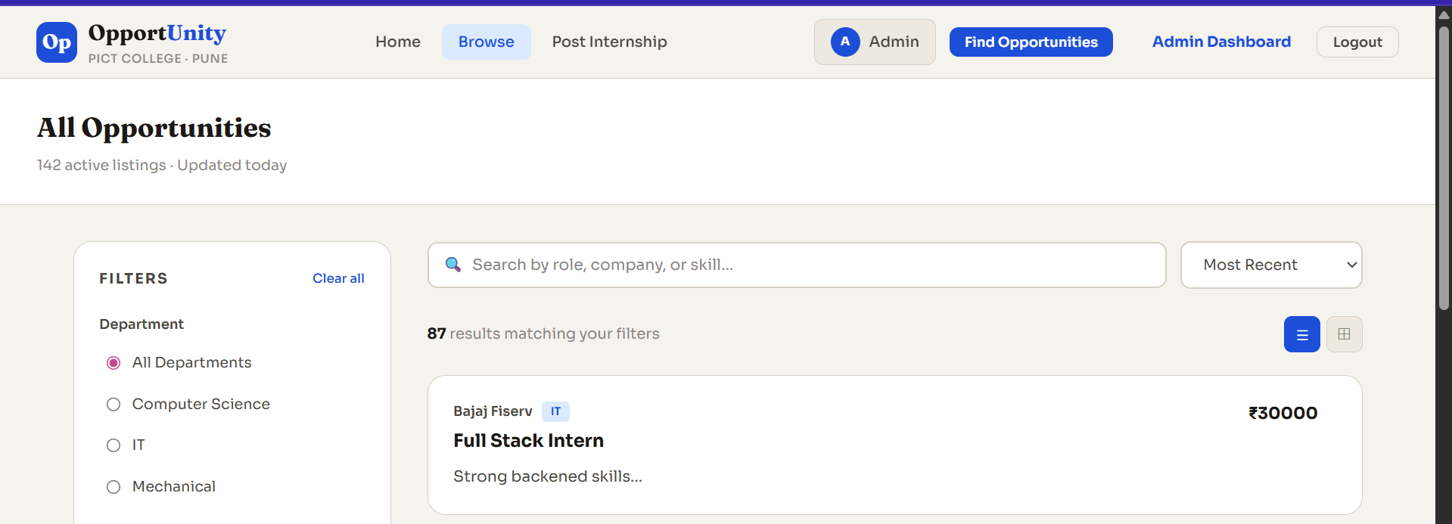
5. Conclusion
Integrating Node.js, Express, and MongoDB creates a versatile platform capable of handling diverse use cases from e-commerce to service booking. The combination of an asynchronous backend and a flexible NoSQL database provides the agility required to adapt to changing user requirements and data structures in a modern digital marketplace.

