mysql> USE MYDATA;

Database changed

--Create a table:

mysql> CREATE TABLE Employees (

-> EmpID INT PRIMARY KEY,

-> Name VARCHAR(100) NOT NULL,

-> Age INT,

-> Department VARCHAR(50),

-> Salary DECIMAL(10, 2),

-> JoiningDate DATE,

-> City VARCHAR(50)

-> );

Query OK, 0 rows affected (0.05 sec)

--Question 2:Insert at least 10 records into the Employees table with sample data.

mysql> INSERT INTO Employees (EmpID, Name, Age, Department, Salary, JoiningDate, City)

-> VALUES

-> (1, 'Ram Patil', 28, 'IT', 60000.00, '2022-01-15', 'Mumbai'),

-> (2, 'Harry Kumar', 34, 'HR', 55000.00, '2021-06-10', 'Pune'),

-> (3, 'Samarth Mahajan', 40, 'Finance', 75000.00, '2020-11-25', 'Nashik'),

-> (4, 'Prachi Sapkal', 25, 'Marketing', 45000.00, '2023-03-01', 'Bhusawal'),

-> (5, 'Pradnya Narwade', 30, 'IT', 70000.00, '2021-09-18', 'Raver'),

-> (6, 'Likhita Satav', 38, 'HR', 58000.00, '2019-02-22', 'Mumbai'),

-> (7, 'Bhumi Arya', 45, 'Finance', 80000.00, '2018-08-30', 'Pune'),

-> (8, 'Om Sangle', 27, 'Marketing', 40000.00, '2022-11-15', 'Jalgoan'),

-> (9, 'Narendra Harankar', 32, 'IT', 65000.00, '2021-05-10', 'Pune'),

-> (10, 'Mohit Ingle', 29, 'Marketing', 42000.00, '2020-07-05', 'Delhi');

Query OK, 10 rows affected (0.03 sec)

Records: 10 Duplicates: 0 Warnings: 0

--3: Write an SQL query to display all the records from the Employees table.

mysql> SELECT * FROM Employees;

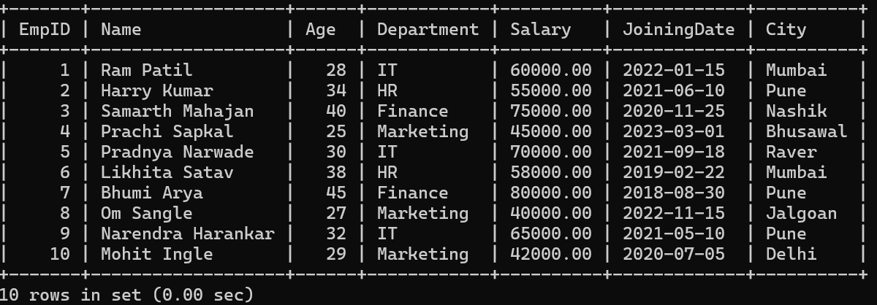

--4: Display only the Name, Department, and Salary of all employees

mysql> SELECT Name, Department, Salary FROM Employees;

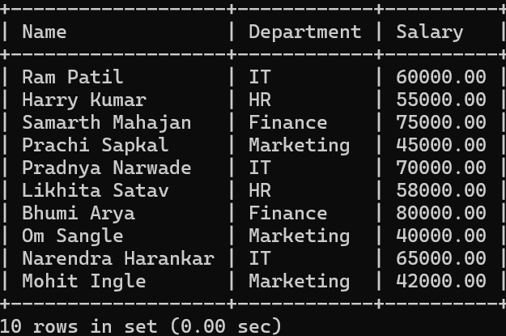

--- Question 5: Display the records of employees who earn a salary greater than ₹50,0 00

mysql> SELECT * FROM Employees WHERE Salary > 50000.00;

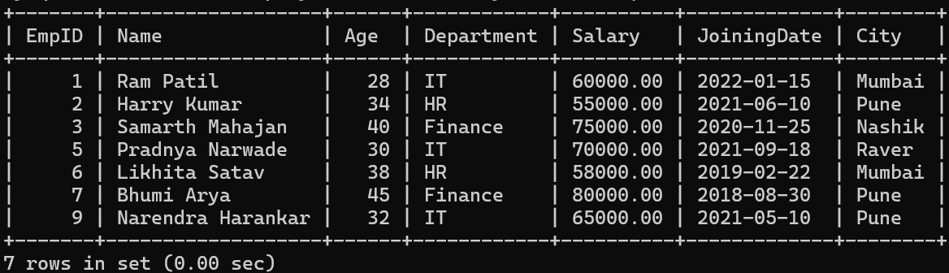

--Question 6:Display the employees who belong to IT depertment string comparison

mysql> SELECT * FROM Employees

-> WHERE LOWER(Department) = 'it';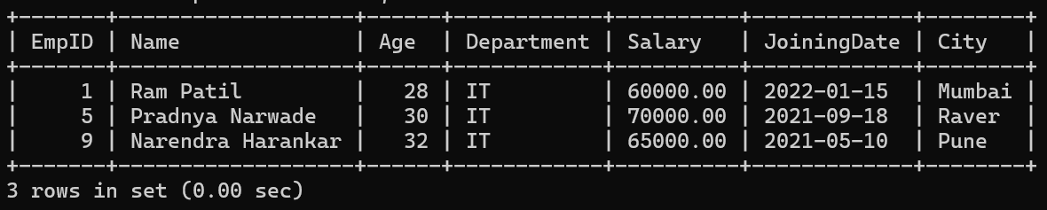

--Question 7: Display Employees Whose Age is Between 25 and 35

mysql> SELECT * FROM Employees

-> WHERE Age BETWEEN 25 AND 35;

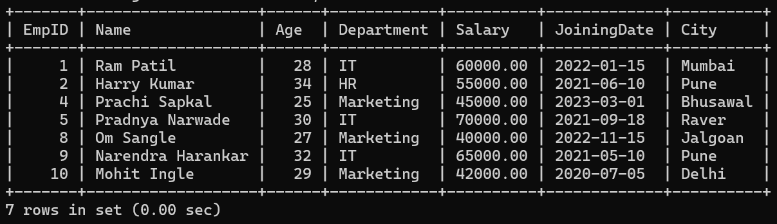

--Question 8:Display the the employees who joined the company after 1st Jnanuary 2022.

mysql> SELECT * FROM Employees

-> WHERE Age > 25 AND Age < 35;

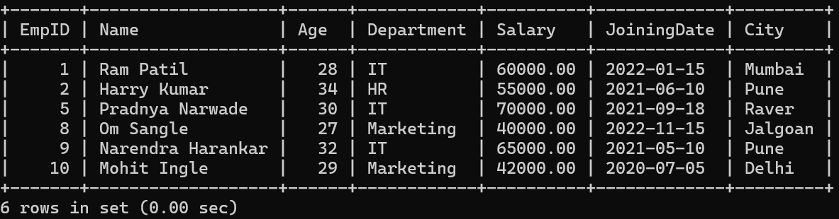

--Question 9:Display the employee from Mumbai or Pune city.

mysql> SELECT * FROM Employees

-> WHERE City IN ('Mumbai', 'Pune');

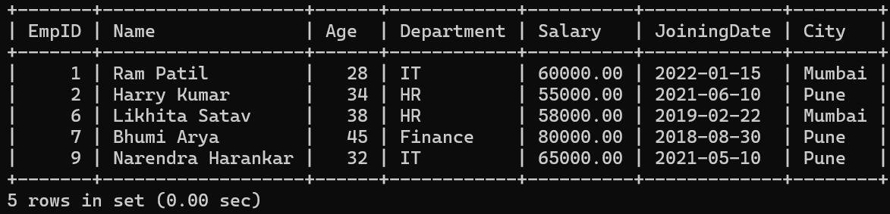

--Question 10:Display the total number of employees in each Department.

mysql> SELECT Department, COUNT(*) AS TotalEmployees

-> FROM Employees;

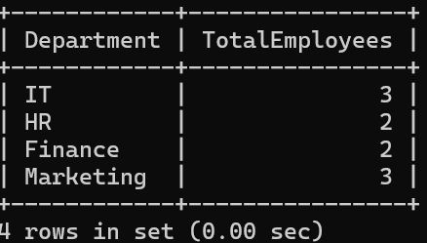

--Question 11:Display the average salary of employees in eacha Department.

mysql> SELECT Department, AVG(Salary) AS AverageSalary

-> FROM Employees

-> GROUP BY Department;

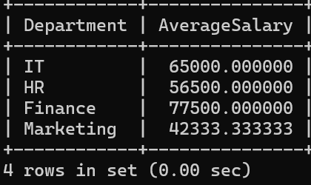

--Advanced Question:

--Question 12:Display the employee with the higest salary

mysql> SELECT Name,Salary FROM Employees

-> WHERE Salary = (SELECT MAX(Salary) FROM Employees);

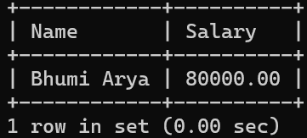

--Question 13:Display the top 3 higest-paid employees

mysql> SELECT * FROM Employees

-> ORDER BY Salary DESC

-> LIMIT 3;

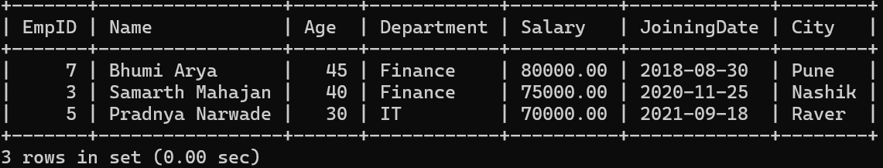

--Question 14:Display employees sorted in Ascending order by Name and descending order by salary.

mysql> SELECT * FROM Employees

-> ORDER BY Name ASC, Salary DESC;

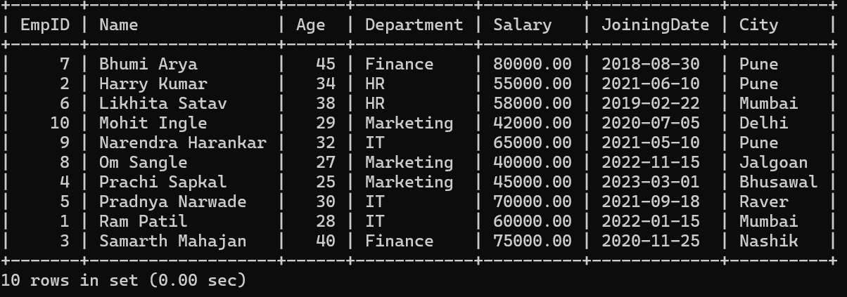

--Question 15:Update the salary of employees in the It department by increasing it by 10%.

mysql> UPDATE Employees

-> SET Salary = Salary * 1.10

-> WHERE Department = 'IT';

Query OK, 3 rows affected (0.02 sec)

Rows matched: 3 Changed: 3 Warnings: 0

mysql> SELECT * FROM Employees

-> WHERE Department = 'IT';

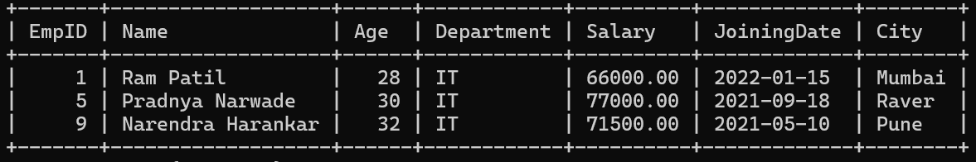

--Question 16: Delete employees who belong in HR department.

mysql> DELETE FROM Employees

-> WHERE Department = 'HR';

Query OK, 2 rows affected (0.01 sec)

mysql> SELECT * FROM Employees;

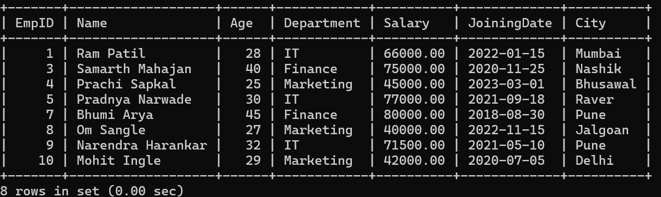

--Question 17:Create a New table called project with the following colums

mysql> CREATE TABLE Project (

-> Projected INT PRIMARY KEY,

-> ProjectName VARCHAR(255),

-> EmpID INT,

-> StartDate DATE,

-> EndDate DATE,

-> FOREIGN KEY (EmpID) REFERENCES Employees(EmpID)

-> );

Query OK, 0 rows affected (0.17 sec)

--Question18:Insert asample data inti Project table and Display all Project assigned to employee

INSERT INTO Project (project_id, project_name, start_date, end_date, manager_id)

VALUES

(101, 'Project Alpha', '2025-04-01', '2025-09-30', 1),

(102, 'Project Beta', '2025-05-15', '2025-10-15', 2),

(103, 'Project Gamma', '2025-06-01', '2025-12-31', 3),

(105, 'Project Epsilon', '2025-05-15', '2025-10-15', 5),

(106, 'Project Zeta', '2025-06-01', '2025-12-31', 6),

(107, 'Project Eta', '2025-04-01', '2025-09-30', 7),

(108, 'Project Theta', '2025-05-15', '2025-10-15', 8),

(109, 'Project Iota', '2025-06-01', '2025-12-31', 9),

(110, 'Project Kappa', '2025-04-01', '2025-09-30', 10);

Query OK, 10 rows affected (0.03 sec)

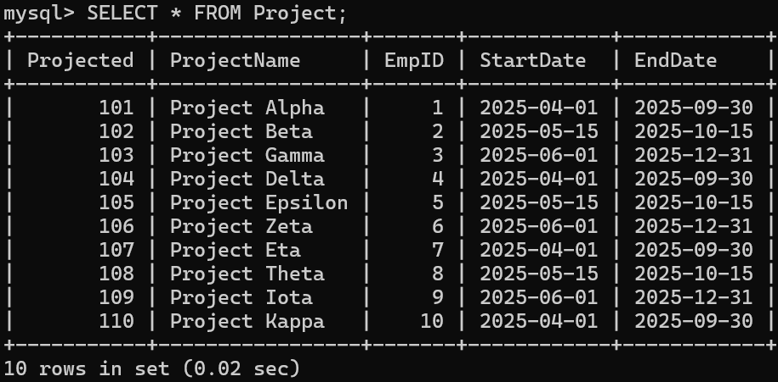

mysql> SELECT

-> p.Projected AS ProjectID,

-> p.ProjectName,

-> p.StartDate,

-> p.EndDate,

-> e.Name AS EmployeeName

-> FROM

-> Project p

-> JOIN

-> Employees e ON p.EmpID = e.EmpID;

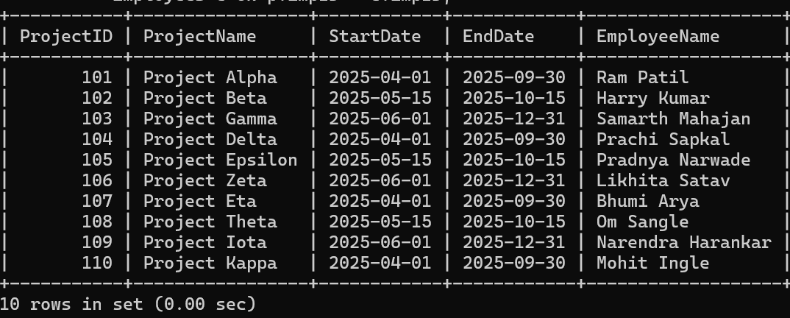

--Question 19:Display the list of employess who are working on a project that start after 1 january 2023.

mysql> SELECT

-> e.EmpID,

-> e.Name,

-> e.Department,

-> e.Salary,

-> e.JoiningDate,

-> p.Projected AS ProjectID,

-> p.ProjectName,

-> p.StartDate

-> FROM

-> Employees e

-> INNER JOIN

-> Project p ON e.EmpID = p.EmpID

-> WHERE

-> p.StartDate > '2023-01-01';

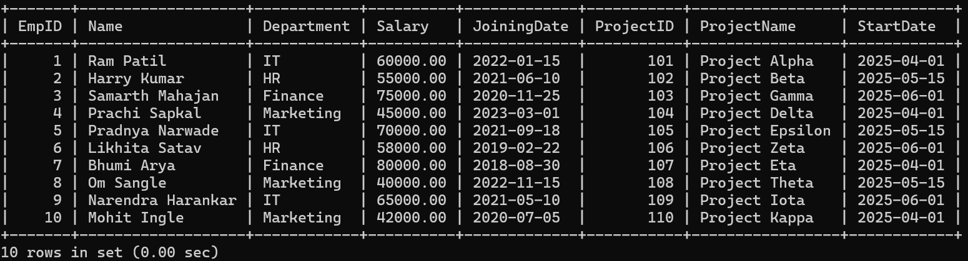

--Question 20:Display employees who are not assigned to any project.

mysql> DELETE FROM Project

-> WHERE Projected = 101;

Query OK, 1 row affected (0.03 sec)

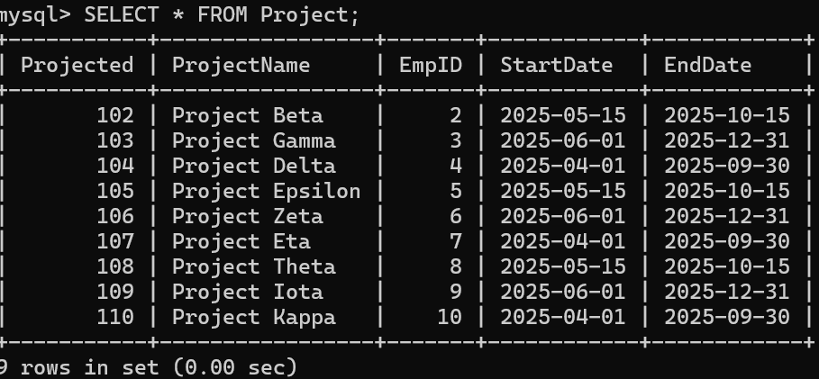

mysql> SELECT

-> e.EmpID, e.Name, e.Department,

-> e.Salary,

-> e.JoiningDate,

-> e.City

-> FROM

-> Employees e

-> LEFT JOIN

-> Project p ON e.EmpID = p.EmpID

-> WHERE

-> p.Projected IS NULL;

